
Lime Microsystems Ltd

Surrey Technology Centre
Occam Road
Surrey Research Park
Guildford, Surrey GU2 7YG
United Kingdom

Tel: +44 (0) 1483 685 063
Fax: +44 (0) 1428 656 662
e-mail: enquiries@limemicro.com

LMS6002/LMS7002
USB Dongle User Guide

- User guide to configure dongle with lms_suite and Raspbian OS -

REVISION HISTORY

The following table shows the revision history of this document:

Date | Version | Description of Revisions
01/12/15 | 1.0 | Initial version

Table of Contents

1Introduction 4
2Complete Development Package 5
3uSTREAM Key Features 6
3.1USB Dongle architecture 7
4Getting Started with USB dongle 8
4.1DEMO Setup 8
4.2DEMO Procedure 8
4.2.1Connect USB dongle to PC/Laptop 9
4.2.2Connect lms-suite.exe software to the dongle 9
4.2.3Setup USB dongle by loading LMS6002D/LMS7002M register pre-set file 10
4.2.4Load waveform for Tx Path 11
4.2.5Run FTTviewer to analyze receiver spectrum 12
5Connecting USB dongle to Raspberry Pi 14
5.1Controlling USB dongle (uMyriadRF6002 version)via Raspbian OS 14
5.1.1Enabling Raspberry Pi SPI interface 14
5.1.2Run Python script from command line 15
6Single-board PCs suitable for USB dongle 17
7Appendix I 18
7.1FX3 microcontroller drivers installation 18
7.2USB3 Windows driver installation procedure 18
7.3Firmware installation for USB microcontroller 21
7.3.1Uploading firmware to the FX3 RAM 22
7.3.2Uploading firmware to empty FLASH 23
7.3.3Uploading firmware to non-empty external FLASH memory 23
8Appendix II 24
8.1Load bitstream to FPGA 24

Introduction

USB dongle consist of uSTREAM and uMyriadRF6002 or uMyriadRF7002. It is a low cost, software defined radio (SDR) platform, based on LMS6002D/LMS7002M transceiver and Altera Cyclone IV FPGA. The platform connects to a standard PC via the USB3 interface and turns it to a universal wireless communication tool.

The highly flexible LMS6002D/LMS7002M transceiver enables developers to work on the wide range of wireless communications applications in industry, education and research, which are used in a frequency range from 300MHz to 3.8GHz (LMS6002D) and 100kHz to 3.8GHz (LMS7002M).

The USB dongle is an open source platform and all example applications/software is available to download from myriadrf.org website [link].

This document provides the following information:
- SDR hardware description
- Programming with FX3 firmware and running FPGA bitstreams
- Working with Raspberry Pi

Complete Development Package

Complete USB dongle content showed in Figure 1.

Figure 1 Complete USB dongle package

Development kit content:
- uSTREAM board and uMyriadRF6002 or uMyriadRF7002 board
- 2 x UFL to SMA cable
- USB stick containing:
  - lms-suite GUI and register setup for LMS6002D/LMS7002M transceiver
  - FPGA demo bitstreams and project design files
  - USB3 controller drivers
  - Waveforms
  - Windows drivers
  - Raspbian OS scripts

uSTREAM Key Features

The main uSTREAM components are highlighted in the Figure 2.

Figure 2 uSTREAM components

- FPGA Features
  - Cyclone IV EP4CE10F17C8N device in 256-pin FBGA
  - 10’320 LEs
  - 414 Kbits embedded memory
  - 23 embedded 18x18 multipliers
  - 4 PLLs
- FPGA Configuration
  - JTAG mode configuration
  - Serial mode configuration via Cypress FX3
- Memory Devices
  - 512M (32M x 16) bit DDR2 SDRAM
- USB Interface
  - Cypress FX3 Supper Speed USB 3rd generation controller (CYUSB3013)
- Connections
  - 40-pin Raspberry Pi socket
- Clock System
  - 30.72MHz on board TCXO
  - 8-bit DAC (TCXO frequency adjustment)
- Board Size 31mm x 108mm (1.22” x 4.25”)

USB Dongle architecture

The digital signals are driven from the PC via USB3.0 controller (or Raspberry Pi connector), Altera FPGA and to the DAC within the LMS6002D to produce analog I&Q output, then mixed with an adjustable frequency RF carrier through the quadrature modulator. The resulting RF signal is transmitted to the analyser through the TX RF output, see Figure 3.
The incoming RF signal is converted to baseband through the quadrature de-modulator, digitized through the ADC, processed in the FPGA and sent to the PC via USB3.0 controller (or Raspberry Pi connector). The digitized signal can be analysed with LimeSuite software.
uSTREAM
uMyriadRF
6002/7002

TXRF TXdig

RXRF RXdig

connector
Raspberry Pi connector

USB3.0 A connector

Altera
Cyclone IV

FX3
USB3.0 MCU

FLASH
DDR2 SDRAM
CLKs
circuit

Figure 3. USB dongle block diagram

The TCXO frequency (+/- 100 Hz) can be adjusted via FPGA to correct for the frequency error.

Getting Started with USB dongle

The USB dongle comes with LimeSuite software, which enables to control the LMS6002D or LMS7002M transceiver, run the “FFTviewer” to analyse the ADC spectrum, load wanted waveforms to FPGA. Two example waveforms are available in the kit:

- Single tone generated in the digital domain by a programmable logic-based
- W-CDAM TM1 with 64ch waveform

DEMO Setup

The demo setup is showed in Figure 4 . This demo uses single control software “lms-suite.exe” to control USB dongle.

Figure 4 Demo Setup for USB dongle

DEMO Procedure

The DEMO procedure is common for both uMyriadRF6002 and uMyriadRF7002.
Steps are showed below:
- Connect USB dongle to PC/Laptop
- Connect lms-suite.exe software to the dongle
- Setup USB dongle by loading register pre-set file
- Load waveform for Tx Path
- Run FFTviewer to analyse receiver

Connect USB dongle to PC/Laptop

The USB dongle comes preprogrammed and ready to use. Once board is connected to PC or laptop, after few seconds firmware will load from memory and LD6, LD7 will lit and LD2, LD5 start flashing indicating that the board is ready for operation.

Connect lms-suite.exe software to the dongle

When DEMO setup is ready, run the “lms-suite.exe” software, select Options, Communication Settings in top menu. New pop-up window should appear. Select COM port dedicated to the USB dongle. See figure Figure 5.

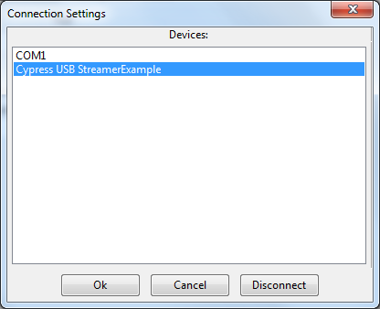

Figure 5 Comunicaton port selection for USB dongle

When board is successfully connected, you should see the indication in bottom of the main GUI window, see figure Figure 6.

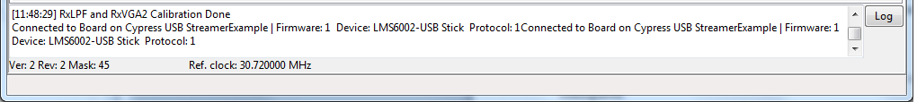

Figure 6 lms7suite board connections indication

NOTE: If Communication Setting window shows up as empty, install windows drivers for the board. Please follow the procedures described in the chapter “USB3 Windows driver installation procedure USB3 Windows driver installation procedure”.

Setup USB dongle by loading LMS6002D/LMS7002M register pre-set file

When board is connected to the lms_suite software, the registers for the transceiver IC can be configured by loading the configuration file. In order to do that, press Open button in the GUI front panel. See Figure 7.

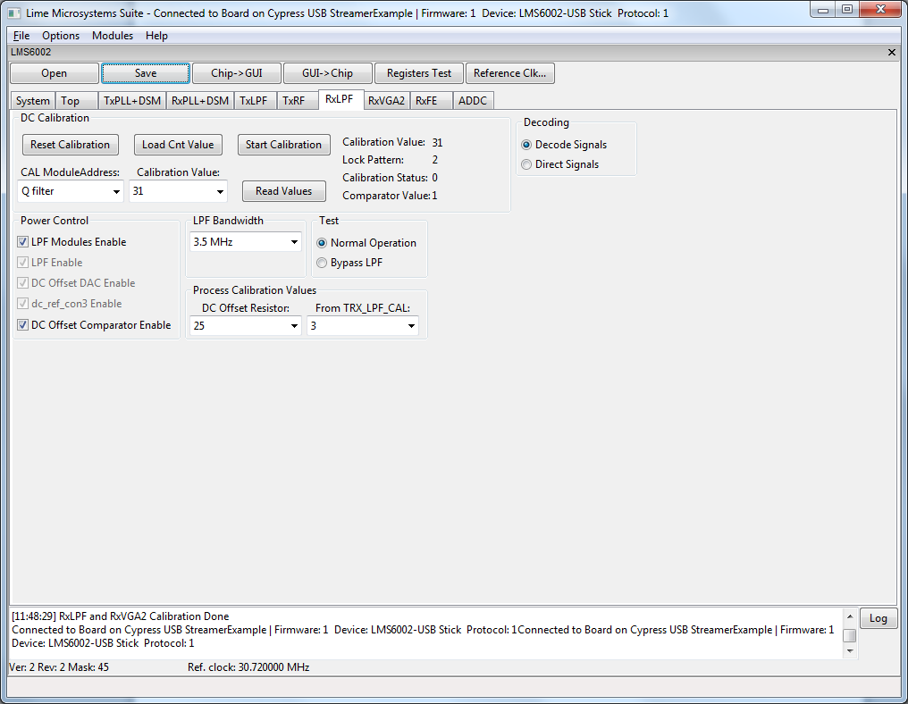
Figure 7 Select the pre-set file for transceiver

Select the lms6usb_reguister_settings.ini file in the ..\ lms6_usb_distro_03v\gui location, and press OPEN (for LMS7002M - lms7usb_reguister_settings.ini file in the ..\ lms7_usb_distro_01v\gui location).

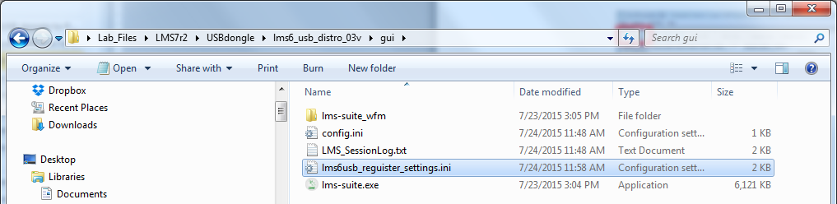

Figure 8 Select the lms6usb_reguister_settings.ini file

In order for the changes to take effect press GUI→ Chip, as shown below in .

At this point you should see the TX LO at 2140 MHz on analyser screen.

NOTE: If TX LO appears to be not locked, select the TxPLL+ DSM tab on the GUI, press Calculate and Tune.

NOTE: The register pre-set file configures transceiver to transmit 2140 MHz and receive signal at 1950 MHz.

Load waveform for Tx Path

The programed FPGA is acting as waveform player for LMS6002D/LMS7002M transceiver. In order to load the waveform, select Modules from top menu, then FPGA Controls from the drop down menu. See Figure 9.

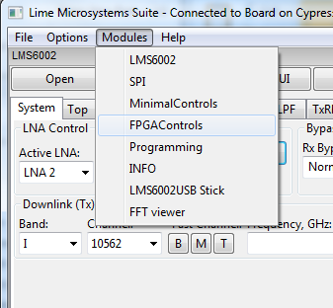

Figure 9 Select FPGA Control window

New window will appear in the bottom of the GUI, offering you to load supplied waveforms or custom waveforms. Please select to load WCDMA waveform by clocking on W-CDMA button. See Figure 10.

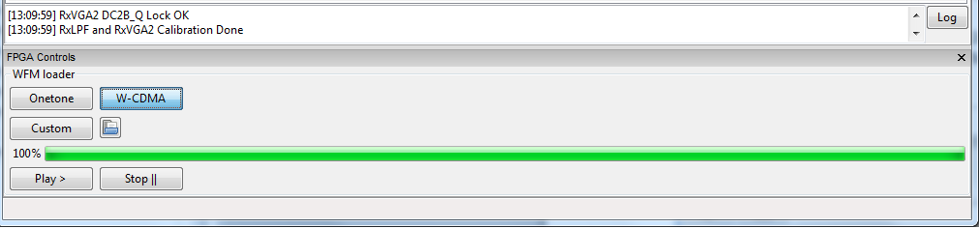

Figure 10 Waveform selection

Run FTTviewer to analyze receiver spectrum

FFTviewer module is a part of lms_suite software. To run FFTviewer, go to top menu, select Modules and choose FFTviewer.

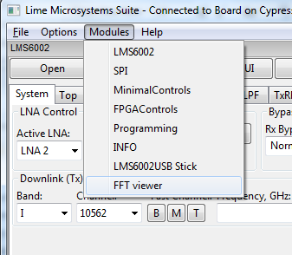

Figure 11 lms_suite module menu to select FFTviewer

FFTviewer control window will appear. Before start capturing data, set the Sampling frequency, select windowing function and press Start. See Figure 12.

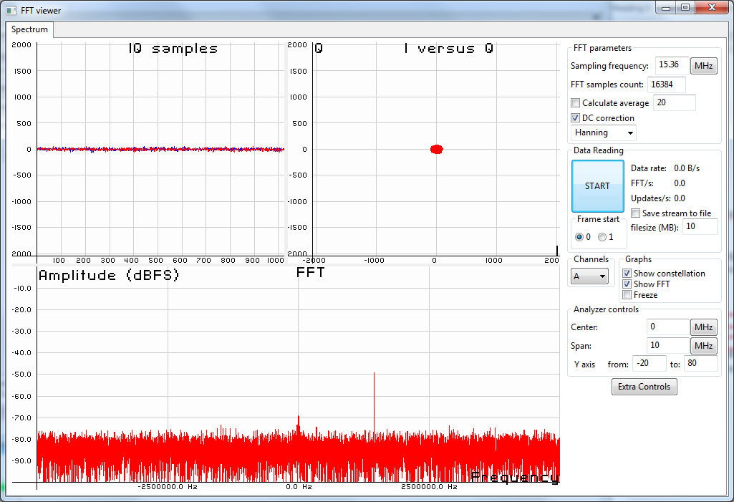

Figure 12 FFTviewer Controls

At this point, the FFTviewer start capturing data. Connect the generator to USB dongle receiver path. In the Figure 13 showed the FFTviewer data capture with 1 MHz CW signal offset from LO.

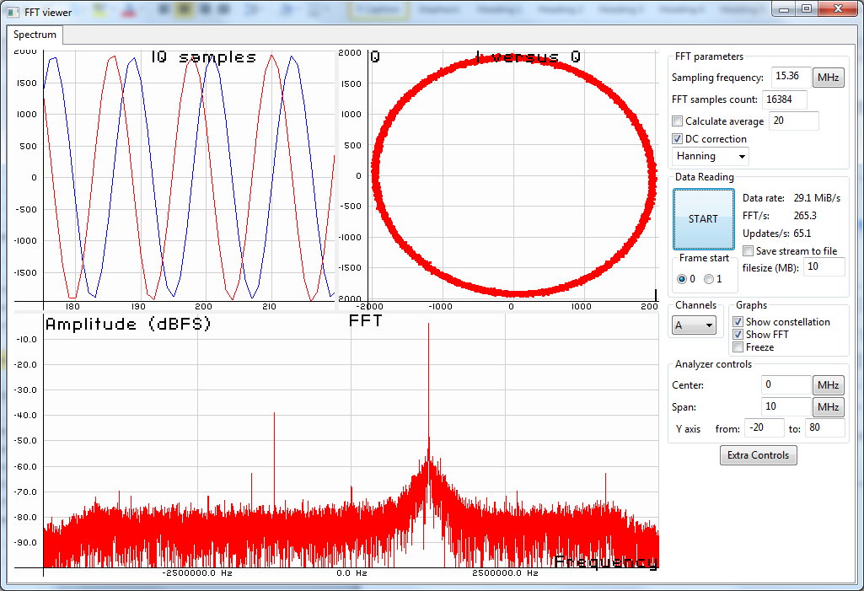

Figure 13 FFTviewer window in operation

Connecting USB dongle to Raspberry Pi

The USB dongle has an option to connect to Raspberry Pi board through 40-pin connector, as shown in the Figure 14.

Figure 14. USB dongle (uMyriadRF6002 ver.) connected to Raspberry Pi

Controlling USB dongle (uMyriadRF6002 version)via Raspbian OS

Before connecting both board together, the FPGA bitsream has to be updated. To do that, please follow the instructions showed in “Load bitstream to FPGALoad bitstream to FPGA” chapter, and load the …/RPi_prog/LMS6002spi_150721.rbf file. This enables the SPI interface control for LMS6002D chip through the Raspberry Pi connector.

Enabling Raspberry Pi SPI interface

Plug the USB dongle on the Raspberry Pi and power ON. Once Raspbian OS is loaded, follow the steps below to setup up the SPI interface:

- Use Raspberry Pi Software configuration tool - in LXTerminal * run command:

sudo raspi-config

- Enable SPI interface through Advanced options. For detailed guidance please use “Enabling The SPI Interface On The Raspberry Pi” tutorial from this [link].

- Set up the SPI interface on the Raspberry Pi Computer with python. The detailed constructions can be found in the “Simple SPI on Raspberry Pi” tutorial from this [link].

*NOTE: It is strongly recommended to update LXTerminal tool to the latest version, to do that select Advanced -> Update in start menu.

Run Python script from command line

Copy LMS6002spi_latest.py and TXsetup_latest.py to Python SPI development directory:

pi/py-spidev/

Then run TXsetup script – in LXTerminal run command:

cd /home/pi/py-spidev

sudo python TXsetup_latest.py

See Figure 15

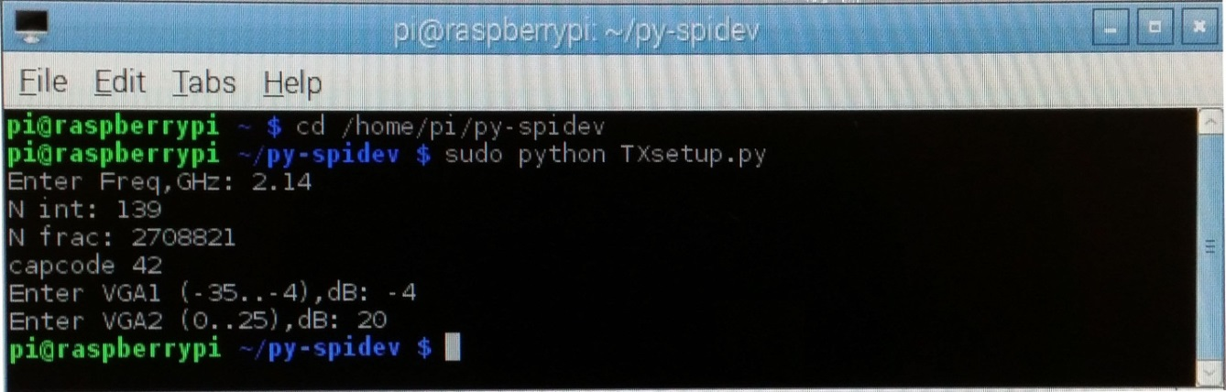

Figure 15 LMS6002D TX setup using Raspberry Pi command line

This will configure LMS6002D chip to transmit LO at 2140MHz as shown in the Figure 16.
.

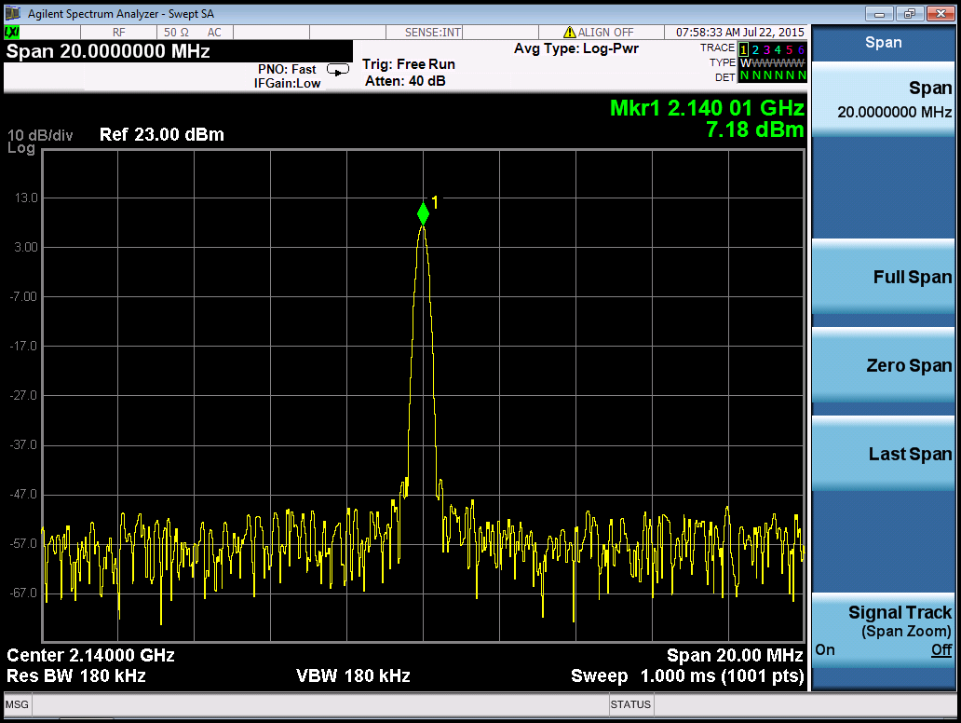

Figure 16 TXsetup.py sets LMS6002D LO to 2.14GHz

Also LMS6002D registers can be set by command line running LMS6002spi_150721.py script.

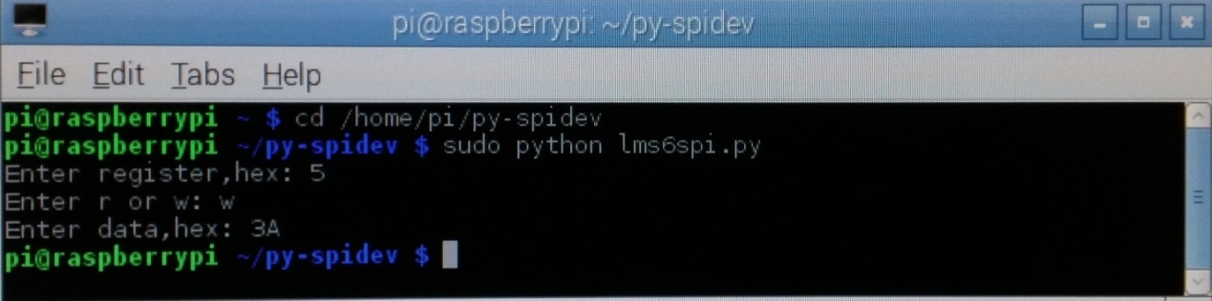

Figure 17 LMS6002D registers setup using Raspberry Pi command line

Single-board PCs suitable for USB dongle

Table 1. Single-board PCs
Single-board PC | Connection to USB dongle | Comments
Raspberry Pi | 40-pin Pinheader
BeagleBoneBlack | 2x 46-pin sockets | Adapter needed
Odroid-XU3 | USB3.0 Host
Odroid-C1 | 40-pin Pinheader
UDOO | 36-pin socket | Adapter needed
Cudieboard | 48-pin Pinheader | External dongle supply needed
Marsboard | 2x 50-pin sockets | Adapter needed
A13-OLinuXino | 40-pin Pinheader | Connect pin 39 to dongle’s 2 pin, external dongle supply needed

Appendix I

This chapter guides through the USB3 interface installation for the USB dongle on Windows.

FX3 microcontroller drivers installation

The communication between USB dongle and PC (lms_suite) is done via the USB3 interface. Initially, USB dongle comes with preprogramed drivers and ready to use. If new drivers require to be installed or firmware update, the steps have to be taken:

- Install windows drivers. Follow chapter “USB3 Windows driver installation procedure USB3 Windows driver installation procedure”.
- Install USB3 microcontroller drivers. Follow chapter “Firmware installation for USB microcontroller Firmware installation for USB microcontroller”.

USB3 Windows driver installation procedure

When USB dongle is connected, follow the installation procedure below.

- Press “Start Menu” and right click on “Computer”, select “Properties” and “Device Manager”.

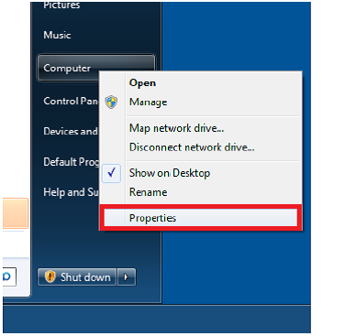

Figure 18 Open computer properties

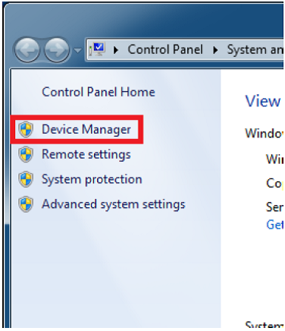

Figure 19 Open device manager

- When USB dongle is plugged in, on “Device Manager” menu it appears as “WestBridge” under “Other devices”. Right click on the “WestBridge” and select “Update Driver Software”.

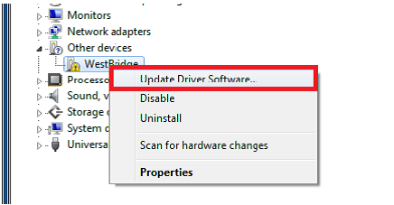

Figure 20 Update driver software

- Select driver installation manually and choose driver from the following location:
..\lms6_usb_distro_03v\fx3\drivers\bin.

Choose the driver which is suitable for the operating system running:

- Windows XP (wxp)
- Windows Vista (vista)
- Windows 7 (win7)
- Windows 8 (win8)

CPU type:

- x86(32bit-i386)
- x64(64bit-amd64)

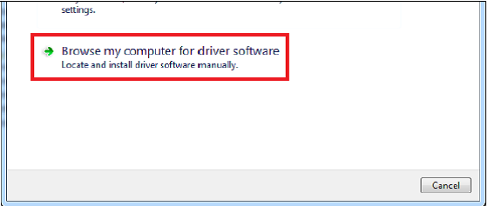

Figure 21 Browse for driver software

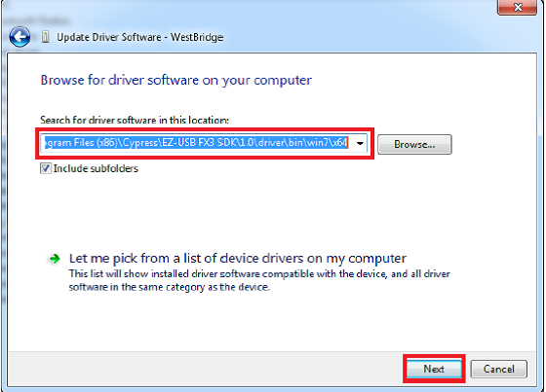

Figure 22 Select driver location

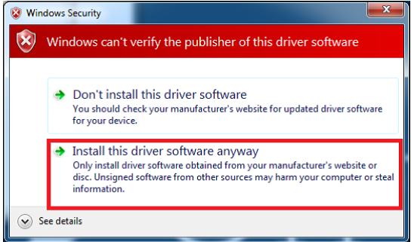

Figure 23 Confirm installation of unsigned driver

- After successful installation “Cypress USB BootLoader” will appear under USB controller devices.

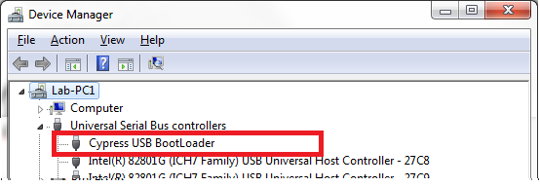

Figure 24 Device manager window after installation

NOTE: If you are using Windows 7 64 bit OS, you must disable Driver Signature Enforcement. To do this, Restart you PC, press F8 at startup and choose Disable Driver Signature Enforcement. This step is required to done once.

NOTE: If you are using Windows 8 or later, to disable driver signature enforcement manual can be found in this [link].

Firmware installation for USB microcontroller

For USB microcontroller firmware installation, please use the “CyControl.exe” (..\lms6_usb_distro_03v\fx3\software folder).

Cypress FX3 USB microcontroller has an integrated boot loader, which starts automatically after power-up or reset.

If FLASH memory is empty or connector J5 (on uSTREAM) is open, USB3 microcontroller boots-up with factory firmware. Run the “USB Control Center” application and in the menu select "Cypress USB BootLoader" line as shown in Figure 25.

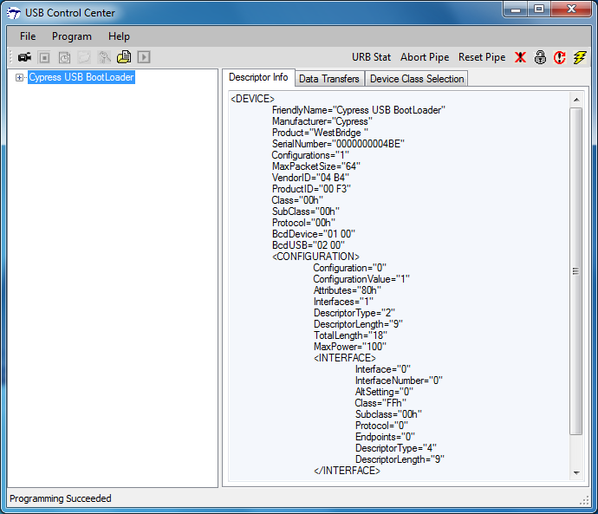

Figure 25 Default FX3 firmware, supplied by internal logic

There are two ways of uploading the firmware to USB3 microcontroller:

- Program internal RAM memory. Follow procedure described in chapter “Uploading firmware to the FX3 RAM Uploading firmware to the FX3 RAM”. The memory will be cleared after first power cycle.
- Program external FLASH memory connected to USB3 controller. Follow procedure described in chapter “Uploading firmware to empty FLASH Uploading firmware to empty FLASH”. The USB3 microcontroller will boot from FLASH memory after every power-on.

Uploading firmware to the FX3 RAM

Start “CyControl.exe” application and select Cypress USB BootLoader as shown in Figure 25. Choose menu command Program → FX3 → RAM. In the new pop-up window, select lms6002-usb (GPIO PS, FLASH, compressed ) 2015 06 25.img file provided (..\\lms6_usb_distro_03v\fx3\firmware_img folder) and press Open. Status bar of the USB Control Center application will indicate Programming RAM. This message will change to the Programming succeeded after programming is done.

If you expand Cypress USB StreamerExample line in USB Control Center application now, you will see different USB configuration as shown in Figure 26.

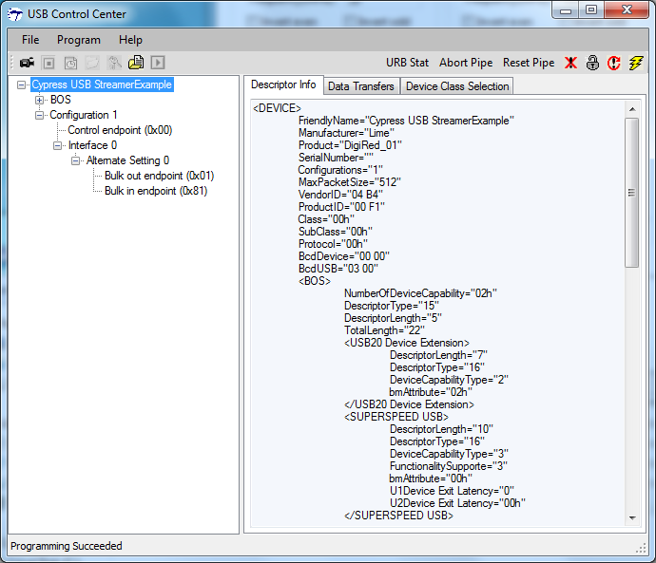

Figure 26 FX3 after custom firmware is downloaded

Uploading firmware to empty FLASH

If external FLASH is empty, short the jumper J5 and connect USB dongle to the PC. Start “CyControl.exe” application and select Cypress USB BootLoader as shown in Figure 25. Choose menu command Program → FX3 → SPI FLASH. In the status bar you will see Waiting for Cypress Boot Programmer device to enumerate.... and after some time window will appear. Select provided lms6002-usb (GPIO PS, FLASH, compressed ) 2015 06 25.img file (..\lms6_usb_distro_03v \fx3\firmware_img folder) and press Open. Status bar of the USB Control Center application will indicate Programming of SPI FLASH in Progress…. This message will change to the Programming succeeded after FLASH programming is done.

NOTE: USB3 microcontroller mi will boot firmware uploaded to FLASH each time after power-on if jumper J5 is shorted.

Uploading firmware to non-empty external FLASH memory

To update external FLASH memory with new firmware, follow these steps:

- Disconnect USB dongle from USB port.
- Make sure that jumper J5 is open.
- Connect USB dongle to USB port.
- Short jumper J5.
- Do the steps described in section Uploading firmware to empty FLASH.

Appendix II

This section describes how to load custom bitstream to USB dongle FPGA.

Load bitstream to FPGA

The Altera Cyclone IV FPGA which sits on the USB dongle can be programmed using “lms7suite”software. To call FPGA programing function, go to Modules form top menu and select Programing form the drop down menu. See Figure 27.

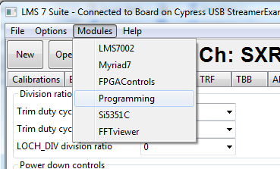

Figure 27 lms7suite module menu to select FPGA programing tool

New control section should appear in the bottom of the main window, as shown in the Figure 28.

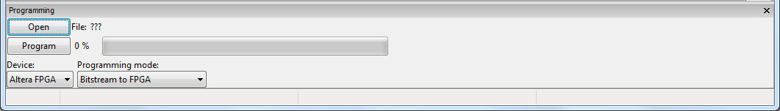

Figure 28 FPGA programing tool interface

Software loads raw binary files (*.rbf) to FPGA and it offers couple options to do that, see Figure 29.

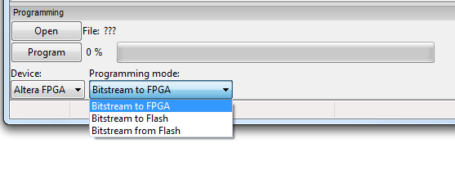
Figure 29 FPGA programing options
The programing functions are described below:

- Bitstream to FPGA – this function loads selected *.rbf file from PC to FPGA. Select your wanted bitstream file by clicking Open and initiate FPGA programing by clicking on Program.
- Bitstream to FLASH – this function loads selected *.rbf file from PC to external FPGA FLASH memory. Select your wanted bitstream file by clicking Open and initiate FLASH memory programing by clicking on Program.
- Bitstream from FLASH - loads bitstream from external FPGA FLASH memory to FPGA. To initiate programing click on Program button.

The new massage will come up when the programing is finished.

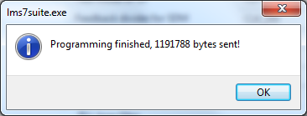
Figure 30 Successfully FPGA programing massage

