LMS7002M VNA Demo

Introduction
Field programmable RF (FPRF) is mainly used in software defined radio (SDR) applications. The flexibility of FPRF allows its use for RF measurements as well. In this document we will demonstrate the use of LimeSDR for reflection coefficient measurement. Dedicated instrument for reflection coefficient magnitude measurement is called Scalar Network Analyzer (SNA), while the instrument which can measure both magnitude and phase is called Vector Network Analyzer (VNA). Using the features of LMS7002M, such as test mode signal generation, integrated RSSI meter and TDD operation, both magnitude and phase of reflection coefficient can be measured, making it a low-cost VNA. As an additional benefit, the measurement can be performed with stand-alone LMS7002M, without the need for external DSP or FPGA.

Theory of operation
Reflection coefficient Γ is a complex quantity which can be represented in polar form by its magnitude and phase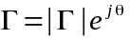. Measurement of reflection coefficient magnitudecan be performed with a setup shown in Fig. 1.
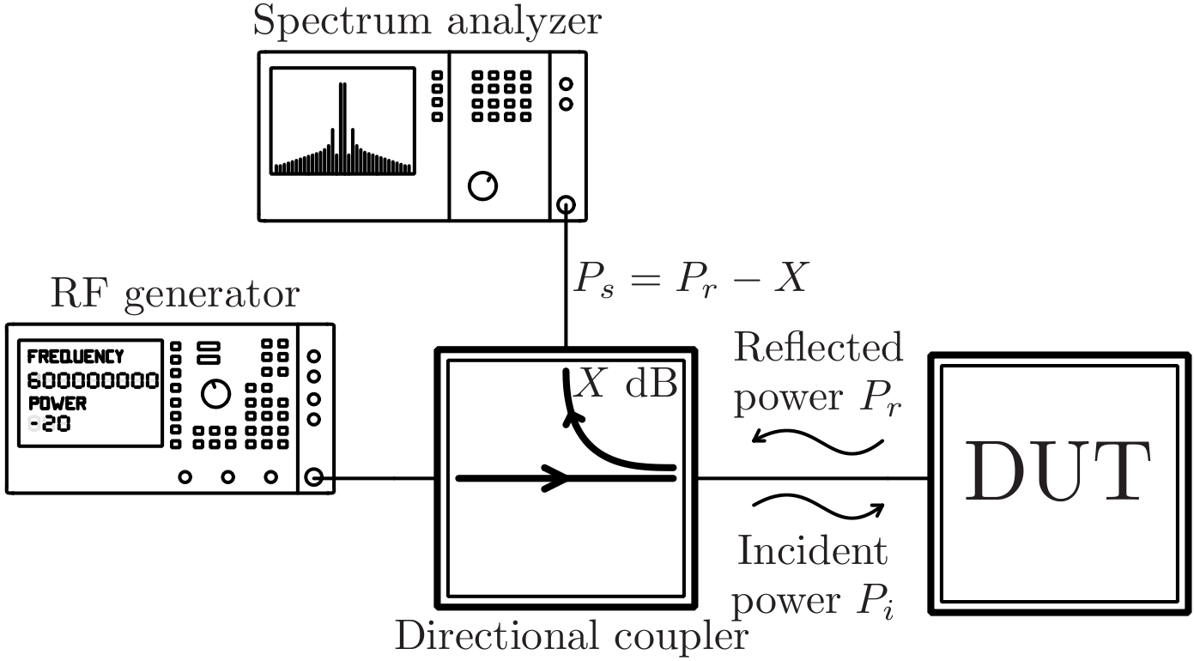Figure 1: Scalar reflection coefficient measurement setup
The RF generator outputs a CW signal at measurement frequency, which is passed through a directional coupler to excite the Device Under Test (DUT). Due to DUT impedance mismatch, i.e. nonzero reflection coefficient, portion of the incident power will be reflected from DUT. The reflected powerin Watts is given by:
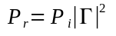
or in dBm:
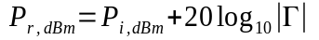
Reflected power can be measured by connecting a spectrum analyzer to directional coupler's coupled port. Power measured by the spectrum analyzer is X dB lower than the reflected power, where X is the coupling factor – usually >10 dB.
Reflection coefficient magnitude measurement is performed in two steps. In the first step a highly reflective load, e.g. short or open, is connected instead of DUT. Assuming that the reflection coefficient is unity, power measured by the spectrum analyzer is (in dBm):
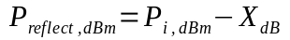
The reflected power measurements should be performed at all frequencies of interest. In the second step, the DUT is connected to directional coupler. Power measured by the spectrum analyzer is:
Return loss can then be calculated as
RF signal generator and spectrum analyzer can be replaced with LMS7002M, as shown in Fig. 2. Both the RF signal generator and received power measurement can be made with stand-alone LMS7002 by using the on-chip RF, analog and digital resources, without the need for additional FPGA or DSP.
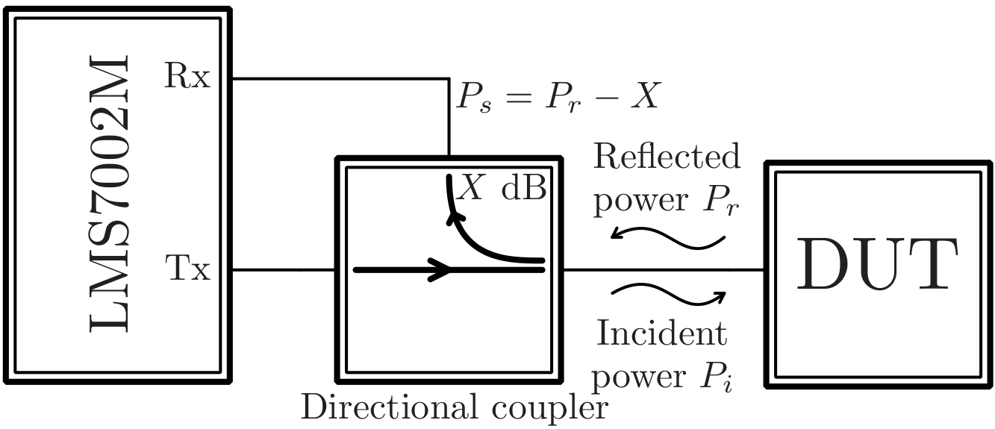
Figure 2: Scalar reflection coefficient measurement setup with LMS7002M
RF signal can be generated by putting the TxTSP block in test mode with DC input and locking the Tx PLL to the desired frequency. The output power level can be adjusted by controlling the gain of TBB and/or TRF blocks. Received power can be measured by using the RSSI block from RxTSP module. RxTSP module also contains programmable rate decimation implemented by half band filters, which can be used to reduce the noise bandwidth. Optionally, general purpose FIR filters can be used for further noise shaping before the signal power is measured by RSSI. Therefore, scalar reflection coefficient measurement can be performed by stand-alone LMS7002M. The only external resource needed is microcontroller to control the LMS7002M via SPI interface and software to perform the measurement and a directional coupler.
The reflected voltage wave contains the information about the magnitude and phase of the DUT reflection coefficient. As explained in the previous text, the magnitude of reflection coefficient can be determined from two power measurements. In principle, the phase could be determined by measuring the phase of reflected voltage wave. Relative phase measurements require that the signal generator and receiver operate at exactly the same frequency and that both incident and reflected waves phases are measured. Dedicated VNAs measure the relative phase by sampling both the incident and reflected waves.
Flexible architecture of LMS7002M allows the measurement of relative phase of reflected voltage waves. Although LMS7002M has two dedicated PLLs to allow full duplex FDD, it can also be configured for TDD mode, when both transmitter and receiver operate from Tx PLL as shown in Fig. 3. Using TDD configuration ensures that transmitter and receiver operate at exactly the same frequency, which is one of the requirements for phase measurements.
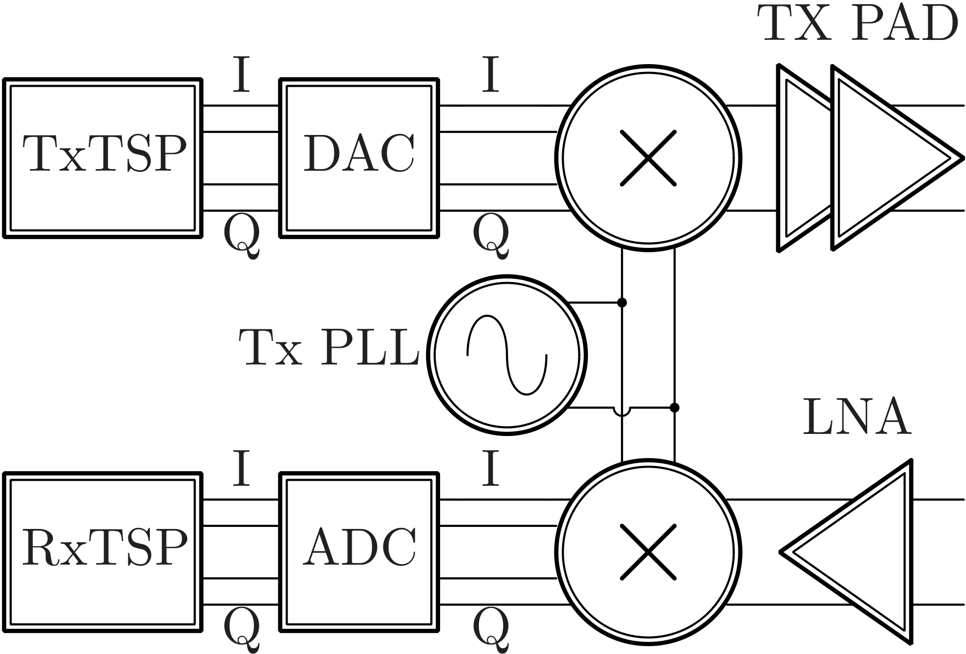
Figure 3: LMS7002M in TDD mode
Consider a case when there is a phase shift from transmitter to receiver, as shown in Fig. 4.
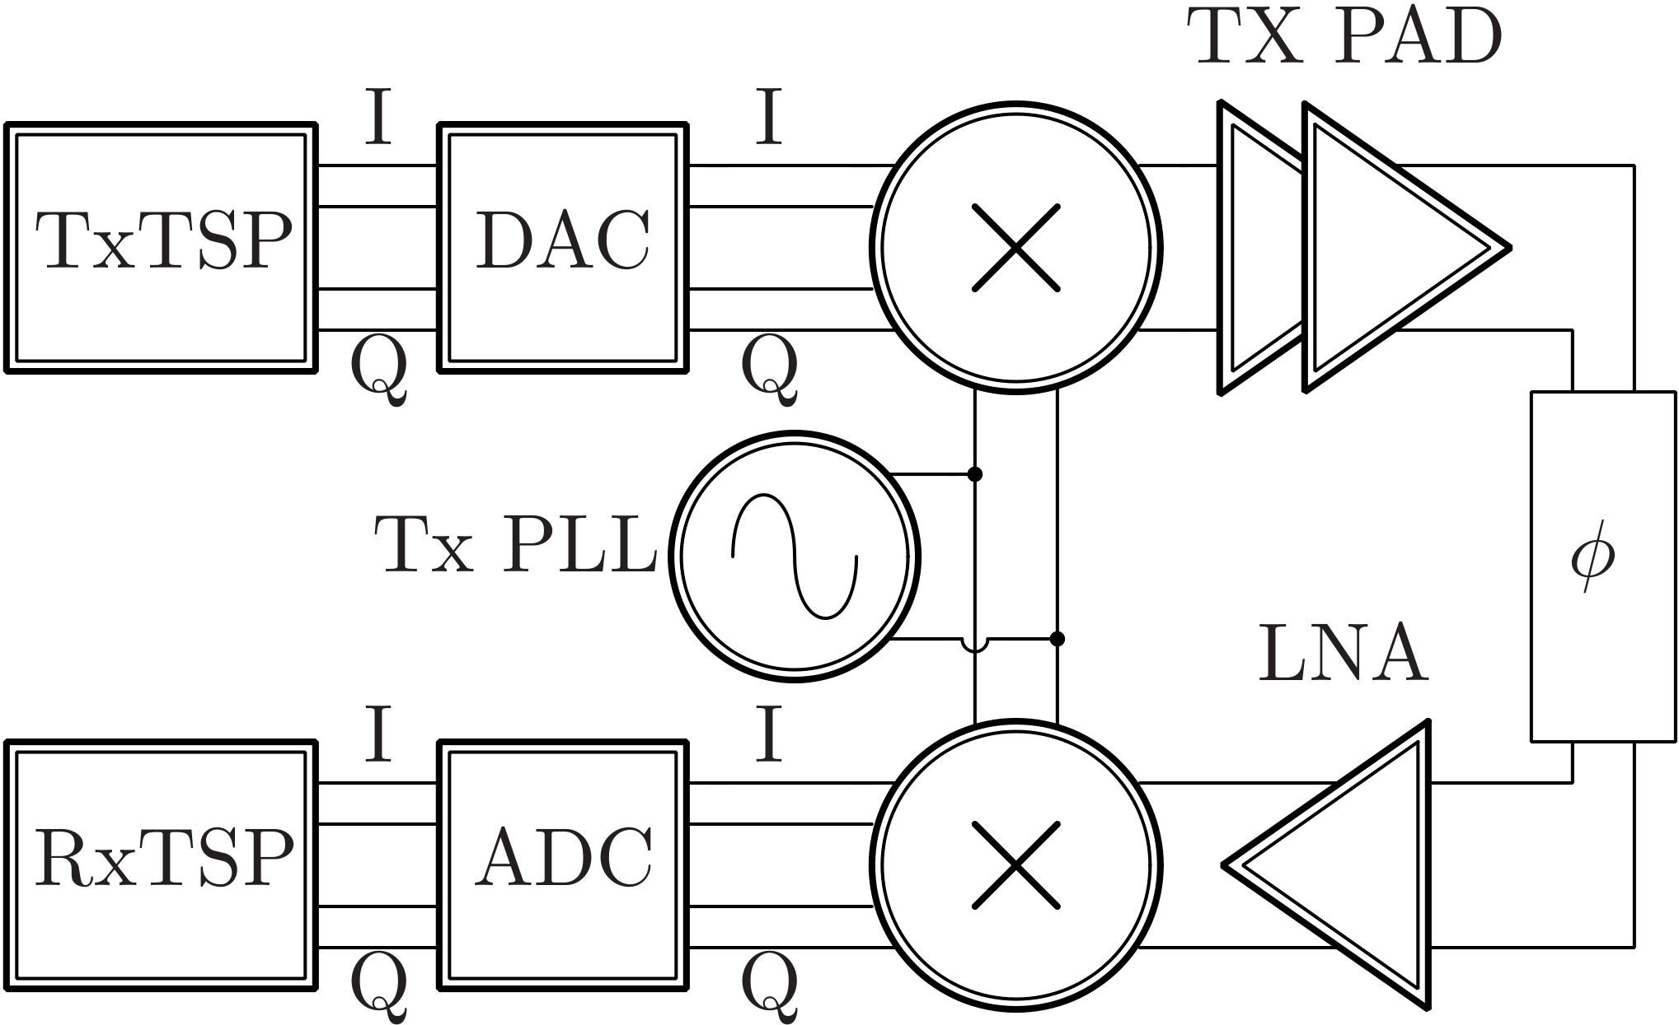Figure 4: Phase shift from Tx to Rx
Transmitted signal phase can be set to  by setting the values of transmitter I and Q signals, as shown in Fig. 5:
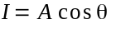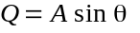
Received signal phase is shifted by the phase of the Tx-Rx path. RSSI reading will be constant regardless of received signal phase:
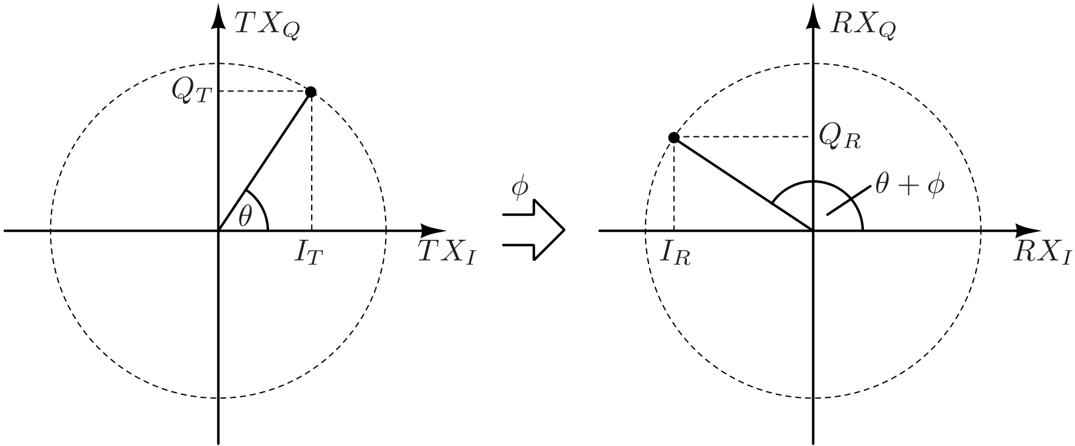
Figure 5: Transmitted and received complex baseband signal
Phase measurement can be performed by setting the I channel gain to 0 by using the RxTSP gain corrector block. RSSI reading is then:
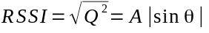
RSSI reading is at minimum when the received phase is zero, which occurs when the transmitter phase is 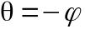. By adjusting the transmitter phase to minimize RSSI reading, the phase shift between transmitter and receiver can be measured in the range ±π/2. Phase can be fully resolved by examining the sign of I signal at ADC output. If the I signal is negative, the phase should be shifted by π.
Reflection coefficient phase can be measured in two steps. In the first step the phase of known reflective load – e.g. short – is measured to establish the reference phase. Measured phase is then
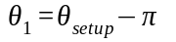
The measured phase consists of unknown measurement setup phase shift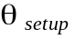and phase of short load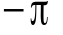. In the second step the phase with DUT as load is measured
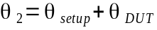
from which the phase of DUT reflection coefficient can be determined
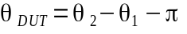
Having measured the reflection coefficient magnitude and phase the DUT reflection coefficient can be calculated.
Presented measurement algorithm is the simplest form of one-port calibration. We have assumed that the short standard is ideal, having the reflection coefficient 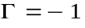. Better accuracy can be achieved by using the Short-Open-Load calibration. However, SOL calibration requires the use of calibration kit, which is an expensive piece of equipment.
The presented algorithm has been implemented in Python by using the pyLMS7002M library. Python script measures the reference reflected power and phase when the short is connected to the directional coupler, and the DUT reflected power and phase, from which the DUT reflection coefficient is calculated. To speed-up the measurements, averaged RSSI readings and phase measurements have been implemented in the LMS7002M MCU.

Software requirements
Python script for VNA measurements uses the following packages:
- pyLMS7002M
- Numpy
Please refer to package documentation for installation instructions. Python script for calculating the DUT S parameters from measurements does not require additional packages for calculation. If the data is to be drawn, the following packages should be installed:
- Matplotlib
- pySmithPlot 0.1.0 from https://github.com/vMeijin/pySmithPlot/archive/65ad9db09276a5c7fb4cf4371647293c5e910bbc.zip . Please note that at the time of writing the current master branch (0.2.0) does not work with Python 2.7.

VNA setup and measurement results
VNA setup used for measurements in 2.4 GHz band is shown in Fig. 6 and Fig. 7. Directional coupler used in setup is MiniCircuits ZHDC-16-63-S+. Attenuator in transmit path is used to reduce the variation of impedance seen by LMS7002M when different loads are connected to the directional coupler. Without the attenuator, impedance variation would cause variation in output power and cause measurement errors.
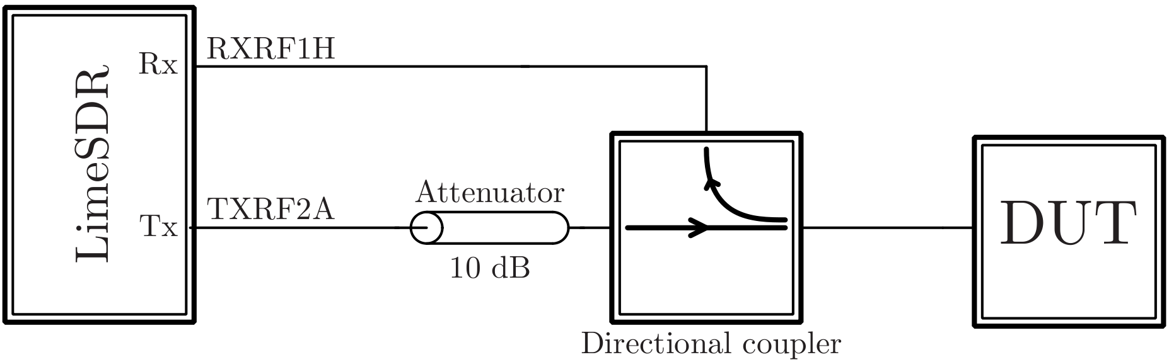Figure 6: VNA setup for 2.4 GHz
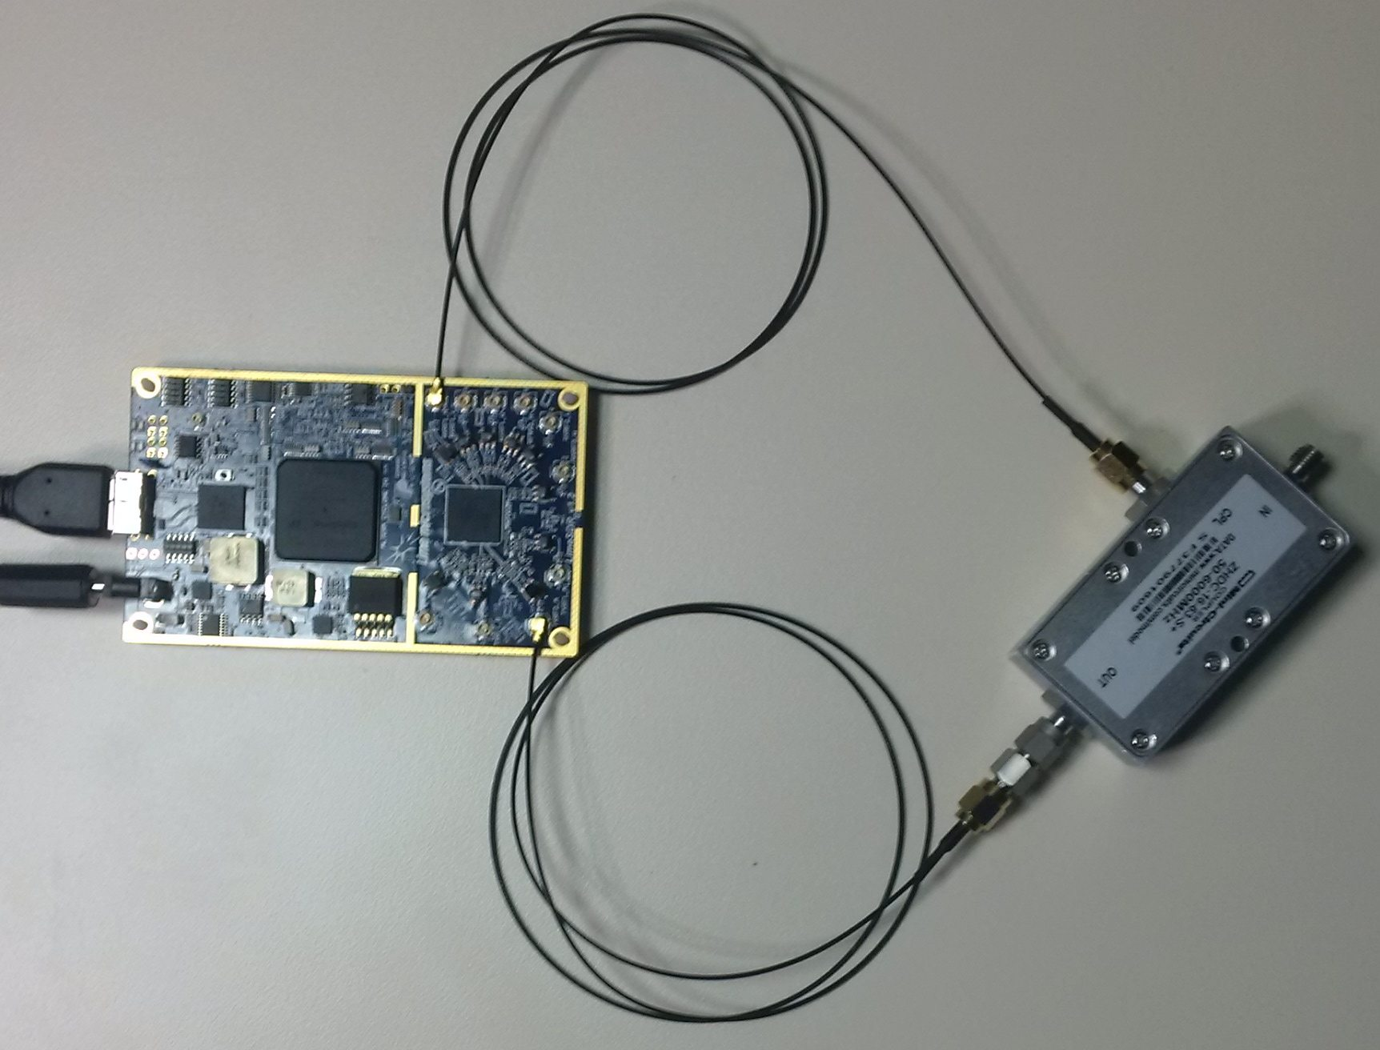
Figure 7: VNA setup photograph
Measurement is performed by starting the Python script. Argument to the script is the measurement name, in this example “r50”:
>python measureVNA.py r50
Searching for LimeSDR... FOUND
Tuning CGEN... OK (0.5 s)
Tuning SXT... OK (1.0 s)
Loading MCU program... OK (Firmware ID = 49)
Calibrating RX path...
Connect SHORT. Type y to continue.
At this point the SMA short should be connected to the directional coupler, and confirmed by typing “y” to the command prompt. The measurement will start and status will be printed:
f=2300000000.0... OK(3.4 s)(1/101)RSSI=41313.0(Cal=368, PGA=22, LNA=8) phase=0.0
When reference measurements are completed, the message
Connect DUT. Type y to continue.
will indicate that the DUT should be connected to the directional coupler. When the measurement is completed, the results should be processed by second Python script:
>python calculateVNA.py r50
which calculates the DUT S parameters and writes them into file in Touchstone format. If a second argument is specified, the calculated data can be plotted and saved. For example:
>python calculateVNA.py r50 plot
will plot the calculated results, while
>python calculateVNA.py r50 save
will plot the calculated results and save S11 and Smith chart figures.
As a first example, the 50 Ohm termination is measured to determine the dynamic range. Measurement results are shown in Fig. 8.
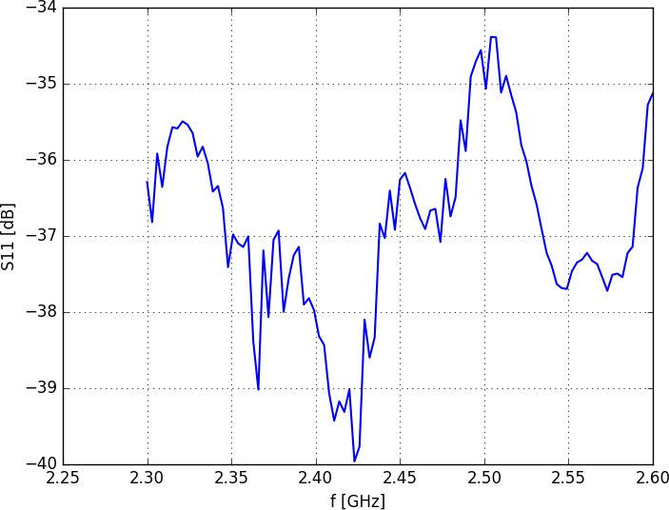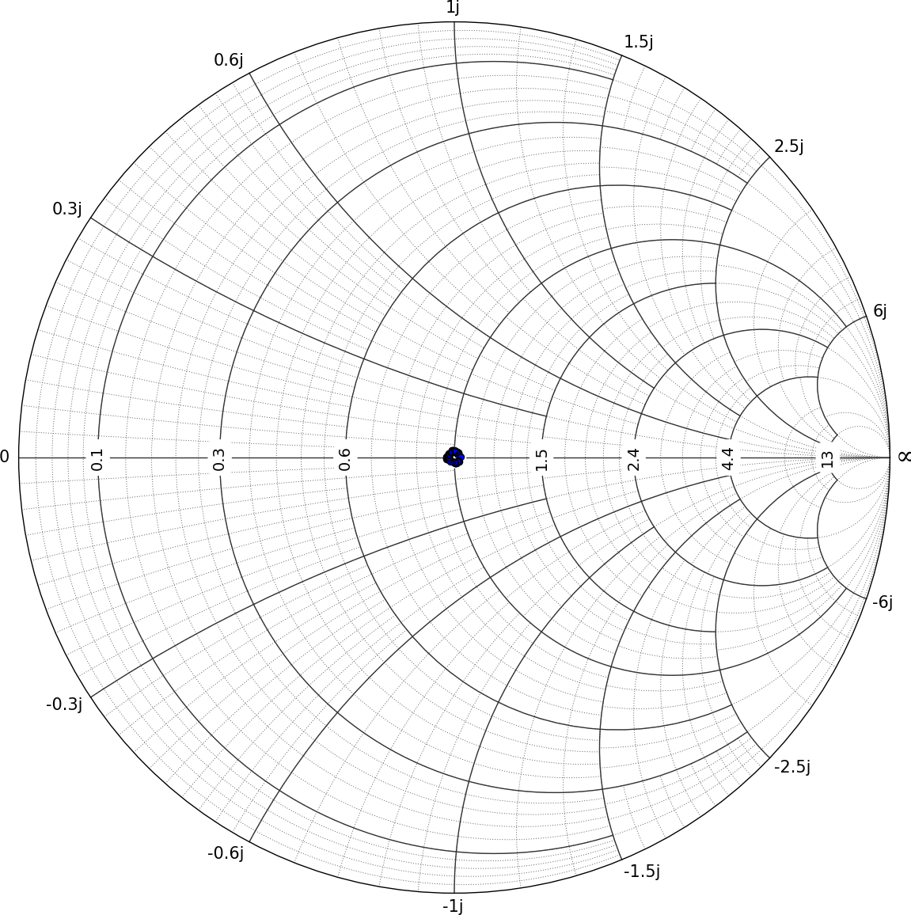
Figure 8: Measurement results of 50 Ohm termination
Measurement results show that low VSWR loads can be measured with LMS7002M. As a second example, a 10 dB attenuator terminated with short was measured and shown in Fig. 9. Theoretically, ideal attenuator terminated with ideal short would have 20 dB return loss, which is in good agreement with measurements.
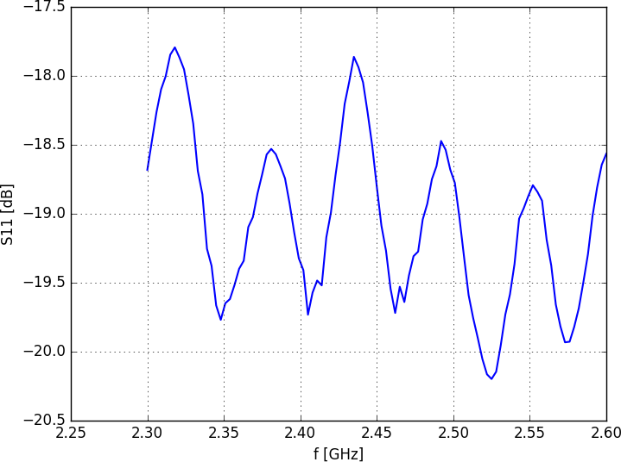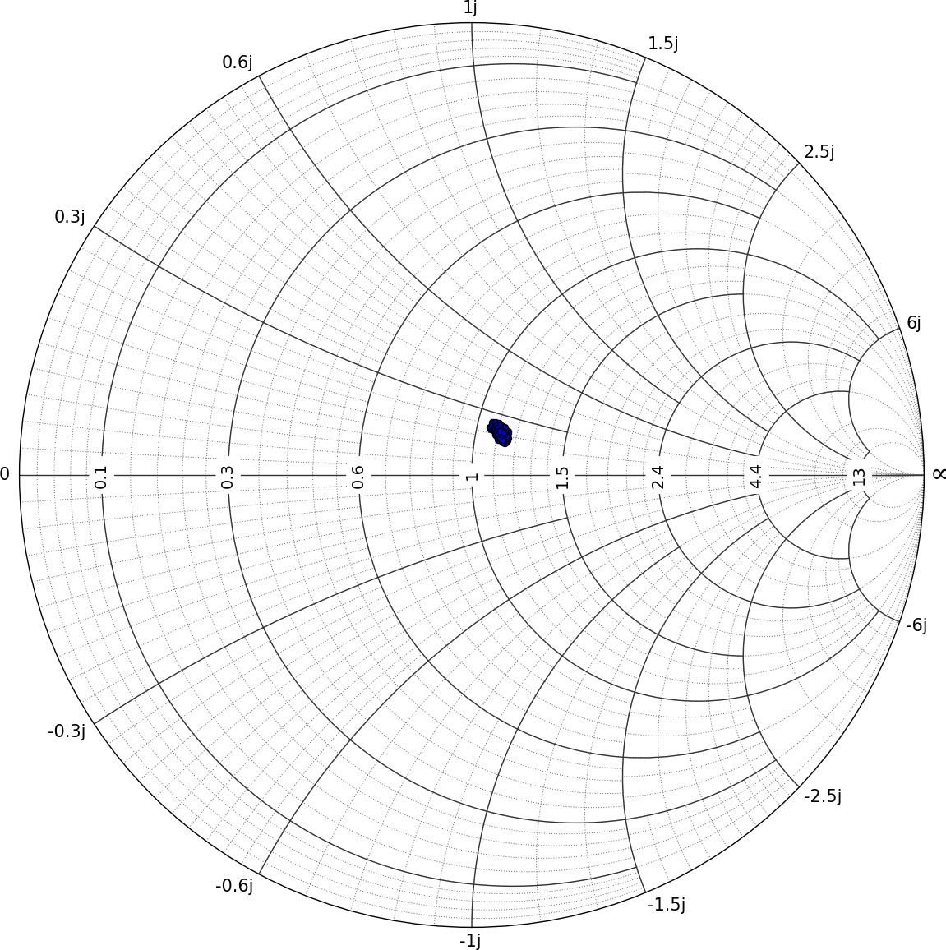
Figure 9: Measurement results of 10 dB attenuator terminated with short
As a third example, input matching of RF Bay LNA-6G was measured, and the results are shown in Fig. 10. Measurement results are in agreement with product specifications.
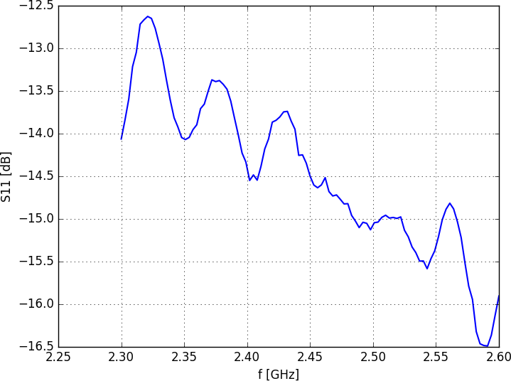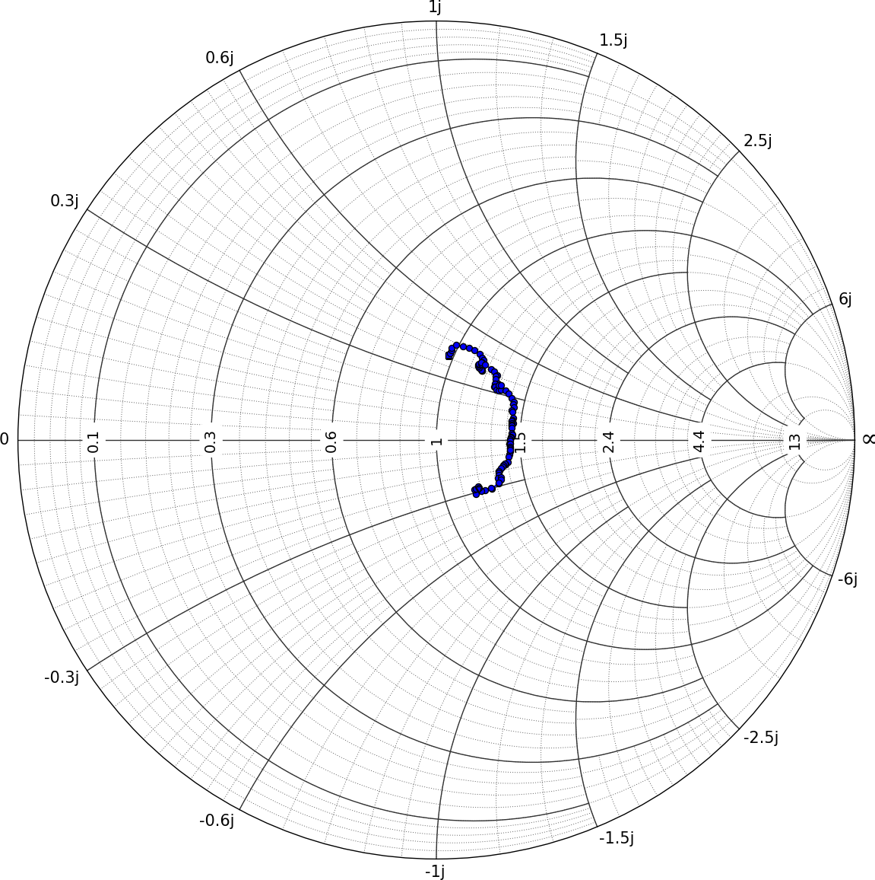
Figure 10: Measurement results of RF Bay LNA-6G
In conclusion, LMS7002M can be used as a low-cost VNA, requiring only a directional coupler. Using a simple calibration algorithm with low-cost SMA short standard can provide usable measurement results. If calibration standards are available, e.g. Short Open Load, the measurement accuracy can be improved.

