How to run
Set the parameter for the project in config.py
Constants for simulation:
- NUM_PARAMETER_SETS - The number of sets for each Cell
- NUM_REPLICATIONS - The number of Replication for each Set
- NUM_AREA - The number of vehicle and run area
Parameter ranges for entire Heatmap:
- MAX_INTERARRIVAL_RANGE - axes X - The interval time of event (minute). # (500,10000) full heatmap
- MAX_TOTAL_SERVICE_RANGE = axes Y - The total service time of vehicle (minute) (service + response time). # (10,500) full heatmap
- STEP_INNTERVAL – the step size for axes X
- STEP_TOTAL_SERVICE – the step size for axes Y
- SERVICE_RT_RATIO – the ratio between service time and response time.
example if SERVICE_RT_RATIO = 0.75 so
MAX_TOTAL_SERVICE_RANGE = 0.75 * Service time + 0.25* Response Time
Range of variance to generate Service & Response Time to Lognormal distribution:
- CV_SERVICE_RANGE
- CV_RESPONSE_RANGE

Run project in main.py
main.py is devised in two function, choose one:
- Run the simulation and the heat map.
- Every time you run it it’s creating a new folder with the date and the time and will be save in it all the excel .
- The final result get save in a new folder with the data and time of the run in the fire_emergency_OG folder.
- In the end of the run the compiler will ask you to chose witch heat map you want
- Run the heatmap based on the final result.
- Copy and past the excel result_project.xlsx in the folder project : fire_emergency_OG.
- The compiler will ask you to chose :
- Witch policies you want to see
- Witch heatmap you want to see (RT, Queue or both)
- Witch alpha you want (pv valu < alpha )
Run the project and get the final result –
When the project end running, it saves all the result to an excel file. The output of the function get_final_results () is the path of the excel file with the result.
Chose the pairs of policies for the heatmap –
Chose witch pairs of policies you want to run the heatmap.
Input of pd.read_excel is the sheet_name that you need to choose from the list
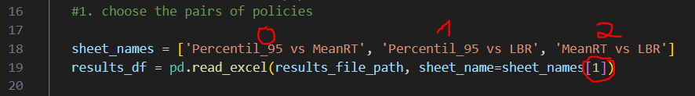

Run the heatmap based on the final result –
Need to chose witch heatmap you want to run: for RT or Queue (put the unchosen one in comment “#”)
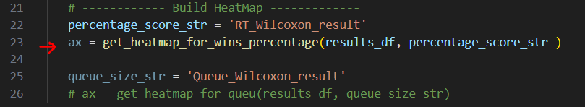

Excel File result
- List_parameter_from_replication.xlsx – in project.py row 140.
Each row represents a Set.
For each set we save in a list the values we got from each Replication (one simulation run) :
- Percentile_RT
- Queue_size
- Wilcoxon_result_RT.xlsx – in project.py row 150.
- Wilcoxon_result_Queue.xlsx – in project.py row 151.
The result of Wilcoxon test for each set , pvalue…
- Parameter_result_for_set.xlsx - in project.py row 170.
Summarize parameter for each set.
- Result_project.xlsx – in result_project.py
Summarize result for each cells

