3D visualizing with ray-casting.
Martin Yrjölä
84086N
Tietotekniikka I
18.2.2010

Description
A simple 3D rendering engine using the Java Swing library. The world consists off a plane with solid walls aligned in a grid. You are able to move in the plane, but not through walls.

The technique used for the rendering is called ray-casting, a subclass of ray tracing. The after-mentioned could be shortly described as tracing rays of light from the viewers eye to the object in the scene. Ray-casting is simpler and faster. You cast only one ray for every vertical strip on the screen.
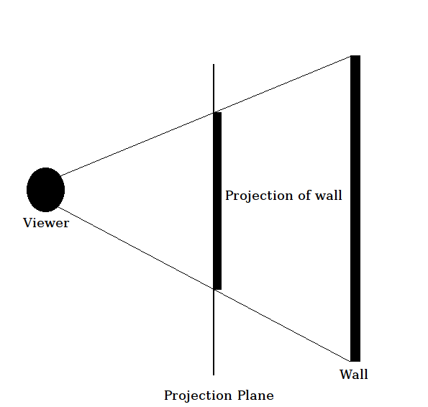

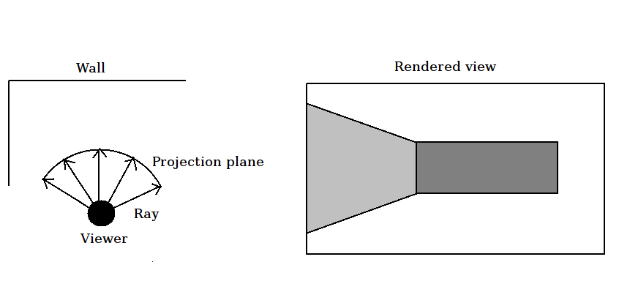

The walls are textured and shaded darker the further they are from the viewer. There will be options available for the user through a settings file. The field-of-view, number of rays cast and display resolution as a few examples of the available options. The project will be implemented conforming to the hard difficulty.

If time permits these extra features will be implemented:

- Support for looking up and down.
- The world is made in a level-editor, which could be an integral part of the application. For example it could be invoked when the rendering is running and the world could be edited in real-time.
- The settings are changed real-time in another window or an options screen.
- Support for static sprites like the lamp in the picture below.
- Support for actors with simple AI.

User Interface
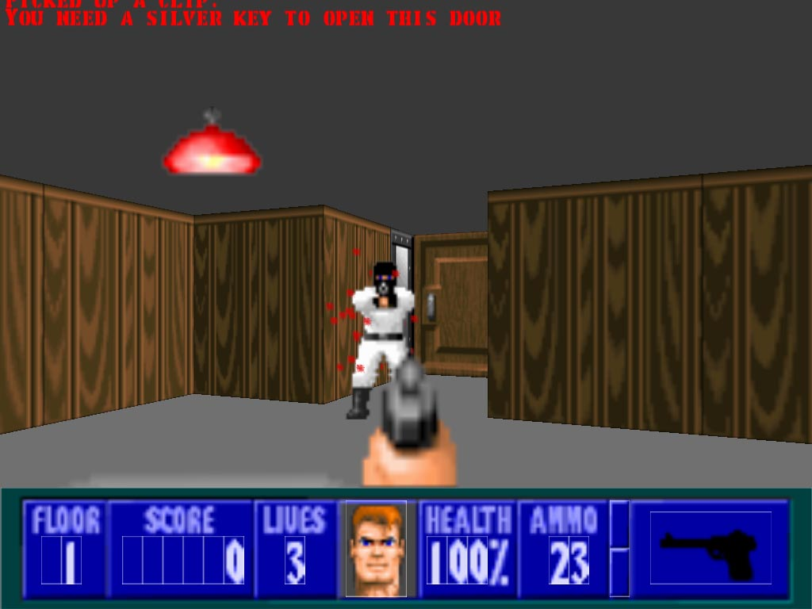Ray-casting in Wolfenstein-3D by iD-software.

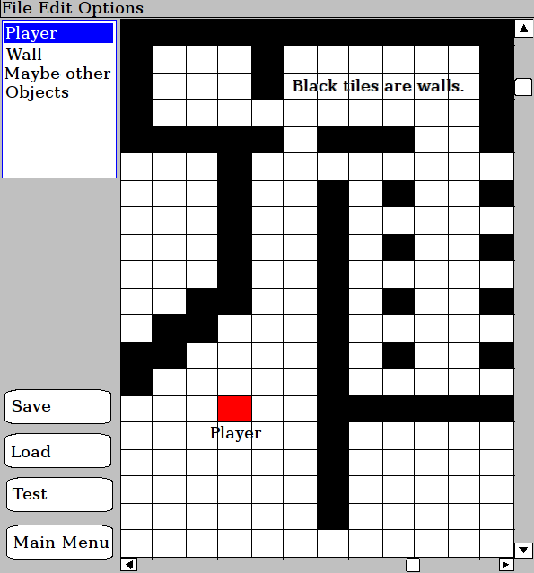A draft of the level editor design.

File formats
- The settings will be saved in plain text.
- The wall textures are image-strips in the .png format.
- The level-layout is a two-dimensional matrix with the wall and viewer positions flagged. The file will be a serialized object containing the 2D-array and additional information, such as map width and height.

System testing plan
The viewer should be able to move smoothly in the plane, but not through walls. There will be tests for moving freely and when there's walls involved.
The application must be able to load and save the supported file formats and detect if there's something wrong. Proper testing is especially important for the world- and settings-files.
The rendering could be tricky to test. Performance is more necessary than pixel-perfect correctness. The ray-casting itself could be tested for finding walls correctly and projecting them at correct heights. I will proceed with getting the rendering working good enough for eyesight and after that start figuring out if testing is worthwhile.

