Assignment 3 - collaboration document for report

Kim Rejström, 79530T

Martin Yrjölä, 84086N

Nestor Köhler, 78660A

Learning objectives:

Reading of image metadata using Adobe XMP

Concept of content based image retrieval

Learn the characteristics of different low level feature descriptors

Limitations of current method

Applications for the current method

The assignment featured (yet again!) quite extensive documentation and a heap of unfamiliar libraries with very little pointers given in the assignment description as to what was suppose to be done. Paired with last minute edits to the example code, the overall feel of the assignment became very hazy and the learning objectives didn’t naturally unfold themselves at any time during the assignment. Judging by how the events unfolded, we can’t be alone in this sentiment. Seeing as the assignment was basically solved for us by the last minute example addition to Optima not 18 hours before the deadline, one should really question the quality of the assignment in the first place.

Especially the use of XMP baffled us, as it’s really (at least for this assignment) only used to get the news item guid from the images - which is one single string(!). From there we relied on Sanselan to get the relevant image metadata and create the minimal NewsItems required. A big portion of the code from Assignment 2 was usable in this assignment. Task 1 really didn’t touch much on the concept of content based image retrieval as the the method used the guid to find matches. On the other hand, this was the only part of the assignment that actually required us to do something concrete. Task 2 was basically handed to us, and the rest of the time was spent on google trying to find up-to-date documentation for obscure libraries.

Task 2 on the other hand was more concerned with content based image retrieval. Here it was not a unique guid that acted as the identifier, but the search was to be based on the images themselves. The assignment uses LIRE to index a set of images based on different criteria, and then search through the indexed images returning a set of related ones. The assignment includes several different indexing methods, resulting in different search results.

Running the image searcher on the image:

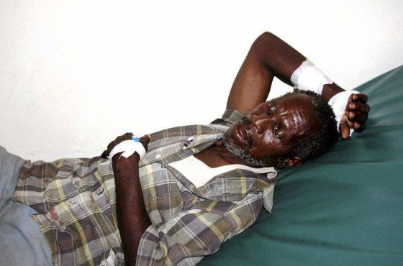

Results in the following output (The top three images are attached for easier verification):

Finished indexing.

Results for search based on Color Histogram

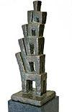

1.0: /mpup_part3_images/3f511615-f021-44bf-8c72-54b702f241cb.jpg

0.5225806: /mpup_part3_images/f76df9d4-5505-4ba4-bcf1-7108c3b339d8.jpg

0.4645161: /mpup_part3_images/dc902adb-dc73-47af-bb3e-82696a6718a7.jpg

0.4532258: /mpup_part3_images/47cd160f-27fb-4c7e-8a15-bf726dc35a4e.jpg

Results for search based on Edge Histogram

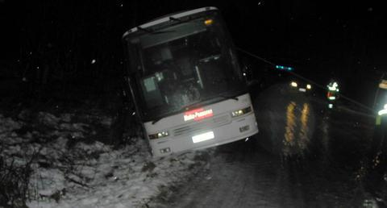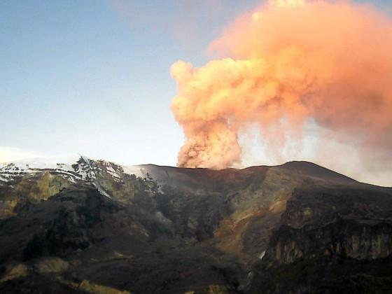

1.0: /mpup_part3_images/3f511615-f021-44bf-8c72-54b702f241cb.jpg

0.24122256: /mpup_part3_images/4ca83cc8-3bc4-4980-a6d5-e512db903aad.jpg

0.11073142: /mpup_part3_images/c3db2bf6-fc3e-443d-ac46-a5220131d018.jpg

Results for search based on Color Layout:

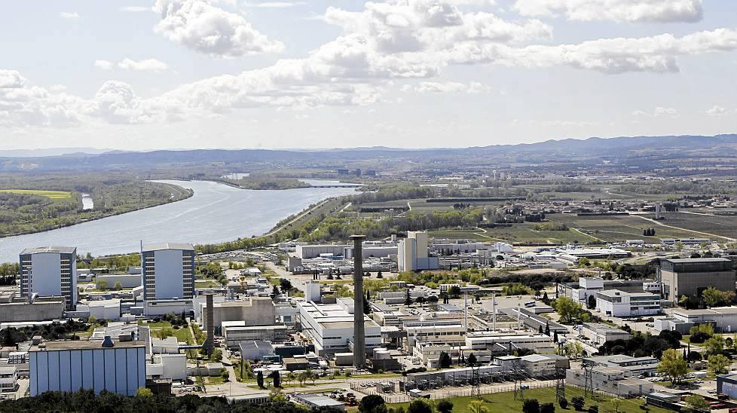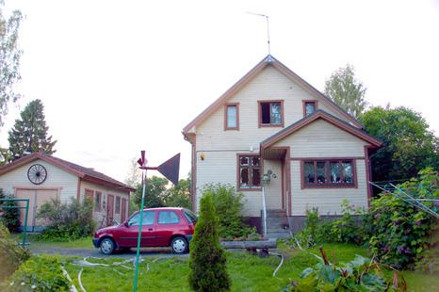

1.0: /mpup_part3_images/3f511615-f021-44bf-8c72-54b702f241cb.jpg

0.09594178: /mpup_part3_images/07c46d52-5558-4f31-834d-d5203ddf7bf5.jpg

0.08885002: /mpup_part3_images/e2833e77-a81b-4864-aef2-0d0290b4f82e.jpg

0.08401686: /mpup_part3_images/6d48977f-6831-4e4d-b212-3dbf4c43925f.jpg

Results for search based on CEDD:

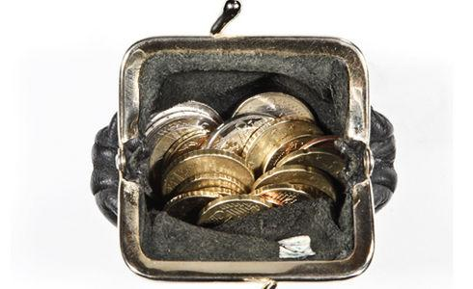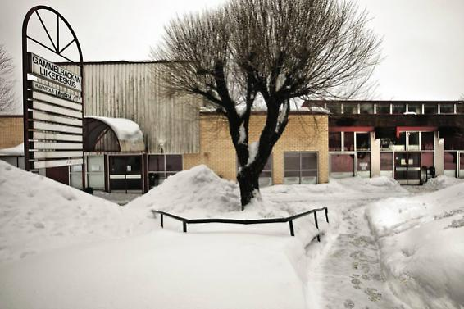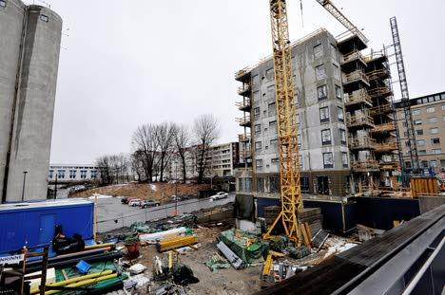

1.0: /mpup_part3_images/3f511615-f021-44bf-8c72-54b702f241cb.jpg

0.30057192: /mpup_part3_images/8b476fb9-abed-4e5d-ac0f-5f82c873f7bf.jpg

0.19534373: /mpup_part3_images/b69702f3-8fca-478e-b830-652996a2d613.jpg

0.19526827: /mpup_part3_images/2ba0c5bd-1e07-4a87-93a5-f836d528c691.jpg

The results aren’t that impressive, but for this image the ratings weren’t that good.

Running the program is easiest with Eclipse.

You’ll have to pass the right paths as the arguments.

This finds the corresponding NewsItems from path_to_newsitems and generates the NewsItem-xml files including image metadata to the pictureitems-folder.

ImageParser [img_dir]

This finds similar images from img_dir to img_file

ImgIndxr [img_dir] [img_file]