|  |
| --- |
| **T-75.4210 Media Production & Use Processes** |
|  |
| Group Assignment, Part 4  Group 8 |

Kim Rejström, 79530T

Martin Yrjölä, 84086N

Nestor Köhler, 78660A

# Architecture

The most important packages are:

## aalto.media.newsml

This package includes classes to support the NewsML-G2 standard. They are already familiar from earlier assignments. The ImageParser is used to generate the NewsItems from assignment 2 to include their corresponding images from assignment 3.

## vaadin.main.window.NewsItemDisplayer

This is the main class for the web application. All control logic is implemented here through ItemClickListener which listens to events to the vaadin.ui.NavigationTree class.

## vaadin.ui

The package includes all of the visual components on the web page. NavigationTree is the hierarchical view of the news categories and articles. NewsItemView is responsible for showing NewsItems, it uses the topic, body matter and the image in each NewsItem.

# User Interface

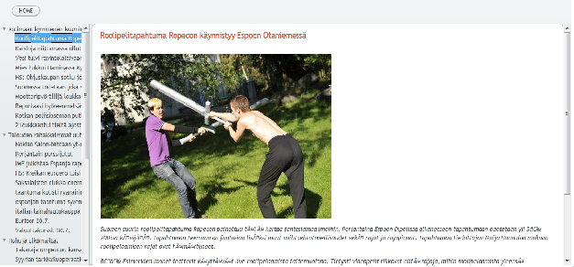

We make use of a very simple user interface. On the left there is a scrollbar that contains all the different news categories. By clicking on a category all the articles pertaining to that category are shown after each other. The categories can be expanded to show the articles in them by clicking the small arrow to the left of them, and then collapsed by clicking it again. The individual articles can then be viewed by clicking on their name.

The home button above the navigation bar can be clicked to return to the front page.

To the right of the navigation bar, the articles themselves are shown.

# Vaadin framework

The project uses the Vaadin framework <http://www.vaadin.com>. It uses AJAX to display dynamic HTML5 pages. Most of the logic runs therefore server-side. The client-side representation is implemented in Google Web Toolkit.