POSTURE CHECK
Phase 3 — Core Implementation & Initial Testing
Run completed: 29 October 2026, 09:00 PM (Asia/Manila)

1. Scope, methods and fixed inputs
The integrated pipeline processes a user-selected exercise: OpenCV decoding → RGB conversion → pretrained MediaPipe Pose Landmarker → visibility/geometry gates → geometric rules → optional temporal post-processing → annotated video and JSON.
Baseline: independent per-frame rules plus fixed clip aggregation. Main: the same pose model and exercise rules, with feature EMA (0.12 s), phase dwell (0.10 s), feedback dwell (0.15 s), missing-pose reset (0.50 s), and full-cycle repetition estimates. It does not automatically identify exercise type. No custom model was trained.
The user confirmed the supplied YouTube excerpts were not used to develop or tune this system. Input/model/code hashes were frozen before inference. No parameters were changed. The user subsequently supplied manual references: all four clips correct; counts 4 push-ups, 4 squats, 3 lunges and 10 jumping jacks. These post-run references are not independently expert-verified; source URLs were not supplied.
Input | Frames | FPS | Duration | Dimensions
push_up.mp4 | 363 | 30 | 12.10 s | 1920 × 864
squat.mp4 | 483 | 30 | 16.10 s | 1920 × 864
lunge.mp4 | 278 | 30 | 9.27 s | 1920 × 864
jumping_jacks.mp4 | 576 | 50 | 11.52 s | 1920 × 864
Total: 1,700 unique input frames; 3,400 frame passes across eight baseline/main runs. Every annotated output was decoded and checked against its input frame count. No run failed.

Conditions and test-set limits
The clips include side/oblique push-ups, side-view squats and lunges, and front-view jumping jacks. Editing/zoom changes, small subjects within padded frames, cropped body parts, and player overlays provide framing/visibility challenges. Controlled poor-lighting, heavy-blur and clutter cases are not adequately represented. Four clips are insufficient for broad generalization claims.
One-command examples (after environment/model setup):
python run.py --exercise squat --method baseline --input squat.mp4 --output baseline.mp4
python run.py --exercise squat --method main --input squat.mp4 --output main.mp4

2. Preliminary baseline–main comparison
Exercise | Method | Feature coverage | Processing FPS | State changes¹ | Reps² | Clip prediction³
Push-up | baseline | 57.3% | 33.25 | 2 | Not impl. | correct
Push-up | main | 57.3% | 34.99 | 3 | 2 | correct
Squat | baseline | 100.0% | 35.46 | 0 | Not impl. | correct
Squat | main | 100.0% | 35.09 | 1 | 4 | correct
Lunge | baseline | 62.2% | 37.14 | 22 | Not impl. | correct
Lunge | main | 62.2% | 36.80 | 27 | 0 | correct
Jumping jack | baseline | 83.0% | 35.79 | 18 | Not impl. | unassessable
Jumping jack | main | 83.0% | 35.62 | 23 | 1 | unassessable
¹ All adjacent status changes, including pending and unassessable. These are not classification error counts. Actionable rule_pass ↔ rule_flag flips were zero in every run. Main introduces warm-up/gap states, so total changes can increase.
² Compare main estimates with the user-supplied counts below. Baseline has no repetition counter, so its missing value is not zero. Reference counts were supplied after predictions were disclosed.
³ Provisional whole-clip rule output, not a verified form label. Jumping-jack clip form classification is intentionally unassessable; open/closed motion can still be tracked.
Observed phase changes (baseline→main): Push-up 12→10; Squat 16→17; Lunge 34→15; Jumping jack 56→31. Fewer phase changes do not prove more accurate phase tracking.
Timing machine: cloud Linux, AMD EPYC 9V74 80-Core Processor, 5 visible logical CPUs, Python 3.12.14, CPU inference. Processing FPS includes inference/features/rules/main temporal updates but excludes startup, decoding, drawing and encoding. Full-run throughput, including those costs, is logged separately. Baseline ran before main for each clip; single-run differences are not evidence of a speed improvement.

Reference-based accuracy and counting errors
Both methods agree with 3/4 reference labels (75%, counting the jumping-jack abstention as a miss). Assessed-only agreement is 3/3 (100%), with 75% classification coverage. All references are correct: this cannot measure incorrect-form detection, false accepts or balanced-class performance. Binary macro F1 is not reported.
Confusion matrix — identical for baseline and main; rows are user references:
Reference | Pred. correct | Pred. incorrect | Abstained
Correct (4 clips) | 3 | 0 | 1
Incorrect (0 clips) | 0 | 0 | 0
Exercise | Reference reps | Main estimate | Absolute error
Push-up | 4 | 2 | 2
Squat | 4 | 4 | 0
Lunge | 3 | 0 | 3
Jumping jack | 10 | 1 | 9
Main repetition MAE = 3.50 reps/clip; exact counts on 1/4 clips. Baseline counting error is unavailable because counting is not implemented. Laptop FPS remains unmeasured; the timings above are cloud measurements.

3. Failure gallery — ten observed rejection frames
These are ten distinct non-assessable main-run frames from three clips, not ten independent videos or ten proven classification mistakes. They show technical/input failure cases; some abstentions are appropriate. Captions identify observed gate failures. Framing/occlusion explanations are hypotheses unless directly visible.
Joint confidence — Required joint visibility/presence falls below 0.5.
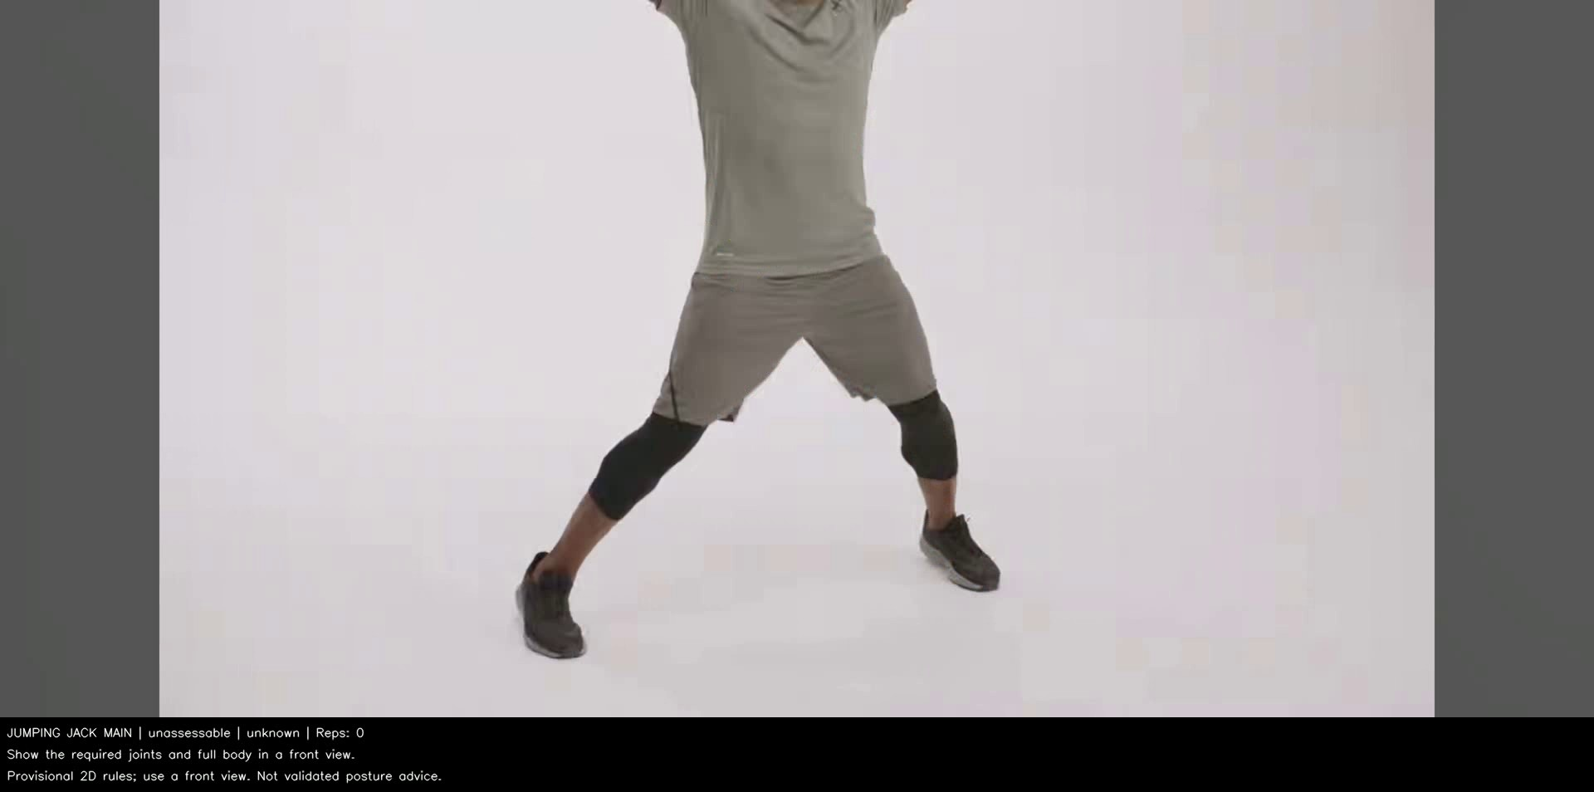  F08 · Jumping jack · 4.62 s · frame 231 | 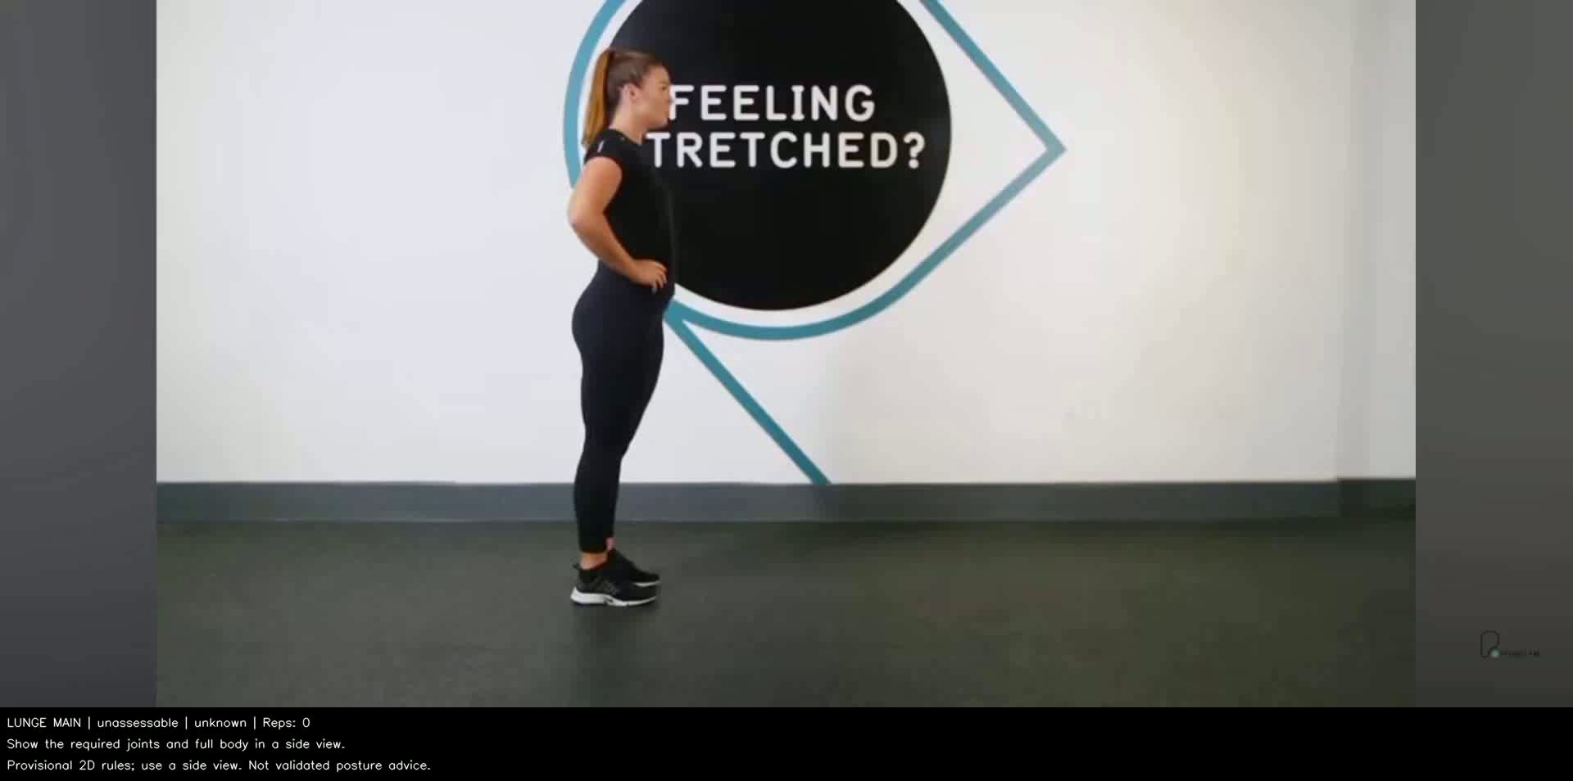  F05 · Lunge · 0.00 s · frame 0 | 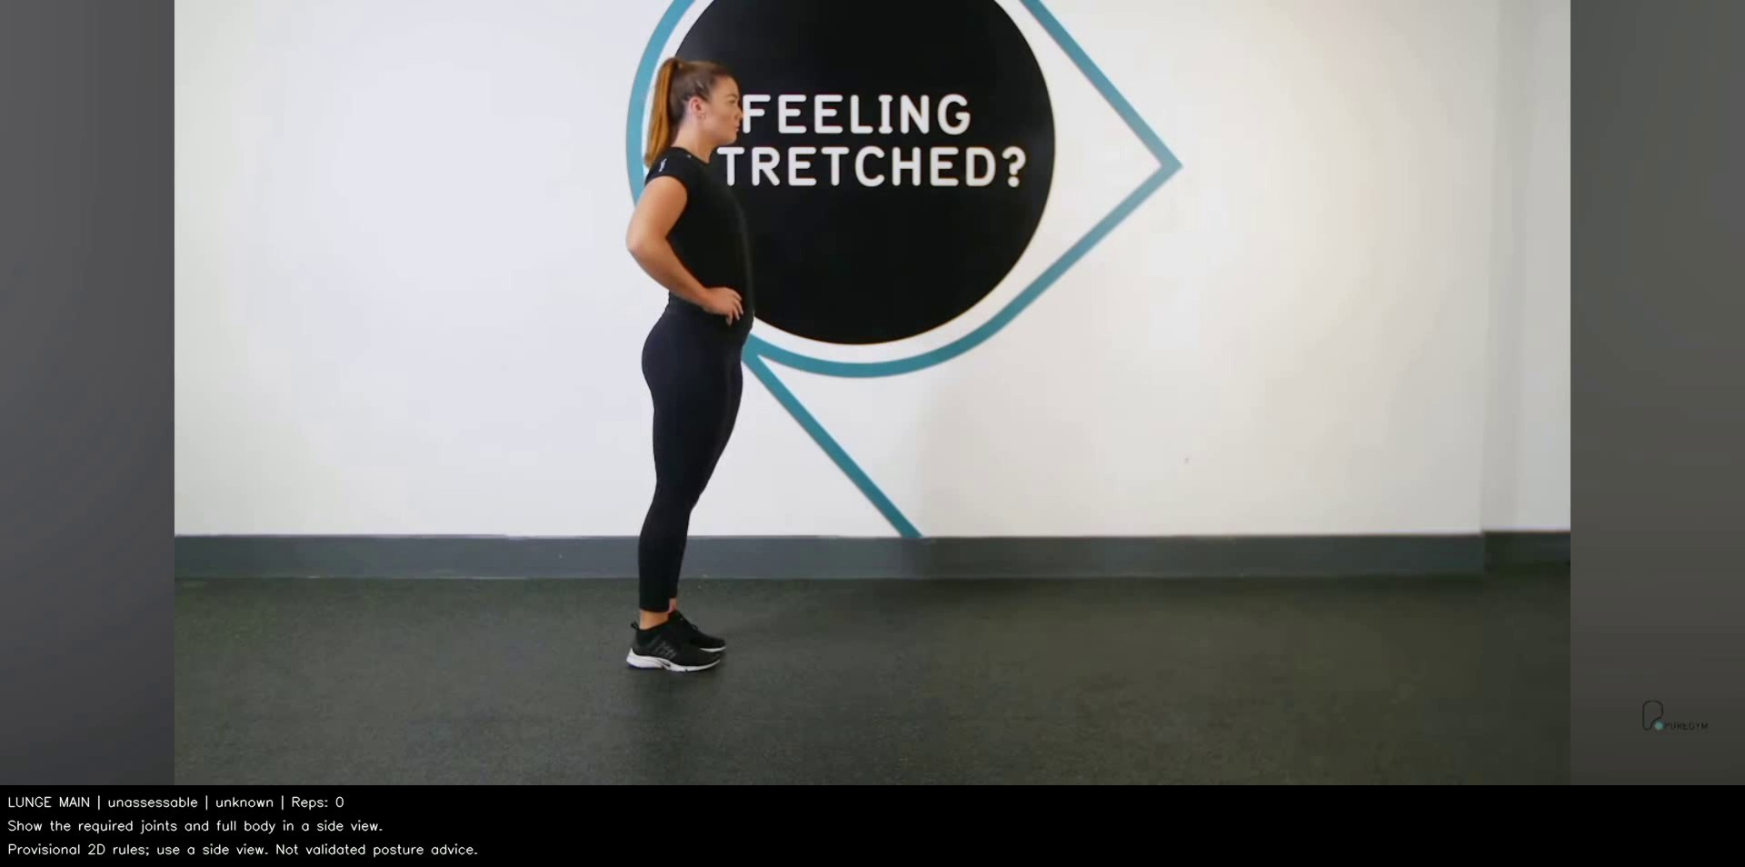  F06 · Lunge · 6.43 s · frame 193
Out-of-frame joints — Required predicted landmarks lie outside the image.
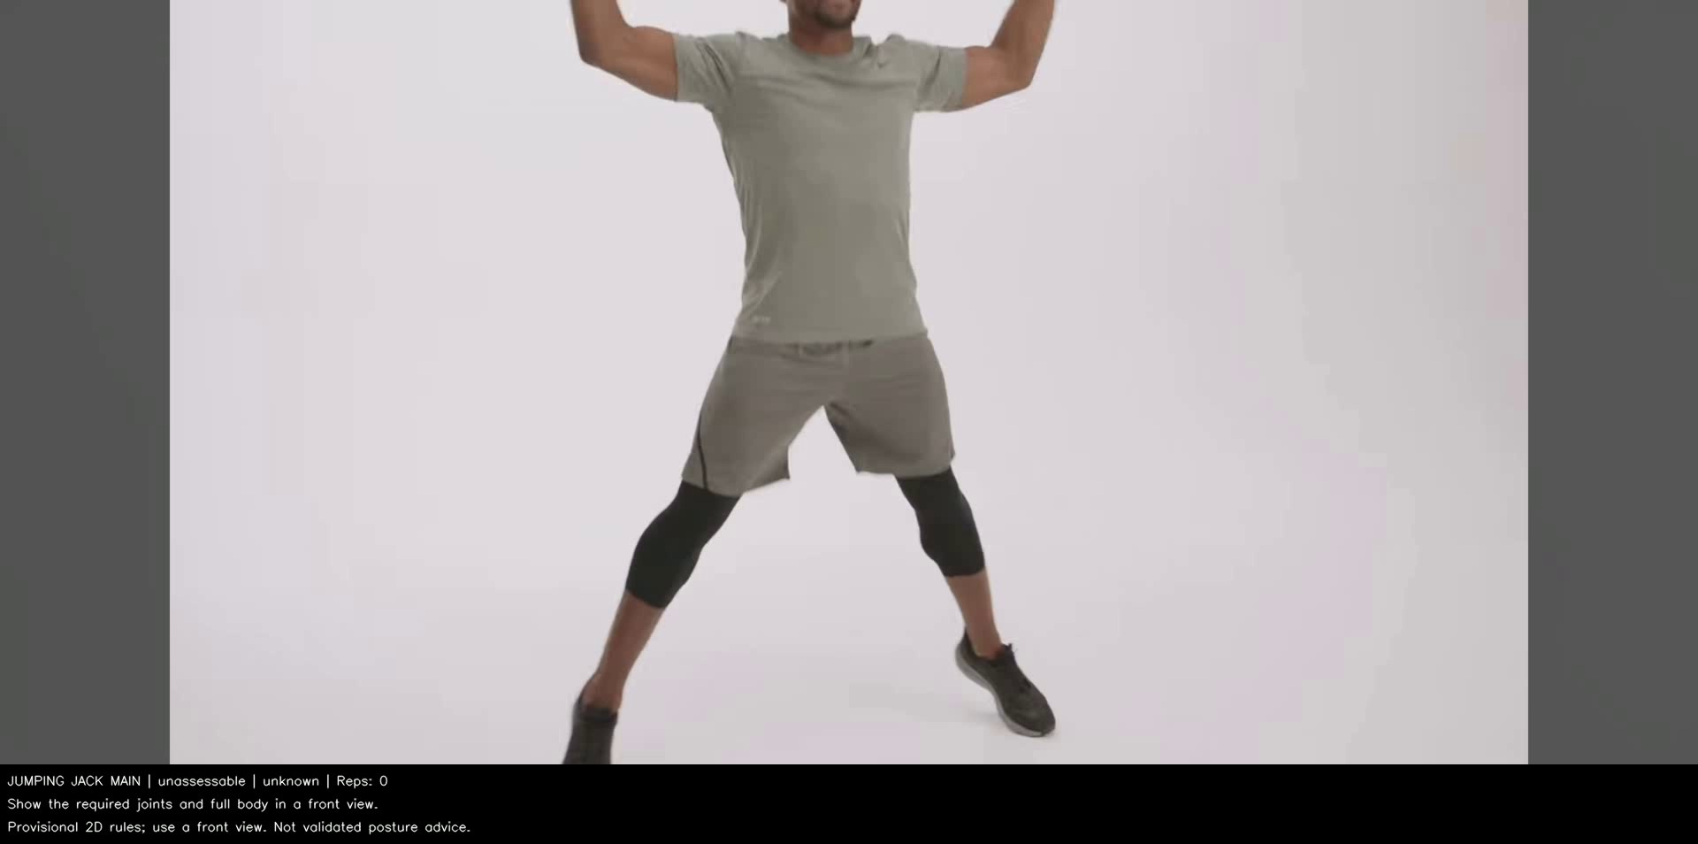  F09 · Jumping jack · 5.76 s · frame 288 | 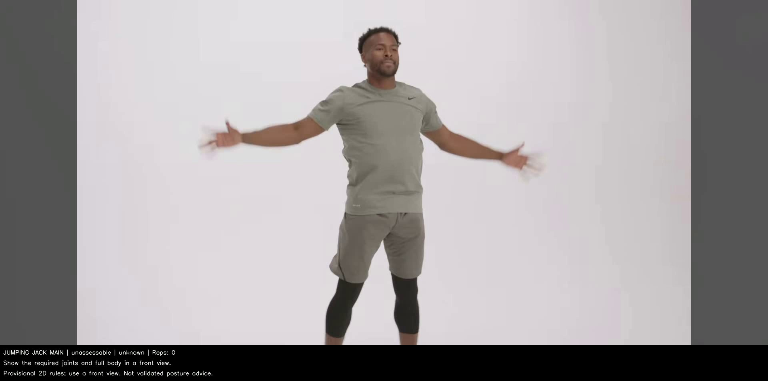  F10 · Jumping jack · 7.94 s · frame 397
Size/confidence gates — One side fails confidence; the other fails the body-size gate.
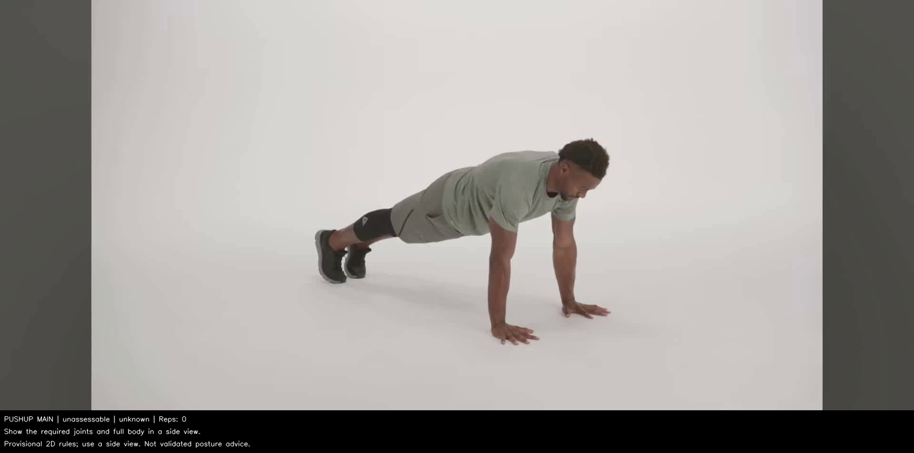  F01 · Push-up · 0.00 s · frame 0 | 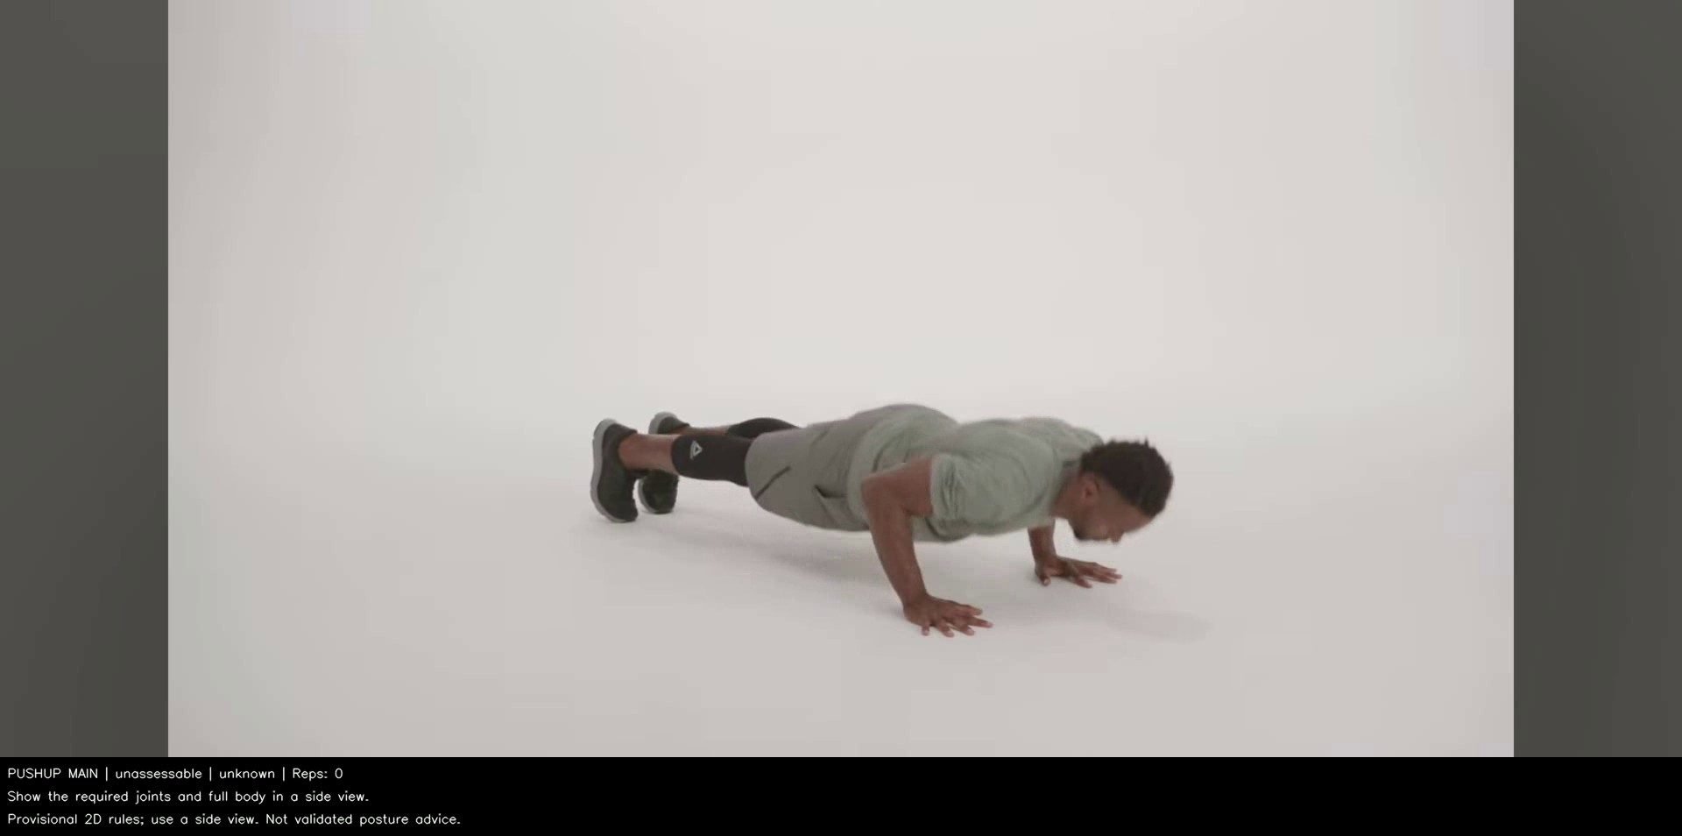  F02 · Push-up · 1.70 s · frame 51 | 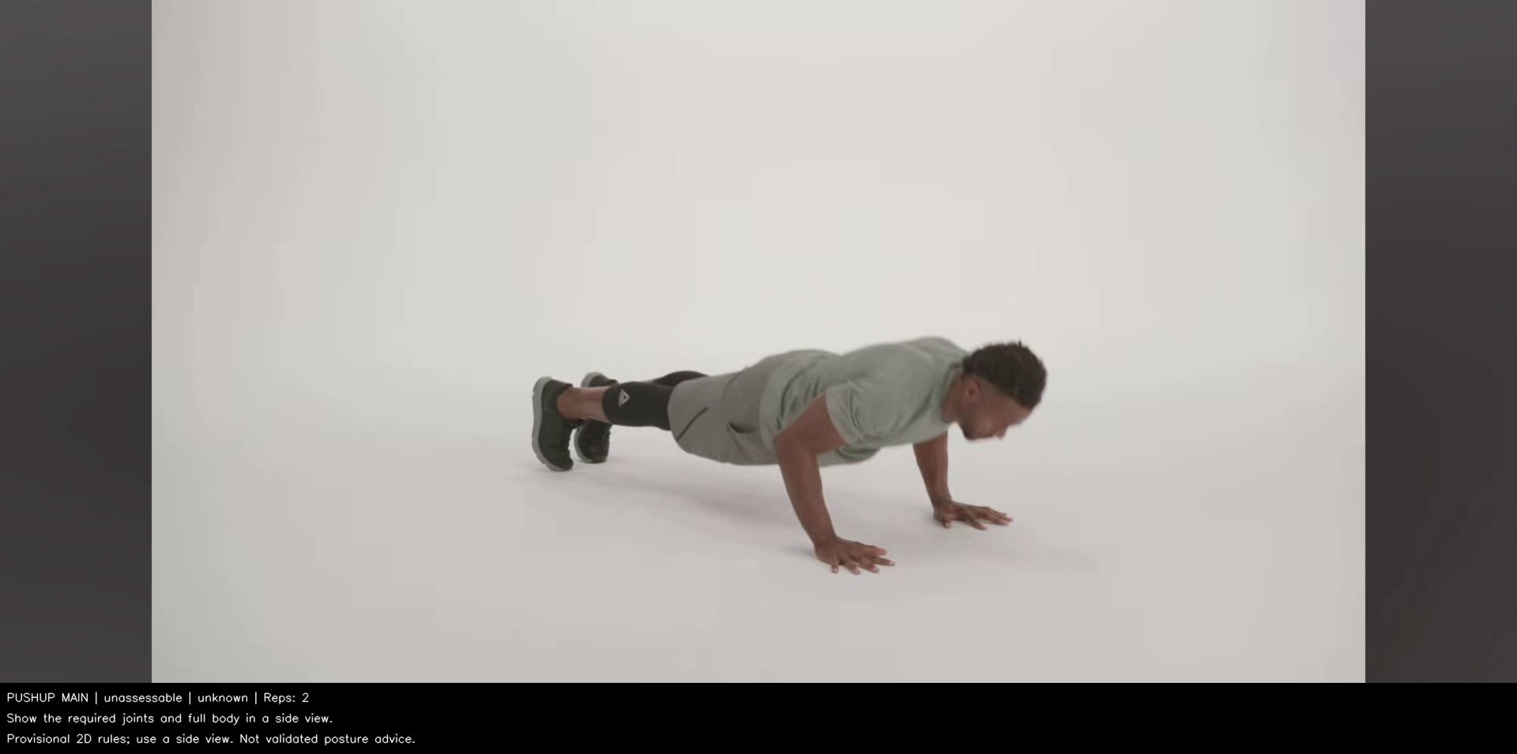  F03 · Push-up · 10.37 s · frame 311
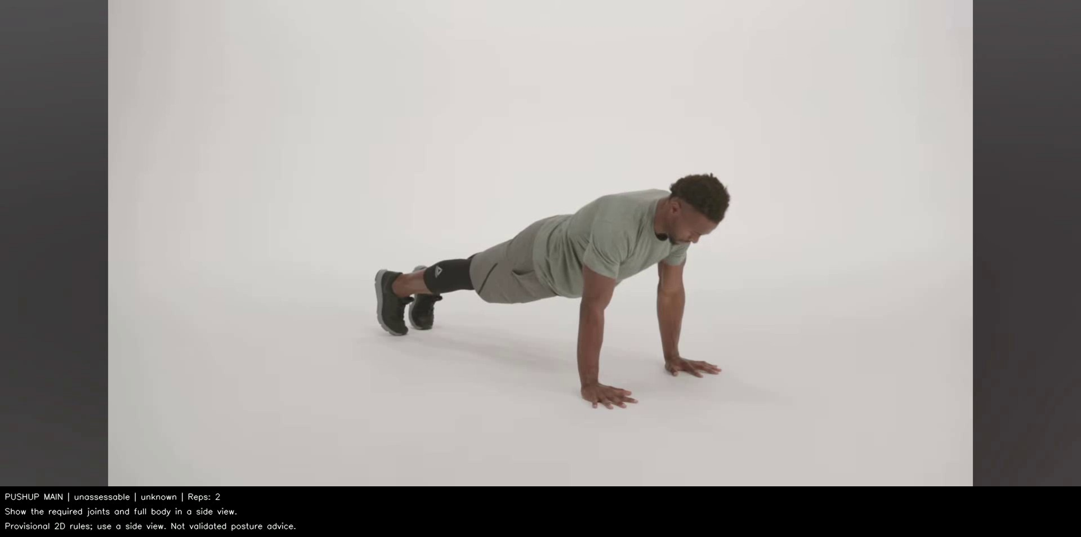
F04 · Push-up · 12.07 s · frame 362
No pose output — No landmarks returned in a cropped/overlay end frame; abstention is appropriate.
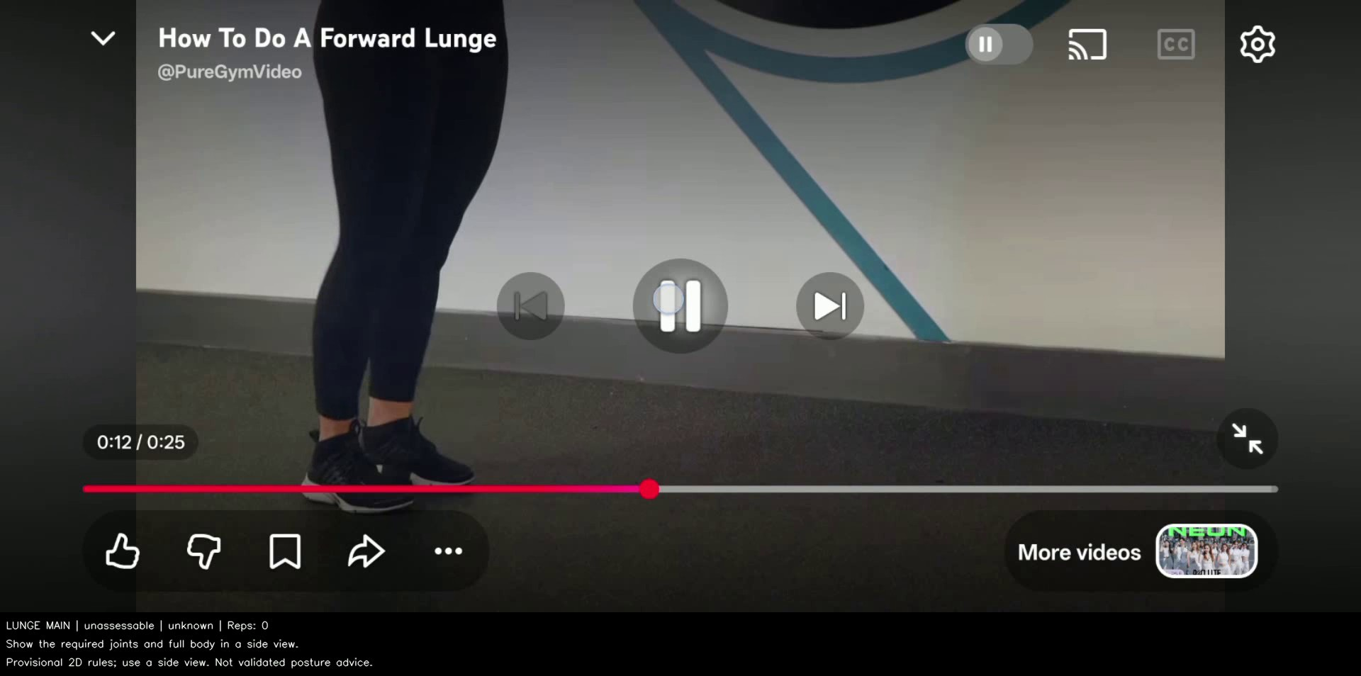
F07 · Lunge · 9.23 s · frame 277
All images are actual annotated test outputs, not simulations. Full-resolution images, frame indices and diagnosis notes are in failure_manifest.json and failures/. The squat run had no feature rejection; this does not establish correct landmarks or form.

4. Interpretation, improvement plan and pending work
The main method adds temporal state and movement counts while preserving missing-pose abstention. It does not improve form-label agreement on this set: both methods score 75% overall against the supplied references. All clips are reference-correct, so the result gives no evidence about recognizing incorrect form. All eight actionable-feedback flip counts are zero; total main status changes increase because of warm-up/gap transitions.
Both methods share the same pose detector and geometry gates, explaining unchanged feature coverage. Main undercounts push-ups by 2, lunges by 3 and jumping jacks by 9; its squat count matches the reference. Short clips, camera edits, missing states and the full-cycle definition are candidate contributors. Count MAE is 3.50 reps/clip. These results were scored post hoc without retuning or rerunning the methods.

Top three proposed changes (not applied to this test)
Observed cause | Proposed change | Expected effect / verification
Padding/scale and cropped predicted joints (F01–F04, F09–F10) | Detect active video/person region before relative size checks; separate unsupported/cropped inputs from pose failure. | Fewer framing-related rejections; verify on separate development clips with checked landmarks and count references.
Low-confidence required joints / lost pose (F05–F08) | Use view-aware required-joint selection and tracked subject identity; keep honest abstention where reliable angles cannot be measured. | Improve usable pose coverage without accepting equipment/background poses; audit false detections manually.
Extra pending/gap transitions and incomplete cycle evidence | Test confidence-aware temporal hysteresis and exercise/variant-specific cycle endpoints on independently counted development clips. | Reduce feedback instability and counting errors; measure count MAE and completion events against manual references.

What is still needed for the hand-in
• Independently review the user-supplied form labels and repetition counts, ideally without viewing predictions. Document the form criteria and partial-cycle convention.
• Add reference-incorrect clips and a separate fixed hard-case set covering low light, blur, clutter and occlusion. Keep this expanded test set out of tuning.
• Run the unchanged methods on a laptop and record CPU/RAM/OS/power mode. Copy the code, model, supplied clips and frozen manifest before using the command below.
• After reviewing results and pending items, commit/tag the submission as cp3-core. No such tag is created by generating this report.
Laptop command (environment activated; default manifest/freeze paths):
python scripts/phase3/run_fixed_tests.py --runtime-label laptop --results docs/phase3/laptop_test_log.json --output-dir outputs/phase3_laptop

Reproducibility and source files
test_manifest.json: input hashes and updated references. reference_annotations.json: user reference values, origin and post-run timing; reference_metrics.json: scores and confusion matrices. test_log.json preserves the original eight runs, when labels were still unknown. frozen_configuration.json holds source/model hashes; comparison_summary.json contains merged scores; failure_manifest.json records gallery provenance. Annotated videos/JSON are in outputs/phase3/. Original YouTube channel/URL attribution remains to be supplied.
This editable preliminary report distinguishes model predictions, user-supplied references and independently verified measurements. The original clips, inference outputs, method parameters and measured timings are unchanged.

