

**Nicholas** **Moore**

**sideQUEST: Saving the World, One Task at a Time**

**Description:** The web game “sideQUEST” combines the nostalgia of 8-bit, NES style role playing experiences with the exciting concept of gamification. Your quest is to save the world of Enthysia from the ominous darkness that is slowly turning the inhabitants into idle shells. In order to progress through the game, you too must save yourself from idleness: various real-world tasks are added as you advance, and by completing them and updating your status through a mobile device you open up new areas of the “sideQUEST” world. The people of Enthysia are counting on you, and the only way to save the world is to believe in yourself; or just your ability to take out the trash.

**Instructions:** In order to play “sideQUEST”, you must register on the website and download the mobile application on an Android device. As you progress by clicking arrows and areas on the screen that navigate the world, you will be prompted when new tasks are added and the application is updated. In order to reach certain areas of the game, you must submit the task on the application, and then you will be able to continue advancing in the game on the website.

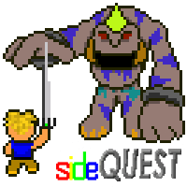**Tools:** “sideQUEST” is developed primarily in HTML5, PHP/mySQL, and Javascript/JQuery. Most of the programming was done in Dreamweaver, and the artistic design work in Photoshop.

**About the Artist:** Nicholas Moore is an aspiring computer designer who hopes to one day lead a successful game development team. You can check out more of his web, digital and game design work at <http://www.tcnj.edu/~moore56/> and contact him with any questions or comments at [Myrmidon16@gmail.com](mailto:Myrmidon16@gmail.com).