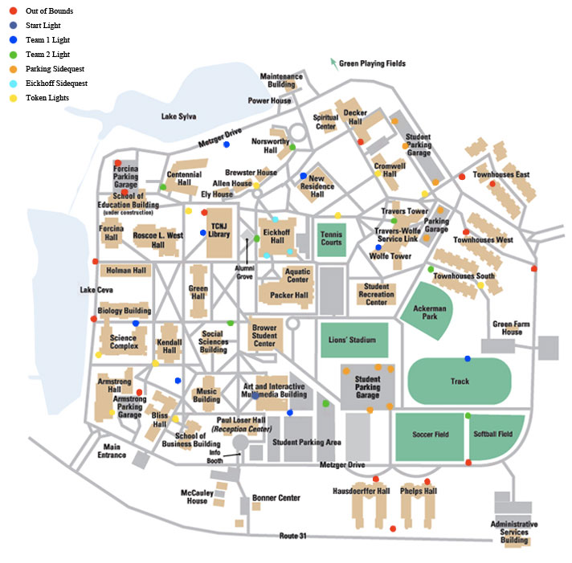

**Team 1 Clues**

**Starting Point:** A clue can be found where music, theatre, and religion all meet.

Eickhoff Side Quest

Try to collect all three tokens around Eickhoff to gain 5 points each. Get as many as you can.

**Light 1**: There might be a larger dose of gravity where this clue can be found.

Side Quest

Collect all the tokens in each garage to gain points.

Lot 8: 2 token, 5 points. Lot 9: 3 token, 10 points.

**Light 2**: Make sure you return any overdue books when grabbing this clue.

**Detour:** Visit Athena and her little owl.

**Light 3**: Make sure you greet Lady Sylva when you are grabbing this clue.

**Light 4**: Why is it still “New?”

Side Quest

Watch a lion fight a snake.

**Light 5**: A clue at a great place for the more canine of incoming students.

**Detour**: Tells you the time. If there’s sunlight.

**Light 6**: Take a quick run when you stop by to pick up this clue.

Side Quest: Just begs to by photoshopped into a Pokeball.

**Light 7**: Artistic commuters love this lot.

**Final Clue**

We dragged you across campus just to lead you to the other side of the starting building.

**Team 2 Clues**

**Starting Point**: You can find this clue at the hub of social activity on campus. PS Let’s go smash some cars.

Eickhoff Side Quest

Try to collect all three tokens around Eickhoff to gain 5 points each.

**Light 1**: This home was once an elementary school.

Side Quest

Collect all the tokens in each garage to gain points.

Lot 6: 5 tokens, 15 points.

**Light 2**: This clue loves getting to know TCNJ alumni.

**Detour:** Dr. Eickhoff Portrait: I wonder why he doesn’t have his eyepatch in this painting…

**Light 3**: We’re not totally sure you are WORTHY of this clue.

**Light 4**: We hope you didn’t have to Travers too far to grab this clue.

Side quest

Hope you’re not too “tired” to play with this.

**Light 5**: Three little towns, one direction missing. This clue is found at the opposite of that direction.

**Detour**: This building was the home of the original owners of this land.

**Light 6**: You don’t have to choose between softball and soccer when grabbing this clue.

Side Quest: Swimming in this is on everyone’s TCNJ Bucket List.

**Light 7**: Apartment students pass this when going to the big game.

**Final Clue**

We dragged you across campus just to lead you to the other side of the starting building.

**Parking Garage Sidequest**

Collect all the tokens in each garage to gain points.

Lot 6: 5 tokens, 15 points.

**Token Lights**

Each extra token you grab from these lights gains you another 5 points.

Winning Team: 20 points

Parking Garage side quest: 15 points

Eickhoff Side quest: 5 points each

Lion Statue: 10 points

Tire Swing: 10 points

Pokeball: 10 points

Fountain: 10 points

Tokens: 5 points

10 tokens total