**BROPOCALYSE**

Seth Konoza, Nicholas Moore, Michael Murphy, Harris Weinstein

1. Design History

*Thursday, December 8th:* Created a flowchart of the game state and some preliminary concept art. Added some more sections to the game document, such as “Game Play”, “Game Characters”, “Game World”, “Media List”, and “Tech Specs”.

*Thursday, December 1st:* Created the official *Bropocalypse* logo. Put together a rough prototype of basic gameplay in Scratch, including one player and four zombies, with a health and stamina bar for player and health for zombies.

*Thursday, November 17th:* Wrote up a preliminary beginning narrative for the game. Put together a wireframe of the command string of the game play, as well as several prototype screenshots of the game in action.

*Thursday, November 10th:* Began design statement. Chose an art style (see vision statement). Created a paper prototype to test game play before we begin production.

*Monday, November 7th:* Pitched two game ideas to class. After initial feedback and further brainstorming, decided to pursue game idea *Bropocalypse*. Figured out a couple new additions to game statement, including story elements and level design.

*Thursday, November 3rd:* Brainstorming session. Created second game idea, side-scrolling beat-em-up *Bropocalypse*, set in post-apocalyptic environment where the only people not turned to zombies are those with the “bro-gene”. Characters based off of stereotypes of college fraternity and varsity sports members. Added alcohol/stamina bars and in game item ideas.

*Monday, October 31st:* Brainstorming session. Created fighting game idea *Regular Fighter*, where characters were everyday people who fought each other using super powered clichés and stereotypes of that person (EX. Janitor, fights with mop, Windex, can affect environment).

1. Vision Statement

College is no longer about drinking, partying, and “broing” out; it’s about surviving the ***Zombie Apocalypse***…and “broing” out.

*Bropocalypse* will be a traditional side-scrolling beat-em-up in the fashion of *River City Ransom*, *The Simpsons Arcade*, and *Golden Axe*, among others. On a regular college campus, the living dead have awoken, establishing the setting of a post-zombie-apocalypse college campus with the protagonists being of the elite “bro” society, and the antagonists being the zombified remnants of society, which is basically everyone else. Tread carefully, as zombies lurk at every turn. Levels will be launched from a central “hub” (in the form of a fraternity house), where players may choose which levels to beat as they become available. Certain levels will have items that the players can use that will assist them in other levels, somewhat similar to the Mega Man series of games.

You will have to use the members of your fraternity wisely, as each member has certain strengths that may help you survive. With a vast number of “bro” characters from fraternities at your disposal, the frat’s survival is in your hands. Combat will be dictated by very simple, fluid controls. Player combat will have basic, combo-able attacks and special flavor moves that are unique to each different character type. This system can be implemented with just movement and attack buttons.

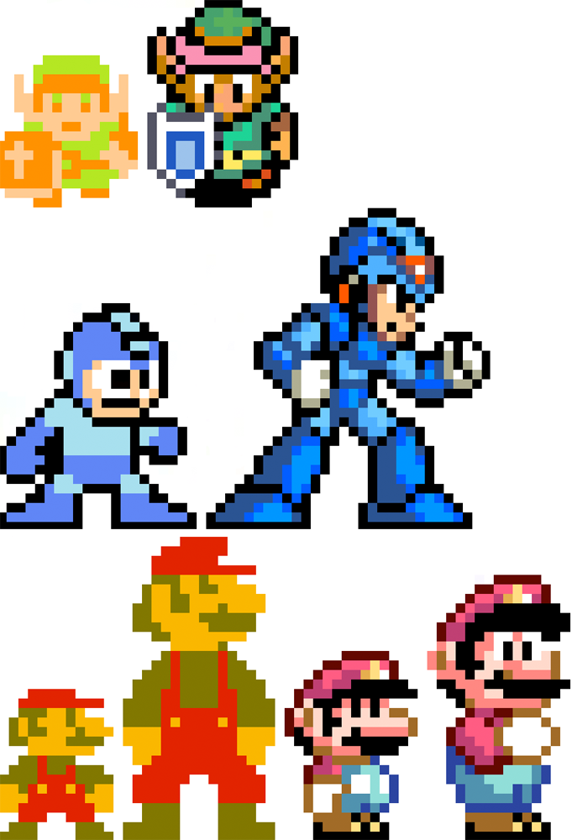What would college life be without alcohol? You will go through the campus picking up various items, amongst them alcohol, the consumption of which will be measured by your alcohol bar. Other pick-ups will include red bulls to increase stamina, and the ever-popular “fat sammich” to increase health. In addition, there will be various weapons scattered around campus that add to the characters “bro-stat”, making it easier to fight off the hoards of enemies. By utilizing what you would find on and around your campus, the battle against the zombie horde begins!

Artistically, things will be presented in a pixilated, retro-style with a very colorful and humorous approach, similar to the Metal Slug series. Game elements are rendered through 16-bit sprites (a comparison is found to the left; 8-bit vs. 16-bit designs). We decided on our art style by looking at games with similar pixel designs and high contrast color schemes, such as the Scott Pilgrim game and *No More Heroes*, some examples of which are found below.

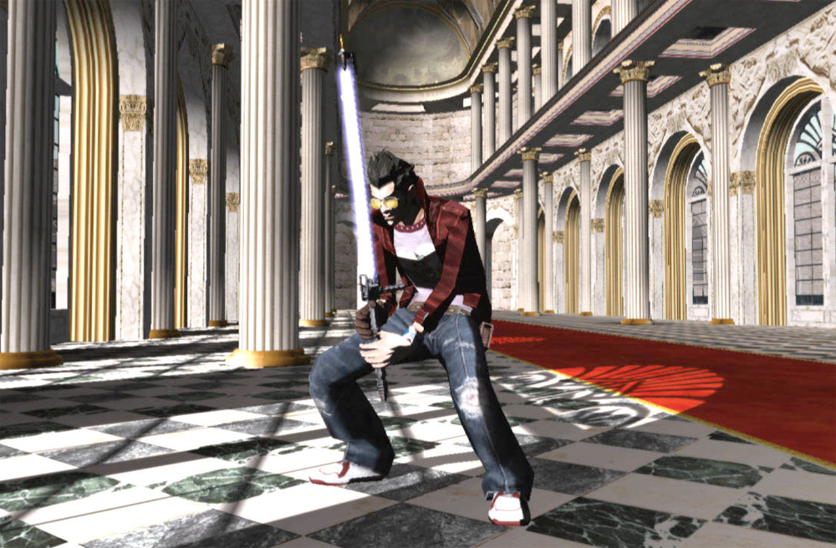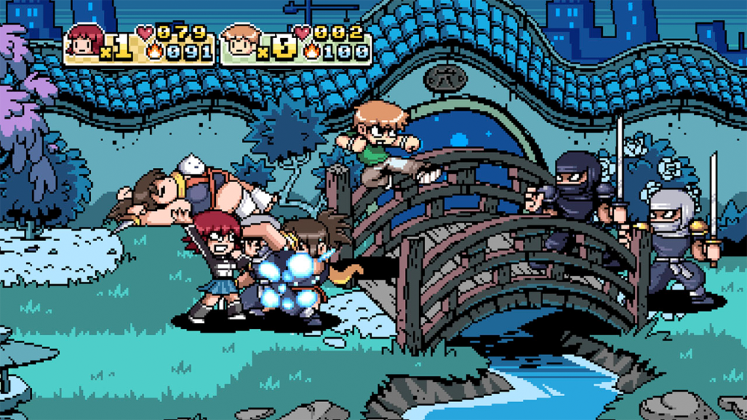

1. Target Audience

The target audience of *Bropocalypse* is anyone who is a fan of the arcade beat-em-up games and anybody who knows of the “bro” stereotype in a college atmosphere. However, knowledge of this stereotype is not required to enjoy the game; rather it dictates the aesthetic feel of the environment the game takes place in (inversely, those unfamiliar to the idea of being a “bro” will be introduced to it through the game play and story). The controls are meant to be accessible and easy to figure out for any player, and the mechanics (like inventory management, score, etc.) should be easy to understand without much deliberation. *Bropocalypse* takes the easily recognizable game play of beat-em-ups and throws the “bro” storyline on top of it, and hopes to draw in players yearning for the nostalgia of arcades as well as those who will enjoy the theme and story.

*Bropocalypse* will be playable on PC as either a Facebook or downloadable Steam game. Because of the simple game mechanics and 16-bit design style, the specifications should be minimal, what you would need to run a simple Flash or Java based computer game. Similar games have been the *Teenage Mutant Ninja Turtles* and *Simpsons* arcade games, which have found current success through re-releases on Xbox Live Arcade, iOS platforms, and PC DOS. *Retro City Rampage* is a game currently in production for WiiWare and Xbox Live Arcade, taking its design styles and game play from these previous popular arcade games, similar to what we are planning. It has gained much hype over the Internet with its game play contents and mechanics.

1. Game Play

*Bropocalypse* will play similar to the arcade style games mentioned earlier in the document. Basic controls will include movement, basic and special attacks, and screen selections. Movement in game will be executed by the arrow keys for a single player and WASD for a second player, if applicable. Basic attacks will be executed by the space bar, where special moves will be executed by pressing the left or right arrows in combination with the space bar. There will be two distinct screens that can be called upon; the pause screen, which will stop gameplay temporarily by pressing the ESC button, and the “Stash”, or inventory screen, which will bring up the current players inventory for examining and swapping items, and will also pause the game. This is executed by the Control button and can be navigated using the arrow and space keys.

When in game, the character can interact with the environment and the enemies, usually zombies. The boundaries of the environment are displayed by the foreground, where the player can move upon, the background, which displays the current level background sprites and cannot be moved upon, and the left and right sides of the screen. The players are contained within these boundaries while there are still threats in the area, but when all of the enemies have been defeated the player will be able to move to the right along the level. In addition, items will be scattered across the foreground and are able to be picked up and used, depending on what they are. Alcohol, Red Bull, and “fat sammichs” are used immediately, but weapons and armor can be stored in the “Stash” screen and swapped out at a later time.

Interactions with the enemies can happen in one of two ways; if the player is passive and the zombie touches him and attacks, the player takes damage, or if the zombie is passive and the player touches it and attacks, the zombie takes damage. Passive means the character is not in an attacking animation. If both characters are active the player deals damage to the zombie.

Players will have three types of power bars; health, stamina, and alcohol level. The player’s health is dependent on the type of character and goes down whenever they take damage from an enemy. The player can only regain health by picking up a “fat sammich”. The player’s stamina level goes down with every special attack they perform. If the stamina bar is empty the player cannot use special attacks. This bar refills slowly over time if the player is passive or using basic attacks. The Red Bull item temporarily boosts stamina, but this boost decreases rapidly until it is gone. The alcohol level goes up whenever a player consumes alcohol. The players attack strength goes up as the alcohol bar does up to a certain point; if the alcohol bar goes over that point the player is drunk, and their attack decreased exponentially the more the level goes over that point. The alcohol bar decreased over time of no alcohol consumption. Red Bull also decreases the alcohol bar.

Each character in the game has four corresponding statistics; health, attack, defense, and speed. Health is total damage a character can take, attack is how much damage the character can give, defense is how much damage a character can take with each hit, and speed is the quickness to which the character can move across the screen (or escape an enemy). Weapons and armor can increase and decrease these stats when being used.

The basic goal of each level is to defeat all of the enemies, travel across the entire level, and defeat the boss at the end. When a level has been cleared it shows up in the main game statistics, which can be observed in the main base point (the frat house). From the base hub players can choose different levels to battle through when they become available. The game has been won when all of the provided levels in the game have been cleared.

1. Game Characters

*Bropocalypse* will be originally developed as a single player game; however the final goal is to have a possible four players like the arcade games we are modeling the game after. At the beginning of each level, the possible number of players will be able to choose between a yet to be determined number of characters, who will each have unique attacks and statistics. For example, the footbro, a football player bro, will have a higher health, attack, and defense, but be very slow. He will also lack ranged attacks, leaving him more susceptible to damage; his basic attack will be swiping at the zombies and special will be a short ranged charge. Character would have to choose what combination of attacks and statistics they would prefer when choosing what character to fight the zombie apocalypse with.

List of Preliminary Characters:

* Footbro: High Health, Attack, and Defense. Low Speed. Only close combat attacks. Basic: Swipe at Enemy. Special: Short Ranged Charge.
* Laxbro: Medium Health, Attack, Defense and Speed. Basic attack: Swing lacrosse stick, has a long reach. Special: Throw ranged items from lacrosse stick. Limited ammo that is picked up through the game.
* Basebro: Low Health, High Attack, Medium Defense and Speed. Basic attack: Swing baseball bat. Special: Throw baseball, unlimited ammo.
* Wrestlebro: Low Health. High Defense and Speed. No attack. This character is basically useless. Both of his attacks are to try and wrestle the enemy, however the attack is useless and the wrestlebro is damaged at the same time.

Enemies will consist of varying numbers and sizes of zombies. The most common zombie will have basic health, attack and speed, but there will also be a bigger, slower zombie with higher health and attack. At the end of each level will be a unique boss that is stronger than the other zombies. The bosses will have varying statistics and attacks depending on the environment they are found in.

We have thrown around the idea of certain NPC’s that will appear either randomly or during special events over the course of the game. These NPC’s will be based on popular alcohol symbols, such as Keith Stone and The Most Interesting Man in the World, and they will give out advice and items to the players. These ideas will become better implemented after the game has been more developed.

1. Narrative

*Synopsis*: In a University Science Laboratory, scientists are working on a new way to genetically enhance the human race. Thought by many to not only be unethical, but impossible, the egotistical scientists will not stop until they have created the perfect genetic species. During the experiment, the scientist’s assistant accidentally mixes the wrong two chemical components. “What have you done?!” shrieks the scientist. “All hell will now break loose!”

This “botched” experiment has turned this campus into a living nightmare. The improper mix of chemicals has created an airborne virus in which all members of the college community are infected, and everyone begins mutating into zombies … except, surprisingly, for those with the “bro” gene!

*Introduction*: At the start of the game there will be a watchable narrative, depicting a scene from the College Science Laboratory where the scientists realize their “botched” experiment; the zombies spread across campus, infecting everyone, except for the Fraternity Bros. There will be audio and music to accompany this brief narrative, giving the player a sense of the impending doom that lurks on campus. The introduction will be interactive, where the player will watch a scene, and then control the character to fulfill the brief narrative.

A playable/watchable narrative is used to get the player introduced to the story that will drive the game play. Audio will be integrated into the narrative, including player voices, sounds for “twists and turns” in the narrative, etc. This would be done with recording software and then transferred to the game. It will begin with a scene showing the bros looking out from the frat house window, witnessing the chaos in the campus with a massive zombie horde approaching.

The basebro says: “I bet I can hit that zombie with a baseball!”

The player will then become the basebro, where they will be instructed on what controls to use in order to hit the zombie. Upon completion, he hits the zombie, who grunts loudly and shakes his head. Basebro then begins bragging to the rest of the frat.

The rest of the bro characters will be introduced in a similar fashion. For example, the laxbro launches a lacrosse ball that nails the zombie… zombie shakes head and groans aloud. The footbro says, “Now it’s on!” and runs down and barrels over a couple zombies.

Then the camera will zoom out to a shot of the massive zombie horde approaching the fraternity house. Now all of the bros are together in front of the frat house; this will serve as the first “location” and first level in the game. Then screen then pops up for character selection, and after the actual game play will begin.

*Level Examples:*

1. In Front of the “Frat” House; i.e. the Greek Row.

The bros begin to bash zombies as they run through Greek Row, clearing the streets of zombies, making sure they know: “Never mess with the bros!” Upon completion of the level, the player will have defeated the zombies in front of the Frat house. They now go back inside their frat house, but realize they now have nothing to do. Instead of their usual night of slamming down beers and throwing parties with the sororities, the reality sets in that they now ARE THE ONLY ONES WHO ARE NOT ZOMBIES!

This angers the bros more than ever as they cannot party and jam out without the ladies.

They decide to take out their anger, and spend the rest of the night eliminating all zombies in the honor of the “Bro Code.”

1. Student Center

The bros now venture out into the Student Center, where they see a massive horde of zombies, and proceed to wipe them out. The Bros leave the Student Center for the Convenience Store on campus after working up a nice sweat. They break open the refrigerator door and begin to devour raw eggs to get a nice protein high going. They are now running purely on a rush of protein and adrenaline and their desire to destroy zombies has escalated ten-fold. However, the zombies are now growing stronger as well. The zombie gene is beginning to regenerate rapidly, resulting in increasing speed and strength of the zombies. They will no longer be as easily defeated as they were in the early rounds. The Bros, however, are up for the challenge.

1. On to the Football Field!

The field in which the footbro spent many of his Saturday’s bashing in other player’s heads is now filled with mindless zombies. This angers him to no end. Instead of spending the night beating other player’s to a pulp with his fellow footbros, he makes a plea to mash the zombies in the “Bro Code” Honor of Football! The other bros are eager to help, because as the bros say, “bros stick together.” They battle the massive zombie horde on the field, crushing them in a bloody pulp. They now jump into a deserted Campus Shuttle Bus and head to the main party street nearby to see if anyone has survived the Apocalypse. The bros drive past their favorite night club/party spots, to find them all completely deserted. In the distance they more zombies are coming towards them. It’s on!!

1. Potential Subplots

There may be a point in the game where the player finds out that the scientist who conducted the failed experiment in the narrative is actually a “mad” scientist, angry because he got fired from his company for having insane idea to enhance the human race through gene experimentation. He continues to conduct his experiments in his new job as a professor at the college. Because of his advanced scientific knowledge, the player will learn that the experiment produced far worse affects than just the genetic mutation of humans, but now every living creature, including squirrels, rats, some dogs, foxes, and birds that roam the campus are now infected as well, giving the bros even more enemies to battle!

After the epidemic spreads, the Bros find out that the Poison Control Agency has quarantined the entire campus area so the disease would not spread further, so now the Bros are stuck there unless they find a way out. The zombies will begin to mutate as the rounds grow longer, and more chances will be given for the bros to escape the campus. There may be a bonus level where the bros take a deserted van and run over the barricade to escape to freedom, but the airborne virus now spreads to the surrounding areas and infects more people, where the bros will now have an even bigger challenge to tackle.

1. Game World

The game world will consist of the college campus and various locations throughout the campus that will simulate what you see in an ordinary university. We will look to create a world like a typical university, and places that would appear familiar to players. Some key locations will be the levels summarized in the narrative above, which will include: The Fraternity House, “Greek” Row, the Campus Student Center, the Football Field, and the Ghost Town Bar’s Street, among others.

The players will directly control only moving to attack zombies and moving through the level. The travel to the next location upon completion of a level will be driven by the game itself, in the form of a watchable scene. The mapping will be in a straight line, where the player will advance their character using the joystick. This is similar to many side-scrolling arcade fighting games. The players and enemies will be scaled in similar proportions to each other, with much larger buildings and other objects in the background of the levels.

The physical objects in the game will include item pick-ups such as Red Bull, “fat sammich”, and alcohol. Weapons and armor can also be picked up and stored for later use. Rocks and garbage will be among other physical objects which can be used as ranged weapons for the players.

The weather will remain constant throughout the game and will not be a factor. The transition from day to night and time changes may occur across different levels, but during the course of single level game play the lighting will remain constant. The dynamic of physics will not be applicable in the game. Players will remain on even level along with zombies, the physical objects, and the buildings in the background that serve as the setting.

1. Media List

As stated in the vision statement, the graphics for the game will be primarily in 16-bit sprites, so for environments, interfaces, characters, and items the only media necessary will be image sprites. Animation would be defined through coding the change between different produced sprites for each character. Music and sound effects will also be in classic 16-bit fashion, developed through music editing platforms such as Garage Band and through various recording devices.

1. Tech Specs
2. Development Platform and Tools
   1. Prototype
      1. Software
         * Scratch
         * Photoshop
      2. Hardware
         * Apple Computers
         * PC
   2. Full Game
      1. Software
         * GameMaker 8.1
           + Lite
           + Standard Edition
         * Photoshop
         * Illustrator
      2. Hardware
         * Apple computers
         * PC
3. Delivery
   1. Internet
      1. Download
      2. Online Gaming Websites
      3. Facebook
4. Game Engine
   1. Prototype
      1. Scratch
         * Technical Specs
           + Display

800x480 or larger

* + - * + OS

Windows 2000 or later

Mac OS X 10.4 or later

* + - * + Disk

120 MB

* + - * Design
        + Features

Drag and Drop Code

* 1. Full Game
     1. GameMaker 8.1
        + Technical Specs
          - Display

800x600 or larger

16-bit or 32-bit colors

* + - * + OS

Windows 2000 or later

Mac OS X 10.5 or later

* + - * + Graphics Card

DirectX 8 compatible

* + - * + Processor

Pentium or equivalent

* + - * + RAM

32 MB

* + - * + Disk

128 MB

* + - * Features
        + 2D and 3D graphics

3D in standard edition only

* + - * + GameMaker Language

Based off of C, C++, and Java languages

* + - * + Load and use Dynamic-link Libraries

1. Risks

No one in our group has ever worked with the GameMaker engine before, but since our head programmer has experience in C, C++, and Java languages, the programming side of the project should not take long to understand.