lotsgrabs
Nikhil Muthukrishnan
2 May 2019
library(psych)
library(tibble)
library(data.table)
library(caret)
library(tidyverse)
library(data.table)
library(readxl)
library(zoo)
library(lubridate)
library(rio)
options(max.print=10,digits = 10)
setwd("C:/Users/in0166/Desktop/newpip")
#INPUT
input<-data.frame(fread("2017,5min,.pv.csv",header = T))
t1<-input$t1
input<-input[,c(F,T)]
input$t1<-NULL
phasemaps<-read.csv("phasesmaps.csv")
sensornames<-names(input)
sensornames<-data.frame(sensornames)
names(sensornames)<-"Name"
phasenames<-merge(sensornames,phasemaps,"Name",all.x=T)
phasenames$Name<-NULL
names(input)<-phasenames$PhaseNum
input<-apply(input,2,as.numeric)
input<-data.frame(t1,input)
input$t1<-dmy_hm(input$t1)
mind<-as.POSIXct("2017-02-6 00:00:00 UTC")
maxd<-as.POSIXct("2017-04-11 00:00:00 UTC")
gts<-data.frame(seq.POSIXt(mind,maxd,"mins"))
names(gts)<-"t1"
input<-data.frame(merge(gts,input,sort = T,all.x = T))
input$SC2_PIC20002.pv_Ph_2<-NULL
input$SC2_TIC20627.pv_Ph_2<-NULL
input$SC2_TIC20712.pv_Ph_7<-NULL
#OUTPUT
df1<-import_list("Product2_Grab_Spec_Limits.xlsx")
#LOTS
lots<-data.frame(df1$LotSamples)
lots<-lots[lots$Component=="Param 1",c("BatchNumber","SampleTime","Result","offspec")]
colnames(lots)[2]<-"t1"
colnames(lots)[3]<-"lots"
lots$t1<-ymd_hms(round(lots$t1,"mins"))
mind2<-as.POSIXct("2016-02-6 00:00:00 UTC")
maxd2<-as.POSIXct("2019-04-11 00:00:00 UTC")
gts2<-data.frame(seq.POSIXt(mind2,maxd2,"mins"))
names(gts2)<-"t1"
lots<-merge(gts2,lots,"t1",all = T)
#lots<-na.locf(lots)
#GRABS
grabs<-df1$GrabSamples
t2<-grabs$CollectionTime
date1<-mdy(substr(t2,1,8))
time1<-substr(t2,11,14)
hour1<-substr(time1,1,2)
min1<-substr(time1,3,4)
sec1<-c("00")
time2<-paste(hour1,min1,sec1,sep = ":")
all<-paste(date1,time2,sep = " ")
grabs$t1<-ymd_hms(all)
duration<-data.frame(table(grabs$ProcessOrderNumber))
names(duration)<-c("ProcessOrderNumber","time")
grabs<-merge(grabs,duration,"ProcessOrderNumber",all.x = T)
grabs$index<-ave(grabs$time,grabs$ProcessOrderNumber,FUN = seq_along)
grabs<-grabs[grabs$Component == "Param 12",c("t1","Result","ProcessOrderNumber","index")]
grabs<-grabs[!grabs$ProcessOrderNumber == c("100067407"),]
grabs<-grabs[!grabs$ProcessOrderNumber == c("100071073"),]
grabs<-grabs[!grabs$ProcessOrderNumber == c("100073926"),]
grabs<-grabs[!grabs$ProcessOrderNumber == c("100075401"),]
grabs<-grabs[!grabs$ProcessOrderNumber == c("100075662"),]
grabs<-grabs[!grabs$ProcessOrderNumber == c("100071073"),]
grabs<-grabs[!grabs$Result=="NR",]
grabs<-grabs[grabs$Result>0.4,]
grabs<-grabs[grabs$Result<0.8,]
grabs$Result<-as.numeric(grabs$Result)
mind1<-as.POSIXct("2016-02-6 00:00:00 UTC")
maxd1<-as.POSIXct("2019-04-11 00:00:00 UTC")
gts1<-data.frame(seq.POSIXt(mind1,maxd1,"mins"))
names(gts1)<-"t1"
grabs<-data.frame(merge(gts1,grabs,sort = T,all.x = T))
#grabs<-na.locf(grabs)
colnames(grabs)[2]<-"grabs"
lotsgrabs<-merge(grabs,lots,by = "t1",all = T)
lotsgrabs$lots<-na.locf(lotsgrabs$lots,na.rm =F)

p1<-lotsgrabs[lotsgrabs$ProcessOrderNumber=="100067508",c("grabs","lots")]
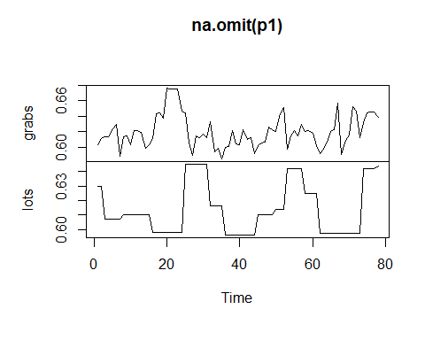
p1<-lotsgrabs[lotsgrabs$ProcessOrderNumber=="100068306",c("grabs","lots")]
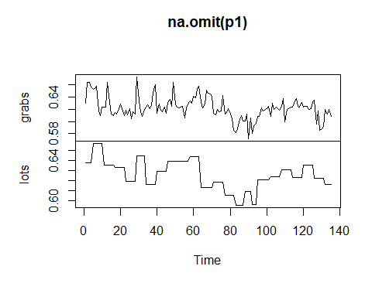
p1<-lotsgrabs[lotsgrabs$ProcessOrderNumber=="100068632",c("grabs","lots")]
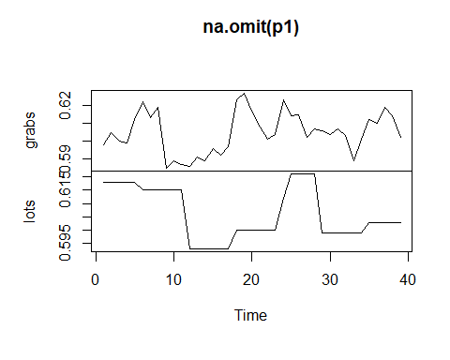
p1<-lotsgrabs[lotsgrabs$ProcessOrderNumber=="100069930",c("grabs","lots")]
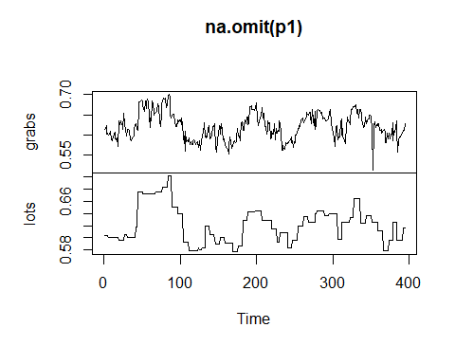
p1<-lotsgrabs[lotsgrabs$ProcessOrderNumber=="100070150",c("grabs","lots")]
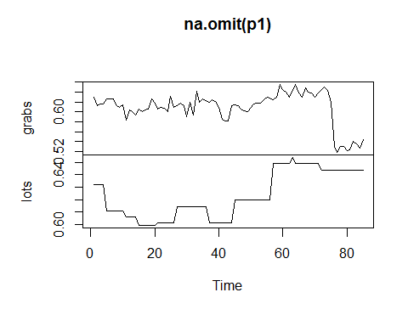
p1<-lotsgrabs[lotsgrabs$ProcessOrderNumber=="100070346",c("grabs","lots")]
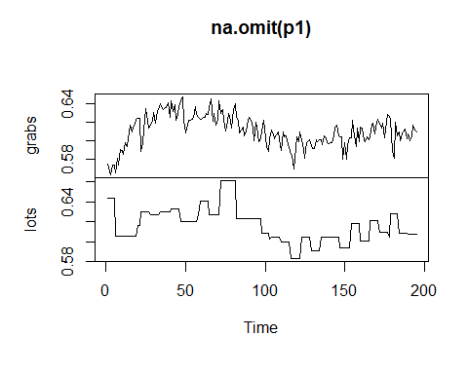
p1<-lotsgrabs[lotsgrabs$ProcessOrderNumber=="100071646",c("grabs","lots")]
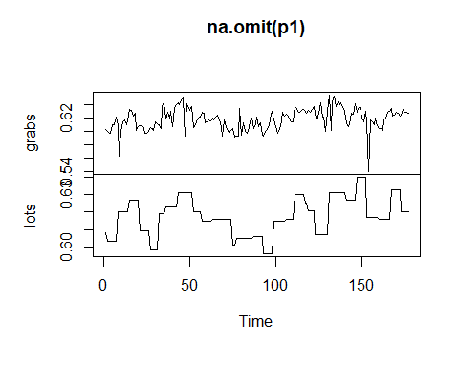
p1<-lotsgrabs[lotsgrabs$ProcessOrderNumber=="100072542",c("grabs","lots")]
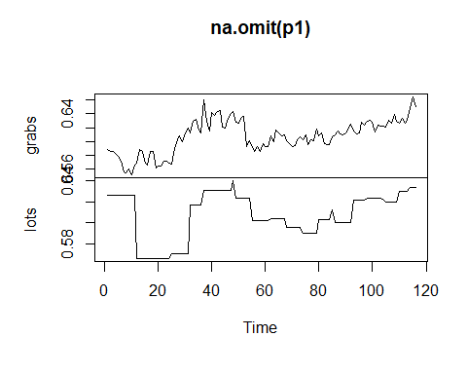
p1<-lotsgrabs[lotsgrabs$ProcessOrderNumber=="100073776",c("grabs","lots")]
