**Determining if cyberattacks can be detected and analysed by using network logs from devices**



Myron Furtado

19703402

19703402@students.lincoln.ac.uk

I want to know if DDoS attacks be detected using network log data

School of Computer Science

College of Science

University of Lincoln

Submitted in partial fulfilment of the requirements for the

Degree of BSc(Hons) Computer Science

*Supervisor:* Dr Yvonne James

April 2022

**Acknowledgements**

Firstly, I would like to thank my supervisor Yvonne James that has been there to help me with ideas when looking for the topic and then answer questions. I would also like to thank my Tutor, Dr Heriberto Cuayahuiti for doing a Microsoft team meeting with me and being supportive when I was thinking about how to approach this project.

**Abstract**

This project tries to confirm if cyberattacks such as a DDoS attack can be detected using machine learning models on network log data collected from a network-connected computer. In today’s world cyberattacks happen all too often and they cause financial and reputational damage to the target individuals/ organisations/ companies. This is a major motivator for cybersecurity personnel to work on methods to detect and mitigate the effects of Cyberattacks such as a DDoS attacks. This project explores coding a DDoS attack script in python to launch the attack, then utilises Wireshark to collect packet Network data. This data has features which can be classified by using a machine learning model. Then create a machine learning model to perform predictions on the dataset we collected from the DDoS attack. The results of this process can be used by network/system admins to help institute security measures and policies for more robust network security.

Keywords: Cyberattacks, network logs, Log file analysis, Network anomalies, NetFlow data, Machine learning Models, Classifying data, Cybercrime

**Table of Contents**

Introduction 1

1.1 Introduction to the Cyberattacks 1

1.2 Main ideas to be examined, developed and discussed 3

1.2 Aims 4

1.3 Objectives and Milestones 4

Literature Review 5

2.1 Background 5

2.2 DDoS attacks 6

2.3 New emerging technologies to combat cyberthreats 7

Methodology 10

3.1 Project Management 11

3.1.2 Gantt chart 13

3.1.3 Risk Assessment 16

3.1.4 Supervisor Meetings 20

3.1.5 Evaluation Methodologies 21

3.2 Software Development 23

3.3 Toolsets and Machine Environments 27

3.3.1 Programming Languages 27

3.3.2 IDE 29

3.3.3 Project management tools 31

3.3.4 Github 31

3.3.5 Data Collection and cleaning 32

3.3.6 Libraries Used 33

3.4 Research Methods 33

Design, Development and Evaluation 34

4.1 Software Development Projects 34

4.2 Research Projects 35

Conclusions 35

Reflective Analysis 36

References 37

Word Count 40

**List of Figure**

Figure 1- Common motivation behind Cyberattacks bar chart (Alghamdie, 2021, 4) 2

Figure 2- Basic SDN Architecture (Sahoo et al., 2019) 7

Figure 3 - Advanced ML models used for cyberattack detection (Ning and Jiang, 202, 1158) 8

Figure 4 - Five phases of Project Management (Friedman, 2020) 11

Figure 5 - Project timeline Gantt chart after completion 14

Figure 6 - SCRUM model stages (Cohen, 2022) 25

Figure 7 - Screenshot of the main branch of the artefact files on Github 31

Figure 8 - List of all the commits to the Project Github main branch 32

**List of Tables**

Table 1: The table below considers the risk involved in different Project management models Risk assessment 17

Table 2 - Table to describe the relation between software engineering frameworks and project characteristics 22

Table 3 – This table compares the Kanban and SCRUM project management models 25

Table 4 - Compare some available IDEs to measure their effictiveness 29

**Chapter 1**

# Introduction

## Introduction to the Cyberattacks

The internet is a vast space that has changed our world. It has reshaped technology, businesses, human interactions, society, and information exchange. Around 10 billion devices are connected to the internet as of recently. This however also increases the number of devices that can be at risk of being attacked and compromised. Cyberattacks can come in many forms such as Viruses, spyware, phishing attacks and so on. The attackers are after sensitive information so they can share it publicly or hold it at Ransome for financial or personal gain (Alghamdie, 2021). For companies, cyberattacks can add significantly to their operating cost by requiring additional security measures, litigation costs, fines and penalties, not to mention the loss of customers and reputation (Kamiya et al., 2021, 721). The figure below breaks from a 2012 study that breaks down the common motivation of attackers based on what they want. And the most prevalent reason, at 30% is to gain access to private/personal sensitive information.

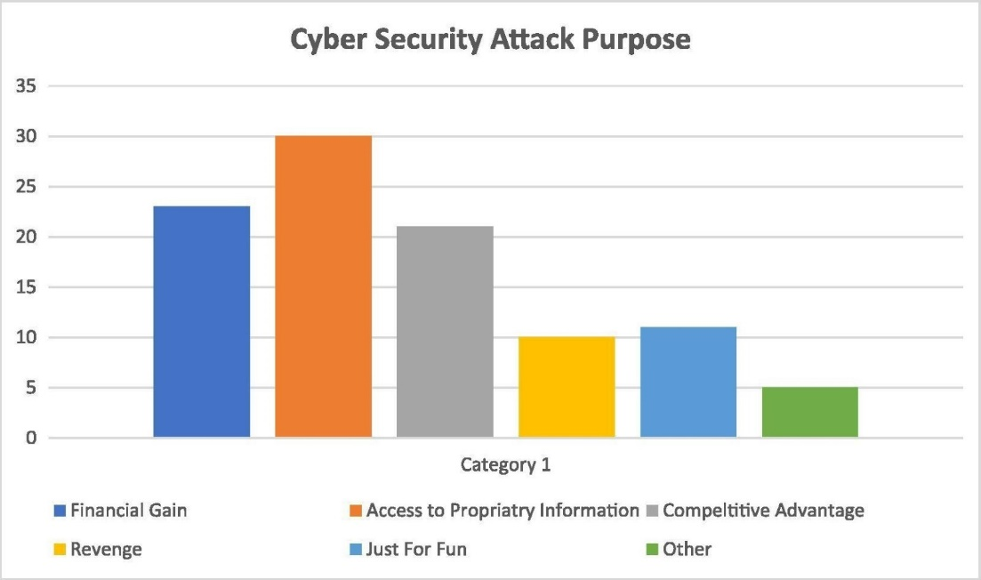

Figure 1- Common motivation behind Cyberattacks bar chart (Alghamdie, 2021, 4)

There are many types of attack vectors such as DDoS attacks, Viruses, spyware, SQL injections and so on. The attackers are after sensitive information that can either be made public or held at ransom till, they get paid to return the information (Alghamdie, 2021). For companies, cyberattacks can add significantly to their operating cost by requiring additional security measures, litigation costs, fines and penalties, not to mention the loss of customers and reputation (Kamiya et al., 2021, 721).

One method of detecting cyberattacks is to perform real-time analysis of network traffic and system files, but this is a very difficult process and cannot be relied upon a 100%. System Log analysis is another way of checking what has happened in the system as they provide concrete proof of the activities that happened in the machine. One of the newest methods of detection is the training of machine learning/deep learning models to learn and detect cyberattacks (Liu et al., 2021, 10985). To ensure that the models were making credible detections they are compared to the results of other methods of analysis (Liu et al., 2021, 10985). Deep learning and machine learning methods are far from perfect but are improving every day.

This project will try to study/analyse network log data using datasets collected by me from a Mac or Windows machine. It will contain network packet data received/sent from the machine, collected when a cyberattack was happening. This is supposed to identify abnormalities/irregularities in the network traffic data. I am confident this project will give me insights into some areas of the job role of a network engineer. As I am interested in applying for this role after completing university.

## Main ideas to be examined, developed and discussed

The main question asked in this project is if cyberattacks can be detected by performing an analysis of network data that is recorded from the concerned computer. Cyber attacks come in many forms but this project will focus only on Denial of service (DoS) and Distributed Denial of Service (DDoS) attacks as going diving into other threats will greatly increase the size of the project. This is because not every threat can be detected using the same model, each threat needs a threat specific technology to be detected. DDoS attacks are very common on corporate entities and government agencies.

The DDoS script used for this project is not very powerful but still does send quite a lot of HTTP flood traffic over to the target. This script will perform the DDoS attack on the target device. Then Wireshark is used to collect the packet data using the npcap library and displays it on the screen. Wireshark is a packet sniffer tool available on Windows and macOS, both of which have been used in some stages of the project as the target devices. Using Wireshark network data was collected. Wireshark allows the user to record many components of network traffic data. For example, the project dataset needed the source and destination port numbers in the exported file, so these had to be selected during the export process. The next step will involve creating an ipynb file, which is a python file that can be used in the Jupiter notebook environment. Then import all the libraries that are going to be used for plotting and working with the data. The project dataset then gets imported into the python file and goes through phases that include data visualization, which is the stage where the data is explained using plots and tables and then the data is pre-processed to be used in the machine learning models, which is the next step.

The data is then run through a Machine learning model. In the project, the Machine learning model that was used is called k-nearest neighbor/kNeighbors Classifier (kNN) from the sklearn library, as it can predict the dataset used with really good accuracy. In addition to this, the author also implemented 2 additional ML models, a Linear Regression (LR) model, and a Random Forests Classifier (RFC) model both from the sklearn library as well.

## 1.2 Aims

This project aims to analyse and study Network packet log data by utilising Machine learning models to do the analysing and make the decision. This will help to determine if the machine models selected can be used to detect traces of DDoS attacks from the network packet logs. The data is collected on a macOS device as the target and the DDoS attack was performed on a Windows system using a python script.

## 1.3 Objectives and Milestones

1. Conduct a thorough Literature review
2. Research how to code a DDoS script, then code it in python
3. Test the DDoS script to make sure it works
4. Research what program to use to collect the Network log data
5. Launch DDoS attacks and record the resulting log data
6. Clean the Recorded data to remove Null, None and empty values
7. Select a Machine learning model from Scikit-learn to use for analysing data
8. Code the Machine learning part of the project, which includes importing the dataset to X and Y matrices, splitting the new dataset matrix into test and train, and training the model
9. The Model should output data that need to be displayed to the user. E.g., If DDoS has been detected or not, graphs breaking down and visualising the input dataset- IP address breakdown, port breakdown and so on
10. Write up the Final report explaining the process

**Chapter 2**

# Literature Review

## 2.1 Background

Network logs can be analysed using machine learning algorithms to detect abnormalities in the log data. These models can then be used to predict cyberattacks. Bad actors can gain access to network systems through the network with the intent to cause disruption, breakdown, operational failure, and service interruptions. Studies such as (Ning and Jiang, 2021, 1154) have studied well-documented cyberattacks including Stuxnet on Siemens and Black energy that affected electrical grids in Ukraine. Both incidents caused physical and financial damage. One way to tackle this would be to use application network monitoring software but attacks on the hardware level will slip by undetected in this case, a better way to boost network security would be to study the network logs and analyse the data.

## 2.2 DDoS attacks

The internet has revolutionized the world since its inception. In their paper (Musumeci et al., 2021) say “it reshaped the technology, business communication, society, economic and many more.” They also note that it increases the level of risk for users connected to the internet. Distributed denial of service (DDoS) attacks is very dangerous for servers and systems that are connected to the internet. They explain that in a DDOS attack the attacker sends massive amounts of malicious traffic to cause the CPU or NIC (Network interface card). (Musumeci et al., 2021) notes that multiple vectors of attack can be deployed using dynamic/spoofed IP addresses to perform a combined attack and since there are massive numbers of IP addresses coming in making it is difficult to block them all by backlisting IP addresses consistently. “The most utilized DDoS attacks are typically grouped in the following categories: TCP SYN flood, UDP flood, ICMP flood and HTTP flood”. Another serious type of DDoS attack is the TCP SYN attack which is used a lot in today’s environment. This attack exploits the “TCP connections’ initiation packets to target the victim” (Musumeci et al., 2021). They discovered three ways to prevent and mitigate DDOS attacks. These are:

* Source based detection, where the incoming IP addresses are blacklisted
* Destination based detection, where the target system performs detection
* Network-based detection, where switches and routers are used to detect incoming attacks

In their paper (Musumeci et al., 2021) perform network-based detection by implementing defence mechanisms at the SDN (Software defined network) switches and block traffic at the data plane level while also saving the SDN controller from breakdown or going out of service.

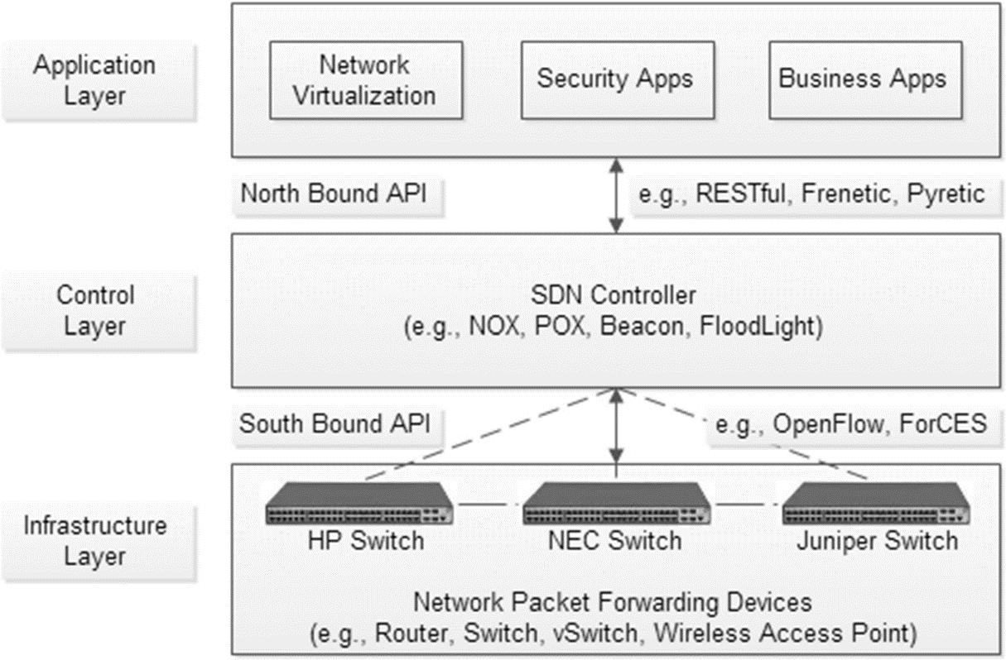

Figure 2- Basic SDN Architecture (Sahoo et al., 2019)

## 2.3 New emerging technologies to combat cyberthreats

Recent Developments: In their paper (Sahoo et al., 2019) they identified SDN (Software Defined Networks) as the new technology that many organisations need as a defence mechanism against cyber threats such as DDoS attacks. It helps solve network classification problems by using software to keep tabs on the traffic flow and root out DDoS or suspicious traffic. In my opinion, while this improves security it is not unbreakable as it is still possible to find new exploits in different layers of SDN. So, it is important to keep an eye on the logs in conjunction with SDN deployment.

The ELK stack is a package of open-source software (i.e., Elasticsearch, Logstash, and Kibana) that allows for the extraction of information for the log files and collects the required data metrics for processing (Liu et al., 2021, 10986). These provide a very concrete way of protecting potential high-risk targets like healthcare institutions. For example, healthcare devices can be vulnerable to Denial of Service (DoS) attacks due to the Software-defined Network (SDN) controller’s limitation with flow tables (Huertas et al., 2021, 2719-2720). These can be mitigated by using policy-based architecture for Multi-Access edge computing (MEC) that allows it to detect and protect against cyberattacks that exploit SDN’s weakness. This can help protect wearable health devices that are used by patients which will help save their lives and associated costs (Huertas et al., 2021, 2720). Research journals such as (Yang et al., 2019, 6344) have used log monitoring using the ELK stack to make networks safer. Collecting data for network logs and NetFlow logs using the Filebeats tool to convert the data to a visual format. Then combining that data with the NetFlow log data using the ceph file system (aka, CephFS) allowed them to compare the performance of the Reliable Autonomic Distributed Object Store (RADOS) gateway. This ensures that the people making the decisions on issues of network security have the most accurate, up-to-date, and safe information on the state of network security allowing them to make informed decisions.

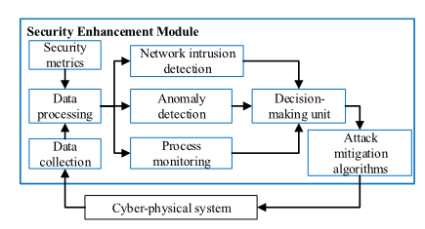

Figure 3 - Advanced ML models used for cyberattack detection (Ning and Jiang, 202, 1158)

Deep neural networks (DNNs) are Artificial intelligence models that are well known to be used for making predictions. First, DNNs are fed data (in our case network log data) and then the training data can be used on other test datasets to make predictions on the data we need to classify. DNN models do have a problem, when upper and lower neurons are fully connected the model can form a connection resulting in overfitting of the data (Vinayakumar et al., 2019).

The most cutting-edge technology being experimented on for providing a scalable cyberattack detector uses a deep neural network (DNN) as produced in the study by (R et al., 2019, 41525) the models used are flexible and effective at learning different types of unpredictable cyberattacks. The way the attacks are evolving requires a scalable fast-paced method of learning which facilitates the improvement of the algorithm which can accurately detect most of the attack types it has studied up to that point. The main advantage of using DNN is the vast number of datasets available out there that can be used to train the algorithm.

The project will need a plan to test if the analysis work can identify threats. This can be done by generating various attack scenarios to test if the systems fail to detect attempts of cyberattack. Second, it would be to test again with the highest intensity attack and lowest intensity attack to see what changes that could have (Ning and Jiang, 2021, 1156). The test results from here will be able to help give insight into what policies can be adopted to minimize and mitigate future attacks.

Another tool available for data visualization functionality that allows for tracking network traffic with more options for editing. This can then be aplite to machine learning models such as DNN. This advanced feature allows for real-time data management to interpret if a cyber-attack is taking place, if a cyberattack is happening then network administrators can be alerted to it. One downside of this is that the model can raise false positives.

Kozik developed a combo of NetFlow’s that contained a machine learning classifier, in which the Map reduce model is used. Before that Kiran and Chhabra investigated real-time classification of network data using a supervised model and achieved over 90% accuracy in correctly classifying their elephant and mice data. This model might be able to translate the accuracy of our dataset as well.

Add more images if possible

**Chapter 3**

# Methodology

Project Methodology can be defined as a set of conventions that a team working on a project agrees to follow while working on a project. In their book, they explain that project management is meant to make better use of the existing resources by making the workflow horizontal as well as vertical (Kerzner, 2003). They explain Project management is the planning, organising, directing and controlling of resources to split up the objectives and complete them as set goals/objectives. This requires the project manager, in this case, just me since it is an individual project assigning a completion date for each objective. Since this is an individual project the project management does not allow for vertical scaling (e.g., assigning more people to a team). The project can only be completed faster by utilising horizontal scaling (e.g., working on more than one objective/task at a time). This can cause difficulties during project progression since there aren’t other team members to check my progress and keep me in line making sure I am hitting my deadlines for the individual tasks. This could contribute to me losing sight of key goals and deviating from my original aims and going beyond the scope of my original project framework. This makes the Project management lifecycle (APM) necessary to increase the chance of successfully completing the project and set proper time management for it.

## 3.1 Project Management

This section will be used to discuss some of the tools and project management techniques that were available for use and discuss which ones were used or not used.

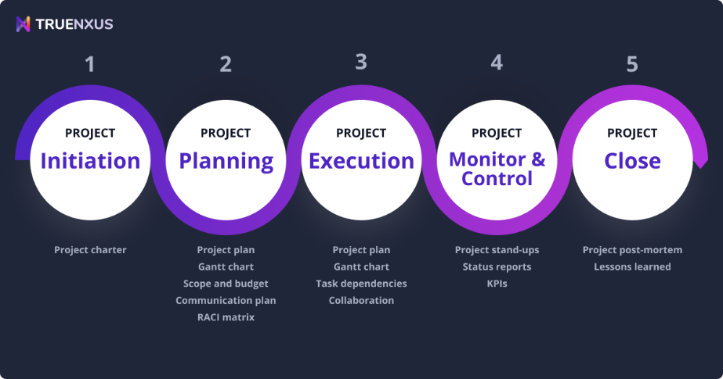

Figure  - Five phases of Project Management (Friedman, 2020)

Based on the 5 phases of the PM model the following aims were drawn up to start the project, they are listed below:

* Conduct a literature review to find learn about the subject and technologies involved
* Requirement gathering and making a list of things to set up before starting coding
* Research and code the DDoS script that will be required to collect the DDoS dataset needed for the next step
* Run the DDoS attack and collect the dataset
* Clean the dataset and export it to the required format
* Import libraries needed to perform the setup for the Machine learning environment
* Make a requirement list of what the Machine learning model should output
* Code the Machine learning model. Includes data pre-processing, training model, using the trained data on the test set, and output of the desired results on the screen
* Test the Machine learning model under different conditions
* Wire the final report and fulfil other requirements

**3.1.1 Project management principles/Project Characteristics**

This project is fundamentally not normal as normally it would be a team of people working on different tasks and then bringing it together to finish it, but here it is an individual project, it is only going to be me that manages the project all through the process.

As the sole author of the project, they also do not have much experience in both areas of the project, they will have to learn how to perform DDoS attacks, collect log data and Perform Machine learning operations. Sufficient time should be allocated to work on the Machine learning section of the artefact. Since these are relatively new topics for the user there will be a learning curve before they become proficient at programming DDoS scripts and machine learning programming.

The project also has a deadline which limits the amount of time that is available to complete the project. The author does not however have to worry about the budget of this project as most of the requirements and tools needed are either open source or available freely. The budget is therefore going to be very low or free of cost altogether.

The project overall had its major objectives all listed in the proposal but the smaller objectives were not decided on at the start. As the result of previous tasks would decide what the next task to do would be. An example of this is cleaning the DDoS dataset would require collecting the DDOS dataset first, that in turn would rely on having a DDoS script. This meant the projects had realistic and quantifiable goals but the smaller tasks to do were not clearly defined at the start.

Project scheduling was handled using a Gantt chart that had most of the main tasks that need to be carried out to complete this project and each task and section has due dates. Some of the tasks were planned and worked on in parallel to reduce the time spent on implementing the project artefact.

## 3.1.2 Gantt chart

A Gantt chart was created at the start of the project and submitted along with the Project Proposal, it contained most of the tasks that needed to be performed to complete the project and each task had a start and end date assigned to it. The chart was also separated into 3 sections based on the work that needed to be done for the 3 individual assignments that this project is comprised of and each section also had its due dates. These task entries were then updated as each task was progressed through and completed. The updated Gantt chart is shown in the figure below.

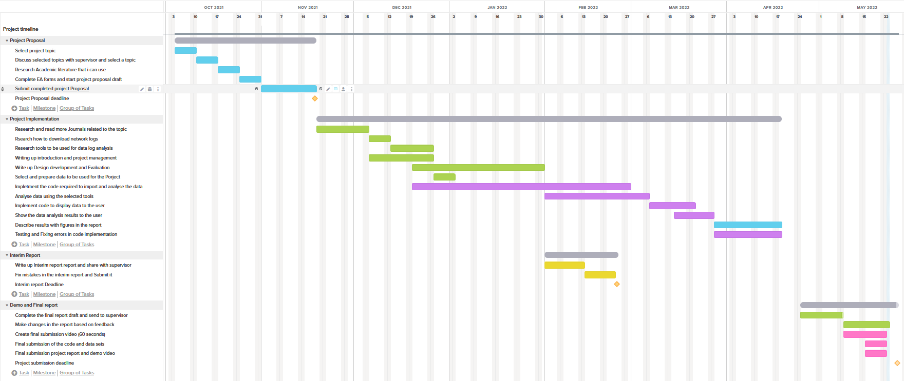

Figure - Project timeline Gantt chart after completion

The Gantt chart was created to show the time scale that the tasks were to be completed but it is not completely accurate and might be missing some of the smaller tasks undertaken to add toward the completion of the project. Some of the tasks were completed earlier than expected. For example, researching academic literature was completed a week before its due date, also writing up the Interim report was completed weeks before the deadline date. At the same time not, all task progression was properly marked and documented. For example, writing up the Introduction, Project management was supposed to be finished by end of December but was not fully completed even by the 25th of May. It was the same case with writing up the section about Design development and evaluation that was supposed to be partially completed by the end of January but was not fully completed by the 25th of May. And lastly, the task where the machine learning model had to be implemented is called “Implement the code required to import and analyse the data” so the name here does not properly explain what the task accomplishes. Also, it was supposed to be completed by the end of February but, actually was not fully completed before the 15th of May.

The advantage of utilising a Gantt chart for this project was that it displayed a detailed view of all the big tasks and most small tasks that needed to be accomplished making it very difficult to miss tasks and milestones that needed to be worked on and what each task flow looks like. Conversely, the bigger tasks encompassed smaller tasks that were combined to complete the big task this means that the big task needed further planning to show what tasks needed to be done at the lower level. For example, the biggest task “Implement the code required to import and analyse the data” which is the Machine Learning implementation included lower-level tasks such as:

1) Import the .CSV format DDoS dataset file

2) Perform data pre-processing

3) Print dataset information and useful plots that helps the user understand the dataset

4) Split the input dataset into test and train datasets required for the machine learning model

5) Implement the machine learning model

6) Train the machine learning model on the training dataset

7) Test the trained model on the test DDoS dataset

8) Display the predictions made

The smaller steps above are the breakdown of the one step shown in the Gantt chart. It was not feasible to mention all these small steps in the Gantt chart so it tends to show generic overviews in some sections.

## 3.1.3 Risk Assessment

In their paper (Lavanya N. *et al*., 2008) state that risk analysis is the process of identifying and analysing potential problems that could negatively impact the project, helping to avoid and mitigate the identified risks. It allows the team to be ready for any identified problems that might crop up and they can use the formulated strategy to deal with the problem and solve it. It is a very important part of Project management requirements

This section will look at some of the risks associated with the models that are going to be considered to be used for completing this project. As described earlier each model has its advantages and disadvantages, some of these disadvantages can give rise to risks and threats that will be explored below:

Table : The table below considers the risk involved in different Project management models Risk assessment

|  |  |  |  |
| --- | --- | --- | --- |
| Risk | Chance of occurring | Impact on the Project | Mitigation steps |
| Some of the smaller tasks required are not completed | Low | High | Regularly check the Gantt chart to check which main task is in the process of being completed and make a requirement list for the smaller tasks present in it |
| Main DDoS datasets are too complex for the machine learning model | High | Low | Consider what columns of data are relevant to getting the results that are required. Clean the data before importing it into python. Also, perform data pre-processing |
| The model chosen does not produce the result wanted | Low | High | Make changes to the model like upgrades to the steps, layers, algorithms and so on. If the model cannot be adjusted then choose a new model if time allows |
| Hardware is not robust enough to perform the machine learning processing | Low | Medium | Test the machine learning model on the system being used at home, if it falls short then use the computers in the university labs. Also, consider dropping data columns that are not as important for the ML model |
| The dataset does not have enough features for training a machine learning model | High | High | Research what features have been used to train ML models in previous studies. Use different methods to collect data, e.g., Wireshark or tcpdump |
| The model fails to address the dates for tasks completion not being met | Low | Medium | Keep a month of time buffer from the due date of the project, if any problems arise then the model can be adjusted |
| Not enough time to finish the project before the due date | Low | High | Stick to the tasks due dates specified in the Gantt chart to complete the objectives on time |
| The model does not allow for testing and fixing bugs in the ML code | Low | Medium | Create a timeslot for testing and fixing bugs in the Gantt chart. Also, contact the supervisor if any help is needed with where to find resources to fix ML code |

The risk analysis table above has brought to light some of the issues that can crop up during the duration of the process. This would allow for a predetermined plan to go into action to save time and the author would be ready if these problems came up.

## 3.1.4 Supervisor Meetings

Another valuable resource throughout the project completion process was the ability to set up a meeting with the author's project supervisor. At the start of the project for about two months these meetings happened on a bi-weekly or sometimes weekly basis. The author in these meetings could bring up and discuss the problems in the project, the progress made since the last meeting, and also list what they plan on working on until the next meeting. This also allowed for a chance to ask for feedback on any work they wanted to show the supervisor and get feedback on it, then improve or make corrections to their work. Since these meetings were done throughout the project timescale it made progressing through the project one step at a time easier and make sure they were constantly making progress and not missing most of their objectives.

After January the meetings were not done on weekly basis and it was up to the author to set up the meeting by messaging the supervisor. This allowed the author to set up meetings when they felt like they had made enough progress to share, faced a problem or wanted to get feedback on their work. This put pressure on the author to work regularly and do tasks in small chunks.

Also, the author did not have any knowledge and experience in the field of writing DDoS scripts and data collection thereafter to make up the dataset. The tips from their supervisor motivated and pointed them in the right direction at the start of the project. Also, the help they were having issues getting started on the literature review as it is a very long and daunting process. The help they got for the supervisor during the initial weekly meeting helped them in completing the Literature review for all 3 reports.

## 3.1.5 Evaluation Methodologies

Software engineering frameworks can be considered as either Heavyweight or lightweight frameworks. Heavyweight frameworks are better suited for projects that have all their requirements and objectives already listed and require more documentation for the planning process, an example of this framework is the Waterfall model. Lightweight frameworks allow for more modular iterative planning and development, the agile model is an example of this framework.

A heavyweight framework makes it next to impossible to make changes to the project plan once it starts, to make changes current plan will need to be cancelled and a new plan created. Lightweight frameworks on the other hand make it easy to make making changes in requirements or objectives easier and we can accommodate them into the model.

Based on the characteristics of this project the Methodology framework would need the following requirements:

* Flexibility
* Adaptability
* Low budget
* Scale
* Small team/Individual work
* Timely delivery

Table - Table to describe the relation between software engineering frameworks and project characteristics

|  |  |  |  |  |  |
| --- | --- | --- | --- | --- | --- |
| Model Type | | Heavyweight framework | | Lightweight framework | |
| Project characteristics | Model name | Waterfall model | Spiral model | Agile model | SCRUM (Agile) model |
| Delivery time | | On time | Early | Early | Early |
| Team size | | Large | Small | Small | Small |
| The scale of the project | | Large | Large | Large | Medium |
| Budget | | Medium | Medium | Medium | Small |
| Risks | | Low | Medium | Low | Low |
| Adaptability and Flexibility | | Low | High | High | High |
| Project requirements planning | | High | Low | Low | Low |

After comparing the frameworks above and comparing different models that use them, the author of the project chose to go with the Lightweight framework and use the SCRUM model to plan and complete this project. As it allowed them to develop the project in small steps/iterations thus providing the flexibility to make changes in the project plan when needed rather than following the project structure to the T. This was important to the author as they did not have a detailed plan on every task they were going to undertake in the project, so it is important that they can slot in new tasks and objectives as the project progressed.

## 3.2 Software Development

This section will briefly explore the Software development techniques used for this project. This is important as it provides a structured plan for the author to follow so they don’t lose their focus from the objective.

**KANBAN:**

Kanban board was a project management framework created by Toyota. (Björkholm and Björkholm, 2015) They note that the Kanban model relies on the project manager to decide the roles of the team members, this would be for the author in this project as they are the only individual working on this project. This makes the team roles and responsibilities principles of this model useless.

Another principle of Kanban is its focus on working on the first card in order. This will be beneficial to the author as it will prevent the author from working on too many tasks/objectives at the same time and becoming overburdened with work and improve the effectiveness of the author leading to speedy delivery of the artefact. Kanban board also show the overall progress of the project in an easy-to-understand format making helping the user to keep track of how much work is left.

Kanban also has a feature called Work in progress Limits that tracks how much work the team is currently working on and prevents them from taking up additional work that might overburden them making them less effective (Björkholm and Björkholm, 2015). This would also be a good feature for the author as the sole person working on the project, they could have easily been overwhelmed by the taking on too much work but setting the WIP limit to 2 tasks at a time stopped them from being overburdened.

A downside of Kanban is that they don’t have timeframes for completing the tasks this could negatively affect the author when doing coding tasks where it is important to have due data for tasks/cards as the next task depends on it, so they need to be finished on time. This could make the author run out of time before finishing the machine learning artefact.

**SCRUM**

SCRUM is another variant of Agile methodology that suits the requirements of this project. It allows the user to organise and manage their work, this is don’t by doing tasks in iterative cycles that are done over equal periods of time ( 1 month or 1 week) called sprints (Rubin, 2013). Sprints are a very important concept to understand as they will make the process of planning the project simpler. At the end of each sprint, the team is supposed to hold a meeting called “Scrums” but these are not useful for our project as it is an individual assignment. This can have a negative effect as in a team project, team members can spot problems in the planning and can point them out. But for this project (Sommerville, 2016). The author also has other commitments that mean that they are not going to make the same amount of progress in every single sprint, this means each sprint might need to be slightly adjusted in terms of how much time each sprint gets. SCRUM also tracks the workflow using a Scrum board, the same as Kanban it can be digital or physical with cards that represent the tasks to be done. Scrum also does not require an end date to be decided this can lead to the author not being able to finish the project on time, leading to failure.

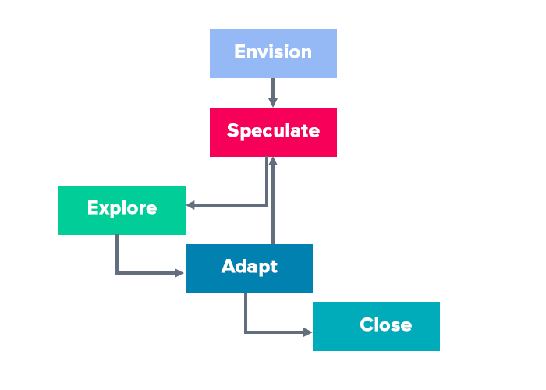

Figure - SCRUM model stages (Cohen, 2022)

**KANBAN VS SCRUM**

Table 3 – This table compares the Kanban and SCRUM project management models

|  |  |
| --- | --- |
| **Scrub** | **Kanban** |
| Does not rely on a project manager but on the team instead to manage tasks | Relies on the project manager to assign tasks |
| Has a smooth workflow that is very beneficial for software development work | Has a smooth workflow that is very beneficial for software development work |
| More flexible in the mid stages of the project as new/unforeseen requirements can be slotted in and worked on | Not as flexible as it does not allow to slot in new requirements in the middle of the project |
| Mandates need for team meetings at the end of each Sprint, but Scrum meetings are useless for this project | No requirement for team meetings but teams can choose to have them |
| Having a bigger team is beneficial, as they can also spot and point out problems in the project | More effective with a team of people with fixed roles/cards assigned |
| The project is completed in iterations of a fixed amount of time, which are called “Sprints” | The project is completed in iterations, where the cards are ordered in a list and the top cards are worked on first |
| Any of the tasks from the requirements can be worked on at any stage, with no top to bottom structure | Helps to focus by working on cards/tasks from the top card to the last card |
| No such system to prevent overburdening of team members | WIP limits prevent team members from being overburdened by working on too many cards at the same time |
| Not all sprints are going to have the same amount of work done due to other commitments the author has | Depending on the tasks being worked on, the cards decide how much need to be done |
| Has a time frame to complete each task called Sprint (e.g., 30 days, 7 days) | Does not have timeframes or due dates for each card can lead to the author running out of time |
| Very flexible and adaptable | Not as flexible and adaptable |
| No fixed end date can result in not finishing the project on time | No fixed end date can result in not finishing the project on time |

For this project, the author decided to use the SCRUM model as it would fit their loose requirement list better and changes can be made to the model structure at any time as long as it fits the timeframe of the project. Scrum was chosen over Kanban because it has the Sprints and Kanban does not have a similar system that keeps the authors focus on the objective and get them to complete the given task before the next Sprint.

It also allowed for easier shifting of priorities and the tasks being worked on making it more flexible and adaptive compared to Kanban which has a more rigid structure

## 3.3 Toolsets and Machine Environments

This section is going to explore the tools and resources used to build and deploy the DDoS attack detection machine learning artefact and the software libraries used. Also, in addition to the version control system used to store and update the artefact code.

## 3.3.1 Programming Languages

**Python**

Python is a very powerful language that supports level two access to network services and Machine learning modules and libraries. Python is also an easier language to learn for new programmers. Python can access low-level sockets from the operating system, which allows to implement network communications. It also supports high-level protocols such as FTP, and HTTP (used in the project for DDoS script) (Python - Network Programming, 2022).

Python is one of the best for Machine learning and deep learning. A lot of programmers prefer using python because it has a big selection of libraries that can perform data manipulation, it also has libraries that contain numerous ML algorithms suck as Scikit-learn (used in this project), TensorFlow and so on (Lashchuck, 2022).

**C++**

C++ is a high-level programming language that can be used to perform networking and Machine learning. C++ does allow to connect two nodes on the network by using the Socket libraries that could be used to code a DDoS script with extensive research.

It can also be used in Machine learning but is comparatively harder to get into (learning and coding proficiency) and harder to code compared to python. It does execute faster than python.

Table - Table comparing Programming languages that can be used for this project

|  |  |  |
| --- | --- | --- |
|  | Python | C++ |
| Socket support | Yes | Yes |
| Third-party library Support (including machine learning) | Yes | Partial support |
| GUI Coding Environment | Yes | Yes |
| Out plots for data visualisation | Yes, using external libraries | Yes, using external libraries |
| Language readability | Very Readable | Not very readable |
| Level | High level | High level |
| Open source | Yes | N/A |
| IDE support | Jupyter-notebook  Visual Studio Code | Visual studio 2019 |

From the comparisons above the author decide to use Python for both phases (DDoS script and Machine learning) for the project as it is easier to learn for beginners. Also, the author has previous experience in using Machine learning models inside Jupyter- notebook IDE which will make working with it a bit easier and take less time to complete the project. IT also has excellent Machine library support (e.g., Scikit-learn/sklearn) that can be used for using pre-existing ML models

## 3.3.2 IDE

Integrated Development Environment (IDE) is the software that can consolidate basic tools required to code an application and execute it. IDEs contain also contain a code editor, compiler and interpreter and debugger that can be interacted with using a Graphical user interface (GUI). There were several IDE options available for both stages of the project including Jupyter-notebook, PyCharm, Visual Studio Code, and Spyder and the table below will compare some of these listed IDEs:

Table - Compare some available IDEs to measure their effectiveness

|  |  |  |  |  |
| --- | --- | --- | --- | --- |
|  | Jupyter Notebook | PyCharm | Visual Studio code | Google Collab |
| Cost | Free | Free version available  Paid version available | Free version available | Free version available with limited capability  Paid version available |
| Open Source | Yes | Yes | Yes | No |
| Licence | Modified BSD | Apache | MIT | Google |
| Python support | Yes | Yes | Yes | Yes |
| Line numbering | Partial | Yes | Yes | Yes |
| Built-in version control (e.g., Git) | No | Yes | Yes | Partial support |
| Code auto-complete | No | Yes | Yes | Yes |
| Debugger | Yes | Yes | Yes | Partial |

Based on the comparisons above both Jupyter-notebook and Visual studio code were really good options for the author to code the artefact.

For the DDoS script, the Ide choice will be Visual studio code. The networking libraries like sockets can be imported directly. It also supports threading that allows the use of multiple threads for more requests per second when sending network traffic.

They decided Jupyter notebook would be a better option as they had previous experience working on Machine learning models using it. It also has many ML libraries which are a big part of the ML part of the artefact.

## 3.3.3 Project management tools

## Gantt Chart

A Gantt chart was created to help with project planning to complete the project successfully. It helped with balancing a large number of tasks that otherwise would have been very overwhelming (Gantt Charts: Definitions, Features, & Uses | TeamGantt, 2022). For the project, the Gantt chart was created using an online service at [www.teamgantt.com](http://www.teamgantt.com). This service was used as it was freely available and had lots of useful features such as tracking overall project progress and set start and end dates for each task.

## Testing

The testing approach used for the SCRUM model used is described below:

* A table of test cases will need to be prepared
* Test the artefact after it is deployed
* The results of the test will need to be displayed in a table

The benefit of Testing in a SCRUM model is that each deployment can be tested at deployment, alternatively, testing can also be performed at the end of each Sprint. This allows more flexibility to the author because they don’t have to wait till the artefact is finished and can perform testing as each Sprint/ task is completed. This also allows for quick feedback from the project supervisor making it easy to fix bugs as early as possible, thus saving time.

Considering the advantages listed above a lightweight Agile strategy will be used for testing in this project artefact.

## 3.3.4 Github

Git/ Github is a version control system used to periodically update or sync code. Version control can be described as a system that records changes to a code file or any file over time so it can recover previous versions of the file can be restored if required (Cachon and Straub, 2014). Version control can also be accomplished by manually making copies of the file from time to time but this can be time-consuming, a better alternative for this is Github. It treats the file data as a series of snapshots of a miniature file system (Cachon and Straub, 2014).

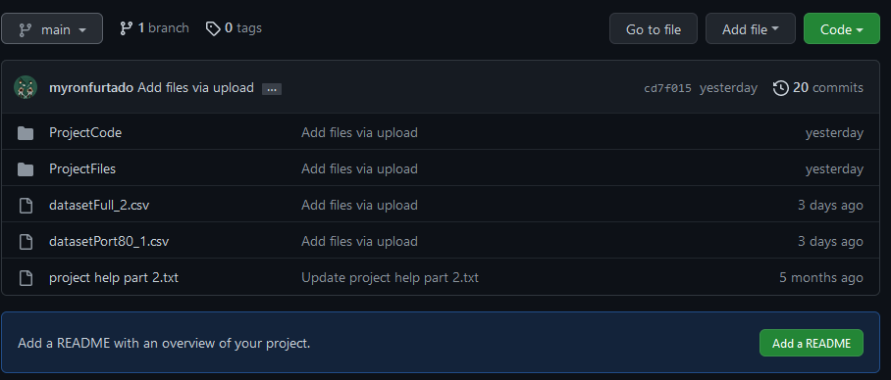

Figure 7 - Screenshot of the main branch of the artefact files on Github

Git is the best too for use in this project because it allows the author to have different branches of code so they can compare and have previous versions of the files if they need to look at them. This allows the author to work on different lines of development without having to make changes to the main branch of the code (Cachon and Straub, 2014). IT also allows the user to fetch the code directly to the IDE if it is supported and also supports local download of the development code files.

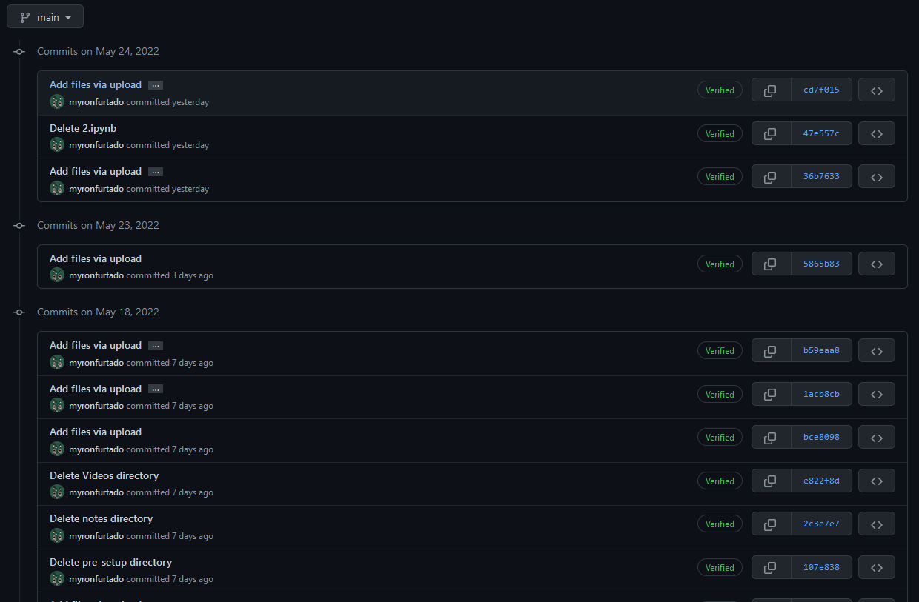

Figure - List of all the commits to the Project Github main branch

## 3.3.5 Wireshark

Wireshark is a Program available for Many types of operating systems at are used for network monitoring. It captures packets sent over the network interface card by using the npcap library. It also provides filters that can be used to sort through captured data, capture filtered data, and look at the contents of captured packets. It also allows easy export of the captured data into the CSV format making it easy to work with the dataset.

It was preferred over built-in libraries like tcpdump, which are built into the Linux system because it provides a GUI and is easy to understanding layout. It is also easier to read the data because all data packets captured are colour coded making it easier to spot erroneous or odd connections

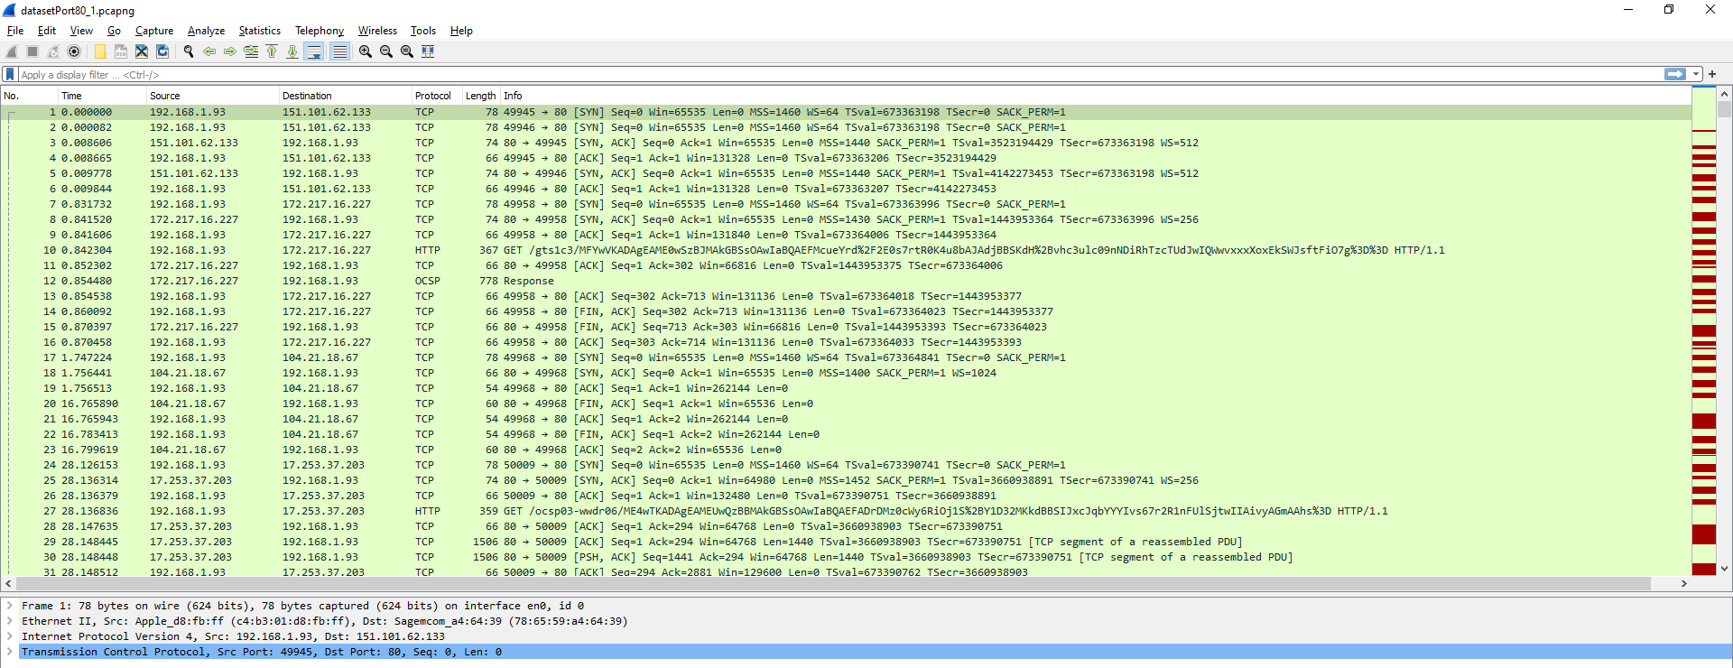

Figure 9 - Original unfiltered data captured inside of Wireshark

## 3.3.6 Microsoft Excel

Microsoft Excel was used to clean and organise the data collected from Wireshark. This was done because excel allows the user of easy filters to remove unwanted columns and rows of data. Excel is also allowed for the dataset to be transferred out as CSV format after cleaning the dataset, this format is important as it makes importing data into pandas DataFrame a breeze.

Excel also allowed the author to enter the classifier/label column easily by entering the values into hundreds of columns at the same time.

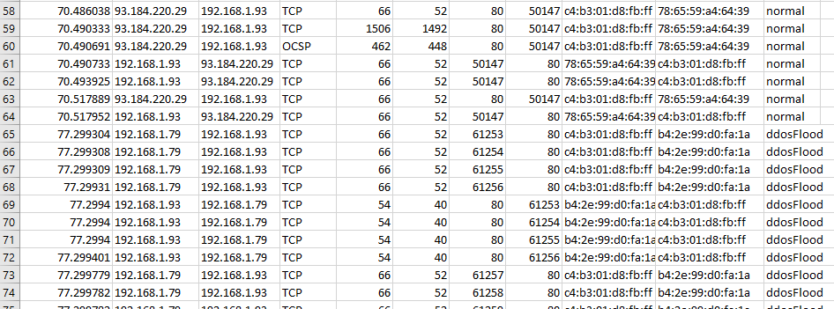

Figure 10 - Sample of the dataset showing both types of network data in excel (cleaned data)

## 3.3.7 Libraries Used

## Sockets and Threading

The sockets module is a Python library that accesses a computer's socket interface from the operating system. It can open a socket instance at the target device port that is passed to it and send HTTP requests to other devices inside the network to communicate with it.

The threading library in python allows the code to start multiple threads/executions to execute at the same time, or in the case of python appears to run at the same time, but runs very fast in a sequence (Python, 2022). This will allow the DDOs Script to open multiple connections requests at the same time instead of sending them one request at a time making the attack more lethal

## NumPy and Pandas

Both NumPy and pandas are open-source libraries that can be imported easily and used for high-performance data processing in machine learning. These are essential to perform data pre-processing on the dataset before the data can be fed into the ML model. They have really easy syntax and good performance allowing the calculations to be fast (Pandas vs NumPy - javatpoint, 2022).

## Matplotlib and Seaborn

Matplotlib is an open-source Python 2D plotting library that allows the user to plot graphs and figures based on the data that is inputted into the system. Some examples of plots it can generate include Histograms, bar plots, line graphs and so on (Matplotlib, 2022).

Same as matplotlib, seaborn is also a plotting library with similar features. One difference is that seaborn can handle pandas DataFrame better than matplotlib.

## Scikit-learn/ sklearn

Scikit-learn is another open-source machine learning library created for Python. It is similar to the very popular TensorFlow ML library, but a little less sophisticated and less advanced. It is more focused on performing predictive data analysis tasks (Scikit-learn, 2020). This library provides access to ML models such as Classifiers, regressors, and Clustering. This is very beneficial to the project as it means the author will not have to build models from scratch, a daunting task and would greatly increase the scale of the project.

## 3.4 Research Methods

Research methods are strategies or techniques that can be used in the collection of data and evidence for analysis, this allows the researcher to answer the question they proposed in their project (Booth D. *et al*., 2019). Research methods can be broken down into two categories: Qualitative and Quantitive research.

In this project the author uses Quantitative research data, this can be explained as numerical data that can be measured. In the project, Wireshark will be used to collect network traffic data that will contain two different types of data. The First will be normal traffic data and the second will be DDoS attack network traffic. This data will be used inside of machine learning models so that the model can predict and classify the data as either “normal” or “DDoS”. The results will allow us to determine if the machine learning models used can correctly classify the data or if they fail to do that, summarising the research question asked in this project.

**Chapter 4**

# Design, Development and Evaluation

3-4k words

Text

This section of the report will vary significantly in both structure and content, depending on the type of project you are undertaking. For example, a Games design project may include a Game Design Document. However, it must be noted that if your project contains significant software development work, this should be presented in the structure expected of a formal development report. If your project involves an experimental evaluation – especially if that evaluation involved human participants – you are expected to write this work up in the format expected in Section 4.2.

## 4.1 Software Development Projects

Include this section if you are undertaking a software development project. You should discuss:

1. Requirements elicitation, gathering, collection and analysis
2. Design
3. Building and programming
4. Testing
5. Operation

## 4.2 Research Projects

If your project includes primary research components it is expected that you present this work in a manner appropriate to a scientific report:

1. Participant recruitment
2. Evidence that ethical procedures have been followed
3. Study design (short summary of research methods section) – including hypotheses/research question as appropriate
4. A detailed description of the procedure
5. Results of experiment
6. Analysis of results. Consider the results of your work with respect to both your own specific hypotheses/research question and wider context identified in your literature review.

**Chapter 5**

# Conclusions

The results from this project indicate that ...

1k words

**Chapter 6**

# Reflective Analysis

The project went well ...

1k words

# References

Alghamdie, M. (2021) Cyber security attack purpose. [image] Available from https://ars.els-cdn.com/content/image/1-s2.0-S2214785321029345-gr2.jpg [Accessed 16 November 2021]. (cit. on p. 2).

Vinayakumar, R., Alazab, M., Soman, K., Poornachandran, P., Al-Nemrat, A. and Venka-traman, S. (2019). Deep Learning Approach for Intelligent Intrusion Detection System. IEEE Access, [online] 7, pp.41525-41550. Available from https://ieeexplore-ieee-org.proxy.library.lincoln.ac.uk/stamp/stamp.jsp?tp=&arnumber=8681044&tag=1 [Accessed 23 February 2022]. (cit. on p. 6).

Musumeci, F., Fidanci, A., Paolucci, F., Cugini, F. and Tornatore, M., 2021. Machine-Learning-Enabled DDoS Attacks Detection in P4 Programmable Networks. Journal of Network and Systems Management, 30(1).

Sahoo, K., 2022. A Comprehensive Tutorial on Software Defined Network: The Driving Force for the Future Internet Technology. [image] Available from https://dl-acm-org.proxy.library.lincoln.ac.uk/doi/pdf/10.1145/2979779.2983928 [Accessed 22 May 2022]. (cit. on p. 7).

Sahoo, K., Panda, S., Sahoo, S., Sahoo, B. and Dash, R., 2019. Toward secure software-defined networks against distributed denial of service attack. The Journal of Supercomputing, 75(8), pp.4829-4874.

Alghamdie, M. (2021). A novel study of preventing the cyber security threats. Materials Today: Proceedings, [online] p.1-2. Available from https://www.sciencedirect.com/science/article/pii/S2214785321029345 [Accessed 16 No-vember 2021]. (cit. on p. 6).

Huertas Celdrán, A., Karmakar, K., Gómez Mármol, F. and Varadharajan, V. (2021). De-tecting and mitigating cyberattacks using software defined networks for integrated clinical environments. Peer-to-Peer Networking and Applications, [online] 14(5), pp.2719-2734. Available from https://link-springer-com.proxy.library.lincoln.ac.uk/article/10.1007/s12083-021-01082-w [Accessed 18 November 2021].

Kamiya, S., Kang, J., Kim, J., Milidonis, A. and Stulz, R. (2021). Risk management, firm reputation, and the impact of successful cyberattacks on target firms. Journal of Financial Economics, [online] 139(3), pp.719-749. Available from https://www.sciencedirect.com/science/article/pii/S0304405X20300143 [Accessed 16 No-vember 2021].

Liu, J., Yang, C., Chan, Y., Kristiani, E. and Jiang, W. (2021). Cyberattack detection model using deep learning in a network log system with data visualization. The Journal of Super-computing, [online] 77(10), pp.10984-11003. Available from https://link-springer-com.proxy.library.lincoln.ac.uk/article/10.1007/s11227-021-03715-6 [Accessed 17 Novem-ber 2021].

Ning, X. and Jiang, J. (2021). Design, Analysis and Implementation of a Security Assess-ment/Enhancement Platform for Cyber-Physical Systems. IEEE Transactions on Industrial Informatics, [online] 18(2), pp.1154-1164. Available from https://ieeexplore-ieee-org.proxy.library.lincoln.ac.uk/document/9444805 [Accessed 18 November 2021].

Ning, X. and Jiang, J. (2021). Functional blocks in the security enhancement module.. [im-age] Available from https://ieeexplore-ieee-org.proxy.library.lincoln.ac.uk/mediastore_new/IEEE/content/media/9424/9594725/9444805/jiang4-3085543-small.gif [Accessed 18 November 2021].

R. Vinayakumar, M. Alazab, K. P. Soman, P. Poornachandran, A. Al-Nemrat and S. Ven-katraman (2019). Deep Learning Approach for Intelligent Intrusion Detection System. in IEEE Access, [online] vol. 7, pp. 41525-41550, Available from https://ieeexplore-ieee-org.proxy.library.lincoln.ac.uk/document/8681044/authors#authors [Accessed 18 November 2021].

Vaishali, V. (2021). Types of Cyber-attacks. [image] Available from https://d1m75rqqgidzqn.cloudfront.net/2019/10/26-september-cyber-security-attack-infographic-1.jpg [Accessed 18 November 2021].

Yang, C., Kristiani, E., Wang, Y., Min, G., Lai, C. and Jiang, W. (2019). On construction of a network log management system using ELK Stack with Ceph. The Journal of Supercom-puting, [online] 76(8), pp.6344-6360. Available from https://link-springer-com.proxy.library.lincoln.ac.uk/article/10.1007%2Fs11227-019-02853-2 [Accessed 18 No-vember 2021].

NeuralNine. (2019). *Code A DDOS Script In Python - NeuralNine*. [online] Available from <https://www.neuralnine.com/code-a-ddos-script-in-python/> [Accessed 21 May 2022].

CloudFlare. (2022). *What is a DDoS attack?*. [online] Available from https://www.cloudflare.com/learning/ddos/what-is-a-ddos-attack/ [Accessed 21 May 2022].

Kerzner, H. (2003_. *Project management workbook*. Hoboken, N.J.: Wiley, p.4. (cit. on p. 10).

Friedman, J., 2020. *5 Phases of Project Management*. [image] Available from https://www.truenxus.com/blog/five-phases-of-project-management [Accessed 23 May 2022]. (cit. on p. 11).

Cohen, E. (2022). The Definitive Guide to Project Management Methodologies. [Blog] *workamajig*, Available from https://www.workamajig.com/blog/project-management-methodologies [Accessed 23 May 2022].

Cohen, E., (2022). *The Definitive Guide to Project Management Methodologies*. [image] Available from https://www.workamajig.com/blog/project-management-methodologies [Accessed 23 May 2022]. (cit. on p. 11, 12).

Lavanya, N. and Malarvizhi, T. (2008). Risk Analysis And Management. [online] Pmi.org. Available from https://www.pmi.org/learning/library/risk-analysis project management-7070 [Accessed 24 May 2022]

Björkholm, T. and Björkholm, J. (2015) Kanban in 30 Days. Birmingham, UK: Impackt Publishing. Available from: https://search.ebscohostcom.proxy.library.lincoln.ac.uk/login.aspx?direct=true&db=e020mww&AN=1021979&site=e ds-live&scope=site (accessed: 25 May 2022).

Rubin, K. (2013) Essential Scrum. Upper Saddle River, NJ: Addison-Wesley.

Sommerville, I. (2016) Software engineering, 10th edition. Boston, USA: Pearson Education Limited

Tutorialspoint.com. (2022). *Python - Network Programming*. [online] Available from https://www.tutorialspoint.com/python/python_networking.htm [Accessed 25 May 2022]

Lashchuck, A. (2022). *8 Reasons Why Python is Good for Artificial Intelligence and Machine Learning*. [online] Medium. Available from https://towardsdatascience.com/8-reasons-why-python-is-good-for-artificial-intelligence-and-machine-learning-4a23f6bed2e6 [Accessed 25 May 2022]

Teamgantt.com. (2022). *Gantt Charts: Definitions, Features, & Uses | TeamGantt*. [online] Available from https://www.teamgantt.com/what-is-a-gantt-chart [Accessed 25 May 2022]

Chacon, S. and Straub, B. (2014) Pro git. Apress.

D. Booth. Libguides.newcastle.edu.au. (2019). Libguides: Research Methods: What Are Research Methods?. [online] Available from https://libguides.newcastle.edu.au/researchmethods [Accessed 25 May 2022].

Python, R. (2022). *An Intro to Threading in Python – Real Python*. [online] Realpython.com. Available from https://realpython.com/intro-to-python-threading/#what-is-a-thread [Accessed 25 May 2022]

www.javatpoint.com. (2022). *Pandas vs NumPy - javatpoint*. [online] Available from https://www.javatpoint.com/pandas-vs-numpy [Accessed 25 May 2022]

Matplotlib (2020) Matplotlib N/A: Matplotlib. Available from https://matplotlib.org/ [Accessed 25 May 2022].

Scikit-Learn.org (2020) Scikit Learn Available from https://scikit-learn.org/stable/ [Accessed 25 May 2022]

University of Lincoln (2020) Referencing Handbook: Harvard. Lincoln: University of Lincoln.

# Word Count

XXXX