Project 1 - Escape Room Robot
  - Exploration, Mapping and Key Discovery
Platform: Elephant Robotics myAGV 2023 Pi (omnidirectional) - real robot, ROS 2

Team 02
Chatziparaskeva Anastasia 1104665
Pnevmatikaki Myrsini 1101023

1. Introduction and Problem Statement

1.1 Project Overview
The objective of this project is to develop and deploy a fully autonomous robotic pipeline capable of navigating, mapping, and solving an unknown "escape room" style maze environment. Utilizing the Elephant Robotics myAGV 2023 Pi—an omnidirectional mobile robot platform equipped with a 2D LiDAR and an RGB camera—the system must explore a completely unmapped space without human intervention.
The task introduces a dynamic spatial puzzle: the environment contains restricted regions bounded by "doors," which are physically designated by 2 ArUco markers. A door is treated as a solid obstacle until the perception system discovers and localizes its corresponding "key" (represented by a separate, unique ArUco marker ID). While the logical mapping between key-door pairs is known a priori, the physical coordinates of these landmarks, doors, and maze walls must be discovered dynamically.
The mission is successfully completed when two core evaluation criteria are satisfied:
- Exploration Completion: The robot fully traverses all accessible and unlockable areas of the maze and automatically terminates execution.
- Post-Exploration Navigation: The robot leverages its self-generated map to efficiently plan and execute a path back to its starting coordinate, demonstrating the ability to reliably navigate to any arbitrary target coordinate requested during testing.

1.2 Scope of Challenges
While the high-level logic is straightforward, executing this behavior on physical hardware in real time introduces several complex sub-problems:
- Perception: Robustly detecting and computing the spatial coordinates of structural boundaries, ArUco markers and corner landmarks.
- State Estimation: Minimizing odometric drift and localizing the robot within a growing map using sensor fusion.

1.3 System Structure
To manage these challenges, the problem is decomposed into the four core pillars of a autonomy stack: Sensing, Perception, State Estimation (SLAM), Exploring and Decision Making.
To maximize computational throughput on the embedded processor, the entire pipeline is implemented as a collection of modular ROS 2 nodes executing concurrently within a singular multi-threaded executor. This architectural choice prevents critical operations-such as the Extended Kalman Filter (EKF) update loop, sensor callbacks, and path planners-from blocking one another.

2. System Architecture

2.1 Execution Model and Concurrency
The software architecture is designed as a modular, decentralized pipeline. The entire ROS 2 autonomy stack is initialized via a central entry point (main.py), which registers all sensor interfaces and core computational nodes to a single MultiThreadedExecutor.
Because the robot must react to real-time physics, managing concurrency is critical. We utilized a ReentrantCallbackGroup to allow multiple callbacks to execute in parallel. This highly concurrent design necessitated strict thread-safety measures. Without mutual exclusion (threading.Lock), severe race conditions would occur between the mapping and exploration threads. To prevent memory corruption, all shared spatial structures are guarded by dedicated locks and use copy-on-write mechanisms.

2.2 Hybrid ROS Interface and System Launch
While our custom autonomy stack is built on ROS 2 Galactic, the native hardware drivers provided for the myAGV 2023 Pi—including the chassis odometry (myagv_active) and the YDLidar (ydlidar_ros_driver)—operate on ROS 1 Noetic.
To facilitate seamless communication across this middleware boundary, we implemented a hybrid architecture using the ros1_bridge.
- The Parameter Bridge: We utilize a parameter_bridge configured via a custom bridge.yaml to explicitly map critical topics between the two environments. The bridge successfully translates hardware states to the ROS 2 layer (/scan, /odom, /imu, /tf, /tf_static) and passes motion commands back down to the ROS 1 base (/cmd_vel).
- Sequential Bring-Up: Because the bridge requires the ROS 1 master and topics to be fully initialized before mapping, starting the system concurrently would lead to orphaned topics or crashes. To solve this, the deployment relies on a custom bash script utilizing tmux to enforce a strict, sequential launch procedure. The script pauses execution at each step—verifying roscore, base odometry, and LiDAR are actively publishing—before deploying the parameter bridge and finally launching the native ROS 2 camera node (v4l2_camera).

2.3 Node Topology and Data Flow
The active components of the ROS 2 system are divided into specialized nodes communicating asynchronously:
- Sensor Abstraction Nodes: To decouple the core logic from raw hardware drivers, lightweight nodes (LidarSensor, CameraSensor, OdometrySensor) subscribe to the bridged topics and cache the latest messages.
- EKFLidarSLAM: The central state estimation authority. It consumes odometry and processed LiDAR data to maintain the robot's global pose and construct the log-odds occupancy grid.
- ArucoMonitor: The visual perception node evaluating the camera feed to detect, classify, and compute the relative poses of ArUco markers.
- RRTExplorer: The integrated mapping and control node. It actively reads the SLAM-generated occupancy grid to identify unmapped frontiers, plans paths, and generates velocity commands to drive the robot.

2.4 Distributed Visualization and Docker Integration
To preserve the Raspberry Pi's computational resources strictly for real-time autonomy tasks (SLAM, perception, and control), all graphical rendering and user monitoring are offloaded to a remote operator laptop. The robot and laptop communicate over a local Wi-Fi network using matching ROS_DOMAIN_ID configurations to isolate the ROS 2 DDS traffic.
The visualization pipeline relies on several dedicated helper scripts to bridge the raw data into standard ROS 2 monitoring tools:
- Coordinate Frame Broadcasting (TF2): The custom SLAM output is not natively tracked by the standard ROS TF tree. To resolve this, a dedicated script (slam_pose_to_tf.py) executes on the robot to continuously translate the EKF-SLAM pose output into standard tf2 transforms (bridging the map frame to base_link).
- URDF and State Publishing: On the remote laptop, the physical dimensions and visual meshes of the robot are loaded by parsing the myagv_plus.urdf.xacro file using the xacro utility. This URDF ( urdf ) is fed into the robot_state_publisher, which broadcasts the static transforms of the chassis.
- Dynamic Wheel Animation: To provide accurate visual feedback of the omnidirectional kinematics within RViz, a custom script (slam_wheel_animator.py) is run alongside the joint_state_publisher. This dynamically animates the Mecanum wheels based on the robot's physical movement.
Cross-Distribution Docker Environment A significant system integration challenge arose due to operating system constraints: the operator laptop runs natively on ROS 2 Humble, while the myAGV base is strictly bound to ROS 2 Galactic. To prevent DDS middleware incompatibilities between the two distributions, RViz2 is executed via containerization.
The operator laptop spins up an osrf/ros:galactic-desktop Docker container (Docker) utilizing the --network=host flag to capture the robot's domain traffic. To render the graphical user interface out of the container and onto the host machine, X11 server forwarding is established by mapping the .X11-unix socket (--volume /tmp/.X11-unix:/tmp/.X11-unix) and passing the host's DISPLAY environment variables into the Docker instance. Once launched, RViz2 renders the live map, ArUco spheres, and the loaded URDF model seamlessly.

3. Sensors and Preprocessing
To maintain a strict boundary between the ROS 2 middleware and our core algorithmic logic, each physical sensor is encapsulated within its own dedicated, lightweight ROS 2 node. These sensor nodes (LidarSensor, OdometrySensor, CameraSensor) subscribe to their respective topics and stash the latest messages behind thread-safe getters. This design ensures that the rest of the autonomy stack never interacts with raw ROS message types directly, making the system decoupled and allowing for isolated unit testing of the algorithmic components via sensors.

3.1 LiDAR Sensing and Scan Preprocessing
The LidarSensor reads polar coordinate arrays from the /scan topic. As implemented, this node is purposefully maintained as a thin data-ingestion layer. During the ROS callback, it dynamically constructs a synchronized angles array utilizing the message's minimum, maximum, and increment bounds. It manages initial data integrity by truncating any length mismatches between the range and angle arrays, and it rapidly masks any raw NaN or inf values, replacing them with a predefined maximum safe range (10.0 m). To ensure thread safety when concurrent nodes request the sensor data, the getter method strictly yields decoupled copies of the NumPy arrays.
Once safely ingested, the arrays are passed to the stateless ScanPreprocessor, which takes ownership of the spatial filtering. The preprocessing pipeline executes three sequential operations:
- Range Clipping: Measurements are tightly constrained to a reliable working window to filter out self-collisions with the robot chassis and exclude the 10.0 m replacement values assigned to invalid rays.
- Signal Smoothing: To prevent the corner-extraction algorithms from falsely triggering on single noisy beams, the ranges are smoothed using a small moving average kernel of size 5.
- Coordinate Transformation: The preprocessor transforms the cleaned polar scan ri,i into Cartesian coordinates xi,yi. This Cartesian matrix is the required format for both the EKF landmark extractor and the log-odds occupancy grid update.

3.2 Odometry Sensing and the Motion Model
The OdometrySensor node isolates the core autonomy stack from the complex nav_msgs/Odometry message structure. Subscribing to the /odom topic, the callback extracts the positional coordinates x,y and utilizes tf_transformations.euler_from_quaternion to collapse the 3D orientation quaternion into a single planar yaw angle (). Simultaneously, it extracts the body-frame twist velocities (vx,vy,ω). Consistent with the system's thread-safety protocols, both the pose and velocity states are stored as NumPy arrays and yielded to the requesting nodes via strict .copy() operations.
Because the myAGV utilizes a four-wheel Mecanum chassis, standard differential-drive kinematics are insufficient. The raw body velocities provided by the sensor node are passed to a custom, stateless OmniMotionModel that accurately integrates them into the world frame:
$$\left[\begin{aligned}\overset{˙}{x} \overset{˙}{y} \overset{˙}{θ}\end{aligned}\right]=\left[\begin{matrix}cosθ & -sinθ & 0 sinθ & cosθ & 0 0 & 0 & 1\end{matrix}\right]\left[\begin{aligned}v_{x} v_{y} ω\end{aligned}\right]$$

Crucially, this model also computes and returns the state transition Jacobian F with respect to the robot's pose, which is mathematically required by the EKF for the covariance prediction step.
During physical deployment, we identified a critical hardware calibration anomaly: a sign inversion between the odometry's reported yaw rate and the expected cmd_vel rotational axis. If left uncorrected, the opposing data causes the robot to spin aggressively in place as the path follower fights the odometry estimation. To resolve this handedness mismatch, a configurable yaw_sign parameter was integrated into the motion model to dynamically invert the angular velocity coordinate frame before integration.
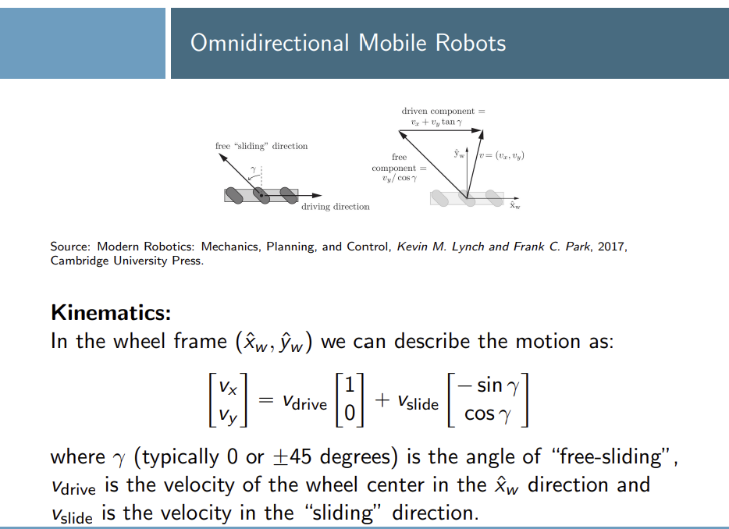

3.3 Camera Sensing and Visual Interface
The CameraSensor node serves as the dedicated visual ingestion layer, subscribing to the uncompressed /camera/image_raw topic. Upon receiving a ROS sensor_msgs/Image payload, the node utilizes the cv_bridge library to seamlessly decode the message into a standard OpenCV-compatible bgr8 NumPy matrix.
Consistent with the architecture's concurrency protocols, the getter method strictly yields decoupled .copy() instances of the most recent frame. This guarantees that downstream computer vision algorithms can aggressively process the image array without risking memory corruption from the asynchronous ROS subscriber thread continuously updating the buffer.
To ensure spatial accuracy during subsequent ArUco 3D pose estimation, the camera's intrinsic matrix (K) and distortion coefficients (D) are loaded at runtime from a localized config/camera_calibration.json file. By design, this high-bandwidth camera stream is explicitly routed only to the visual perception node (responsible for classifying semantic "doors" and "keys") and is strictly excluded from the geometric EKF-SLAM pipeline, thereby preserving critical computational bandwidth on the Raspberry Pi.

EKF-LiDAR SLAM

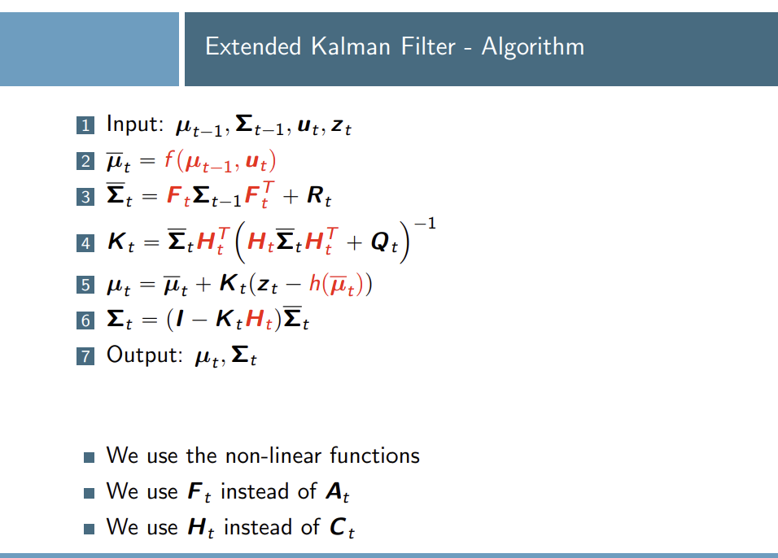
The mathematical core of the robot's spatial awareness is the EKFLidarSLAM node. It executes a landmark-based Extended Kalman Filter (EKF) utilizing geometric corners extracted from the LiDAR scan as static map features.
The system state vector at time-step k continuously expands as new landmarks are confirmed. It is defined as:
$$Xₖ = [xₖ, yₖ, θₖ, m₁,ₓ, m₁,ᵧ, …, mₙ,ₓ, mₙ,ᵧ]ᵀ$$
where xₖ, yₖ, θₖ represents the robot's pose in the global frame, and mᵢ,ₓ, mᵢ,ᵧ represents the stationary 2D Cartesian coordinates of the i-th confirmed map corner.

4.1 Kinematic Prediction
On every odometry callback (running at 20 Hz), the prediction step integrates the omnidirectional body-frame velocities (vₓ, vᵧ, ω). To preserve linearization accuracy over larger time intervals, the integration is split into sub-steps of at most 0.05 s. The covariance is propagated using the linearized error dynamics:
$$Σₖ|ₖ₋₁ = Fₖ Σₖ₋₁|ₖ₋₁ Fₖᵀ + Rₖ$$
where Rₖ is the motion noise matrix (diagonal, with σ = 0.02 m in x/y and σ = 1.5° in heading), and the state transition Jacobian Fₖ is structured so that only the top-left 3×3 robot block is updated, as stationary landmarks do not move during prediction:
$$Fₖ = \left[\begin{matrix} F_{robot} & 0₃ₓ₂ₙ \\ 0₂ₙₓ₃ & I₂ₙₓ₂ₙ\end{matrix}\right]$$

4.2 Feature Extraction via RDP and Arm Verification
Raw LiDAR scans are highly susceptible to noisy spikes that can be misclassified as corners. The feature extraction pipeline uses a robust, distance-invariant polyline method:
RDP Segmentation: The ordered LiDAR points are first clustered into continuous segments based on range gaps (gap threshold: 0.20 m). Each segment is then simplified using the iterative Ramer-Douglas-Peucker (RDP) algorithm (ε = 0.04 m). Segments with fewer than 6 points are discarded before RDP is applied. The vertices of the simplified polylines form the initial corner candidates.
Arm Length Verification: To reject noise spikes (e.g., a single errant laser return on a flat wall), the physical length of both arms extending from each candidate vertex is computed. Both arms must exceed a minimum length of 0.15 m, and the interior angle must lie within the range [85°, 95°] to be classified as a valid physical corner.
Deduplication: Observations whose projected world positions lie within 0.70 m of an already-accepted observation in the same scan are discarded.

4.3 Data Association and the Candidate Buffer
To prevent a single spurious detection from permanently polluting the state vector, unassociated observations are routed to a temporary candidate buffer.
Data Association: For each extracted corner, the predicted measurement ẑ (range and bearing) to every known landmark is computed via the observation model. The innovation ν = z − ẑ is evaluated using the Mahalanobis distance:
$D²ₘ = νᵀ S⁻¹ ν$
where
$S = H Σ Hᵀ + Q$
A match is accepted if D²ₘ < 5.99 (95% confidence interval for 2 DOF), the raw range error is < 0.5 m, and the bearing error is < 20°.
Promotion Criteria: If an observation fails the gate, it is tracked as a candidate, with its position updated as a running weighted average. A candidate is promoted to the permanent EKF state vector if it is observed ≥ 4 times, or ≥ 3 times with a spatial variance below 0.08 m. New landmarks are initialised with a position uncertainty of σ = 0.28 m per axis.

4.4 EKF Correction
For successfully associated landmarks, the state is updated using the standard EKF equations. The Kalman gain is:
$$K = Σ Hᵀ S⁻¹$$
The state and covariance are then updated as:
$$μₖ = μₖ|ₖ₋₁ + K ν$$
$$Σₖ = (I - K H) Σₖ|ₖ₋₁$$
As a safety net, the proposed correction is evaluated before being applied. If a single update would shift the robot's XY position by more than 5 cm or its heading by more than 3°, the correction is discarded entirely, as such large jumps indicate a data association failure rather than a valid state update.

4.5 Occupancy Grid Mapping and Concurrency
In parallel with the landmark filter, the node maintains a dense log-odds occupancy grid at 5 cm/cell resolution over a 30 × 30 m area. For every scan, rays are traced from the robot's cell to each LiDAR endpoint, decrementing the log-odds of intermediate cells (free space, Δ = −0.9) and incrementing the endpoint cell (occupied, Δ = +1.4), clamped to [−5.0, +10.0]. Every second ray is used to reduce computational load on the hardware.
Deploying this on physical hardware required three engineering solutions:
Thread Synchronization: The grid arrays are written by the map-update callback and read concurrently by the 2 Hz map publisher. Access is guarded by a threading.Lock() (map_lock). A dedicated _scan_lock decouples the scan stash written by the 5 Hz correction step from the map publisher, preventing the publisher from reading a partially updated scan array.
Decoupled Raycasting: Raycasting is performed inside publish_map_step() (running at 2 Hz) rather than inside correction_step(). This prevents the computationally expensive grid update from blocking the 20 Hz EKF prediction timer and starving the localization pipeline.
Rotation Freezing: Omnidirectional robots experience map smearing when pivoting in place due to timing delays between odometry and LiDAR. If the angular velocity from odometry exceeds 0.18 rad/s while linear speed remains below 0.01 m/s, all raycasting updates are suspended until the rotation completes, preserving map fidelity during turning manoeuvres.

Section 5: Perception: Keys and Doors,
The perception subsystem bridges the gap between semantic visual identification and spatial mapping. It is responsible for detecting ArUco markers, estimating their 3D poses, projecting them into the 2D global map, and managing the logical rules that dynamically update the navigation costmap.

5.1 Marker Detection and Pose Estimation
Visual processing is isolated within the ArucoMonitor node, which samples the camera frame at a throttled rate of 5 Hz (a 0.2-second timer) to conserve CPU cycles. To prevent the same camera frame from being counted multiple times toward detection confirmation, the node compares the timestamp of each incoming frame against the last processed timestamp and skips duplicates.
For each new frame, it invokes the ArucoDetector, which first converts the image to grayscale and then runs cv2.aruco.ArucoDetector using the DICT_4X4_50 dictionary and default detector parameters. Upon successful detection, the pipeline calls cv2.aruco.estimatePoseSingleMarkers to compute, for each detected marker, the rotation vector rvec and the translation vector tvec = [x_cam, y_cam, z_cam]^T relative to the camera's optical centre. A full homogeneous transformation matrix T_cm (marker frame → camera frame) is also constructed via the Rodrigues formula, though the primary localization path relies on tvec directly. In the standard OpenCV camera frame the x-axis points right, the y-axis points down, and the z-axis points forward.
Confirmation gating. To avoid acting on a single spurious detection, every marker must be detected in at least confirmation_frames consecutive unique frames (default: 3, loaded from config/key_doors.json) before it is treated as confirmed. Per-marker counts are tracked in _detection_counts; only confirmed markers proceed to localization and registry updates.

5.2 Spatial Localization (Camera to World Frame)
When a marker is confirmed, its coordinates exist strictly within the local 3D camera frame. The DoorLocalizer module is responsible for transforming this local coordinate into a stable global 2D world coordinate matching the SLAM map.
The camera is mounted with physical offsets dx = 0.13 m, dy = 0.0 m relative to the robot's base footprint. Because the OpenCV z-axis points forward and the x-axis points right, the projection onto the ground plane maps as follows:
$$x_{rob} = z_{cam}+ d_{x}$$
$$y_{rob} = -x_{cam}+ d_{y}$$
Once converted to the robot's local frame, the point is transformed into the global world frame using the current SLAM pose $(x_{r},y_{r},θ_{r})$:
$$\left[\begin{aligned}x_{w} \\ y_{w}\end{aligned}\right]=\left[\begin{aligned}x_{r} \\ y_{r}\end{aligned}\right]+\left[\begin{matrix}\cos{θ_{r}} & -sin⁡θ_{r} \\ \sin{θ_{r}} & \cos{θ_{r}}\end{matrix}\right]\left[\begin{aligned}x_{rob} \\ y_{rob}\end{aligned}\right]$$
Position averaging. Camera pose estimates jitter frame-to-frame. To prevent a door boundary from jumping around the map (and leaving stale blocked-door overlays), the DoorRegistry maintains an incremental running mean over all observations of each marker. Every new observation is blended with the prior average weighted by observation count, so the estimated world position converges smoothly without storing the full history.
These transformed global coordinates $(x_{w}, y_{w})$ are published to the /aruco/markers_viz topic as a MarkerArray — an orange sphere of diameter 0.15 m at ground level together with a white TEXT_VIEW_FACING label ("ID <n>") floating 0.3 m above it — providing live tracking in RViz.

5.3 Configuration (key_doors.json)
The key–door mapping is loaded entirely from config/key_doors.json at startup. The file specifies which pairs of ArUco IDs constitute each door, which key ID unlocks each door, and the required confirmation frame count:
{
"door_marker_pairs": [{"door_id": 1, "markers": [5, 6]}],
"key_to_door": {"10": 1},
"confirmation_frames": 3
}
This means marker IDs 5 and 6 form the boundary of Door 1, and marker ID 10 is its key. The loader validates that door IDs are unique, that no marker ID is reused across doors, that no key ID is also a door-marker ID, and that every key references a defined door.

5.4 Logical Registries and Costmap Management
Two registry classes separate the concerns of spatial bookkeeping and logical state:
- DoorRegistry (perception layer): stores the (markerA, markerB) → door_id mapping, maintains the running-mean world positions of all observed markers, computes each door's left, right, and center world coordinates once both of its markers are localized, and delegates key/door lock logic to KeyDoorRegistry.
- KeyDoorRegistry (state estimation layer): owns the key_to_door and door_to_key mappings, tracks the set of discovered keys, and exposes queries such as is_door_unlocked(door_id), get_locked_doors(), and get_unlocked_doors().
The ArucoMonitor drives four distinct actions based on what is detected each cycle:
- Door boundary found – once both markers of a door are localized and the door is not yet unlocked, explorer.block_door_in_costmap(left, right, door_id) is called. This inserts the segment between the two markers as a solid obstacle into the RRT costmap, preventing the path planner from routing through it. A _blocked flag on the door entry prevents repeated calls.
- Key found – when a confirmed marker ID matches a key in the key_to_door map, DoorRegistry.register_key() is called. On the first detection (is_new_key = True), the monitor triggers explorer.unblock_door(left, right, door_id), reclassifying that region as passable free space. It then immediately calls explorer.navigate_to_door(door_id, center) to pre-empt the current exploration goal and drive the robot toward the newly opened passage.
- Key seen before door is mapped – if a key is confirmed but neither marker of its corresponding door has been localized yet, the key is stored in key_world_positions without triggering an unblock. A second pass at the end of every detection cycle checks all known door positions and handles this deferred case: if a door is now unlocked and has not yet been unblocked, the unblock and navigation goal are issued then.
- Door seen before its key – the door is blocked in the costmap as described in (1). Once the key is subsequently confirmed, (2) or (3) above fires and opens it.

6. Exploration and Navigation
Exploration logic in this project is implemented through the RRTExplorer node, which runs two independent timers on a ReentrantCallbackGroup: a planner timer (every 3 s) that grows the RRT tree toward the nearest unmapped frontier and publishes the resulting path to RViz, and a control timer responsible for physical motion. Because reliably following RRT waypoints on the real robot proved difficult due to SLAM pose lag and odometry drift during in-place rotation, the system was split into two distinct operational configurations — two separate entry points, main.py and main2.py — each making a different trade-off between planning sophistication and motion reliability.

6.1 Map snapshot and the semantic costmap
Each planning cycle starts with get_map_snapshot(), which reads the EKF-SLAM log-odds grid and known-cell mask, thresholds them into occupied/free/unknown, and inflates obstacles by robot_radius_cells (5 cells = 0.25 m) using a circular structuring element via scipy's binary_dilation. Locked doors reported by the ArucoMonitor (block_door_in_costmap) are stored in_locked_doors as line segments and rasterized into this snapshot on every call via _rasterize_segment(), so a door blocks the planner the instant both of its markers are localized, and disappears the instant unblock_door() is called after its key is found. This costmap is rebuilt from scratch each cycle, so unlocking is immediate and leaves no stale occupied cells.

6.2 RRT Planning and Frontier Selection
build_path() grows a tree from the robot's current pose for up to 1000 iterations. With 30% probability a new sample is drawn near an already-found frontier; otherwise it is drawn uniformly in a disk of radius 1.35 m around the robot. Each candidate node is connected to its nearest existing node with a fixed step size of 0.50 m, and is kept only if both the node and the connecting edge are collision-free against the inflated costmap (point_safe / line_safe). A node is recorded as a frontier candidate if any cell in its 3×3 neighbourhood is unknown (-1) and its distance from the robot falls inside [0.75 m, 1.35 m]. Among the found frontiers, the planner does not simply pick the nearest one — it scores each by |distance − 1.0 m| plus a small heading-change penalty, preferring a short, forward-facing goal over a distant one, then re-validates the chosen frontier against a fresh map snapshot before returning the path. The resulting path is published on /exploration_path and the goal marker on /rrt_goal, making both visible in RViz as the robot moves through the room.
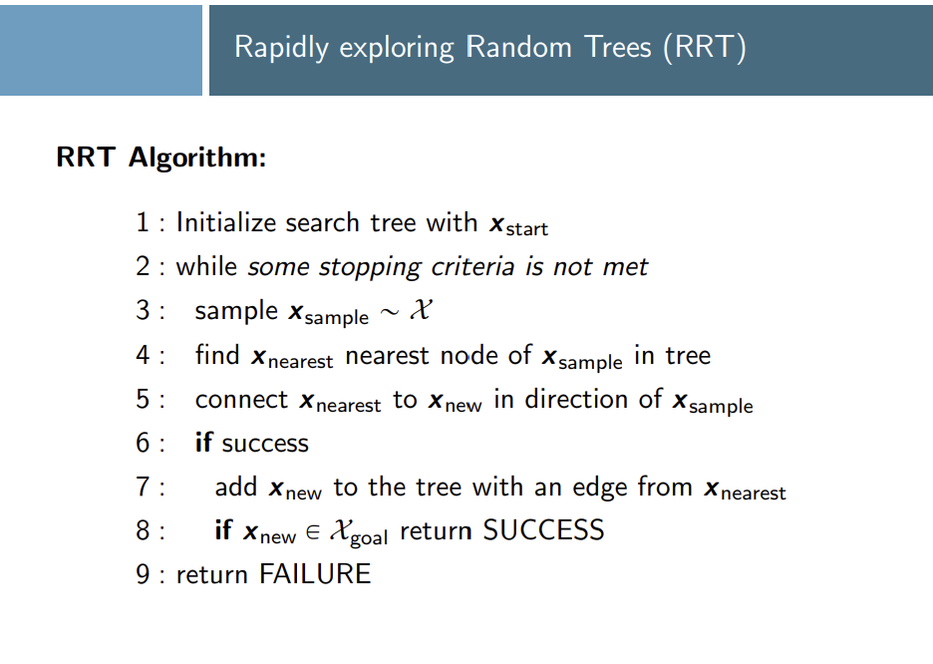

6.3 Motion Control: Two Operational Configurations
During development it became clear that connecting the RRT planner's waypoint output directly to the robot's motion controller was not yet reliable enough for a live demonstration. The two-phase follower implemented in an earlier version of the explorer — first rotating in place until aligned with the next waypoint (TURN phase), then driving straight toward it (DRIVE phase) — works correctly in isolation, but on the physical robot the combination of SLAM pose lag, wheel-slip during rotation, and the 3-second replanning interval causes the robot to overshoot waypoints and occasionally drive into walls. To keep the demonstration safe while still showing the full planning pipeline, the system was split into two configurations.
Configuration 1 — main.py (presented first). The RRT planner runs normally: every 3 seconds it takes a map snapshot, grows a tree toward the nearest frontier, and publishes the path and goal marker to RViz. Physical motion, however, is handled entirely by the SafeLidarMotion node — a dedicated reactive controller that reads seven LiDAR sectors at 10 Hz and steers the robot away from obstacles with no dependence on the SLAM pose or planned path. The path-follower and control timer inside RRTExplorer are commented out so they cannot conflict with SafeLidarMotion. The result is a robot that roams the room safely while the audience can watch the RRT tree expand toward unexplored frontiers in RViz in real time. This corresponds to the standard global-planner / local-planner separation used in production mobile-robotics stacks: the global planner (RRT) computes where to go, and the local planner (SafeLidarMotion) handles how to get there without hitting anything.
Configuration 2 — main2.py (shown as work-in-progress). This entry point uses rrt_explorer2.py, which is an earlier version of the explorer (commit 9686606) that includes the two-phase waypoint follower and drives the robot directly via /cmd_vel. No SafeLidarMotion is running; the RRT explorer is the sole source of motion commands. The semantic costmap updates from the ArUco pipeline — door blocking, key detection, unblocking, and priority navigation — are all active and affect both the planned path and the motion commands. This configuration demonstrates the intended end-to-end pipeline: plan a path to a frontier, follow it, detect a door, block it, find the key, unblock the door, and drive through. Path tracking on the physical robot remains sensitive to drift and is the primary area of ongoing improvement.

7. Evaluation and Discussion

Exploration completion. In the primary configuration (main.py), the robot explored the room continuously throughout all test runs without a single collision. The SafeLidarMotion reactive layer proved robust: even in narrow corridors and near door frames the robot detected the obstacle in time and steered clear. Simultaneously, the RRT planner correctly identified frontier cells every 3 seconds and published updated paths that visibly pushed toward unmapped areas of the room. The occupancy grid grew steadily and the SLAM landmark map remained stable — no spurious corners were inserted after the candidate-buffer gating was introduced. The robot did not terminate autonomously when all frontiers were exhausted (a termination condition tied to the live control loop was not implemented), but the RRT planner correctly returned no path once the entire reachable area was mapped, which would serve as a clean termination signal once wired to the motion layer.

Path following. In the secondary configuration (main2.py), the two-phase follower succeeded in reaching nearby waypoints in open space but struggled in two specific situations: after a long in-place rotation (where wheel-slip accumulated enough odometry error to misalign the heading estimate) and when the replanning interval produced a new path while the robot was mid-turn toward the previous one. Both failure modes resulted in the robot drifting off the planned line and, in some cases, approaching a wall before the next planner tick could issue a corrected path. These issues are well understood and fixable — tighter replanning intervals, a yaw-calibration step before each motion segment, and a local obstacle-avoidance overlay would all reduce the collision rate significantly.

ArUco perception and costmap management. Marker detection, door-boundary blocking, and key-triggered unblocking all worked correctly during testing. Once both markers of a door were confirmed, the segment between them appeared as a solid obstacle in the RRT costmap within one planning cycle, and the planner routed around it on the next tick. When the matching key marker was confirmed, the blocked segment was removed immediately and the priority navigation goal was inserted. In main2.py this correctly interrupted the current frontier path and steered the robot toward the door center. The running-average position estimation in the DoorRegistry kept marker coordinates stable even when the camera angle changed between frames.

What worked well overall. The EKF-SLAM landmark and occupancy pipeline, the full ArUco perception stack, the SafeLidarMotion reactive controller, and the RRT frontier planner all performed reliably across multiple test runs. The candidate-buffer landmark gating remained the single most impactful improvement to map quality: before it was introduced, the filter repeatedly inserted landmarks on noisy single-beam returns and the pose drifted; after it, the map stayed clean and the occupancy grid accurately reflected the geometry of the room. The main difficulty throughout was the gap between how individual components perform in isolation and how they compose on real hardware — SLAM drift, wheel-slip, LiDAR noise, and timing jitter interact in ways that are difficult to tune without extensive physical testing on the actual platform.

8. Conclusion

We built and demonstrated a working autonomy pipeline on a real omnidirectional robot: thin sensor nodes feed a scan preprocessor; an EKF estimates the robot's pose while simultaneously building a landmark map and an occupancy grid; the ArUco perception layer localizes keys and door boundaries, updates the semantic costmap the instant a key is confirmed, and redirects the robot toward the newly opened passage; and an RRT planner correctly identifies frontier cells in the growing map and computes obstacle-free paths toward them, publishing the results to RViz for live inspection.
For the live demonstration the system runs in two configurations. In the primary configuration (main.py), the RRT planner fires every 3 seconds and publishes frontier-directed paths to RViz, while physical motion is handled by the SafeLidarMotion reactive controller. SafeLidarMotion reads seven LiDAR sectors at 10 Hz and steers the robot away from obstacles with no reliance on the SLAM pose or planned path — which is precisely why it does not collide. This separation mirrors the standard global-planner / local-planner architecture: the RRT global planner decides where to explore, and the reactive local planner ensures the robot moves safely at all times. In the secondary configuration (main2.py), the earlier version of the explorer drives the robot directly by following RRT waypoints with a two-phase turn-then-drive controller, with the full semantic costmap pipeline active. This configuration shows the intended closed-loop behavior — plan, follow, detect, unlock, navigate — and represents the state of the system before the reactive motion layer was separated out. Path tracking on real hardware remains the main open problem.
The highest-value remaining work is not new algorithms but integration: once SLAM pose lag and rotational odometry drift are reduced to the point where the two-phase follower reliably reaches waypoints, the SafeLidarMotion reactive layer can be replaced by the RRT-directed follower and the two configurations can be merged into a single fully autonomous pipeline.

