
Twitter
|
Internet
|
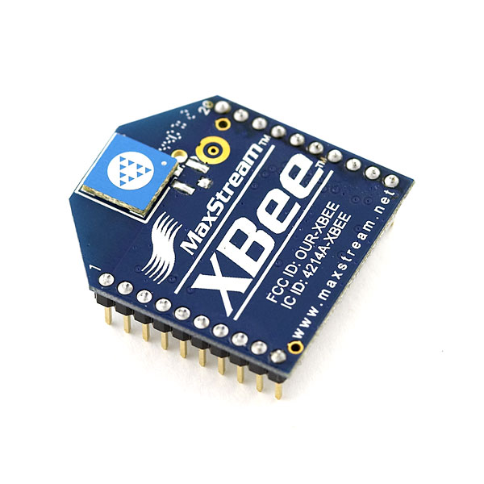
Computer
|
Radio Transmitter
|
Arduino Blimp (Radio Receiver)

