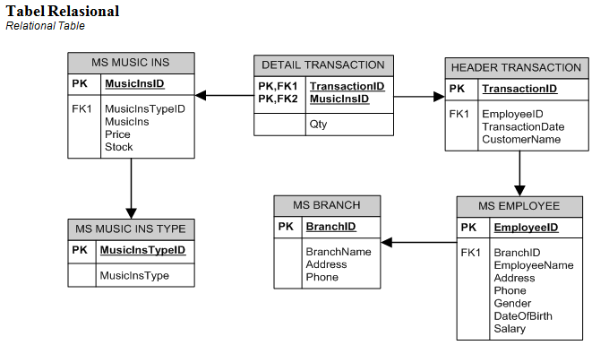

1. Displays top 2 of Employee_ID, Employee Name, Gender where Gender is 'F'

**(top, like)**

1. Show MsEmployee table where the last digit of Phone is a multiple of 5 and salary is greater than 4000000

**(right)**

1. Create a view with the name view_1 and display a table MsMusicIns where the price is between 5000000 and 10000000, with MusicIns starting with the word Yamaha. Show the view and create a syntax to delete the view

**(create view, between, like)**

1. Show BranchEmployee ( obtained from employeename and first name employeename replaced with branchID ) where employeename has at least 3 words.

**(replace, substring, charindex, like)**



1. Brand (obtained from the first word MusicIns), Price (obtained from price added the word 'Rp. ' in front of it), Stock, Instrument Type (obtained from MusicInsType) **(substring,charindex,cast)**

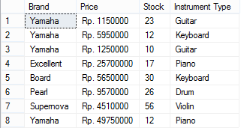

1. Display EmployeeName, Employee Gender(derived from gender), Date with format dd mm yyyy, CustomerName where Gender is 'Male' and EmployeeName has 2 or more words.

**(convert, join, like, order by)**

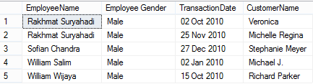

1. Display EmployeeID, EmployeeName, DateOfBirth in the format dd mm yyyy, CustomerName, Transactiondate where DateOfBirth is the month 'December' and TransactionDate is the 16th.

**(convert, join, datename, month, day)**

1. Show BranchName, EmployeeName where the transaction occurred in October and Qty is more than equal to 5.

**(exists, in, datename, month)**



1. Create a store procedure for the search function with the name search that displays EmployeeName, Address, Phone, Gender. This function will search the entire column according to the input.

**(create procedure, like)**

* search ‘lim’



* search ‘19’



* search ‘F’

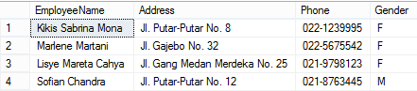

1. Create a Stored Procedure with the name "Check_Transaction" which displays the CustomerName, EmployeeName, BranchName, MusicIns, Price data based on the inputted TransactionID.

Check_Transaction'Tr001'



1. Display data that shows the details of the number of musicins transactions per employee

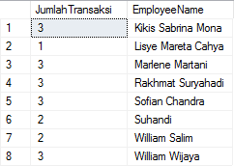

1. Create a Stored Procedure with the name "Add_Stock_MusicIns" to add stock MusicIns. If the inputted stock is less than or equal to 0, then a message will appear "Inputted stock must be greater than 0"

Add_Stock_MusicIns'MI001','0'



Add_Stock_MusicIns'MI001','2'



1. Create a Stored Procedure with the name “Check_Sale” to see what MusicInsType was sold in a certain month and the amount sold.

Check_Sale'November'

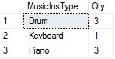

1. Create a Stored Procedure with the name "Check_Employee" which serves to provide information on employeename, address, phone, DateOfBirth, and BranchName based on TransactionID. If TransactionID is not entered, all existing employee data will be displayed.

Check_Employee

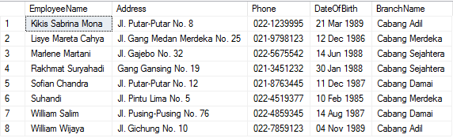

Check_Employee'Tr001'

