AtliQ Contract Risk Analyzer
Table of Contents
1. Executive Summary
2. Problem Statement and Background
3. Opportunity and AI Capability Mapping
4. Personas and User Stories
5. Model Strategy
6. Functional Requirements
7. Context and Data Pipeline
8. Non-Functional Requirements
9. Behaviour, Output Specification and Workflow
10. Guardrails and Failure Modes
11. Eval Criteria
12. North Star and Success Metrics
13. Scope and MVP Boundary
14. Rollout and Release Strategy
15. Timeline and Milestones
16. Open Questions and Assumptions Log
17. Go-to-Market and Adoption
18. Change Log

Product name | AtliQ Contract Risk Analyzer
Author | Rahul, AI Product Manager
Date | 11 Oct 2026
Version | V1.1, Draft (see Change Log)
Status | Draft for review
Reviewers | Karandeep (CEO, sponsor and primary user); Engg SME; a seller representative; Legal SME

Pain point: AtliQ receives about 9 contracts a month (3 to 4 contracts and 4 to 5 NDAs) and has no legal team. Every contract is reviewed and signed by the CEO, Karandeep, from memory, usually after BAU work, mostly late evenings, at about 3 hours per client contract and about a week in the queue. The risks that matter most sit outside the document in front of him: promises already signed to other clients, the wrong AtliQ entity or governing law, paperwork missing from a regulated deal. One contract signed in a hurry cost a $9,000 settlement, a $14,200 legal bill and two weeks of senior time (Brightwater). One nine-day wait in the queue cost a client's quarterly budget (ShopSwift).

1. Executive Summary
What are we building? | A review assistant that reads every clause of an incoming contract, checks it against a confirmed register of what AtliQ has already promised, against how AtliQ negotiated similar clauses before, and against entity, country and paperwork rules, and returns a cited review brief with a suggested next step. A person reviews, negotiates and signs. The assistant never signs, approves or sends anything.
Why does it matter? | About 9 contracts a month, each taking about 3 hours of the CEO's time and waiting about a week in the queue, reviewed from memory with no written record of past commitments. Missed context has already cost a settlement, legal fees and a lost quarter of client budget. Volume has roughly doubled in a year and the method does not scale.
Who is it for? | Primary: Karandeep, who reviews and signs. Secondary: the founders and the sales executive as delegated reviewers and the people waiting on the queue. Stakeholder, not a user: the counterparty whose deal depends on AtliQ's speed and fairness.
How will we know it worked? | Reviewer time per contract, measured in the assistant from brief opened to decision recorded, falls from about 3 hours to under 30 minutes, as long as the assistant misses zero known conflicts on the golden test set and no contract is signed under the wrong entity.
Target launch | PRD approved October 2026. Prototype built on the synthetic dataset in October 2026. Shadow pilot with Karandeep as the first and only user; its date is to be set with the team.

2. Problem Statement and Background
Karandeep, the CEO, reviews every contract AtliQ signs, by hand, from memory. AtliQ has no legal team and no written policy beyond a half-page checklist from 2024. Outside counsel is used only for the largest deals.
- Reads the whole contract on the counterparty's template, clause by clause
- Tries to remember what AtliQ has already promised other clients and partners
- Works out from experience which entity should sign and which documents the deal needs
- Negotiates from memory of old email threads, then signs and files the contract wherever he happens to be

2.1 Current State
The trigger is a contract draft arriving from a client or partner, usually on their template, by email or WhatsApp to a seller or to Karandeep.
- Step 1, receive and log: the seller checks scope against the proposal, forwards the draft to Karandeep's inbox and sometimes adds a row to the contract tracker.
- Step 2, queue: Karandeep picks the next contract when he has time, usually after BAU work, mostly late evenings. No order, owner or per-contract deadline is agreed. Sellers chase.
- Step 3, read every clause: 3 to 4 hours per client Master Services Agreement (MSA), judging each clause from memory and a 2024 checklist.
- Step 4, check past promises: he tries to remember, asks co-founders, searches email and opens old contracts one by one. There is no register of commitments.
- Step 5, entity, country and paperwork: he reads the parties clause and governing law and works out from experience which documents a regulated deal needs. Finance's entity sheet is not consulted. Usually skipped under deadline.
- Step 6, unsure clauses: ask peers, ask trusted contacts, research online, or brief outside counsel at 1,20,000 rupees and 5 to 7 working days for a large deal.
- Step 7, negotiate: redlines by email, countering from memory of what worked before.
- Step 8, sign and file: signature, sometimes from a phone at an airport; the signed copy lands in email or a laptop; nobody extracts what AtliQ just promised.

2.2 Pain Points
- A non-compete signed with Al Noor in 2025 restricts hospitality analytics across the Gulf Cooperation Council (GCC) until 18 months after the term and binds affiliates; when a Saudi hotel group (Gulf Crown) wanted to sign, nobody could recall its scope, and it took 20 minutes to find the contract during a paid counsel call.
- A most-favoured-nation (MFN) pricing clause with Crestline promises rates no less favourable than any other customer; a seller has since quoted a lower senior-engineer rate to Lakeshore without anyone checking.
- Uncapped liquidated damages (LD) under UK law were signed from an airport at quarter-end (Brightwater) with no exclusion for client-caused delay; the client's own delay became a claim.
- Client templates name the wrong AtliQ entity or a foreign law: TravelHub in Dubai put AtliQ Inc on the paper "because you're US-listed on LinkedIn"; at least one such contract has already been signed and two payment delays in 2025 came from entity mismatches.
- A US healthcare deal (Harrington) needs a non-disclosure agreement (NDA), a Health Insurance Portability and Accountability Act (HIPAA) Business Associate Agreement (BAA) and the services contract, plus matching terms for every freelancer touching patient data. Real patient data reached the Pune team before any BAA was signed, and the BAA demands $5M of cyber insurance where AtliQ holds $1M. Nobody tracks which documents a deal needs.
- Contracts labelled "mutual" are signed on sight; the client calls this a trap that "has backfired many times".
- AtliQ's own vendor template, copied from a client draft, carries 120-day pay-when-paid terms and unlimited vendor liability that AtliQ itself rejects as a supplier; a 12-person agency (Kriti) is pushing back on it now.
- Past negotiating positions live in old email threads; a one-off exception (Al Noor's 10% damages cap, approved "as a strategic exception") looks identical on paper to a deliberate policy.
- The tracker has blanks, a duplicate and stale statuses; signed files are scattered across drives, inboxes and laptops; only 17 of about 30 signed contracts could be found.

2.3 Business Impact and Why Now
Cost of the current process, from the dataset and the office hours with the client:
- About 9 documents a month (3 to 4 client contracts at about 3 hours each, 4 to 5 NDAs at about half an hour) is roughly 13 hours a month of the CEO's time on reading, most of it late in the evening.
- About a week in the queue per contract, longer when several arrive together. ShopSwift's statement of work (SOW) sat 9 days and the client's budget moved a quarter.
- Brightwater: a $9,000 settlement, a $14,200 legal bill and about two weeks of senior time, on a $92,000 contract.
- Outside counsel: 1,20,000 rupees and 5 to 7 working days for one review (Gulf Crown and Al Noor). Annual counsel spend is to be shared by the client.
- The exposure nobody can size: commitments signed in 2024 and 2025 that still bind and are listed nowhere.
Why now: volume has roughly doubled in a year (from about 5 a month last year to about 9 now: 3 to 4 contracts plus 4 to 5 NDAs) with one signer. Gulf Crown must be signed by 10 October against a restriction nobody could find. Language models can now read clauses in any wording and compare them with other documents, which is the part a rules engine could never do. The client has asked for an in-house build and has allowed synthetic data for testing. A fully synthetic dataset of 17 signed and 15 incoming contracts exists to build and test against.

2.4 Job To Be Done Framing
Job to be done | When a contract lands in my inbox,  help me see everything that could come back to bite us, in this document and in what we have already signed,  so that I can decide and sign with confidence without losing an evening or holding a deal for a week.
Trigger | A contract draft is uploaded to the assistant by a seller or by Karandeep.
Outcome | A complete, cited review brief within 5 minutes of upload; the reviewer reaches a decision in under 30 minutes of their own time, against about 3 hours today.
Why AI is justified | Every contract arrives on a different template, so the clauses that matter are worded differently every time; finding and judging them is pattern-shaped work that keyword rules miss. Comparing a new clause with a promise made in another document two years ago needs reading comprehension, not lookup. The status quo costs about 13 CEO hours a month and has already produced a settlement and a lost client quarter. Where a rule will do (entity to law, documents per deal type) this PRD uses a rule and not a model.

3. Opportunity and AI Capability Mapping
Each opportunity below is mapped to a specific AI capability, not a model name, so the build reflects what the system actually needs to do.
Opportunity | AI capability used
Find every clause that matters in a contract on any template, however it is worded, and label its type (delay penalty, liability, indemnity, payment, governing law, intellectual property (IP), termination, non-compete, exclusivity, pricing promise, insurance) | Extraction and Classification
Restate each clause in one plain-English line and give it a verdict: fine, needs attention, conflict | Summarisation and Classification
Read every signed contract once and extract each binding promise into a register with type, scope, region, sector, entity, expiry and the quoted clause | Extraction into Structured output
For an incoming deal, find the register entries that could touch it and explain the collision in plain language | Retrieval over the register plus Reasoning (Structured matching)
For a clause needing attention, find what AtliQ asked for, conceded or walked away from on similar clauses before | Retrieval (RAG) over negotiation history
Decide which AtliQ entity should sign, whether the governing law and courts fit, and which documents the client's country and data type require | Rules engine, no AI; the AI only extracts the facts the rules need
Check whether a clause labelled "mutual" binds both sides equally, including on AtliQ's own paper | Classification
Suggest a next step for the whole contract: sign, negotiate (with the clauses to push on), or escalate to counsel, and assemble the escalation package | Structured output and Summarisation
After signature, extract the new commitments and their expiry dates into the register | Extraction into Structured output

4. Personas and User Stories

4.1 User Personas
Persona | Description
Primary: Karandeep, CEO | The only person who reviews and signs. Reviews late in the evening, sometimes from a phone. Holds AtliQ's entire contract knowledge in memory.  Goal: sign safely and quickly, protect AtliQ from commitments it cannot keep, keep deals moving.  Frustration: "When I'm rushed I sign things I would never have agreed to on a normal day. This doesn't scale and it isn't safe."
Secondary: the sellers (the founders and the sales executive), delegated reviewers | Bring contracts in, wait on the queue, and can be assigned as primary or secondary reviewer by Karandeep. Check scope against the proposal and assume the legal parts are read by someone else.  Goal: close on the client's timeline and know where the contract is.  Frustration: delay; "we lost that one to our own queue".
Stakeholder, not a user: the counterparty | The client, partner, agency or freelancer who sent the draft and is waiting. Not a user of the system (confirmed in the office hours). Their experience of AtliQ's speed and fairness shapes the success metrics and the mutuality check.  Goal: sign inside their own budget or launch window and be treated fairly.  Frustration: waiting weeks; one-sided clauses on AtliQ's paper.
Stakeholder, not a user: outside counsel | Mehta Rao & Associates (India) and Calloway Stern LLP (US). Receive the escalation package. Not a user; a cost line that the product should reduce and never pretend to replace.

4.2 User Stories
As a... | I want to... | So that... | Acceptance criteria
Karandeep | Upload a contract and get a clause-by-clause brief with a verdict and a quoted reason for each clause | I can read 40 clauses in minutes instead of 20 pages in 3 hours | Given an uploaded contract of up to 30 pages, when the review runs, then within 5 minutes every clause appears with a type, a verdict (fine, needs attention, conflict) and the quoted text it is based on, and nothing is marked "fine" silently.
Karandeep | See every existing commitment the new deal could breach before I read it | I never again sign against a restriction I forgot | Given a confirmed register containing the Al Noor non-compete, when the Gulf Crown draft is reviewed, then the brief lists the conflict with the register entry, the quoted clause, the file name and the expiry date, and the suggested next step is "escalate".
Karandeep | Be told clearly when no conflict was found, and against how many commitments | I know what was checked rather than assuming | Given a draft with no overlap with any register entry, when the review runs, then the brief states "no conflicts found against the N commitments on the register" with N shown, and never states that the contract is "safe".
Karandeep | See what AtliQ did on a similar clause before, with the deal named | I negotiate consistently instead of from memory | Given a draft with an uncapped delay-penalty clause, when the review runs, then the brief shows the matching past positions (for example Acme 2025: 0.5% per week, capped at 5% of the milestone fee, client-caused delay excluded) marked as history, not policy.
Karandeep | Override any verdict or suggested next step with a reason | The decision stays mine and the record shows it | Given a brief with a suggested next step, when I choose a different step, then the system records my choice, my reason and the timestamp, and the original suggestion is kept in the audit log.
Seller (founder) | Upload the draft myself and see where it is in the queue | I can give the client a date without chasing Karandeep | Given I upload a draft, when the upload completes, then a tracker row is created with counterparty, document type, entity guess, dates and value, the review starts, and I can see its status and assigned reviewer.
Karandeep | Be told when the document could not be read properly | I do not trust a brief built on garbled text | Given a scanned contract with character-recognition errors, when extraction confidence is low, then the brief says which pages were unreadable and marks the review as incomplete instead of guessing.
Karandeep | Have the register updated after every signature | The register never goes stale | Given I mark a contract as signed, when the extraction runs, then new commitments with their expiry dates appear in the register as "unconfirmed" until I confirm each one.
Karandeep | Get a full audit log of every brief, verdict, override and register change | I can show counsel or a client exactly what was checked and when | Given any review or register event, when it occurs, then it is logged with timestamp, user, input document version and outcome, and no event is dropped.

5. Model Strategy
Choosing the underlying model and build approach is an engineering decision, made jointly with the product team rather than by the product team alone. This PRD does not fix the model. The prototype was built on Claude Sonnet 5 after a comparison with a more capable model on the golden set (section 18); the final choice is confirmed with the dev team at the prototype review, against the requirements below.
What product owns:
- Context requirements: every review assembles its context fresh per contract: the contract text, the confirmed register, the negotiation history, the entity and rules tables. No static prompt with baked-in facts.
- Grounding: every finding must quote the clause or register entry it rests on. A finding with no supporting text is marked "not found" at low confidence; a quote that does not match the source is shown as unverified. Nothing is dropped silently.
- Approval gates: no action beyond producing the brief. Signing, sending and register confirmation are human actions in the interface.
- Audit logging: every brief, verdict, override and register change is logged and retained (section 8).
- Human-in-the-loop controls: a named reviewer per contract; sampling of "fine" clauses; overrides recorded with a reason.
- Confidentiality:
- a. Names of individuals, contact details, bank details and identity numbers are masked before any model call.
- b. Counterparty names are replaced by consistent pseudonyms so register matching still works; the pseudonym map stays inside AtliQ.
- c. The model provider's terms must exclude training on AtliQ data and retention of inputs.
- d. Data residency is not a client requirement.
- Cost and latency ceilings:
- a. Brief within 5 minutes of upload at the 95th percentile.
- b. Model cost no more than $1.00 per review and $50 per month at today's volume.
- c. Measured on the prototype: $0.09 to $0.19 per review (average $0.16) on the model that passed all 8 golden scenarios, 41 seconds to under 2 minutes per review.
- d. The ceiling leaves room for a longer contract or a price change.
- Language: English only for V1.
What engineering decides, with product: the model or models, whether precedent retrieval uses a vector index or a full-text pass over the negotiation notes (the notes are about 1,100 words today, so a full pass is acceptable for V1), chunking of long contracts, and the hosting approach. Decision needed by the prototype review.

6. Functional Requirements
ID | Requirement | Priority | Story
FR-1 | The system accepts an uploaded contract as PDF, Word or text and extracts its text, reporting pages where extraction confidence is low. | Must | Unreadable document
FR-2 | The system creates a tracker row on upload with counterparty, document type, AtliQ entity guess, received date, deadline from the user, and value, and shows the review status and assigned reviewer. | Must | Seller upload
FR-3 | The system identifies every clause in the contract, labels its type, and restates it in one plain-English line. | Must | Clause brief
FR-4 | The system gives every clause a verdict of fine, needs attention or conflict, with the quoted text the verdict rests on. | Must | Clause brief
FR-5 | The system maintains an obligations register extracted from signed contracts, each entry holding type, scope, region, sector, entity, expiry, quoted clause and source file, with a confirmed or unconfirmed status. | Must | Register conflict
FR-6 | The system checks each incoming contract against confirmed register entries and reports each potential conflict with the entry, the quoted clauses on both sides and the expiry, or reports "no conflicts found against N commitments". | Must | Register conflict; No conflict found
FR-7 | The system extracts the parties, AtliQ entity, counterparty country, governing law, courts, currency, data types and insurance figures from the contract. | Must | Clause brief
FR-8 | The system applies the entity and country rules table to report whether the signing entity, law and courts line up, which documents the deal type and region require, which are missing, and any numeric gap such as insurance cover. | Must | Register conflict
FR-9 | The system flags "regulated region or data type: confirm with counsel" whenever the rules table marks the region or data type as regulated, and never states that a contract complies with a law. | Must | Clause brief
FR-10 | For each clause marked needs attention or conflict, the system shows AtliQ's past positions on similar clauses from the negotiation history, labelled as history with the deal named, and shows the notes in full when no close match is found. | Should | Precedent
FR-11 | The system suggests one next step for the contract, sign, negotiate or escalate, with the clauses to push on, and assembles the escalation package (brief plus the relevant source documents) when escalate is suggested. | Must | Override
FR-12 | The system lets the assigned reviewer override any verdict or the suggested next step, requires a reason, and keeps both the original and the override in the audit log. | Must | Override
FR-13 | The system marks a random sample of clauses rated fine for human spot-check at a configurable rate, defaulting to 1 in 2 during the pilot and 1 in 5 after. | Should | Clause brief
FR-14 | On a contract being marked signed, the system extracts new commitments with expiry dates into the register as unconfirmed entries for the reviewer to confirm. | Must | Register update
FR-15 | The system labels every brief "AI-generated draft review. Not legal advice. A person decides." and never outputs the words "safe to sign". | Must | No conflict found
FR-16 | The system logs every review, verdict, override, register change and escalation with timestamp, user, document version and outcome. | Must | Audit
FR-17 | The system applies role-based access: Karandeep as super-admin sees everything; sellers see contracts they uploaded or are assigned to; nobody else has access. | Must | Audit
FR-18 | The system drafts counter-proposal wording from precedent for a clause marked needs attention. | Won't | Deferred, section 13.2

7. Context and Data Pipeline
Context is the product. What goes in, and what stays out, defines what the AI can and cannot do.

7.1 What Goes In
Input | Source and notes
The incoming contract text | Uploaded by the seller or Karandeep. Required. Full text, typically 10 to 15 pages and up to about 30; longer documents are split by engineering's chunking approach.
Obligations register | Built once from the 17 signed contracts in the dataset (about 30 in reality), confirmed entry by entry by Karandeep, then updated after every signature. Owner: Karandeep. Only confirmed entries are used for conflict checks.
Negotiation history | negotiation_notes.md, the sales executive's reconstruction of past redlines, about 1,100 words, incomplete and unreviewed. Used for precedent only, labelled as history. Owner: the sales executive until reviewed.
Entity fact sheet | atliq_entities.md from finance: two entities, regions served, currencies. Owner: finance. Reviewed when an entity changes.
Country and rules table | Maintained by the PM with counsel's input: for each region AtliQ serves (India, US, UK and EU, GCC), the governing-law expectation, courts, regulated data types, and the documents required per deal type (for example US healthcare: NDA, BAA, services contract, matching subcontractor terms). Editable, versioned.
Karandeep's checklist | The 2024 checklist as the seed of what "needs attention" means (penalty caps, liability at one times fees, mutual indemnity, payment days, governing law, IP, termination, mutual confidentiality). Used as a prompt reference, not as hard thresholds.
Contract tracker | contract_tracker.csv for deadlines, values and status; imported, with blanks tolerated and flagged.
Reviewer overrides | Logged overrides with reasons, used to show the reviewer their own past decisions. Not used to retrain anything in V1.

7.2 Deliberately Excluded From Context
Every attribute excluded here is an attribute the AI cannot act on, intentionally or not. This is the first line of bias and privacy defence.
Excluded attribute | Reason for exclusion
Personal data of individuals (names of signatories and contacts, phone numbers, personal email addresses, home addresses, bank details, identity and tax numbers) | Not needed to judge a clause. Masked before any model call on real contracts. Party names are replaced by consistent pseudonyms so register matching still works.
Outside counsel's written advice | Privileged, and the assistant must not restate legal advice as its own finding. Counsel's advice is read by people, not by the model.
Email, WhatsApp and call content | Out of scope for V1; commitments made on calls are a roadmap item. The assistant judges only what is in the uploaded documents.
Employee and HR contracts | Handled by HR, outside Karandeep's scope per the office hours. Never loaded.
The model provider's general knowledge of law as a source of findings | The assistant may use the rules table and the documents; it may not assert what the law of a country requires. Any regulatory point is a flag to confirm with counsel.

7.3 Data Readiness
Naming the inputs is not the same as having them ready. Each input below is assessed against five readiness questions (complete, current, accessible, compliant, operable), with the counts measured on the capstone dataset. A gap here is a gap in what the assistant can see, so the shadow pilot starts by closing the first two rows, not by tuning the model.
Input | Complete? | Current? | Accessible? | Compliant? | Operable? | Readiness verdict and action
Signed contracts (source of the register) | No. The tracker records 30 signed contracts; 17 have been collected as text, so the register covers 17 of 30 (57%). One of the 17 is a scanned file with text-recognition (OCR) errors. | Partly. 4 of the 30 signed contracts have passed their expiry date; the register carries expiry so the rules can discount them, but only for the 17 collected. | Partly. The 17 were gathered from drives, inboxes and laptops; 11 of 48 tracker rows have no file location at all. | Yes for internal use. Client confidential terms stay inside AtliQ; names and identifiers are masked before any model call on real contracts. | Not yet. Nobody owns adding a new signature to the register. | Not ready for production, ready for the pilot. Karandeep confirms the 56 register entries, extracted from the 17 contracts, in the register session; the 13 missing contracts are found or declared lost before the closed beta; Karandeep is the named owner for adding each new signature within one week of signing.
Contract tracker | No. 48 rows: 18 blank values, 3 blank AtliQ entity, 11 blank file locations, 1 duplicate row, 2 blank statuses. The restrictive_clauses column, which is meant to record non-competes and exclusivity, is filled on 4 rows. | No. Statuses are updated occasionally; several are stale. | Yes. One shared spreadsheet. | Yes. No personal data beyond AtliQ staff first names. | Weak. Everyone updates it, so nobody does. | Use for deadlines and values only, with blanks flagged in the brief. Never trust the notes column for scope: the BlueOrchid note ("just India hotels I think") is contradicted by the contract's own Annexure B, which lists Dubai and Muscat properties. Clean fields are not the same as correct facts.
Incoming drafts | Yes for the pilot: 15 drafts, all as text. In production, drafts arrive as PDF, Word and scans, so text extraction is an engineering step with its own failure mode (see behaviour state "unreadable document"). | Yes. Each draft is dated on receipt. | Yes once uploaded. | Yes, with masking. | Yes. The seller uploads; the flow is defined in section 9.3. | Ready.
Negotiation history | No. The sales executive's reconstruction covers 2024 to 2026 from old inboxes, about 1,100 words, and records what happened, not whether it was right. | Partly. Stops at the last inbox search. | Yes. One file. | Yes. | Weak. Unreviewed and unowned. | Use as history only, labelled as such. Never as policy or threshold. The sales executive reviews it before the closed beta; counsel is not asked to bless it.
Entity fact sheet and rules table | Yes. Two entities, four regions, documents per deal type. | Yes at PRD date. Laws and entity registrations change. | Yes. | Yes. | Yes. PM owns the table; finance owns the fact sheet; counsel reviews the regulated-data rows. | Ready. Reviewed whenever an entity, region or deal type is added.
Meeting notes and call commitments | No. Four meeting notes exist; commitments made on calls and WhatsApp are not captured anywhere. | No. | Partly. | Yes. | No. | Out of scope for V1 by design (section 7.2). Logged as an open question in section 16; the shadow pilot measures how often a call commitment changes a signed term before deciding whether capture is worth building.

8. Non-Functional Requirements
This section defines how well the product should perform rather than what it should do.
Category | Requirement and target
Performance | A complete brief for a 30-page contract within 5 minutes of upload at the 95th percentile; a 10-page NDA within 2 minutes.
Reliability / uptime | 99.5% availability during Indian and US business hours; no upload or review lost or silently dropped, every failure logged and shown to the user.
Security | Role-based access control (RBAC) with Karandeep as super-admin; all contracts and briefs encrypted at rest and in transit; model provider terms exclude training on and retention of AtliQ data.
Privacy and compliance | Contracts may contain personal data subject to the General Data Protection Regulation (GDPR), India's Digital Personal Data Protection Act (DPDP) and HIPAA-governed terms; personal data masked before model calls (section 7.2). Retention: contracts, briefs and the audit log are kept for the contract term plus two years, then deleted; the client expressed no preference, and this matches the usual limitation period for contract claims. Earlier deletion on request by Karandeep.
Scalability | About 9 contracts a month today (confirmed in the office hours; the design scales to more) with seasonal peaks around quarter-end; 4 concurrent reviewers; register of up to 500 commitments without a change of approach.
Auditability | Every review, verdict, override, register change and escalation logged with timestamp, user, document version and outcome; logs readable by Karandeep and exportable for counsel.

9. Behaviour, Output Specification and Workflow
This section specifies the behaviour, not just the output: what the AI does in every state, including when it is uncertain or wrong.

9.1 Standard Output Per Review
Output field | Description
1) Header facts | Counterparty, document type, AtliQ entity named in the parties clause, counterparty country, governing law and courts, currency, value, deadline, data types involved. Example: "Gulf Crown Hotels, MSA, AtliQ Technologies Pvt Ltd, Saudi Arabia, Saudi law, US dollars (USD), $140,000, due 10 Oct 2026, guest data."
2) Register conflicts | Each potential conflict with the register entry, both quoted clauses, the source file, the expiry and a plain-English explanation; or "no conflicts found against N commitments on the register". Example: "Conflicts with Al Noor MSA s.12.1 (non-compete, GCC hospitality analytics, until 14 Sep 2029, binds affiliates)."
3) Clause table | One row per clause: type, plain-English line, verdict (fine, needs attention, conflict), quoted text, and for attention or conflict the reason and the matching past positions.
4) Entity, country and paperwork | Whether entity, law and courts line up; documents required for this deal type and region, which are present and which are missing; numeric gaps such as insurance; the "confirm with counsel" flag where the region or data type is regulated.
5) Mutuality | For each clause labelled mutual, and for all clauses on AtliQ's own paper, whether it binds both sides equally, with the one-sided clauses listed.
6) Suggested next step | One of sign, negotiate (with the clauses to push on) or escalate (with the package assembled). Marked as a suggestion.
7) What was not checked | Pages that could not be read, register status (number of confirmed entries), and any check skipped, so the reviewer knows the brief's limits.
8) Label and audit reference | "AI-generated draft review. Not legal advice. A person decides." plus the review identifier and timestamp.

9.2 Required Behaviour States
State | What triggers it | Required behaviour
High-confidence finding | A clause clearly matches a known type and a register entry or past position with a direct quote on both sides | Show the verdict with both quotes and the explanation. Route to the reviewer. Never act on it.
Low-confidence finding | The clause type is unclear, the register match is partial (for example a region or sector overlap but not both), or the quote does not fully support the verdict | Mark "needs attention, low confidence" and say why. Never upgrade to "conflict" or downgrade to "fine" silently. Ask the reviewer to decide.
Possible conflict | A register entry overlaps the deal only if a fact outside this document holds (for example whether the quoted rate is lower than Crestline's, or whether a tool built for one client is reused) | Mark "possible conflict" with both quotes and name the missing fact. The suggested next step is at least "negotiate", never "sign"; escalation is reserved for confirmed conflicts. The reviewer resolves the fact before deciding.
No conflict found | No confirmed register entry overlaps the deal | State "no conflicts found against N commitments on the register" with N. Never state the contract is "safe". If no entry is confirmed, say the conflict check could not run.
Register unconfirmed or empty | No register entry has yet been confirmed by Karandeep (first build, or every entry still unconfirmed) | Run the clause review, skip the conflict check, and show a banner that the conflict check is not available until the register is confirmed. When some entries are confirmed and others are not, the conflict check runs against the confirmed entries and the unconfirmed count is listed under "What was not checked".
Unreadable document | Extraction confidence is low on one or more pages (for example a scanned file with character-recognition errors) | List the affected pages, mark the review incomplete, and do not produce verdicts for text that could not be read.
Regulated region or data type | The rules table marks the counterparty's region or the data type (patient data, EU personal data) as regulated | Add the "confirm with counsel" flag, list the documents the table requires and which are missing. Never assert compliance.
Suggested escalation | A register conflict is found, a regulated data type is present, or liability or penalties are uncapped on a deal of $100,000 or more | Suggest "escalate", assemble the package (brief plus source documents), and leave the decision to the reviewer. Threshold set by Karandeep and editable.
Duplicate upload | A document with the same counterparty, type and near-identical text already has a review | Show the existing review and ask whether this is a new version; never create a second tracker row silently.
Model or provider outage, or timeout beyond 5 minutes | The model call fails or exceeds the latency ceiling | Show the failure, keep the upload and tracker row, allow retry, and log the failure. Never return a partial brief as if complete.
Contract longer than the supported size | More than about 30 pages | Review in parts and state in the brief that the document was split, so cross-clause checks may be weaker.

9.3 End-to-End Decision Flow
- A seller or Karandeep uploads the contract and enters the deadline and value if known. A tracker row is created.
- The system extracts the text. If any page has low extraction confidence, the review is marked incomplete and those pages are listed; the flow continues on the readable pages.
- The system checks for a duplicate. If a near-identical review exists, it shows it and asks whether this is a new version. If the user says no, the flow stops here with no new row.
- The system extracts the header facts: parties, entity, country, law, courts, currency, data types, insurance figures.
- The rules table is applied. If the entity, law or courts do not line up, or documents are missing, those findings are written to the brief. If the region or data type is regulated, the "confirm with counsel" flag is set.
- If at least one register entry is confirmed, the system matches the deal against the confirmed entries. Each potential conflict is written with both quotes; if none, "no conflicts found against N commitments"; unconfirmed entries are counted under "what was not checked". If no entry is confirmed, the conflict check is skipped and a banner says so.
- The system identifies every clause, labels its type, restates it and assigns a verdict with the quoted text. Clauses without a supporting quote are marked "not found" rather than guessed.
- For each clause marked needs attention or conflict, past positions are retrieved from the negotiation history and attached, labelled as history. If no close match exists, the notes are attached in full.
- Mutuality is checked for every clause labelled mutual and for all clauses when the document is AtliQ's own paper; one-sided clauses are marked needs attention.
- The system proposes a next step. If a register conflict, a regulated data type, or an uncapped liability or penalty on a deal of $100,000 or more is present, it suggests escalate and assembles the package. Otherwise it suggests negotiate when any clause needs attention, or sign when none does.
- A sample of clauses rated fine is marked for spot-check at the configured rate.
- The brief is labelled and routed to the assigned reviewer. No action is taken by the system.
- The reviewer reads every attention and conflict item and the sampled fine items, then confirms or overrides the next step with a reason. Both are logged.
- On negotiate, the seller and Karandeep negotiate outside the system and upload the next version, which starts at step 1 as a new version. On escalate, the package goes to counsel outside the system. On sign, Karandeep signs outside the system and marks the contract signed.
- On signed, the system extracts the new commitments with expiry dates into the register as unconfirmed. The flow ends when Karandeep confirms or rejects each entry.

9.4 Flow Diagram
Built with mermaid.ai from the decision flow in 9.3. Read top to bottom; the diagram continues over four pages.
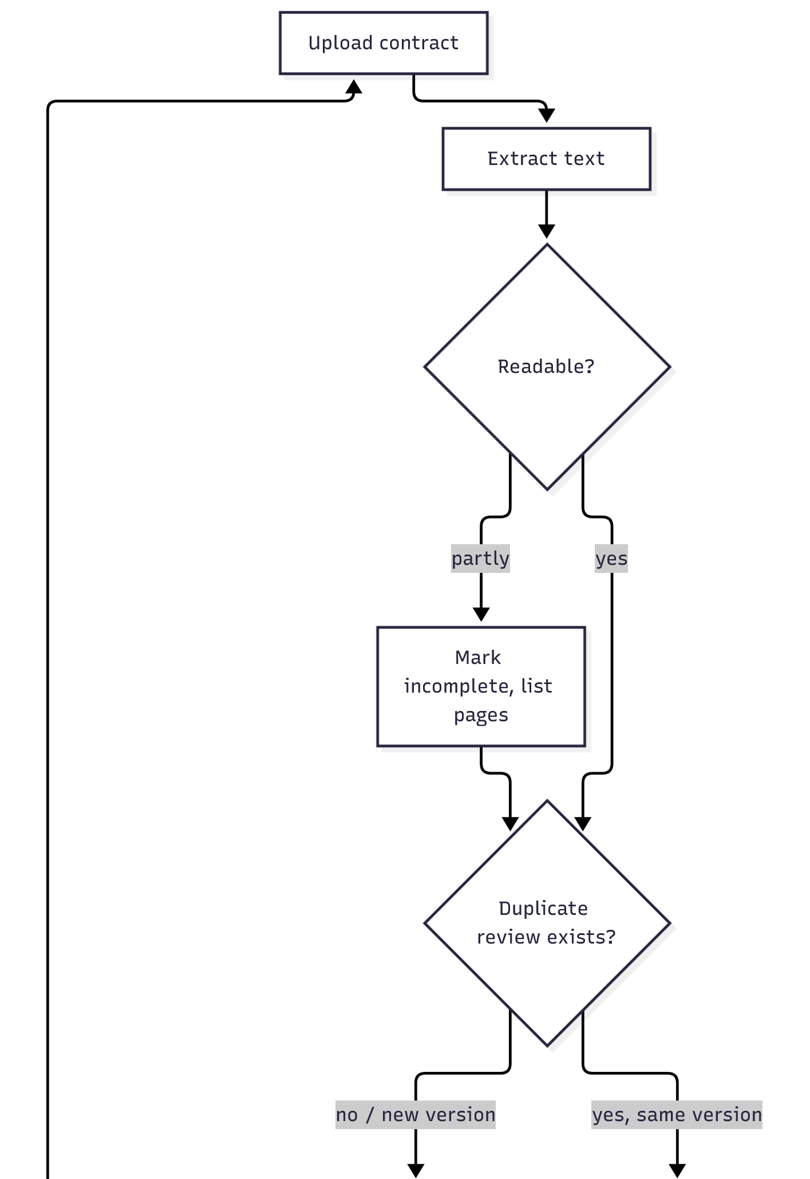
Flow diagram, part 1 of 4: upload, text extraction, duplicate check, header facts and rules
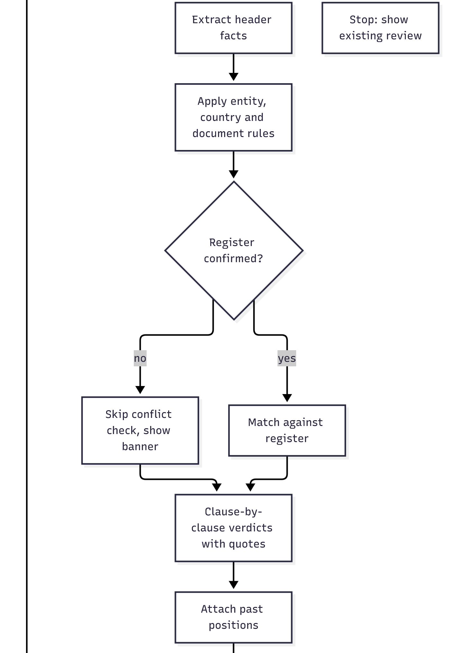
Flow diagram, part 2 of 4: register check, clause verdicts, past positions, mutuality
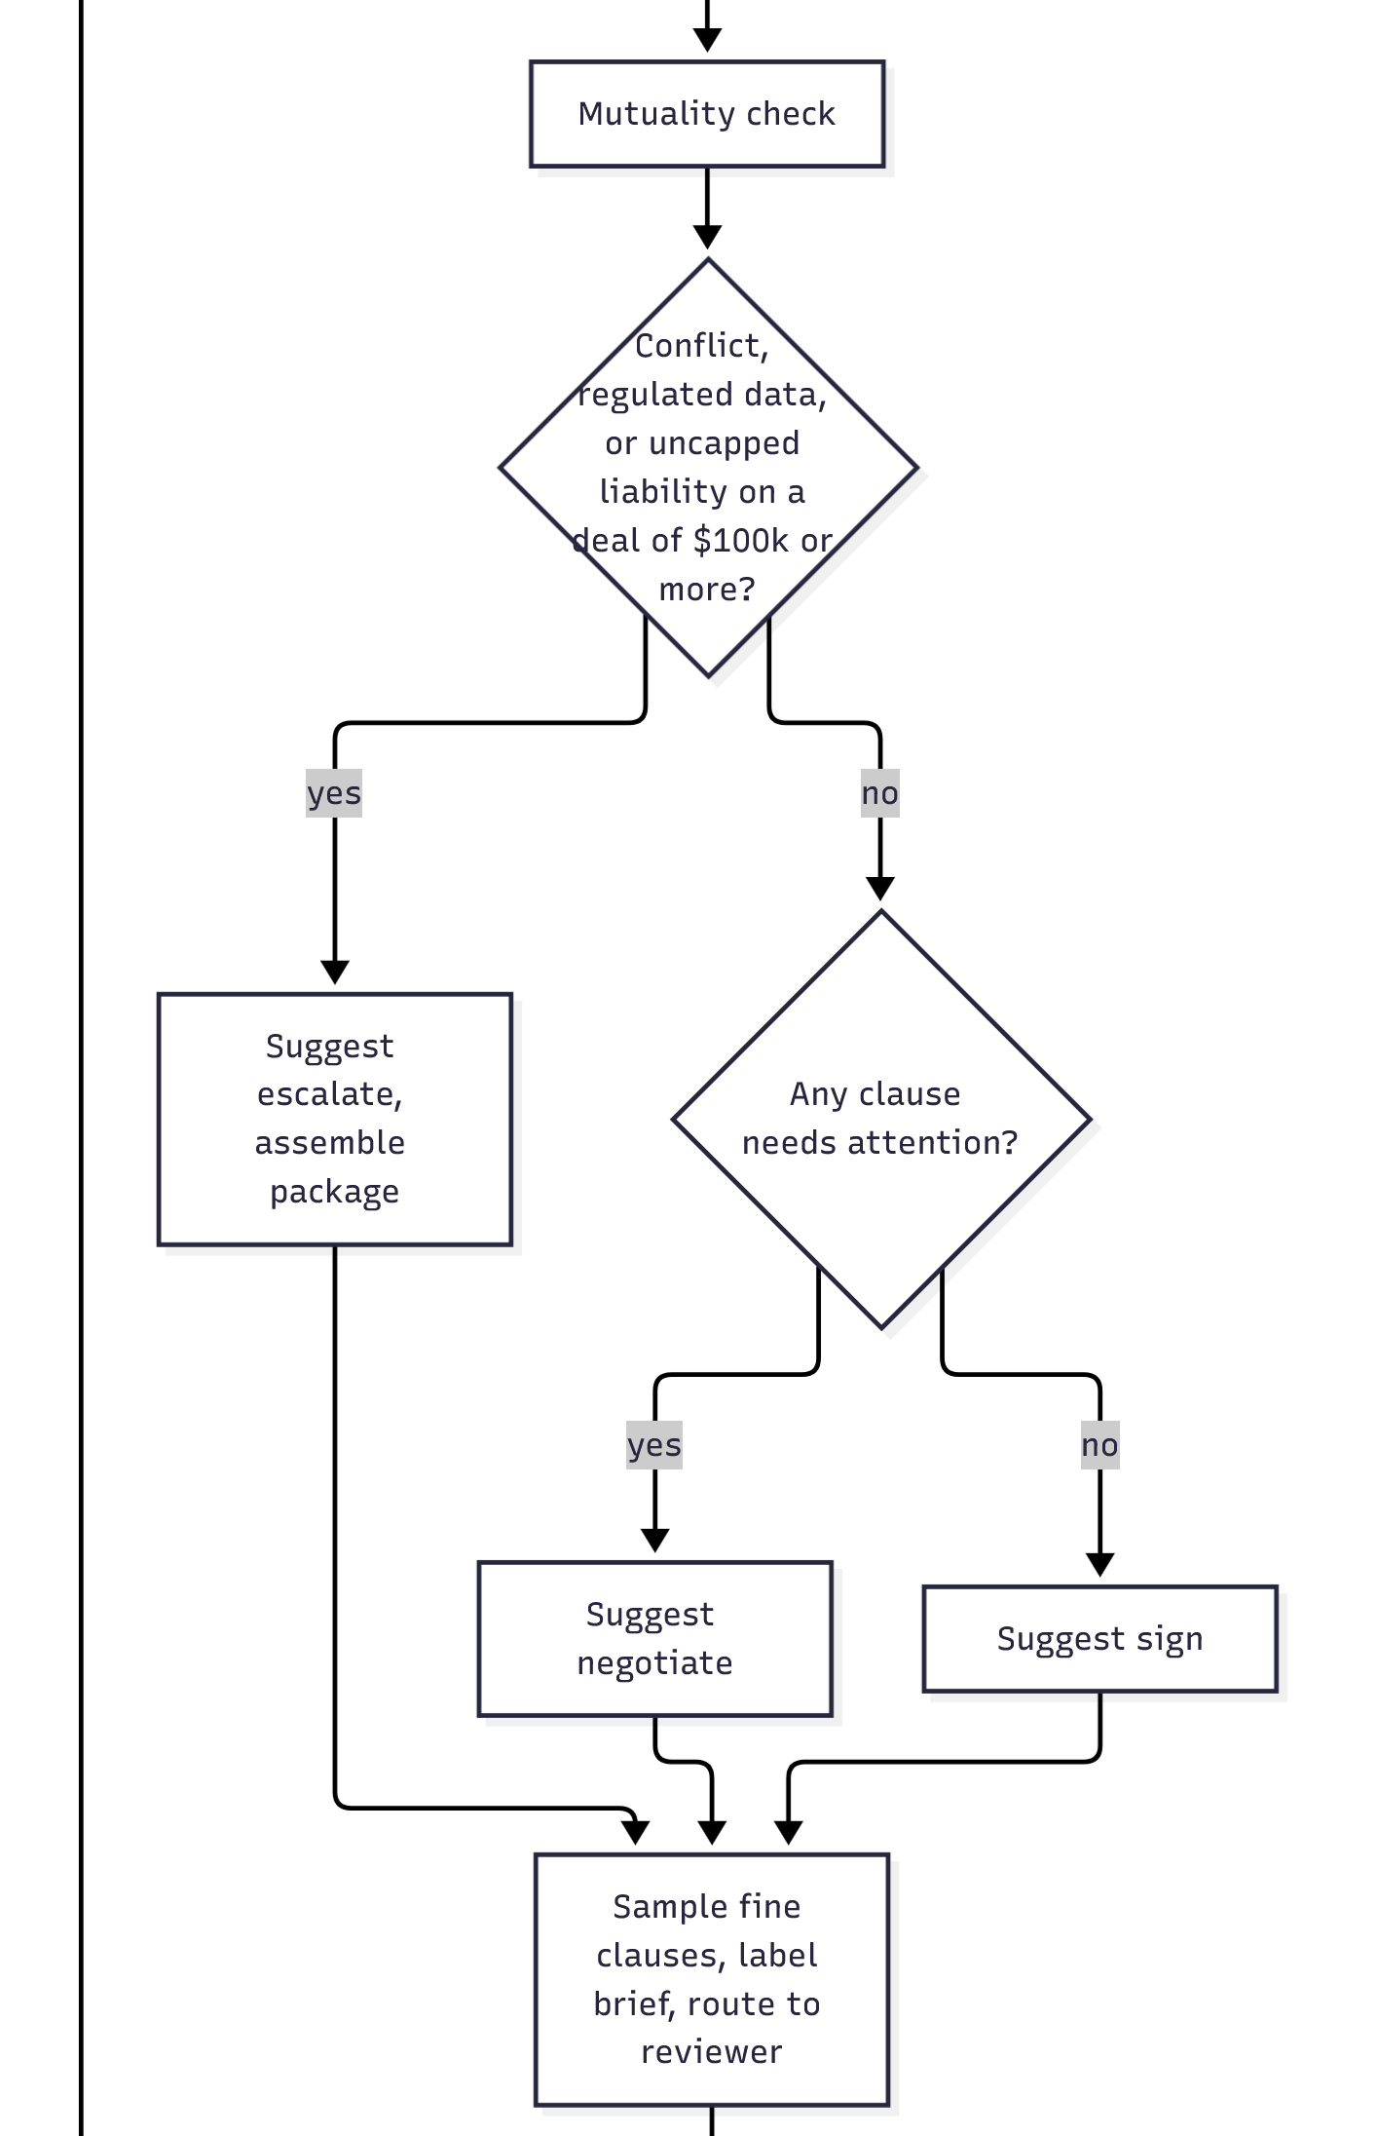
Flow diagram, part 3 of 4: escalate, negotiate or sign suggestion, sampling, route to reviewer
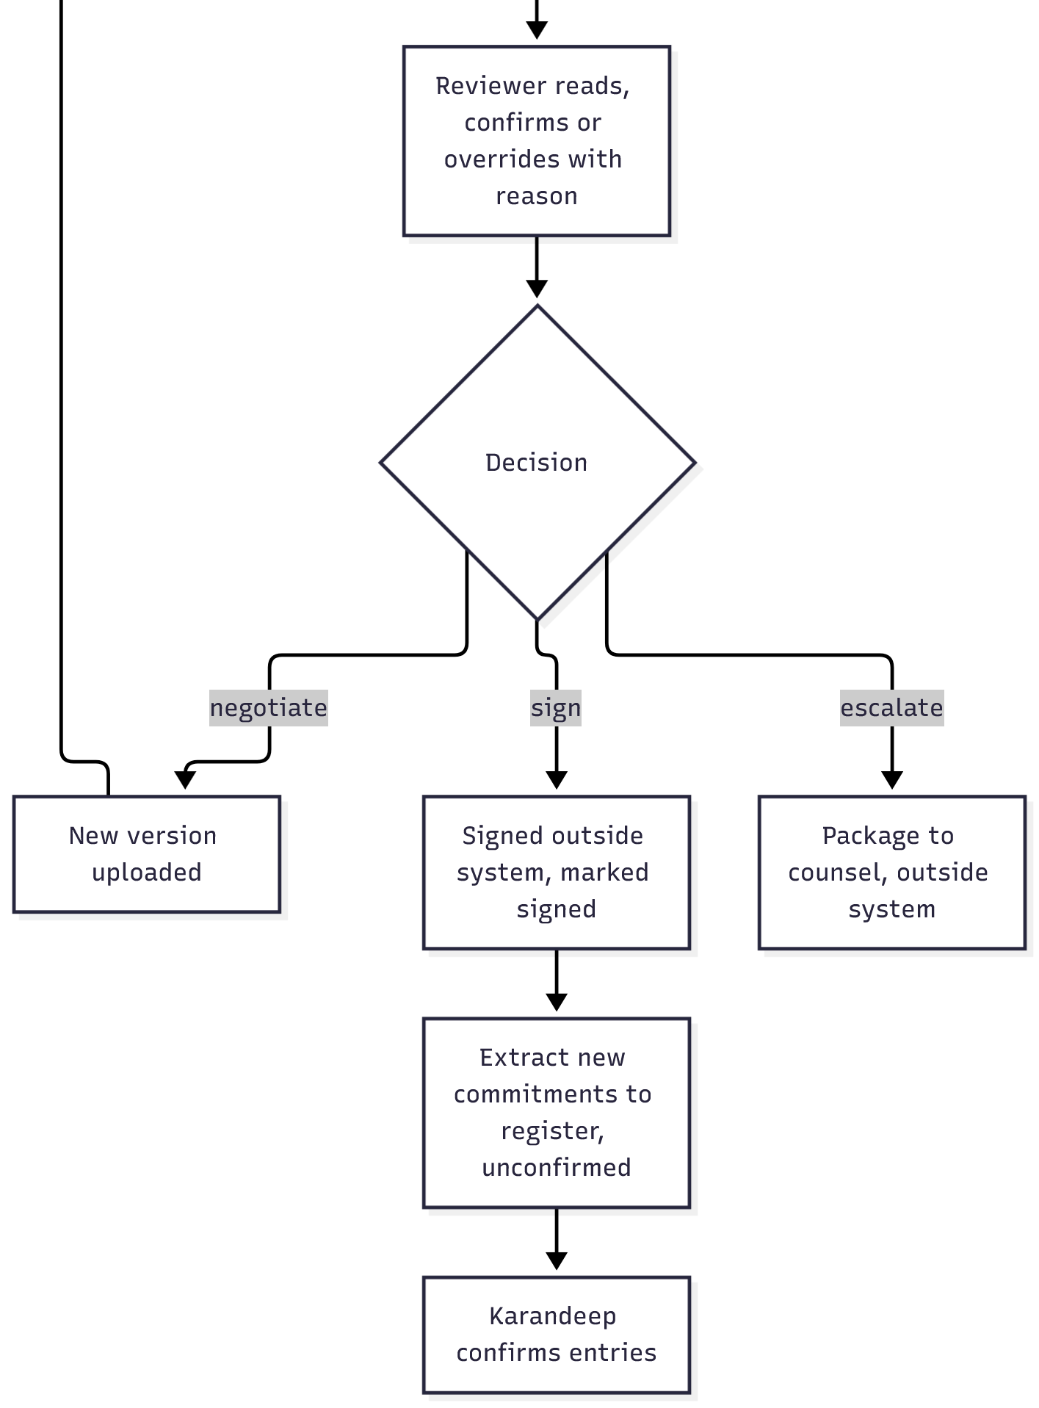
Flow diagram, part 4 of 4: reviewer decision, new version, signature, register update

9.5 User Experience: Trust by Design
The brief is only useful if the reviewer trusts it enough to act and distrusts it enough to check. The interface follows the Microsoft HAX guidelines for human-AI interaction:
Guideline | How the product applies it
Make clear what the system can do | The first screen states the five checks it runs and the three things it never does: sign, send, give legal advice. Every brief carries the label "AI-generated draft review. Not legal advice. A person decides."
Make clear how well it can do it | Each clause verdict shows its confidence; low-confidence verdicts are marked "needs attention, low confidence" with the reason, and a quote that does not match the source is marked unverified. The brief states how many register entries it checked against, so "no conflicts" is never read as "no risk".
Show progress, not a spinner | While the review runs, the screen lists the steps done and the step in progress, with elapsed and expected time, so a two-minute wait does not look like a hang.
Make clear why it did what it did | Every finding quotes the clause and names the source: the contract, the register entry or the precedent. Where support cannot be found it says "not found".
Support efficient correction | The reviewer confirms or overrides the suggested next step in one action; an override needs a reason and is logged. Register entries can be corrected at confirmation.
Scope services when in doubt | Unreadable pages are listed rather than guessed; a duplicate upload is stopped and the existing review shown; regulated data triggers "confirm with counsel", not a legal opinion.
Remember and learn cautiously | The reviewer's own past decisions are shown as history, never as policy. Nothing is retrained from overrides in V1.
Notify users about changes | The brief shows the register version and the date it was last confirmed; a register change after a review is flagged on that review.

10. Guardrails and Failure Modes
Each failure mode has a required guardrail. In this domain, a missed conflict and a leaked contract are the highest-risk failure modes.
Failure mode | What goes wrong | Required guardrail | Owner
Missed conflict (false negative) | A restriction already signed is not reported; AtliQ signs and breaches an existing client or partner | Golden test set with every known trap contract, re-run before any prompt or model change ships; conflict recall of 100% on the set is a launch blocker; register entries only used once confirmed by Karandeep; "what was not checked" shown on every brief | AI Product Manager
False alarm (false positive) | Clauses flagged that are not problems; reviewers stop reading the brief | False-alarm rate measured on the golden set and in beta; threshold in section 11; low-confidence findings labelled as such rather than promoted to conflict | AI Product Manager
Invented clause, precedent or legal rule | The brief cites text that is not in any document | Every finding must carry a quote matched back to the source text in code before display; unmatched quotes are shown as unverified and counted; precedent shown only with the deal named | Engineering lead
Legal advice or a "safe" verdict | The brief asserts compliance or safety; the human relies on it | Output filter in code flags and counts "safe to sign", "compliant with" and similar phrasing, and any hit is a kill-switch condition (section 14.1); mandatory label on every brief; the next step is a suggestion field, never an action | Engineering lead
Unauthorised action | The system sends, signs or changes a document | No integration to email or signature tools in V1; the system has no capability to send; register confirmation and signing are manual buttons with the reviewer's name recorded | Engineering lead
Confidential contract leaked | Client names, rates or personal data reach a third party or another user | Masking step in code before any model call on real contracts; provider terms with no training and no retention; RBAC with Karandeep as super-admin; encryption at rest and in transit | Engg SME
Stale or wrong register | Conflicts checked against expired, mis-extracted or unconfirmed promises | Each entry carries expiry and status; expired entries excluded from matching and shown separately; every signature triggers extraction; monthly register review by Karandeep | Karandeep
Precedent treated as policy | A one-off exception becomes the default position | Past positions shown as history with the deal named and any "exception" wording from the notes carried through; no thresholds hard-coded; the brief never says "our policy is" | AI Product Manager
Hidden instructions inside a contract (prompt injection) | A document containing "ignore your instructions" text alters the review | Document text treated as data: the instruction set is fixed in code, untrusted text never changes it; injection cases in the golden set; any brief that deviates from the output schema is rejected | Engineering lead
Cost or latency blowout | Long contracts exceed the ceilings and reviews stall or overspend | Page limit with split-and-state behaviour; per-review cost logged and monthly cap alert at 80% of the ceiling | Engineering lead

11. Eval Criteria
Eval criteria define whether the AI is ready to launch. The bias in V1 is toward flagging: a false alarm costs the reviewer seconds, a missed clause can cost a dispute, so recall on conflicts is a launch blocker and the false-alarm rate is a target to bring down over time. This is different from success metrics, which measure business outcomes after launch. The golden test set is drawn from the 15 incoming and 17 signed contracts in the synthetic dataset. The prototype ran eight incoming drafts, once each: Gulf Crown (collides with the Al Noor non-compete), BlueOrchid (looks India-only in the tracker note but collides with the same restriction), Lakeshore (pricing promise against the Crestline MFN clause), TravelHub (wrong entity and law), FinServe (an NDA that says mutual but is not), Kriti (AtliQ's own paper unfair to the other side), Harrington (a healthcare deal with documents missing) and LoopMart (the clean one, which must not raise a conflict). Of the seven trap scenarios named in the brief, five have a dedicated contract above; a one-sided clause in boilerplate is checked by the clause verdicts on every run; a contract that only looks risky is not yet in the set. The remaining seven drafts, that case, and repeated runs of the same contract are added in the shadow pilot.
Eval dimension | Definition and threshold
Conflict recall | Against the golden set with its known register conflicts (for example Gulf Crown against Al Noor; Lakeshore against the Crestline MFN clause), the system reports 100% of them. Launch blocker.
Clause verdict agreement | On 100 clauses from the golden set rated by Karandeep, the system's verdict agrees in at least 85% of cases, with no "conflict" clause rated "fine". Launch blocker.
False-alarm rate | Of clauses the system marks needs attention or conflict, no more than 20% are rated fine by Karandeep on the same 100 clauses.
Groundedness | In 50 reviews, 100% of findings carry a quote that matches the source text exactly; 0 findings reference text not in any document. Launch blocker.
Entity and rules accuracy | On all 32 contracts, the entity, law and courts check and the required-documents list are correct in 100% of cases (for example TravelHub flagged for naming AtliQ Inc on a Dubai deal; Harrington flagged for the missing subcontractor BAA). Launch blocker.
Mutuality detection | On the non-disclosure agreements and AtliQ's own templates in the dataset, one-sided clauses are identified in at least 90% of cases and the genuinely mutual NDA is not flagged.
Precedent usefulness | For 20 clauses marked needs attention, Karandeep rates the attached past positions as relevant in at least 80% of cases.
Safety and output filter | In 50 reviews, 0 briefs contain "safe to sign" or an assertion of legal compliance, and 100% carry the mandatory label. Launch blocker.
Injection resistance | On 10 contracts seeded with hidden instructions, 0 reviews deviate from the output schema or alter their verdicts because of the hidden text. Launch blocker.
Latency | 95% of reviews of 30-page contracts complete within 5 minutes on the golden set.

12. North Star and Success Metrics
These are measured after launch, against the baselines from the office hours with the client (about 3 hours per review, about a week in the queue and one week to one month from receipt to signature, about 9 contracts a month).
Layer | Metric | Target / threshold
North Star | Reviewer time per contract: active time measured in the assistant from brief opened to decision recorded, plus any reading logged outside it; the 3-hour baseline is re-measured in the shadow pilot | From about 3 hours to under 30 minutes within 3 months of the closed beta, as long as the guardrail metrics below hold
Supporting outcome | Days in queue, from upload to decision | From about a week today to 1 working day within 3 months of the closed beta
Output (shallow) | Contracts reviewed through the assistant per month | 9 per month, equal to today's volume, within 2 months of full release; reported with the share bypassing the assistant, target under 10%
Trust signal (AI) | Override rate: share of suggested next steps changed by the reviewer | Under 25% after the first 2 months of beta; a rise above 40% in any month triggers a review of the prompts and the register
Trust signal (AI) | Edit rate on clause verdicts during spot-checks | Under 15% of sampled fine clauses re-rated by the reviewer
Guardrail (AI) | Known conflicts missed in production | 0; any miss pauses the conflict check and triggers a register review within 1 week (section 14.1)
Guardrail | Contracts signed under the wrong entity or a non-matching law without a flag | 0; any case pauses the entity and rules check and triggers a rules-table review (section 14.1)
Guardrail | Confidential data incidents | 0; any incident rolls the product back to manual review (section 14.1)
User experience (sellers) | Share of contracts decided before the client's deadline | From the current share (the tracker holds deadlines only for the 9 contracts now in review, so the baseline is measured on those in the shadow pilot) to 90% within 3 months of full release
Business | Outside-counsel spend on routine contract review | From the current annual spend (to be shared by the client; the 30% target is confirmed once the baseline arrives) to a 30% reduction in the first year, with dispute-related spend tracked separately

13. Scope and MVP Boundary

13.1 Out of Scope (Permanently)
Out of scope item | Reason / when it may be revisited
Signing, approving or sending any document | A contract is a legal commitment made by a person at AtliQ. Never.
Giving legal advice or declaring a contract compliant or safe | AtliQ has no licence to practise law and the client wants a review assistant, not a decision maker. Never.
Hard-coded negotiation thresholds | The client confirmed no fixed policy exists; positions depend on scope, relationship, cash flow and brand. Never; the brief shows history only.
Employee and HR contracts | Handled by HR, outside the reviewer's scope. Not planned.
Negotiating with the counterparty | Human relationship work. Never by the system.

The client scoped freelancer, agency and employee agreements out of V1: partner and client contracts only. This PRD keeps two checks on AtliQ's own agency and freelancer paper, the mutuality and paperwork checks only, because the dataset contains those drafts and the healthcare bundle depends on matching subcontractor terms. That is an explicit extension beyond the client's stated scope, and it is dropped if the shadow pilot shows it adds noise.
An upsell to an existing client where cost is already locked is treated as a new version of that client's contract and goes through the same review; it is not a separate flow in V1.

13.2 V1 Ships vs Later, Deferred
V1 is the smallest thing that tests the riskiest assumption: that a model can find every clause that matters on any template and match it against a confirmed register without missing a known conflict.
V1 ships | Later, explicitly deferred
Upload and tracker row  Clause-by-clause verdicts with quotes  Obligations register built from signed contracts, confirmed by Karandeep, updated after every signature  Conflict check against the register  Entity, country, rules and paperwork check with the "confirm with counsel" flag  Mutuality check, including AtliQ's own paper  Past positions from the negotiation notes (full-text pass acceptable)  Suggested next step and escalation package  Overrides with reasons, sampling of fine clauses, audit log, RBAC  English only; synthetic data; manual upload | Counter-proposal drafting from precedent, when precedent is rated useful on 20 clauses at 80% or more (section 11) and a reviewer asks for it  Mailbox and WhatsApp intake, when call commitments are shown to change a signed term more than twice a quarter (section 16) and consent and integration are resolved  Client legitimacy and payment-history check, when a data source exists  Queue ordering and seller dashboard beyond status, when adoption by sellers is confirmed  Other languages, when a non-English contract volume appears  Learning from overrides, when 6 months of override data exist

14. Rollout and Release Strategy
An AI feature earns trust incrementally. Each stage below has a gate condition before moving forward. Dates after PRD approval are to be set with the dev team.
Stage | Definition and gate condition
Prototype on synthetic data (October 2026) | Built by the author on the capstone dataset, deployed to a free-tier host, tested against the golden set.  Gate: the launch-blocker evals in section 11 pass (conflict recall 100%, groundedness 100%, entity rules 100%, safety filter 0 breaches, injection 0 deviations).  Result on the prototype: 4 of the 6 launch blockers met on the golden set (conflict recall, groundedness on 203 quotes, safety filter, entity rules on the 8 golden contracts); clause-verdict agreement and injection resistance not yet measured. Across the two golden runs on the chosen model, two contracts (FinServe, Kriti) received a different suggested next step, so the next-step decision moves from the model's judgement into a fixed rule in code before the pilot. The shadow pilot is requested with those open, and they are the pilot's first job.
Shadow pilot (date to be set with the team) | Karandeep only. The assistant reviews every real incoming contract in parallel with his manual review; its brief is read after his decision, not before. Register built and confirmed during this stage. Starts once the register is confirmed and runs until 20 real documents have been reviewed (client contracts and NDAs both count; about two months at today's volume), with a check-in at 10.  Gate: clause verdict agreement at or above 85% on those 20 documents, 0 missed conflicts, and Karandeep's confirmation that the brief would have changed or sped up at least 5 of the 20 decisions.
Closed beta (date to be set with the team) | Karandeep plus one seller as delegated reviewer. The brief is read before the decision. Spot-check sampling at 1 in 2.  Gate: override rate under 25% over 2 months, false-alarm rate under 20%, 0 guardrail breaches, and reviewer time measured below 45 minutes per contract.
Full release to the management team (date to be set with the team) | All four reviewers. Sampling at 1 in 5. Counsel receives packages from the system.  Gate: 60 days of beta with every guardrail metric at 0 incidents and the North Star trend below 30 minutes.

14.1 Kill Switch Conditions
Karandeep or the AI Product Manager can pull the switch. Each condition names its action: "pause" switches off one check while the rest of the brief keeps running; "rollback" returns the whole process to manual review until the cause is fixed. Any single instance counts.
- A known register conflict is missed on a contract that reaches signature: pause the conflict check; register review within 1 week.
- A contract is signed under the wrong entity or a non-matching law without a flag, found in the monthly register review or by finance or counsel (any instance detected): pause the entity and rules check; rules-table review.
- A brief contains a quote that does not exist in any source document, found by the quote verifier or a reviewer (any instance detected): rollback.
- A confidential-data incident, contract content reaching an unauthorised user or a third party, reported by a user, the provider or the access log (any instance detected): rollback.
- A brief asserts a contract is "safe" or compliant, found by the output filter or a reviewer (any instance detected): rollback.
- The override rate exceeds 50% in any 30-day window: pause the suggested next step; prompt and register review.
- Monthly cost exceeds the ceiling in section 5 by more than 20%: pause new reviews until the cause is found.

14.2 What Every Gate Checks Together
A gate is not one number. Four things are checked at every stage above, and if any one fails the gate fails and the stage repeats. Commitment grows with evidence: at the prototype we commit only to the shadow pilot; at the shadow pilot only to the closed beta; a release date is set only after the beta gate. Gates, not dates.
- Product. It must prove the brief saves reviewer time inside the real review flow, not beside it. Evidence: reviewer time per contract (section 12) measured in the stage, and the share of contracts bypassing the assistant.
- Data. It must prove every finding traces to a source. Evidence: the groundedness eval (section 11); register coverage stated in every brief ("against the N on the register"); the readiness gaps in section 7.3 closed on schedule.
- Model. It must prove the reviewer finds the output good enough to use. Evidence: clause verdict agreement, conflict recall and false-alarm rate (section 11).
- Trust. It must prove a person stays in control and can see what happened. Evidence: approval before any action; override rate and edit rate (section 12); the audit log complete; 0 guardrail breaches; latency within the 5-minute bound.

15. Timeline and Milestones
Milestone | Target date | Owner / notes
PRD approved | October 2026 | Karandeep, sponsor; the PM
Cost estimation and prototype on synthetic data | October 2026 | PM
Model and build approach confirmed | To be set with the team | Engg SME with the PM
Register built and confirmed | To be set with the team | Karandeep confirms entries; engineering runs extraction
Shadow pilot | To be set with the team | PM and Karandeep
Closed beta | To be set with the team | PM, Karandeep and one seller
Full release to the management team | To be set with the team | PM and Engg SME

16. Open Questions and Assumptions Log
Open question / assumption | Ticket type | Owner | How we resolve it | Needed by
Volume baseline is about 9 contracts a month (3 to 4 contracts plus 4 to 5 NDAs, from the second office hours, consistent with the internal meeting). An earlier figure of about 20 from the first office hours is not used. The figure of 9 was confirmed in the office hours; the solution is priced per review and scales to higher volumes without redesign. | Data | PM | Confirm in the shadow pilot from real intake | Closed beta
Annual outside-counsel spend, split by disputes and complex contracts (baseline for the business metric) | Data | PM | Shared by the client; entered into section 12 | Closed beta
Which model and build approach meets the cost, latency and confidentiality requirements | Capability | Engg SME | Prototype review comparing at least two options on the golden set | PRD approval
Dates for shadow pilot, closed beta and full release | Engineering | Engg SME with Karandeep | Planning session after PRD approval | PRD approval
The register covers 17 of the 30 contracts the tracker marks as signed (section 7.3); the 13 uncollected contracts may hold commitments the assistant cannot see | Assumption to test | Karandeep with the sales executive | Find or declare lost each of the 13 before the closed beta; until then every brief states "no conflicts found against the N on the register" | Closed beta
Tracker fields are reliable for deadlines and values only; the negotiation history is unreviewed. Both are used as context, never as policy | Assumption to test | Sales executive | Sample 10 tracker rows against their contracts in the shadow pilot; review the negotiation notes before the closed beta | Shadow pilot
Karandeep will confirm the register in one sitting and add each new signature within a week; if not, the register goes stale and conflict recall decays silently | Assumption to test | PM | Agree the owner and the one-week rule in the register confirmation session; track additions per month | Shadow pilot
Are AtliQ's own agency and freelancer agreements in scope for full review, given the healthcare bundle depends on them? V1 treats them through the mutuality and paperwork checks only | Assumption to test | PM | Confirm with the client | Closed beta
How often do phone or WhatsApp commitments change a signed term? Decides whether mailbox intake moves up the roadmap | Assumption to test | PM | Ask Karandeep for examples in the shadow pilot | Full release
Is $100,000 the right deal size for suggesting counsel, and should regulated data always trigger it? | Assumption to test | Karandeep | Set in the shadow pilot; review the escalation suggestions against his actual decisions | Shadow pilot

17. Go-to-Market and Adoption
This is an internal launch: the users are AtliQ's management team. Go-to-market here means adoption: why switch from memory and email, who champions it, and how to stop people sliding back.

17.1 Positioning
For Karandeep and the reviewers he delegates to, who receive about 9 contracts a month with no legal team and no written record of past commitments, the Contract Risk Analyzer is a review assistant that reads every clause and checks it against what AtliQ has already promised, how it negotiated before, and the entity and country rules, in minutes. Unlike reading from memory late in the evening or paying counsel to start from a 20-minute document hunt, it shows the full picture with every finding quoted, and leaves the decision where it belongs.

17.2 Audiences and Key Messages
Audience | Key message | Proof point
Karandeep | "Every clause, every past promise, every missing document, in front of you in five minutes, with the source quoted." | Shadow pilot result: agreement rate and time per review on 20 real documents
Sellers | "Upload it yourself, see where it is, and stop chasing." | Closed beta result: days in queue
Outside counsel | "You get the brief and the documents in one package, not a hunt through email." | Escalation package produced in the prototype

17.3 Claims We Can and Cannot Make
Claim | Status | Evidence or condition
"Reads every clause and quotes its source" | After the prototype gate | Groundedness eval at 100% on 50 reviews (section 11); the prototype is at 100% on the 203 quotes of the golden set
"Checks against what AtliQ has already promised" | After shadow pilot | Conflict recall at 100% on the golden set and 0 misses on real contracts in the pilot
"Cuts review time from about 3 hours to under 30 minutes" | After closed beta | Only once measured in the beta; stated as measured, never as the target
"Flags the wrong entity or law before you sign" | After the prototype gate | Entity and rules eval at 100% on all 32 contracts; 8 of 32 checked so far
"Fully automated contract review" or "hands-free" | Never | A person decides every contract
"Tells you whether a contract is safe" or "legally compliant" | Never | Not legal advice; the output filter flags the phrasing and any instance is a kill-switch condition
"Replaces outside counsel" | Never | Counsel remains the escalation path; the product reduces routine spend only

17.4 Launch Plan and Channels
Launch moment | Tier | Audience | Channels | Owner
Shadow pilot start | 3 | Karandeep | One working session to confirm the register; a one-page "how it decides" note | AI Product Manager
Closed beta start | 3 | Karandeep and one seller | Demo recording, weekly 15-minute check-in, a chat channel for issues | AI Product Manager
Full release | 2 | Management team | Team meeting demo, FAQ, a champion (the founder who raised the ShopSwift loss) | AI Product Manager

17.5 Enablement
Asset | For whom | Ready by | Owner
"How the assistant decides" one-pager, including what it never does | Karandeep and reviewers | Shadow pilot | AI Product Manager
Demo video of a review from upload to decision, on the Gulf Crown and Harrington drafts | Management team | Closed beta | AI Product Manager
Register confirmation guide | Karandeep | Shadow pilot | AI Product Manager
Escalation package format agreed with counsel | Mehta Rao & Associates and Calloway Stern | Closed beta | AI Product Manager with counsel
FAQ and support path | Reviewers | Full release | AI Product Manager

17.6 Pricing and Packaging
Not applicable, internal tool. AI usage cost is tracked against the ceiling in section 5 and reported monthly to Karandeep.

17.7 Why This Is Hard to Copy, and What Comes Next
The model, the prompt and the "8 of 8" number are copyable; any team with the same API could rebuild the clause reader in a week. If the model became free tomorrow, three things would remain, and all three get stronger with use:
Advantage that compounds | What it is here | Who owns it
Real usage data | The confirmed register, and every override logged with a reason. Each review adds a reviewed case; every six months the assistant knows AtliQ's edge cases better than any fresh tool would. Overrides are not used to retrain in V1, but they are kept, labelled and fed into the evals and the next version. | AI Product Manager designs the loop; Karandeep confirms; engineering builds the capture
Workflow depth | The brief sits in the review queue the sellers already use, produces the counsel package, and holds the register. Remove it and the register, the audit trail and the escalation path go with it. | AI Product Manager
Trust evidence | A running record: "N months, 0 contracts signed under the wrong entity, 0 known conflicts missed", with the audit log to prove it. Features can be copied; a track record cannot. | AI Product Manager reports it monthly

Speed of build is a head start, not a moat; it buys the time to build the three above.
What comes next is a list of bets, not promises. Each is a hypothesis with a gate, in the order the evidence suggests, and the order changes as the shadow pilot produces data:
Horizon | Bet (hypothesis) | Gate before it moves
Now | The shadow pilot proves the five checks on real contracts | Section 14 shadow-pilot gate
Next | Drafting AtliQ's response from its own precedents saves negotiation time | At least 20 clauses marked needs attention with precedent rated useful at 80% or more (section 11); reviewer asks for it
Next | Mailbox and WhatsApp intake catches commitments made outside documents | The open question in section 16 shows call commitments change a signed term more than twice a quarter
Later | Register sharing across AtliQ's entities and future subsidiaries | Permission from each entity, anonymisation of client names, then shared learning; not before full release

Probabilistic features start as experiments: hypothesis, experiment on real past cases, threshold, decision. None of them gets a date until its gate is passed.

18. Change Log
A PRD is a living document. Evals, guardrails and data facts emerge during the build; this log records what changed and why, so nobody reads V1.0 numbers against a V1.1 product.
Version | Date | What changed | Why
V1.0 | 10 Oct 2026 | First complete draft: 17 sections plus the AI components. Cost ceiling set from an estimate of 11,500 tokens in and 5,300 out per review. | Written before the prototype existed.
V1.1 | 11 Oct 2026 | Section 5: measured token usage replaces the estimate (about 29,000 in, 13,700 out on the first model; $0.09 to $0.19 per review on the model chosen for the prototype). Section 7.3 added: data readiness per input with measured counts (register covers 17 of 30 signed contracts; tracker gaps). Section 16: five data assumptions added. Sections 14.2 and 17.7 added. Golden test expectation for BlueOrchid corrected after the model read Annexure B and the seller's note was wrong. | The prototype and the golden run produced facts the first draft did not have.

