

TRIBHUVAN UNIVERSITY **INSTITUTE OF ENGINEERING**

# PASHCHIMANCHAL CAMPUS

LAMACHOUR, POKHARA

A Project Reports on

**SUPERMARKET MANAGEMENT & BILLING SYSTEM**

SUBMITTED BY:

## Alima Subedi 072BCT603 Asim Sharma 072BCT606 Jasmine Baral 072BCT624 Rabinson Ghatani 072BCT635

**SUBMITTED TO:**

DEPARTMENT OF ELECTRONICS AND COMPUTER ENGINEERING

*ASAR, 2075*

# ACKNOWLEDGEMENT

Working on this project has been a great learning experience for us. There were moments of anxiety, when we could not solve problems for several days and also with struggling for long. But we have enjoyed every bot of the process and are thankful to all people associated with us during the period.

We convey our sincere thanks to our project supervisor Mr. Ramesh Thapa for providing us all sort of guidance and suggestions. His support and guidance helped us to carry out the project. We owe a great debt of gratitude for his constant advice, support, cooperation & encouragement throughout the project.

# ABSTRACT

The project is on Supermarket Management and Billing. Supermarket is a huge organization where we all can find lot and lots of products may that be grocery or fashion or utensils etc. in various category in different departments. Also, there is huge number of staffs of different position. It has to keep all the records of its staffs so as the employee management would be effective. So, to make such problems easier to handle we have developed this system that not only keeps authentic data may that be of transaction into and out of the supermarket or that be the information of its employee. Manager module in the software helps to keep information of employees and the cashier and data entry operator module helps to keep record of transaction inside and out of the supermarket. The barcode scanning system in the software help to run the transaction process fast and effective.

LETTER OF APPROVAL

TRIBHUVAN UNIVERSITY

INSTITUTE OF ENGINEERING

PASHCHIMANCHAL CAMPUS

DEPARTMENT OF COMPUTER AND ELECTRONICS ENGINEERING

The undersigned certify that they have read, and recommended to the Institute of

Engineering for acceptance, a project report entitled "*Supermarket Management and Billing System*" submitted by “*Alima Subedi, Asim Sharma, Jasmine Baral, Rabinson Ghatani*” in partial fulfilment of the requirements for the Bachelor’s degree in Computer Engineering.

___________________________

Supervisor *Ramesh Thapa*

*Lecturer*

*Department of Electronic and Computer Engineering*

**DATE OF APPROVAL:** *10/05/2075*

# COPYRIGHT

The author has agreed that the Library, Department of Electronics and Computer Engineering, Pashchimanchal Campus, Institute of Engineering may make this report freely available for inspection. Moreover, the author has agreed that permission for extensive copying of this project report for scholarly purpose may be granted by the supervisors who supervised the project work recorded herein or, in their absence, by the Head of the Department wherein the project report was done. It is understood that the recognition will be given to the author of this report and to the Department of Electronics and Computer Engineering, Pashchimanchal Campus, Institute of Engineering in any use of the material of this project report. Copying or publication or the other use of this report for financial gain without approval of to the Department of Electronics and Computer Engineering, Pashchimanchal Campus, Institute of

Engineering and author’s written permission is prohibited.

Request for permission to copy or to make any other use of the material in this report in whole or in part should be addressed to:

Head

Department of Electronics and Computer Engineering

Pashchimanchal Campus, Institute of Engineering

Lamachaur, Pokhara

Nepal

# LIST OF FIGURES

1. Use Case Diagram of Cashier Module ……………………………………..………..……… 10
2. SSD Cashier Module………………………………………………………...……………….10
3. Use Case Diagram of DEO Module………………………………………………………..…12
4. SSD DEO Module………………………………………………………………………...….12
5. Use Case Diagram of Manager Module.……………………………………….………….….13
6. SSD Manager Module………………………………………………………………………..14
7. Use Case Diagram of Shop Assistant Module………………………………………..………15
8. SSD Shop Assistant Module………………………………………………………………….16
9. Model View Controller……………………..…………………………...……………………17
10. ERD database……………………………………………………………..………………….19
11. Search Window……………………………………..…………………..……………………19
12. Notification in Manager Module…………………………………….……………………….20
13. Add Items in DEO Module …………………………………………………………………..20

# TABLE OF CONTENTS

*ACKNOWLEDGEMENT* ii

*ABSTRACT* iii

*LETTER OF APPROVAL* iv

*COPYRIGHT* v

*LIST OF FIGURES* vi

1.INTRODUCTION 1

1.1 Statement of Problems 1

1.2 Objective and Scopes 1

2.LITERATURE REVIEW 2

3.SYSTEM ANALYSIS 3

3.1 Cashier Module 3

3.1.1 Use Cases 3

3.1.2 Use Case Diagram 4

2.1.3 System Sequence Diagram 4

3.2 Data Entry Operator Module 5

3.2.1 Use Case 5

3.2.2 Use Case Diagram 6

3.2.3 System Sequence Diagram 6

3.3Manager Module 7

3.3.1 Use Cases 7

3.3.2 Use Case Diagram 8

3.3.3 System Sequence Diagram 8

3.4Shop Assistant Module 9

3.4.1 Use Cases 9

3.4.2 Use Case Diagram 10

3.4.3 System Sequence Diagram 10

4.METHODOLOGY 11

4.1 Overall System View 11

4.2 Description 11

4.3 Developments Tool Used 12

5.SYSTEM DESIGN 13

5.1 Database ER Diagram 13

5.2 Some Snapshots 13

6.CONCLUSION 15

7.REFERENCES 16

# INTRODUCTION

The Supermarket Management and Billing System, a desktop application, is developed to provide all the facilities and services required in various shops like shopping center, mini-mart, fancy shops etc. The main objective of the system is to provide efficient transaction with minimal error. Bar code scanning technology helps cashier for faster and efficient billing. Cashier, manager and data entry operator are provided with their own authorization account so that only the authorized person can perform respective jobs. Users in the system: -

* Cashier: - person who handle the transaction
* Data entry operator- enter the products imported in the store as well as to update the details.
* Manager- supervise all the activities going on the shop

## 1.1 Statement of Problems

* Manual data entry takes much time then barcode method.
* Manual calculation can generate error while buying or selling goods.
* More time consumption for any transaction and findings of the products.

## 1.2 Objective and Scopes

* To provide efficient and effective billing methodology.
* To keep record of every business transaction
* Maintain the stock management and the billing system
* Reduce the time consumption for every process in the buying and selling goods.

# LITERATURE REVIEW

Barcode has a large history from 1948 when Bernard Silver mad a first barcode in the beach with a sand to now days where every items in the market has its own barcode. In July 1972 an 18-month test in a Kroger store in Cincinnati began to fully utilize barcode (universal product code) in stores. This was the first time a barcode was used in the store. Since then barcode system took high grasp on every system and now days we may see the effect.

Popular and large supermarket organization have been using the similar system for their everyday business transaction. This software has become a vital requirement for them. Bhatbhateni, Saleways are some of those organization. However, in those software we didn’t find any function that is customer friendly. So we have proposed for functions such as the market assistant whose purpose is to serve the customer directly. This software is not in the reach of comparatively small business individuals. Hence we are determined to make this system for every individual business owner who is associated with the retail domain.

# SYSTEM ANALYSIS

## 3.1 Cashier Module

### 3.1.1 Use Cases

* Use Case Name: Process Sale
* Primary Actor: Cashier, Customer
* Stakeholder and Interests
* Cashier wants fast and accurate billing with no errors.
* Customer wants fast and accurate billings with minimal effort and clear entry of purchased item
* Manager wants customer satisfaction
* Deo wants accurate selection of the sold items so that the number of remaining items can be known easily.
* Pre-Conditions: Valid cashier recognition and authentication.
* Success Guarantee

Sale is saved. Tax is correctly calculated. Accounting and Inventory are updated. Receipt generated.

* Basic Flow
* The customer comes to the cashier with the items to be purchased.
* The cashiers scan every item one by one with barcode scanner, its batch, calculates the total amount to be paid for each customer and keeps the record.
* The customer provides amount in cash and then cashier provides the bills to the customer with changes (if any ) .
* Special Requirements

Flat panel monitor display and barcode scanner.

* Frequency of Occurrence

Nearly Continuous.

### 3.1.2 Use Case Diagram

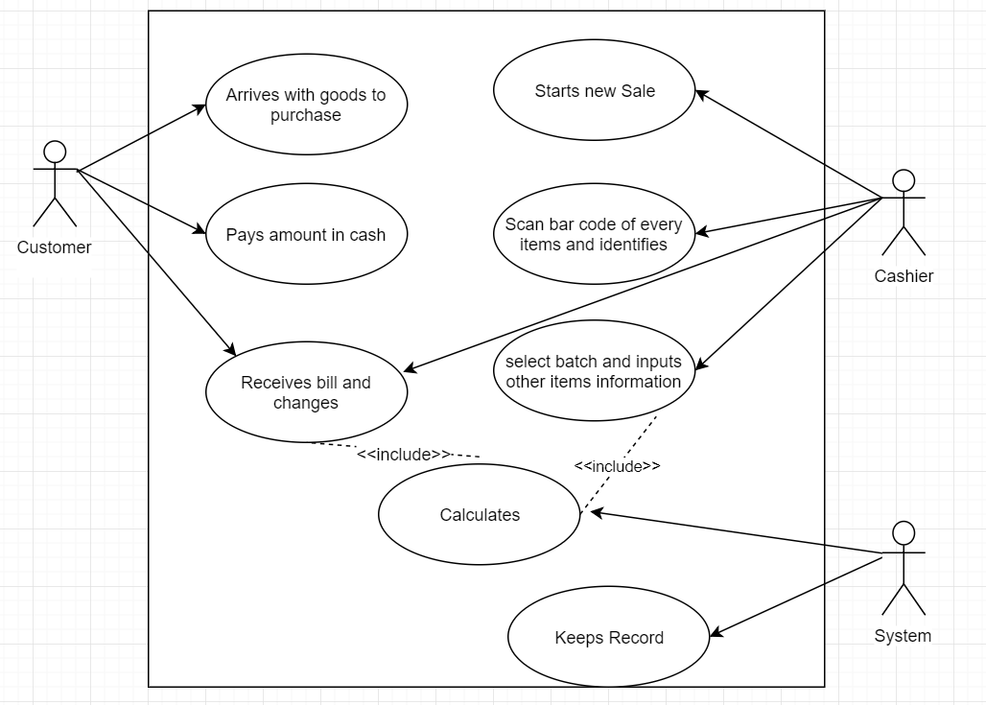

Fig 1.1: UML Diagram of Cahier Module

### System Sequence Diagram

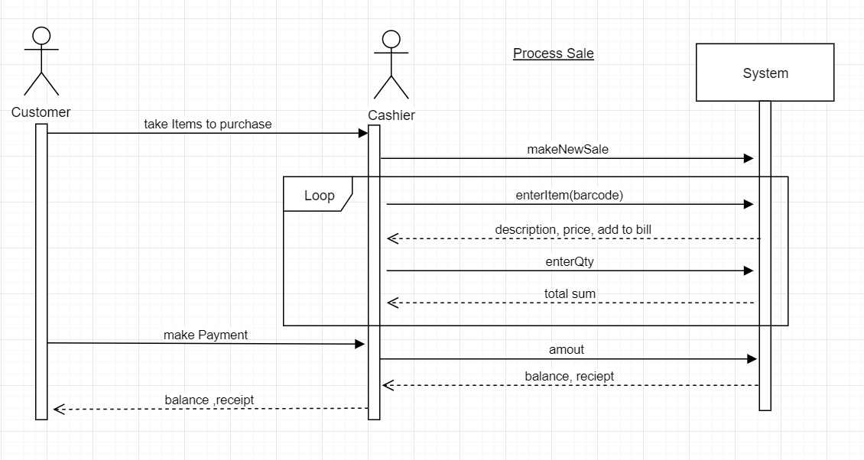

Fig 1.2: SSD of Cashier Module

## 3.2 Data Entry Operator Module

### 3.2.1 Use Case

* Use Case Name: Operate data items
* Primary Actor: Data Entry Operator
* Stakeholder and Interests
* DEO wants accurate and fast entry. (Information about all items required)
* Cashier wants accurate and updated information about all items.
* Manager wants accurate record of all items.
* Pre-Conditions: DEO is identified and authentication.
* Success Guarantee

All entries are saved. Accounting is updated. Information about each item are recorded correctly.

* Basic Flow
* New items/products arrives at supermarket.
* DEO updates the information about each item in the database. (Information such as price barcode, arrived quantity, expire date, department, category, sub-category.) Product ID and the entered date is automatically set by the system.
* The cashiers scan every item one by one with barcode scanner, its batch, calculates the total amount to be paid for each customer and keeps the record.
* The customer provides amount in cash and then cashier provides the bills to the customer with changes ( if any ) .
* Special Requirements

Flat panel monitor display and barcode scanner.

Robust Recovery.

* Frequency of Occurrence

Nearly Continuous.

### 3.2.2 Use Case Diagram

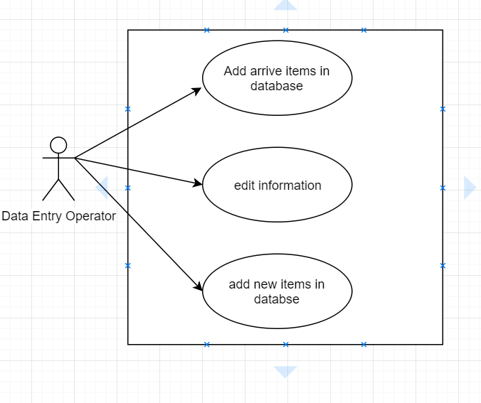

Fig 2: UML Diagram of DEO module

### 3.2.3 System Sequence Diagram

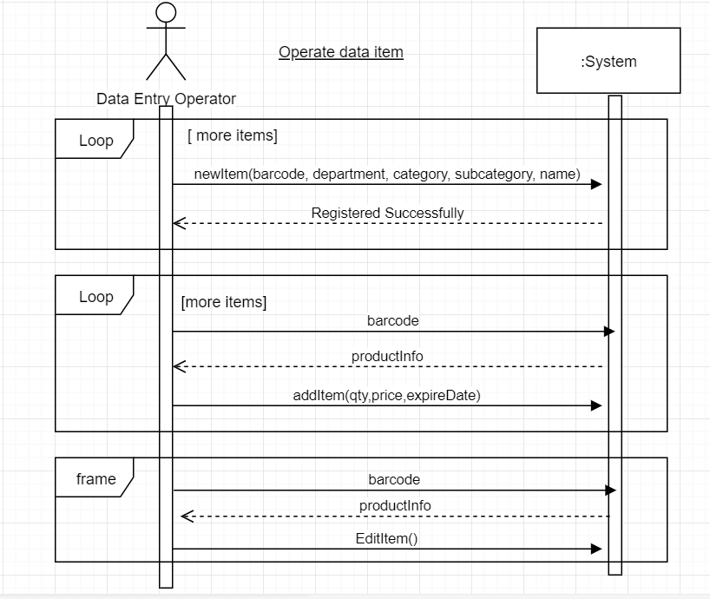

Fig 2.2: SSD DEO Module

## 3.2 Manager Module

### 3.3.1 Use Cases

* Use Case Name: Manager employee management
* Primary Actor: Manager
* Stakeholder and Interests
* Manager wants to register cashier, DEO or other employee and keep record of their address, contact no, etc.
* Pre-Conditions: Manager is identified and authentication.
* Success Guarantee

Employee are registered and viewed. Notification is viewed and respective action is taken such as sale or return for expiring and expired items.

* Basic Flow
* Manager creates account for employee separately.
* The information about expiring or soon to be finished product are provided to the manager as notification.
* Manager views the notification and takes necessary action.
* Special Requirements

Large flat panel monitor.

Robust Recovery.

* Frequency of Occurrence

Nearly Continuous.

### 3.3.2 Use Case Diagram

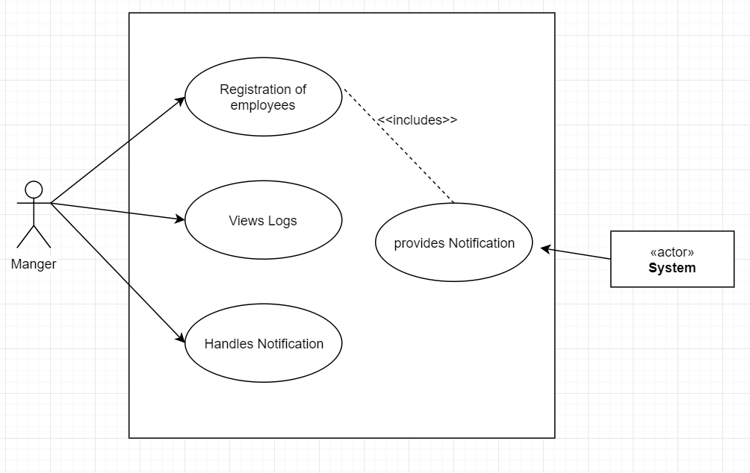

Fig 3.1: UML Diagram of Manager Module

### 3.3.3 System Sequence Diagram

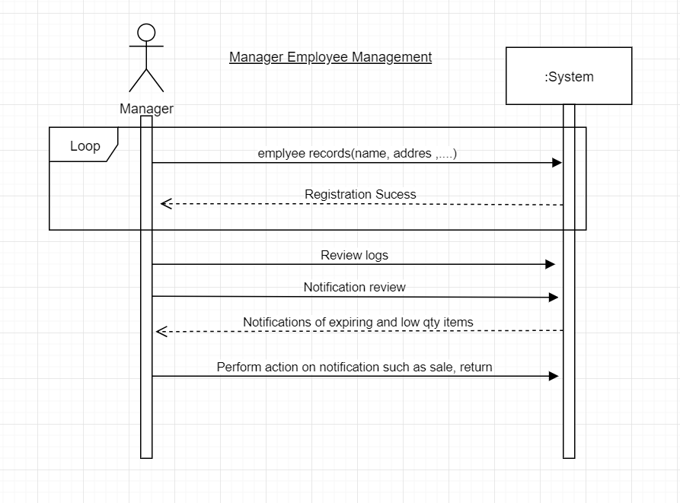

Fig 3.2: SSD Manager Module

## 3.3 Shop Assistant Module

### 3.4.1 Use Cases

* Use Case Name: Assist Shopping
* Primary Actor: Customer, System
* Stakeholder and Interests
* Customer wants accurate information about searched items.
* Manager wants customer satisfaction.
* Pre-Conditions: All items are updated accurately.
* Success Guarantee

Employee are registered and viewed. Notification is viewed and respective action is taken such as sale or return for expiring and expired items.

* Basic Flow
* Customer arrives at the shop assistant system.
* Customer searches the required items information and system displays the information about searched item.
* If the searched item is not found in the database the system redirects to the search option window.
* In search option window the customer can select the department, category and sub- category and get information about all the items in that sub- category in the supermarket.
* Special Requirements

Large flat panel monitor.

Quick Response.

* Frequency of Occurrence

Often.

### 3.4.2 Use Case Diagram

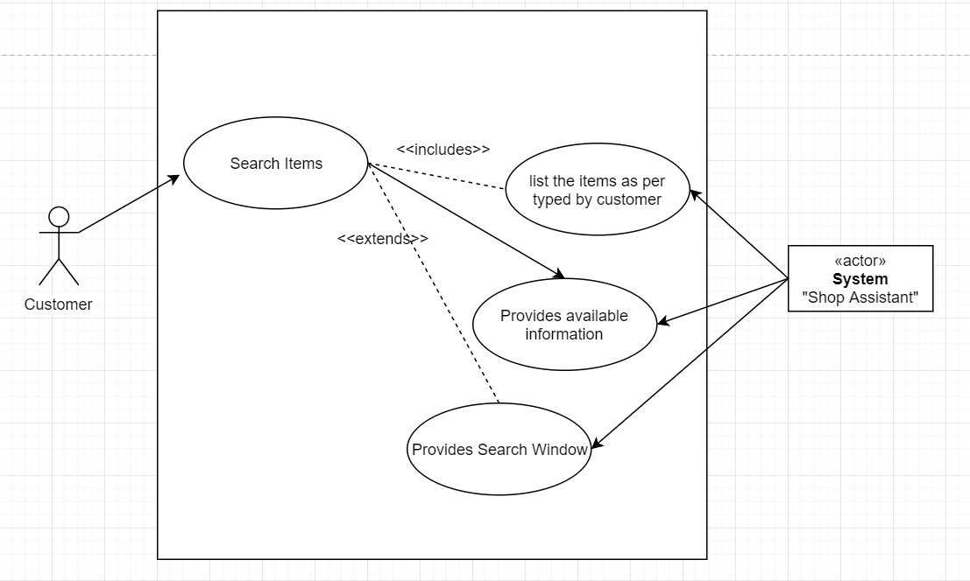

Fig 4: UML Diagram of Shop Assistant Module

### 3.4.3 System Sequence Diagram

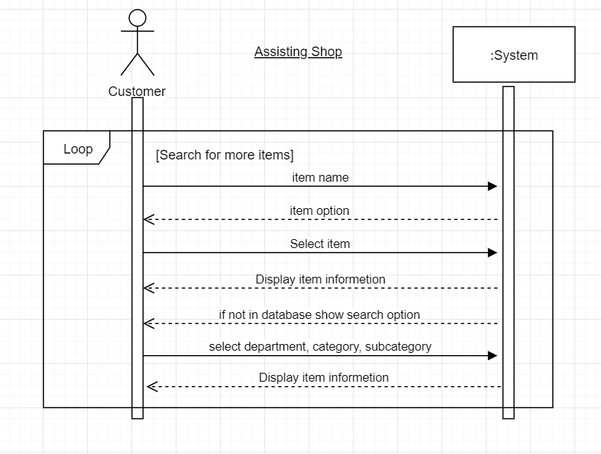

Fig 4.2: SSD Shop Assistant

# METHODOLOGY

## 4.1 Overall System View

The project will be developed with the desktop based and database in MVC approach.

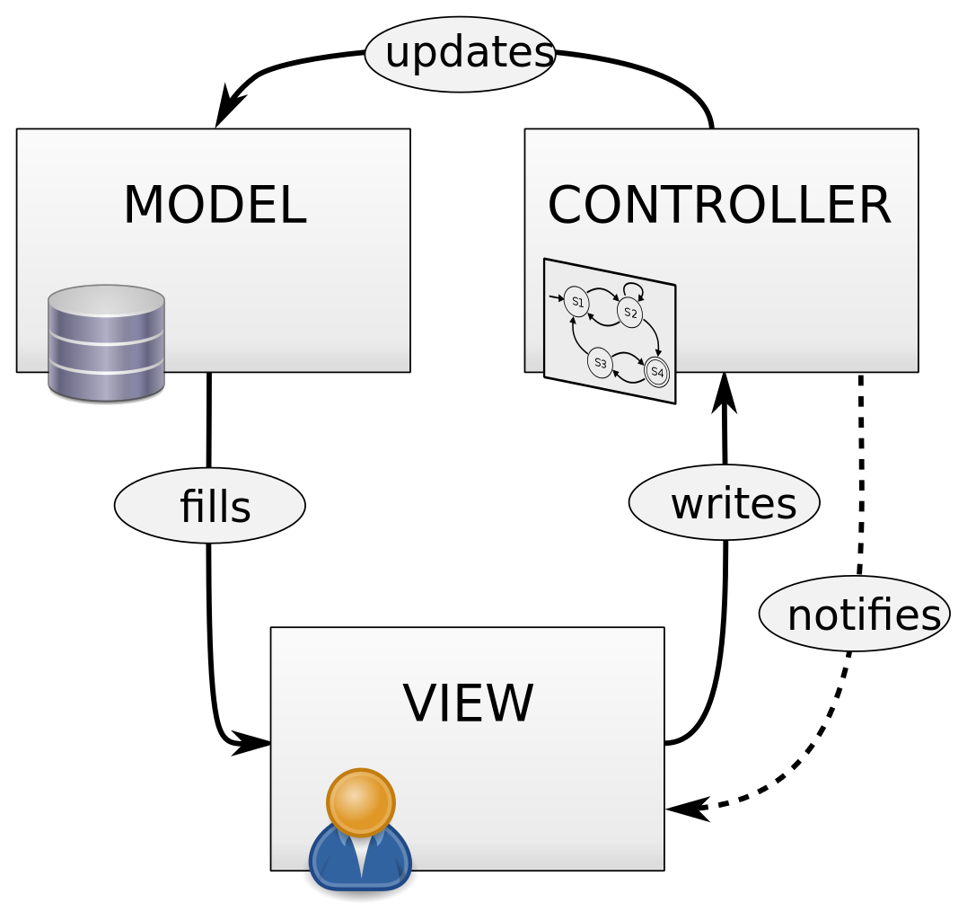

Fig4.1.1:Model View Controller

.

## 4.2 Description

The project is to done with the concept of OOP (Object Oriented Programming) with Java and relational database with MYSQL and to excess printer for the billing process we use Visual Basic Script (VBscript). Taking into account the statements of the problem, we developed a system that not only helps in maintaining precise transaction but also keep track of every business that has been done. There is the provision of login module for individual employee as per their job title after which they will be provided with their respective job function. With the help of the software they can achieve better working experience along with consistent precision. There are various organized table which makes the software very effective. The shop assistant module is the symbol of modern business techniques. It is a customer friendly module. The manager has an organized manner of employee management such as addition or removal of cashier or data entry operator or shop walker. S/he has access to the profile of every employee in his hand at any time of necessity. Logs module helps him/her to analyze the customer’s choice. Furthermore, the automation in the billing system helps the cashier in their transaction in a very precise manner. The use of barcode makes it easier for making bills and the automatic calculation prevents them from simple mistake.

## 4.3 Developments Tool Used

**Java**

JAVA was developed by Sub Microsystems Inc in 1991, later acquired by Oracle Corporation. It was developed by James Gosling and Patrick Naughton. It is a simple programming language. Writing, compiling and debugging a program is easy in java. It helps to create modular programs and reusable code. JavaFx is a library for building rich client applications with Java. It provides an API for designing GUI applications that run on almost every device with Java support.

**MySQL**MySQL is a relational database management system (RDBMS). The program runs as a server providing multi-user access to a number of databases. MySQL works on many different system platforms, including AIX, BSDi, FreeBSD, HP-UX, i5/OS, Linux, Mac OS X, NetBSD, Novell NetWare, Windows 95, Windows 98, Windows ME, Windows NT, Windows 2000, Windows XP, and Windows Vista. A port of MySQL to OpenVMS is also available.

# SYSTEM DESIGN

## 5.1 Database ER Diagram

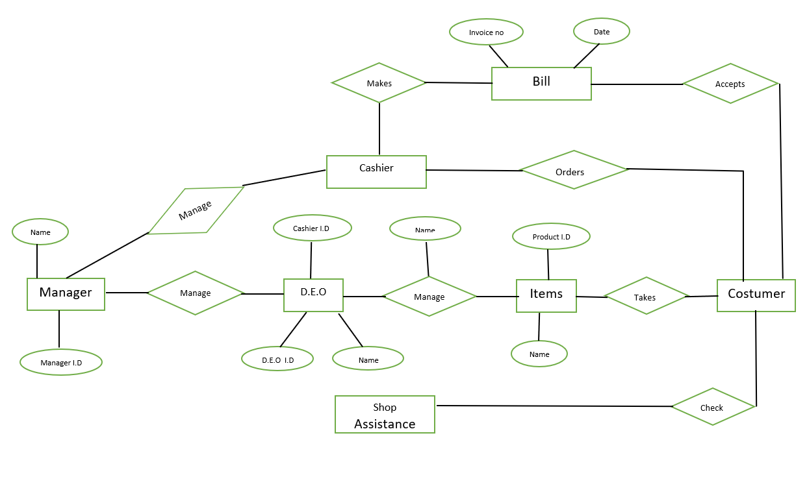

Fig5.1.1: ERD database

## 5.2 Some Snapshots

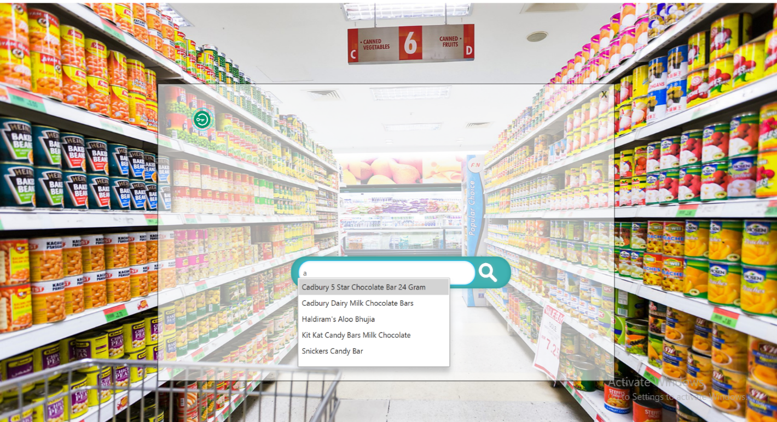

Fig 5.2.1: Search window

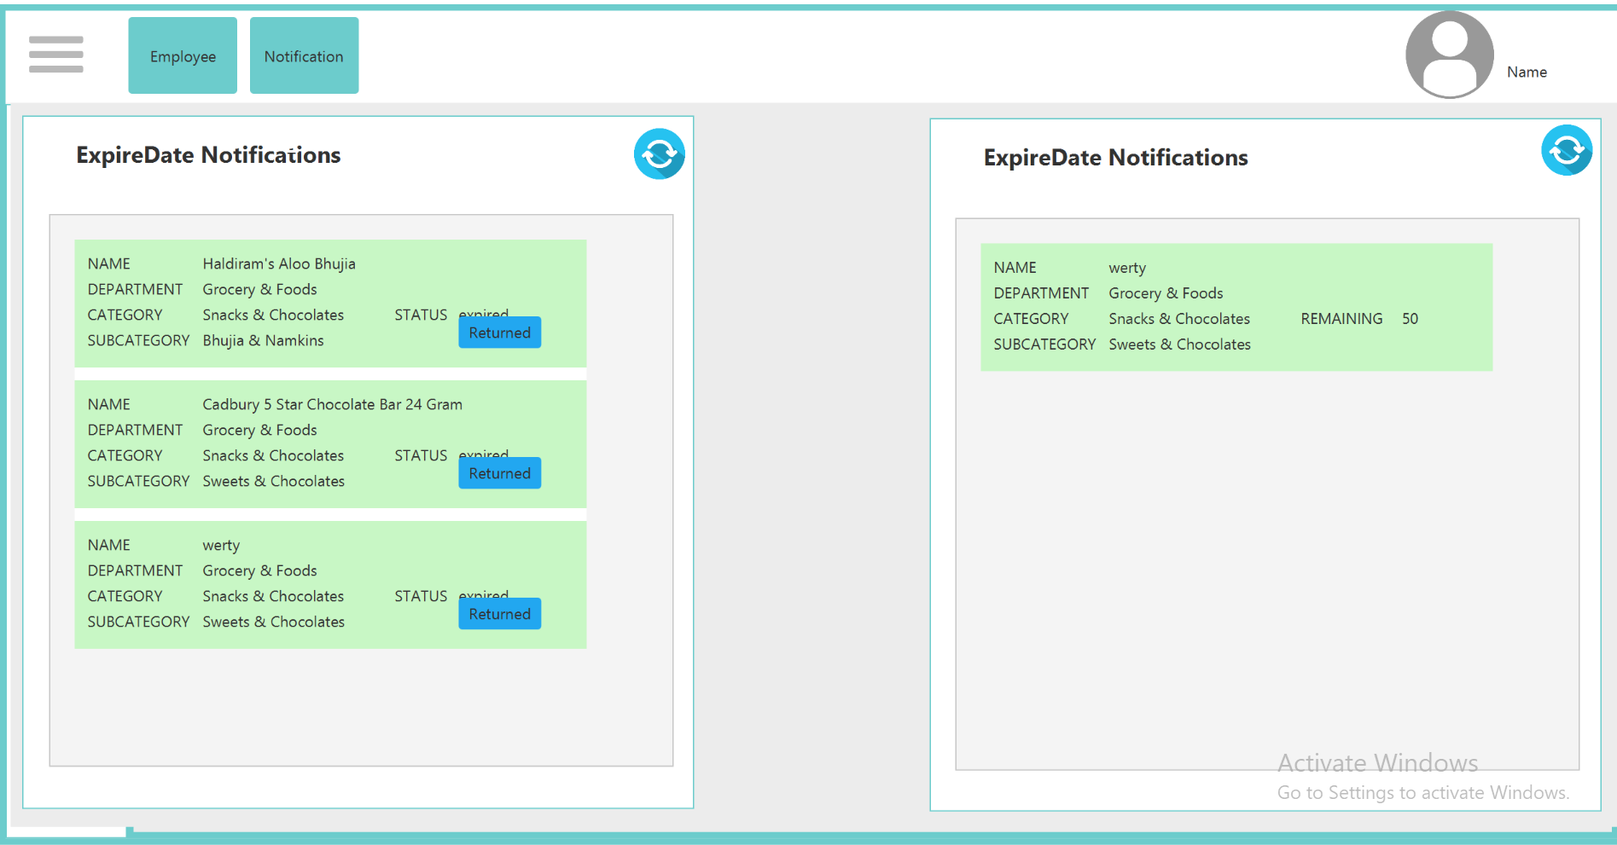

Fig5.2.2: Notification in manager module

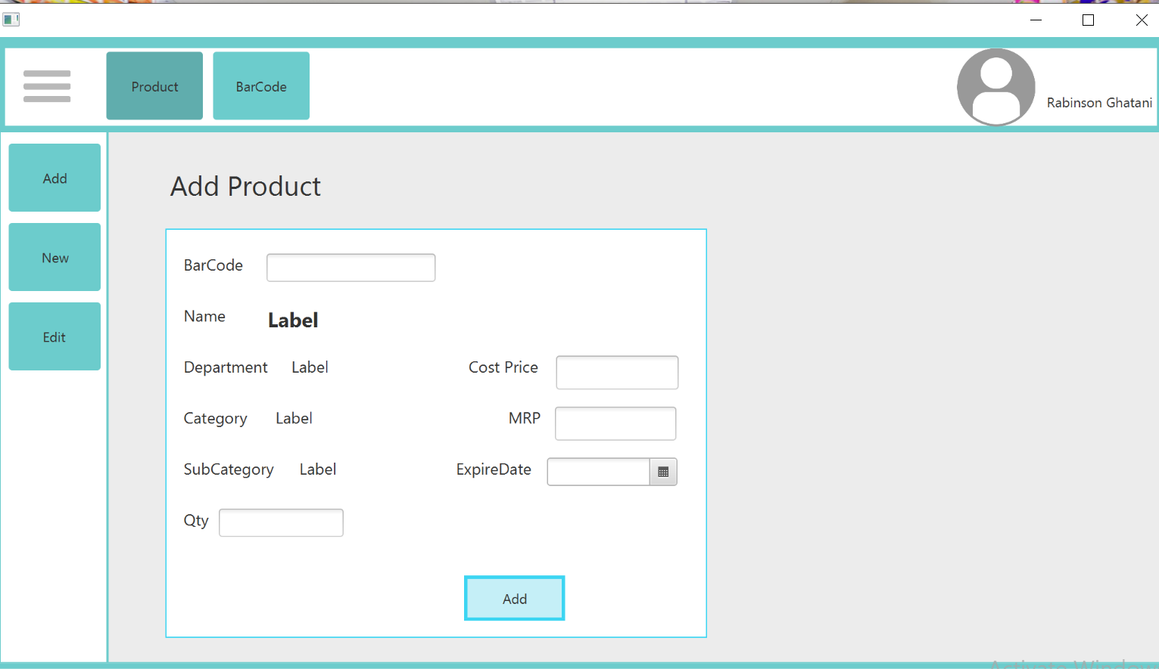

Fig 5.2.3: Add product in DEO Module

# CONCLUSION

Supermarket Management and Billing System is developed for the professional handling of the supermarkets sales and buy as well as the management of the whole supermarket. It is a very easy and useful application software which increases the productivity of the business.

Our project on Supermarket Management and Billing System has been implemented successfully. We take this opportunity to express our sense of indebtedness and gratitude to all those people who helped us in completing this project.

# REFERENCES

[1] "Release: JavaFX 2.1" Internet:' <https://docs.oracle.com/javafx/2/layout/style_css.htm'> April 24, 2013 [june ,2018]

[2] "Lesson: All About Sockets (The Java™ Tutorials > Custom Networking)" Internet:'https://docs.oracle.com/javase/8/javafx/api/javafx/scene/layout/HBox.html' , February 10, 2015 [may,2018]

[3] "SQL Tutorial" Internet:'https://www.w3schools.com/sql' [may,2018]

[4]"VBox(JavaFX8)"Internet:'https://docs.oracle.com/javase/8/javafx/api/javafx/scene/layout/ VBox.html', February 10, 2015,[april,2018]

[5]"Pane(JavaFX8)"Internet:'https://docs.oracle.com/javase/8/javafx/api/javafx/scene/layout/ Pane.html' , February 10, 2015, [may ,2018]

[6] "flatuicolorpicker : Best Flat Colors For UI Design" 'Internet:'http://www.flatuicolorpicker.com', , [june,2018]

[7] "MySQL SELECT only not null values" Internet:'https://stackoverflow.com/questions/5285448/mysql-select-only-not-null- values', ,[june,2018]

[8] "Handling the null value from a resultset in JAVA" Internet:'https://stackoverflow.com/questions/5991360/handling-the-null-value-from-a- resultset-in-java', , [april,2018]

[9] "Account Suspended" Internet:'[http://www.jfoenix.com/documentation.html#TreeTableView](http://www.jfoenix.com/documentation.html)', , [june 2018]

[10] "JavaFX Tutorial - JavaFX PasswordField"Internet:'http://www.java2s.com/Tutorials/Java/JavaFX/0470 __JavaFX_PasswordField.htm', ,[april,2018]