TRIBHUVAN UNIVERSITY INSTITUTE OF ENGINEERING PASCHIMANCHAL CAMPUS Lamachour,Pokhara

**DEPARTMENT OF COMPUTER ENGINEERNG**

**C PROGRAMMING MINI PROJECT PROPOSAL**

**C:\Program Files (x86)\Microsoft Office\MEDIA\CAGCAT10\j0292982.wmf**

**TITLE: IQ Challenge**

*“Test your Brain”*



SUBMITTED BY: RABINSON GHATANI ROLL NO.: 072BCT635 JAWALAKHEL, LALITPUR

**INTRODUCTION**

This is quite a quiz challenge where anybody can test their IQ status. There are several question of general knowledge of different section in random manner such as national, international, literature, geological, sports, etc. Users can compare each other score and try to increase their IQ in competition. The scores are calculated at the end of several numbers of questions. And the quicker user give answer more will they score.

In the coding prospects there has been use of several C-programming terms such as input/output, control statements, functions, strings, arrays, pointer, structure, file handling, and other basic terms.

**OBJECTIVES**

Its objective is just for trying out users IQ status and inspire him/her for learning general facts, and knowledge. In other word we are trying to make the user a good learner and smart.

**PROJECT RELATED INFORMATIONS**

**ALGORITHM:**

STEPS

1. Start.
2. Display menu for playing, score, help, exit.
3. If play is chosen then goto playing screen.
4. Several question are asked to with the user will choose the option for their answer
5. If the answer is correct print correct else print wrong with the correct answer.
6. Show the score.
7. Ask for the user if he wants to play again or not, if yes than goto 3 else goto 2.
8. Stop

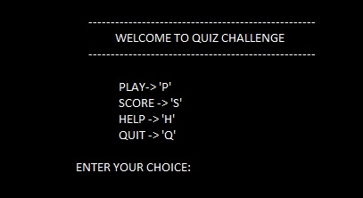

**FLOWCHART**

CHOOSE 'P','S','H','Q'

IF choice='P'

**T**

DISPLAY Play Zone

**F**

**T**

DISPLAY score

IF choice='S'

**F**

**T**

DISPLAY help content

IF choice='H'

**F**

IIF choice='Q'

**EXPECTED INPUT AND OUTPUT**

• PLAY ZONE AFTER YOU CHOOSE 'P' IN THE MENU

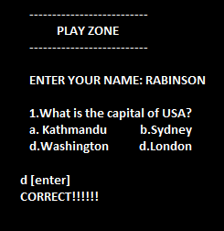

• SCORE BOARD after you choose 'S' in the menu

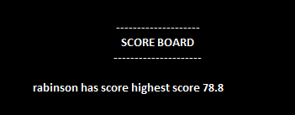

• HELP after you choose 'H'

