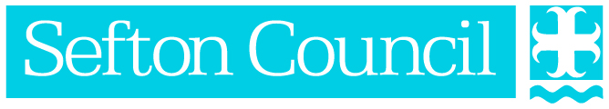

# Sefton’s Climate Change Emergency Implementation Plan

## Introduction

This document sets out Sefton Council’s delivery of the commitment made within our climate strategy “Sefton’s Climate Change Emergency Plan”.

Sefton Council joins over 60% of UK local authorities in declaring a climate emergency and a growing consensus worldwide that urgent action is needed.

We will look at both the challenges and opportunities and engage with our communities to ensure we undertake actions to adapt to and mitigate the effects of climate change now and into the future.

This work will be aligned to the delivery of the Sefton 2030 Vision and the Council’s Core Purpose with the aim of making Sefton a great place to be.

We will achieve this by following the below principles as set out in our climate strategy:

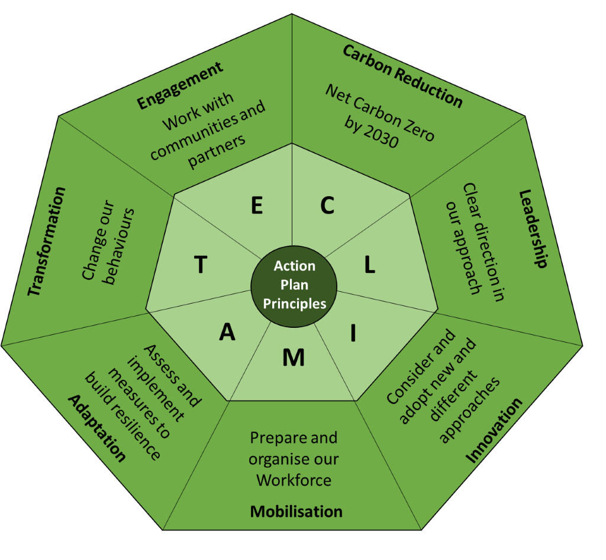

## Action Plan

Action Plans will be created to cover three 3 year phases in order to align with the Council’s financial planning cycle (shown below), supplemented by annual progress reports. This provides us with the opportunity to review and revise our approach as opportunities arise.

Phase 1 2020 – 2023;

Phase 2 2023 – 2026; and

Phase 3 2026 -2029.

Our action plan will include both mitigation and adaptation measures. This recognises that some impacts of a changing climate cannot be changed in the short/medium term. We must recognise that impacts, such as future sea level rises and an increase in summer temperatures will pose risks and opportunities to how we live and work, so we must alter our approach via adaptation measures. Offsetting is included within mitigation and is the practice of increasing carbon capture to compensate for carbon release that cannot be avoided.

## Covid-19

COVID-19 was an unexpected interruption to the timetable of Sefton Council’s Climate Emergency response. We do not see this as a major setback, rather, a challenge to keep to our original targets and to learn from one global crisis in response to another. Global carbon emissions have fallen in all countries and will help us to meet the global Paris accord target to limit warming.

This demonstrates a valuable lesson, that there is no quick fix and reduction in carbon emissions has to be sustained and long term to have a significant impact.

We can also learn valuable lessons on a Sefton basis

* COVID-19 has forced teams to work from home without adversely affecting delivery of services. Future flexibility in agile working will be a key element of reducing employee commuting and office energy consumption.
* COVID-19 has prompted a rapid response to a short term crisis; this mindset and sense of urgency can be redirected to tackle a climate crisis that is perceived to be long term, but in reality, is causing problems for communities now.

In order to meet the net zero carbon target, we will develop detailed a carbon reduction trajectory for the period 2020 – 2030, during phase 1. We will also explore options to introduce Carbon budgeting alongside corporate financial models.

We have defined our organisation as, all our depots, leisure centers, libraries, fleet vehicles and office spaces. We will define our emissions according to the Greenhouse Gas Protocol. This will include the most direct emissions Scope 1 and Scope 2, with some additional emissions captured within Scope 3, namely business travel and commuting.

## Sefton’s Carbon Baseline / Footprint

Here is a summary of the Council’s carbon footprint in CO2. The total emissions from the scope we have defined is **10,017 Tonnes.**

|  |  |
| --- | --- |
| **Activity** | Emissions (tCO2) |
| Scope 1 Gas | 3,173 |
| Scope 1 Oil | 0 |
| Scope 1 Diesel | 142 |
| Scope 2 Electricity | 4,411 |
| Scope 3 Business Travel | 313 |
| Scope 3 Staff Commute | 1,978 |
| **Total emissions** | **10,017** |

Here is a summary of the Council’s carbon footprint in CO2e. (CO2e means carbon dioxide equivalent and is a measure that takes into account the emission of other greenhouse gases associated with the activity undertaken). CO2e allows other greenhouse gas emissions to be expressed in terms of CO2 based on their relative *global warming potential* (GWP). This means that this measure will be slightly higher than CO2, because it captures additional emissions causing global warming/climate change.

The total emissions from the scope we have defined is **10,077 Tonnes.**

|  |  |
| --- | --- |
| **Activity** | Emissions (tCO2e) |
| Scope 1 Gas | 3,180 |
| Scope 1 Oil | 0 |
| Scope 1 Diesel | 144 |
| Scope 2 Electricity | 4,451 |
| Scope 3 Business Travel | 351 |
| Scope 3 Staff Commute | 1,988 |
| **Total emissions** | **10,077** |

The Carbon Baseline/Footprint will be regularly monitored and used to assist in the prioritisation of the carbon mitigation elements of our action planFollowing our Climate Strategy principles C.L.I.M.A.T.E., our action plan outlines the key areas of work we will undertake over the next 3 phases of our journey to 2030. This will be revised and updated each year in order to capture achievements, opportunities, technological developments and additional challenges.

# Sefton Council Action Plan

## **Carbon Reduction**

### We will work towards becoming net carbon zero by 2030

We will take local action by

* Maintaining (and refining) the carbon baseline for Council emissions. This will have a high impact and will be implemented in phase 1-3.
* Identifying all current/planned projects and evaluate their contribution/risk to the climate emergency agenda. This will have a high impact and will be implemented in Phase 1.
* Exploring options to improve thermal efficiency at council sites through retrofit. This will have a high impact and will be implemented in Phase 1.
* Reducing electricity and gas usage: no/low cost energy saving and reduction schemes e.g. Education and awareness campaigns. This will have a low impact and will be implemented in Phase 1.
* Reducing electricity and gas usage: medium / high cost energy saving and reduction schemes e.g. Street lighting LED upgrade. This will have a high impact and will be implemented in Phase 1 and 2.
* Exploring the opportunities and feasibility for expanding sustainable transport networks and facilities such as cycle routes. This will have a medium impact and will be implemented in Phase 1-3.
* Reducing fuel consumption through promoting ecodriving, and reduced travel via agile working etc. This will have a medium impact and will be implemented in Phase 1.
* Moving to low carbon fleet vehicles. This will have medium impact and be implemented in Phase 3.

### We will achieve 100% clean energy by 2030

We will take local action by

* Investigating self-supply of Biogas (generation) - e.g. through use of municipal waste streams and agricultural waste stock. This will have a high impact and be implemented in Phase 2 – 3.
* Developing renewable energy (electricity) generation across Sefton – solar, on shore wind. This will have a medium impact and will be implemented in phase 1-2.
* Supplying Biogas via Gas purchase agreement / renewable electricity - purchase REA & REGO certificates with a direct agreement between company generating and Sefton. This will have a high impact and be implemented in Phase 2 for electricity and Phase 3 for gas.
* Investigating Carbon offsetting options – local then global. This will have a low impact and be implemented in Phase 3.

## **Leadership**

### We will provide clear direction in our approach

We will take local action by

* Lobbying central government for increased funding for climate related projects. This will have a high impact and be implemented in Phase 1.
* Reviewing new policies and strategies, forthcoming budget proposals, Treasury Management Strategy and all cabinet and council decisions to ensure they have considered climate change adaptation and mitigation issues. This will have a meidum impact and be implemented in Phase 1.
* Sharing expertise and advice with our community, providing details of the Council’s commitments and encouraging behaviour change in local homes, businesses and schools. This will have a high impact and be implemented in Phase 1-3.
* Working with local partners across the LCR to a coordinated approach and to identify areas for collaboration and resource. This will have a high impact and be implemented in Phase 1-3.
* Using our role as a large organisation to encourage change in the borough, by requiring large suppliers to report on climate impact of activities implemented on our behalf. This will have a high impact and be implemented in Phase 1-3.
* Assessing the impacts of local events and activities via the Southport Master Plan and seek to mitigate where necessary. This will have a high impact and be implemented in Phase 1.

## **Innovation**

### We will consider and adopt new & different approached

We will take local action by

* Exploring options for investment in low carbon energy & innovative technology and seek innovative low carbon options for any new developments. This will have a high impact and be implemented in Phase 1-3.
* Approaching the climate emergency with a long-term mindset, exploring ‘spend to save’ methods of climate action. This will have a high impact and be implemented in Phase 1-3.
* Exploring options for local offset via climate adaptation programmers and local landscape enhancement. This will have a medium impact and be implemented in Phase 1-3.
* Identifying and channel the existing enthusiasm for climate action in the workforce. This will have a high impact and be implemented in Phase 1.
* Continuing to invest in Sustainable IT systems to allow for flexibility for agile and home working. This will have a medium impact and be implemented in Phase 1.
* Developing a Green Sefton membership scheme for our communities to inspire them to take action and buy into the approach being taken by the Council. This will have a medium impact and be implemented in Phase 1.

## **Mobilisation**

### We will prepare and organize our workforce to support climate change action

We will take local action by

* Developing and deliver training & awareness raising for staff at all levels, to encourage low carbon and adaptation measures and informed decision making, among our workforce. This will have a high impact and be implemented in Phase 1.
* Supporting departments to assign responsibility and actively contribute to the officers/members working group(s). This will have a high impact and be implemented in Phase 1.
* Providing timely reporting to members (Cabinet and Overview & Scrutiny Committees) and staff on progress and other developments. This will have a high impact and be implemented in Phase 1-3.
* Improving knowledge and understanding of how the Council is affected by extreme weather events in terms of providing its services and financial impacts. This will have a high impact and be implemented in Phase 1-3.

## **Adaptation**

### We will access and implement measures to build resilience

We will take local action by

* Completing a full risk assessment of Climate Change impacts, identifying threats and how they can be managed as well as realising the opportunities (such as offsetting emissions and assessing carbon capture). This will have a high impact and be implemented in Phase 1.
* Developing a place based strategy/framework for Sefton's landscape portfolio for the delivery of any carbon offsetting, adaptation and mitigation measures whilst working with natural processes. This will have a medium impact and be implemented in Phase 1.
* Identifying and quantifying opportunities for carbon offsetting, urban greening and improved site sustainability; through local landscape management. This will have a medium impact and be implemented in Phase 1.
* Reviewing impacts of measures on air quality outcomes. This will have a medium impact and be implemented in Phase 1.
* Working with the Planning Authority on developing guidance for development, that includes climate benefits, for the built and natural environment. This will have a medium impact and be implemented in Phase 1.

## **Transformation**

### We will change our behaviour

We will take local action by

* Aligning our climate work with the 2030 vision and other transforming principles. This will have a high impact and be implemented in Phase 1-3.
* Utilising existing groups and tools internally to engage staff and raise awareness of low carbon & adaptation activities and encourage action. This will have a medium impact and be implemented in Phase 1.
* Reducing commuting and business travel impacts through the implementation of a council travel plan and associated policies. This will have a high impact and be implemented in Phase 1.
* Embedding responsibility for delivery this agenda at all levels. Support those people to fully understand the expectations of their position in relation to the climate emergency. This will have a high impact and be implemented in Phase 1.

## **Engagement (and Education)**

## We will work with communities and partners

We will take local action by

* Ensuring all information on our climate emergency is available in an easy read format and is accessible to all our residents. This will have a high impact and be implemented in Phase 1.
* Establishing and engage with an expert panel and a diverse citizens panel (including youth). This will have a high impact and be implemented in Phase 1.
* Working with partners (Schools, New Directions, Businesses etc) to adopt low carbon & adaptation measures. This will have a high impact and be implemented in Phase 1-3.
* Engaging our communities to raise awareness of the Council’s commitments and encourage appropriate behaviour change. This will have a high impact and be implemented in Phase 1-3.