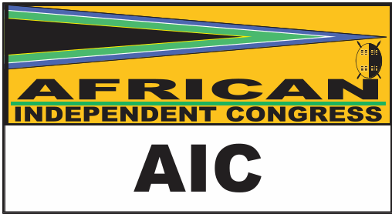
POSTAL ADDRESS PHYSICAL ADDRESS
P.O. BOX 15 95-100 GH BUILDING
CAPE TOWN PARLIAMENT
8000 CAPE TOWN
TEL: 021 403 8653 FAX: 021 403 8884

CONSTITUENCY OFFICES OF THE AFRICAN INDEPENDENT CONGRESS

Constituency Office in Matatiele (Eastern Cape)
Administrator : Busisiwe Jozana
Coordinator : Fundiswa Ndyebo
Cleaner : Mantsane Makaba
Community Development Field Worker : Nonzwakazi Princess Nyamakazi

Contact details are as follows:
Tel. 039 737 4095/4184
Fax. 039 737 4234

Physical Address is as follows:
No. 127 High Street
Matatiele
4730

Constituency Office in Port Elizabeth (Eastern Cape)
Administrator : Norma Nkewuse
Coordinator : Phumzile Jozana
Cleaner : Lindela Rala

Contact details are as follows:
Cell. 081 869 2255 or 082 709 356

Constituency Office in Durban (KwaZulu Natal)
Coordinator : Lihle Ngcobo
Administrator : Smangele Cele
Cleaner : Bulelwa Jozana

Contact Details are as follows:
Tel. 031 301 1191
Fax. 031 301 0427

Physical Address is follows:
Tower B Salisbury Centre
7th Floor
Suite 713 – 715
Durban
4001

Constituency Office in Johannesburg (Gauteng)
Coordinator : Tony Ngodwana
Administrator : Margaret Arnolds
Cleaner : Koliswa Nguqu

Contact details are as follows:
Tel. 011 492 0191
Fax. 011 492 0083

Physical Address is follows:
646 Kaalfontein
Midrand
1685

