To implement Firebase connectivity with Flutter UI and perform Email–Password Authentication using the Flutter framework and Firebase authentication service.

Step 1: Create Flutter Project
- Open Android Studio.
- Click File → New → New Flutter Project.
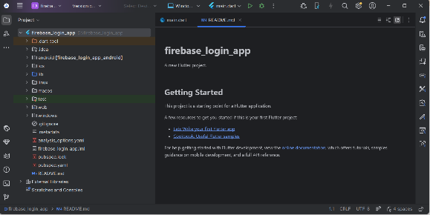
- Project Name: firebase_login

Step 2: Create Firebase Project
- Go to Firebase Console:
https://console.firebase.google.com
- Click Create Project.
- Enter project name.

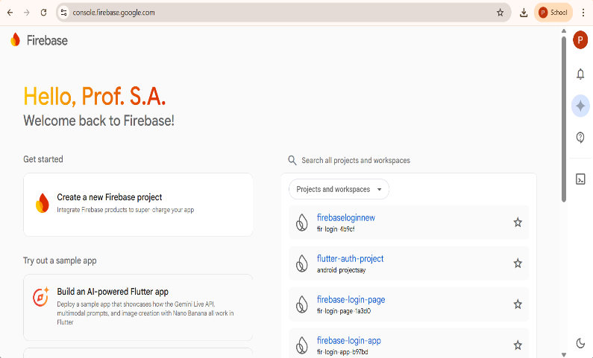
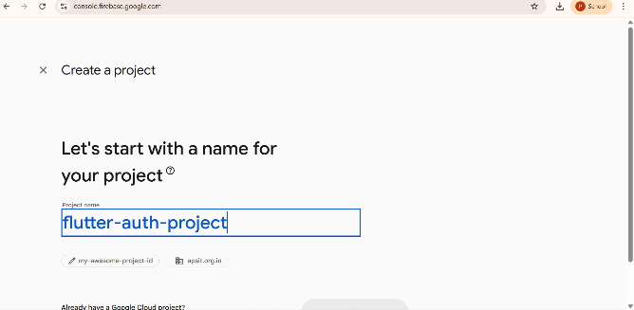

Step 3: Register Android App in Firebase

Firebase must know which Android app will connect to it.
- In Firebase Dashboard click Add App.
- Select Android icon.

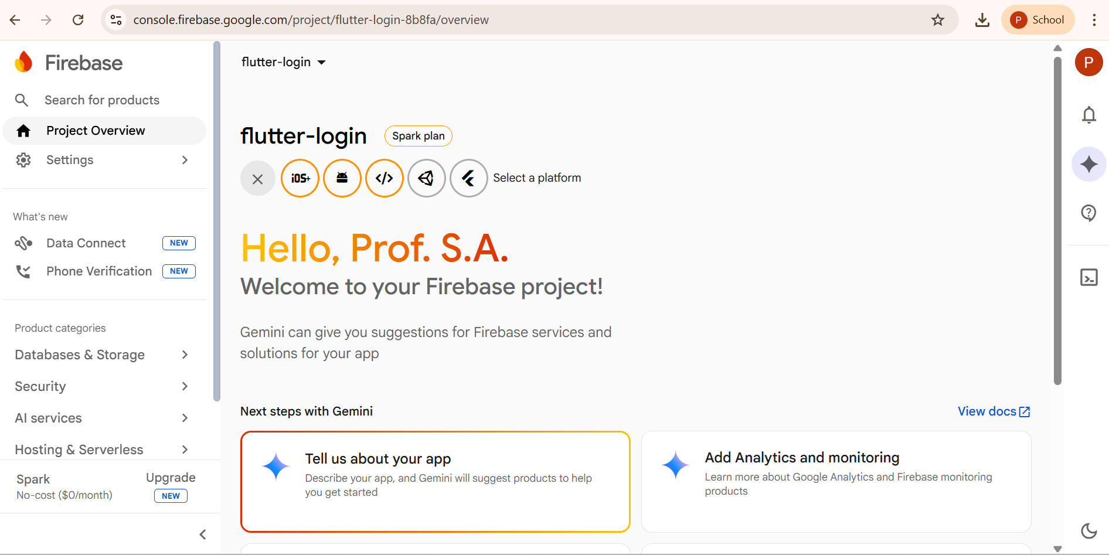

Now enter:
Android Package Name
Open Flutter project
android → app → build.gradle
Find:
applicationId "com.example.firebase_login"
com.example.firebase_login
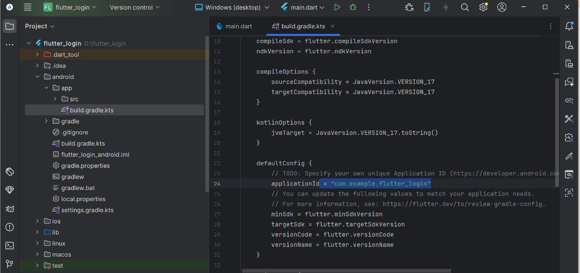

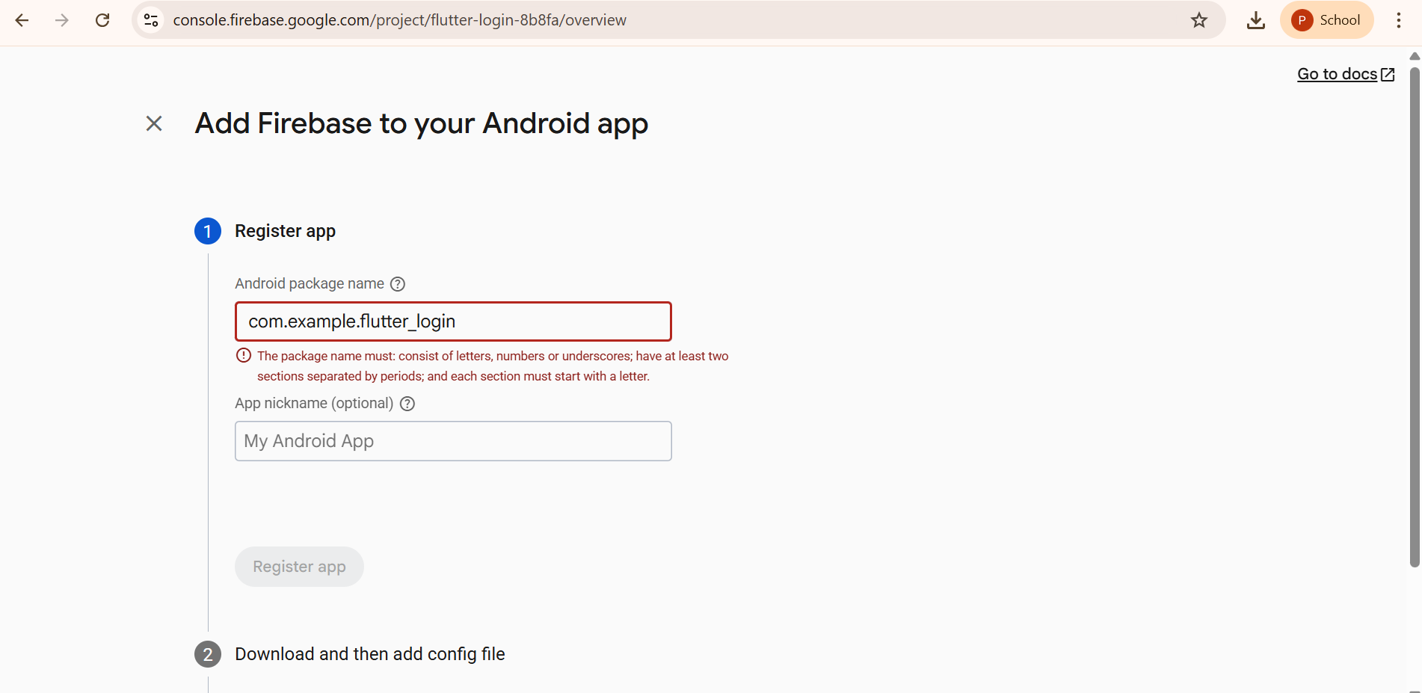

Step 4: Download google-services.json
After registering the app:
- Firebase generates file:
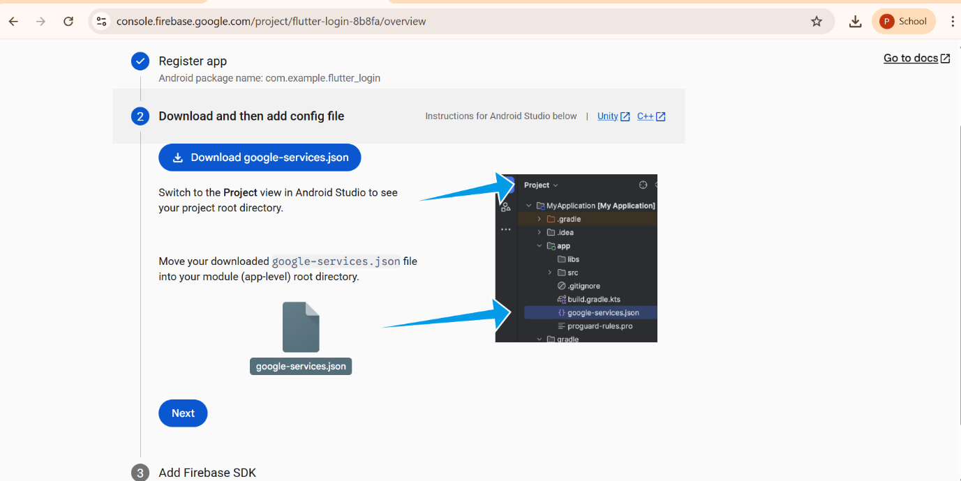
google-services.json

Step 5: Configure Firebase in Android
Open File
android/build.gradle
Add inside dependencies:
classpath 'com.google.gms:google-services:4.3.15'
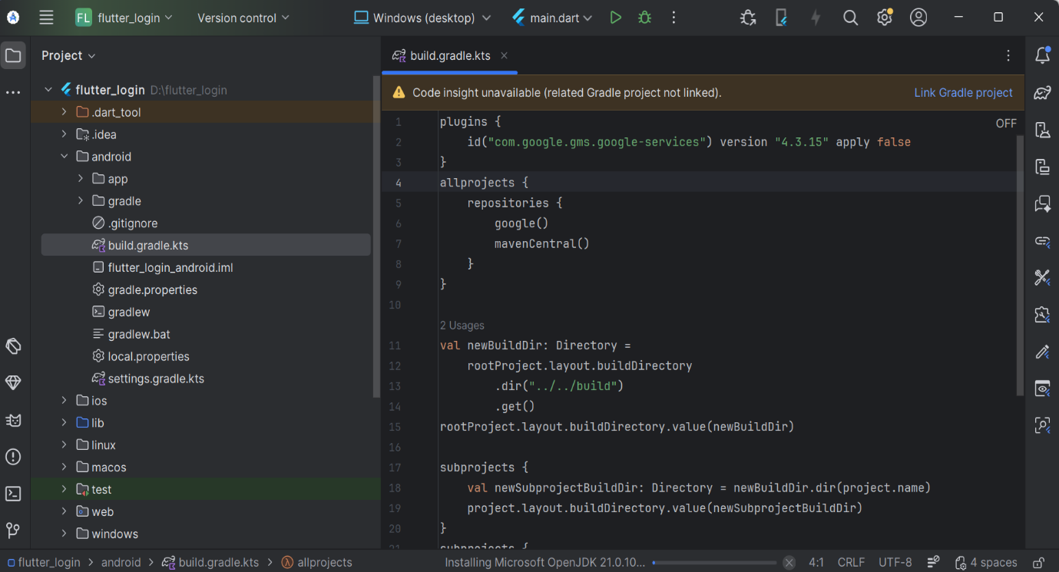
Open File
android/app/build.gradle

Add at bottom:
apply plugin: 'com.google.gms.google-services'
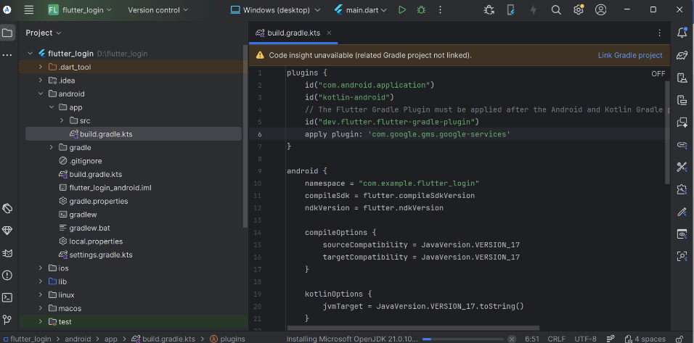

Step 6: Enable Email Password Authentication
- Open Firebase Console.
- Click Authentication.
- Click Get Started.
- Select Sign-in Method.
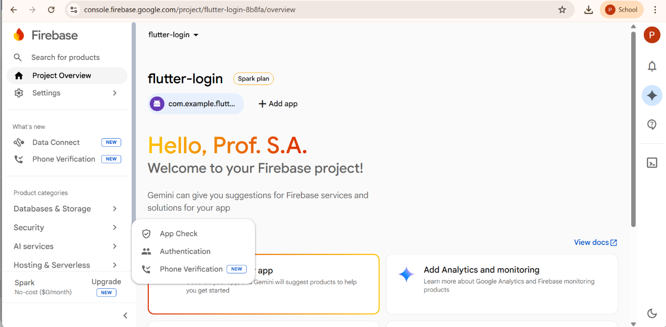
- Enable:
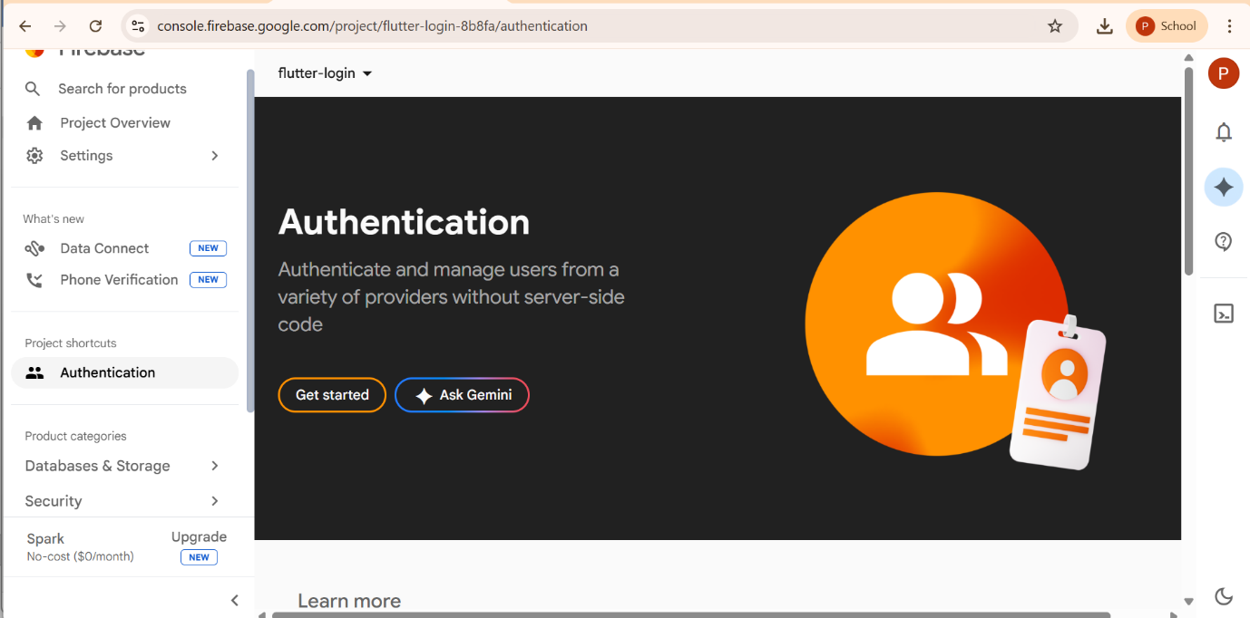

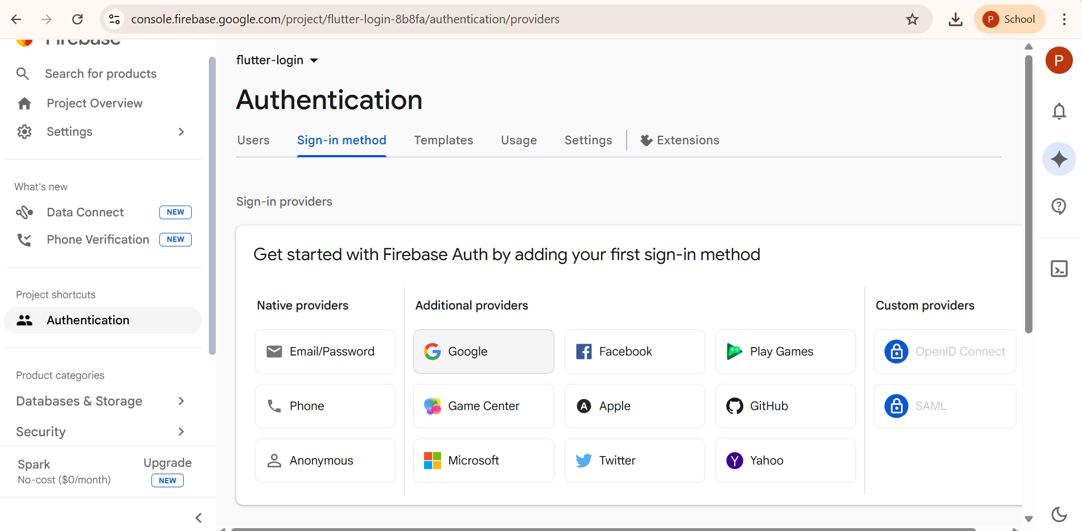

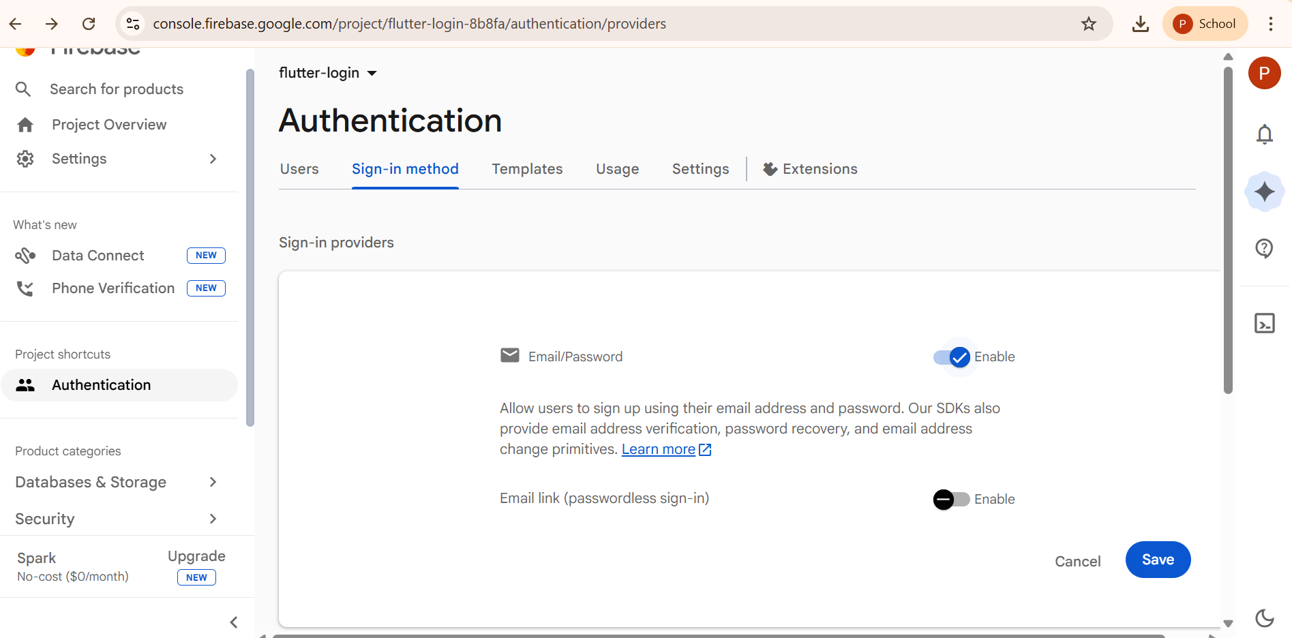
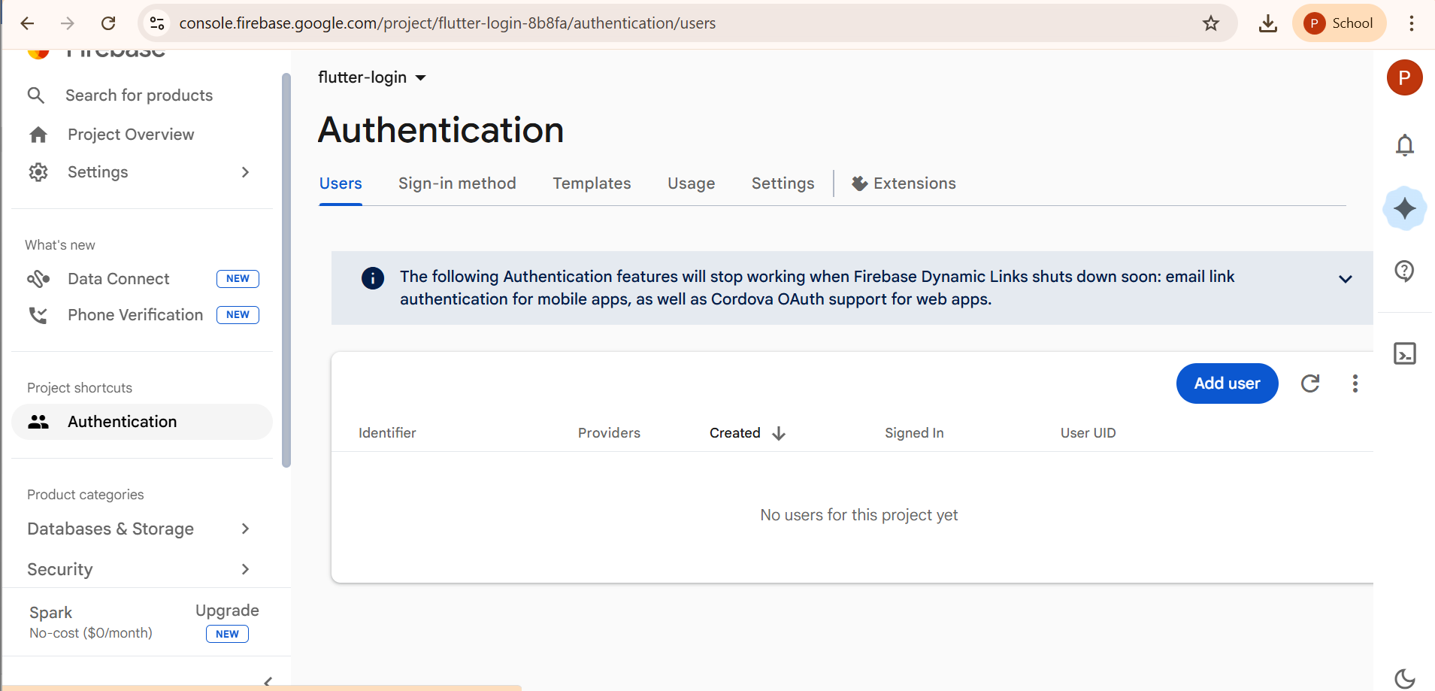
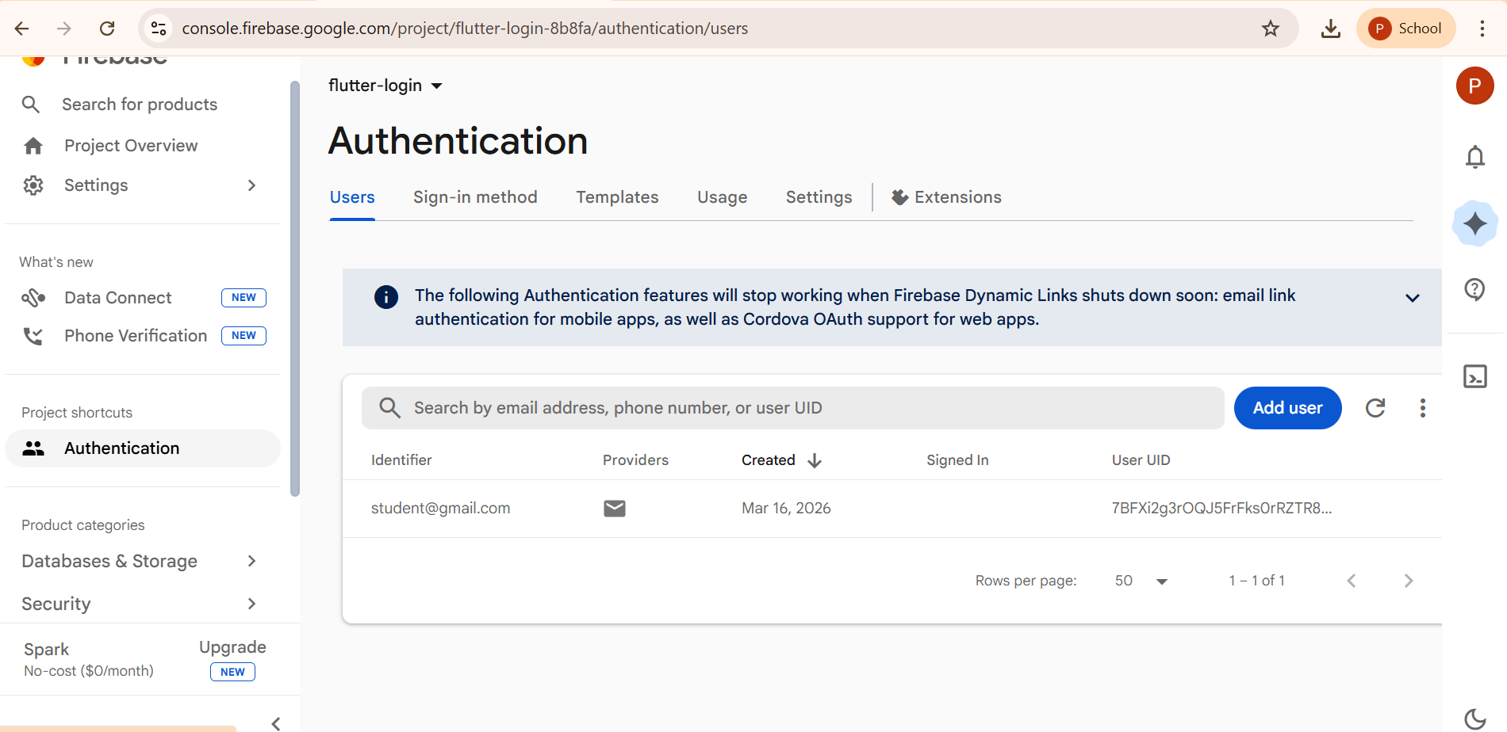

Step 7: Add Firebase Dependencies
Open:
pubspec.yaml
Add
firebase_core: ^2.0.0
firebase_auth: ^4.0.0
flutter pub get

Step 8: Initialize Firebase
Open:

import 'package:flutter/material.dart';
import 'package:firebase_core/firebase_core.dart';
import 'login_screen.dart';

void main() async {

WidgetsFlutterBinding.ensureInitialized(); // Ensures Flutter framework is initialized before Firebase starts

await Firebase.initializeApp(); // Initialize Firebase

runApp(MyApp());

}

class MyApp extends StatelessWidget {

@override
Widget build(BuildContext context) {

return MaterialApp(
debugShowCheckedModeBanner: false,
title: "Firebase Login",
home: LoginScreen(),
);

}

}

Step 9: Create Login UI
Create two TextFields:
- Email
- Password

login_screen.dart
import 'package:flutter/material.dart';
import 'package:firebase_auth/firebase_auth.dart';

class LoginScreen extends StatefulWidget {

@override
_LoginScreenState createState() => _LoginScreenState();

}

class _LoginScreenState extends State<LoginScreen> {

final TextEditingController emailController = TextEditingController(); // Controller to store email entered by user
final TextEditingController passwordController = TextEditingController(); // Controller to store password entered by user

// Login function to authenticate user using Firebase
Future loginUser() async { // Firebase method for user login

try {

await FirebaseAuth.instance.signInWithEmailAndPassword(
email: emailController.text.trim(),
password: passwordController.text.trim(),
);

ScaffoldMessenger.of(context).showSnackBar(
SnackBar(content: Text("Login Successful")),
);

}

catch (e) {

ScaffoldMessenger.of(context).showSnackBar(
SnackBar(content: Text("Login Failed")),
);

}

}

// Function to create new user account
Future registerUser() async {

try {

await FirebaseAuth.instance.createUserWithEmailAndPassword(
email: emailController.text.trim(),
password: passwordController.text.trim(),
);

ScaffoldMessenger.of(context).showSnackBar(
SnackBar(content: Text("Registration Successful")),
);

}

catch (e) {

ScaffoldMessenger.of(context).showSnackBar(
SnackBar(content: Text("Registration Failed")),
);

}

}

@override
Widget build(BuildContext context) {

return Scaffold(

appBar: AppBar(
title: Text("Firebase Login"),
),

body: Padding(

padding: EdgeInsets.all(20),

child: Column(

mainAxisAlignment: MainAxisAlignment.center,

children: [

TextField(

controller: emailController,

decoration: InputDecoration(
labelText: "Email",
border: OutlineInputBorder(),
),

),

SizedBox(height: 20),

TextField(

controller: passwordController,
obscureText: true,

decoration: InputDecoration(
labelText: "Password",
border: OutlineInputBorder(),
),

),

SizedBox(height: 30),

ElevatedButton(

onPressed: () {

loginUser();

},

child: Text("Login"),

),

SizedBox(height: 10),

ElevatedButton(

onPressed: () {

registerUser();

},

child: Text("Register"),

)

],

),

),

);

}

}

