History of Approvals and Revisions
Revision Date | Version | Author | Description
July 26, 2006 | 0.1 | Dmitry Bugaichenko | First version
July 28, 2006 | 0.2 | Dmitry Bugaichenko | High-level architecture, Object Descriptors and Command Handlers are described. Document and Views are in process.
July 31, 2006 | 0.3 | Dmitry Bugaichenko | Document and Views are completed, IDE façade, Connection Wrapper and Utilities are completed. DDEX support entities are in process.
August 1, 2006 | 1.0 | Dmitry Bugaichenko | Document and Views description is completed.
August 25, 2006 | 1.1 | Dmitry Bugaichenko | Descriptors description is refined to reflect actual implementation.

Contents
The Document 4
Introduction 5
About DDEX 5
Terms and Conditions 6
High-Level Architecture 8
Database Objects and Commands 9
Dynamic Component Pattern 11
Register Dynamic Class Collaboration 13
Create Instance Collaboration 13
Known Bottlenecks 14
Data Object Support XML 14
Data View Support XML 15
Command Definitions 15
DDEX Support Entities 16
DataObjectEnumerator 17
DataViewCommandHandler 18
DataConnectionSupport 18
Command Handlers 20
ICommand Interface 21
BaseCommand Base Class 21
OpenEditorCommand Base Class 22
Final Command Handler Class 23
Usages and Dependencies 23
Documents and Views 24
Common Interfaces 25
IDocument Interface 25
IEditor Interface 26
Documents 26
BaseDocument Class 27
Data Loading 28
Changes Saving 28
Attributes Accessing 29
Final Documents 29
Views 30
BaseEditor Class 30
Final View 31
Usages and Dependencies 32
IDE façade 33
Hierarchy Accessing 33
RDT integration 34
Object Descriptors 35
IObjectDescriptor Interface 36
ObjectDescriptor Class 36
Final Object Descriptor Classes 37
Usages and Dependencies 37
Utilities 39
DataInterpreter utility 39
Enumerator utility 39
QueryBuilder utility 40
Connection Wrapper 41
Appendix A: Files Listing 42

The Document
This document is indented to describe architecture of Data Designer Extensibility (DDEX) provider for MySQL package. The document is structured as follows:
- The “Introduction” section gives brief description of the library goals and provides definition of the main terms. This section also contains brief description of DDEX technology and gives useful documentation reference.
- The “High-Level Architecture” section describes package components with their dependencies and interactions. It also describes main principles of the architecture and guide reader through other sections with detailed description of each component.
- The sections below “High-Level Architecture” contain detailed component description for each component.
- The “Appendix A: Files Listing” contains listing of the provider files with its short descriptions.
The reader is assumed to be familiar with Microsoft .NET platform, C# language and fundamentals of the Microsoft Visual Studio IDE integration.

Introduction
Visual Studio IDE provides developers with set of useful tools intended to simplify data-driven application development. This tool set includes, for example, Server Explorer, Data Explorer and DataSet designer. These tools are based on the two closely related technologies:
- ADO.NET 2.0 is used at the data-driven application run-time. Visual Studio IDE tools help developers to correctly setup ADO.NET and data binding mechanisms for the application. ADO.NET is used to manipulate data.
- Data Designer Extensibility (DDEX) is used at the design time by Visual Studio IDE tools to get information about underlying data source and its schema. This information is used to setup ADO.NET and data bindings. DDEX is used to manipulate schema creating, modifying and deleting tables, views, stored procedures and etc. DDEX is used to work with metadata.
To support different types of data sources Visual Studio allows creation of custom ADO.NET data providers and DDEX data providers. The second is typically based on the first.
The main goal of this project is to implement custom DDEX provider for MySQL. At the first stage, while there is no stable official ADO.NET 2.0 data provider for MySQL, custom DDEX provider will support only database management and will not support other data designer features.

About DDEX
The Data Designer Extensibility (DDEX) is the way to extend Visual Studio IDE design time abilities and allow data designer tools to work with specific data source. Detailed information about DDEX technology is available at http://msdn.microsoft.com/library/en-us/dnvs05/html/ddexintro.asp and in the Visual Studio SDK documentation at ms-help://MS.VSCC.v80/MS.VSIPCC.v80/MS.VSSDK.v80/dv_vsintegration/html/29ee1968-f420-46aa-ba99-5fe710dc16bb.htm.
DDEX provider should implement several support entities which will be used by Visual Studio IDE tools. These entities include:
- Data source information entities provide information about specific underlying data source. This information may include, for example, SQL syntax details (which character should be used to quote identifiers or to mark query parameters), identifiers management (truncating, expanding and comparing identifiers using data source rules), etc.
- Data communication entities provide ability to manage connection with underlying data source and retrieve data. These entities may include connection wrapper, connection UI dialog, etc.
- Data object support entities describe underlying data source meta-model. Specific XML format is used to declaratively define meta-model.
- Data view support entities describe meta-model representation in the Server Explorer window. Specific XML format is used to declaratively define this representation.
DDEX provider can be implemented in several ways. The simplest way is to develop two XML file with meta-model and its view definition and properly register these files in the registry. In that case standard wrappers will be used for other support entities. But the simplest way is the most restricted way too. It typically allows only basic Server Explorer integration.
The most flexible way is to develop package based DDEX provider as Visual Studio package (see ms-help://MS.VSCC.v80/MS.VSIPCC.v80/MS.VSSDK.v80/dv_vsintegration/html/cad0893a-9c5f-45b7-952a-e2294f83e324.htm for details). This package should include XML definitions of meta-model and its view as embedded resources and implement factory to access other support entities. In that case complete integration, including custom Server Explorer commands and custom Visual Studio editors, is possible.
In this project we are going to develop DDEX package base provider for MySQL.

Terms and Conditions
Following terms and abbreviation are used in the document:
ADO.NET | The technology commonly used by .NET applications to manipulate data. See http://msdn.microsoft.com/data/ref/adonet/ for further details.
Command | The operation on the Database Objects which can be performed via Server Explorer. See the “Database Objects and Commands” section for further details.
ADO.NET data provider | The .NET Assembly which implements ADO.NET interface for interaction with specific data source.
Component | The set of classes indented to implement single task. Component is accessible via well-defined interface and can be used by other components. Component-based approach is used to encapsulate task implementation details.
CTC | Command table Definition files (CTC) are used to define command which can be integrated into Visual Studio IDE GUI. See ms-help://MS.VSCC.v80/MS.VSIPCC.v80/MS.VSSDK.v80/dv_vsintegration/html/3413dda1-f372-4669-bcf0-c64d3463842c.htm for further details.
Custom Attributes | The way to extend assembly meta-data information with new attributes. Custom attributes can be defined at a design time and are accessible at the run-time via Reflection.
Database Object | The entity which is directly represented in the data source meta-model. See the “Database Objects and Commands” section for further details.
Data | The information about Database Objects read from the data source (typically from the INFORMATION_SCHEMA database).
DDEX | Data Designer EXtensibility is the technology used to extend Visual Studio IDE data-driven application development tools.
DDEX provider | The single extension designed to allow Visual Studio IDE data-driven application development tools usage for specific data source.
Dynamic class | Class, which is accessed via object factory. See the “Dynamic Component Pattern” section for further details.
Dynamic component | Component, which allows developer to create, modify and remove its parts transparently. See the “Dynamic Component Pattern” section for further details.
Meta-data | Information about data source meta-model (in the some sense, can be considered as the schema of the INFORMATION_SCHEMA database).
Provider | The current project, DDEX provider for MySQL.
RDT | The Running Document Table is the internal Visual Studio IDE structure used to control all opened documents and editor windows. RDT functionality is accessible via IVsRunningDocumentTable interface. See ms-help://MS.VSCC.v80/MS.VSIPCC.v80/MS.VSSDK.v80/dv_vsintegration/html/bbec74f3-dd8e-48ad-99c1-2df503c15f5a.htm for details.
Reflection | The technology provided by .NET platform to read meta-data information at run time. See http://msdn2.microsoft.com/en-us/library/cxz4wk15.aspx for further information.
Support entities | The classes implemented by the DDEX provider and directly used by Visual Studio IDE. Each entity is defined in the Visual Studio SDK documentation.
Template Method | The design pattern used to implement common behavior in the non-virtual method, which calls virtual or abstract methods. This common behavior can be customized by the inheritors though those virtual and abstract methods. See http://en.wikipedia.org/wiki/Template_method_pattern for further details.
WiX | The common open source XML-based format used to design installation packages.

High-Level Architecture
The provider at the highest level can be divided in to several components as shown at the Figure 1.
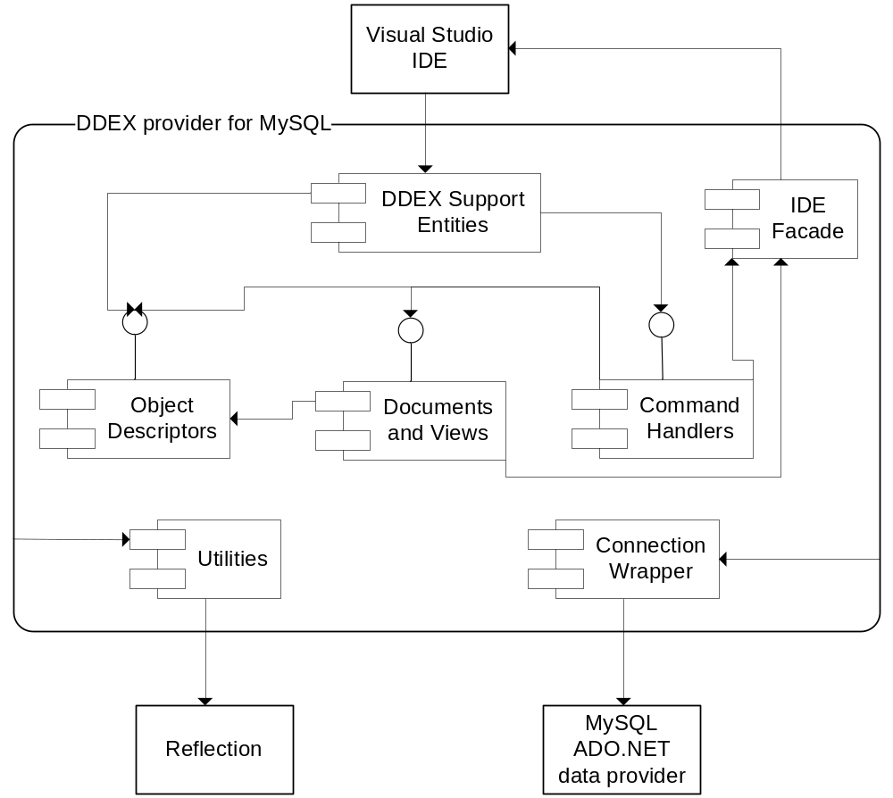
Figure 1. High-level architecture.
Following components form the provider:
- DDEX support entities – the top level component, which contains classes directly used by the Visual Studio IDE. Each class in this component implements single DDEX support entity. This component is described in more details at the “DDEX Support Entities” section.
- Command handlers – the set of the classes used to handle commands from the Server Explorer context menu. This component is used by the Data Command Handler support entity which receives those commands directly and forwards them to the command handlers. This component is described in more details at the “Command Handlers” section.
- Document and Views – the set of the classes used to implement custom editors for the database objects. Document/View design pattern is used to implement custom editors. Document and Views component is used by the command handlers which requires open editor functionality (for example, create object and alter object command handlers). This component is the most complex part of the provider. This component is described in more details at the “Documents and Views” section.
- IDE façade – this component is used by the command handlers and documents and views to interact with Visual Studio IDE. It includes Server Explorer window and hierarchy interaction, operation with RDT and etc. This component is described in more details at the “IDE façade” section.
- Object Descriptors –these classes describe the available Database Objects types, including their attribute names, enumeration SQL and etc. They are responsible for enumeration of database objects. These classes are very closely related with data source meta-model defined in the Data Object Support XML. Any difference with meta-model definition could lead to provider failure. Object descriptors are used by the SQL generation utility to build enumerate queries, document objects use descriptors to get attribute names for represented object type and command handlers use descriptors to get information necessary to build identifiers for newly created objects. This component is the simplest one, but it is probably the most important. This component is described in more details at the “Documents and Views” section.
- Utilities – the set of the static classes where each class is designed for its own purpose and can be widely used by other components. Each utility class is static and easy to access. Utilities include SQL gemeration, data interpretation utility, Visual Studio UI accessing utility and Reflection usage utility. Utilities are used widely by all other components. These classes are described in more details at the “Utilities” section.
- Connection Wrapper – this component is used by other component to interact with the underlying data source via MySQL ADO.NET Data Provider. It wraps DataConnection object and expose methods for the safe SQL query execution and connection information retrieving. This component is described in more details at the “Connection Wrapper” section.
There are two very important high-level concepts which determined provider architecture. These concepts are Database Object and Command. Database Object is the database entity like table, view, stored procedure, etc, and Command is the operation which can be performed on the Database Object. Detailed description of these concepts and their representation in the architecture can be found at the “Database Objects and Commands” section.
Three “middle-tier” components (Command Handlers, Documents and Views, Object Descriptors) are very closely related with those concepts – their main content is the set of homogenous classes which are in one-to-one relation with commands or database objects. Hence content of these components is volatile. New command may be introduced at any time and it can require new command handler, new object type can be introduced and it definitely requires dedicated object descriptor and probably requires document and editor objects.
In contrast, other components are static – there are composed with set of heterogeneous classes and each of these classes has its own unique role and they use dynamic components to perform specific processing. For example, enumeration utility class uses object descriptor to get required for the enumeration information and perform other processing using universal algorithm.
Because of the volatility of the dynamic components, they are implemented using dynamic component pattern which is described in more details at the “Database Objects and Commands” section.
However, DDEX and Visual Studio integration put on some restrictions which not allow us to completely eliminate volatility bottlenecks. These bottlenecks are described in more details at the “Known Bottlenecks” section.

Database Objects and Commands
The aim of the DDEX provider is to allow developer to browse database objects and perform several operations with them. That is why the role of Database Object and Command concepts is so significant.
Database Object is the entity which has direct representation in the data source model and meta-model, for example, table, view, table column, stored procedure, etc. In the provider architecture Database Object has following relevant entities:
- Data Object Type definition – each Database Object is described in the Data Object Support XML file with corresponding Type node. The name declared for this Type node is used in other components to identify and reference Database Objects of that type. This name is also used by Visual Studio IDE to query information about available objects of that type.
- Data Object Type visual representation – additional information about Database Object visual representation (like displayable names and descriptions) can be defined in the Data View Support XML file using TypeExtension node, which references source type description using type name.
- Object Descriptor – each Database Object has corresponding object descriptor, which is static class with information about this Database Object type. Descriptors are used by other components to get required type information. The relevance between descriptors and Database Objects is determined using type name – each descriptor has the static property TypeName which is equal to some type name introduced in the Data Object Support XML and, hence, corresponds to certain Database Object type. Note that descriptors and data object support XML must contain coherent information.
- Document and Editor – for the Database Objects which allows creation, editing, dropping and cloning via Server Explorer and custom editors, Document object and Editor object should be created. Editor object is a simple view and Document object is the one responsible for proper database interaction. Relevance between documents and Database Objects is determined using type name and object identifier. Each document has a property TypeName which directly identifies relevant object descriptor and Data Object Support XML Type node. But, in contrast to first two entities, document represents data and not the meta-data. That is why each document has ObjectID property which identifies exact object in the data source. This identifier is the sequence of the names in the Database Objects hierarchy, for example {“mysql”, “func”, “name”} sequence identifies “name” column in the table “func” of “mysql” schema.
Command is the operation which can be performed on the Database Object via Server Explorer context menu. Each command is identified with the command group global unique identifier and its own integer identifier. Commands have following representations in the provider architecture:
- Command definition – identifiers for all groups and command must be declared in the Command Table Configuration (CTC) file. This file defines which commands can appear in the Visual Studio IDE GUI and how they should appear. For further information on the CTC files see ms-help://MS.VSCC.v80/MS.VSIPCC.v80/MS.VSSDK.v80/dv_vsintegration/html/3413dda1-f372-4669-bcf0-c64d3463842c.htm.
- Command handler – each command should have corresponding command handler object, which executes it. Commands are handled by the DataCommandHandler DDEX support entity, which forwards them to the proper command handler. Relevance between command and command handlers is determined using command group GUID and command ID.
- Command reference – to define what command should be accessible via Server Explorer context menu references in the Data View Support XML file are required. For each defined Server Explorer tree node this XML defines set of accessible commands and references them using command group GUID and command ID.

Dynamic Component Pattern
The main goal of the dynamic component pattern is to localize possible changes for volatile components like command handlers, documents and views and object descriptors. Main part of all these components provides the set of similar independent objects (command handler for single command, document, view and object descriptor for single object type). Dynamic component pattern allows us to localize changes for new class addition, existing class modification and existing class removal in the single class (this new/modified/deleted class). Public interface of the component and all other classes remains unchanged.
Pattern is founded on the following concepts:
- Common Interface – common interface is defined for classes in the component and all dynamic classes implement this common interface.
- Objects Factory – component includes object factory class, which is able to create an instance of the dynamic class by given type identifier (for the command handlers this identifier is the command group GUID and command identifier, for the documents, views and descriptors it is the object type name from the Data Object Support XML). This factory is singleton object and therefore accessible from everywhere.
- Registration in Factory – for internal classes factory allows dynamic class registration. It means that new dynamic class can call factory’s registration method and provide identifier and create method delegate. After registration is completed, factory is able to create registered class instance using create method delegate in the response for the object request with the corresponding identifier.
- Reflection Markup – custom reflection attribute is created to simplify class registration. These attributes receives all necessary registration data (identifier value and System.Reflection.Type object for the class), extracts proper constructor information into local variable and registers create method (internal attribute method which calls stored constructor).
- Base Dynamic Class – the base class for all dynamic classes implements required interface. Some part of the interface can be implemented using reflection, without involving inheritors (for example, dynamic identifier retrieving can be implemented using custom markup attribute).
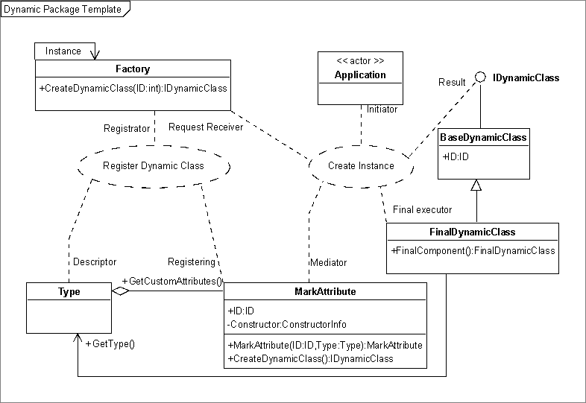
Figure 2. Roles and Collaborations.
Main roles of the pattern and their relations are represented at the Figure 2. Two main collaborations are identified on the figure:
- Register Dynamic Class – the factory, the custom markup attribute and the type descriptor collaborate to register new dynamic class within the factory. Instance of the dynamic class is not created at this moment and, hence doesn’t participate in collaboration. This collaboration described in more details at the “Register Dynamic Class Collaboration” section.
- Create Instance – the application (any entity outside this component), the factory, the custom markup attribute and the dynamic class itself collaborate to create instance of the dynamic class. Application initiates this collaboration and gets reference to desired interface implementation as a result of the collaboration. This collaboration described in more details in the “Create Instance Collaboration” section.
This implementation of the registration and creation process makes introducing of the new dynamic class very simple. The dynamic class must satisfy following requirements to be accessible via factory:
- The dynamic class implements proper common interface. Usually this requirement satisfied using inheritance from base dynamic class, which is already implements common interface.
- The dynamic class provides public constructor with proper signature. This signature is specified for each component.
- The dynamic class is marked with proper custom attribute. This attribute is the internal part of the component.

Register Dynamic Class Collaboration
Register dynamic class collaboration is used to “teach” dynamic class factory to create instances of the specific dynamic class. Typical scenario of the collaboration can be found at the Figure 3. Following roles are involved in the collaboration:
- Package – the package is responsible for creation of the custom attributes. Custom attributes are created only when the instance of the marked class is created or when custom attributes are requested, but no one of these events occurs by default, hence factories won’t work unless someone forces all custom attributes to be created at the initialization. This is the package role.
- Registering – the custom attribute validates dynamic class type to which it applies and registers creation method for this dynamic class in the factory. It uses reflection to validate class and get constructor information.
- Descriptor – the reflection Type object which describes dynamic class. It is used by registering to validate dynamic class and retrieve constructor information.
- Registrator – the factory receives registration message and stores information about dynamic class in the private collection.
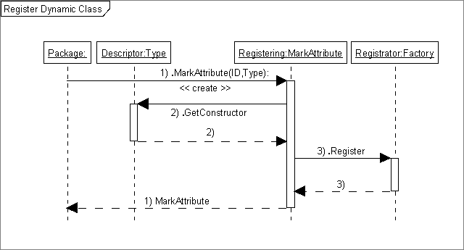
Figure 3. Dynamic Class Registration.
Typical registration scenario includes following steps:
- The package creates the custom mark attribute. To force creation package iterates through all classes in the assembly and calls GetCustomAttributes method for each of them.
- The custom mark attribute retrieves constructor information using GetConstructor with specified desired signature.
- The custom attribute calls internal registration method, provided by the factory to register dynamic class.

Create Instance Collaboration
Create instance collaboration is initiated by package entity to get reference to the dynamic class interface implementation for specified dynamic class identifier. Typical scenario for this collaboration can be found at the Figure 4. Following roles are involved in the collaboration:
- Initiator – the package entity which wants to get reference to the dynamic class instance. It calls factory and provides identifier for desired dynamic class.
- Request Receiver – the factory receives request for creation, searches for registered creation method for desired dynamic class and executes it.
- Mediator – the custom mark attribute provides creation method and uses reflection constructor info to create instance of the dynamic class.
- Final Executor – the dynamic class provides constructor which is executed by mediator using reflection information.
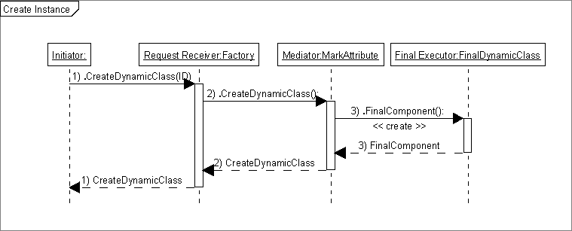
Figure 4. Create Instance Collaboration.
Typical registration scenario includes following steeps:
- The initiator calls factory method and provides desired dynamic class identifier.
- The factory extracts previously registered creation method (provided by the mediator) and executes it.
- The mediator uses reflection constructor information and executes constructor of the proper dynamic class. Results of this call are returned to the initiator.

Known Bottlenecks
Following bottlenecks are identified at his moment:
- Data Object Support entity – the XML file used to define data source meta-model seems to be worst bottleneck, because it concentrates definition of all object types in single place, hence it is very volatile. This bottleneck is described in more details in the “Data Object Support XML” section.
- Data View Support entity – the XML file used to define meta-model representation in the Server Explorer tree. This file also contains information about all types, their representation and commands. This bottleneck is described in more details in the “Data View Support” section.
- Command definitions – the Visual Studio requires all command to be defined in the CTC file. This file must be changed if new command is introduced or exists command is removed. This bottleneck is described in more details in the “Command Definitions” section.

Data Object Support XML
The worst known bottleneck is the Data Object Support entity – the XML file used to describe data source meta-model. It is going to be very volatile, because each meta-model change requires proper modification of this file. Furthermore, all changes made to this file must be synchronized with proper object descriptor objects.
At this point only one way to eliminate this problem is identified – automatic generation of the Data Object Support XML based on the object descriptors. But it is to complex to be a good choice.
However, we can significantly reduce impact of this bottleneck using unit test for Data Object Support entity. This unit test will iterate though all defined types and call Data Object Enumerator entity to enumerate objects of this type and compare results with type declaration. Each property declared in the Data Object Support XML for that type must have corresponding column in the retrieved data reader and their types must be compatible.

Data View Support XML
Data View Support XML contains definition of the data source meta-model visual hierarchical representation. Some changes in the meta-model could lead to the changes in the Data View Support XML. This XML also contains references to the command, and hence changes in the command set could lead to the changes in this XML. Furthermore, information in the Data View Support XML must be coherent with the Data Object Support XML file and objects descriptors, command handlers and CTC file.
To reduce impact of this bottleneck we use unit test for the Data View Support entity this test iterates through XML file and ensures that:
- All referenced types have relevant object descriptor and the Data Object Support XML entry.
- All referenced commands have registered command handlers.
- All referenced string resources are present.
This unit test will allow us to detect probable inconsistency at the early phase.

Command Definitions
Command table Definition files (CTC) are used to define command which can be integrated into Visual Studio IDE GUI. Since all commands are collected in the single file, this file must be changed if the command set is changed.

DDEX Support Entities
DDEX support entities are the classes which are directly used by the Visual Studio IDE. These classes each inherit one of the standard base DDEX classes and extend their functionality with ability to interact with MySQL ADO.NET data provider. Following entities are supported by this provider version:
- DataObjectSupport – this entity contains definition of the meta-model for the data source, including available Database Object types and their structure. This entity is a wrapper MySqlDataObjectSupport over XML file MySqlDataObjectSupport.xml which is compiled as embedded resource. Format of this XML file is described in more details at ms-help://MS.VSCC.v80/MS.VSIPCC.v80/MS.VSSDK.v80/dv_vsdecon/html/ef752e05-dab7-45f9-b99e-e119ef3ae227.htm.
- DataViewSupport – this entity contains definition of meta-model representation in the Server Explorer hierarchy window. This entity is a wrapper MySqlDataViewSupport over XML file MySqlDataViewSupport.xml which is compiled as embedded resource. Format of this XML file is described in more details at ms-help://MS.VSCC.v80/MS.VSIPCC.v80/MS.VSSDK.v80/dv_vsdecon/html/f448f9b3-bbd1-4ed9-a2bc-373672da983c.htm.
- DataObjectEnumerator – this entity is used by the DDEX to enumerate Database Objects of given type with given restrictions and sort order. This entity is implemented in the MySqlDataObjectEnumerator which is described at the “DataObjectEnumerator” section.
- DataViewCommandHandler – this entity is used by the DDEX to validate and execute commands from the Server Explorer context menu. This entity is implemented in the MySqlDataViewCommandHandler which is described in more details at the “DataViewCommandHandler” section. Information on this entity and its role is available in the Visual Studio SDK documentation at ms-help://MS.VSCC.v80/MS.VSIPCC.v80/MS.VSSDK.v80/dv_vsdas/html/T_Microsoft_VisualStudio_Data_DataViewCommandHandler.htm.
- DataSourceInformation – this entity is used by the DDEX to get general and connection specific data source information. This entity is implemented in the MySqlDataSourceInformation class. This class adds only “DataSource” property to the available properties and overrides reading of “DefaultSchema” property. Over properties are general and their values are initialized in the constructor. Information on this entity and its role is available in the Visual Studio SDK documentation at ms-help://MS.VSCC.v80/MS.VSIPCC.v80/MS.VSSDK.v80/dv_vsdas/html/T_Microsoft_VisualStudio_Data_DataSourceInformation.htm.
- DataConnectionSupport – this entity is used by the DDEX to interact with the underlying MySqlConnection object and create over support entities, including DataObjectSupport, DataViewSupport and DataSourceInformation. This entity is implemented in the MySqlDataConnectionSupport class which is described in more details at the “DataConnectionSupport” section. Information on this entity and its role is available in the Visual Studio SDK documentation at ms-help://MS.VSCC.v80/MS.VSIPCC.v80/MS.VSSDK.v80/dv_vsdas/html/T_Microsoft_VisualStudio_Data_DataConnectionSupport.htm.
- DataConnectionProperties – this entity is used by the DDEX during connection creation. This entity defines available properties for the connection, determines minimal required set of the properties and tests connection. This entity is implemented in the MySqlConnectionProperties class. Information on this entity and its role is available in the Visual Studio SDK documentation at ms-help://MS.VSCC.v80/MS.VSIPCC.v80/MS.VSSDK.v80/dv_vsdas/html/T_Microsoft_VisualStudio_Data_DataConnectionProperties.htm.
- DataConnectionUIcontrol – this is the GUI control displayed for the user during connection initialization. This control uses DataConnectionProperties entity to store connection properties. This entity is implemented in the MySqlDataConnectionUIControl. Information on this entity and its role is available in the Visual Studio SDK documentation at ms-help://MS.VSCC.v80/MS.VSIPCC.v80/MS.VSSDK.v80/dv_vsdas/html/T_Microsoft_VisualStudio_Data_DataConnectionUIControl.htm.
- Object Factory – this is the entry point for the provider. This factory is used by the DDEX to create entities including DataConnectionUIControl, DataConnectionProperties and DataConnectionSupport (other entities are created by DataConnectionSupport). This entity is implemented in the MySqlProviderObjectFactory class. Information on this entity and its role is available in the Visual Studio SDK documentation at ms-help://MS.VSCC.v80/MS.VSIPCC.v80/MS.VSSDK.v80/dv_vsdas/html/T_Microsoft_VisualStudio_Data_DataProviderObjectFactory.htm.
- Package – this is the root entity of the provider. Package class is loaded directly by Visual Studio IDE and it is responsible for initialization and factory service registration. This entity is implemented in the MySqlDataProviderPackage. Information on this entity and its role is available in the Visual Studio SDK documentation at ms-help://MS.VSCC.v80/MS.VSIPCC.v80/MS.VSSDK.v80/dv_vsintegration/html/cad0893a-9c5f-45b7-952a-e2294f83e324.htm.

DataObjectEnumerator
This entity is used by the DDEX to enumerate Database Objects and it is implemented in the MySqlDataObjectEnumerator class. It implements only one method EnumerateObjects with following parameters:
- typeName – name of the Database Object type to enumerate. This is the name of the one of Type nodes in the Data Object Support XML file.
- items – this parameter is not supported now. This parameter is used only if provider supports filtering.
- restrictions – object array with restrictions on the Database Objects. These restrictions will be converted to strings, escaped, quoted and inserted into enumeration SQL query. If value for restriction slot is missing, default restriction value read from the object descriptor used for this slot.
- sort – string with default sort expression. This expression will be appended to the enumeration query after ORDER BY clause. If sort expression is not specified, default sort expression from the object descriptor used instead.
- parameters – this parameter is not used. Information supplied in this parameter can be used to provide extra data indicating how to perform the enumeration, allowing implementations of this method to be more data driven.
This class uses Enumerator utility to enumerate Database Objects. Note that the same entry point is used for enumeration by all entities.

DataViewCommandHandler
This entity process requests for commands from the Server Explorer window and it is implemented in the MySqlDataViewCommandHandler class. The commands are executed over hierarchy items in the Server Explorer tree, and these items are accessible via DataViewHierarchyAccessor class (see ms-help://MS.VSCC.v80/MS.VSIPCC.v80/MS.VSSDK.v80/dv_vsdas/html/T_Microsoft_VisualStudio_Data_DataViewHierarchyAccessor.htm for further information). This entity implements following methods:
- GetCommandStatus – this method is used by the IDE to determine if the given command is valid for given array of the hierarchy items identifiers. This method can show/hide, enable/disable commands and customize their text.
- ExecuteCommand – this method is used by the IDE to execute given command for given array of the hierarchy items (or single hierarchy item). Result of execution is the object value, which is always null.
Command Handlers component is used to determine status of the command and execute it. This support entity is responsible for creation of the IDE façade object (see the “IDE façade” section for further details) and forwarding it to the command handlers. And command handlers will propagate IDE façade to the document objects.
For command execution MySqlDataViewCommandHandler simply forwards execution query to the Execute method of the proper command handler. Command status retrieving is more complex from its point of view. It is performed in following steps:
- Get proper command handler using command handler factory. If command handler not founded, forward call to the base class and return.
- Call command handler GetIsVisible method. If command not visible, hide it and return.
- Show command and make it enabled.
- Call GetText method of the command handler to get localized and customized command text. If localized text founded, alter command text.

DataConnectionSupport
This entity is used by the IDE and over entities to access underlying MySqlConnection object. At this point official release of the MySqlConnection doesn’t support ADO.NET 2.0 provider and we have to implement our own support instead of using standard wrapper. This entity is implemented in the MySqlConnectionSupport class.
Note that DataConnectionSupport should not be used directly – IDE wraps it with DataConnection object which is used by DDEX. Provider entities additionally wrap DataConnection with the DataConnectionWrapper object (see the “Connection Wrapper” section for details).
Following method and properties are overridden to support underlying connection interaction:
- ProviderObject property – this property returns reference to the underlying MySqlConnection object. It should not be used directly, GetLockedProviderObject method of the DataConnection wrapper should be used instead.
- ConnectionString property – this property used to get and set connection string for the underlying connection object.
- ConnectionTimeout property – this property can be used to set maximum wait time for the connection, but it is not supported now.
- State property – this property returns DataConnectionState value which is selected depending on the underlying connection state.
- Initialize method – this method is called by the IDE to initialize connection support. MySqlConenction is created in this method. Reference to the existing MySqlConnection can be passed in this method to create clone of this connection, but this feature is not supported.
- Open method – is used by the IDE to open connection. It forwards call to the underlying MySqlConnection.
- Close method – is used by the IDE to close connection. It forwards call to the underlying MySqlConnection.
Additional responsibility for this support entity is to create other connection-depended support entities, including DataObjectSupport, DataViewSupport and DataSourceInformation entities. Creation is performed in the overridden GetServiceImpl method.

Command Handlers
The Command Handlers component contains implementation of processors (or handlers) for all supported by provider commands, which are accessible from the Server Explorer context menu. Main consumer of this component is the DataViewCommandHandler support entity which redirects each Visual Studio IDE request to the proper command handler.
Since this component is dynamic, it is implemented using Dynamic Component pattern (see the “Dynamic Component Pattern” section for further details). Architecture of this component is presented at the Figure 5.
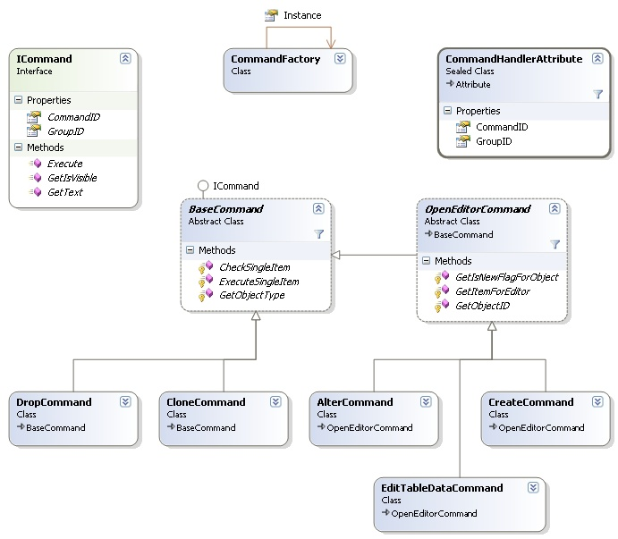
Figure 5. Command Handlers.
The entry point for the component is singleton CommandFactoy with static Instance property and public method CreateCommandHandler, used to get command handler for given command group global unique identifier and command identifier. Note that the command handlers are stateless – context is provided by caller for each method call. Hence the same instance of the command handler will be returned to every call with the same command group GUID and command ID.
CreateCommandHandler method returns reference to the common for all command handlers interface ICommand. Detailed information about this interface can be found at the “ICommand Interface” section.
Base class for all commands is the BaseCommand class. It implements proper interface using template methods and provides several abstract and virtual methods to customize its behavior. This class is described in more details at the “The common interface for all command handlers is the ICommand. It defines two properties to identify command GroupID and CommandID. First property is the global unique identifier of the command group and the second is the identifier of the group itself. Values of these properties are equal to the identifiers declared in the CTC file.” section.
For the commands which open custom editors (like “Create Object” and “Alter Object” commands) OpenEditorCommand base class is introduced. It inherits BaseCommand class and implements several additional template methods. This class is described in more details at the “OpenEditorCommand Base Class” section.
Each command handler class must inherit the BaseCommand or OpenEditorCommand base classes and must implement abstract methods of the base class. Additionally it can override base class virtual methods. Detailed information about final descriptor classes can be found at the “Final Command Handler Class” section.
Usages of the Command Handlers component and its dependencies are discussed at the “Usages and Dependencies” section.

ICommand Interface
The common interface for all command handlers is the ICommand. It defines two properties to identify command GroupID and CommandID. First property is the global unique identifier of the command group and the second is the identifier of the group itself. Values of these properties are equal to the identifiers declared in the CTC file.
It also defines several methods for command validation and execution. Each method takes reference to the IDE façade object and array of identifiers of hierarchy items. Each hierarchy item represents single node in the Server Explorer tree view and may be related with Database object (or may be static like “Tables” node). For more information on IDE façade object and its role see “Error: Reference source not found”.
Following methods are defined:
- Execute – this method is used to execute command for each given hierarchy item. It returns array of objects each of those are the result of command execution for single hierarchy item. Typically it is the array of null’s.
- GetIsVisible – this method is used to determine if command should be visible for given items. It returns true or false flag.
- GetText – this method is used to get localized text for the command. This text is also may be customized depending on the items for which command is shown. For example, “Alter Object” command should become “Alter Table” if the items are database tables.

BaseCommand Base Class
This is the base class for all command handlers and it implements common interface ICommand.
To implement properties GroupID and CommandID reflection is used. Base class retrieves CommandHandlerAttribute custom attribute for the inheritor type information and uses it to get necessary information. Hence, all final inheritors should be marked with that attribute.
Template method design pattern is used to implement other interface methods. Three abstract methods are used in these templates. Each of these abstract methods takes IDE façade reference and identifier of the single hierarchy item. Following abstract methods are defined:
- CheckSingleItem – this method is used to check command visibility for a single item. In the GetIsVisible method implementation base class iterates though item identifiers array and checks each item using this method. If for any item command is inaccessible, GetIsVisible returns false.
- ExecuteSingleItem – this method is used to execute command for the single hierarchy item and it returns object. In the Execute method implementation base class iterates through item array, calls this method for each item and collects results in array.
- GetObjectType – this method returns Database Object type which is related to the given hierarchy item. It can be the type of the Database Object directly related to given hierarchy item or type of one of possible children. It is used to adjust command text with the proper object type name.
In addition to abstract methods, base class provides several virtual methods and properties which are implemented using default (more common behavior) and can be overridden if specific behavior is required. These are:
- IsEmptyAllowed property – this Boolean property indicates if this command can be executed on the empty array of the items. The default value is false. This property is used in the GetIsVisible method implementation to validate input array length.
- IsMultiselectAllowed property – this Boolean property indicates if this command can be executed on the several items simultaneously. The default value is false. This property is used in the GetIsVisible method implementation to validate input array length.
- CommandText property – this string property returns localized command text template with the placeholder for localized type name. Default implementation generates resource identifier using command group GUID and command identifier and reads localized value from the resources using this identifier.
- FormatText method – this method takes string with command text template, IDE façade object and array of hierarchy items identifiers. It returns formatted command text string. Default behavior is to get localized object type name for the first item and place it into template using String.Format method.
The most intrusting feature of the base class is command text generation in the GetText implementation. As a first step this implementation get localized text template using CommandText property. By default this property reads text from the resource file using generated resource identifier:
- If the command is provider specific command (if it belongs to the guidMySqlProviderCmdSet group with GUID “B87CB51F-8A01-4c5e-BF3E-5D0565D5397D”) identifier is “Command_{ID}” where ID is the hexadecimal representation of the command identifier (“Command_100” for provider command with identifier equals to decimal 256).
- If the command is the build-in Server Explorer command (if it belongs to the guidDataCmdSet group) identifier is “CommandBuiltIn_{ID}” where ID is the same ass above.
- In other case identifier is “Command{GroupID}_{ID}” where GroupID is the group GUID converted to string using default conversion (“xxxxxxxx-xxxx-xxxx-xxxx-xxxxxxxxxxxx”) and ID is the same as above.
Additionally the base class provides several useful protected utility methods for the inheritors.

OpenEditorCommand Base Class
This base class is used for the command handlers which opens custom editors for Database Objects. It implements CheckSingleItem and ExecuteSingleItem methods of the abstract BaseCommand. The first is implemented using GetObjectType method – if object type can be retrieved, command considered as valid. And the second implementation is the template method which uses following additional abstract methods:
- GetObjectID – this method return array with Database Object identifier using IDE façade reference, object type name string and hierarchy item identifier.
- GetIsNewFlagForObject – this method returns Boolean flag indicating if this command will create new object or will open editor for the exist object. It takes IDE façade object reference and hierarchy item identifier.
- GetItemForEditor – this method returns hierarchy item identifier which should be used to register document and editor in the RDT. It takes IDE façade object reference and hierarchy item identifier. Result may be the identifier of the new hierarchy item or may be the same as input identifier.
ExecuteSingleItem template method involves following steps:
- Get the object type name for the operation using GetObjectType method.
- Get the object identifier for the operation using GetObjectId method.
- Determine if command will create new object using GetIsNewFlagForObject method.
- Get the hierarchy identifier for document and editor using GetItemForEditor method.
- If object is new, initialize name property for the hierarchy item.
- If object is not new, try to find already opened editor using object identifier, and if founded, activate it and return.
- Create document object and editor object using DocumentViewFactory.
- Call RegisterEditor method of the IDE façade object.
Additionally the base class provides several useful protected utility methods for the inheritors.

Final Command Handler Class
The final command handler must inherit proper base class – BaseCommand or OpenEditorCommand depending on the command type and implements proper abstract method. If necessary, final class can override any virtual method.
To be accessible via command handler factory final class must be marked with CommandHandlerAttribute custom reflection attribute, which requires command group global identifier, command identifier and reflection Type object with description of the final command handler class.
It is also required for the final classes to support public default constructor.

Usages and Dependencies
The Command Handlers component is used by the DataViewCommandHandler support entity which redirects each Visual Studio IDE request to the proper command handler.
Command handlers use following other components:
- Document And Views component is used to create custom editor and perform operations on the Database Objects.
- Object Descriptors component is used to generate proper identifier for the new objects.
- RelectionHelper utility is used to interact with reflection.
- IDE façade is used to interact with Visual Studio IDE, including building of the document monikers, custom editor registration and searching for the opened editors.

Documents and Views
The Document and Views component contains implementation of the custom editors for the Database Objects. It implemented using Document/View architecture where document object provides data, operations and event and view object is responsible for visual representation of the data and execution of the document commands.
Since this component is dynamic, it is implemented using Dynamic Component pattern (see the “Dynamic Component Pattern” section for further details). High-Level architecture of this component is presented at the Figure 6.
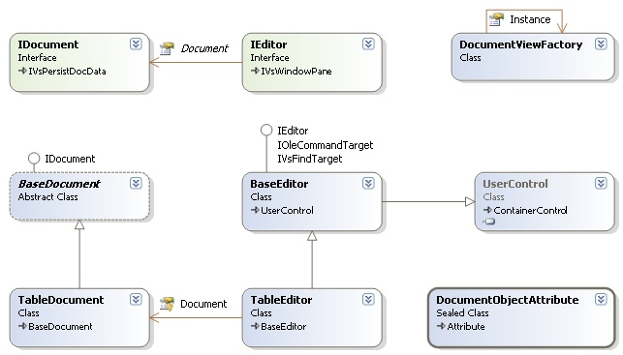
Figure 6. Document and Views
The entry point for the component is singleton DocumentViewFactoy with static Instance property and two public methods CreateDocument and CreateView. First is used to create new instance of the document object and it takes following parameters:
- typeName – string with the Database Object type name.
- hierarchy – reference to the IDE façade object, which should be used to manipulate Server Explorer tree hierarchy and interact with RDT.
- isNew – Boolean flag, indicating that this document is created for the new Database Object.
- id – array with Database Object multipart identifier.
The CreateView method is used to create new instance of the view object and it takes only one parameter – reference to the proper document object.
These methods return references to the IDocument and IEditor interfaces accordingly and these interfaces are common for all documents and views. Detailed information about these interfaces can be found at the “Common Interfaces” section.
Documents are the core of this component. They are responsible for data source interaction, including data extraction and changes application. They are closely related with object descriptors and use them to reference meta-data at the design time and to perform data validation at runtime. Documents are described in more details at the “This is the common interface for all views objects and it is designed to combine two roles: Visual Studio custom editor and the View object. Functionality for the first role is defined by the interface IVsWindowPane from which current interface is derived. This interface is standard and information about it can be found at ms-help://MS.VSCC.v80/MS.VSIPCC.v80/MS.VSSDK.v80/dv_iashrf/html/T_Microsoft_VisualStudio_Shell_Interop_IVsWindowPane.htm. This interface is used by the simplified embedding mechanism described at ms-help://MS.VSCC.v80/MS.VSIPCC.v80/MS.VSSDK.v80/dv_vsintegration/html/f1292478-a57d-48ec-8c9e-88a23f04ffe5.htm.” section.
Views are the “face” of the provider – they are responsible for visual representation of the document data visual representation in the Visual Studio IDE GUI. They are implemented as custom editors and fully integrated in the Visual Studio environment. Views are described in more details in the “Views” section.
Documents and Views component are used by the command handlers then they need to open custom editor. The component itself widely use object descriptors and several utilities. Detailed information on the usages of this component and its dependencies is available at the “Usages and Dependencies” section.

Common Interfaces
There are two common interfaces for the Document and Views component: IDocument for document objects and IEditor for view objects. Structure and relations of these interfaces are presented at the Figure 7.
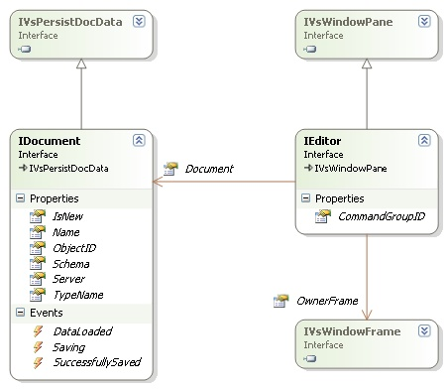
Figure 7. Common Interfaces.

IDocument Interface
This is the common interface for all document objects and it is designed to combine two roles: Visual Studio storable document and the document object for a view. Functionality for the first role is defined by the interface IVsPersistDocData from which current interface is derived. This interface is standard and information about it can be found at ms-help://MS.VSCC.v80/MS.VSIPCC.v80/MS.VSSDK.v80/dv_iashrf/html/T_Microsoft_VisualStudio_Shell_Interop_IVsPersistDocData.htm.
The second role is not standard and necessary functionality is defined by the IDocument interface itself. This functionality includes common information about the underlying Database Object and set of events used by view objects.
This interface defines following properties:
- TypeName – this string property returns the underlying Database Object type name.
- ObjectID – this object array properties returns underlying Database Object identifier. Typically identifier is the sequence of strings, for example { null, “mysql”, “db”, “host” } identifier references “host” column of the “db” table from the “mysql” schema.
- Server – this string property returns host name of the server machine on which MySQL instance is executed.
- Schema – this string property returns name of the database schema to which the underlying Database Object belongs.
- Name – this string property returns the underlying Database Object name. Note that all Database Objects have own names.
- IsNew – this Boolean property is used to indicate whenever underlying Database Object is new and was not yet saved to the database.
These common properties are used by the other provider entities, including base class for all view objects.
Another common functionality defined by this interface is the set of events, listed below:
- DataLoaded – this event is fired then object data are loaded form the database. View which receives this notification from the underlying document should ensure that all loaded data are properly represented in the GUI. This event supplies no additional information and EventHandler delegate expected as its listener.
- Saving – this event is fired then object data are to be saved to the database. View which receives this notification from the underlying document should ensure that all cached changes are applied to the document object. This event supplies no additional information and EventHandler delegate expected as its listener.
- SuccesfulyChanged – this event is fired then object data successfully saved to the database. View which receives this notification from the underlying document should modify GUI if necessary to reflect this fact (for example, it should change editor caption if the object name was changed). This event supplies no additional information and EventHandler delegate expected as its listener.

IEditor Interface
This is the common interface for all views objects and it is designed to combine two roles: Visual Studio custom editor and the View object. Functionality for the first role is defined by the interface IVsWindowPane from which current interface is derived. This interface is standard and information about it can be found at ms-help://MS.VSCC.v80/MS.VSIPCC.v80/MS.VSSDK.v80/dv_iashrf/html/T_Microsoft_VisualStudio_Shell_Interop_IVsWindowPane.htm. This interface is used by the simplified embedding mechanism described at ms-help://MS.VSCC.v80/MS.VSIPCC.v80/MS.VSSDK.v80/dv_vsintegration/html/f1292478-a57d-48ec-8c9e-88a23f04ffe5.htm.
The second role is not standard and necessary functionality is defined by the IEditor interface itself. This functionality includes common properties used by the provider infrastructure to initialize editor instance.
This interface defines following properties:
- CommandGroupID – this property returns global unique identifier of the command groups for this editor. Value of this property is used during editor registration process and passed to the InitializeEditorInstance call.
- OwnerFrame – this property is used to pass IVsWindowFrame reference to the view object after editor is successfully registered. This frame object is the owner of the view and view can use this reference, for example, to control frame caption.

Documents
Documents are the sources of the data for the custom editors and they are responsible for all interaction with the data source, including data extraction and changes application. Structure and relations of document classes are partially represented at the Figure 8 (only TableDocument final document class is presented to illustrate final class specific).
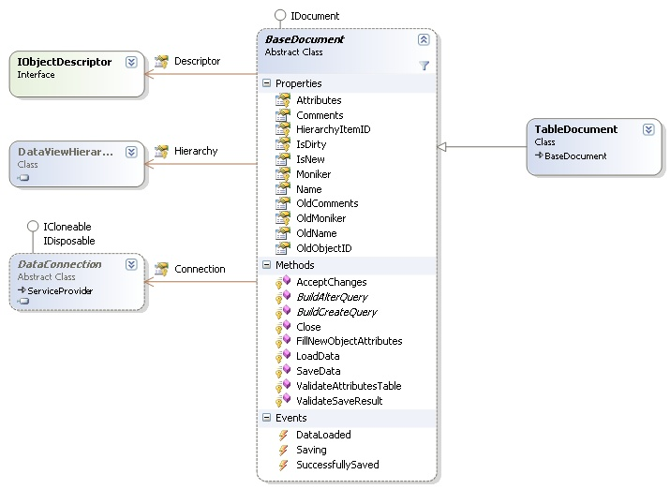
Figure 8. Documents.
The base class BaseDocument is created to contain a lot of common functionality. This class implements IDocument interface using template methods, it provides a set of virtual and abstract methods to customize its behavior and it provides a lot of useful utility methods for inheritors. This class is described in more details at the “BaseDocument Class” section.
All final document classes should inherit the base class, implement its abstract methods and, if necessary, override its virtual methods. Detailed information on requirements for the final document classes can be found at the “To read original values inheritors can use: GetOldAttributeAsInt, GetOldAttributeAsString and GetOldAttributeAsSqlBool typed methods. These methods take attribute name as input and returns typed value read from data row using DataInterpreter utility.” section.

BaseDocument Class
The BaseDocument class contains a lot of common for all document objects functionality. It implements IDocument interface using template methods, provide set of abstract and virtual methods and set of useful utility methods. This functionality can be divided in several groups:
- Data Loading – virtual methods used to load object data from the database. This group is described at the “Data Loading” section.
- Changes Saving – virtual and abstract methods and properties used to save object changes. This group is the most interesting and it is described at the “Changes Saving” section.
- Attributes Accessing – set of useful protected methods which simplify working with the Database Object attributes loaded form the database. These methods are described at the “Attributes Accessing” section.

Data Loading
The LoadDocData method of the IVsPersistDocData interface is implemented in the base class as a template method which calls virtual method LoadData and, if it succeeds, fires DataLoaded event. So, the core method of the data loading functionality is LoadData.
The LoadData method takes on Boolean parameter which indicates should data be loaded or reloaded. Inheritors can vary their behavior depending on this flag, but the base class ignores it. This method returns Boolean value which indicates the success of the load operation.
Base implementation of the LoadData method contains following steps:
- Load object attributes table using EnumerateObjectsToDataTable method of the Enumerator utility with type name set to the current object type name restrictions set to the full current object identifier.
- Validate loaded data using ValidateAttributesTable virtual method. Default implementation of that method ensures that all attributes declare by the proper object descriptor have relevant columns in the loaded table.
- If the object is new, add new row to the table and fill this row with data using virtual FillNewObjectAttributes method.
- Stores attribute row (the first row and only one row of the table) into private variable for later usages.
Each inheritor should override this method to extend data loading mechanism, but it also should call base method as the first step of the overridden method to perform common loading processing.

Changes Saving
This functionality includes IsDirty Boolean virtual property, SaveData virtual method and AcceptChanges virtual method.
The IsDirty property is used by the IsDocDataDirty method implementation and it should return true if document contains unsaved changes and false otherwise. Base implementation of this property checks for changes only in the attribute row and each inheritor should override it if additional data are supported. But each overridden property should call base property to.
The SaveData method is the virtual template method used by the SaveDocData method implementation. It takes Boolean parameter which indicate should save operation be silent or not and returns Boolean value (true if save operation succeeds and false otherwise). Implementation of this method in the base class includes following steps:
- Fire Saving event for views to fix all cached changes.
- Build SQL query required to save changes. If the object is new, call BuildCreateQuery abstract method, otherwise call BuildAlterQuery abstract method. Each final inheritor must override these methods.
- If mode is not silent, display confirmation message with full SQL query text using ShowMessage method of the UIHelper utility.
- Execute SQL query using ExecuteScalar method of the QueryExecutor utility.
- Validate execution result using virtual ValidateSaveResult method. Implementation of this method in the base class returns true. Typically inheritors don’t need to override this method. If query executes without exceptions, data are successfully saved.
- Call virtual AcceptChanges method to mark document as unchanged. Implementation of this method in the base class calls AcceptChanges for attributes data row. Inheritors should override this method if they use additional data.
- Fire successfully saved event for views to reflect results.

Attributes Accessing
As mentioned above at the “Data Loading” section, base class loads Database Object attributes and stores them into private DataRow variable. This data row can be accessed by any inheritor via protected Attributes property. Inheritors are free to read form this data row and to modify its values.
Note that DataRow object can have several versions, including current version with current values and the original version with original values. This ability is widely used by the document objects to determine what changes are made to them.
To simplify operations over attributes data row base class expose set of protected typed methods:
- To read current values inheritors can use: GetAttributeAsInt, GetAttributeAsString and GetAttributeAsSqlBool typed methods. These methods take attribute name as input and returns typed value read from data row using DataInterpreter utility.
- To read original values inheritors can use: GetOldAttributeAsInt, GetOldAttributeAsString and GetOldAttributeAsSqlBool typed methods. These methods take attribute name as input and returns typed value read from data row using DataInterpreter utility.
- To modify attribute value inheritors can use SetAttribute method which takes attribute name and new value as object. This method compares new value with current value using DataInterpreter utility and writes new value if any difference detected.
- To check if attribute was changed or not inheritors can use IsAttributeChanged method which takes attribute name and returns true, if attribute was changed. Otherwise it returns false.
The base class also defines accessors for common Database Object properties: Name (OldName) and Comments (OldComments). Inheritors should provide similar accessors for their specific properties and these accessors should be used by a corresponding view object.

Final Documents
Since BaseDocument class does almost all work (see the “BaseDocument Class” section for details) final document classes have not so much to do. However they must to implement two abstract methods BuildCreateQuery and BuildAlterQuery which are used by the base class to generate SQL queries. And this is the most difficult task.
Final document class should provide typed accessors for its specific attributes. These accessors will be used by the corresponding view object.
If final document class contains additional data besides attribute row, it should override LoadData and AcceptChanges virtual methods and IsDirty virtual property. If final class does so, it must call base method as the first step of the overridden methods.
In addition final document can override any virtual method or property of the base class if this is necessary.
To be accessible via DocumentViewFactory final document class should be marked with DocumentObjectAttribute custom attribute. This attribute requires Database Object type name and reflection Type object to be specified. First is the string equals to the name of the object type, described by this descriptor, and it must corresponds to the name of the Data Object Support XML file Type node. And second is the reference to the reflection Type description of this object descriptor class typically provided using typeof directive.
It is also required for final document class to have a public constructor with (ServerExplorerFacade hierarchy, bool isNew, object[] id) signature, but typically this constructor only calls the constructor of the base class.

Views
Views are the “face” of the provider. They implements custom Visual Studio editors and allow user to view, create and modify Database Objects. Views use documents to get information about Database Objects and perform operations with them. Structure and relations of the views classes are partially represented at the (only TableEditor final view class is presented to illustrate final class specific).
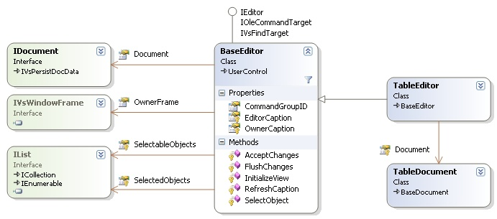
Figure 9. Views.
The BaseEditor base class is created to implement common for all editors functionality. This class implements all necessary interfaces and exposes virtual methods and properties to customize its behavior. Base class is described in more details at the “BaseEditor Class” section.
Final view classes should inherit base class, implement additional GUI and override inherited virtual methods then it is necessary. Usually final classes use directed access to the underlying document. Requirements to the final view class are described in more details at the “Final View” section.

BaseEditor Class
The BaseEditor class contains implementation of the common functionality for all views. Its implements necessary interfaces and exposes virtual methods to customize its behavior. It contains no GUI.
Main virtual methods, exposed by the BaseEditor class are:
- InitializeView – this method is called then document data are loaded. Inheritors should override it and fill their GUI with data in this method. This method takes no input and returns no result. In most common case this is only one method inheritor need to override.
- FlushChanges – this method is called before document data are to be saved. Inheritors should override it and apply all cached in GUI changes to the document. This method takes no input and returns no result. Inheritor may need to override this method if it uses complex GUI controls, like DataGrid, which can cache changes.
- AcceptChanges – this method is called then document data are successfully saved. Inheritors should override this method to update GUI to reflect the fact of the save and probable changes.
Base class controls its owner frame caption and exposes two virtual properties for inheritors to customize it. These properties are OwnerCaption and EditorCaption. The first is usually the title of the database connection, including its default schema, and the second is the name of the underlying Database Object. The title of the custom editor is formed from these two values in the following format “{OwnerCaption} {EditorCaption}” and the following defaults are used “{server name} ({schema name}) [{object name}]”.
In several cases owner frame caption should be refreshed, for example, if object was renamed. By default base class automatically refreshes it after document is saved. Inheritors can force caption refresh using protected RefreshCaption method.
Additional responsibility for the base class is to integrate with the Properties Window. Interaction is performed using private SelectionContainer object. Inheritors can participate in Properties Window interaction using following protected members:
- SelectableObjects property – this property returns list with the objects which can be selected in the Property Window. Inheritors can add any object to this list if they want to display this object in the Property Window.
- SelectedObjects property – this property returns list with the objects which are selected in the Property Window. Inheritors can add and remove objects form this list to control Property Window selection.
- SelectObject method – this method can be used by the inheritors to select single object in the Property Window. Note that this object must be previously registered in the SelectableObjects list. As a result of this method content of the SelectedObjects list will be set to the single given object or will be cleared if the given object is null.
Base document declares implementation of the IOleCommandTarget and IVsFindTarget interfaces, but it contains no implementation. Inheritors can implement these interfaces if they want to present its specific menu, integrate with clipboard or “Find and Replace” feature. See ms-help://MS.VSCC.v80/MS.VSIPCC.v80/MS.VSSDK.v80/dv_iashrf/html/T_Microsoft_VisualStudio_OLE_Interop_IOleCommandTarget.htm and ms-help://MS.VSCC.v80/MS.VSIPCC.v80/MS.VSSDK.v80/dv_iashrf/html/T_Microsoft_VisualStudio_TextManager_Interop_IVsFindTarget.htm for further details.

Final View
All final view classes must be inherited form the BaseView class, marked with ViewObjectAttribute custom reflection attribute and support constructor which takes one parameter of IDocument type. If all conditions are hold, view will be accessible via document and view factory.
Main task for final view is to implement custom GUI for Database Object editing and override InitilizeView virtual method to fill this GUI with document data. Typically final view is closely related with the underlying document and it introduces protected property which casts document to the desired type.
If final class uses complex GUI controls for data editing it should override FlushChanges method and fix all cached changes. For example, if view uses DataGridControl, it should call commit for opened column editor in the overridden method.
Final view can modify editor caption behavior by overriding virtual properties OwnerCaption and EditorCaption. It may be necessary if underlying object is not owned by schema directly.
Final class may use protected collections SelectabeObjects and SelectedObjects to interact with Properties Window if it needs to expose something except document itself in the Properties Window.
If final view class needs custom toolbar or custom behavior for standard toolbar commands it needs to override and implement IOleCommandTarget methods inherited form the base class.
To participate in the “Find and Replace” functionality, final view class must override and implement IVsFindTarger methods inherited form base class.

Usages and Dependencies
The Documents and Views component is very closely related with the Object Descriptors component. Each document object has a reference to the descriptor object for proper Database Object type. Furthermore each document may use static references to the static part of the corresponding descriptor, for example, to reference the attribute name.
Documents are using IDE façade to interact with the Server Explore, including refreshing server explorer window and renaming corresponding hierarchy node after save. IDE façade is also used to get the Connection Wrapper, which is used to get connection information and executes queries.
The Enumerator utility is used by documents to enumerate child Database Objects and read corresponding Database Object properties.
The QueryBuilder utility is used by documents in the BuildCreateQuery and BuildAlterQuery to support SQL generation.
The ReflectionHelper utility is used by base classes for both document and views to read reflection custom attributes for the inheritors.
The Documents and Views component itself is used by the Command Handler component to create custom editors implementation which can be registered using IDE façade.

IDE façade
The IDE façade component is the single class ServerExplorerFacade which is used to wrap interaction with the Visual Studio IDE. Its functionality can be divided in three main blocks:
- Hierarchy Accessing – interaction with the Sever Explorer data view hierarchy, including reading information about exists nodes and creating new nodes. This block is the largest one and it is described in more details at the “Hierarchy Accessing” section.
- RDT integration – integration with Running Document Table (RDT), including registration of the new custom editors, searching for the existing custom editors and renaming documents in the RDT. This block is described in more details at the “RDT integration” section.
- Connection wrapper accessing – the single property used to retrieve wrapper over underlying DataConnection object. This property may be used by the entity which needs to execute SQL queries or retrieve connection information.
IDE façade instance is created by the MySqlDataViewCommandHandler support entity and supplied to the command handler it uses. Command handlers propagate IDE façade reference to the documents they create.
The main aim of the introducing IDE façade is to encapsulate complex IDE interaction scenarios and hide them form other components.

Hierarchy Accessing
Main aim of the hierarchy accessing functionality is to allow read and modify Server Explorer tree hierarchy. Following properties are accessible for each hierarchy node:
- Name – this property represents the name under which node are visible in the Server Explorer and under which document (registered using hierarchy item identifier of the node) appears in save pending changes confirmation dialog. This property can be get using GetName and set using SetName methods for given hierarchy item identifier.
- Parent – this property represents the hierarchy identifier of the parent hierarchy node. This property can be get using GetParent method. It is used by the command handlers in the new object identifier generation process.
- Object Identifier – this property represents multipart identifier of the underlying Database Object. It can be get using GetObjectIdentifier method.
- Object Type – this property represents type name of the underlying Database Object. It can be get using GetObjectType method.
- Child Types – this property represents type names of the possible child nodes. It can be get using GetChildTypes.
Additionally, Hierarchy accessing functionality support creation of the new contextless nodes using CreateChildNode method and refreshing Server Explorer window using Refresh method. The first method is used then new Database Object is created to associate it with virtual hierarchy item, and the second method is used after Database Object is saved to ensure that new object appears in the Server Explorer tree.
We didn’t found any information about using SetNodePath method, which is declared in the documentation as the right way to integrated contextless nodes in the hierarchy, so we used a simple trick to get desired behavior:
- Each document, after its data are saved, forces Server Explorer to refresh using refresh method of the IDE façade. It allows us to see new node in the server explorer.
- Each document object ensures that it is registered in the RDT under the right moniker. After each save it checks if moniker changed and call to Rename method of the IDE façade if necessary.
- Before open new editor command handler tries to find registered under the same moniker (not the hierarchy item identifier) document, and if it is founded, ensures that it is registered under the right hierarchy identifier by calling Rename method of the IDE façade.
This simple trick allows us to switch new object node form contextless virtual node to ordinary Server Explorer node transparently to user.

RDT integration
RDT integration functionality includes following methods:
- BuildMoniker – this method is used by any entity which requires moniker generation. It allows us to build monikers in the same way at the all places. Following format is used for monikers: “mysql-{object type name}://{server name}.{schema}.{name}. …”. This method takes string with the Database Object type name, array with Database Object identifier and returns monikers string.
- RegisterEditor – this method is used to register given document and view object in the RDT and opens custom editor. It takes hierarchy item identifier (for item to associate with editor) and references to the document and view objects. InitializeEditorInstance method of the IVsUIShellOpenDocument interface is used to register editor.
- FindAndActivateEditor – this method is used to locate registered editor and activates it. At first this method ensures that editor is registered under correct hierarchy item identifier by calling Rename method with the same moniker and supplied hierarchy item, and only after ActivateDocuemntIfOpen is called. This method takes string with object type name and array with identifier for the Database Object and identifier of the corresponding hierarchy item. If editor was found and activated it returns true and it returns false otherwise.
- Rename – this method is used to change associated moniker or hierarchy item identifier for registered document. This method takes existing document moniker (oldMoniker parameter) and lookups RDT for document with this moniker using FindAndLockDocument. If document was founded, it calls ReameDocument method and supplies new moniker string (newMoniker parameter) and new hierarchy item identifier (item parameter). This method returns nothing.

Object Descriptors
The Object Descriptors component contains several semi-static classes with information about Database Objects structure. These classes describe available database object types, including their attribute names, enumeration SQL and etc. These classes are very closely related with data source meta-model defined in the Data Object Support XML. Any difference with meta-model definition could lead to provider failure.
Since this component is dynamic, it is implemented using Dynamic Component pattern (see the “Dynamic Component Pattern” section for further details). Architecture of this component is presented at the Figure 10.
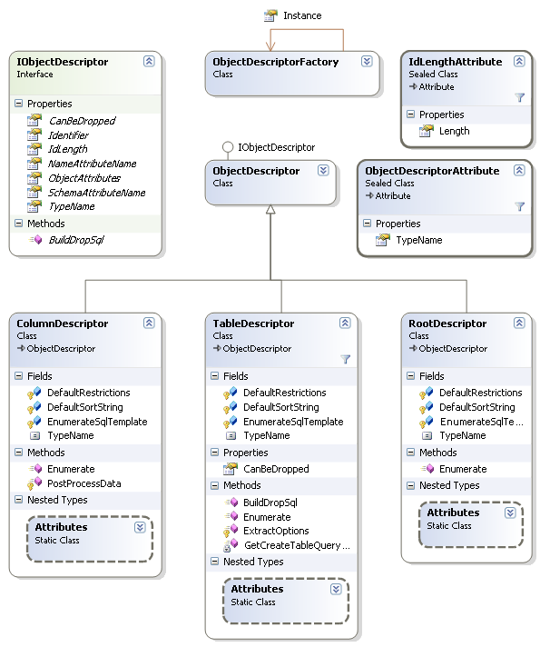
Figure 10. Object Descriptors.
The entry point for the component is singleton ObjectDescriptorFactoy with static Instance property and public method CreateDescriptor, used to get descriptor object for given object type name. Note that object descriptors are actually stateless, and hence the same instance of the descriptor will be returned to every call with the same type name.
CreateDescriptor method returns reference to the common for all descriptor interface IObjectDescriptor. Detailed information about this interface can be found at the “IObjectDescriptor Interface” section.
Base class for all descriptors is the ObjectDescriptor class. It implements proper interface and uses reflection to extract static information from inheritor at the runtime. This class is described in more details at the “ObjectDescriptor Class” section.
Each object descriptor class must inherit the ObjectDescriptor base class and must provide set of static properties and nested type with list of known attributes. It also should be marked with two custom attributes. Information from these attributes and static structure will be used by base class to return properties values in response to the calls to IObjectDescriptor properties. Detailed information about final descriptor classes can be found at the “Final Object Descriptor Classes” section.
Object Descriptors is one of the most widely used components of the provider and not all usages are limited to the interaction via factory and common interface. Detailed information on the usages of this component and its dependencies is available at the “Usages and Dependencies” section.

IObjectDescriptor Interface
The common interface for all descriptors is the IObjectDescriptor and it defines following properties:
- TypeName – name of the type which is described by this descriptor. This name is equals to the “name” property value of the corresponding Type node in the Data object Support XML. This name is used as the identifier for dynamic classes.
- IdLength – amount of strings in the identifier for the Database Object. Each object, except root, has at least three strings: database catalog name (which is always empty), schema name, and its own name.
- ObjectAttributes – string array with names of the attributes for this Database Object type.
- Identifier – string array with names of the object identifier parts.
- CanBeDropped – returns true if this type of objects can be dropped.
- NameAttributeName – returns name of object attribute which represents database object name.
- SchemaAttributeName – returns name of object attribute which represents database object schema name.
Interface describes on method BuildDropSql which returns DROP SQL statement by given object identifier.

ObjectDescriptor Class
This is the base class for all descriptors and it implements IObjectDescripter interface. It uses reflection to extract data from inheritor static properties at the runtime in response to interface properties calls. Following logic is used to implement interface properties:
- TypeName – value for this property is read from the custom attribute of the type ObjectDescriptorAttribute which is used to mark every final object descriptor class.
- EnumerateSqlTemplate – value for this property is read from the inheritor string constant with name “EnumerateSqlTemplate”.
- DefaultRestrictions – value for this property is read from the inheritor static read-only field with name “DefaultRestrictions”.
- DefaultSortString – value for this property is read from the inheritor string constant with name “DefaultSortString”.
- IdLength – value for this property is read from the custom attribute of the type IdLengthAttribute which is used to mark every final object descriptor class.
- ObjectAttributes – value for this property is the list of string constants values from the inheritor nested class with name “Attributes”.
To avoid using reflection each time interface property is accessed, all necessary values are read in the base class constructor.
Introducing of the base class simplifies implementation of the inheritors. Each inheritor required only to declare proper constants, static fields and nested type, and to be marked with two custom attributes.
Additionally base class defines static method EnumerateObjects which returns DataTable object by given object type name, restrictions and connection wrapper. This static method is used by al other components to enumerate database objects. This static method includes following steps:
- Create object descriptor instance using factory.
- Read initial data using virtual method ReadTable of the created descriptor. On this stage typically simple SQL query to INFORMATION_SCHEMA database is executed.
- Initiate advanced data post-processing using PostProcessData virtual method of the created descriptor. On this stage advanced data processing performed, including option string and CREATE TABLE parsing.
PostProcessData itself is a template method with following steps:
- ExtendData method called to calculate additional options. This method calls ExtractOptions virtual method for each table row. ExctractOptions returns dictionary with option values.
- ValidateObjectAttributes method called to check that all required object attributes are read.
- AddPrimaryKey method called to set primary key constraint for DataTable.

Final Object Descriptor Classes
Final object descriptor classes are very simple – they are inherited form the base class and contain only definitions and no functionality. Each object descriptor class should:
- Be a successor of the ObjectDescriptor base class.
- Declare public static constant string EnumerateSqlTepmplate. This string contains SQL statement used to enumerate database objects of this type with placeholders for restrictions. Placeholders will be substituted with real restriction values using String.Format method.
- Declare public static read-only string array field DefaultRestrictions. This array contains default values for the restrictions, which should be used if the exact value not specified. Note that this values should be written in the quoted and escaped fashion, because they will be placed to the placeholders “as is”, without any processing (it allows us, for example, to use column names in default restrictions). In contrast, restriction values provided at the runtime by the external entity will be quoted and escaped.
- Declare public static constant string DefaultSortString. This string should contain default sort expression for the ORDER BY clause. Note that the names of the database columns and not the names of object attributes should be used in this expression.
- Declare public static nested class Attribute which must declare set of the public string constants. These string constants represent names of the supported object attributes and they must be equals to the names of the columns in the enumeration result DataTable or DataReader.
- Be marked with ObjectDescriptorAttribute custom attribute. This attribute requires Database Object type name and reflection Type object to be specified. First is the string equals to the name of the object type, described by this descriptor, and it must corresponds to the name of the Data Object Support XML file Type node. And second is the reference to the reflection Type description of this object descriptor class typically provided using typeof directive.
- Be marked with IdLengthAttribute custom attribute. This attribute requires single integer value to be specified and this value is equals to the amount of the slots in database object multipart identifier.
If enumeration of database objects is to complex and could not be implemented as a simple SQL query, final class may override ReadData method to provide custom enumeration of any kind.

Object Attributes markup
To help base class correctly interpret database object attributes final descriptor class should include reflection markup for string constant declared in the Attributes nested class. Following refection attributes can be used:
- IdentifierAttribute should be used to mark identifier parts. Note that database (catalog) should not be marked as identifier part, because it contains null values. Name and Schema identifier parts can be marked by this attribute with additional flag IsName or IsSchema set to true.
- OptionStringAttribute is used to mark attribute which contains string with advanced options to parse.
- OptionAttribute is used to mark advanced attributes which should be read from the option string or in other way. When using this attribute you should specify additional OptionName and AttributeType flags. Only string, int64 and Boolean types are supported for options.

Usages and Dependencies
The Object Descriptors component is one of the most widely used components of the provider. It is used via common interface and factory by:
- Enumeration DDEX support entity enumerate objects.
- “Create Object” command handler to get identifier length for the object type. This information is used to generate new object identifier.
- “Drop Object” command handler to build DROP statement.
- Base document class to get information about identifier length and list of the supported attributes. This information is used to validate data retrieved from database.
Object descriptors can also be used directly by any class which wants to get information about pre-known (known at the design time) Database Object type. For example, document objects designed for specific Database Object type can use related object descriptor static fields directly to get attribute names constants.
Since this command is widely used, it is designed to be very independent. It uses only several utility classes: ReflectionHelper utility class to retrieve custom attributes and static field values, QueryBuilder utility class to build parts of the SQL query, DataInterpreter and Parser classes are used for advanced data processing.

Utilities
Utilities component includes several static classes each of those is created for its own purpose. These classes may be widely used by any other component. Following classes are included in the utilities component:
- DataInterpreter – this class is used to interpret read from database data tables. It is described in more details at the “DataInterpreter utility” section.
- QueryBuilder – this class is used to support correct SQL query generation. This class is described in more details in the “QueryBuilder utility” section.
- ReflectionHelper – this class expose set of static method to get typed custom reflection attributes and read static field values. This class is rather simple.
- UIHelper – this class is used to display message boxes. It uses IUIService instead standard MessageBox and expose set of overloads for ShowMessage and ShowError methods.
- Parser – this class is used in different cases for the query and option parsing. For example, it is used to parse CREATE TABLE statement to extract advanced table options.

DataInterpreter utility
DataInterpreter utility is used to interpret read from database data. It supports typed information retrieving methods, working with different DataRow versions and universal value comparing methods.
Each typed get method takes DataRow object and string with column name to get default row version data. Data row version specific overload of get method takes additional DataRowVersion parameter. Following typed get methods are supported:
- GetSqlBool – returns value as SqlBool. Underlying DataRow value considered as true if it is “YES” string and as false if it is “NO” string. Otherwise value considered as undetermined.
- GetInt – returns value as int (using Int32 for 32-bit operation systems and Int64 for 64-bit operation systems). This method uses Int32Converter or Int64Converter to convert value from its own type to int.
- GetString – returns underlying value as string. If underlying value is not null, converts it using ToString method. Otherwise returns null.
- IsNotEmptyString – this method is used to check is underlying value is null or empty string.
DataInterpreter support HasChanged method with parameters data row and column name to check if value of that column was changed. This method compares value in Original data row version with Current data row version using value comparison.
Method CompareObjects is used to perform value comparison. It takes two object values and returns value of first.Equals(second) if first object is not null, otherwise returns second == null.

Enumerator utility
Enumeration utility is used to enumerate Database Objects of given type with given restrictions. It is introduced to encapsulate enumeration method. Current version uses direct queries to the INFORMATION_SCHEMA database, but future version may be switched to the GetSchema method.
This utility exposes two methods: EnumerateObjectToDataTable and EnumerateObjectToDataReader. Both methods take connection wrapper reference, Database Object type name and array with restrictions. They are differ in the results – the first method returns DataTable and the second returns DataReader. Additionally, EnumerateObjectToDataReader method takes string with the sorting expression as the last parameter.
Enumerator utility builds enumeration SQL query using object descriptors and executes generated queries using connection wrapper. Enumeration is performed in following steps:
- Get object descriptor for given Database Object type name.
- Build complete restrictions array by replacing empty restrictions by default restrictions for the object descriptor and extending restriction array to the length of the identifier for given Database Object type. If restriction value is specified, it is escaped using QueryBuilder utility. Note that default restrictions are not escaped.
- Format enumeration SQL template extracted form object descriptor using String.Format method with restriction array as parameter.
- Execute generated query using connection wrapper.

QueryBuilder utility
QueryBuilder utility is used by documents, command handlers and enumeration utility to support SQL generation. It implements following methods:
- EscapeAndQuoteString method is used to escape any special characters in the given string and take it to the quotes. Result string may be used as a value in the SQL query safely.
- WriteIfTrue method is used to append given string expression to the given StringBuilder if the value in the given column of the given data row is true.
- WriteIfFalse method is used to append given string expression to the given StringBuilder if the value in the given column of the given data row is false.
- WriteIfNotEmptyString method used to append the value form given column of given data row (or simply given expression in another overload) to the given StringBuilder with given prefix if the value is not empty string.
QueryBuilder utility uses DataInterpreterUtility to check conditions in its conditional write methods.

Connection Wrapper
DDEX architecture supposes that single connection instance is shared between all entities related to single connection node in the Server Explorer. That is why typical connection object for DDEX applications is not the IDbConnection, but the DataConenction with method GetlockedProviderObject method to get underlying IDbConnection. All entities should lock provider object before operate with it and unlock it then operation is complete using UnlockProviderObject method.
Connection Wrapper component is the single class DataConnectionWrapper which is used by other component to interact with underlying database connection. It encapsulates all interaction related with connection sharing and expose simple methods for query execution and connection information extraction. Each such method locks the underlying connection for the short time and releases it immediately.
Connection wrapper supports following methods for query execution:
- ExecuteSelectTable – this method is used for SELECT queries execution. It takes string with query and returns result as DataTable object.
- ExecuteSelectReader – this method is used for SELECT queries execution. It takes string with query and returns result as DataReader object.
- ExecuteScalar – this method is used to execute queries which returns scalar result or doesn’t return result at all. These are creating, altering or dropping queries. It takes string with query and returns scalar object.
To extract underlying connection information connection wrapper support following properties:
- ServerName – this property returns string with server host name for underlying connection.
- Schema – this property returns default schema name for the underlying connection.
Connection wrapper expose connection itself via Connection property and it can be used for more complex interaction.

Appendix A: Files Listing
This code structured as follows:
- Properties directory contains assembly information and resources.
- Commands directory contains implementations of the Command Handlers component:
  - AlterCommand.cs file contains implementation of the Alter Object command handler.
  - BaseCommand.cs file contains implementation of the base class for all command handlers.
  - CloneCommand.cs file contains implementation of the Clone Object command handler.
  - CommandFactory.cs file contains implementation of the command handlers factory.
  - CommandHandlerAttribute.cs file contains implementation of the custom reflection attribute used to mark command handlers implementations.
  - Commands.cd file contains class diagram for the component.
  - CreateCommand.cs file contains implementation of the Create Object command handler.
  - CreateNewFunctionCommand.cs file contains implementation of create new function command handler.
  - CreateNewProcedureCommand.cs file contains implementation of create new procedure command handler.
  - CreateTriggerCommand.cs file contains implementation of Create Trigger command handler.
  - CreateUdfCommand.cs file contains implementation of create new user defined function command handler.
  - DropCommand.cs file contains implementation of the Drop Object command handler.
  - EditTableDataCommand.cs file contains implementation of the Edit Table Data command handler.
  - ICommand.cs file contains definition for the common command handler interface.
  - OpenEditorCommand.cs file contains implementation of the base class for command handlers which need to open custom editor.
- CtcComponents directory contains definitions of commands and commands groups:
  - PkgCmdID.h file contains definitions of the numeric part of the IDs for the CTC commands.
  - PkgCmd.ctc file defines the actual layout and type of the commands.
  - Guids.h file defines the GUIDs used to identify the command groups.
- Descriptors directory contains implementation of the Document and Views component:
  - Attributes
    - IdentifierAttribute.cs file contains implementation of the Identifier attribute.
    - IdLengthAttribute.cs file contains implementation of the custom reflection attribute used to mark object descriptors implementations with corresponding identifier length value.
    - ObjectDescriptorAtrribute.cs file contains implementation of the custom reflection attribute used to mark object descriptors implementations.
    - OptionAttribute.cs file contains implementation of the Option attribute.
    - OptionStringAttribute.cs file contains implementation of the Option String attribute.
  - AdoNet20Descriptor.cs file contains implementation of the base class for all descriptors which are using GetSchema for enumeration.
  - CharacterSetDescriptor.cs file contains character set Database Object descriptor.
  - CollationDescriptor.cs file contains implementation of the Descriptor for Collation type (not used in the Data Object Support XML, but use to get list of available collations for combobox).
  - ColumnDescriptor.cs file contains implementation for the column database object descriptor.
  - Descriptors.cd file contains class diagram for the component.
  - EngineDescriptor.cs file contains implementation of the descriptor for Engine type (not used in the Data Object Support XML, but use to get list of available character sets for combobox).
  - ForeignKeyColumnDescriptor.cs file contains implementation of the foreign key column descriptor.
  - ForeignKeyDescriptor.cs file contains descriptor for the foreign key database object.
  - IndexColumnDescriptor.cs file contains implementation of the descriptor for the index column database object.
  - IndexDescriptor.cs file contains descriptor for the index database object.
  - IObjectDescriptor.cs file contains definition of common descriptor interface.
  - ObjectDescriptor.cs file contains implementation of the base class for all descriptors.
  - ObjectDescriptorFactory.cs file contains implementation of descriptors factory.
  - RootDescriptor.cs file contains descriptor implementation for the root object.
  - StoredProcDescriptor.cs file contains implementation of the descriptor for stored procedures.
  - StoredProcParameterDescriptor.cs file contains implementation of the descriptor for the stored procedure parameter database object.
  - TableDataDescriptor.cs file contains implementation of the descriptor of the table data pseudo-object.
  - TableDescriptor.cs file contains descriptor implementation for the Table Database Object.
  - TriggerDescriptor.cs file contains implementation of descriptor of database triggers.
  - UdfDescriptor.cs file contains descriptor of user defined functions.
  - ViewColumnDescriptor.cs file contains descriptor of database view’s column.
  - ViewDescriptor.cs file contains descriptor of database view.
- Dialogs directory contains some elements of user interface:
  - SqlErrorDialog.cs file contains implementation of the SQL error dialog.
  - SqlPreviewDialog,cs file contains implementation of the SQL execution confirmation dialog.
- Documentation
  - Architecture.doc file contains architecture specification of project.
  - Documentation.doc file contains project documentation.
  - Documentation.hsp and other files in this directory contains help project (was made in HelpStudio Lite).
  - Build
    - Documentation.hxs file contains compiled help project (Note: doesn’t rebuild automatically)
- DocumentView directory contains implementations of the Documents and Views component:
  - Documents directory contains implementation of the documents objects:
    - LocalizibleAttributes
      - LocalizibleCategoryAttribute.cs file contains implementation of the localizable variant of the Category attribute.
      - LocalizibleDescriptionAttribute.cs file contains implementation of the localizable variant of the Description attribute.
      - LocalizableDisplayNameAttribute.cs file contains implementation of the localizable variant of the DisplayName attribute.
    - TypeConverters
      - BaseValueListConverter.cs file contains implementation of the base class for converters with dynamic list of supported values.
      - CharacterSetConverter.cs class contains implementation of the character set name standard values extractor.
      - CollationConverter.cs file contains implementation of the collations converter.
      - EngineConverter.cs file contains implementation of the engine converter.
    - BaseDocument.cs file contains implementation of base class for all “document” objects. This is base class for all documents. Implements IVsPersistDocData interface and converts it to set of virtual and abstract methods.
    - Documents.cd file contains the class diagram for this part of the component.
    - StoredProcDocument.cs file contains implementation of document functionality and representation of a database stored procedure.
    - TableDataDocument.cs file contains implementation of the document for table and view data editing.
    - TableDocument.cs file contains implementation of “document” object for database table object.
    - TriggerDocument.cs file contains implementation of the document functionality and representation of the database trigger.
    - UdfDocument.cs file contains implementation of user defined function representation.
    - ViewDocument.cs file contains implementation of document view representation.
  - Editors directory contains implementations of view objects:
    - AdvancedDataGridView.cs file contains implementation of the advanced grid control.
    - BaseEditor.cs file contains implementation of base class for all “view” objects.
    - CodeEditor.cs file contains astub for future smart SQL editor.
    - ColumnDetails.cs and ColumnDetils.resx files contains implementation of the columns details editing control.
    - DaraGridViewFlafCell.cs file contains implementation of the custom cell type for flags column in the columns editor.
    - DataGridViewFlagsColumn.cs file contains a custom column type for flags column in the columns editor.
    - DataGridViewNotNullableTextBoxCell.cs file contains stub cell used to prevent null image drawing for some collumns.
    - Editors.cd file contains the class diagram for this part f the component.
    - ForeignKeyEdit.cs and ForeignKeyEdit.resx files contain implementation of the custom user control for foregin keys editing.
    - IndexesEdit.cs and IndexesEdit.resx files contain implementation of the custom user control for indexes editing.
    - KeyEventsManager.cs file contains handling of "KeyDown" events for all children elements of the parent control.
    - NameTextBox.cs file contains implementation of the Name attribute editor.
    - SqlEditor.cs and SqlEditor.resx files contain implementation of the editor for SQL definition of objects.
    - SqlSourceEditor.cs file contains implementation of SQL source editor.
    - TableDataEditor.cs file contains implementation of the table and view data editor.
    - TableEditor.cs and TableEditor.resx files contain implementation of “view” object for database table object.
    - TriggerEditor.cs file contains implementation of the custom editor for triggers.
    - UdfEditor.cs and UdfEditor.resx files contain implementation of editor for user defined functions.
  - DocumentObjectAttribute.cs file contains implementation of the custom reflection attribute used to mark document objects implementations.
  - DocumentViewFactory.cd file contains class diagram for the component entry point.
  - DocumentViewFactory.cs file contains the implementation of Document/View objects factory.
  - DocumentViewInterfaces.cd file contains class diagram for the document view interfaces structure.
  - IDocument.cs file contains definition for the common document object interface.
  - IEditor.cs file contains definition for the common view object interface.
  - ISqlSource.cs file contains implementation of an object defined by its SQL definition.
  - ViewObjectAttribute.cs file contains implementation of the custom reflection attribute used to mark view objects implementations.
- Installer directory contains WiX votive installation project.
  - main.wxs file contains main installation definitions.
  - License.rtf file contains license agreement text (GNU GPL license).
  - Wix.xsd file contains XSD schema for WiX files. It allows using validation and code completion when editing WiX file in Visual Studio XML editor.
  - Bitmaps directory contains several images involved in installation GUI.
  - Other files represent WiXUI library, which is used to implement user-friendly GUI for installation package.
- Resources directory contains several images to use in project.
- Tests folder contains unit tests project which is described in the UnitTests document.
- Utils directory contains several infrastructure classes.
  - DataInterpreter.cs file contains implementation of utility class, which is used to interpret loaded from database data.
  - KeyDisplayValuePair.cs file contains key-displayabe value pair utility used for listboxes and comboboxes.
  - Parser.cs file contains file contains implementation of the Parser utility.
  - QueryBuilder.cs file contains implementation of SQL query builder utility, which is used to perform SQL generation.
  - ReflectionHelper.cs file contains implementation of the reflection accessing utility. It supports custom attributes and static properties value retrieving.
  - ResourceHelper.cs file contains class which is in the unit tests to check existence of the resource entries.
  - UIHelper.cs file contains small utility, which is used to perform user interaction.
- VSSDKBuild directory contains Visual Studio SDK specific build target.
- DataConnectionUIStub.cs file contains stub class, created to allow form designer to edit connection dialog. This class was created because form designer failed to open direct DataConnectionUIControl successor.
- DataConenctionWrapper.cs file contains implementation of the connection wrapper which is used by other components to access data source connection.
- GuidList.cs file contains set of GUIDs, used in this project. It must match CtcComponent\Guids.h.
- MySqlConnectionProperties.cs file contains implementation of customized connection properties. List of all properties are visible in advanced connection options dialog.
- MySqlConnectionSupport.cs file contains implementation of custom connection support for MySQL. It creates MySqlConnection object from given connection string and maintains that object.
- MySqlConnectionUIControl.cs and MySqlConnectionUIControl.resx files contain implementation of custom connection dialog. This dialog allows user to input server host, user name, password and database name.
- MySqlDataObjectEnumerator.cs file contains implementation of data object enumerator. It uses QueryBuilder to build proper SQL query and QueryExecutor to execute it.
- MySqlDataObjectSupport.xml and MySqlDataObjectSupport.cs files contain definition of database object model. They describe object types, object properties, concept mapping and etc.
- MySqlDataProviderPackage.cs file contains implementation of root package class. It registers and creates factory object.
- MySqlDataSourceInformation.cs file contains class with data source specific information. It supports two custom properties – DataSource (server name) and Database (default schema name).
- MySqlDataViewCommandHandler.cs file contains implementation of data view commands handler. It handles context menu commands form Server Explorer window.
- MySqlDataViewSupport.xml and MySqlDataViewSupport.cs files contain definition of data view structure. They defines object layout in Server Explorer tree.
- MySqlProviderObjectFactory.cs file contains implementation of DDEX support entities factory.
- mysqlvs.snk file contains strong key which is used to sign provider assembly.
- ServerExplorerFacade.cs file contains implementation of the IDE Façade component.
- VSDataViewSupport.xsd and VSDataObjectSupport.xsd files are DDEX XSD schemas and they are used to validate respective XML files.

Note that ms-help links are valid only if MSDN library with Visual Studio SDK documentation are installed.
Note that this control is inherited from the empty DataConnectionUIStub. This temporary stub class is introduced to resolve form designer issue – it doesn’t support editing of direct inheritors of the DataConnectionUIControl.
This is the placeholder for database catalog name which is always empty.
Note that table should be empty, because enumeration with restrictions set to the new object identifier should find now matching object and return empty table with only schema initialized.

