TamTam Digital School
[Insert Institution Logo]
Independent Project
WaterTracker: Satellite Monitoring and Short-Term Forecasting of Small Reservoirs around Ouagadougou to Support Dry-Season Water Decisions
Student: [Student Full Name]
Academic Program: [Academic Program]
Supervisor: [Supervisor Name]
Academic Year: 2026
Date: [Submission Date]

Abstract
Small reservoirs are the backbone of dry-season water supply for livestock, market gardening and domestic use around Ouagadougou, Burkina Faso, yet almost none of them is gauged. This project asks whether free satellite archives can provide a reliable monthly measurement of each reservoir and a useful forecast of its state one to three months ahead. A reproducible pipeline built on Google Earth Engine measures the monthly water area of 100 water bodies at 10 m resolution from January 2019 to August 2026, fusing cloud-masked Sentinel-2 imagery with calibrated Sentinel-1 radar, and relates it to CHIRPS rainfall and ERA5-Land climate data. The previous production model was audited first: its reported score (R² = 0.19) became negative (−0.45) under an honest temporal split, and an inference bug made its served predictions unrelated to the model. Under a strict temporal validation, a random forest forecasts the filling ratio one month ahead with a mean absolute error of 0.108, 19.6 % better than reservoir climatology (block-bootstrap p < 0.001); at two and three months it only matches climatology, and an oracle experiment shows that even perfect rainfall knowledge would not help. Conformal intervals reach 80-83 % coverage at one and two months, and an early-warning classifier detects 70-80 % of entries into a critical state with 83-90 % precision. The system's value therefore lies in measuring and anticipating the dry-season drawdown, which points to dry-season irrigation and livestock water planning as the most relevant use.
Keywords: small reservoirs; Sentinel-2; Sentinel-1; Google Earth Engine; water-surface monitoring; forecasting; early warning; Sahel; Burkina Faso.

List of Figures
Figure 1: Project workflow diagram: stages of the Independent Project 5
Figure 2: Technical workflow of the WaterTracker v3 pipeline 10
Figure 3: Study area: reservoirs of the application (red dots), reservoirs added from JRC (orange triangles), analysis regions (cyan) and HydroBASINS level-10 sub-basins (white), on a Sentinel-2 composite of October 2024. Labels in French from the notebook run. 11
Figure 4: Score of the previous model (v2) under a random and a temporal split 18
Figure 5: Total water area of the 96 modelled reservoirs (line, km²) and monthly CHIRPS rainfall (bars, inverted axis), January 2019 - August 2026. Labels in French from the notebook run. 19
Figure 6: Mean regime of the modelled reservoirs: distribution of the filling ratio by calendar month (top) and share of reservoirs below the critical level (bottom) 20
Figure 7: Indicative stored volume of the 53 reservoirs within the domain of validity of the Liebe et al. (2005) relationship 20
Figure 8: Forecast error on the test period by model and horizon 22
Figure 9: Gain of the random forest over climatology, with 95 % block-bootstrap confidence intervals 22
Figure 10: Test MAE by target month for persistence (grey), climatology (yellow-green) and the random forest (purple), at 1, 2 and 3 months. Labels in French from the notebook run ("mois" = month). 23
Figure 11: Early-warning performance on the test set: F1 score by method (left) and detection of entries into crisis (right) 24
Figure 12: Reliability diagram of the alert probabilities on the test set (forecast probability vs observed frequency). Labels in French from the notebook run. 25
Figure 13: Permutation importance of the ten most important features of the random forest, one and three months ahead 25
Figure 14: Forecast issued at the end of August 2026 for the four reservoirs most likely to become critical within three months: observed filling (grey), forecast (purple) with its 80 % interval, and critical threshold (red). Labels in French from the notebook run. 26
Figure 15: Architecture of the WaterTracker system 39

List of Tables
Table 1: Research questions and hypotheses 4
Table 2: Data sources used in the project 11
Table 3: Results of the audit of the v2 model 17
Table 4: Measurement quality indicators 19
Table 5: Test-set performance (target months 2025 - August 2026; 1,920 forecasts per horizon) 21
Table 6: Coverage and width of the 80 % prediction intervals on the test set 24
Table 7: Verdict on the research hypotheses 26
Table 8: Correspondence between the report and the notebook 38
Table 9: Test scores of all models (MAE, RMSE, NSE and KGE at each horizon) 38
Table 10: Main API endpoints of the v3 backend 39
Table 11: The 32 features of the forecasting models, by group 40

List of Acronyms
Acronym | Meaning
API | Application Programming Interface
APA | American Psychological Association
AUC | Area Under the Curve
CHIRPS | Climate Hazards Group InfraRed Precipitation with Station data
CI | Confidence Interval
CQR | Conformalized Quantile Regression
DEM | Digital Elevation Model
DGRE | Direction Générale des Ressources en Eau (Burkina Faso water resources directorate)
ERA5-Land | ECMWF Reanalysis v5, land component
FDR | False Discovery Rate
GEE | Google Earth Engine
GIS | Geographic Information System
HGB | Histogram-based Gradient Boosting
IP | Independent Project
JRC | Joint Research Centre (European Commission)
KGE | Kling-Gupta Efficiency
MAE | Mean Absolute Error
MNDWI | Modified Normalized Difference Water Index
MPIW | Mean Prediction Interval Width
NDVI | Normalized Difference Vegetation Index
NDWI | Normalized Difference Water Index
NGO | Non-Governmental Organisation
NSE | Nash-Sutcliffe Efficiency
ONEA | Office National de l'Eau et de l'Assainissement (national water utility)
OSM | OpenStreetMap
PET | Potential Evapotranspiration
PICP | Prediction Interval Coverage Probability
PR-AUC | Area under the Precision-Recall curve
RMSE | Root Mean Square Error
ROC | Receiver Operating Characteristic
RQ | Research Question
S1 / S2 | Sentinel-1 / Sentinel-2
SAR | Synthetic Aperture Radar
SRTM | Shuttle Radar Topography Mission
SWIR | Short-Wave Infrared
SWOT | Surface Water and Ocean Topography mission
UTM | Universal Transverse Mercator
VV | Vertical transmit, vertical receive (radar polarisation)

Acknowledgements
I would like to thank [supervisor's name], my faculty advisor at TamTam Digital School, for the guidance and critical feedback given throughout this Independent Project, and the teaching staff of the [academic program] for the training on which this work relies.
This project would not have been possible without open data and open software. I am grateful to the European Space Agency and the Copernicus programme for the Sentinel-1 and Sentinel-2 archives, to Google for the Earth Engine platform and the Cloud Score+ dataset, to the Climate Hazards Center (UC Santa Barbara) for CHIRPS, to ECMWF for ERA5-Land, to the European Commission's Joint Research Centre for the Global Surface Water dataset, and to the OpenStreetMap contributors who mapped the water bodies of the Ouagadougou region. I also thank the developers of the scientific Python ecosystem (pandas, scikit-learn, GeoPandas) on which every analysis in this report is built.
[Add any personal acknowledgements: family, classmates, partners met during the project.]

Executive Summary
The problem. Around Ouagadougou, several dozen small reservoirs supply water for livestock, dry-season market gardening and, in places, domestic use. Apart from the large dams operated for the city's drinking water, none of them is gauged. Managers (water agencies, NGOs, agricultural and livestock services) have no consolidated view of which reservoirs are full, falling or nearly dry, and usually discover a drying-up after it has happened. Field visits to dozens of sites are costly and, in the current security context, often impossible.
What was done. The WaterTracker application already displayed a risk status for 65 water points, produced by a first model. This project audited that model, then rebuilt the analytical core. A reproducible notebook extracts from Google Earth Engine the monthly water area of 100 water bodies (the 44 physical reservoirs behind the application's water points plus 56 water bodies of 10 ha or more that were missing from the inventory) at 10 m resolution from January 2019 to August 2026. It fuses cloud-masked Sentinel-2 imagery with calibrated Sentinel-1 radar, relates the series to rainfall and climate, and trains forecasting models that are evaluated on years they never saw.
Key findings.
- The previous model's published score did not survive an honest evaluation (R² from 0.19 to −0.45), and a software bug made its served predictions unrelated to the model. The redesign was therefore necessary.
- The satellite measurement is robust: 98.7 % of reservoir-months are observed directly by Sentinel-2; results barely change with the water-index threshold.
- By April, the median reservoir is dry every year, whatever the rainfall of the previous season: wetter rainy seasons raise the peak (ρ = 0.32) but not the dry-season minimum (ρ = 0.05).
- One month ahead, the random forest beats the reservoir's own climatology by 19.6 % (MAE 0.108 versus 0.134, p < 0.001), with its smallest errors from October to March. Two and three months ahead, it only matches climatology, and knowing future rainfall perfectly would not improve it.
- The early-warning classifier detects 70-80 % of reservoirs entering a critical state (below 20 % of their reference area), with 83-90 % of alerts confirmed.
What it means. The system's value is not a long-range prediction but a reliable monthly measurement and a one-month anticipation of the dry-season drawdown. The most relevant users are therefore those who plan dry-season water use across many sites: irrigation and livestock programmes, NGOs and water agencies.
Recommendations. Refocus the product on two dry-season deliverables (an end-of-rainy-season assessment and a monthly drawdown update with alerts); add a climatological alert baseline and an "expected drying-up month" output; remove the legacy text recommendations built on the old model; validate the measurements in the field with a partner; and run a pilot over the 2026-2027 dry season to measure whether the information changes decisions.
Table of Contents
Abstract i
List of Figures ii
List of Tables iv
List of Acronyms v
Acknowledgements vii
Executive Summary viii
1. Introduction 1
1.1 Problem Statement 1
1.2 Literature Review 2
1.3 Objectives 4
2. Theoretical Framework 6
2.1 The water balance of a small reservoir 6
2.2 Physical basis of satellite water detection 6
2.3 Predictability and the value of a forecast 7
2.4 Honest evaluation: leakage, dependence and uncertainty 8
2.5 Early warning as a decision problem 8
2.6 Conceptual framework 8
3. Methodology 10
3.1 Research design 10
3.2 Study area 10
3.3 Data 11
3.4 Audit of the previous model 12
3.5 Inventory construction 12
3.6 Water-area extraction and fusion 12
3.7 Hydrological analysis 13
3.8 Forecasting design 14
3.9 Uncertainty and early warning 15
3.10 Final model, deployment and tools 15
3.11 Ethical considerations 16
4. Results and Analysis 17
4.1 Audit of the previous model (v2) 17
4.2 Inventory and measurement quality (RQ2) 18
4.3 Hydrological dynamics (RQ1) 19
4.4 Forecast accuracy (RQ3) 21
4.5 Uncertainty and early warning (RQ4) 23
4.6 Explainability 25
4.7 Operational forecast 26
4.8 Summary of the hypotheses 26
5. Discussion 28
5.1 What the satellite pipeline delivers 28
5.2 What the forecasts can and cannot do 28
5.3 Early warning: strong results, one open question 29
5.4 Lessons from the audit of the previous model 29
5.5 Limitations 30
5.6 Practical implications 30
6. Conclusion and Recommendations 32
6.1 Conclusion 32
6.2 Recommendations 32
References 34
Appendices 38
Appendix A. Reproducibility and correspondence with the notebook 38
Appendix B. Complete test scores 38
Appendix C. System architecture and API 39
Appendix D. Forecasting features 40

1. Introduction

1.1 Problem Statement
Burkina Faso is a Sahelian country with a single rainy season, from June to October, followed by seven to eight months with almost no rain. To store water from one season to the next, the country has built a large number of small dams and reservoirs: at least 1,700 small reservoirs had been constructed by the end of the 2000s, most of them in the previous thirty years (Boelee et al., 2009). They support dry-season irrigation, livestock watering, fishing and domestic use, and are a central element of rural livelihoods (Venot et al., 2012).
Despite their importance, these reservoirs are poorly known. Inventories are incomplete and rarely up to date, and the storage of most reservoirs is simply not measured (Liebe et al., 2005; Venot et al., 2012). Around Ouagadougou, only the large dams that supply the capital's drinking water are monitored by the national water utility. The small and medium reservoirs used by farmers and herders have no staff gauge and no regular survey. Their managers, in practice water agencies, agricultural and livestock services, municipalities and NGOs, therefore have no consolidated view of the resource. They usually learn that a reservoir has dried up when it has already happened, and react in emergency: water trucking, forced livestock movements, lost market-garden harvests. Monitoring by field visits is costly when dozens of sites are involved and, in the current security context, often impossible.
Satellite remote sensing offers an alternative. The Sentinel-2 optical and Sentinel-1 radar missions observe every reservoir every few days at 10-20 m resolution, free of charge, and platforms such as Google Earth Engine make these archives usable without local infrastructure (Gorelick et al., 2017). The WaterTracker application was created to exploit this opportunity: it displays the water points around Ouagadougou on a map, with a risk status for each one. Its first analytical model (v2), however, relied on a half-yearly water index measured at a single point per reservoir, and its reported performance had never been checked against an honest evaluation.
The problem addressed by this Independent Project is therefore twofold. Scientifically, it is to determine whether free satellite data can produce a reliable monthly measurement of each reservoir and a forecast of its state one to three months ahead that is better than what a manager could guess from the usual seasonal cycle. Practically, it is to give WaterTracker an analytical core whose outputs can be trusted by the people who have to allocate scarce resources before the dry season becomes a crisis. The significance of the problem lies in the gap between the importance of these reservoirs and the absence of information about them: any reliable, low-cost monitoring would be an improvement over the current situation, provided that its limits are clearly stated.

1.2 Literature Review
Small reservoirs in the Sahel. Small reservoirs have been promoted across sub-Saharan Africa as a low-cost way to secure water for agriculture and livestock. Venot et al. (2012), drawing on cases from Burkina Faso, Ghana, Ethiopia and Zambia, show that their actual costs, performance and governance are often worse than assumed, partly because so little is known about how they function once built. In Burkina Faso, even the number of reservoirs is uncertain: Boelee et al. (2009) report that at least 1,700 small reservoirs have been built, and the lack of up-to-date inventories is repeatedly cited as a key obstacle to their management. This information gap is the starting point of the present work.
Sahelian hydrology. The filling of Sahelian reservoirs depends on runoff, which responds non-linearly to rainfall. Mahé and Paturel (2009) documented the "Sahelian paradox": since the 1970s, runoff coefficients of Sahelian rivers have increased even though rainfall remained below its pre-drought level, mainly because of land-cover change. The amount of rain is therefore an imperfect predictor of how much water reaches a reservoir. Gal et al. (2016) used satellite-derived lake areas combined with a height-area-volume model to estimate inflows over ungauged Sahelian watersheds, illustrating how remote sensing can substitute for missing gauges. During the dry season, reservoirs lose water through open-water evaporation, which is very high in the Sahel, through infiltration and through withdrawals; the relative importance of these terms varies from one reservoir to another and is rarely measured.
Remote sensing of surface water. Open water absorbs strongly in the near and short-wave infrared, which makes it easy to separate from land with normalised difference indices. McFeeters (1996) introduced the NDWI, based on green and near-infrared bands; Xu (2006) proposed the MNDWI, which replaces the near-infrared with the short-wave infrared (SWIR) and better separates water from built-up areas and bare soil, a frequent confusion in the Sahel. Because the Sentinel-2 SWIR band has a 20 m resolution, Du et al. (2016) showed that sharpening it to 10 m before computing the MNDWI produces accurate water maps at 10 m. At the global scale, Pekel et al. (2016) used three decades of Landsat imagery to map the occurrence and seasonality of surface water at 30 m (JRC Global Surface Water); this dataset is retrospective and too coarse for small reservoirs, but it is a valuable reference to locate water bodies and check inventories. Clouds are the main obstacle during the rainy season: scene-level cloud filters discard most images from July to September, while pixel-level quality scores such as Cloud Score+ (Pasquarella et al., 2023) keep the clear parts of each image. Synthetic Aperture Radar (SAR) sees through clouds: smooth open water reflects the radar signal away from the sensor and appears dark. Annor et al. (2009) delineated small reservoirs in northern Ghana with radar imagery, and the Sentinel-1 mission (Torres et al., 2012) now provides free radar data with a regular revisit. Radar is, however, sensitive to wind roughening and confuses water with very dry sandy soils, so radar-derived areas need local calibration.
From area to volume. Satellites measure an area, not a volume. Liebe et al. (2005) surveyed the bathymetry of 61 small reservoirs in the Upper East Region of Ghana, a landscape similar to the central plateau of Burkina Faso, and derived a power-law relationship between surface area and volume, valid for reservoirs of 1 to 35 ha. Rodrigues et al. (2012) applied the same approach in the Brazilian savannah and estimated the total storage of 147 small reservoirs from Landsat images. Such relationships give orders of magnitude only; precise volumes require bathymetry or altimetry, which the SWOT mission now provides for larger water bodies (Biancamaria et al., 2016).
Forecasting and its evaluation. Forecasting literature insists that a model must be compared with simple references: persistence, seasonal naive forecasts and climatology (Hyndman & Athanasopoulos, 2021). In hydrology, model performance is commonly summarised by the Nash-Sutcliffe efficiency (Nash & Sutcliffe, 1970) and by the Kling-Gupta efficiency, which decomposes the error into correlation, bias and variability (Gupta et al., 2009). Tree ensembles such as random forests (Breiman, 2001) and gradient boosting (Ke et al., 2017) are strong learners for tabular data. Their evaluation, however, is easily biased: when observations are correlated in time or space, random cross-validation overestimates performance, and blocked or grouped schemes are required (Roberts et al., 2017); more generally, any information from the future that enters the features or the preprocessing produces "leakage" and optimistic results (Kaufman et al., 2012). Comparing two forecasts requires a significance test adapted to correlated errors (Diebold & Mariano, 1995). For decision-making, a forecast must also carry its uncertainty: conformalized quantile regression (Romano et al., 2019) produces prediction intervals with guaranteed coverage under mild assumptions, and probabilistic alerts are judged by their calibration and Brier score (Brier, 1950). Finally, responsible deployment calls for documenting a model's intended use, performance and limits in a "model card" (Mitchell et al., 2019).
Gap. The literature provides each building block (water indices at 10 m, radar gap-filling, area-volume relationships, honest forecast evaluation), but they are rarely combined into an operational, monthly, reservoir-by-reservoir monitoring and forecasting system for small Sahelian reservoirs, evaluated against strong baselines. Global datasets are retrospective, and studies of small reservoirs usually stop at mapping or storage estimation. Whether such a system can forecast reservoir states better than climatology, and for which decisions it is useful, remains an open, practical question. This project addresses it for the reservoirs around Ouagadougou.

1.3 Objectives
The general objective is to provide WaterTracker with a reliable, reproducible and honestly evaluated analytical core for monitoring and forecasting small reservoirs around Ouagadougou.
The specific objectives are to:
- audit the previous production model (v2) and quantify its weaknesses;
- build a quality-controlled inventory of the reservoirs in a 50 km radius around Ouagadougou;
- produce a continuous monthly series of water area at 10 m for each reservoir from 2019 onwards, by fusing optical and radar data;
- describe the reservoirs' seasonal and inter-annual dynamics and their response to rainfall;
- forecast each reservoir's filling ratio one to three months ahead, with calibrated uncertainty, and compare it with strong baselines;
- issue a probabilistic early warning of a critical level and evaluate it on entries into crisis;
- package the final model so that the application can serve monthly forecasts, and document its limits.
The four research questions and their testable hypotheses are summarised in Table 1.
Table 1: Research questions and hypotheses
Question | Hypothesis | Test
RQ1 (hydrology): What are the seasonal and inter-annual dynamics of the reservoirs' water area, and how do they respond to rainfall? | H1: the water area follows a single annual cycle driven by the rainy season, responds to rainfall within one month, and wetter rainy seasons lead to higher filling. | Cross-correlation; Spearman correlations; Mann-Kendall trends with FDR control
RQ2 (remote sensing): Can Sentinel-2 / Sentinel-1 fusion produce a continuous monthly series despite rainy-season clouds? | H2: a usable value is obtained for at least 95 % of reservoir-months, and the measurement is robust to the index threshold and to resolution. | Share of reliable months; independent validation of the radar fill; sensitivity analyses
RQ3 (AI): Can the filling ratio be forecast one to three months ahead better than simple baselines, and with what uncertainty? | H3: a machine-learning model beats the strongest baseline at each horizon with a significant gain (p < 0.05) and calibrated 80 % intervals. | Temporal validation; MAE, NSE, KGE, skill; block bootstrap; conformal coverage
RQ4 (operations): Can a reliable early warning of a critical level be issued? | H4: a probabilistic classifier detects entries into the critical state with ROC-AUC ≥ 0.8 and a better F1 score than persistence. | ROC-AUC, PR-AUC, Brier, F1; evaluation on entries into crisis

Scope. The study covers a 50 km radius around Ouagadougou (about 7,700 km²) and the period January 2019 to August 2026. It measures water area, not water quality, and estimates volume only as an order of magnitude. User needs were not surveyed during the project; the recommendations on the target users are derived from the results and must be validated with stakeholders.
Stages of the project. The project followed the iterative stages set by the IP guidelines (Figure 1): the problem was defined from the gap between the importance of the reservoirs and the absence of data, and sharpened by the audit of the existing model; research questions and hypotheses were then formulated; the literature was reviewed to choose the methods; the methodology was implemented in a reproducible notebook; finally, the results were analysed against the hypotheses and turned into recommendations.
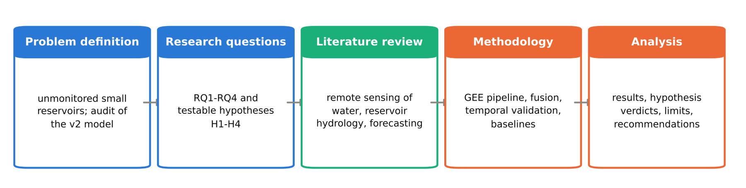
Figure 1: Project workflow diagram: stages of the Independent Project

2. Theoretical Framework

2.1 The water balance of a small reservoir
The state of a reservoir at any time results from a water balance. Writing S for the stored volume, its change over a month is
dS/dt = P·A + Q_in − E·A − W − I − Q_out
where P is the rain falling directly on the water surface A, Q_in the runoff from the catchment, E the open-water evaporation rate, W the withdrawals (irrigation, livestock, domestic use), I the infiltration and Q_out the spill or releases. In the Sahel this balance has two regimes. During the rainy season, Q_in dominates: the reservoir fills within weeks, and the amount of water it receives depends on rainfall intensity, soil crusting and land cover rather than on the rainfall total alone (Mahé & Paturel, 2009). During the dry season, inflows stop and the reservoir follows a drawdown governed by evaporation, which reaches 6 to 8 mm per day, by withdrawals and by infiltration. Because the dry-season terms vary slowly and regularly, the drawdown is expected to be more predictable than the filling.
Satellites observe A, not S. The two are linked by the reservoir's bathymetry, often summarised by a power law V = k·A^b. Liebe et al. (2005) found V = 0.00857 × A^1.4367 (V in m³, A in m²) for small reservoirs of northern Ghana. Since b > 1, volume falls faster than area: a reservoir at half its reference area holds only about 37 % of its corresponding volume. This has two consequences for the project. First, the filling ratio used as the target (area divided by a reference area) is an index of the state of the reservoir, not a direct measure of storage. Second, a critical threshold set at 20 % of the reference area corresponds to roughly 10 % of the volume, i.e. a residual pond.

2.2 Physical basis of satellite water detection
Water absorbs almost all incident radiation in the near-infrared and short-wave infrared, while vegetation reflects strongly in the near-infrared and bare soils and built-up surfaces reflect in the SWIR. Normalised difference indices exploit this contrast. The NDWI = (Green − NIR) / (Green + NIR) (McFeeters, 1996) is positive over water; the MNDWI = (Green − SWIR) / (Green + SWIR) (Xu, 2006) separates water from bright soils and settlements better, and handles the turbid, sediment-laden water of Sahelian reservoirs well. A pixel is classified as water when the index exceeds a threshold, conventionally 0.
Two sources of error follow from the sensor's geometry. First, a pixel on the shoreline mixes water and land, so the area of a small water body carries an error proportional to its perimeter: the finer the resolution, the smaller that error. Second, clouds and their shadows hide the surface; a masked pixel is unknown, not dry, so an image with 30 % masked pixels may underestimate the water area by up to 30 %. Radar avoids the second problem. A C-band SAR emits microwaves that cross clouds; calm open water acts as a mirror and sends the signal away from the sensor, so it appears dark (low VV backscatter). The detection threshold, however, depends on wind roughening and on soil moisture: very dry sandy soils can be as dark as water. Radar areas must therefore be calibrated against optical areas where both are available.

2.3 Predictability and the value of a forecast
A forecast of a reservoir's state draws on two sources of predictability. The first is the initial state: a store of water changes gradually, so its current level and recent trend carry information about the near future. This information decays with the horizon. The second is the seasonal cycle: every reservoir fills and empties at roughly the same time each year, so the long-term average for the target month (the climatology) is a strong predictor at any horizon. What lies beyond these two sources (an unusually wet August, a sudden increase in withdrawals) is the unpredictable part, unless it can be forecast from external information such as seasonal rainfall forecasts.
This framework determines how a model must be judged. A model is useful only if it beats the best simple reference that already exploits these sources: persistence (the current state), the seasonal naive forecast (last year's value) and climatology (Hyndman & Athanasopoulos, 2021). The skill score, 1 − MAE_model / MAE_reference, measures the improvement over that reference; a positive but non-significant skill means that the model has learnt nothing beyond the reference. It also determines what can be expected: at one month, the initial state should add to climatology; at two or three months, the model should converge to climatology unless future rainfall matters and can be anticipated.
Several models are compared. A ridge regression is a regularised linear model that reveals whether the relationships are essentially linear. A random forest averages many decision trees grown on bootstrap samples with random feature subsets, which makes it robust and little sensitive to tuning (Breiman, 2001). Histogram-based gradient boosting builds trees sequentially, each correcting the errors of the previous ones, and supports quantile losses (Ke et al., 2017). Forecasts at several horizons follow a direct strategy (one model per horizon), which avoids the accumulation of errors of recursive forecasts.

2.4 Honest evaluation: leakage, dependence and uncertainty
Machine-learning evaluation assumes that test data are independent of training data. Monthly observations of the same reservoir are strongly autocorrelated, and neighbouring reservoirs share the same weather. A random split therefore places in the training set the months that surround each test month, and the model is rewarded for interpolating rather than forecasting (Roberts et al., 2017). The appropriate design is a temporal split, in which the model is trained on earlier years, tuned on a later year and tested once on the most recent years. Any statistic computed on the whole series and used as a feature, such as a long-term mean that includes future values, is a form of leakage (Kaufman et al., 2012). These principles are the main criteria used to audit the previous model.
A forecast that will support decisions must carry its uncertainty. Quantile regression estimates, for instance, the 10th and 90th percentiles of the target, which form a nominal 80 % interval; in practice such intervals are often too narrow. Conformalized quantile regression (Romano et al., 2019) corrects them using the errors observed on a calibration set, and guarantees a coverage close to the nominal level if future errors resemble the calibration errors (exchangeability).

2.5 Early warning as a decision problem
An early-warning system turns a forecast into a decision: alert or no alert. The event of interest is defined here as the filling ratio falling below 20 % of the reference area. A probabilistic classifier estimates the probability of this event; its quality is assessed by its discrimination (ROC-AUC, and PR-AUC when the event is imbalanced), by its calibration (a predicted probability of 0.8 should materialise 80 % of the time) and by the Brier score, the mean squared error of the probabilities (Brier, 1950). Turning probabilities into alerts requires a threshold, which trades missed events against false alarms; maximising the F1 score is a neutral choice when the costs of the two errors are unknown. Finally, an alert is valuable only if it anticipates something a manager does not already know: reservoirs that are already critical are trivially detected by persistence, so the demanding test is the detection of entries into crisis.

2.6 Conceptual framework
The project combines these elements in a chain (Figure 2): a quality-controlled inventory defines what is measured; physical principles of remote sensing turn images into monthly areas; the water balance and the area-volume relationship give these areas a hydrological meaning; predictability theory and honest evaluation determine what the forecasting models can deliver; and decision theory turns forecasts into alerts. The chain is closed by documentation (a model card, Mitchell et al., 2019) so that users know what the outputs can and cannot support.

3. Methodology

3.1 Research design
The project follows a quantitative, observational and predictive design. It relies exclusively on secondary data: open satellite and climate archives, and the application's database of water points. It proceeds in five steps: (1) audit of the existing model; (2) construction of the reservoir inventory; (3) extraction and fusion of monthly water areas; (4) exploratory hydrological analysis; (5) forecasting, uncertainty and early warning, evaluated on held-out years. All steps are implemented in a single Jupyter notebook (backend/notebooks/WaterTracker_pipeline.ipynb) that reuses the application's configuration and code, so that the model evaluated is exactly the one deployed (Figure 2).
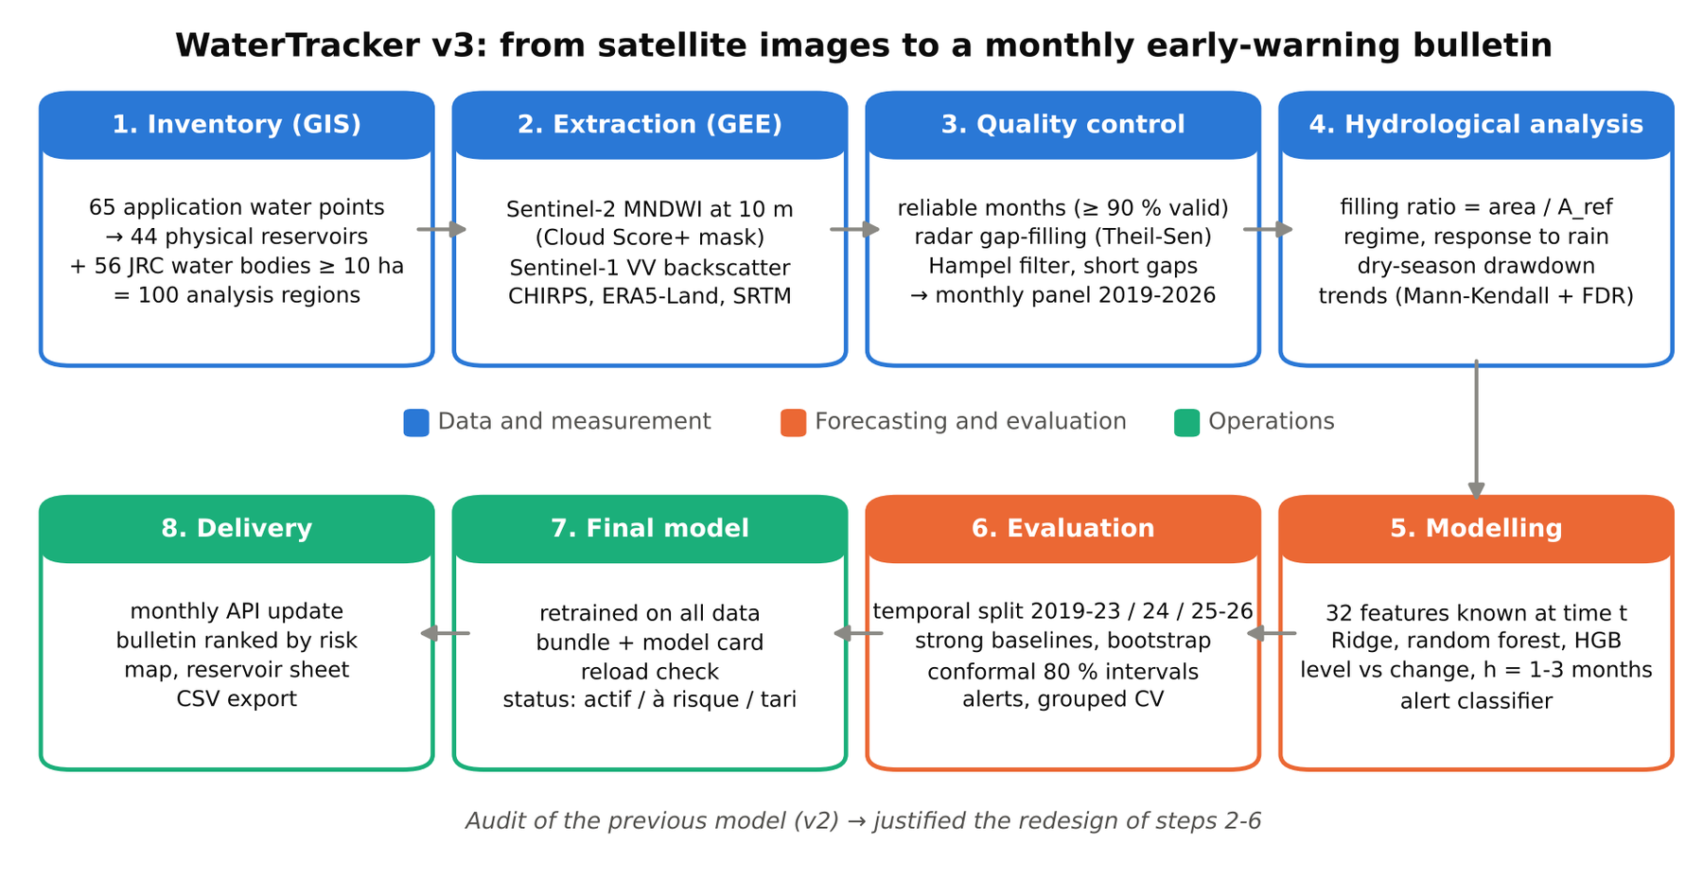
Figure 2: Technical workflow of the WaterTracker v3 pipeline

3.2 Study area
The study area is a 50 km disc around Ouagadougou (centre 12.3647° N, 1.5221° W), covering about 7,729 km² of the central plateau of Burkina Faso. The climate is Sudano-Sahelian, with a single rainy season from June to October and June-September rainfall of 650-800 mm per year over the study period. The area includes large dams supplying the capital (such as Ziga and Loumbila) and many small and medium reservoirs used for agriculture and livestock (Figure 3).
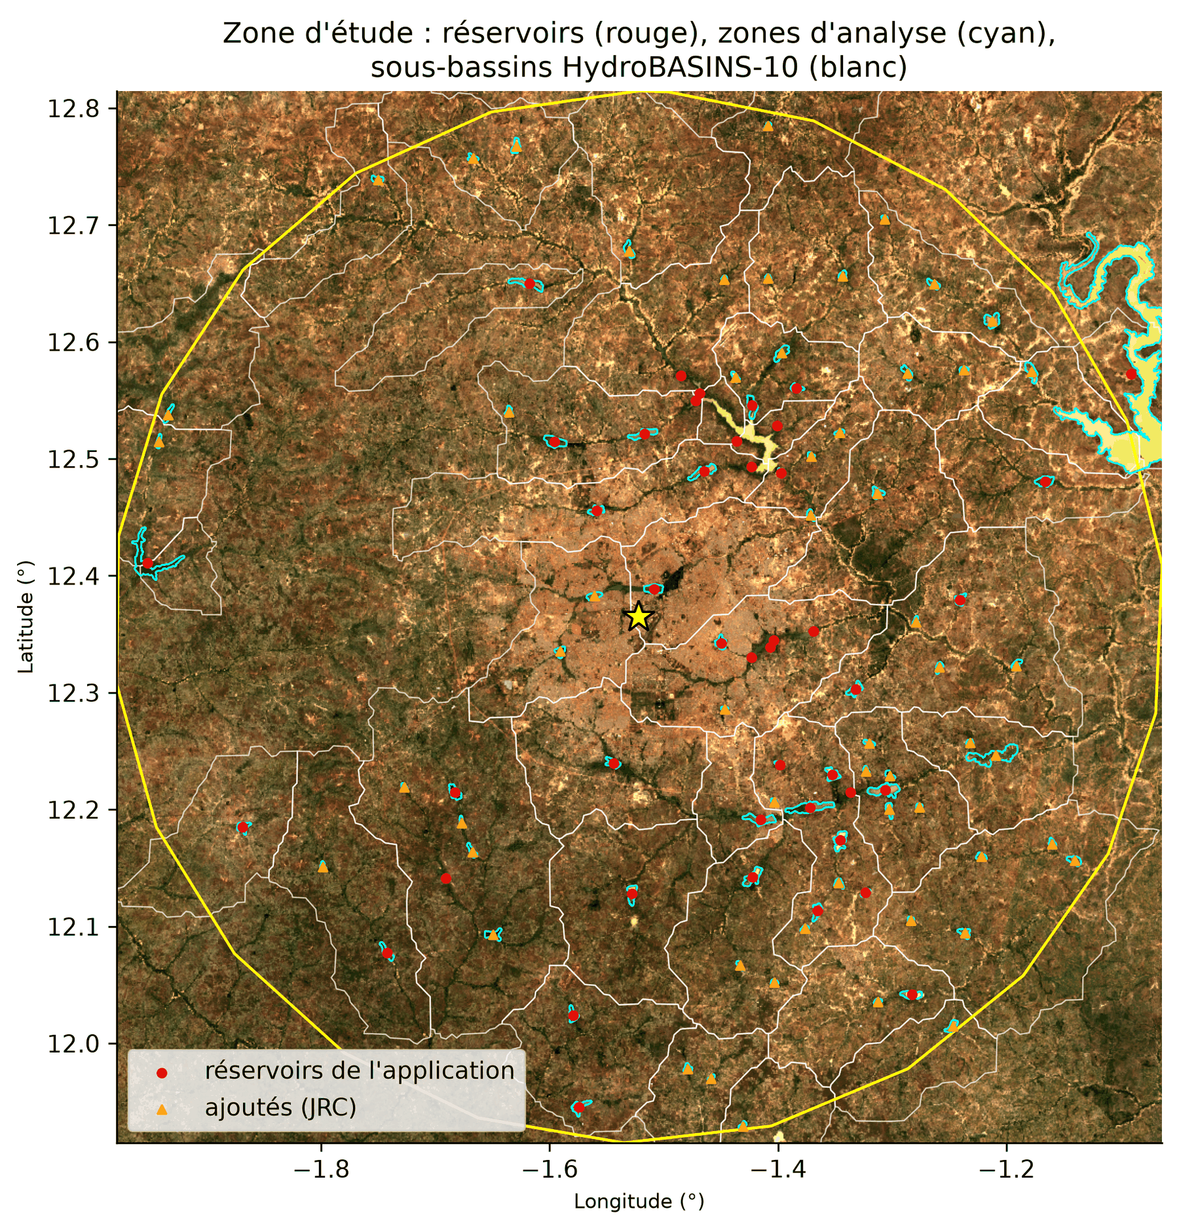
Figure 3: Study area: reservoirs of the application (red dots), reservoirs added from JRC (orange triangles), analysis regions (cyan) and HydroBASINS level-10 sub-basins (white), on a Sentinel-2 composite of October 2024. Labels in French from the notebook run.

3.3 Data
The data sources are listed in Table 2.
Table 2: Data sources used in the project
Dataset | Provider | Resolution | Use
Sentinel-2 surface reflectance (harmonised) | ESA Copernicus, via GEE | 10-20 m, 5-day revisit | Water area (MNDWI), NDWI and NDVI
Cloud Score+ | Google (Pasquarella et al., 2023) | 10 m | Pixel-level cloud and shadow mask
Sentinel-1 GRD, VV, IW mode | ESA Copernicus, via GEE | 10 m pixel | Gap-filling of cloudy months
CHIRPS daily rainfall | Climate Hazards Center (Funk et al., 2015) | 0.05° | Monthly rainfall over each sub-basin
ERA5-Land monthly | ECMWF (Muñoz-Sabater et al., 2021) | 0.1° | Temperature, potential and actual evaporation, soil moisture
JRC Global Surface Water v1.4 | EC JRC (Pekel et al., 2016) | 30 m | Inventory check, permanence features
SRTM | NASA/USGS | 30 m | Elevation and slope
HydroBASINS level 10 | WWF (Lehner & Grill, 2013) | 100-400 km² basins | Catchment of each reservoir
WaterTracker water points | Application database (PostGIS) | 65 points, OSM outlines | Initial inventory
v2 observations | Application database | Half-yearly, 650 rows | Audit of the previous model

3.4 Audit of the previous model
Before any new development, the v2 model was re-run on the database to test four suspected problems: (D1) a target, "number of half-years until the NDWI falls below 0.2", almost determined by the season; (D2) an information leak through a feature computed on the whole series and a random train-test split; (D3) a mismatch between training (raw inputs) and inference (scaled inputs) in the API; (D4) the ability of a single-point NDWI to follow the reservoir's water area. Each problem was tested with a number: the accuracy of a rule based only on the season (D1), the model's score under a random and a temporal split, with and without the suspect feature (D2), the gap between correct and served predictions (D3), and correlations between the point NDWI and the new filling ratio, within dry seasons only (D4).

3.5 Inventory construction
The 65 water points of the application were checked for geometric validity and duplicates: points sharing exactly the same polygon were merged into one physical reservoir, giving 44 reservoirs. Each reservoir received an analysis region large enough to capture its maximum extent: the polygon plus a 100 m buffer for water bodies of 5 ha or more, and a 300 m disc around the centroid otherwise, all computed in UTM zone 30N. The inventory's completeness was then tested against all JRC water bodies of 10 ha or more with an occurrence of at least 10 %; the 56 missing water bodies were added with their JRC outline, giving 100 analysis regions. Each region was linked to its HydroBASINS level-10 sub-basin (42 distinct sub-basins), over which climate variables are averaged, and characterised by static features (JRC maximum extent, permanence and seasonality, elevation, slope, catchment size).

3.6 Water-area extraction and fusion
For every month from January 2019 to August 2026 (92 months), a Sentinel-2 median composite was built after masking pixels with a Cloud Score+ value below 0.60. The 20 m SWIR band was resampled to 10 m (Du et al., 2016) and the MNDWI computed; pixels with MNDWI > 0 were counted as water, and the area summed over each region at 10 m. The same composite also gave the area for MNDWI thresholds of −0.1 and +0.1 (sensitivity analysis), the area from the native-10 m NDWI (control of the sharpening) and the fraction of valid pixels. A month was considered reliable when at least 90 % of the region was observed. In parallel, the monthly median Sentinel-1 VV backscatter gave water areas for thresholds from −14 to −20 dB. All computations ran server-side in Google Earth Engine, with results cached as Parquet files.
The radar threshold was chosen on the reliable months of the training period only, by maximising the median correlation between radar and optical areas per reservoir. A robust linear mapping (Theil-Sen estimator) from radar to optical area was then fitted for each reservoir; it was used only if at least 12 common months and a correlation of 0.6 or more were available. Its accuracy was assessed on reliable months from 2024 onwards, never seen during calibration. The fused series took, in order of priority, the reliable optical value, the recalibrated radar value, or a linear interpolation over gaps of at most two months; isolated spikes in non-optical values were removed with a Hampel filter. Each value keeps its provenance.
The area was then normalised by a reference area A_ref, the 95th percentile of the fused area over the training period only (2019-2023), to obtain a dimensionless filling ratio, capped at 1.5. Reservoirs with A_ref below 2 ha were excluded, leaving 96 modelled reservoirs and 8,832 reservoir-months. An indicative volume was computed with the Liebe et al. (2005) relationship for reservoirs within its domain of validity (1-35 ha).

3.7 Hydrological analysis
The regime was described by the distribution of the filling ratio per calendar month. The response to rainfall was measured by the median, across reservoirs, of the cross-correlation between monthly rainfall and the change in filling at lags of zero to three months. The link between rainy-season rainfall (June-September) and the annual peak and the following dry-season minimum was measured with Spearman correlations, using hydrological years starting in July. The dry-season drawdown was summarised by the median monthly change in filling from November to May. Inter-annual trends in the dry-season minimum were tested reservoir by reservoir with the Mann-Kendall test and Theil-Sen slopes, with a Benjamini-Hochberg correction for multiple testing (Benjamini & Hochberg, 1995).

3.8 Forecasting design
Target and horizons. For each reservoir and each month t, the target is the filling ratio at t + h, for h = 1, 2 and 3 months, with one model per horizon. Two formulations were compared: predicting the level fill(t + h) or the change fill(t + h) − fill(t).
Features. Thirty-two features, all known at the end of month t, describe the current state (filling at lags 0 to 3 and 12 months, recent changes), the reservoir's climatology for the issue and target months and the current anomaly, past forcings (rainfall over 1, 3 and 6 months and its anomaly, potential and actual evaporation, temperature, soil moisture), the calendar (sine and cosine of the issue and target months), static characteristics (reference area, JRC permanence and seasonality, elevation, slope, catchment size) and a data-quality flag. For training rows, the target-month climatology was computed excluding the target's year. The feature code is shared with the API (ml/features.py), so that inference uses exactly the same computation. A control checks that no feature is almost identical to the target (|r| > 0.95).
Validation protocol. Data were split by target month: training (2019-2023), validation (2024) and test (2025 to August 2026; 1,920 rows per horizon). Model selection used the validation set only; each selected model was then retrained on training and validation data and evaluated once on the test set.
Baselines and models. Four baselines were computed: persistence, seasonal naive, climatology (the reservoir's median for the target month) and persistent anomaly. Three model families were tuned on a small grid (90 configurations in total): ridge regression, random forest (300 trees) and histogram gradient boosting, each wrapped in a scikit-learn pipeline with its preprocessing (Pedregosa et al., 2011).
Metrics and significance. The main metric is the mean absolute error (MAE) of the filling ratio, complemented by RMSE, NSE and KGE. The skill score uses as reference the best baseline on the validation set. The significance of the gain over that reference was tested with a block bootstrap resampling whole target months (2,000 replicates), a simplified form of the Diebold-Mariano test (Diebold & Mariano, 1995) that respects the correlation between reservoirs. Errors were also analysed by target month and by reservoir size.
Value of rainfall information. To bound the value of seasonal rainfall forecasts, an "oracle" model was given the rainfall actually observed between t + 1 and t + h; it cannot be deployed but shows the maximum gain a perfect rainfall forecast could bring.
Spatial generalisation. A five-fold cross-validation grouped by reservoir, on target months up to 2024, measured performance on reservoirs absent from training.

3.9 Uncertainty and early warning
Prediction intervals were obtained by two gradient-boosting models with quantile losses (α = 0.10 and 0.90), corrected by conformalized quantile regression calibrated on the validation year (Romano et al., 2019). They were evaluated by their coverage (PICP, target 80 %) and mean width (MPIW).
The early warning targets the event "filling ratio below 0.20". A histogram gradient-boosting classifier with balanced class weights was compared with two rules: persistence (alert if already critical) and the regression rule (alert if the forecast is below the threshold). The decision threshold was chosen on the validation set by maximising the F1 score. Evaluation used ROC-AUC, PR-AUC, the Brier score, precision, recall and F1, a reliability diagram, and the detection of entries into crisis (reservoirs above the threshold at t and below it at t + h). An isotonic recalibration was kept only if it improved the Brier score on the second half of the validation year. Permutation importance on the test set was used to explain the selected model.

3.10 Final model, deployment and tools
The selected configuration was retrained on all data and saved as a single bundle (median regressor, quantile models with their conformal correction, alert classifier and threshold, climatologies and reference areas), together with a model card and the test scores. The bundle is reloaded from disk and its predictions checked against the in-memory model. The API's monthly update uses the same forecasting function (ml/forecasting.py) and maps forecasts to the application's statuses: dried up if the forecast filling is below 5 %, at risk if the probability of a critical level is at least 50 %, active otherwise.
The analysis used Python 3.11.9 with numpy 2.4.6, pandas 3.0.2, scikit-learn 1.9.0, GeoPandas 1.2.0 and the Earth Engine API 1.7.42. The random seed was fixed, satellite extractions were cached, and a fingerprint of the final data panel is recorded in the model card. The application itself runs on FastAPI with a PostgreSQL/PostGIS database and a React frontend (Appendix C).

3.11 Ethical considerations
The project uses only open, aggregated environmental data; no personal data were collected. The main ethical risk is that of over-confident information reaching decision-makers in a humanitarian context. Three measures address it: every forecast is published with its uncertainty, the model card states the intended and non-intended uses, and the report and notebook state the limits openly, including negative results.

4. Results and Analysis

4.1 Audit of the previous model (v2)
The audit confirmed three of the four suspected problems (Table 3). The half-yearly target was largely determined by the season: in the dry season the mean point NDWI was 0.08, almost always below the 0.2 threshold, and a rule that predicts the most frequent target value of each season, with no learning, was right 55.6 % of the time. The published score of the model (R² = 0.19 with a random split) became negative under a temporal split (R² = −0.45; MAE rising from 4.9 to 8.6 half-years), meaning that the model forecast worse than a constant mean (Figure 4); removing the leaking feature changed little, which shows that the inflated score came mainly from the autocorrelation between rows. Most seriously, the API scaled the inputs before passing them to a model trained on raw values: the served predictions differed from the model's own by 6.07 half-years on average, and only 0.4 % of them were identical after rounding. The fourth point was qualified: across half-years the point NDWI followed the new filling ratio (median within-reservoir correlation 0.83), but within dry seasons only, which is what an alert needs, the median correlation fell to 0.39 and 60 % of reservoirs were below 0.5.
Table 3: Results of the audit of the v2 model
Problem | Test | Result | Verdict
D1 Seasonal target | Accuracy of a season-only rule | 55.6 % | Confirmed
D2 Information leak | R² random split vs temporal split | 0.19 vs −0.45 | Confirmed
D3 Training/inference mismatch | Mean gap correct vs served prediction | 6.07 half-years; 0.4 % identical | Confirmed (most serious)
D4 Point NDWI vs water area | Median within-reservoir correlation, all / dry season only | 0.83 / 0.39 | Qualified

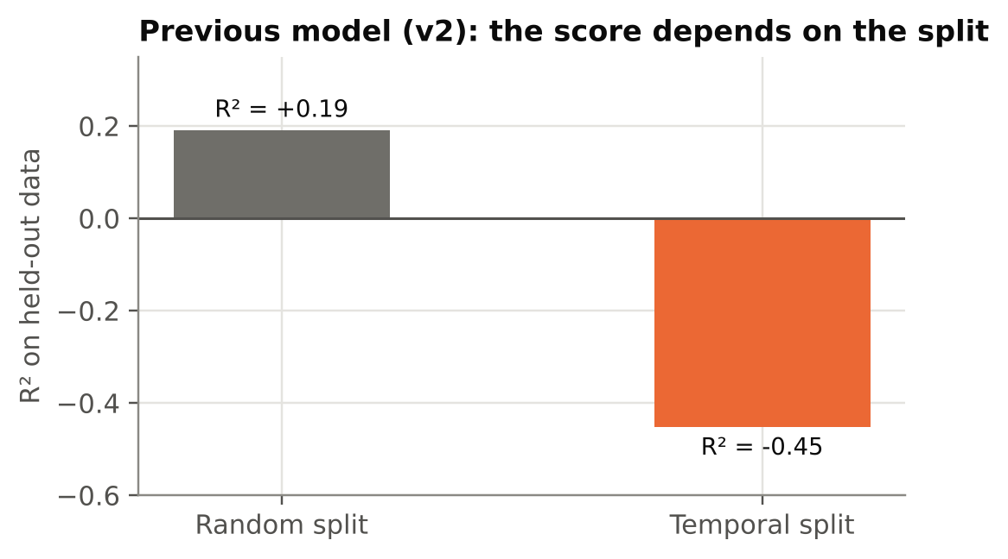
Figure 4: Score of the previous model (v2) under a random and a temporal split
These results justified replacing the whole chain rather than tuning the old model: the variable (a point index), the time step (half-yearly), the target (a censored count of periods) and the deployment code all had to change.

4.2 Inventory and measurement quality (RQ2)
The 65 water points of the application corresponded to 44 physical reservoirs: 12 water bodies were shared by two to five points. Compared with the JRC reference, the application's inventory covered only 38 % of the water bodies of 10 ha or more, but 76 % of their area: the large reservoirs were known, while many medium-sized ones, up to 273 ha, were missing. Adding the 56 missing water bodies brought the study to 100 analysis regions; 96 of them had a reference area of at least 2 ha and were modelled.
Measurement quality was high (Table 4). Thanks to pixel-level cloud masking, 98.7 % of the 9,200 reservoir-months had a reliable optical observation; even in August, the cloudiest month, 88 % were reliable. Radar was therefore needed for less than 1 % of the months. Its threshold was set at −20 dB (median correlation with optical areas per reservoir 0.64), and a usable calibration was obtained for 64 of the 100 reservoirs. On independent months, the radar reconstruction was coarse (MAE 8.2 ha, median relative error 55 %), which is acceptable only because it fills so few values. After fusion, every month of every modelled reservoir had a value: 98.7 % from Sentinel-2, 0.8 % from radar and 0.5 % interpolated.
Table 4: Measurement quality indicators
Indicator | Value
Reservoir-months with a reliable optical observation | 98.7 % (August: 88 %)
Final provenance: Sentinel-2 / Sentinel-1 / interpolation | 98.7 % / 0.8 % / 0.5 %
Radar reconstruction on independent months: MAE, median relative error | 8.2 ha, 55 %
Filling ratio, MNDWI threshold −0.1 / +0.1: correlation with threshold 0 | 0.986 / 0.961
Filling ratio, MNDWI threshold −0.1 / +0.1: mean absolute difference | 0.034 / 0.039
20 m vs 10 m area difference (median): < 5 ha / 5-50 ha / > 50 ha | 4.3 % / 1.2 % / 0.4 %
Sharpened MNDWI vs native 10 m NDWI: median temporal correlation | 0.83

The measurement was robust to methodological choices. Moving the MNDWI threshold by ±0.1 changed the filling ratio by only 0.03-0.04 on average (correlations 0.96-0.99). Working at 10 m instead of 20 m made little difference for large water bodies but mattered for the smallest ones (median difference 4.3 %, up to 27 %, below 5 ha). The sharpened MNDWI followed the native 10 m NDWI closely in time (median correlation 0.83), while the NDWI detected about 20 % less water overall, consistent with its known weakness on turbid water. H2 is supported.

4.3 Hydrological dynamics (RQ1)
All reservoirs share a single, regular annual cycle (Figure 5, Figure 6). Filling starts in June-July, peaks in August (median filling ratio 0.94) and is followed by a long drawdown. By March-April, the median reservoir is empty, and 89 % of the reservoirs are below the critical level of 20 % in April, compared with 3-4 % in August-September. Summed over the 96 reservoirs, the water area falls to 34-43 km² at the end of each dry season and climbs back to 97-108 km² at the peak; the indicative stored volume of the 53 reservoirs of 1 to 35 ha ranges from 16.8 million m³ in August to 0.3 million m³ in April (Figure 7).
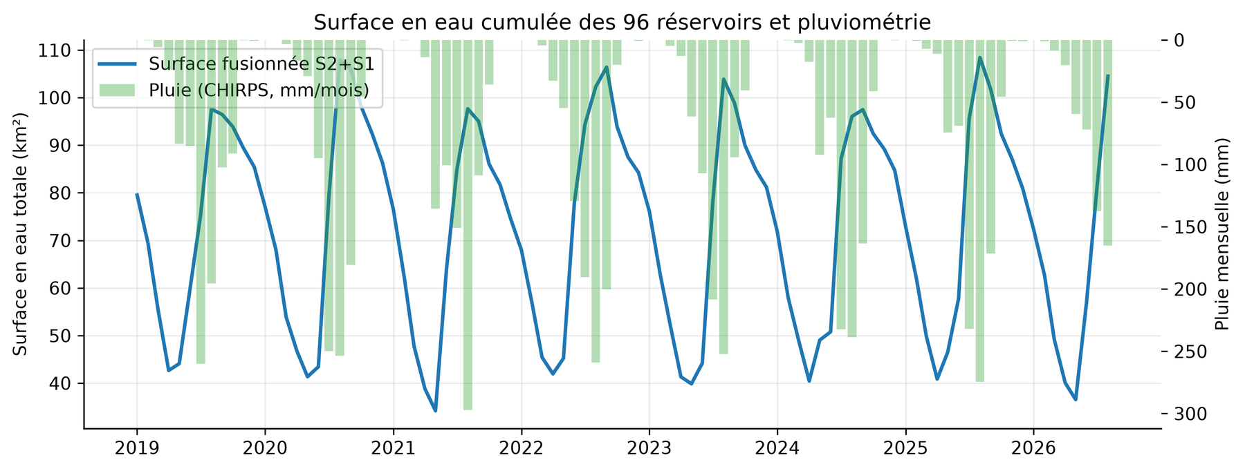
Figure 5: Total water area of the 96 modelled reservoirs (line, km²) and monthly CHIRPS rainfall (bars, inverted axis), January 2019 - August 2026. Labels in French from the notebook run.
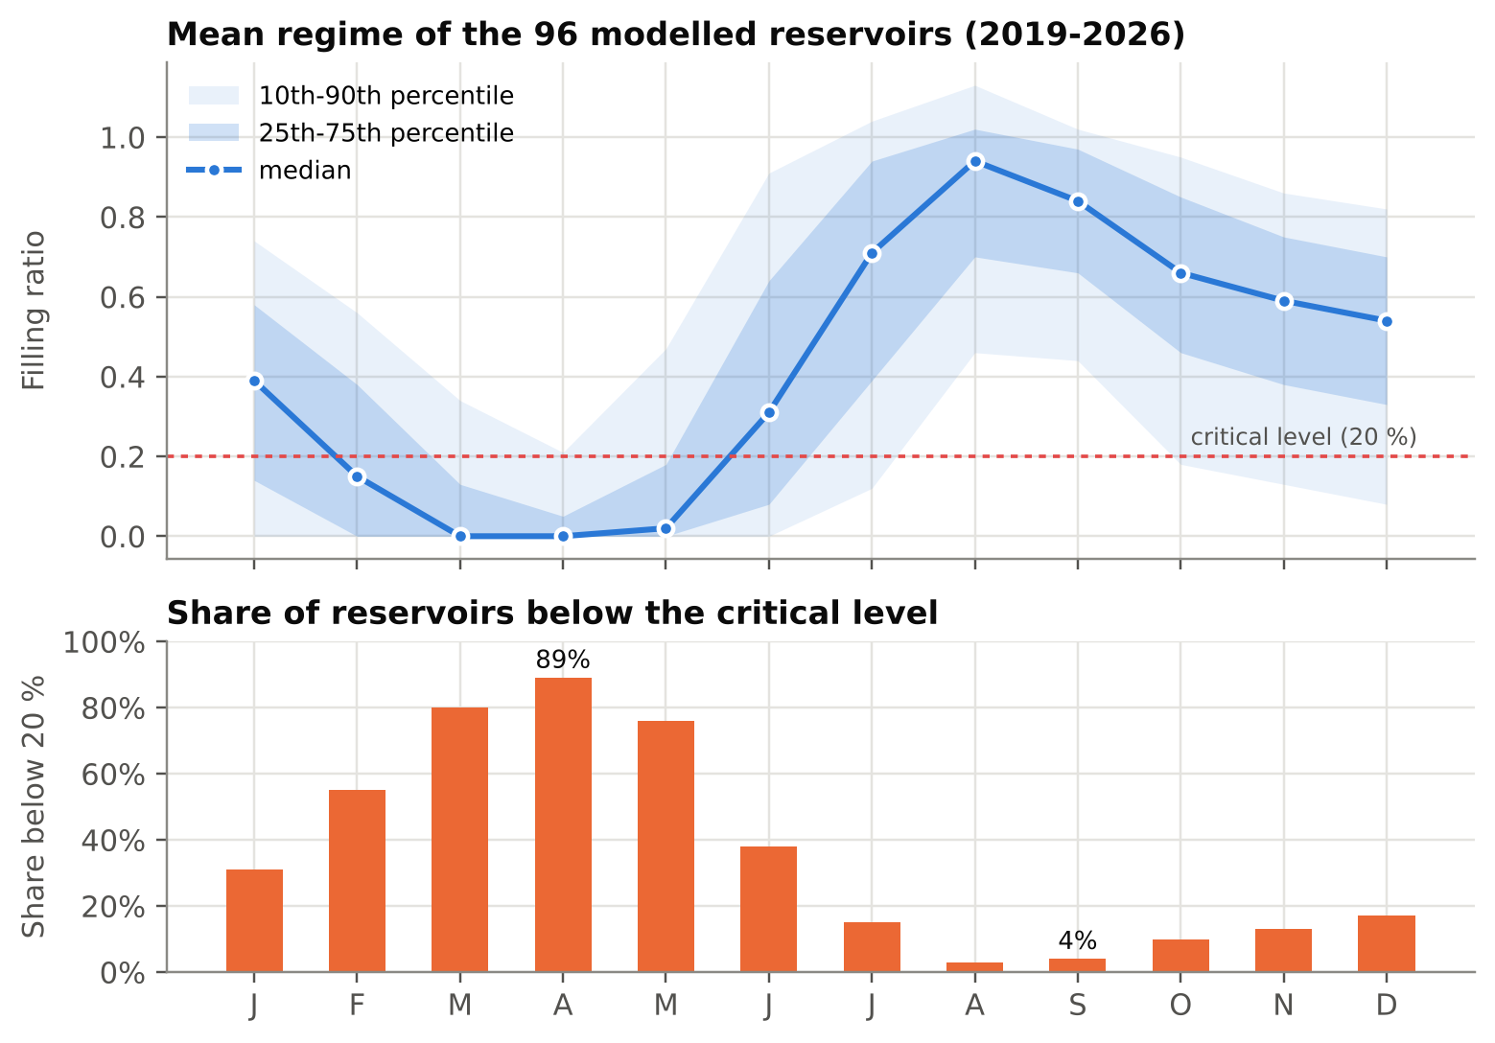
Figure 6: Mean regime of the modelled reservoirs: distribution of the filling ratio by calendar month (top) and share of reservoirs below the critical level (bottom)
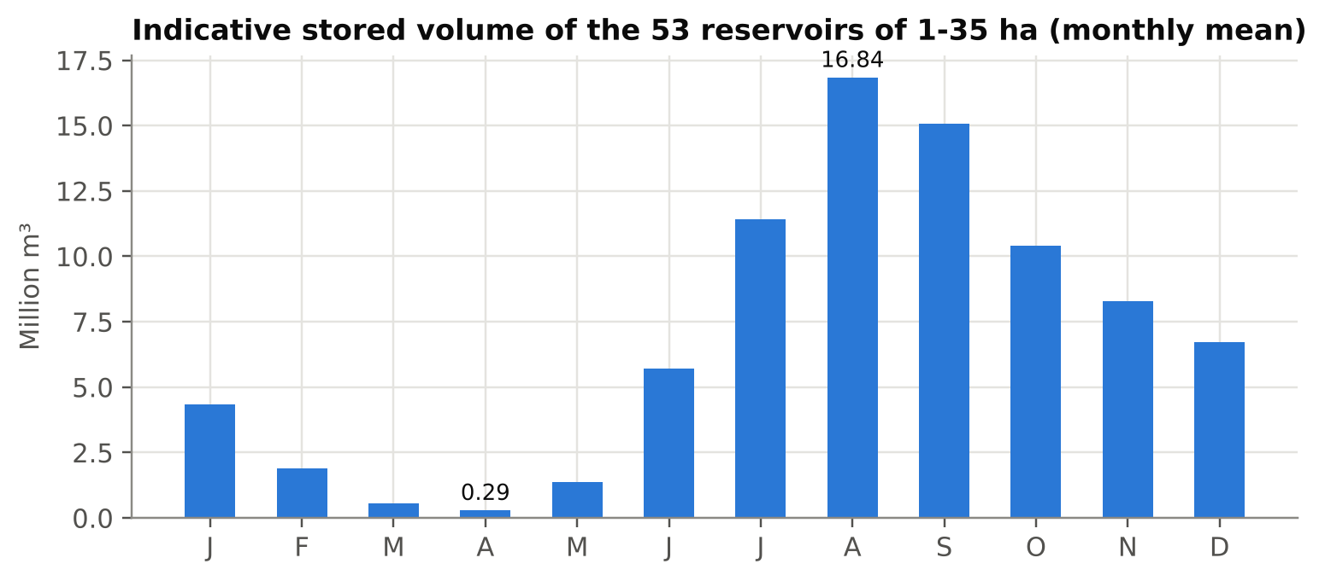
Figure 7: Indicative stored volume of the 53 reservoirs within the domain of validity of the Liebe et al. (2005) relationship
Reservoirs respond quickly to rainfall: the correlation between monthly rainfall and the change in filling peaks at lag 0 (median r = 0.49) and is already weak at lag 1 (0.18). The drawdown accelerates through the dry season, from about 6 points of filling ratio per month in November-December to 13-15 points per month in January-February, while potential evaporation rises from about 330 to 415 mm per month.
The relationship between rainfall and the following dry season is the most striking result. Wetter rainy seasons give higher peaks (Spearman ρ = 0.32, p ≈ 10⁻¹⁷), but they do not predict the dry-season minimum (ρ = 0.05, p = 0.2): in every hydrological year from 2019 to 2025, the median reservoir reached a minimum filling of zero. The size of the reservoir matters more: larger reservoirs keep more water at the end of the dry season (ρ = 0.38, p = 0.0001), although almost every reservoir below about 100 ha reaches a near-zero minimum. Finally, a few reservoirs showed nominal trends in their dry-season minimum, but none remained significant after correction for multiple testing (0 of 72). H1 is therefore partly supported: the cycle and the fast response are confirmed, but the amount of rain does not carry over to the dry-season minimum, and no degradation trend can be claimed over seven years.

4.4 Forecast accuracy (RQ3)
On the validation year, climatology was the strongest baseline at every horizon (MAE 0.134), far ahead of persistence (0.164 at one month and 0.343 at three months); during the rainy season the area can double within a month, which makes persistence a weak reference. The random forest, predicting the level rather than the change, was the best model at every horizon. Table 5 and Figure 8 give the results on the test period (2025 to August 2026), which played no part in any choice.
Table 5: Test-set performance (target months 2025 - August 2026; 1,920 forecasts per horizon)
Model | MAE h=1 | MAE h=2 | MAE h=3 | NSE h=1 | NSE h=3 | Skill h=1 | Skill h=3
Persistence | 0.186 | 0.326 | 0.424 | 0.45 | −0.90 | −38.5 % | −215.7 %
Seasonal naive | 0.133 | 0.133 | 0.133 | 0.68 | 0.68 | +0.6 % | +0.6 %
Climatology (reference) | 0.134 | 0.134 | 0.134 | 0.68 | 0.68 | 0 % | 0 %
Persistent anomaly | 0.133 | 0.165 | 0.170 | 0.66 | 0.55 | +0.7 % | −26.6 %
Ridge | 0.125 | 0.146 | 0.146 | 0.75 | 0.71 | +6.8 % | −8.4 %
Random forest | 0.108 | 0.133 | 0.130 | 0.80 | 0.75 | +19.6 % | +3.4 %
Gradient boosting (HGB) | 0.108 | 0.135 | 0.133 | 0.79 | 0.73 | +19.4 % | +1.0 %

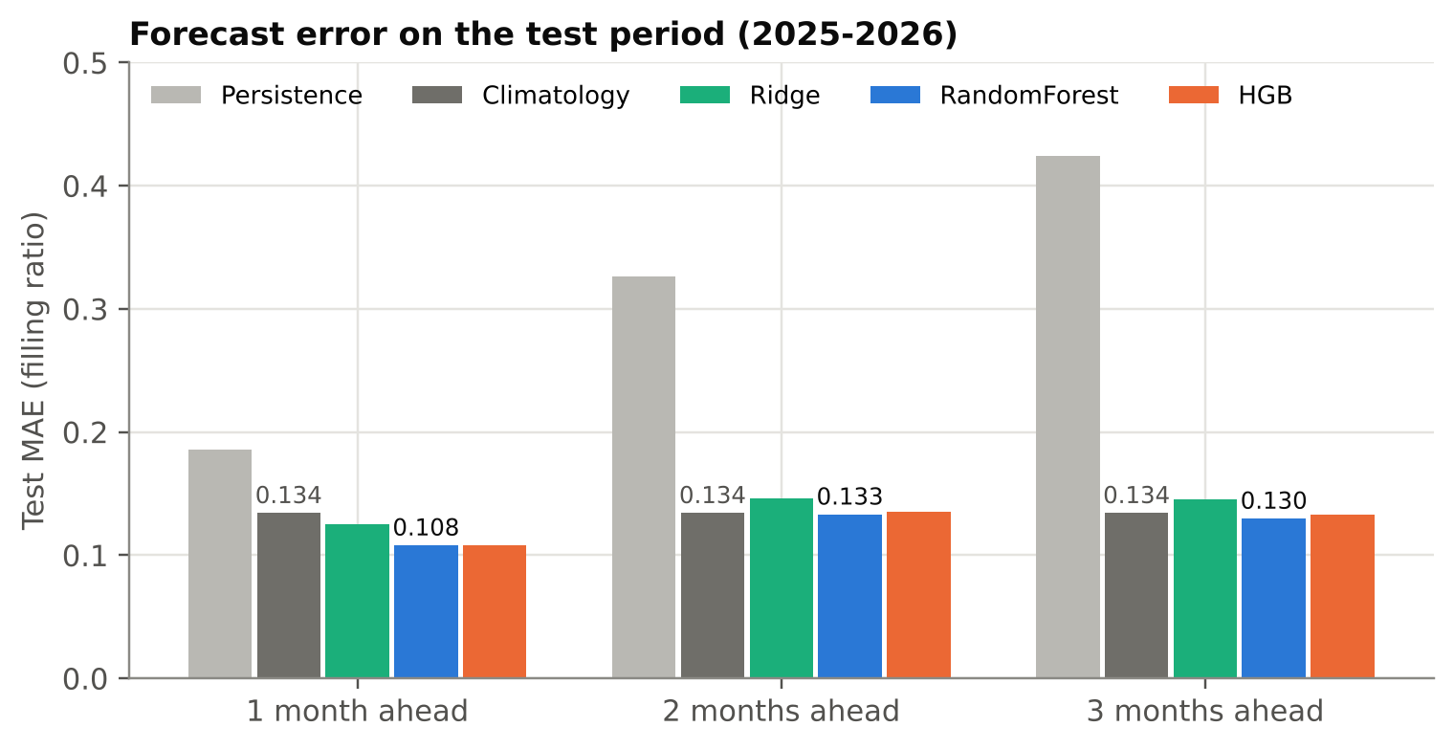
Figure 8: Forecast error on the test period by model and horizon
One month ahead, the random forest reduced the MAE from 0.134 to 0.108, a skill of +19.6 %, with NSE and KGE of 0.80. The block bootstrap confirmed that this gain is robust: 0.026 (95 % CI 0.016 to 0.036, p < 0.001). Two and three months ahead, the gain was small and not significant (+0.9 %, p = 0.41; +3.4 %, p = 0.11): the model only matched climatology (Figure 9). The linear ridge model was clearly worse than the tree ensembles, which indicates non-linear relationships between state, season and forcings. Note that the seasonal naive forecast was marginally better than climatology on the test period (0.1335 versus 0.1342), although climatology had been the better baseline on validation; the conclusions are unchanged.
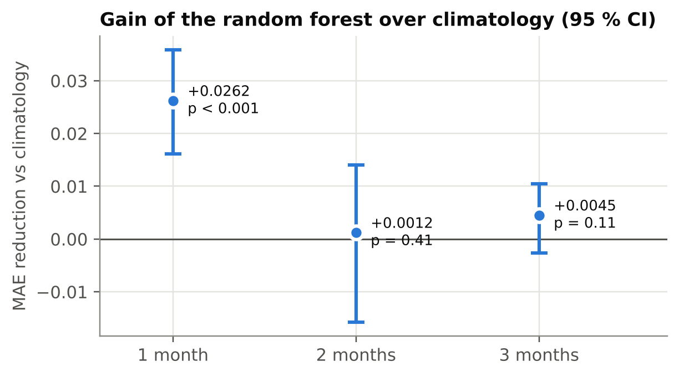
Figure 9: Gain of the random forest over climatology, with 95 % block-bootstrap confidence intervals
The error varies strongly with the season (Figure 10). It is smallest during the dry season, with an MAE of about 0.04 to 0.09 one month ahead from October to March, and largest from June to August, when the filling depends on the onset of the rains. One month ahead, the model beats climatology in every month except April and May, when most reservoirs are dry and all methods are equivalent; its relative advantage is largest from October to February, roughly 30 to 50 % lower error. Small reservoirs had a slightly higher mean error than large ones (0.122 versus 0.100), with similar medians (about 0.06).
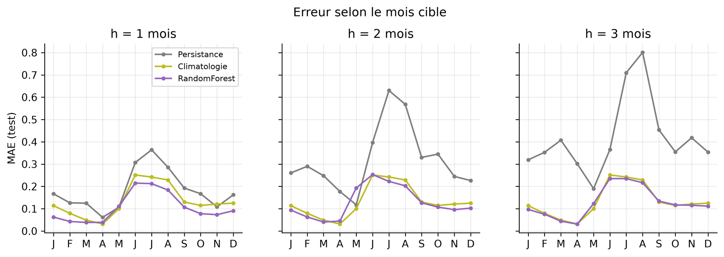
Figure 10: Test MAE by target month for persistence (grey), climatology (yellow-green) and the random forest (purple), at 1, 2 and 3 months. Labels in French from the notebook run ("mois" = month).
The oracle experiment gave a clear negative answer. Giving the model the rainfall actually observed over the forecast window did not reduce the error at any horizon (changes of −0.8 %, −1.0 % and −1.2 %, i.e. noise). Monthly rainfall totals over the sub-basin do not explain the residual error, so integrating seasonal rainfall forecasts would not improve this model.
Finally, the model generalised to reservoirs it had never seen. In the cross-validation grouped by reservoir, its MAE (0.106, 0.130 and 0.136 at one, two and three months, with a standard deviation of 0.006 to 0.011 across folds) stayed close to its test MAE and below both persistence (0.172 to 0.382) and climatology (0.147 to 0.149). H3 is supported at one month only.

4.5 Uncertainty and early warning (RQ4)
The raw quantile intervals were too narrow, covering only 68 to 70 % of the observations for a nominal 80 % (Table 6). After the conformal correction, coverage reached 83 % at one month and 80 % at two months, but remained below nominal at three months (75 %), as the test years differed from the validation year. The 80 % intervals are wide, 0.33 to 0.40 filling points, which reflects the genuine uncertainty of a monthly forecast.
Table 6: Coverage and width of the 80 % prediction intervals on the test set
Horizon | Raw quantile: coverage | Raw quantile: width | Conformalised: coverage | Conformalised: width
1 month | 70.2 % | 0.274 | 83.4 % | 0.333
2 months | 68.0 % | 0.365 | 80.2 % | 0.402
3 months | 69.7 % | 0.394 | 74.9 % | 0.403

The alert classifier discriminated very well between critical and non-critical situations (ROC-AUC 0.96-0.97, PR-AUC 0.94-0.95, for an event rate of 40 %), and its probabilities were well calibrated (Figure 12); isotonic recalibration degraded the Brier score on validation and was not kept. Its F1 score (0.89, 0.83 and 0.85 at one, two and three months) was far above persistence (0.77, 0.57 and 0.40), and slightly above the regression rule (0.88, 0.81 and 0.85) (Figure 11). On the more demanding test of entries into crisis, the classifier detected 123 of 175 entries one month ahead (70 %) with 25 false alarms, and 374 of 468 three months ahead (80 %) with 40 false alarms; 83 to 90 % of these alerts were confirmed. H4 is supported, with one caveat discussed below: critical situations are strongly seasonal, and a climatological alert rule was not evaluated.
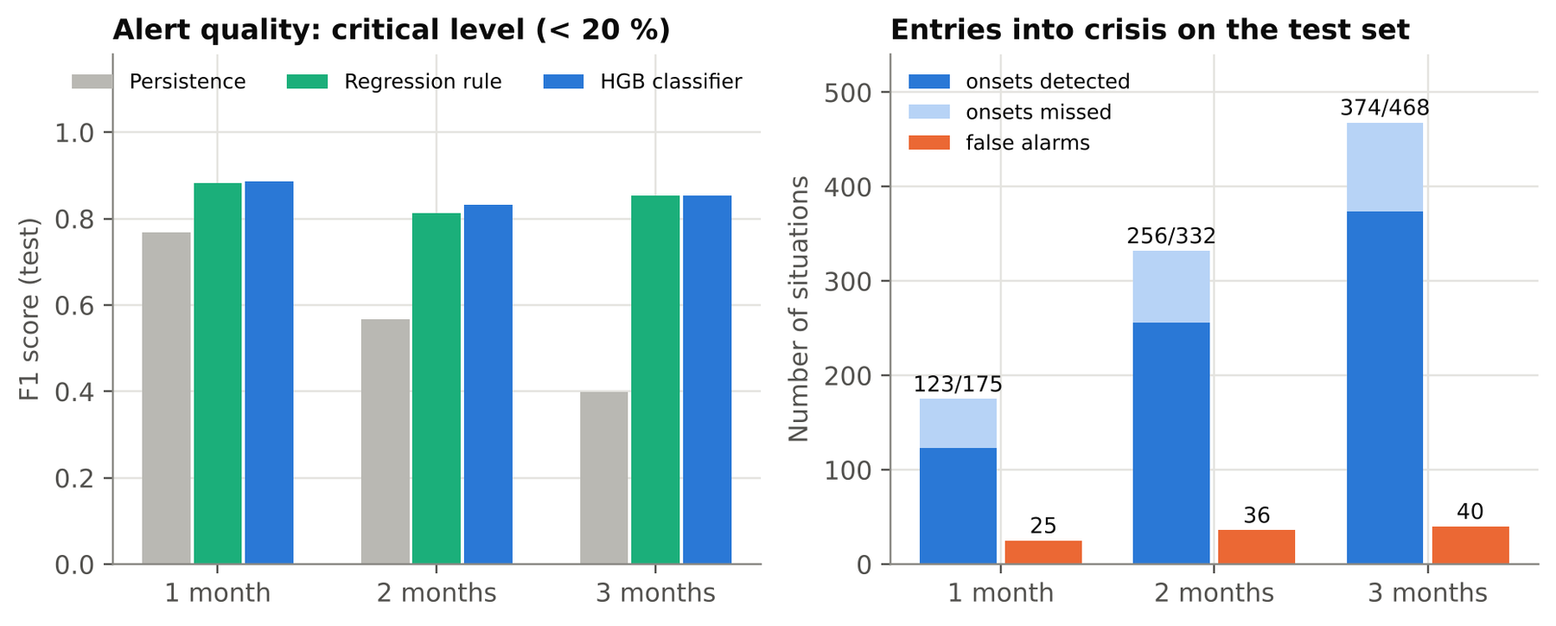
Figure 11: Early-warning performance on the test set: F1 score by method (left) and detection of entries into crisis (right)
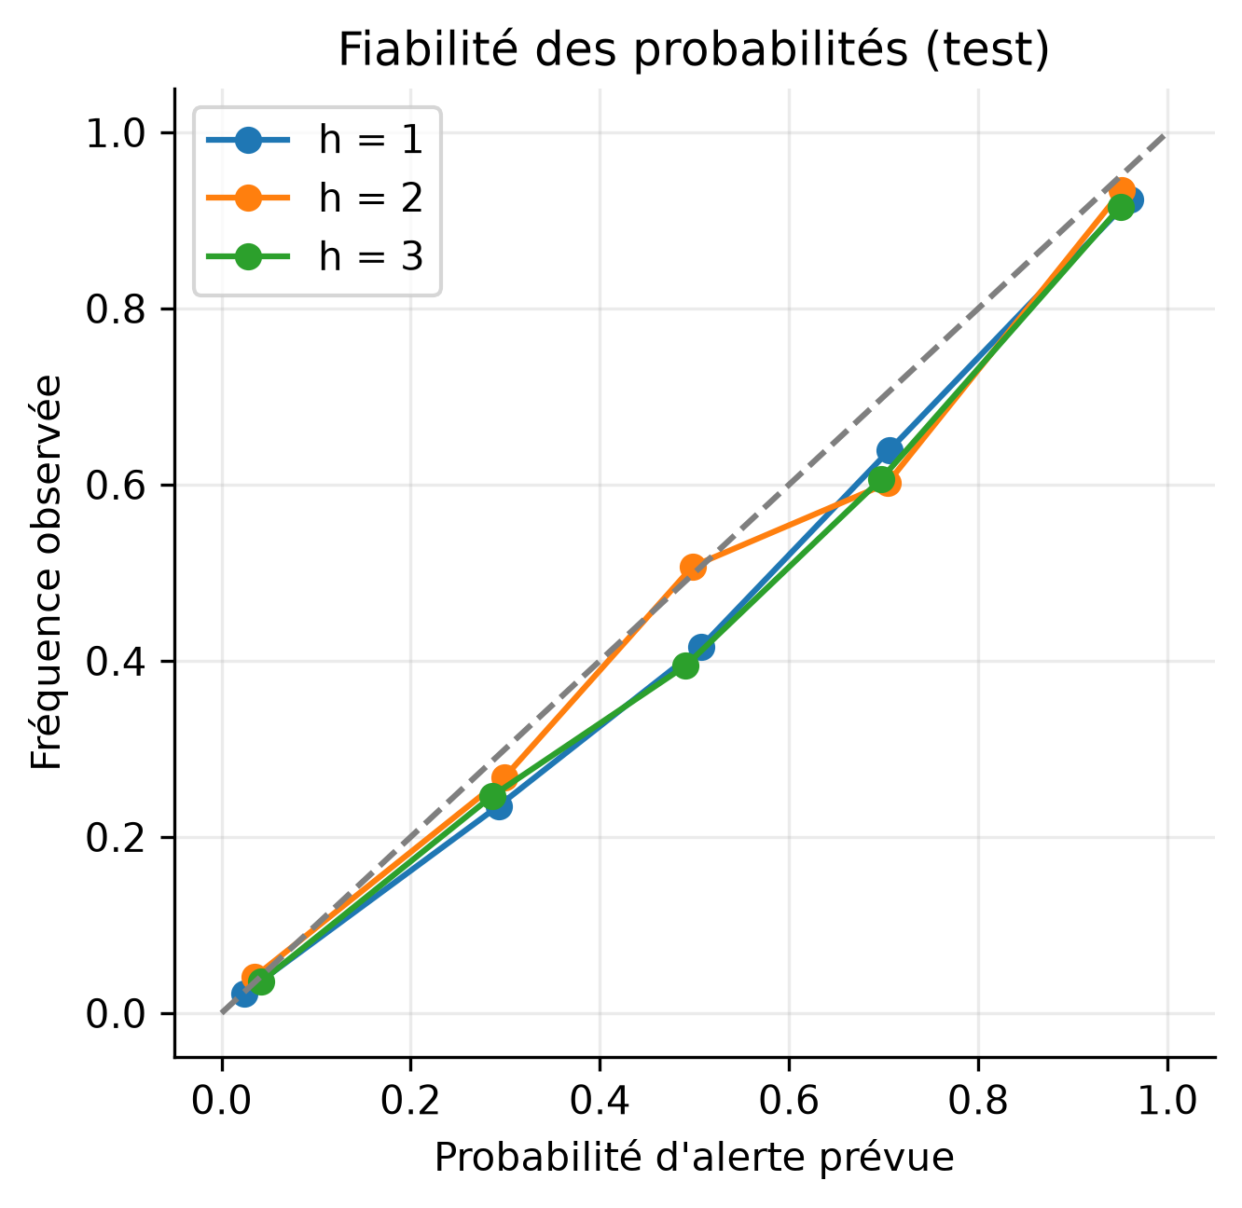
Figure 12: Reliability diagram of the alert probabilities on the test set (forecast probability vs observed frequency). Labels in French from the notebook run.

4.6 Explainability
Permutation importance agrees with the physical expectations (Figure 13). One month ahead, the current filling and the target-month climatology dominate, followed by recent rainfall and its climatology. Three months ahead, the current filling becomes almost irrelevant and the target-month climatology carries nearly all of the information: the model behaves as a refined climatology, which explains why it cannot beat climatology at that horizon.
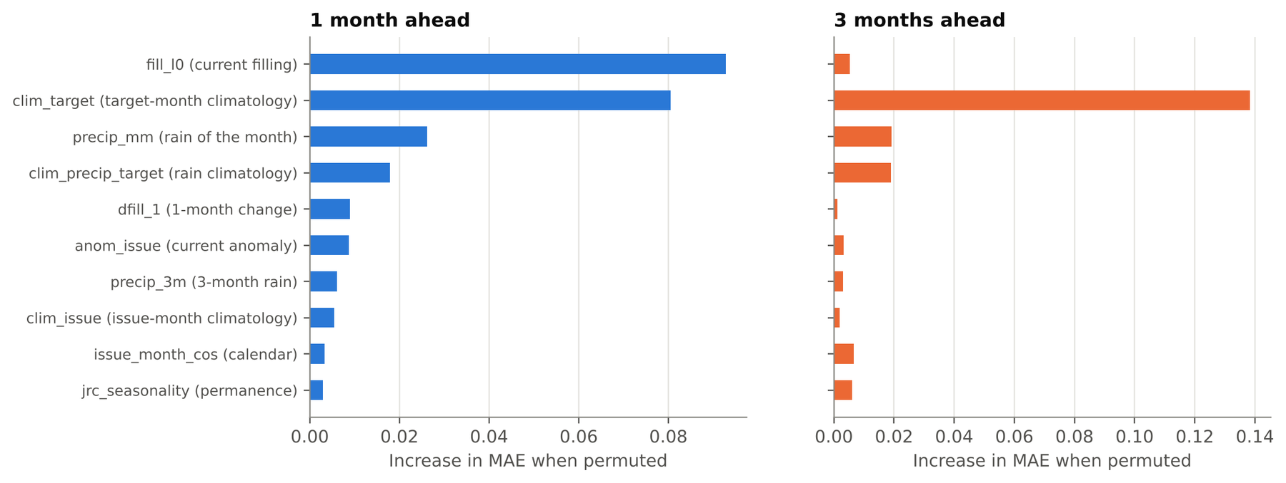
Figure 13: Permutation importance of the ten most important features of the random forest, one and three months ahead

4.7 Operational forecast
The final bundle (44.6 MB) was reloaded and checked, then used to issue the forecast at the end of August 2026, at the peak of the rainy season. One month ahead, 94 reservoirs were active and 2 at risk; three months ahead, 84 were active, 11 at risk and 1 forecast as dried up. Figure 14 shows the four reservoirs most likely to reach the critical level within three months, with probabilities between 93 and 100 %. The forecasts were exported for the 65 water points of the application (189 rows covering three horizons) and are served by the API and the monthly bulletin.
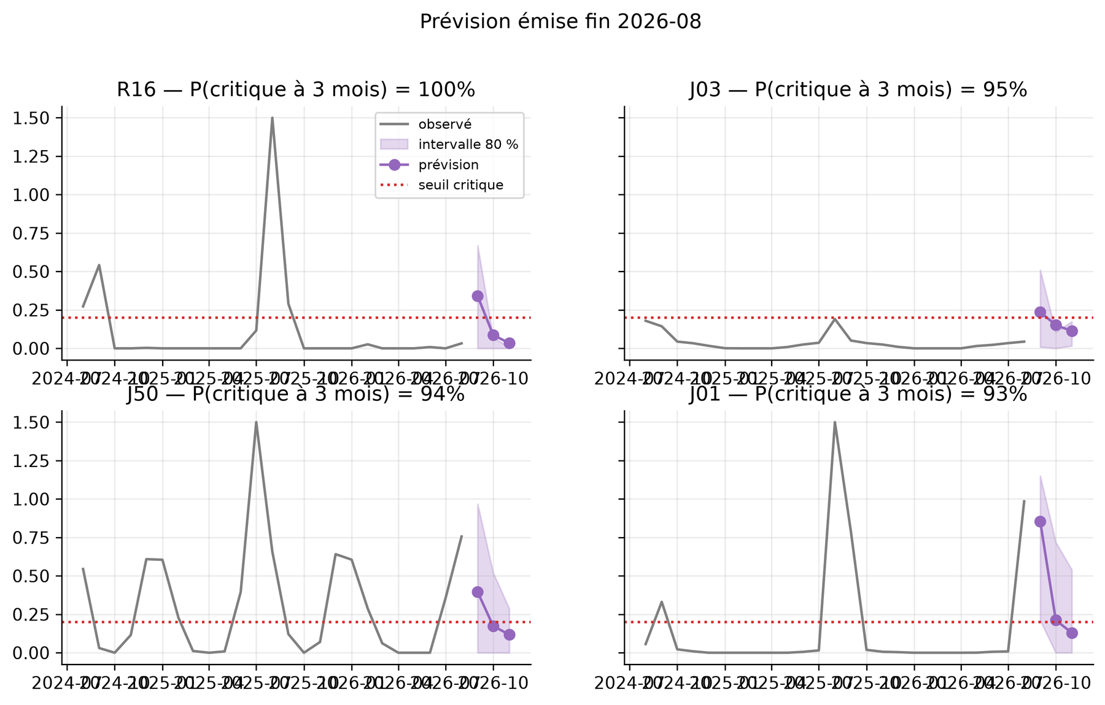
Figure 14: Forecast issued at the end of August 2026 for the four reservoirs most likely to become critical within three months: observed filling (grey), forecast (purple) with its 80 % interval, and critical threshold (red). Labels in French from the notebook run.

4.8 Summary of the hypotheses
Table 7 summarises the verdicts.
Table 7: Verdict on the research hypotheses
Hypothesis | Verdict | Main evidence
H1 Hydrological dynamics | Partly supported | Single cycle, response at lag 0 (r = 0.49); rainfall raises the peak (ρ = 0.32) but not the dry-season minimum (ρ = 0.05); no significant trend
H2 Continuous, robust measurement | Supported | 98.7 % reliable optical months, no missing month after fusion; robust to threshold and resolution
H3 Forecast better than the strongest baseline | Supported at 1 month only | Skill +19.6 % (p < 0.001) at 1 month; not significant at 2-3 months; perfect rainfall would not help; coverage 83 / 80 / 75 %
H4 Reliable early warning | Supported, with a caveat | ROC-AUC 0.96-0.97; F1 0.83-0.89 vs 0.40-0.77 for persistence; 70-80 % of entries into crisis detected; climatological alert baseline not tested

5. Discussion

5.1 What the satellite pipeline delivers
The first contribution of the project is a measurement. For reservoirs that had no data at all, the pipeline now provides a monthly water area since 2019, at 10 m, with a known provenance for every value. The main methodological risk identified in the literature, cloud cover during the rainy season, turned out to be much smaller than expected once cloud masking was done pixel by pixel rather than scene by scene: 98.7 % of reservoir-months were observed directly. This confirms the value of pixel-level quality scores such as Cloud Score+ (Pasquarella et al., 2023), and it relegates radar to a backup role. The radar reconstruction was indeed imprecise (median relative error 55 %), in line with the known sensitivity of C-band backscatter to wind and dry soils, which earlier radar studies of small reservoirs also had to address (Annor et al., 2009). In this setting, its value is to avoid gaps, not to provide precise values.
The sensitivity analyses also support the choice of the MNDWI sharpened to 10 m (Xu, 2006; Du et al., 2016). The results did not depend on the exact threshold, and the gain of 10 m over 20 m was concentrated on water bodies below 5 ha, which are exactly the small ponds that matter for livestock at the end of the dry season. The comparison with the JRC dataset showed that the application's original inventory, produced at 100 m resolution, missed most of the medium-sized water bodies; a monitoring system that ignores them gives a biased picture of the resource, a concern that echoes the inventory gaps reported for Burkina Faso (Boelee et al., 2009; Venot et al., 2012).

5.2 What the forecasts can and cannot do
The forecasting results follow closely the predictability framework of Section 2.3. One month ahead, the current state adds real information to the seasonal cycle, and the random forest improves on climatology by about 20 %, a gain that is statistically robust. Two and three months ahead, the information carried by the current state fades and the model converges to climatology; permutation importance shows this directly. This is not a failure of the learning algorithm but a property of the system: the evidence suggests that, with the information available, the state of a reservoir three months ahead is mostly its seasonal normal.
The oracle experiment adds an important and somewhat counter-intuitive result. A common assumption, and the first improvement one would propose, is that seasonal rainfall forecasts would extend the useful horizon. The experiment shows that even perfect knowledge of monthly rainfall over the sub-basin would not reduce the error. This is consistent with Sahelian hydrology: runoff depends on rainfall intensity, soil crusting and land cover more than on rainfall totals (Mahé & Paturel, 2009), and dry-season losses depend on evaporation and withdrawals. It is also consistent with the hydrological analysis, in which rainy-season rainfall explained part of the peak but nothing of the dry-season minimum. The practical consequence is that effort should not go into integrating seasonal rainfall forecasts, but into better measurement (field validation, volume), finer forcings if any (daily intensity, runoff thresholds) and a better representation of withdrawals.
The seasonal pattern of the error is, from a decision-making point of view, the most useful result. The forecast is most accurate, and most clearly better than climatology, from October to March, during the drawdown. That is when farmers decide how much land to put under dry-season crops, when herders plan their movements, and when programmes decide where to intervene before the end of the dry season. Conversely, the forecast is weakest at the onset of the rainy season, when it matters least for scarcity.

5.3 Early warning: strong results, one open question
The alert classifier performed well on every metric, and its probabilities were well calibrated, which means that they can be communicated as such to users. Its most convincing result is the detection of entries into crisis: 70 to 80 % of the reservoirs that crossed the critical threshold were flagged in advance, with 83 to 90 % of alerts confirmed. Two qualifications are needed. First, the simple rule "alert if the forecast filling is below 20 %" did almost as well as the dedicated classifier, so the value comes mainly from the regression forecast and the threshold, not from a sophisticated classifier. Second, and more importantly, critical situations are strongly seasonal (89 % of reservoirs in April). A rule based only on the calendar, "alert if the climatology of the target month is below 20 %", might achieve much of the same performance, and it was not evaluated. Until it is, the added value of the alert beyond the seasonal calendar remains partly unproven. This is the most important methodological gap of the study, and it is cheap to close.

5.4 Lessons from the audit of the previous model
The audit of the v2 model illustrates the evaluation pitfalls described in the literature. Its published R² of 0.19 was an artefact of a random split on autocorrelated data (Roberts et al., 2017), and the inference bug meant that users had been shown predictions unrelated to the model. Neither problem was visible without deliberately testing for it. The new pipeline was designed to make these errors structurally impossible: temporal splits, features restricted to information available at forecast time, statistics computed on the training period only, preprocessing serialised with the model, and a single feature module shared by the notebook and the API. For an applied project, this is as important a result as the forecasting skill itself: it is what makes the outputs trustworthy.

5.5 Limitations
Measurement. The pipeline measures area, not storage; volumes are indicative, valid only for reservoirs of 1 to 35 ha, and the area-based filling ratio is not linear with storage in flat basins. Aquatic vegetation, which can hide open water, is not treated. The catchment of each reservoir is approximated by a HydroBASINS sub-basin. Most importantly, there is no ground truth: the measurements are validated by inter-sensor consistency and comparison with JRC, not by gauges or field surveys.
Data and validation. The history is short (five rainy seasons for training, about one and a half years for testing), so the test period may not include extreme years, and conclusions on trends are necessarily weak. Reservoirs are not independent, since they share the same weather. Withdrawals and releases are not observed.
Alerts and users. The climatological alert baseline was not evaluated (Section 5.3). User needs were not surveyed: the statement that dry-season planners are the most relevant users is an inference from the results, not an observed demand. The text recommendations displayed by the application are still generated by a language model from the legacy v2 outputs, which contradicts the findings of the audit.
Scope and sustainability. The study covers a single 50 km area. Google Earth Engine is free for research and non-commercial use but requires a commercial licence otherwise, which matters for any paid service built on the pipeline.

5.6 Practical implications
Three implications follow for WaterTracker. First, the product should present itself as a monitoring and short-term anticipation service, not as a long-range prediction tool: "reliable one month ahead, indicative beyond" is the honest promise. Second, it should be organised around the dry season, which is both when the forecast is best and when decisions are made: an end-of-rainy-season assessment in October-November, then a monthly drawdown update with the one-month forecast and alerts until the rains return. Third, the users who can draw the most value from it are those who allocate resources across many sites they cannot visit, such as irrigation and livestock programmes, NGOs working on water and resilience, and water agencies, rather than individual communities, who already see their own reservoir every day. The results also show that the pipeline transfers to reservoirs it has not seen, which makes an extension to neighbouring areas technically realistic at a very low marginal cost, provided that it is revalidated locally.

6. Conclusion and Recommendations

6.1 Conclusion
This Independent Project set out to determine whether free satellite data could provide reliable monitoring and useful forecasts of the small reservoirs around Ouagadougou, which are central to dry-season livelihoods but are not measured. It first showed that the existing model could not be trusted: its score vanished under an honest evaluation, and its deployed predictions were corrupted by a software bug. It then built a reproducible pipeline that measures the monthly water area of 100 water bodies at 10 m since 2019, with almost no gaps, and characterised their dynamics: a fast response to rainfall, a regular drawdown, and a dry-season minimum that does not depend on how wet the previous rainy season was.
The forecasting results are clear and honestly bounded. One month ahead, a random forest improves significantly on the reservoir's own seasonal normal and on all simple references, with well-calibrated uncertainty and an early warning that detects most entries into crisis. Two and three months ahead, the forecast is no better than the seasonal normal, and perfect rainfall information would not change this. In other words, the system's value lies in measuring the state of every reservoir every month and anticipating the dry-season drawdown one month ahead, not in long-range prediction.
The research questions are thus answered as follows: the dynamics are well described and only partly driven by rainfall amounts (H1 partly supported); optical-radar fusion gives a continuous and robust series (H2 supported); machine learning beats strong baselines at one month only (H3 partly supported); and probabilistic early warning is reliable, subject to a comparison with a calendar-based rule (H4 supported with a caveat). Beyond the numbers, the project shows that an honest evaluation, including negative results, is what turns a satellite prototype into information that decision-makers can use.

6.2 Recommendations
For the product.
- Refocus WaterTracker on the dry season with two deliverables: an end-of-rainy-season assessment (filling of each reservoir compared with previous years) and a monthly drawdown update with the one-month forecast, its interval and the alert probability.
- Add an "expected drying-up month" output, which answers the question managers actually ask.
- Replace the language-model recommendations built on the legacy v2 outputs with short, rule-based messages derived from the v3 forecast, validated by a hydrologist, and deliver them in the formats users can access (PDF bulletin, SMS, local languages).
- Communicate the promise honestly: reliable one month ahead, indicative beyond.
For the method.
- Evaluate a climatological alert rule and report the alert's added value over it.
- Organise a field validation with a partner: staff-gauge readings on a few dams and photographs with observed levels taken by field agents on small reservoirs.
- Improve volume estimates with a light bathymetric survey of a few reservoirs and, for the large dams, SWOT altimetry.
- Do not prioritise seasonal rainfall forecasts; consider instead daily rainfall intensity and an explicit representation of withdrawals.
- Retrain the model every year after the rainy season and extend the climatology with Landsat imagery.
For deployment and sustainability.
- Run a pilot with one programme or NGO over the 2026-2027 dry season, starting with the October-November assessment, and measure whether the information changes decisions (sites prioritised, timing of interventions).
- Clarify the Google Earth Engine licensing conditions before any paid offer, and seek funding through development projects that need multi-site monitoring and evaluation.
- Extend to neighbouring areas only after the pilot, with a local revalidation of the inventory and the model.

References
Annor, F. O., van de Giesen, N., Liebe, J., van de Zaag, P., Tilmant, A., & Odai, S. N. (2009). Delineation of small reservoirs using radar imagery in a semi-arid environment: A case study in the upper east region of Ghana. Physics and Chemistry of the Earth, Parts A/B/C, 34(4-5), 309-315. https://doi.org/10.1016/j.pce.2008.08.005
Benjamini, Y., & Hochberg, Y. (1995). Controlling the false discovery rate: A practical and powerful approach to multiple testing. Journal of the Royal Statistical Society: Series B (Methodological), 57(1), 289-300. https://doi.org/10.1111/j.2517-6161.1995.tb02031.x
Biancamaria, S., Lettenmaier, D. P., & Pavelsky, T. M. (2016). The SWOT mission and its capabilities for land hydrology. Surveys in Geophysics, 37(2), 307-337. https://doi.org/10.1007/s10712-015-9346-y
Boelee, E., Cecchi, P., & Koné, A. (2009). Health impacts of small reservoirs in Burkina Faso (IWMI Working Paper 136). International Water Management Institute.
Breiman, L. (2001). Random forests. Machine Learning, 45(1), 5-32. https://doi.org/10.1023/A:1010933404324
Brier, G. W. (1950). Verification of forecasts expressed in terms of probability. Monthly Weather Review, 78(1), 1-3. https://doi.org/10.1175/1520-0493(1950)078<0001:VOFEIT>2.0.CO;2
Diebold, F. X., & Mariano, R. S. (1995). Comparing predictive accuracy. Journal of Business & Economic Statistics, 13(3), 253-263. https://doi.org/10.1080/07350015.1995.10524599
Du, Y., Zhang, Y., Ling, F., Wang, Q., Li, W., & Li, X. (2016). Water bodies' mapping from Sentinel-2 imagery with modified normalized difference water index at 10-m spatial resolution produced by sharpening the SWIR band. Remote Sensing, 8(4), 354. https://doi.org/10.3390/rs8040354
Funk, C., Peterson, P., Landsfeld, M., Pedreros, D., Verdin, J., Shukla, S., Husak, G., Rowland, J., Harrison, L., Hoell, A., & Michaelsen, J. (2015). The climate hazards infrared precipitation with stations—a new environmental record for monitoring extremes. Scientific Data, 2, 150066. https://doi.org/10.1038/sdata.2015.66
Gal, L., Grippa, M., Hiernaux, P., Peugeot, C., Mougin, E., & Kergoat, L. (2016). Changes in lakes water volume and runoff over ungauged Sahelian watersheds. Journal of Hydrology, 540, 1176-1188. https://doi.org/10.1016/j.jhydrol.2016.07.035
Gorelick, N., Hancher, M., Dixon, M., Ilyushchenko, S., Thau, D., & Moore, R. (2017). Google Earth Engine: Planetary-scale geospatial analysis for everyone. Remote Sensing of Environment, 202, 18-27. https://doi.org/10.1016/j.rse.2017.06.031
Gupta, H. V., Kling, H., Yilmaz, K. K., & Martinez, G. F. (2009). Decomposition of the mean squared error and NSE performance criteria: Implications for improving hydrological modelling. Journal of Hydrology, 377(1-2), 80-91. https://doi.org/10.1016/j.jhydrol.2009.08.003
Hyndman, R. J., & Athanasopoulos, G. (2021). Forecasting: Principles and practice (3rd ed.). OTexts. https://otexts.com/fpp3/
Kaufman, S., Rosset, S., Perlich, C., & Stitelman, O. (2012). Leakage in data mining: Formulation, detection, and avoidance. ACM Transactions on Knowledge Discovery from Data, 6(4), Article 15. https://doi.org/10.1145/2382577.2382579
Ke, G., Meng, Q., Finley, T., Wang, T., Chen, W., Ma, W., Ye, Q., & Liu, T.-Y. (2017). LightGBM: A highly efficient gradient boosting decision tree. In Advances in Neural Information Processing Systems 30 (pp. 3146-3154).
Lehner, B., & Grill, G. (2013). Global river hydrography and network routing: Baseline data and new approaches to study the world's large river systems. Hydrological Processes, 27(15), 2171-2186. https://doi.org/10.1002/hyp.9740
Liebe, J., van de Giesen, N., & Andreini, M. (2005). Estimation of small reservoir storage capacities in a semi-arid environment: A case study in the Upper East Region of Ghana. Physics and Chemistry of the Earth, Parts A/B/C, 30(6-7), 448-454. https://doi.org/10.1016/j.pce.2005.06.011
Mahé, G., & Paturel, J.-E. (2009). 1896-2006 Sahelian annual rainfall variability and runoff increase of Sahelian Rivers. Comptes Rendus Geoscience, 341(7), 538-546. https://doi.org/10.1016/j.crte.2009.05.002
McFeeters, S. K. (1996). The use of the Normalized Difference Water Index (NDWI) in the delineation of open water features. International Journal of Remote Sensing, 17(7), 1425-1432. https://doi.org/10.1080/01431169608948714
Mitchell, M., Wu, S., Zaldivar, A., Barnes, P., Vasserman, L., Hutchinson, B., Spitzer, E., Raji, I. D., & Gebru, T. (2019). Model cards for model reporting. In Proceedings of the Conference on Fairness, Accountability, and Transparency (pp. 220-229). ACM. https://doi.org/10.1145/3287560.3287596
Muñoz-Sabater, J., Dutra, E., Agustí-Panareda, A., Albergel, C., Arduini, G., Balsamo, G., Boussetta, S., Choulga, M., Harrigan, S., Hersbach, H., Martens, B., Miralles, D. G., Piles, M., Rodríguez-Fernández, N. J., Zsoter, E., Buontempo, C., & Thépaut, J.-N. (2021). ERA5-Land: A state-of-the-art global reanalysis dataset for land applications. Earth System Science Data, 13(9), 4349-4383. https://doi.org/10.5194/essd-13-4349-2021
Nash, J. E., & Sutcliffe, J. V. (1970). River flow forecasting through conceptual models part I — A discussion of principles. Journal of Hydrology, 10(3), 282-290. https://doi.org/10.1016/0022-1694(70)90255-6
Pasquarella, V. J., Brown, C. F., Czerwinski, W., & Rucklidge, W. J. (2023). Comprehensive quality assessment of optical satellite imagery using weakly supervised video learning. In Proceedings of the IEEE/CVF Conference on Computer Vision and Pattern Recognition Workshops (pp. 2125-2135). https://doi.org/10.1109/CVPRW59228.2023.00206
Pedregosa, F., Varoquaux, G., Gramfort, A., Michel, V., Thirion, B., Grisel, O., Blondel, M., Prettenhofer, P., Weiss, R., Dubourg, V., Vanderplas, J., Passos, A., Cournapeau, D., Brucher, M., Perrot, M., & Duchesnay, É. (2011). Scikit-learn: Machine learning in Python. Journal of Machine Learning Research, 12, 2825-2830.
Pekel, J.-F., Cottam, A., Gorelick, N., & Belward, A. S. (2016). High-resolution mapping of global surface water and its long-term changes. Nature, 540(7633), 418-422. https://doi.org/10.1038/nature20584
Roberts, D. R., Bahn, V., Ciuti, S., Boyce, M. S., Elith, J., Guillera-Arroita, G., Hauenstein, S., Lahoz-Monfort, J. J., Schröder, B., Thuiller, W., Warton, D. I., Wintle, B. A., Hartig, F., & Dormann, C. F. (2017). Cross-validation strategies for data with temporal, spatial, hierarchical, or phylogenetic structure. Ecography, 40(8), 913-929. https://doi.org/10.1111/ecog.02881
Rodrigues, L. N., Sano, E. E., Steenhuis, T. S., & Passo, D. P. (2012). Estimation of small reservoir storage capacities with remote sensing in the Brazilian savannah region. Water Resources Management, 26(4), 873-882. https://doi.org/10.1007/s11269-011-9941-8
Romano, Y., Patterson, E., & Candès, E. (2019). Conformalized quantile regression. In Advances in Neural Information Processing Systems 32 (pp. 3543-3553).
Torres, R., Snoeij, P., Geudtner, D., Bibby, D., Davidson, M., Attema, E., Potin, P., Rommen, B., Floury, N., Brown, M., Navas Traver, I., Deghaye, P., Duesmann, B., Rosich, B., Miranda, N., Bruno, C., L'Abbate, M., Croci, R., Pietropaolo, A., ... Rostan, F. (2012). GMES Sentinel-1 mission. Remote Sensing of Environment, 120, 9-24. https://doi.org/10.1016/j.rse.2011.05.028
Venot, J.-P., de Fraiture, C., & Nti Acheampong, E. (2012). Revisiting dominant notions: A review of costs, performance and institutions of small reservoirs in sub-Saharan Africa (IWMI Research Report 144). International Water Management Institute. https://doi.org/10.5337/2012.202
Xu, H. (2006). Modification of normalised difference water index (NDWI) to enhance open water features in remotely sensed imagery. International Journal of Remote Sensing, 27(14), 3025-3033. https://doi.org/10.1080/01431160600589179

Appendices

Appendix A. Reproducibility and correspondence with the notebook
All results in this report come from the notebook backend/notebooks/WaterTracker_pipeline.ipynb (run of 8 October 2026). The English report figures are re-plotted from the notebook's stored results by docs/independent-project/scripts/make_figures.py; figures marked "labels in French" are the notebook's original outputs, regenerated in English when the notebook is run again.
Table 8: Correspondence between the report and the notebook
Report section | Notebook section
1.1 Problem statement; 1.3 research questions | Introduction cells
3.2-3.6 Study area, data, inventory, extraction | §1-§4
3.4 and 4.1 Audit of v2 | §6
3.7 and 4.3 Hydrological analysis | §5
3.8 and 4.4 Forecasting | §7-§10, §12
3.9 and 4.5-4.6 Uncertainty, alerts, explainability | §11
3.10 and 4.7 Final model and operational forecast | §13
4.8 and 5 Hypotheses, limitations | §14

To reproduce: install the requirements (pip install -r requirements.txt -r requirements-notebook.txt in backend/), authenticate to Earth Engine (earthengine authenticate), set the database URL and Earth Engine project in backend/.env, then run the notebook from backend/notebooks/. The full 10 m extraction takes about one hour; later runs reuse the cache.

Appendix B. Complete test scores
Table 9: Test scores of all models (MAE, RMSE, NSE and KGE at each horizon)
Model | MAE 1/2/3 | RMSE 1/2/3 | NSE 1/2/3 | KGE 1/2/3
Persistence | 0.186 / 0.326 / 0.424 | 0.289 / 0.442 / 0.535 | 0.45 / −0.30 / −0.90 | 0.71 / 0.31 / −0.01
Seasonal naive | 0.133 / 0.133 / 0.133 | 0.220 / 0.220 / 0.220 | 0.68 / 0.68 / 0.68 | 0.83 / 0.83 / 0.83
Climatology | 0.134 / 0.134 / 0.134 | 0.220 / 0.220 / 0.220 | 0.68 / 0.68 / 0.68 | 0.78 / 0.78 / 0.78
Persistent anomaly | 0.133 / 0.165 / 0.170 | 0.228 / 0.260 / 0.260 | 0.66 / 0.55 / 0.55 | 0.83 / 0.78 / 0.77
Ridge | 0.125 / 0.146 / 0.146 | 0.194 / 0.212 / 0.211 | 0.75 / 0.70 / 0.71 | 0.78 / 0.72 / 0.73
Random forest | 0.108 / 0.133 / 0.130 | 0.176 / 0.196 / 0.194 | 0.80 / 0.74 / 0.75 | 0.80 / 0.74 / 0.75
Gradient boosting (HGB) | 0.108 / 0.135 / 0.133 | 0.178 / 0.200 / 0.200 | 0.79 / 0.73 / 0.73 | 0.82 / 0.76 / 0.77

Appendix C. System architecture and API
Figure 15 shows how the components of the system fit together, and Table 10 lists the main endpoints of the backend.
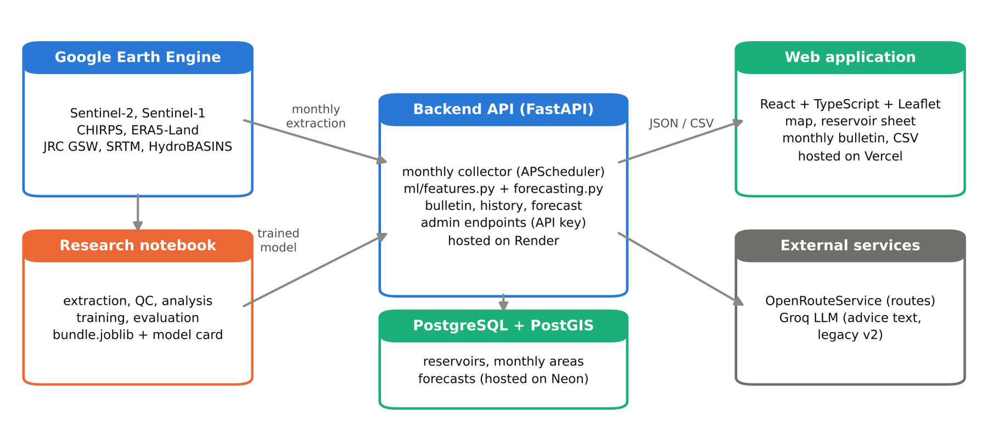
Figure 15: Architecture of the WaterTracker system
Table 10: Main API endpoints of the v3 backend
Endpoint | Purpose
GET /api/reservoirs | Water bodies with origin, validation status and latest filling
GET /api/reservoirs/{id}/history | Monthly series: area, filling, data source, volume, rainfall
GET /api/reservoirs/{id}/forecast | 1-3 month forecast with 80 % interval and probability of a critical level
GET /api/bulletin | Monthly bulletin of all reservoirs ranked by risk (JSON or CSV)
POST /api/admin/monthly-update | Collection of the latest month, forecasts and statuses (API key)
GET /api/health | Status of the database and external services

Appendix D. Forecasting features
Table 11: The 32 features of the forecasting models, by group
Group | Features
State | Filling at lags 0, 1, 2, 3 and 12 months; changes over 1 and 3 months
Climatology | Reservoir climatology of the issue and target months; current anomaly; rainfall climatology of the target month
Past forcings | Rainfall of the month and over 3 and 6 months; rainfall anomaly; potential and actual evaporation; 2 m temperature; soil moisture
Calendar | Sine and cosine of the issue and target months
Physical | Log reference area; JRC mean occurrence and seasonality; elevation; slope; log sub-basin and upstream area; catchment-to-water ratio
Quality | Whether the current value comes from a reliable Sentinel-2 observation

