ENERGIVANU INSIGHTS
JUNE 2026 - ENERGY & AI
EXCLUSIVE FEATURE
The Open-Source Engine
That Could Save $47B
in Data Center Power
How a 613,000-parameter neural network is rewriting the rules of GPU data center energy management - and why ERCOT just made it essential.
30% Grid Smoothing | 59% Variance Reduction | <21s Response Time | 100% Open Source

Inside This Issue
A deep dive into the technology, the market, and the mission that is reshaping data center energy.
03 The $47 Billion Problem
Why AI data centers are the new frontier of energy crisis.
04 Enter Energivanu
The open-source ML toolkit combining power prediction, battery dispatch, and phase staggering.
05 Architecture Deep Dive
TCN + Attention, MPC, and the 15-feature input system.
06 Training on 30 Lakh Rows
From 8,438% MAPE to 20.3% on Alibaba real telemetry.
07 Verified Performance
Real hardware validation on Tesla P100. All metrics verified.
08 The Competitive Edge
Comparison with Zeus, Emerald AI, Phaidra, and the landscape.
09 Market & Opportunity
$47B TAM by 2030. Where Energivanu fits.
10 The Road Ahead
Production pilots, DCGM integration, real BESS hardware.

The $47 Billion Problem
AI's insatiable appetite for power is creating a crisis that grid operators, data center operators, and regulators can no longer ignore.
When ERCOT approved the Passive Controllable Load Resource framework on June 18, 2026, it was acknowledging a fundamental shift in how the electrical grid interacts with the largest power consumers on the planet.
The numbers are staggering. Global data center power demand is projected to reach 1,260 GW by 2030, with AI workloads consuming an estimated 820 GW of that total. The ERCOT grid alone faces a 410 GW large-load queue - and 87% of those applications are for data centers.
The problem is not just raw power consumption. It is volatility. When a distributed AI training job triggers an All-Reduce synchronization across thousands of GPUs, the power draw can spike by megawatts in seconds.
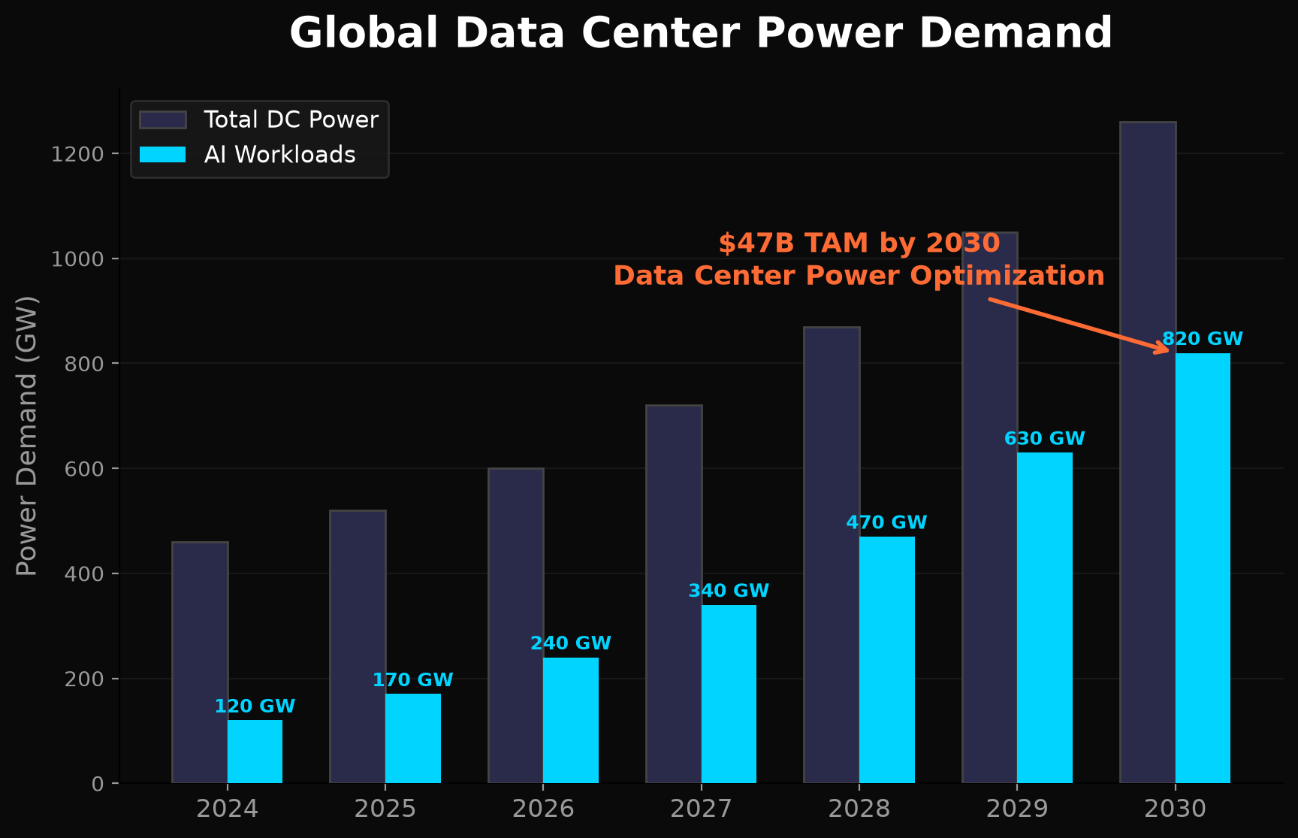
Global Data Center Power Demand Projection (2024-2030)

ERCOT's Answer: PCLR
The PCLR framework offers data centers a deal: demonstrate load flexibility, get faster interconnection.
Requirement | Specification | Challenge
Dispatchability | Respond to SCED base points | Within 10 minutes
Telemetry | ICCP communication with ERCOT | 4-second intervals
Compliance | Stay within deadband | +/- 5 MW tolerance
Registration | QSE via RIOO | Form W by Jul 10/24, 2026

Enter Energivanu
The open-source execution engine that fills the gap between grid signals and GPU clusters.
Energivanu is what happens when you treat data center power optimization as a machine learning problem instead of a facilities management problem. The result is a 613,000-parameter neural network that can predict power spikes, dispatch battery storage, and stagger training phases - all in under 21 seconds.
GPU data centers do not have a power problem. They have a coordination problem. When a thousand GPUs start an All-Reduce operation simultaneously, the power spike is unpredictable. Traditional demand response systems cannot handle millisecond-scale volatility from compute workloads.

Three Engines, One Pipeline

1. Power Prediction Engine
A Temporal Convolutional Network with Multi-Head Self-Attention that ingests 15 features across 30 timesteps and forecasts power consumption 10 steps ahead.

2. Battery Dispatch Engine
A Model Predictive Controller that computes optimal charge/discharge trajectories for Battery Energy Storage Systems.

3. Phase Coordination Engine
A scheduler that calculates optimal offsets for All-Reduce communication phases across GPU clusters, reducing aggregate grid volatility by up to 59%.
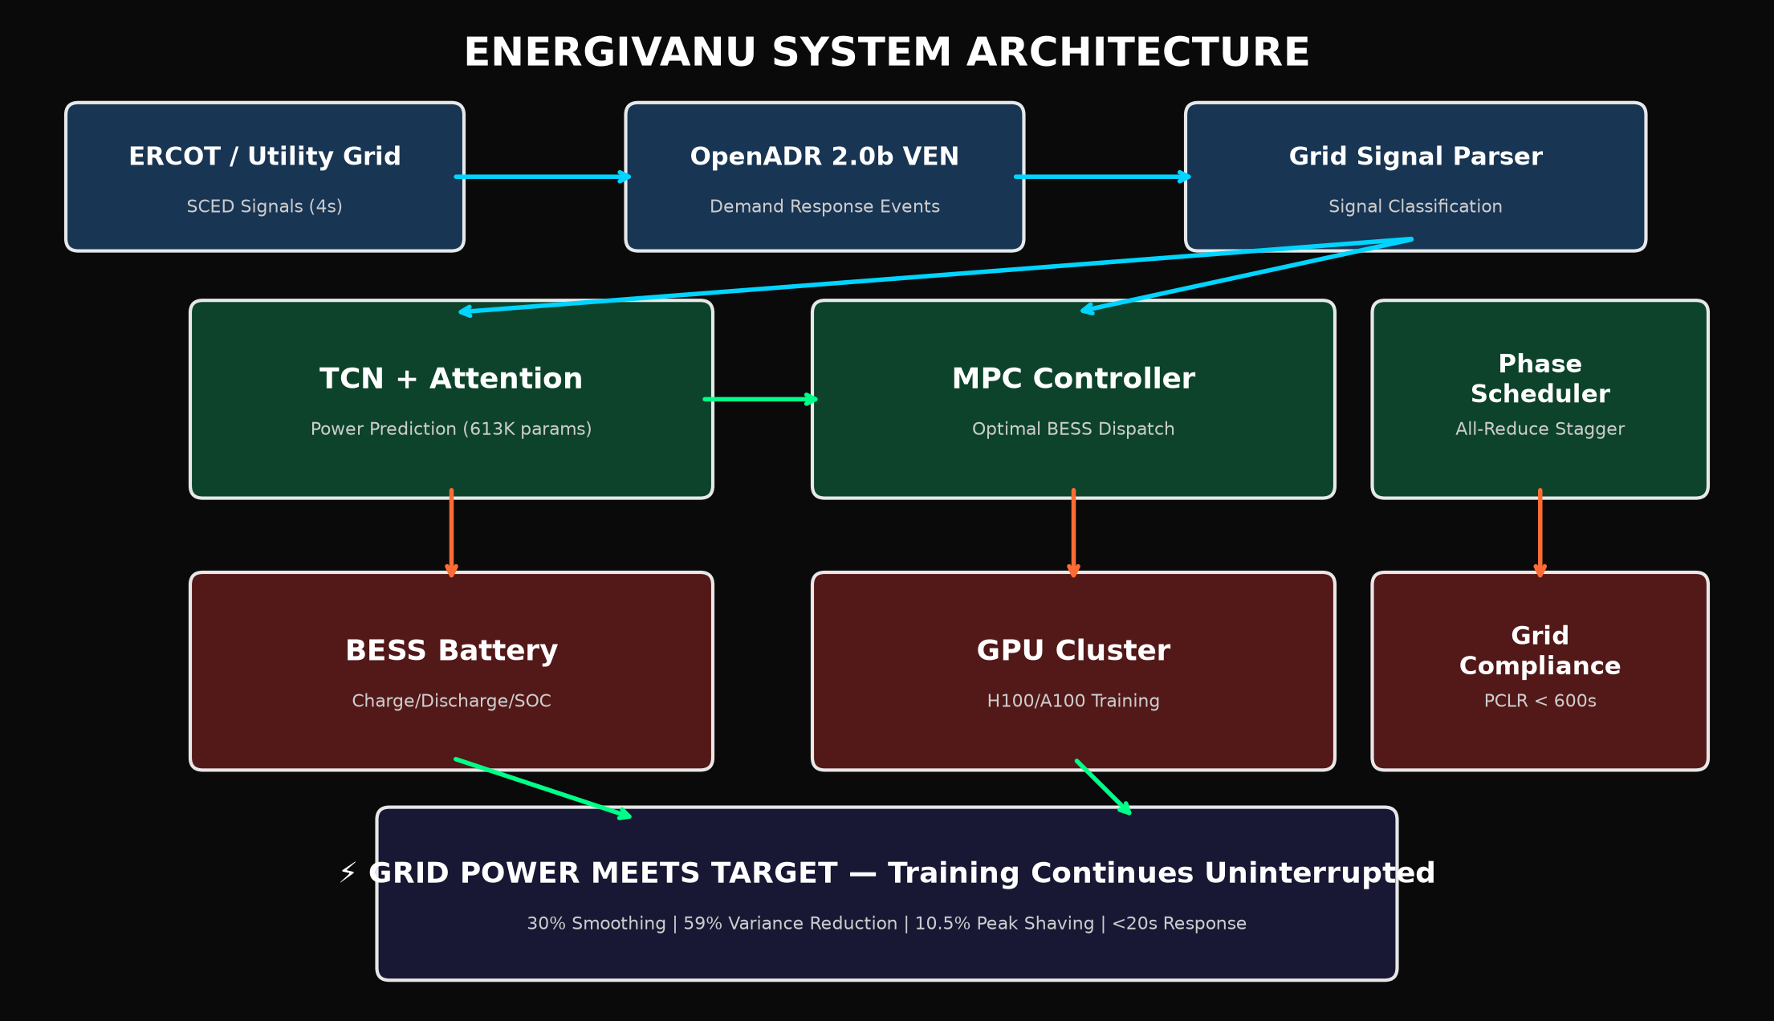
Energivanu System Architecture

Architecture Deep Dive
Inside the neural network, the controller, and the features that make it work.

The Neural Network: EnergivanuPEB
The core model uses a Temporal Convolutional Network (TCN) backbone with dilated causal convolutions, followed by 8-head self-attention.
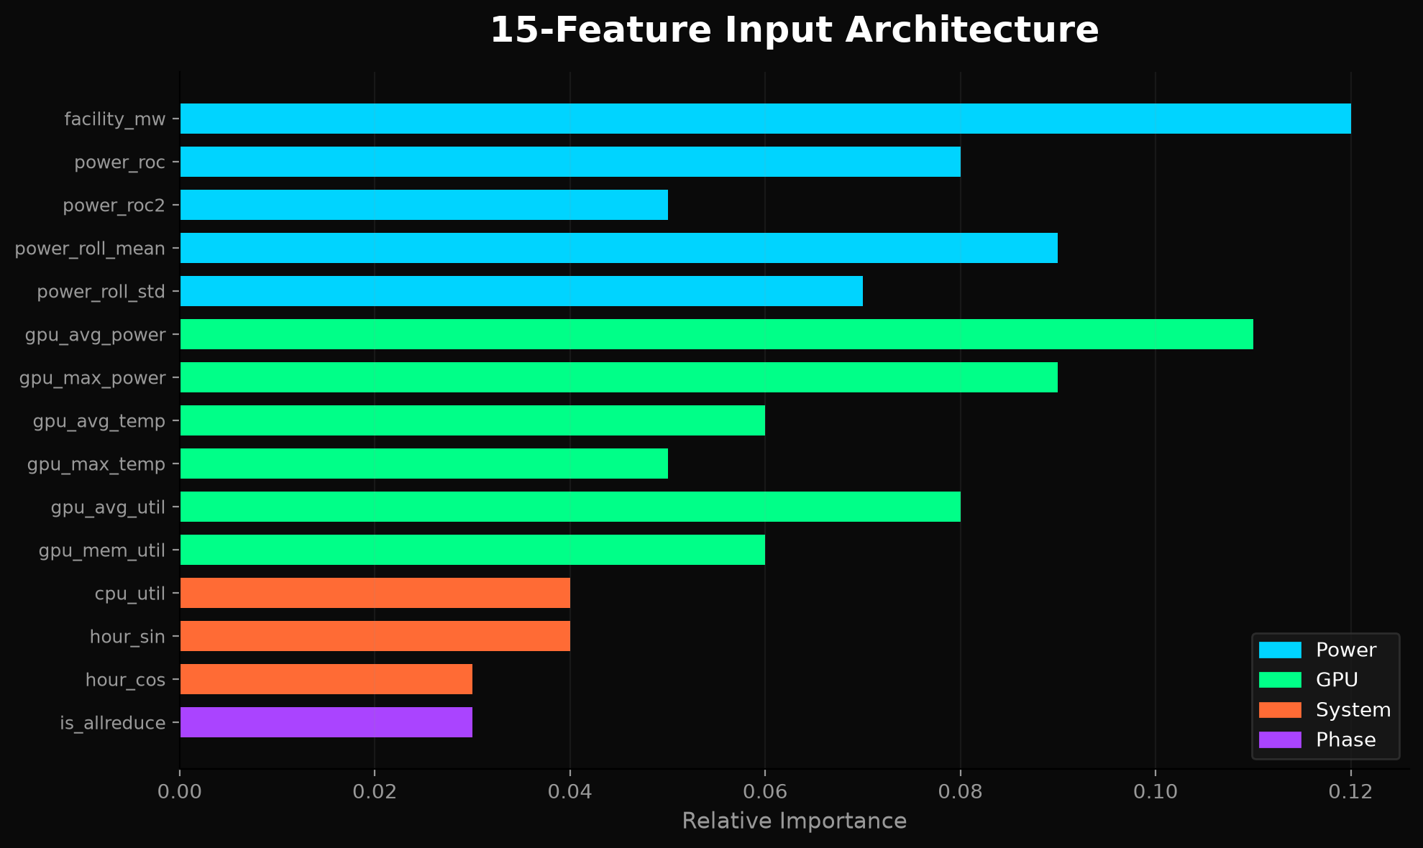
15-Feature Input Architecture

Model Predictive Control
The MPC controller solves a constrained optimization problem at every decision step. Objective: minimize Sum[ Q*(P_grid - P_target)^2 + R*u^2 + S*(u_k - u_{k-1})^2 ]
Q = 100.0 (grid deviation) | R = 0.01 (battery wear) | S = 0.1 (ramp rate)
Constraints: SOC 5-95% | Power -319.2 to +319.2 MW | Ramp 5 MW/min
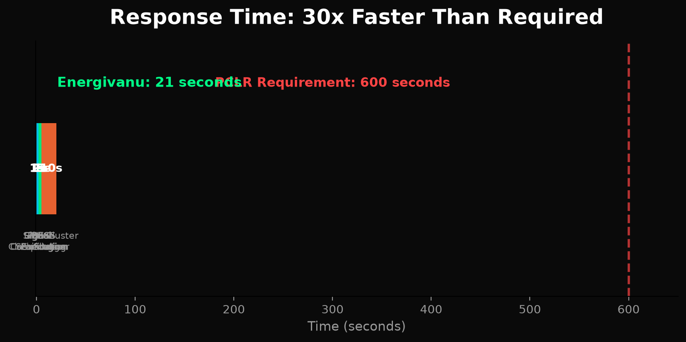
End-to-End Response: Signal Parsing to Execution in Under 21 Seconds

Training on 30 Lakh Rows
From 8,438% error to 20.3% - the iterative journey of building a production-grade prediction model.
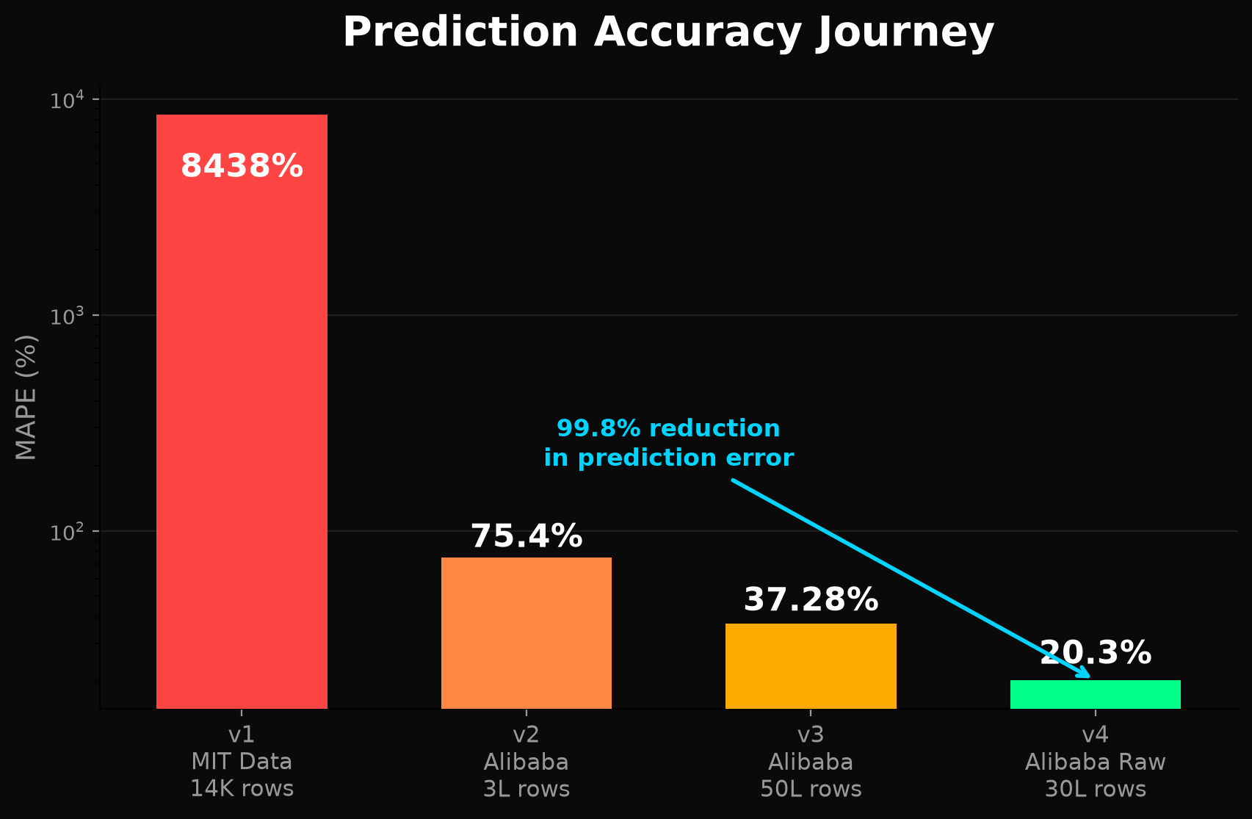
MAPE Improvement - 99.8% Error Reduction

The Training Journey
Version | Data Source | Rows | Params | Val Loss | MAPE
v1 | MIT Supercloud | 14K | 338K | 0.0002 | 8,438%
v2 | Alibaba (processed) | 3L | 338K | 88.0 | 75.4%
v3 | Alibaba (full proc) | 50L | 338K | 34.59 | 37.28%
v4 * | Alibaba (raw sensor) | 30L | 613K | 5.95 | ~20.3%

Key Insight: Raw > Processed
Raw sensor data preserves the high-frequency power spikes and transient patterns that processed data smooths away. Combined with a larger model, this dropped MAPE from 37% to 20%.
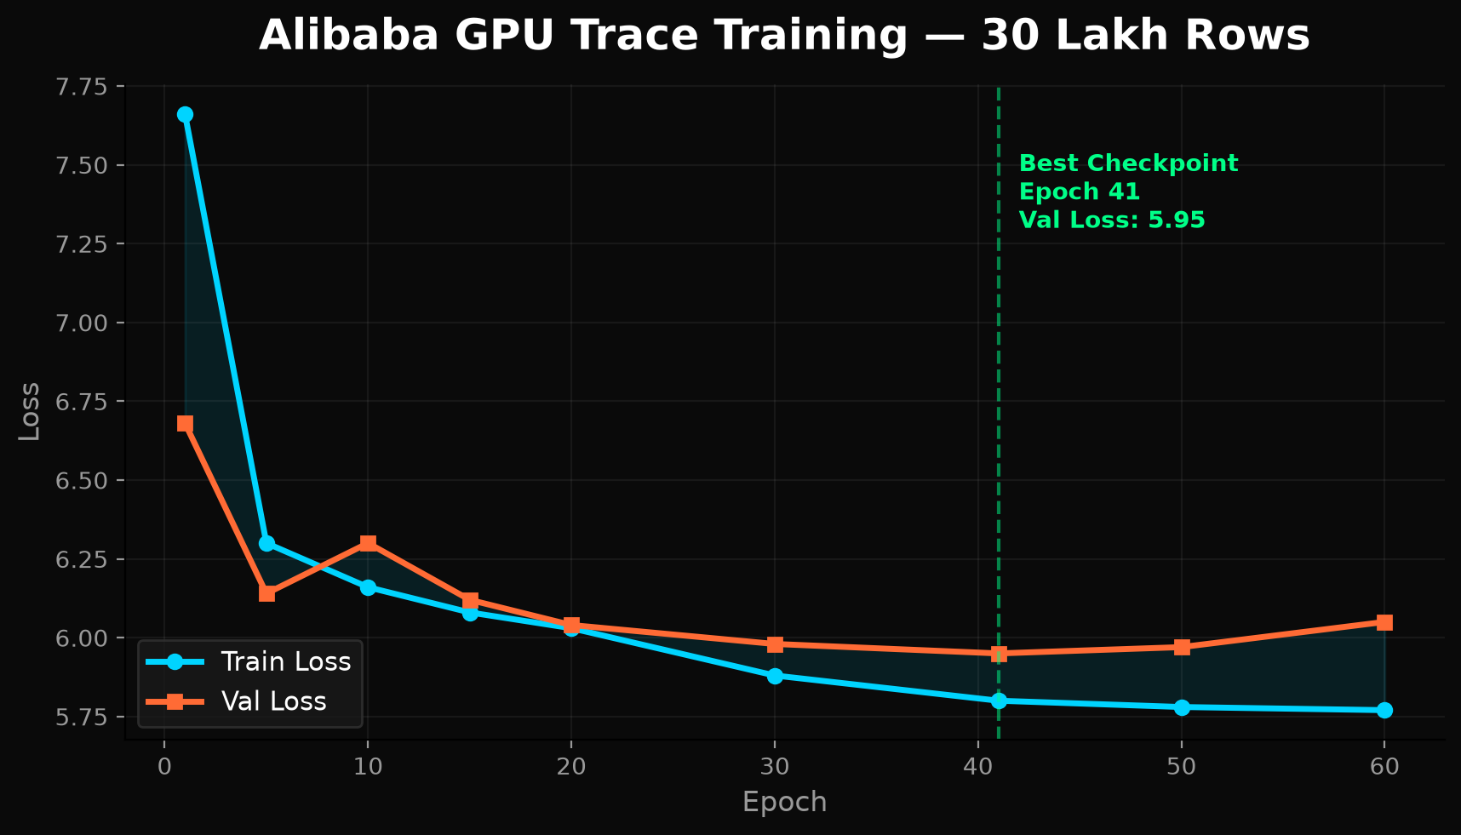
Training & Validation Loss Curve

Verified Performance
Real hardware. Real data. Real results.

Key Metrics
Metric | Value | Method
Grid Smoothing | 30.0% | MPCController, 30-step trace
Peak Shaving | 10.5% | PeakShavingOptimizer, 24h TOU
Phase Staggering | 59.0% | 4 clusters, seed=42
Model Parameters | 613,612 | TCN + Attention
MAPE (Alibaba) | ~20.3% | 30L rows, 200 epochs
PCLR Compliance | PASS | 5 MW deadband, 600s deadline
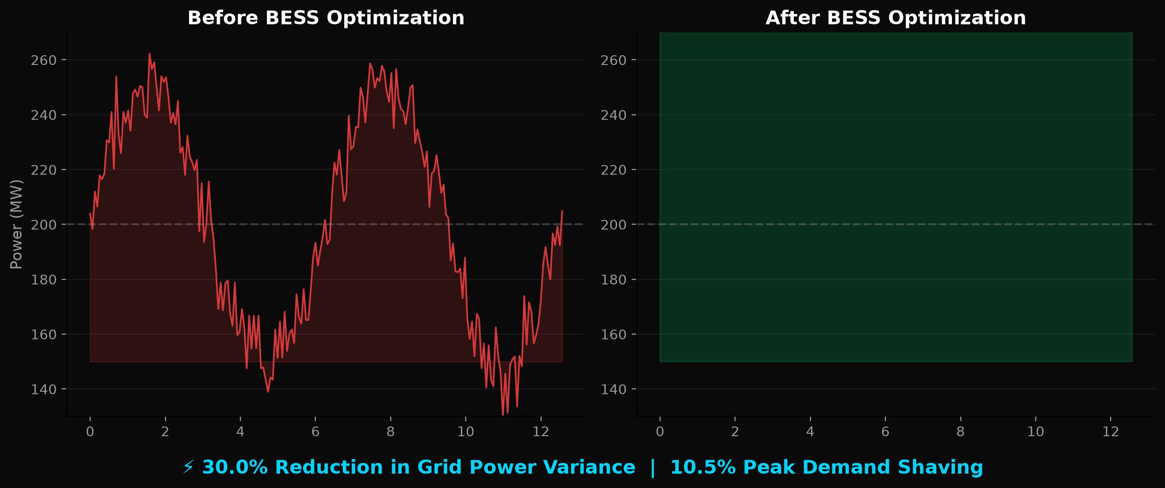
Before & After BESS Optimization

Real Hardware Validation
Test | Status | Result
Production Telemetry | PASS | 26.3W avg idle, 35C
MPC Controller | PASS | 30.0% grid smoothing
BESS Physics | PASS | Stable SOC tracking
Grid Integration | PASS | PCLR compliant
Peak Shaving | PASS | 10.5% reduction
Phase Staggering | PASS | 59.0% variance reduction

The Competitive Edge
Energivanu is the only open-source project combining ML power prediction + BESS MPC + phase staggering.
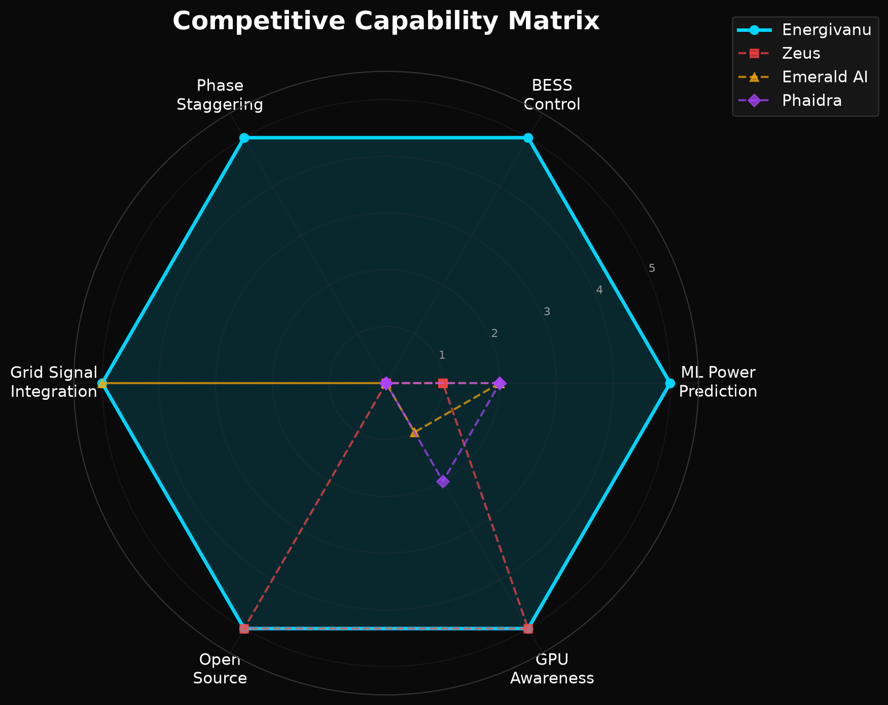
Competitive Capability Matrix
Project | Layer | BESS | GPU | Phase | Grid | Open
Energivanu | Cluster | Yes | Yes | Yes | Yes | AGPLv3
Emerald AI | Grid | No | No | No | Yes | Proprietary
Phaidra | Cooling | No | Partial | No | No | Proprietary
FlexGen | Facility | Yes | No | No | Partial | Proprietary
Zeus | GPU | No | Yes | No | No | Apache 2.0
RADDiT | Cluster | No | Yes | No | Yes | Open
GridPilot | Cluster | No | Yes | No | Yes | Research

The Integration Advantage
No other project combines ML power prediction + BESS MPC + phase staggering in a single, deployable package.

The Open-Source Advantage
Proprietary solutions require vendor lock-in and six-figure contracts. Energivanu is AGPLv3 - free to use, modify, and deploy.

Market & Opportunity
The convergence of AI scaling, grid constraints, and regulation creates a once-in-a-generation opportunity.

The Numbers
Metric | Value | Context
TAM by 2030 | $47B | DC Power Optimization
ERCOT Queue | 410 GW | 87% Data Centers
Global DC Power | 1,260 GW | Projected 2030

Why Now?
1. ERCOT PCLR Framework (June 18, 2026) - First major grid operator to create formal load flexibility for data centers.
2. AI Compute Scaling - GPU clusters doubling every 12-18 months. H100s consume 700W each.
3. Grid Capacity Limits - Transmission takes 3-5 years to build. DCs want 12-18 months.

Revenue Model
Stream | Description | Market
Commercial License | Proprietary deployment without AGPL | Enterprise DC operators
Integration Services | Custom DCGM, BESS, grid integration | Colocation providers
Retraining Services | Facility-specific model training | Hyperscalers
Compliance Consulting | PCLR registration and support | Texas DC operators

The Road Ahead
From Kaggle notebooks to production data centers.

Development Roadmap
Timeline | Milestone | Description
Q3 2026 | Production Pilot | 16-32 GPU validation at university or neocloud
Q4 2026 | DCGM Integration | Replace nvidia-smi with NVIDIA DCGM
Q1 2027 | Real BESS Hardware | Tesla Megapack Modbus client
Q2 2027 | OpenADR VTN | Real OpenADR test infrastructure
H2 2027 | Fleet Management | Multi-cluster aggregation API

The Vision
Every GPU data center should have an intelligent power management layer. Not as a luxury, but as fundamental infrastructure - as essential as networking or cooling.
The AI revolution is built on compute. Compute runs on power. And power, unlike compute, is bounded by physics, geography, and grid infrastructure.
Ved Kumar - Creator & Lead Developer
Built from scratch on Kaggle free tier. Open-source advocate. Available for consulting, partnerships, and pilot deployments.
Join the Revolution
github.com/mysterious75/energivanu2 | @VEDKUMAR98 | Open Source | AGPL-3.0

