**Computer Organization 2019**

**HOMEWORK 6**

系級: 資訊110 學號: F74067094 姓名: 鄭宇澤

**問題(Question)**

Q1. How do you know the number of block from input file?

Cache size *1024(Since it was calculated in kb ) /Block size

Q2. How do you know how many set in this cache?

There are 3 cases

a)Direct mapped -number of set equal to number of block

b)4-way associative -number of set equal to (number of block /4)

because 4 block in a set

c)Fully associative -one set

Q3. How do you know the bits of the width of the Tag ?

a)Calculate the number of word in a block by block size/4

b)Calculate the number of bit required (log(ans(a))

c)Calculate the number of set

d)Calculate the number of bit required by set . Log(ans(c)).If number of set equal to 1, number of bit =0

e) 32 bit – ans(d)-ans(b) -2(byte offset)

Q4. Briefly describe your data structure of your cache.

Cache is a class. Cache contain a private variable ,which is a vector , named setWithin. It contain a collection of class set .The number of element is same as ans calculate in Question 3.

Class set is much similar to cache .It contain private vector named blockwithin which contain a collection of class block. Class set also has a vector named Priority to record the priority of each block .

Class block contain all information required such as tag , valid ans etc

Q5. Briefly describe your algorithm of LRU.

The code required is included in the fucntion updatePriority in set class.

a)According to the block number passed to the function , the function will try to find whether this block number is present in the vector Priority .

--)if present means its a hit . Remove the integer and add it into the tail of vector

--)if absent ,it is a miss . Add it into the tail of vector

Q6. Briefly describe your algorithm of your policy.

Segmented LRU

The policy is much alike LRU except divide each set into two segment named probationary segment and a protected segment. Data from misses is added to the cache at the most recently accessed end of the probationary segment. Hits are removed from wherever they currently reside and added to the most recently accessed end of the protected segment. Since the protected segment is finite, so migration of a line from the probationary segment to the protected segment may force the migration of the LRU line in the protected segment to the most recently used (MRU) end of the probationary segment, giving this line another chance to be accessed before being replaced.

Q7. Run trace2.txt, trace3.txt and then makefile to get the miss rate and put it in your report.

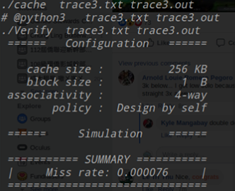

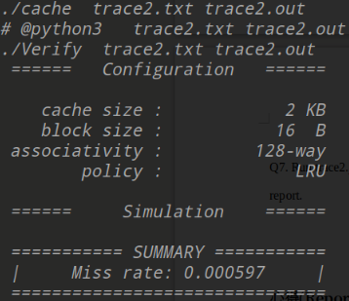

**心得(Report)**

(請寫下完成本次作業的心得、學到哪些東西、困難點的部分。)

(Please write your learned lesson and conclusion, and difficult point.)

這次的作業還滿輕鬆的，感覺這次的作業設計非常好，不但可以了解LRU and FIFO的運作，也可以讓我們自己去挖掘其他的replacement policy .基本上沒有什麼困難的部分。