Practical 3: Test Scenarios for Gmail Login Page

Problem Statement:-
Write and document test scenarios for the Gmail Login Page to verify its login functionality, input validation, navigation, security, and usability.

Objective:-
- To understand the concept of test scenarios.
- To identify different conditions that need to be tested.
- To verify the functionality of the Gmail Login Page.
- To identify positive and negative testing conditions.

Pre-requisites:-
- Basic knowledge of Software Testing.
- Understanding of test scenarios and test cases.
- Web browser.
- Internet connection.
- Gmail Login Page.

Outcome:-
After completing this practical, the student will be able to identify and document test scenarios for a web application and understand different positive, negative, functional, security, and usability testing conditions.

Theory:-
A Test Scenario is a high-level condition or functionality that needs to be tested in a software application. It describes what needs to be tested without providing detailed test steps. Test scenarios are prepared from the software requirements and help ensure that important functionalities are covered.
For a login page, test scenarios are created to verify valid and invalid credentials, empty fields, input validation, password handling, account recovery, navigation, security, and user interface behavior.
Positive Testing verifies the system using valid inputs.
Negative Testing verifies the system using invalid or unexpected inputs.
Functional Testing verifies whether the application performs its required functions correctly.
Usability Testing verifies whether the interface is simple and understandable for users.

Actual Implementation:-
Application: Gmail Login Page
Test Scenario ID | Test Scenario
TS01 | Verify Gmail login page opens successfully
TS02 | Verify login with valid email and valid password
TS03 | Verify login with invalid email
TS04 | Verify login with invalid password
TS05 | Verify login with both email and password invalid
TS06 | Verify login with blank email field
TS07 | Verify login with blank password field
TS08 | Verify login with both fields blank
TS09 | Verify email field accepts valid email format
TS10 | Verify email field rejects invalid email format
TS11 | Verify "Forgot email?" functionality
TS12 | Verify "Forgot password?" functionality
TS13 | Verify password masking functionality
TS14 | Verify "Show password" functionality, where available
TS15 | Verify "Next" button functionality
TS16 | Verify login using registered Gmail account
TS17 | Verify unregistered Gmail account is rejected
TS18 | Verify error message for incorrect password
TS19 | Verify account recovery option is accessible
TS20 | Verify Gmail login page works correctly after page refresh
TS21 | Verify navigation to Google account creation page
TS22 | Verify "Create account" option functionality
TS23 | Verify login page is accessible on different browsers
TS24 | Verify login page is responsive on different screen sizes
TS25 | Verify secure connection (HTTPS) is used on Gmail login page

Test cases
Test Case ID | Test Case Scenario | Test Step | Actual Data | Actual Result | Expected Result | Test Status
TC01 | Verify Gmail login page opens successfully | Open Gmail login page | Gmail login URL | Login page displayed | Gmail login page should open successfully | Pass
TC02 | Verify login with valid credentials | Enter valid email and password and click Next | Valid Gmail credentials | User logged in | User should be logged in successfully | Pass
TC03 | Verify login with invalid email | Enter invalid/unregistered email and click Next | abc123@gmail.com | Error message displayed | System should reject invalid account | Pass
TC04 | Verify login with invalid password | Enter valid email and incorrect password | Wrong password | Error message displayed | System should display incorrect password message | Pass
TC05 | Verify login with blank email | Leave email field blank and click Next | Blank | Validation message displayed | Email field should be required | Pass
TC06 | Verify password masking | Enter password in password field | Password@123 | Password is masked | Password should not be displayed in plain text | Pass
TC07 | Verify Forgot Email functionality | Click "Forgot email?" | — | Recovery page/options displayed | Account recovery option should be available | Pass
TC08 | Verify Create Account functionality | Click "Create account" | — | Account creation options displayed | User should be redirected to account creation | Pass

Actual testing screenshots:-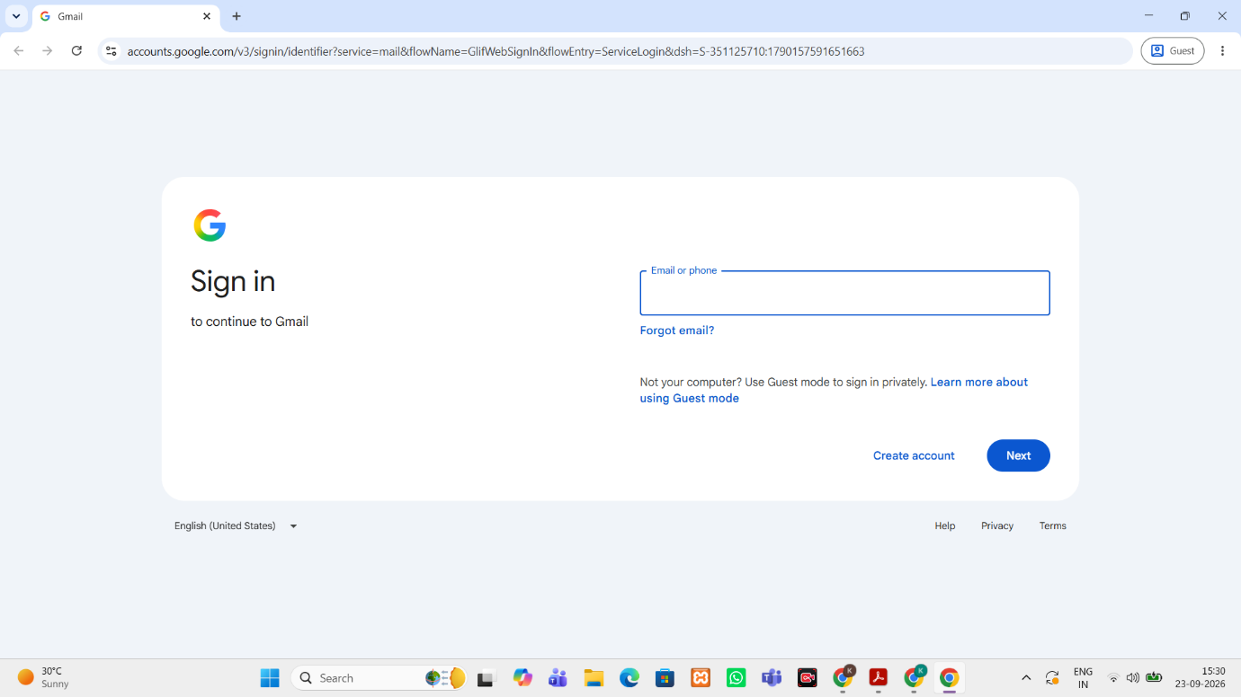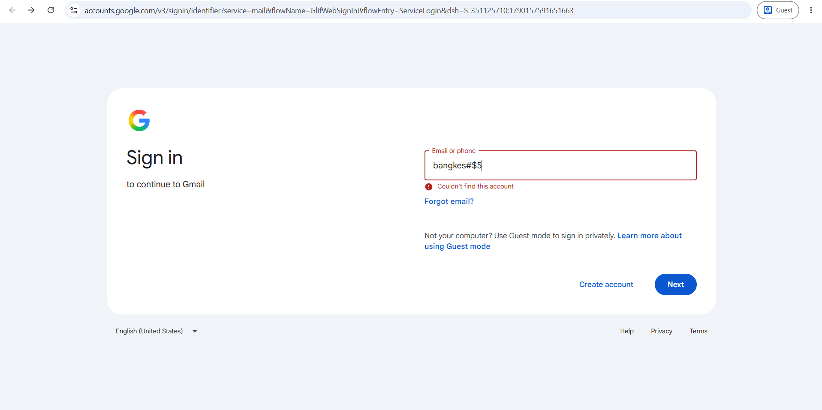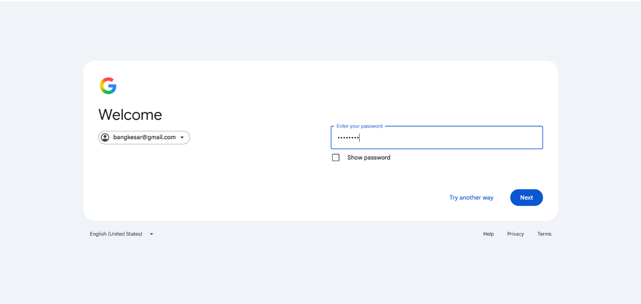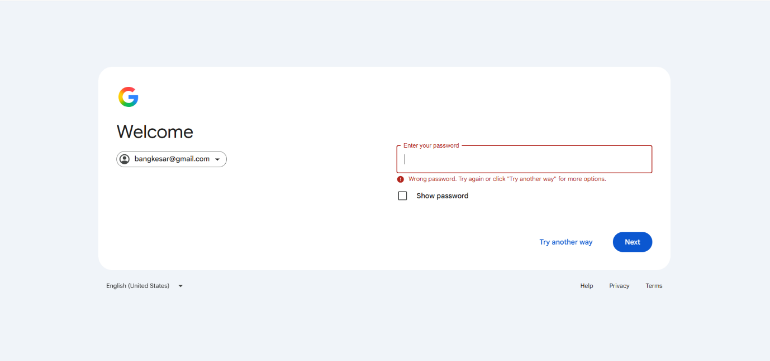

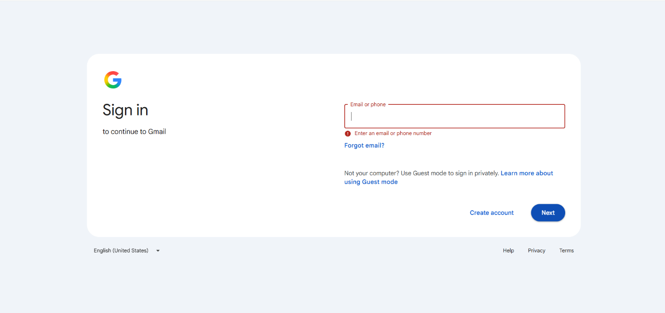

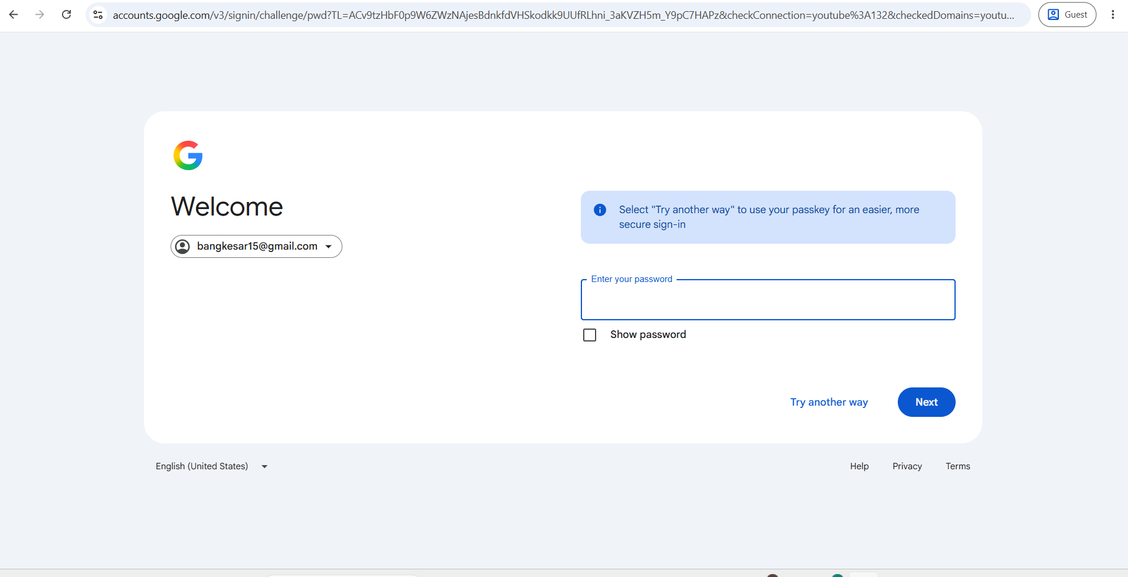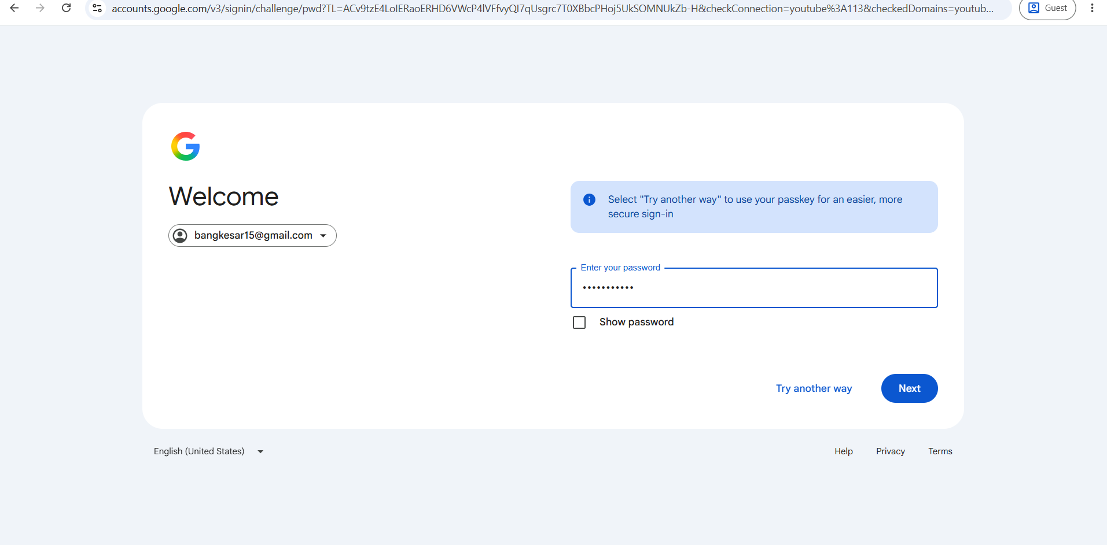

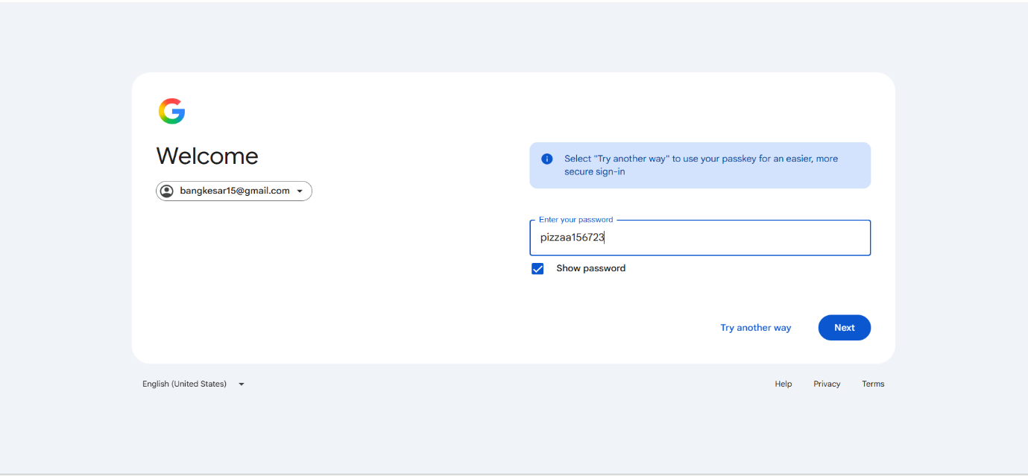

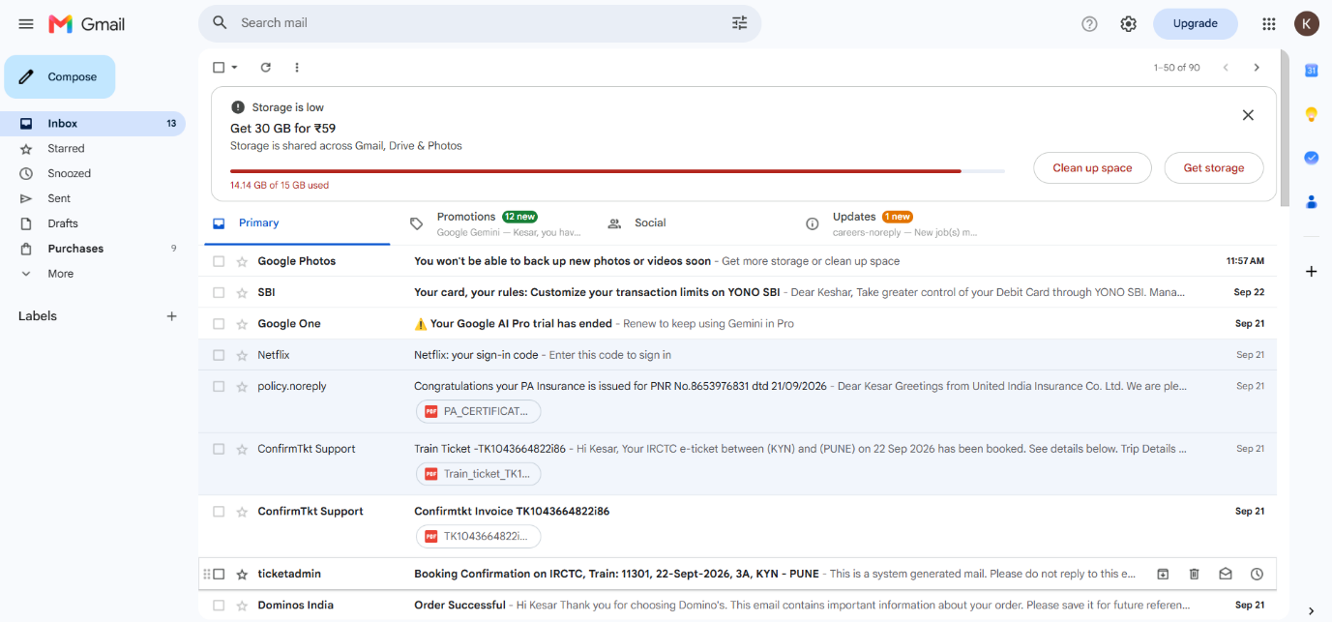

Output:-
The test scenarios for the Gmail Login Page were successfully prepared, covering functional, positive, negative, UI, security, usability, and compatibility aspects.

Conclusion:-
The test scenarios for the Gmail Login Page were successfully identified and documented. This practical helped in understanding how different conditions of a software application are identified and tested systematically.

