Practical 4: Write Test Cases in execel sheet for Scial Media Application or website

Problem Statement:-
Prepare 30 detailed test cases for a Social Media Application to verify its major functionalities such as registration, login, profile management, posts, likes, comments, search, messaging, notifications, and logout.

Objective:-
- To understand the concept of test cases.
- To prepare detailed test cases for a software application.
- To verify different functionalities using valid and invalid data.
- To identify differences between actual and expected results.

Pre-requisites:-
- Basic knowledge of Software Testing.
- Understanding of test scenarios and test cases.
- Basic knowledge of web applications.
- Web browser and internet connection.

Outcome:-
After completing this practical, the student will be able to design and document detailed test cases and verify whether the actual behavior of an application matches the expected behavior.

Theory:-
A test case is a documented set of conditions, inputs, steps, and expected results used to verify a particular functionality of a software application. Each test case has a unique identifier and defines the steps required to perform the test.
Test cases can be positive or negative. Positive test cases verify the system with valid inputs, while negative test cases verify how the system handles invalid or unexpected inputs.

Actual Implementation:-
Application: Social Media Application
Test Case ID | Test Case Scenario | Test Step | Actual Data | Actual Result | Expected Result | Test Status
TC01 | Verify user registration with valid details | Open registration page, enter valid details and click Register | Name: Kesar, valid email, valid password | Account was created | Account should be created successfully | Pass
TC02 | Verify registration with invalid email | Enter invalid email and click Register | kesar@ | Validation message displayed | System should reject invalid email | Pass
TC03 | Verify registration with blank fields | Leave all fields blank and click Register | Blank fields | Required field messages displayed | Required field validation should be displayed | Pass
TC04 | Verify registration with existing email | Enter an already registered email | Existing email | Registration was rejected | System should display email already registered message | Pass
TC05 | Verify login with valid credentials | Enter valid email and password and click Login | Valid email/password | User logged in successfully | User should be logged in | Pass
TC06 | Verify login with invalid password | Enter valid email and wrong password | Valid email/wrong password | Error message displayed | Invalid password message should be displayed | Pass
TC07 | Verify login with invalid email | Enter unregistered email and password | Invalid email/password | Login was rejected | Appropriate error message should be displayed | Pass
TC08 | Verify login with blank fields | Leave email and password blank | Blank | Validation messages displayed | Required field messages should be displayed | Pass
TC09 | Verify password masking | Enter password in password field | Password@123 | Password displayed as dots | Password should be masked | Pass
TC10 | Verify Forgot Password functionality | Click Forgot Password and follow instructions | Registered email | Password recovery page opened | Recovery process should start | Pass
TC11 | Verify profile creation | Open profile and enter profile information | Name, bio, profile picture | Profile information saved | Profile should be created successfully | Pass
TC12 | Verify profile editing | Edit existing profile information and save | Updated bio | Profile was updated | Updated information should be displayed | Pass
TC13 | Verify profile picture upload | Select a valid image and upload it | JPG image | Image uploaded successfully | Selected image should appear as profile picture | Pass
TC14 | Verify invalid profile picture upload | Upload unsupported file | .exe file | Upload was rejected | Unsupported file should be rejected | Pass
TC15 | Verify creation of text post | Enter text and click Post | "Good morning!" | Post published | Text post should be published | Pass
TC16 | Verify creation of image post | Select image and click Post | JPG image | Image post published | Image should be displayed in feed | Pass
TC17 | Verify deletion of own post | Open own post and select Delete | Existing post | Post deleted | Selected post should be removed | Pass
TC18 | Verify like functionality | Click Like on a post | Existing post | Like count increased | Post should be liked | Pass
TC19 | Verify unlike functionality | Click Like again on liked post | Liked post | Like was removed | Like should be removed | Pass
TC20 | Verify comment functionality | Enter comment and click Submit | "Nice post!" | Comment displayed | Comment should be added to the post | Pass
TC21 | Verify empty comment submission | Leave comment box empty and submit | Blank | Comment was not submitted | Empty comment should not be submitted | Pass
TC22 | Verify share functionality | Click Share on a post | Existing post | Share option opened | Post should be shared successfully | Pass
TC23 | Verify follow functionality | Open another user's profile and click Follow | User: TestUser | Follow status displayed | User should be followed | Pass
TC24 | Verify unfollow functionality | Click Unfollow on followed user | Followed user | Follow status removed | User should be unfollowed | Pass
TC25 | Verify user search | Enter username in search box | TestUser | Matching user displayed | Relevant user should appear | Pass
TC26 | Verify sending a message | Open chat, enter message and click Send | "Hello" | Message sent | Message should be delivered to recipient | Pass
TC27 | Verify notification for like | Like another user's post | Existing post | Notification generated | Post owner should receive like notification | Pass
TC28 | Verify notification for comment | Comment on another user's post | "Great post!" | Notification generated | Post owner should receive comment notification | Pass
TC29 | Verify logout functionality | Click Logout | Logged-in account | User logged out | User should be logged out successfully | Pass
TC30 | Verify account access after logout | Logout and press browser Back button | Logged-out account | Protected page was not accessible | User should not access protected account pages | Pass

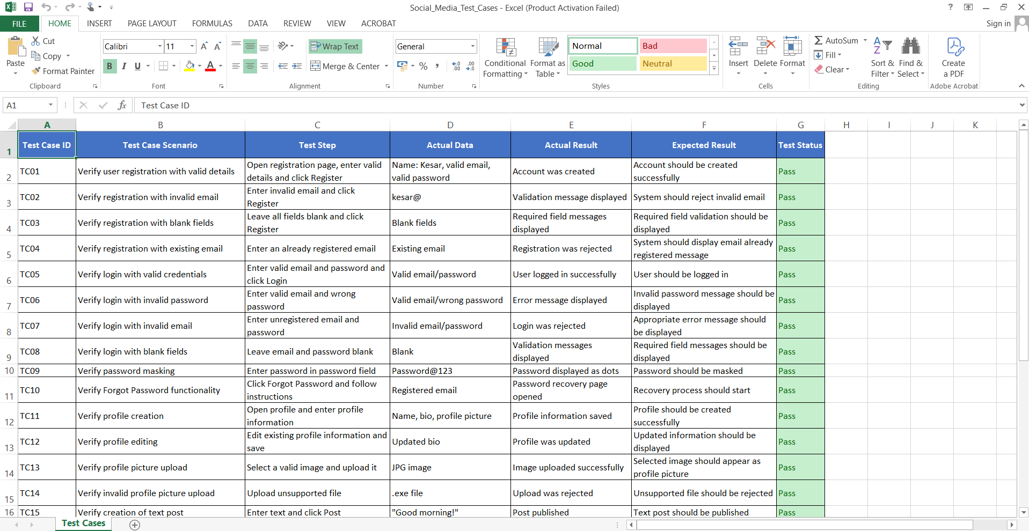

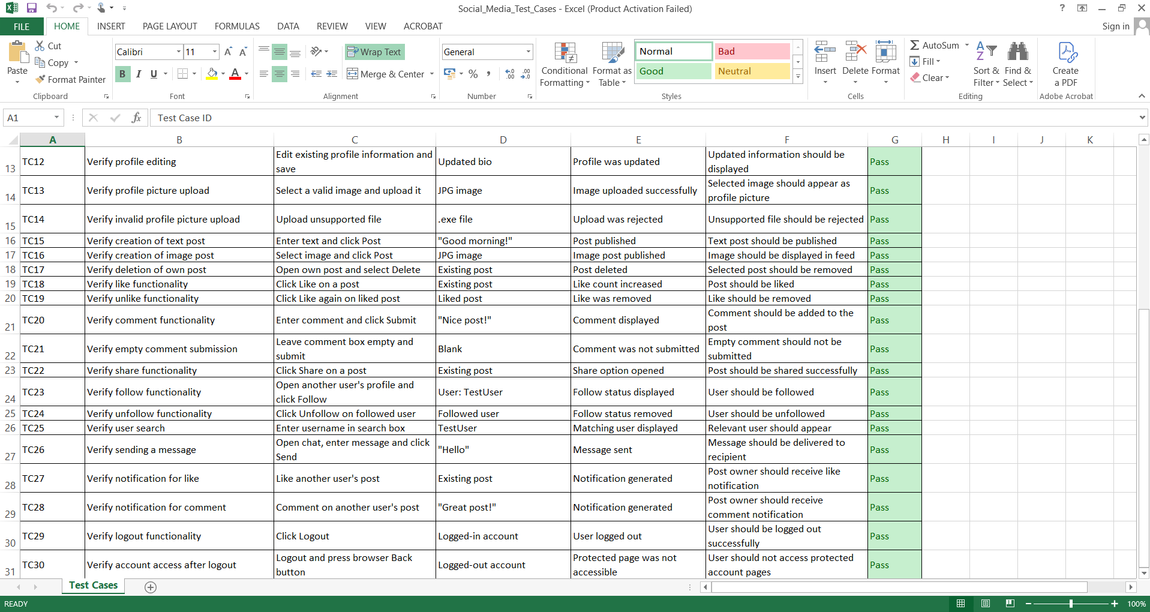

Output:-
30 test cases for the Social Media Application were prepared and documented. The test cases cover registration, authentication, profile management, posts, likes, comments, sharing, following, search, messaging, notifications, and logout.

Conclusion:-
The test cases for the Social Media Application were successfully prepared. The practical demonstrates how application requirements can be converted into detailed test cases and how actual results can be compared with expected results to verify software functionality.

