Medicaid Ex Parte Renewal Process (V3–V7) with AI / Agentic AI Opportunities
The below notes capture my understanding and thoughts around the Medicaid Ex Parte Renewal workflow and areas where AI or Agentic AI can potentially improve automation, reduce worker workload, increase passive renewals, and improve decision explainability.

V3 – Case / Individual Level Validation
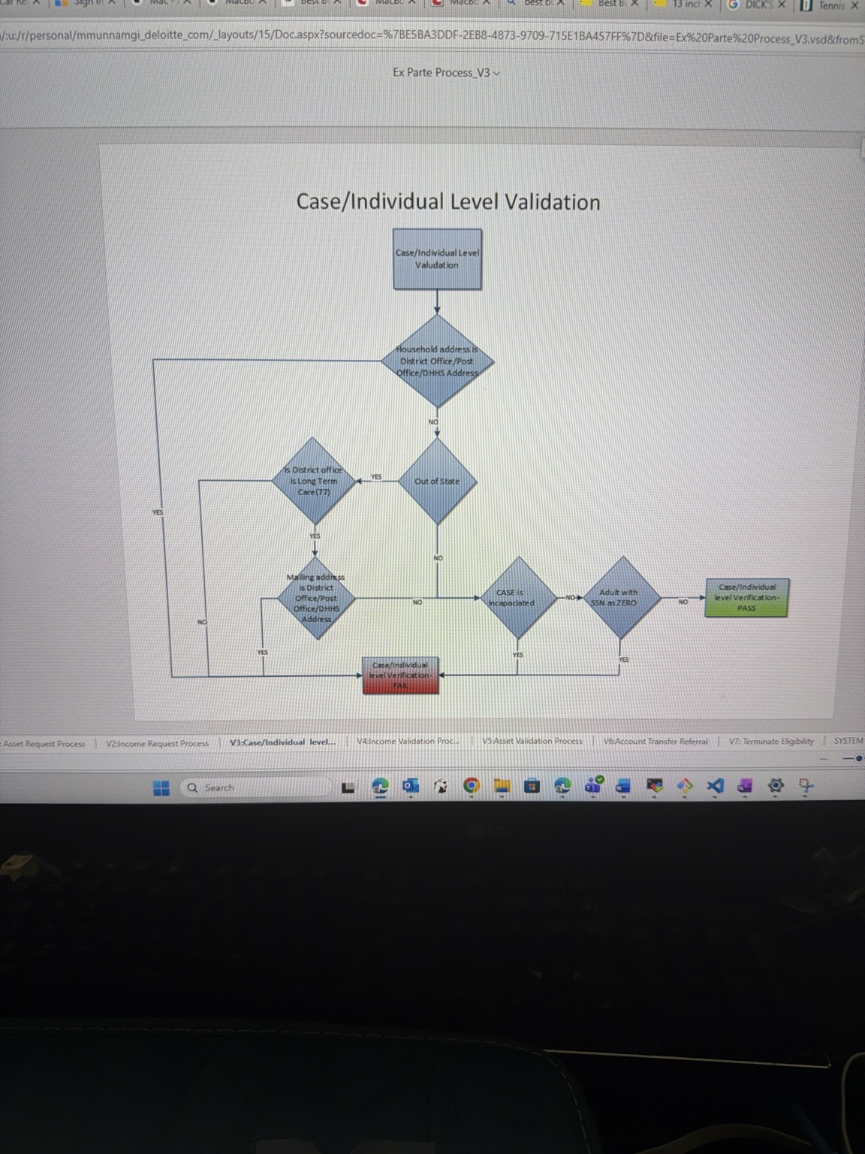
Process Understanding:
- This stage validates whether the case or household meets initial eligibility screening conditions.
- The system checks mailing addresses, district office addresses, out-of-state conditions, incapacitated status, and SSN-related validations.
- Cases either pass validation or fail and move toward manual intervention or additional review.
My Thoughts on AI / Agentic AI Opportunities:
- AI-based anomaly detection can identify suspicious address patterns or repeated mismatches.
- Agentic AI can automatically orchestrate verification calls to external systems when address or identity mismatches are detected.
- An AI worker copilot can summarize why a case failed validation instead of workers manually analyzing multiple fields.
- LLMs can generate human-readable explanations for eligibility validation outcomes for both workers and beneficiaries.
- AI can prioritize high-risk cases for manual review while low-risk cases continue automatically.

V4 – Income Validation Process
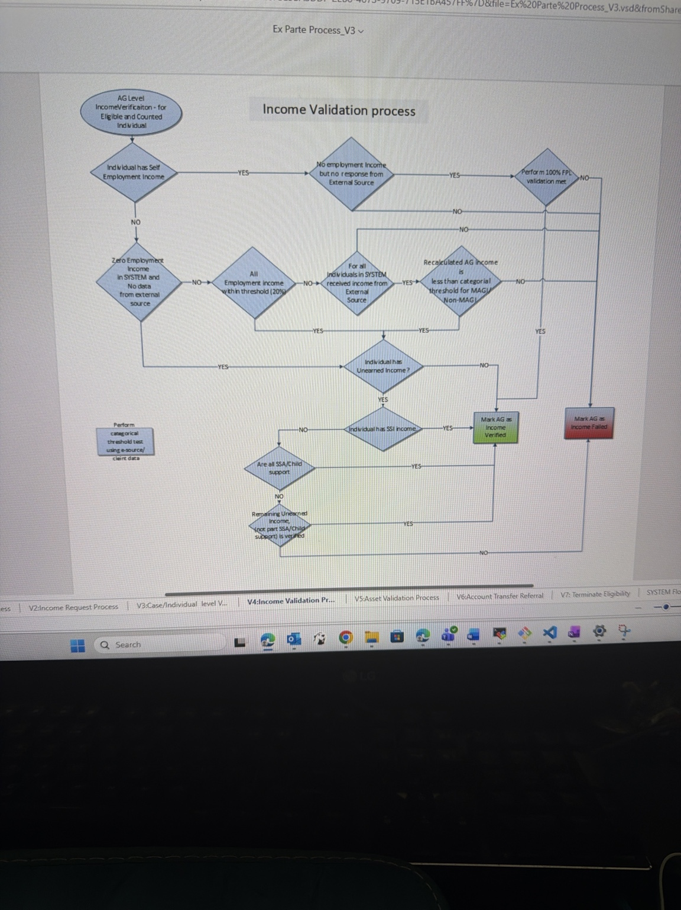
Process Understanding:
- This process validates employment income, self-employment income, SSI income, unearned income, and income received from external sources.
- The workflow recalculates AG-level income and compares it against MAGI or Non-MAGI thresholds.
- The process determines whether income can be verified automatically or if the case should fail and require further action.
My Thoughts on AI / Agentic AI Opportunities:
- AI document extraction agents can automatically process uploaded pay stubs, tax forms, and wage documents.
- LLMs can reconcile conflicting income values between external sources and submitted documents.
- Agentic AI can autonomously request missing documents when income verification confidence is low.
- AI can calculate confidence scores for extracted income and route uncertain cases to Human-in-the-Loop review.
- AI copilots can explain exactly which income source caused verification failure.
- Machine learning models can identify possible fraud or altered pay stubs through anomaly detection.

V5 – Asset Validation Process
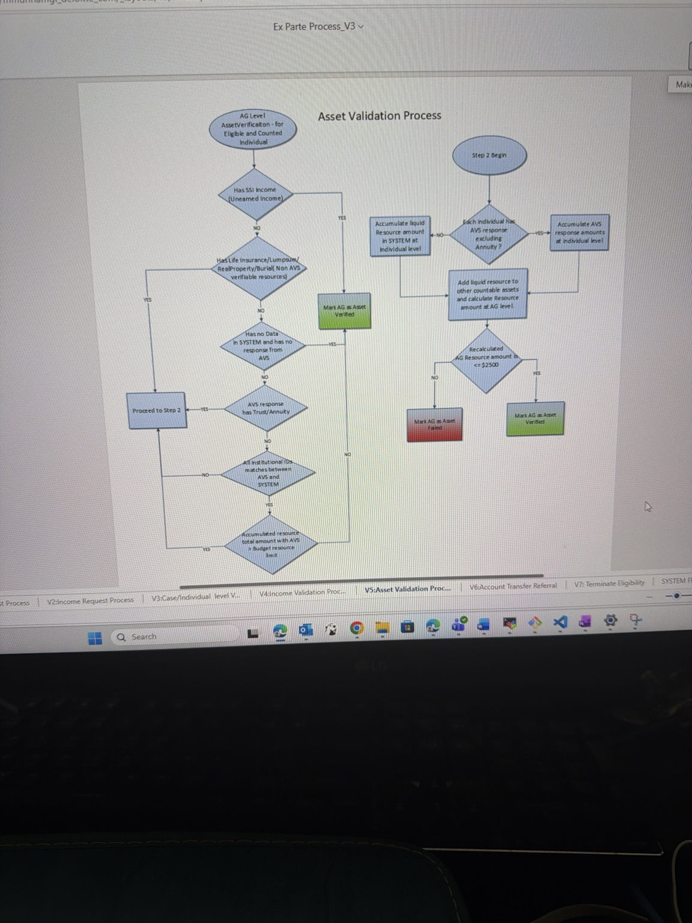
Process Understanding:
- This stage validates assets such as bank balances, trusts, annuities, life insurance, burial funds, and liquid resources.
- The process aggregates resources and compares them against eligibility thresholds.
- Cases are marked as asset verified or asset failed depending on resource calculations.
My Thoughts on AI / Agentic AI Opportunities:
- AI agents can summarize complex financial relationships across multiple accounts and institutions.
- LLMs can normalize and categorize assets from semi-structured financial documents.
- Agentic orchestration can automatically call multiple verification systems and consolidate responses.
- AI can identify inconsistencies between declared assets and external verification systems.
- Predictive models can estimate likelihood of manual review requirement before workers even open the case.
- AI copilots can generate plain-English explanations of why asset thresholds were exceeded.

V6 – Account Transfer Referral
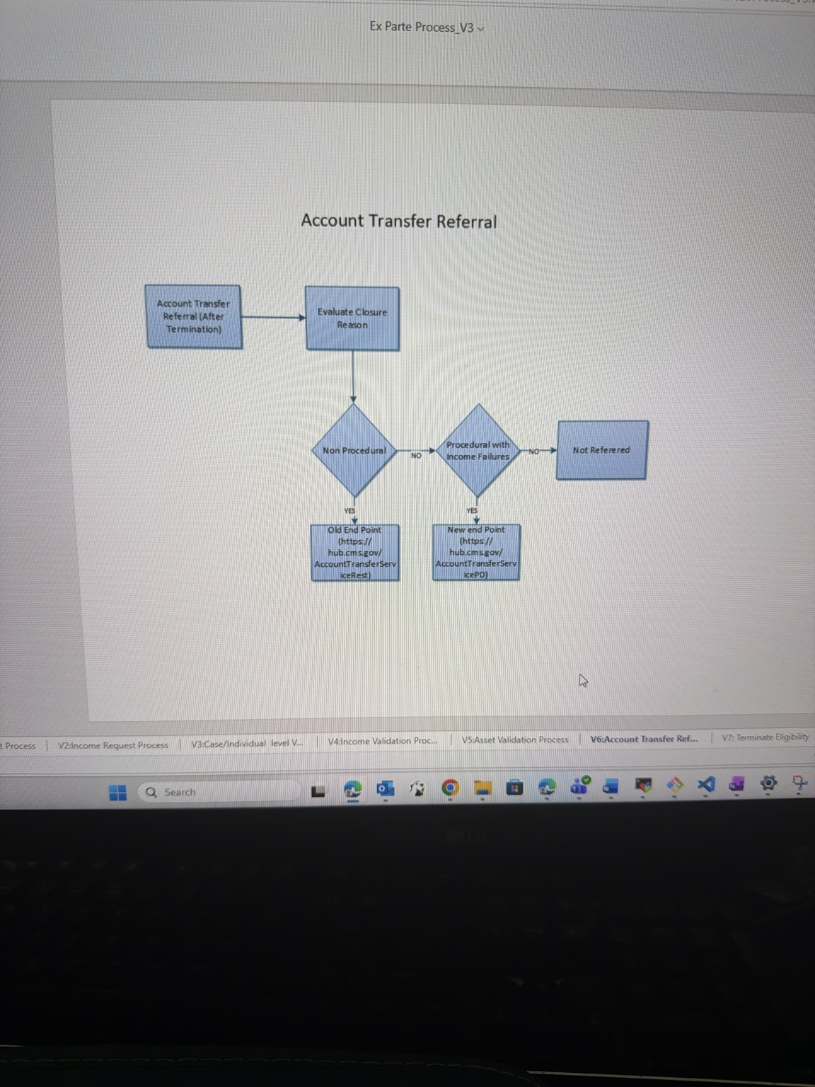
Process Understanding:
- This workflow handles account transfers after termination scenarios.
- The system evaluates closure reasons and determines whether referrals should occur using old or new CMS endpoints.
- Cases may be referred or marked as not referred depending on procedural conditions.
My Thoughts on AI / Agentic AI Opportunities:
- Agentic AI can dynamically determine the correct referral path based on closure reason and historical outcomes.
- AI can validate whether procedural failures are due to missing data, worker error, or system integration issues.
- AI monitoring agents can detect referral API failures and retry automatically.
- LLMs can generate referral summaries for downstream systems or workers.
- AI orchestration agents can monitor end-to-end referral completion status instead of relying on manual tracking.

V7 – Auto Close Termination Logic
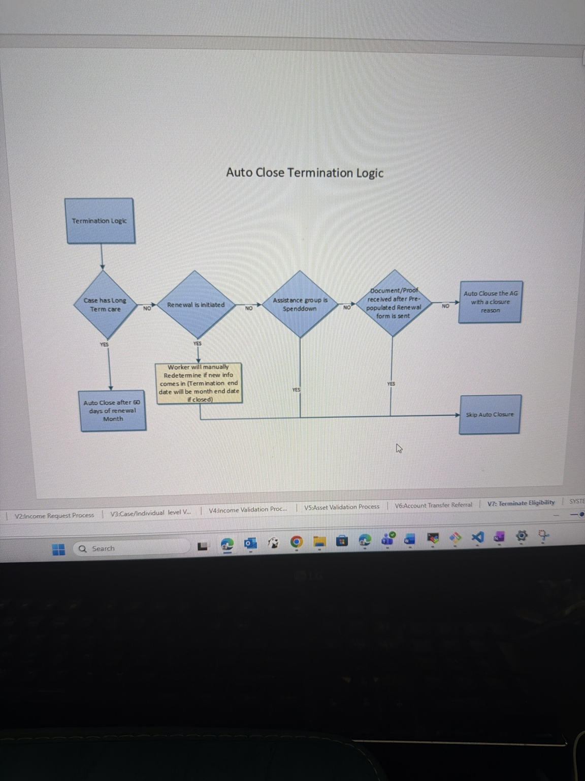
Process Understanding:
- This logic determines whether eligibility should be auto-closed after renewal periods.
- The system evaluates renewal initiation, spenddown conditions, submitted proofs/documents, and long-term care conditions.
- Cases are either auto-closed or excluded from auto closure based on conditions.
My Thoughts on AI / Agentic AI Opportunities:
- AI can predict which beneficiaries are likely to submit documents late and proactively send reminders.
- LLMs can generate personalized notices explaining exactly what documentation is missing.
- Agentic AI can continuously monitor incoming documents and stop auto-closure automatically when sufficient proof is received.
- AI copilots can provide workers with recommended closure decisions and rationale.
- AI-driven workflow automation can reduce unnecessary terminations caused by procedural delays.
- Machine learning can identify trends causing frequent auto closures and recommend policy improvements.

Overall Thoughts
- This workflow is highly rule-driven but also heavily dependent on documents, validations, external integrations, and manual worker intervention.
- The biggest opportunity for AI is reducing manual case reviews while improving passive renewal rates.
- Agentic AI can orchestrate verification steps dynamically instead of relying only on static workflows.
- Human-in-the-Loop systems will still remain important for low-confidence or high-risk eligibility decisions.
- Worker copilots, document intelligence, and intelligent orchestration appear to be the most practical near-term AI implementations for this process.

