My Initial Thoughts - Ex Parte Renewal V3 to V7
Possible AI / Agentic AI implementation in IBM LinuxONE state environment
This is my initial understanding of the V3 to V7 process. I am keeping the AI part practical and not saying everything can be done by AI. The main idea is to use AI only where it can reduce manual review, explain failures, and help workers make faster decision. Final eligibility rules should still stay deterministic and auditable.

1. Overall implementation view
My thought is not to replace the renewal rules engine. The better approach is to keep the existing rules and add a small AI service layer around it. This AI layer can summarize, classify reasons, route exceptions, and explain why a case failed or passed. For government system, this is safer because the final action still comes from rules/workers, not from a black-box model.
Layer | Recommended choice | My reason
Agent framework | LangGraph with LangChain IBM integration | Better than CrewAI for this because we need controlled state machine, approvals, retries, audit trail and tool calling.
Model | IBM Granite through watsonx.ai / approved internal IBM model endpoint | Best fit for IBM ecosystem and enterprise governance. For sensitive state data, use approved on-prem/private endpoint, not random public API.
Deployment | Red Hat OpenShift on IBM LinuxONE if available, otherwise RHEL on LinuxONE with containers | LinuxONE can run the agent/API services close to state systems. Need to validate s390x package support.
AI runtime | Keep LLM inference separate if needed; agent service can call model endpoint | Large LLM may not be best to run directly on LinuxONE unless supported accelerator/runtime is approved. Start with API based model serving.
Rules | Existing eligibility rules engine / business rules | AI should not be the source of truth for eligibility. It should assist and explain.

2. Step-by-step way I would implement this
Step 1 - Read only pilot: First I would create a read-only AI service. It should read case output, validation result, reason codes and notices, but not update eligibility. This reduces risk.
Step 2 - Case summary API: Create /case-summary/{caseId}. It returns short summary: what passed, what failed, missing info, and next best action for worker.
Step 3 - Tool calling: Agent should call only approved tools: case API, income API, asset API, document store, notice history, and rules result. No direct database writes in first phase.
Step 4 - HITL queue: If AI confidence is low or case impacts termination, send to worker review. AI only suggests, worker accepts/rejects.
Step 5 - Audit log: Every AI output should store input ids, model name, prompt version, retrieved fields, decision reason, confidence, and worker action.
Step 6 - Limited automation: After pilot, allow automation only for low-risk actions like generating summary, creating missing-doc checklist, drafting notice text, or assigning case category.
Step 7 - Production guardrails: Add PII masking where possible, role based access, prompt injection checks, no free form internet access, and strict policy that final eligibility is rules based.

3. V3 - Case / Individual Level Validation
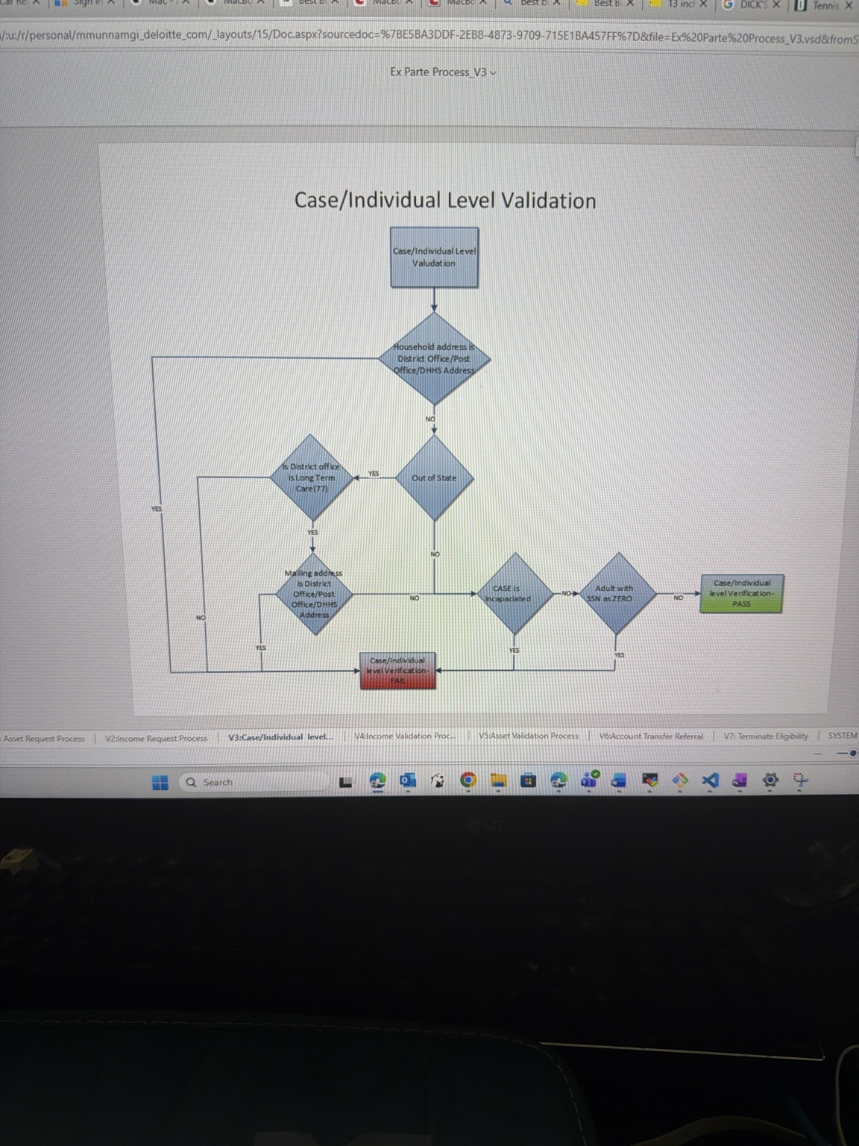
My understanding: This step checks if the household/case is valid before income and asset checks. It looks at district office address, mailing address, out-of-state condition, long term care, incapacitated status, and SSN related checks.
Where I think AI can help, but in limited way:
- AI can create a simple failure summary like: address mismatch + out of state check failed + SSN missing.
- Agent can call address verification API and case profile API, then prepare a worker note.
- Do not let AI decide pass/fail here. The pass/fail should come from existing rules.
Implementation: Create a validation-summary agent. Input will be caseId and V3 reason codes. Agent calls address service, case member service and notice history. Output is one JSON summary and one worker readable note.

4. V4 - Income Validation Process
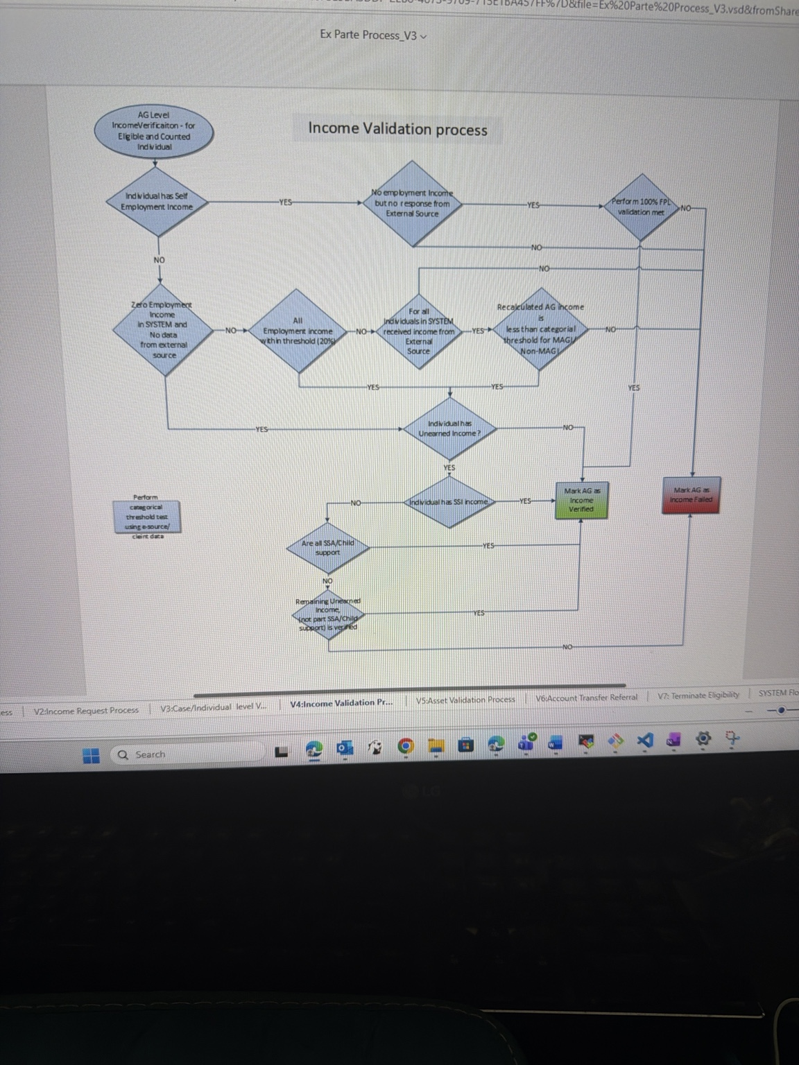
My understanding: This step validates earned income, self employment income, unearned income and SSI income. It also compares external source income with system data and checks thresholds for MAGI / Non-MAGI.
Where I think AI can help, but in limited way:
- AI can compare income from system, external source and uploaded document and show mismatch clearly.
- If paystubs are submitted, document AI can extract employer, pay period, gross pay, hours and YTD values.
- Agent can prepare missing income proof checklist instead of worker manually reading everything.
Implementation: Use Azure/IBM document extraction if documents come in, then pass extracted fields to rules. LangGraph node 1 gets income records, node 2 compares, node 3 prepares explanation, node 4 sends to HITL if mismatch or low confidence.

5. V5 - Asset Validation Process
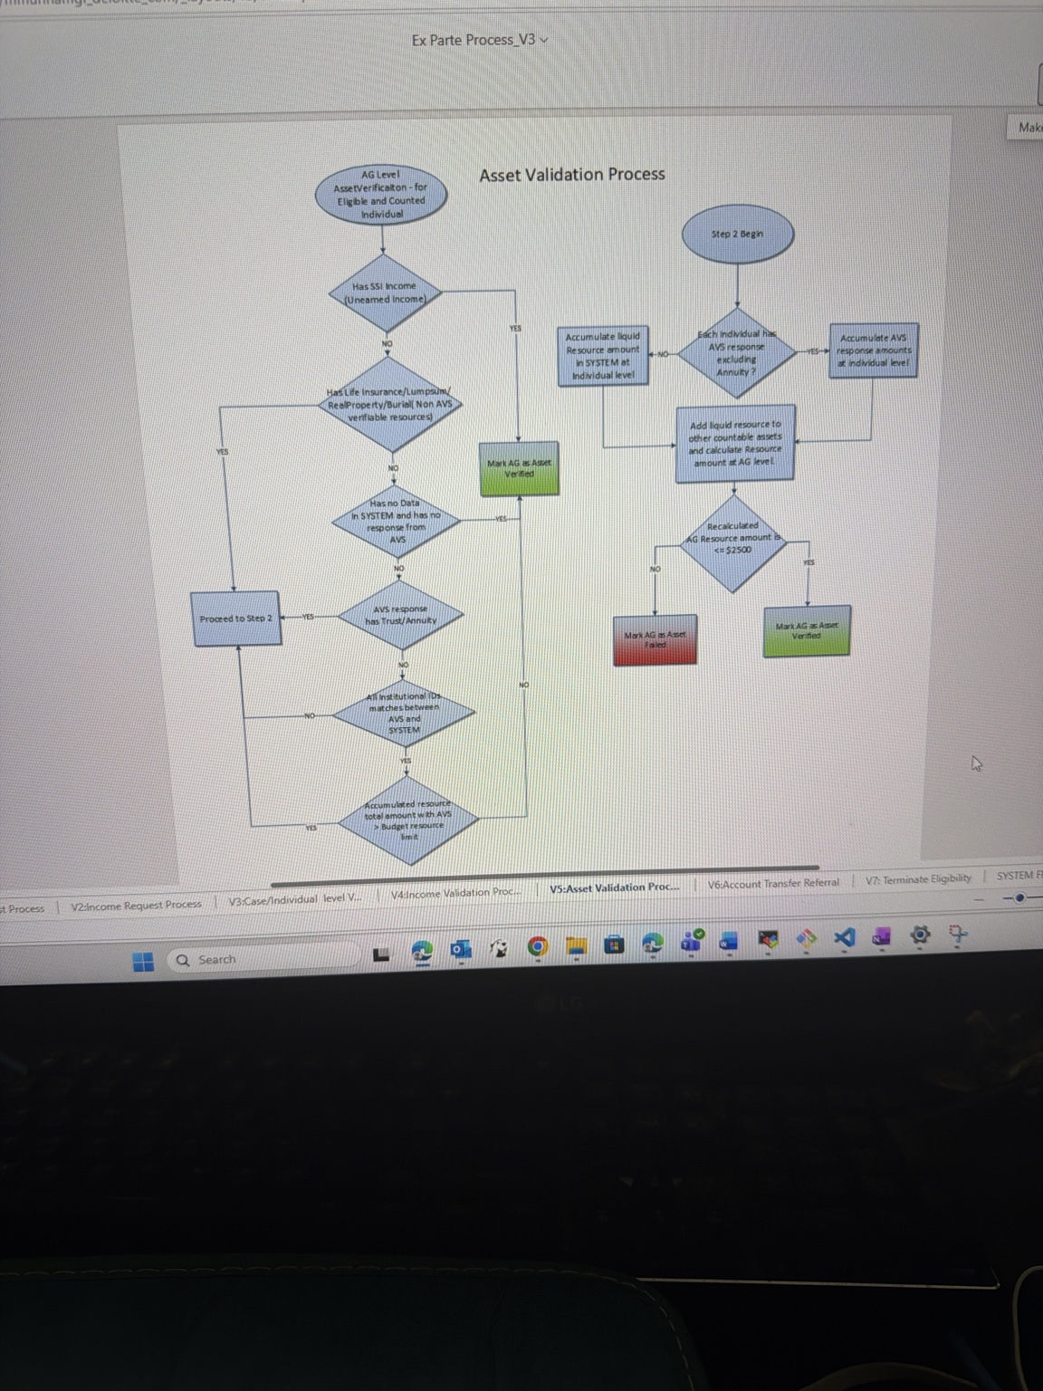
My understanding: This step checks liquid resources and other assets like trust, annuity, burial fund, life insurance and bank resource amounts. Then it compares total resource amount with the limit.
Where I think AI can help, but in limited way:
- AI can summarize assets in one view for worker, especially when many sources are involved.
- AI can detect mismatch between declared asset and AVS response, but final threshold result should be rules based.
- Agent can collect all asset evidence and generate explanation why asset failed or verified.
Implementation: Build asset-summary tool that pulls AVS response, declared resources and rules output. Agent should not calculate final eligibility by itself. It can only explain and flag inconsistent items.

6. V6 - Account Transfer Referral
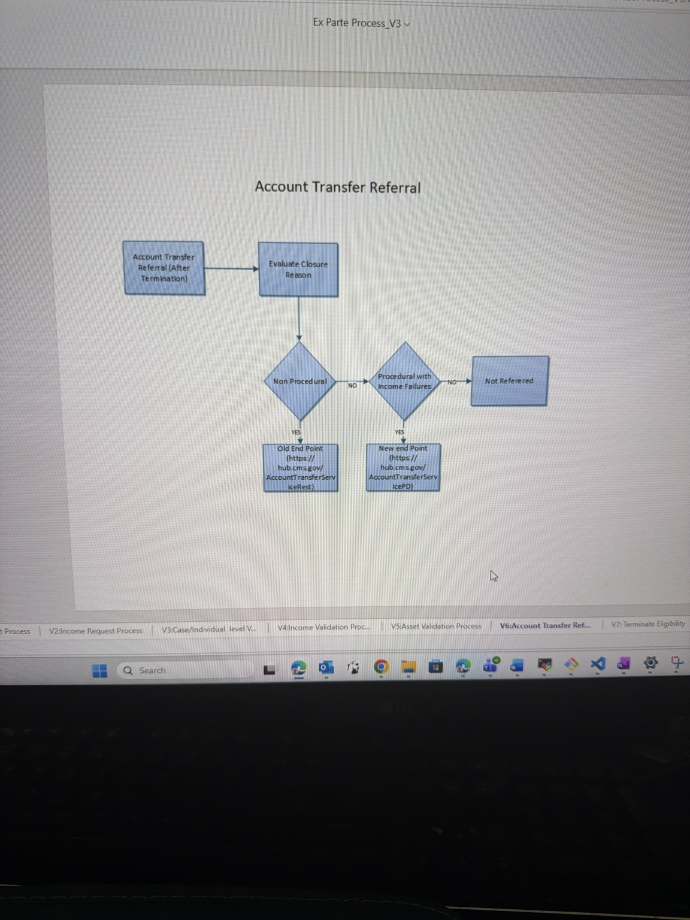
My understanding: After termination, system checks closure reason and decides whether account transfer referral is needed. It also decides old endpoint vs new endpoint based on procedural/non-procedural and income failure logic.
Where I think AI can help, but in limited way:
- AI can explain why case was referred or not referred.
- Agent can monitor failed API referrals and create retry/task for support team.
- This is more workflow automation than LLM reasoning.
Implementation: Use normal service orchestration first. Add AI only for exception summary and failure classification. For example, when referral API fails, agent reads error, maps to known issue, and suggests next action.

7. V7 - Auto Close Termination Logic
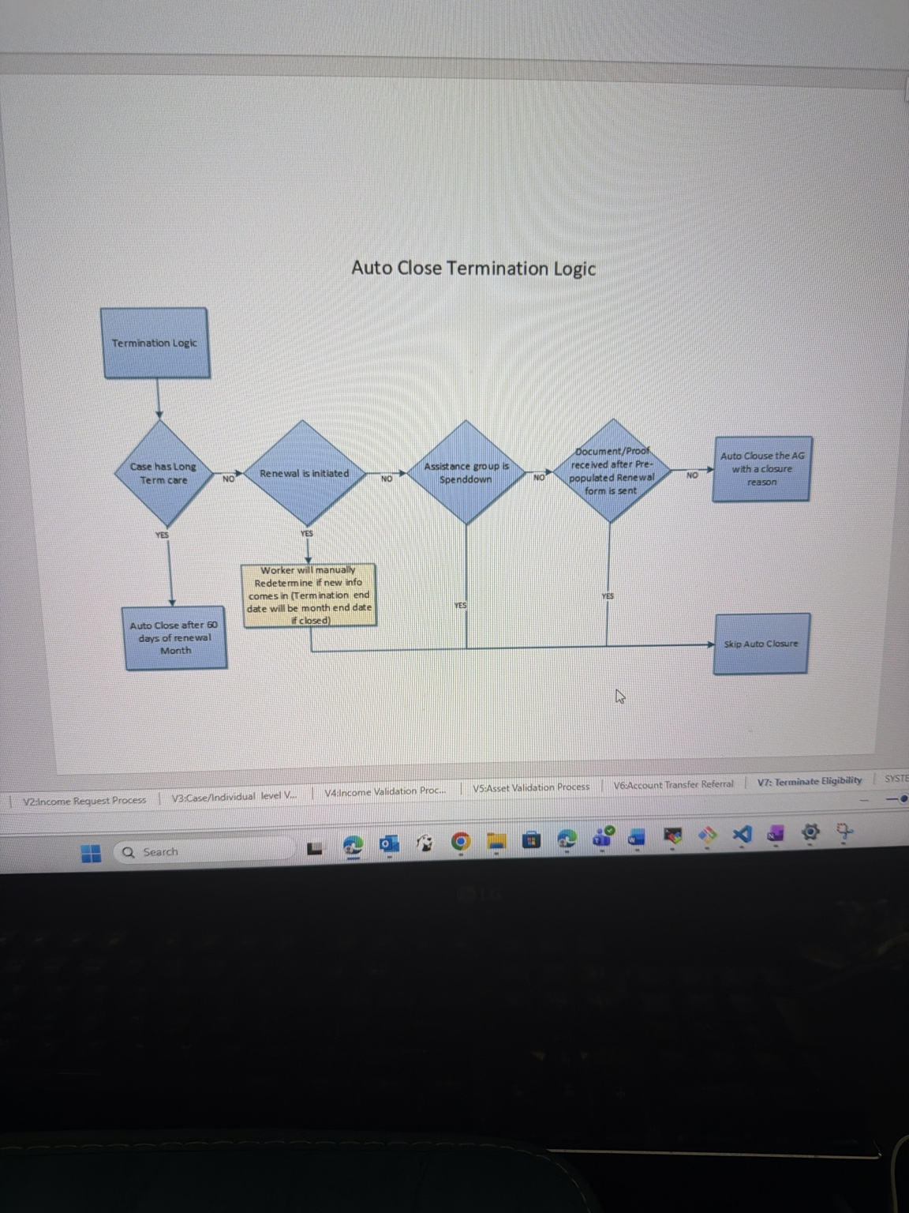
My understanding: This decides whether the case should auto close. It checks long term care, renewal initiated, spenddown group, and whether documents/proofs were received after renewal form was sent.
Where I think AI can help, but in limited way:
- AI can prevent wrong auto closure by checking latest documents and summarizing if proof came in.
- Agent can draft reminder notice before closure, but notice should be approved/template based.
- Worker copilot can show: why auto close is allowed or why it should be skipped.
Implementation: Create pre-auto-close review agent. It runs before closure batch. It checks document received date, notice sent date, case status and closure reason. It outputs only recommendation: safe to close / hold for worker / missing proof.

8. IBM LinuxONE feasibility
My current thought: It is possible, but we should split agent application and model inference. LinuxONE can host the APIs, LangGraph service, audit DB connection and integration with existing state systems. For model inference, use IBM approved watsonx/Granite endpoint or IBM AI Toolkit supported runtime if state wants on-platform deployment.
- Good fit on LinuxONE: FastAPI agent service, LangGraph workflow, PostgreSQL/DB2 integration, message queues, audit logging, rule-result summarization.
- Need validation: Python packages on s390x, container images, model runtime, GPU/accelerator availability, OpenShift support and security approvals.
- Avoid in first phase: running very large open source LLM directly on LinuxONE without confirmed supported serving stack and performance testing.
- Best practical option: call watsonx.ai / Granite model from controlled internal network and keep all prompts/outputs logged.

9. Small reference architecture
Existing case system / rules engine -> Event or API -> AI Agent Service on LinuxONE -> approved tools/APIs -> Granite / watsonx model endpoint -> worker summary + audit log + optional HITL queue

10. Model and framework recommendation
- Framework: LangGraph is my first choice because workflow is step based and needs control. CrewAI feels more open-ended and less safe for this government process.
- Model: IBM Granite on watsonx.ai is the first option because it fits IBM environment better. Llama can be second option only if approved and self-hosting is required.
- Serving: If OpenShift AI / Red Hat AI is already in the state environment, use that. Otherwise keep model behind approved IBM endpoint and deploy only the agent service on LinuxONE.
- Data: Use RAG only for policy manuals and SOPs. Do not use RAG to override rules engine.

11. My final initial thought
I think the best first use case is not full automated eligibility decision. The safer and realistic use case is worker copilot + case failure explanation + missing document checklist. Once that works and audit team is comfortable, we can add small agentic automation around routing and reminders. This way we get value without creating compliance risk.

12. References checked
- IBM AI Toolkit for IBM Z and LinuxONE - IBM product page. It says the toolkit provides supported open source AI frameworks adapted for IBM Z and LinuxONE hardware.
- IBM AI Toolkit for IBM Z and LinuxONE - GitHub repository. It provides overview and deployment guidance for AI Toolkit on IBM Z/LinuxONE.
- LangChain IBM integrations documentation - shows IBM watsonx.ai and DB2 integrations for LangChain.
- IBM Developer tutorial - Build a tool calling agent with LangGraph and watsonx.ai flows engine.
- Red Hat OpenShift AI / watsonx.ai blog - describes OpenShift AI as a platform for model serving, monitoring and lifecycle management.

