**Lab 3: Assigning Static IP Address in windows.**

**Objective:**

The objective of this lab is to assign a static IP address on a Windows computer and become familiar with the commands used to assign it.

**Apparatus (Interpreter):** Command Prompt

**Background:**

Background: A static IP address is a fixed numerical address that is assigned to a computer by an ISP, which identifies it with a specific address instead of one that is assigned temporarily. Dynamic Host Configuration Protocol (DHCP) is a more convenient way for devices to connect to a network because users don't have to manually configure IP addressing for each new device. However, automatic addressing has a downside as a device's IP address can change from time to time, which is why certain types of devices require static IPs.

**Procedure:**

To assign a static IP address, follow these steps:

Step 1: Press the windows key and type cmd in search bar.

Step 2: Select Command Prompt and click run as administrator.

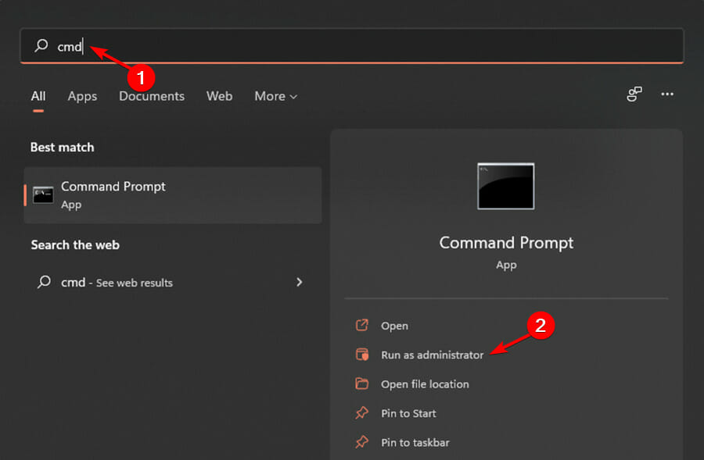

Step 3: Run command “ipconfig /all”

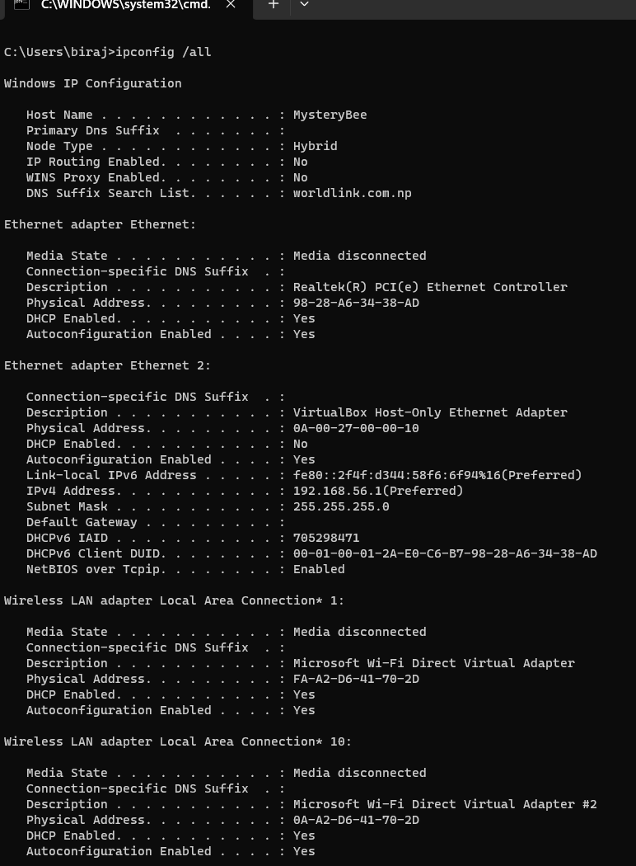

Step 4: Run command “netsh interface ip set address name="Ethernet" 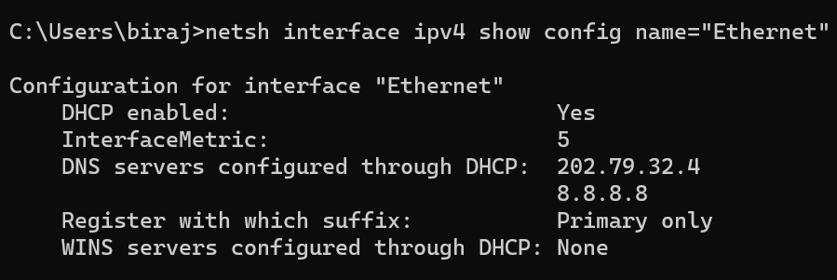

Step 5: Run command “netsh interface ip set address name="Ethernet" static 10.1.2.220 255.255.255.0 10.1.2.1”

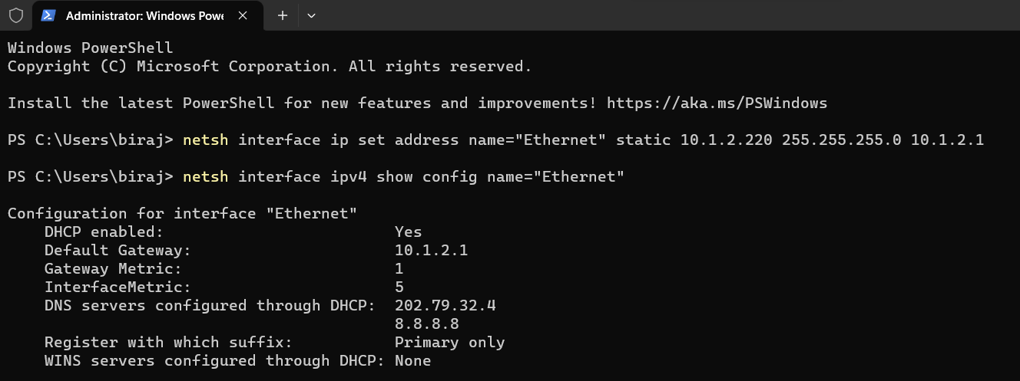

Step 6: Finally, run command “netsh interface ip add dns name="Ethernet" 8.8.8.8 index=2” to assign an alternate DNS address.

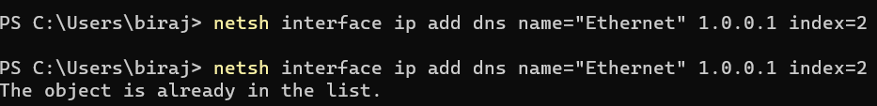

**Conclusion:**

Assigning a static IP address on a Windows computer can be useful for certain devices that require a fixed numerical address. While DHCP is a convenient way to connect devices to a network without having to manually configure IP addressing, it can result in IP address changes from time to time. By assigning a static IP address, a device can maintain a consistent address that is easily recognizable on the network.