**Lab 6 Routing**

**LAB 6.1: Understanding and configuring Static Routing by using Packet Tracer.**

**Objective:**

* To perform Static Routing operation on the network and observe the network behavior using static routing.

**Devices used:**

|  |  |  |  |
| --- | --- | --- | --- |
| **S.N.** | **Device** | **Model** | **Quantity** |
| 1 | PC | PC | 4 |
| 2 | Switch | PT-Switch | 2 |
| 3 | Router | PT-Router | 2 |
| 4 | Cable | Straight through | 6 |
| 5 | Cable | Serial DEC | 1 |

**Background:**

Static routing is a simple method of network routing where network administrators manually configure the routing table on routers. It involves manually specifying the paths that network traffic should take between different networks or subnets. Static routes remain fixed unless modified by administrators, providing stability but limited adaptability to network changes. It is commonly used in small networks or as a backup for dynamic routing protocols. However, it can become impractical for large and complex networks where dynamic routing protocols are preferred.

**Topology:**

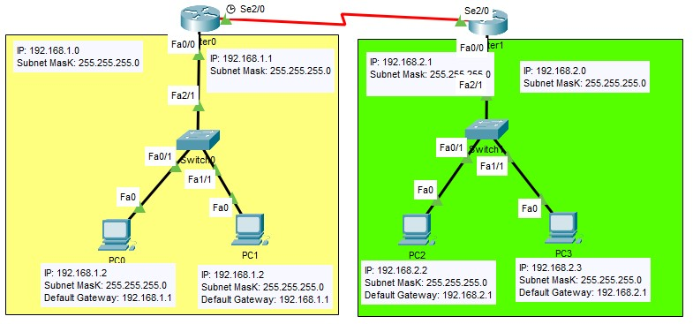

**IP Address Plan:**

|  |  |  |  |  |  |
| --- | --- | --- | --- | --- | --- |
| **Device** | **Interface** | **IP** | **Subnet Mask** | **VLAN** | **Default gateway** |
| PC0 | NIC | 192.168.1.2 | 255.255.255.0 | Default | 192.186.1.1 |
| PC1 | NIC | 192.168.1.3 | 255.255.255.0 | Default | 192.168.1.1 |
| PC2 | NIC | 192.168.2.2 | 255.255.255.0 | Default | 192.168.2.1 |
| PC3 | NIC | 192.168.2.3 | 255.255.255.0 | Default | 192.168.2.1 |
| Router 0 | Fa 0/0 | 192.168.1.1 | 255.255.255.0 | Default | - |
| Router 0 | Se 2/0 | 11.0.0.1 | 255.255.255.0 | Default | - |
| Router 1 | Fa 0/0 | 192.168.2.1 | 255.255.255.0 | Default | - |
| Router 1 | Se 2/0 | 11.0.0.2 | 255.255.255.0 | Default | **-** |

**Procedure:**

1. Routers are joined together with Serial DCE wires
2. Switches are joined with each router individually
3. 2 PCs are joined with each switches
4. Set IP and Default gateway in each PC
5. Set the IP addresses in the routers interfaces

In Router 0:

Router(config-if)#ip address 192.168.1.1 255.255.255.0

Router(config-if)#ip address 11.0.0.1 255.255.255.0

In Router 1:

Router(config-if)#ip address 192.168.2.1 255.255.255.0

Router(config-if)#ip address 11.0.0.2 255.255.255.0

1. Set Static routes

Static path setting in Router 0: Router(config)# ip route 192.168.2.0 255.255.255.0 11.0.0.2

Static Path Setting in Router 1: Router(config)# ip route192.168.1.0 255.255.255.0 11.0.0.1

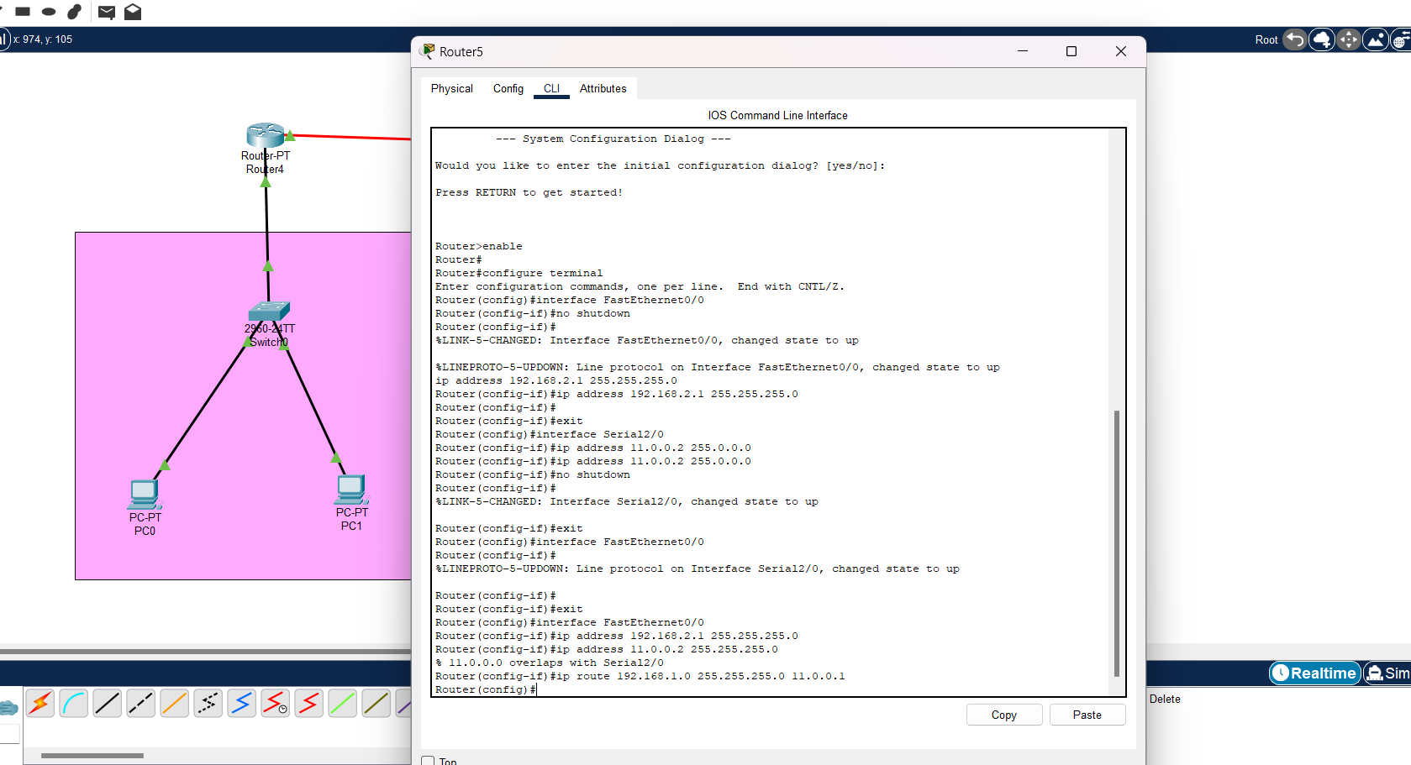

**Verification:**

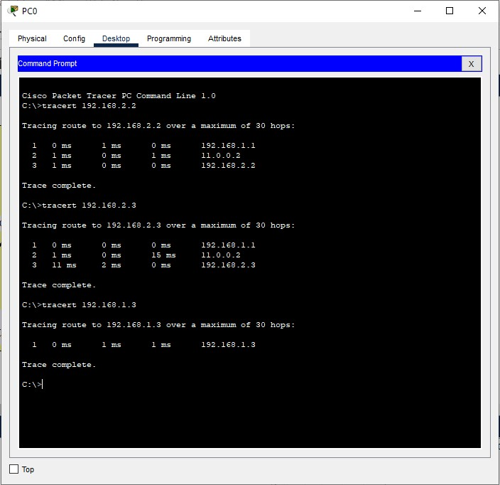

**Conclusion:**

Static routes were established and found to remain unchanged unless manually modified by the administrator. This characteristic provides stability and control over network traffic paths. However, it also revealed the limitation of static routing, as it lacks the ability to adapt automatically to network changes. Dynamic routing protocols are preferred in larger networks for their ability to adjust routes dynamically.

# LAB 6.2: Understanding and configuring Routing Information Protocol (RIP) by using Packet Tracer.

**Objective:**

* To understand and illustrate the dynamic routing protocol RIP by using Packet Tracer.

**Background:**

Routing Information Protocol (RIP) is a dynamic routing protocol which uses hop count as a routing metric to find the best path between the source and the destination network. RIP is one of the oldest dynamic routing protocols which is a distance - vector routing protocol.

**Devices used:**

|  |  |  |  |
| --- | --- | --- | --- |
| **S.N.** | **Device** | **Model** | **Quantity** |
| 1 | PC | PC | 6 |
| 2 | Switch | PT-Switch | 3 |
| 3 | Router | PT-Router | 3 |
| 4 | Cable | Straight through | 9 |
| 5 | Cable | Serial DEC | 2 |

**Topology:**

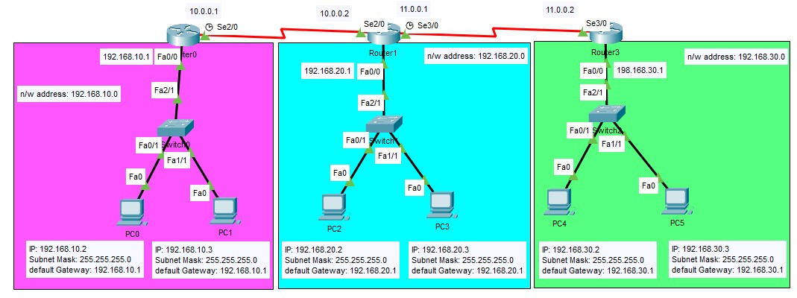

**IP Address Plan:**

|  |  |  |  |  |  |
| --- | --- | --- | --- | --- | --- |
| **Device** | **Interface** | **IP** | **Subnet Mask** | **VLAN** | **Default gateway** |
| PC0 | NIC | 192.168.10.2 | 255.255.255.0 | Default | 192.186.10.1 |
| PC1 | NIC | 192.168.10.3 | 255.255.255.0 | Default | 192.168.10.1 |
| PC2 | NIC | 192.168.20.2 | 255.255.255.0 | Default | 192.168.20.1 |
| PC3 | NIC | 192.168.20.3 | 255.255.255.0 | Default | 192.168.20.1 |
| PC4 | NIC | 192.168.30.2 | 255.255.255.0 | Default | 192.168.30.1 |
| PC5 | NIC | 192.168.30.3 | 255.255.255.0 | Default | 192.168.30.1 |
| Router 0 | Fa 0/0 | 192.168.10.1 | 255.255.255.0 | Default | - |
| Router 0 | Se 2/0 | 10.0.0.1 | 255.255.255.0 | Default | - |
| Router 1 | Fa 0/0 | 192.168.20.1 | 255.255.255.0 | Default | - |
| Router 1 | Se 2/0 | 10.0.0.2 | 255.255.255.0 | Default | - |
| Router 1 | Se 3/0 | 11.0.0.1 | 255.255.255.0 | Default | - |
| Router 3 | Fa 0/0 | 192.168.30.1 | 255.255.255.0 | Default | - |
| Router 3 | Se 2/0 | 11.0.0.2 | 255.255.255.0 | Default | - |

**Procedure:**

1. Routers are joined together with Serial DCE wires
2. Switches are joined with each router individually
3. 2 PCs are joined with each switches
4. Set IP and Default gateway in each PC
5. Set the IP addresses in the routers Interfaces as shown in the IP address plan table

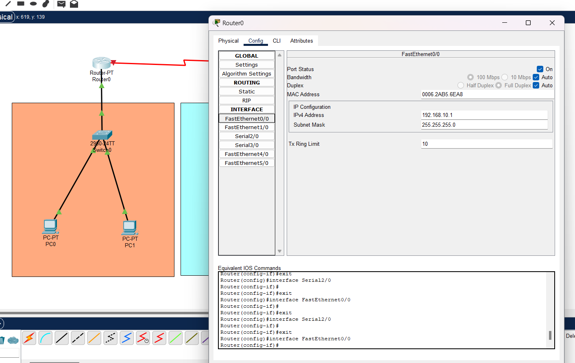

1. Perform the following setup to illustrate dynamic routing using RIP

In router 0:

Router(config)#router rip

Router(config)#network 192.168.10.0

Router(config)#network 10.0.0.0

In router 1:

Router(config)#router rip

Router(config)#network 192.168.20.0

Router(config)#network 10.0.0.0

Router(config)#network 11.0.0.0

In router 2:

Router(config)#router rip

Router(config)#network 192.168.30.0

Router(config)#network 11.0.0.0

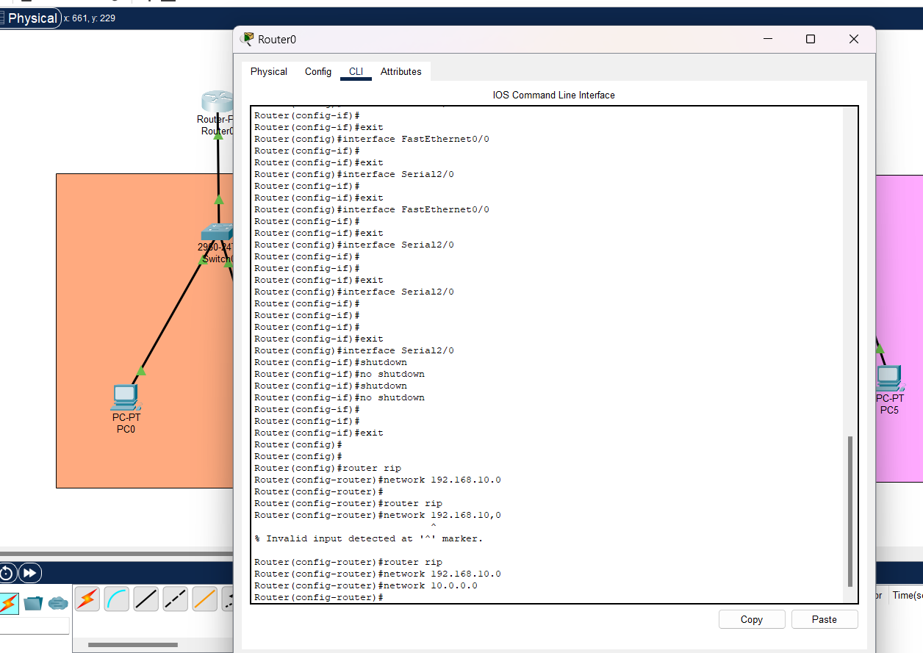

**Verification:**

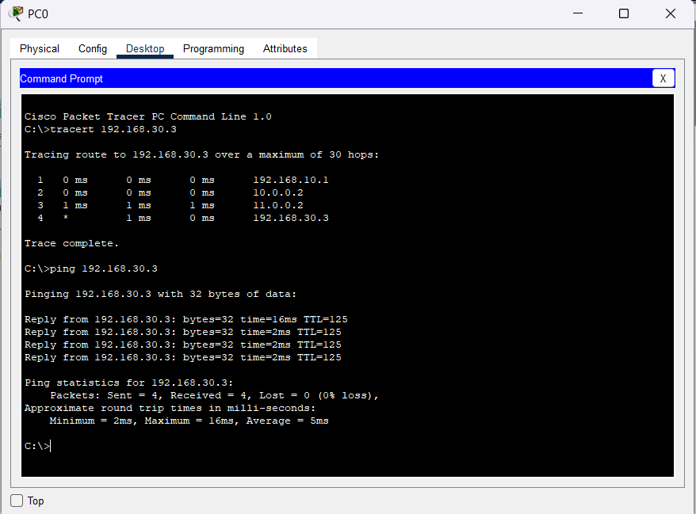

**Conclusion:**

The objective of understanding and illustrating the dynamic routing protocol RIP has been successfully accomplished in this study. Through experiment, we have gained a clear understanding of how RIP operates as a distance-vector routing protocol.

**LAB 6.3: Understanding and configuring Open Shortest Path First (OSPF) by using Packet Tracer.**

**Objective:**

* To configure and understand the OSPF as a dynamic routing protocol.

**Background:**

OSPF (Open Shortest Path First) is a link-state routing protocol used in computer networks. It calculates the best path for routing IP packets based on the network's link state. OSPF organizes networks into areas, uses Dijkstra's algorithm, and has fast convergence. It supports both IPv4 and IPv6, includes authentication mechanisms, and is commonly used in large enterprise and ISP networks for its scalability and efficiency.

**Devices used:**

|  |  |  |  |
| --- | --- | --- | --- |
| **S.N.** | **Device** | **Model** | **Quantity** |
| 1 | PC | PC | 3 |
| 2 | Switch | PT-Switch | 3 |
| 3 | Router | PT-Router | 3 |
| 4 | Cable | Straight through | 6 |
| 5 | Cable | Serial DEC | 3 |

**Topology:**

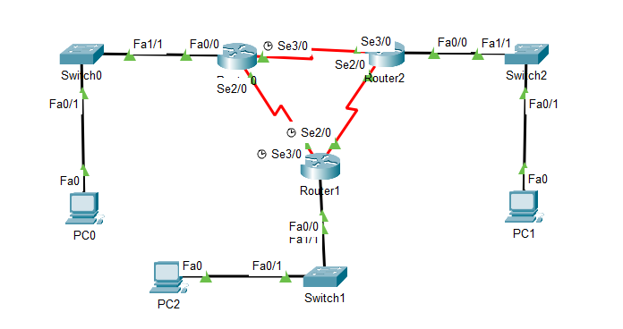

**IP Address Plan:**

|  |  |  |  |  |  |
| --- | --- | --- | --- | --- | --- |
| **Device** | **Interface** | **IP** | **Subnet Mask** | **VLAN** | **Default gateway** |
| PC0 | NIC | 192.168.10.2 | 255.255.255.0 | Default | 192.186.10.1 |
| PC1 | NIC | 192.168.30.2 | 255.255.255.0 | Default | 192.168.30.1 |
| PC2 | NIC | 192.168.20.2 | 255.255.255.0 | Default | 192.168.20.1 |
| Router 0 | Fa 0/0 | 192.168.10.1 | 255.255.255.0 | Default | - |
| Router 0 | Se 2/0 | 192.168.150.1 | 255.255.255.0 | Default | - |
| Router 0 | Se 3/0 | 192.168.200.1 | 255.255.255.0 | Default | - |
| Router 1 | Fa 0/0 | 192.168.20.1 | 255.255.255.0 | Default | - |
| Router 1 | Se 2/0 | 192.168.100.2 | 255.255.255.0 | Default | - |
| Router 1 | Se 3/0 | 192.168.150.2 | 255.255.255.0 | Default | - |
| Router 3 | Fa 0/0 | 192.168.30.1 | 255.255.255.0 | Default | - |
| Router 3 | Se 2/0 | 192.168.100.2 | 255.255.255.0 | Default | - |
| Router 3 | Se 2/0 | 192.168.200.2 | 255.255.255.0 | Default | - |

**Procedure:**

1. Routers were joined together with Serial DCE wires
2. Switches were joined with each router individually
3. 2 PCs were joined with each switches
4. Set IP and Default gateway in each PC as shown in the IP address plan table
5. Performed the following setup to configure OSPF in each router

In router 0:

Router(config)#router ospf 1

Router (config-router)#network 192.168.100.0 0.0.0.255 area 0

Router (config-router)#network 192.168.150.0 0.0.0.255 area 0

Router (config-router)#network 192.168.20.0 0.255.255.255 area 0

In router 1:

Router(config)#router ospf 1

Router (config-router)#network 192.168.200.0 0.0.0.255 area 0

Router (config-router)#network 192.168.150.0 0.0.0.255 area 0

Router (config-router)#network 192.168.10.0 0.255.255.255 area 0

In router 2:

Router(config)#router ospf 1

Router (config-router)#network 192.168.200.0 0.0.0.255 area 0

Router (config-router)#network 192.168.100.0 0.0.0.255 area 0

Router (config-router)#network 192.168.30.0 0.255.255.255 area 0

**Verification:**

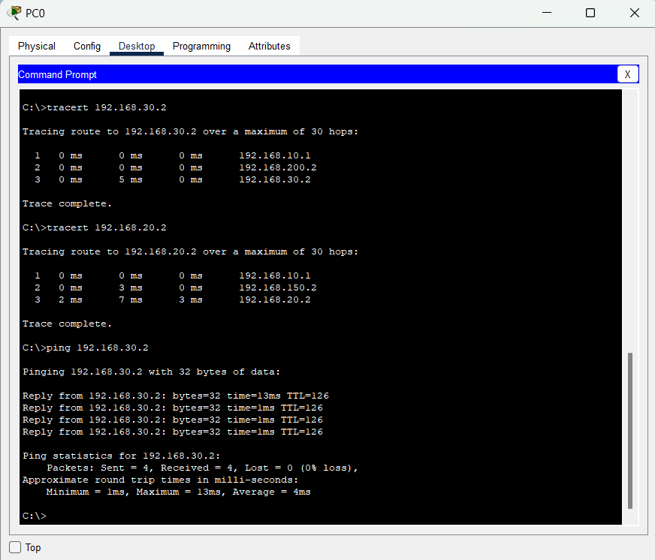

**Conclusion:**

The successful configuration of OSPF in the experiment demonstrated its effectiveness in finding the shortest path from the sender to the receiver. By utilizing the link-state database and Dijkstra's algorithm, OSPF efficiently calculated optimal routes within the network. The verification phase confirmed the accuracy of OSPF in determining the shortest path. Overall, the experiment highlights OSPF's reliability as a dynamic routing protocol for achieving efficient and optimal routing in networks.

**LAB 6.4: Understanding and configuring Broder Gateway Protocol (BGP) by using Packet Tracer.**

**Objective:**

* To configure and understand the BGF by using Packet Tracer.

**Background:**

BGP is the latest routing protocol of the Internet, which is classified as a DPVP (distance path vector protocol). It sends updated router table data when changes are made.

**Devices used:**

|  |  |  |  |
| --- | --- | --- | --- |
| **S.N.** | **Device** | **Model** | **Quantity** |
| 1 | PC | PC | 2 |
| 2 | Switch | PT-Switch | 2 |
| 3 | Router | PT-Router | 2 |
| 4 | Cable | Straight through | 2 |
| 5 | Cable | Serial DEC | 2 |

**Topology:**

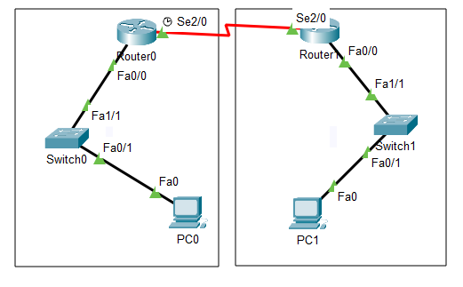

**IP Address Plan:**

|  |  |  |  |  |  |
| --- | --- | --- | --- | --- | --- |
| **Device** | **Interface** | **IP** | **Subnet Mask** | **VLAN** | **Default gateway** |
| PC0 | NIC | 192.168.2.2 | 255.255.255.0 | Default | 192.186.2.1 |
| PC1 | NIC | 192.168.3.2 | 255.255.255.0 | Default | 192.168.3.1 |
| Router 0 | Fa 0/0 | 192.168.2.1 | 255.255.255.0 | Default | - |
| Router 0 | Se 2/0 | 192.168.1.1 | 255.255.255.0 | Default | - |
| Router 1 | Fa 0/0 | 192.168.3.1 | 255.255.255.0 | Default | - |
| Router 1 | Se 2/0 | 192.168.1.2 | 255.255.255.0 | Default | - |

**Procedure:**

1. Routers were joined together with Serial DCE wires
2. Switches were joined with each router individually
3. A PC was joined with each switches
4. Set IP and Default gateway in each PC as shown in the IP address plan table
5. Performed the following setup to configure BGP in each router

In Router 0:

Router(config)#router bgp 1

Router(config-router)#network 192.168.1.0

Rounetwork 192.168.1.0network 192.168.2.0

Router(config-router)#neighbor 192.168.1.2 remote-as 2

Router(config-router)#neighbor 192.168.3.2 remote-as 2

In Router 1:

Router(config)#router bgp 2

Router(config-router)#network 192.168.1.0

Router(config-router)#network 192.168.2.0

Router(config-router)#neighbor 192.168.1.1 remote-as 1

Router(config-router)#neighbor 192.168.2.3 remote-as 1

**Verification:** 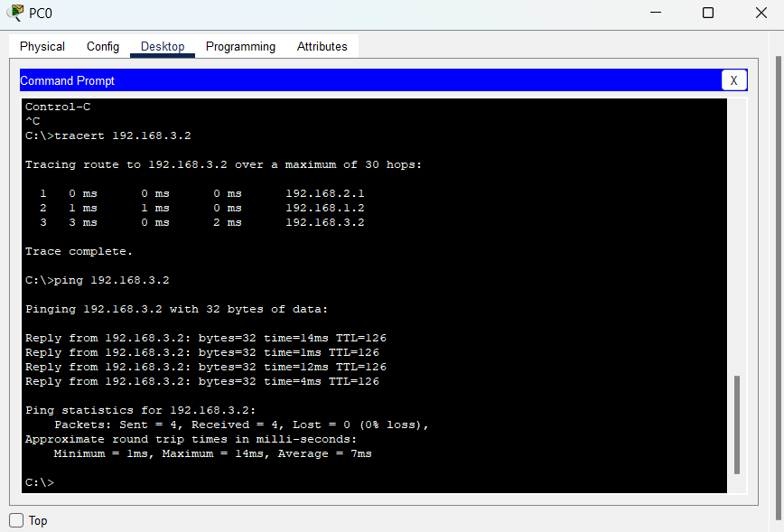

**Conclusion:**

BGP has been successfully configured and found that there is no auto-discovery of topology changes, so the user needs to configure BGP manually.