**LAB 1: Understanding the color-coding standard of UTP cable and construction and verification of straight through and Crossover cable.**

**Objective:**

The primary objective of this lab is to provide a comprehensive understanding of the color-coding standard of Unshielded Twisted Pair (UTP) cable and to create both straight-through and crossover cables while verifying their connectivity.

**Apparatus:**

To achieve this objective, you will require various equipment, including an RJ-45 connector, a crimping tool, a twisted pair cable, and a cable tester.

**Background:**

UTP cable (Unshielded Twisted Pair) is a common type of cable used in computer networking that is made up of two shielded wires twisted around each other. Unlike other types of cables, UTP cables lack insulation between the paired wires, making them vulnerable to electromagnetic interference, which can result in packet loss or corruption. UTP cables are used in Ethernet cables and telephone lines.

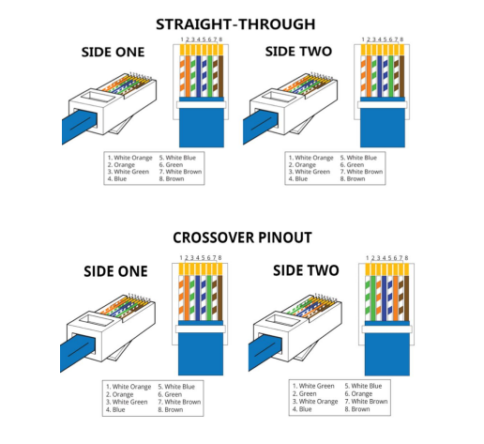

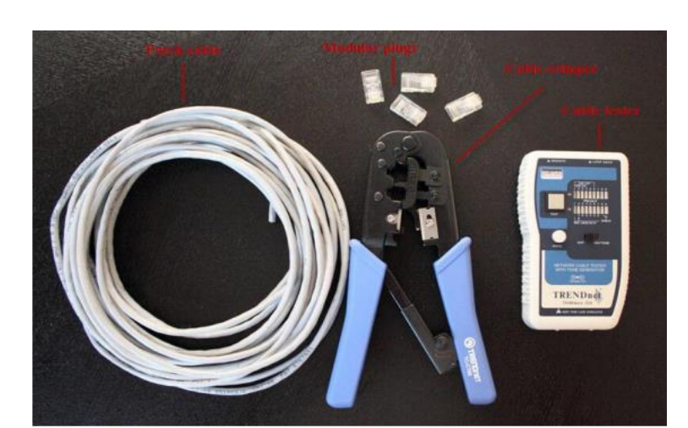

**Procedure:**

To create a UTP cable, follow the steps below:

Step 1: Strip the cable jacket approximately one inch down from the end of the cable. Use a cable stripper tool to strip the insulation off the wire. 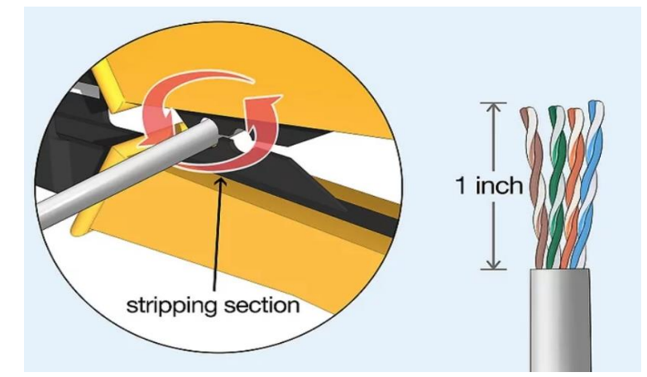

Step 2: Untwist and straighten the wires inside the cable. Inside the cable are a bunch of smaller wires that are twisted together. You need to separate the twisted wires and straighten them out so they are easier to sort into the right order.

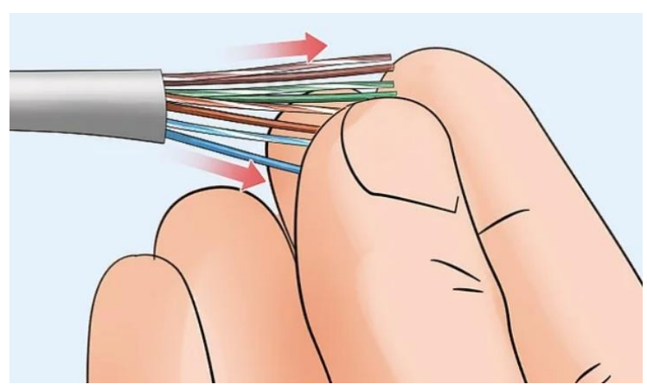

Step 3: Arrange the wires in the correct order as per EIA 568 A or B standard. There are four pairs of wires in an Ethernet cable, and an Ethernet connector (8P8C) has eight pin slots. Each pin is identified by a number, starting from left to right, with the clip facing away from you.

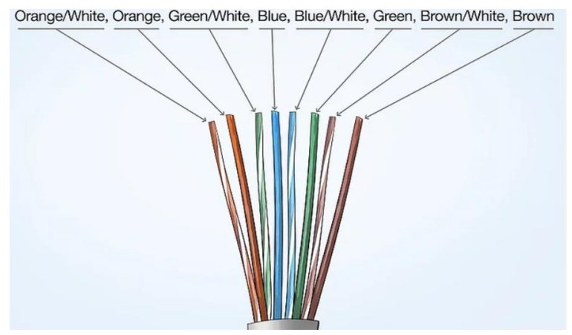

Step 4: Cut the wires into an even line 1⁄2 inch (13 mm) from the sheathing. Hold the wires with your thumb and index finger to keep them in order, then use the cutting section of the crimping tool to cut them into an even line. 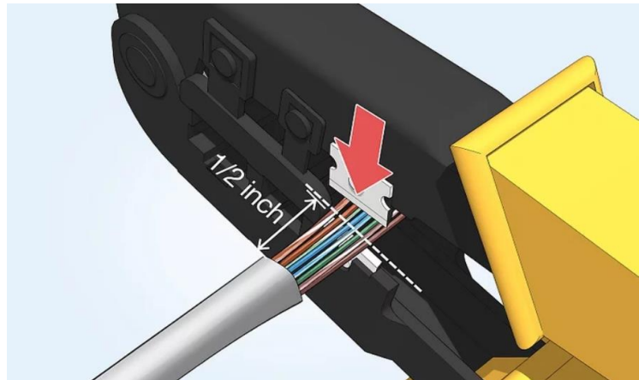

Step 5: Insert the wires into the RJ-45 connector. Hold the RJ-45 connector so the clip is on the underside and the small metal pins are facing up. Insert the cable into the connector so that each of the small wires fits into the small grooves in the connector.

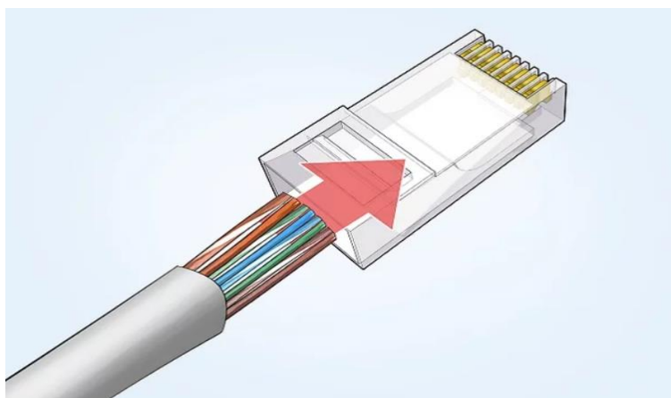

Step 6: Stick the connector into the crimping part of the tool and squeeze twice. Insert the connector in the crimping section of the tool until it can’t fit any further. Squeeze the handles to crimp the connector and secure the wires.

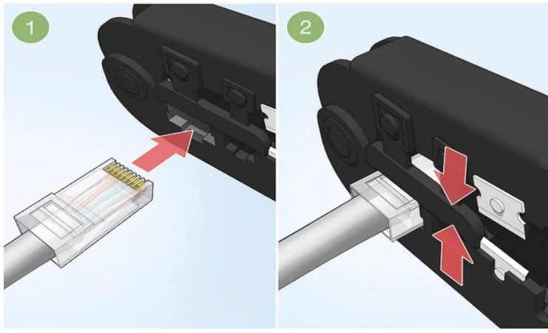

Step 7: Remove the cable from the tool and check that all of the pins are down. Verify that each wire is in its proper location within the connector, and none of the wires are sticking out.

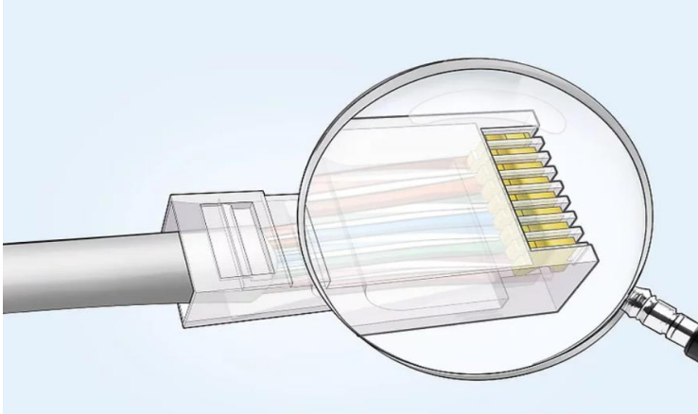

Step 8: Repeat steps 1-7 for the other end of the cable to create a complete UTP cable.

Step 9: Use a cable tester to test each pin of both ends of the cable. A cable tester can quickly detect any connectivity issues that may have been created during the termination process. 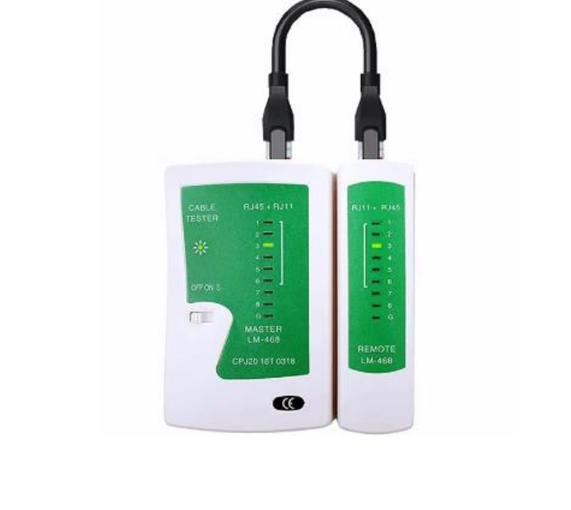

**After all the above steps are completed, the connectors should look like the figure below:**

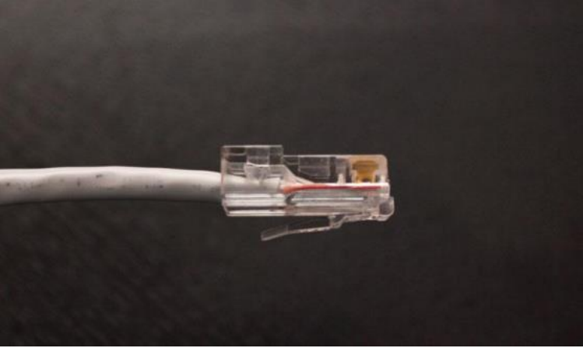

**Conclusion**:

In conclusion, UTP cables are a common type of network cable used to connect devices such as PCs, routers, and switches within a LAN. A straight-through cable is used to connect different devices, while a crossover cable is used to connect similar devices. Creating a UTP cable requires following the correct color-coding standard and properly crimping the connector. By following the procedures mentioned above, you can create and test a UTP cable that meets the requirements of the Ethernet standards.