**Objective:Lab 7: HTTP, DNS and DHCP**

* To configure and understand the HTTP, DNS and DHCP service.

# Devices Used:

|  |  |  |  |
| --- | --- | --- | --- |
| s. No. | Device | Model | Quantity |
| 1. | PC | PC | 4 |
| 2. | Switch | 2960 | 2 |
| 3. | Router | 4331 | 1 |
| 4. | Cable | Straight through | 9 |
| 5. | Server | PT Server | 3 |

**IP Addressing:**

|  |  |  |  |  |  |
| --- | --- | --- | --- | --- | --- |
| Device | Interface | IP | Subnet Mask | DNS Server | Default gateway |
| Router 0 | gig 0/0/0 | 192.168.10.1 | 255.255.255.0 | - | - |
| Router 0 | gig 0/0/1 | 192.168.20.1 | 255.255.255.0 | - | - |
| Server 0 | NIC | 192.168.20.2 | 255.255.255.0 | 192.168.20.13 | 192.168.20.1 |
| Server 1 | NIC | 192.168.20.3 | 255.255.255.0 | 192.168.20.13 | 192.168.20.3 |
| Server 2 | NIC | 192.168.20.4 | 255.255.255.0 | 192.168.20.13 | 192.168.20.1 |

All PC will get the IP address from the DHCP server dynamically.

# Topology:

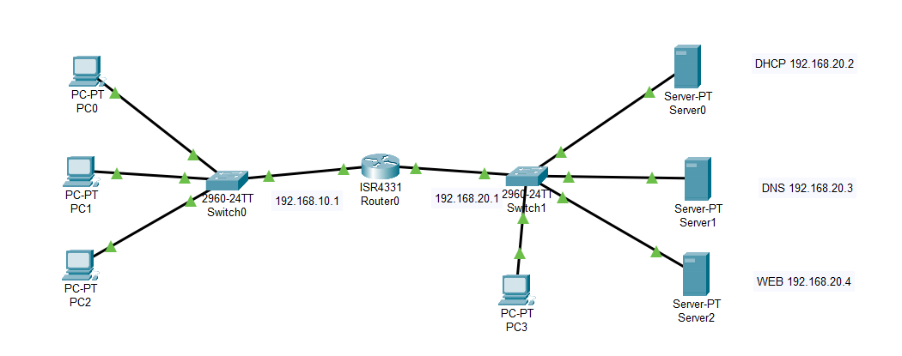

**Background:**

DHCP (Dynamic Host Configuration Protocol) is a network protocol that automatically assigns IP addresses to devices. It simplifies network configuration by dynamically assigning IP addresses, subnet masks, and other parameters. DNS (Domain Name System) is a hierarchical naming system that translates domain names to IP addresses, enabling communication over the internet. It stores domain name records and their associated IP addresses. HTTP (Hypertext Transfer Protocol) facilitates resource retrieval and transfer between web browsers and servers. It uses a request-response model to deliver web content. Together, DHCP, DNS, and HTTP form the foundation of network connectivity and seamless web browsing, providing efficient IP allocation, name resolution, and resource access.

**Procedure:**

1. Create the topology as shown above
2. Assign the IP address to each server as shown in IP table.
3. Set up the DHCP Server as shown below
4. Set up the DNS server as shown below

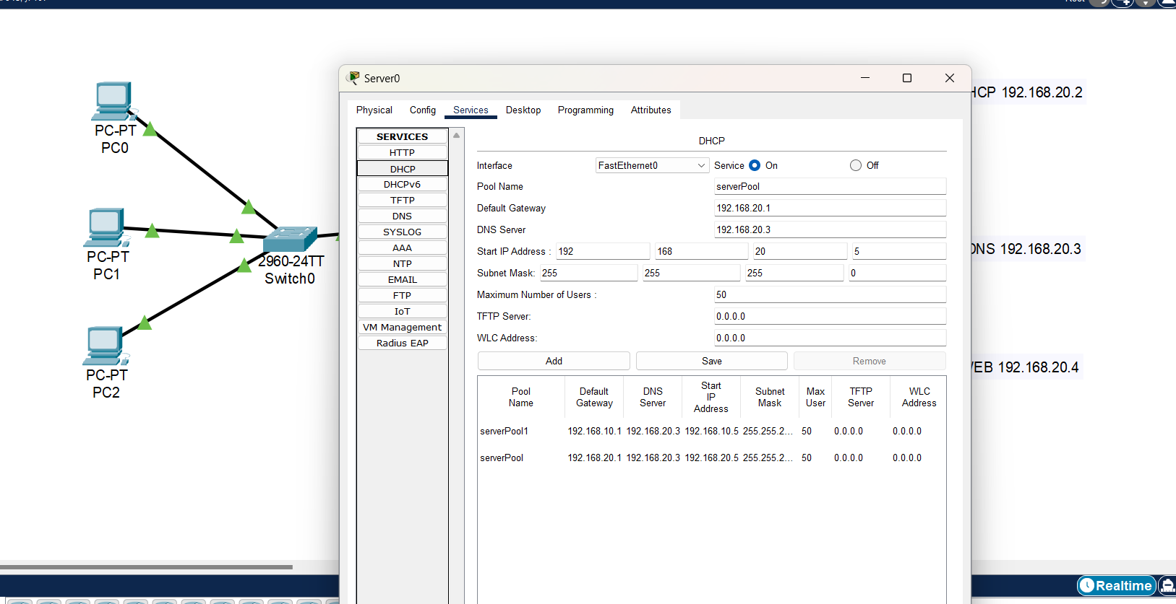

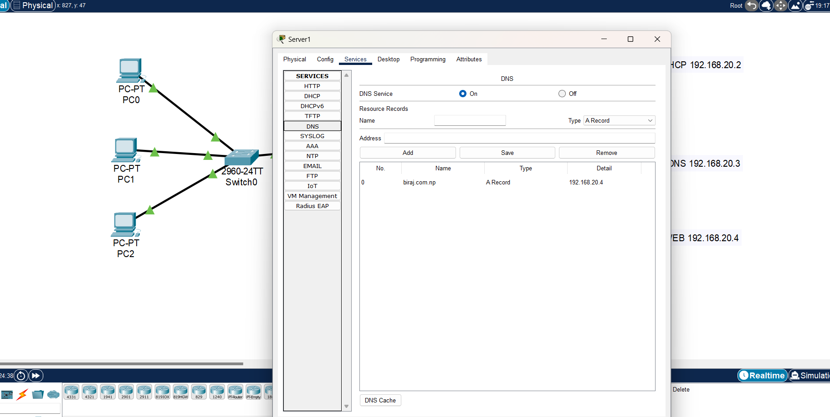

1. Setup the Web server as shown below

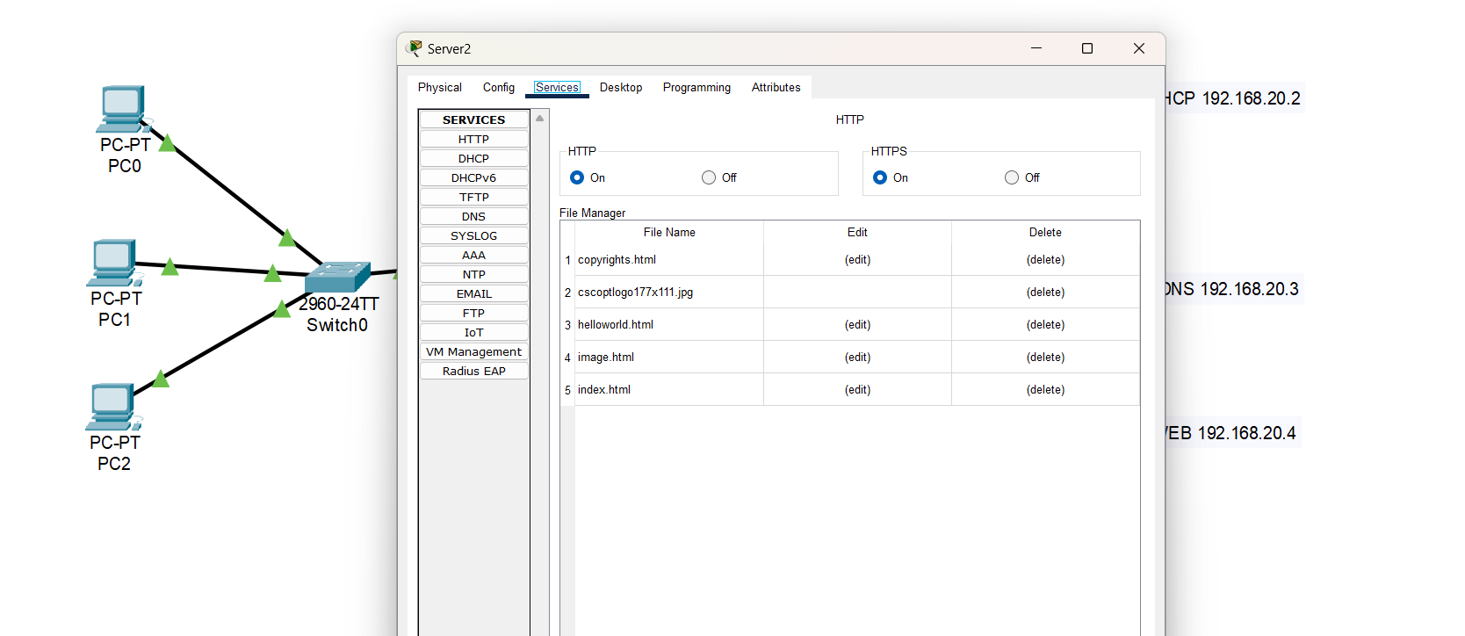

You can also edit existing files and add new your own files as well.

1. Setup the router interface as: Router>enable Router#configure terminal

Router(config)#interface GigabitEthernet0/0/0 Router(config-if)#ip address 192.168.10.1 255.255.255.0 Router(config-if)#no shutdown

Router(config-if)#exit Router(config)#interface GigabitEthernet0/0/1

Router(config-if)#ip address 192.168.20.1 255.255.255.0 Router(config-if)#no shutdown

Router(config-if)#exit

# To forward broadcast message to DHCP server:

Router(config)#interface gig 0/0/0

Router(config-if)#ip helper-address 192.168.20.2

1. Get the IP in each PC by selecting DHCP Option as: click on PC-> click on desktop tab and the select the DHCP then DHCP request sent to the DHCP server and server will assign the IP as shown below.

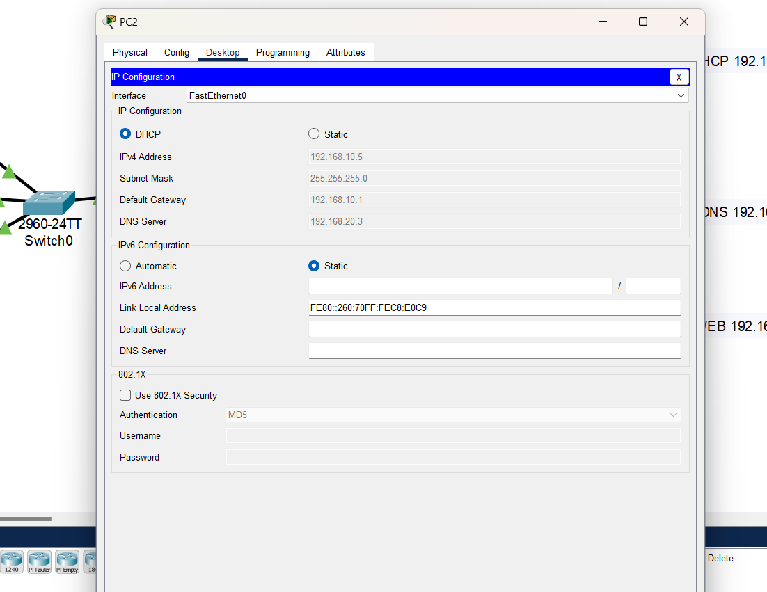**Verification:**

Click in any one PC select desktop tab select web browser and then enter tek.com.np then you will get the following response from the Web server after resolving domain name tek.com.np into ip address 192.168.20.14 by the DNS server.

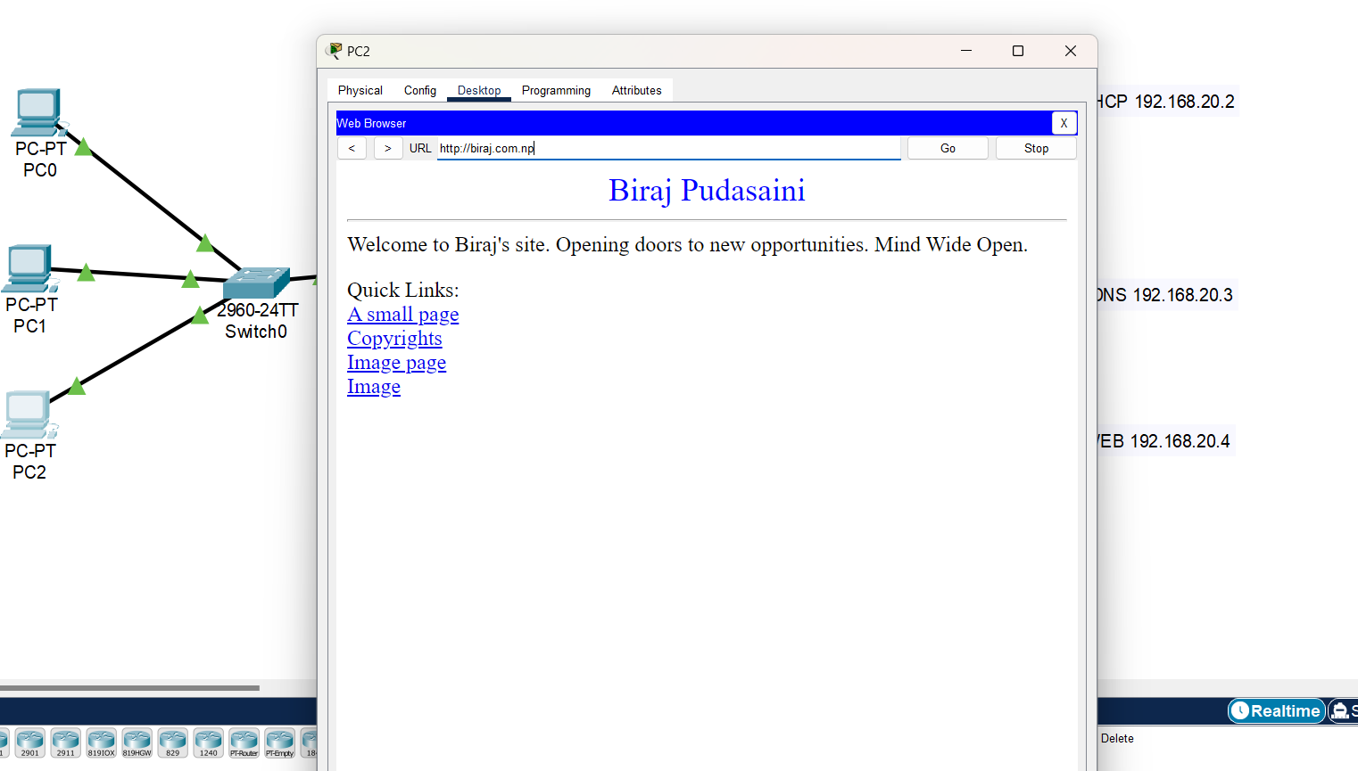

# Conclusion:

The experiment successfully demonstrated the setup and interplay of DHCP, DNS, and a web server within the network. By configuring and implementing these services, we observed their seamless collaboration. DHCP efficiently assigned IP addresses to devices, while DNS resolved domain names to IP addresses, enabling smooth communication. The web server, accessed via HTTP, facilitated resource retrieval and transfer. This experiment illustrates the integral role of DHCP, DNS, and HTTP in network connectivity, highlighting their interconnectedness and importance in establishing a functional network environment.