
IIT JAMMU SUMMER SCHOOL 2026
IoT & Drones Program
ASSIGNMENT REPORT
Assignment: Fundamentals of Drones and UAV Systems

Name: | Abhishek Tandon
Roll No : | IOT045
Course : | IOT and Drones Program
Submission Date: | August 2, 2026

Q1. What is a drone (UAV)? Explain its definition, history, and evolution. [5 Marks]

Definition
A drone, formally called an Unmanned Aerial Vehicle (UAV), is an aircraft that flies without a human pilot physically sitting inside it. Instead, it is either controlled remotely by a pilot on the ground using a radio transmitter, or it flies itself using an onboard flight controller that has been pre-programmed with a mission or that reacts autonomously to sensor data. A complete drone system is more accurately called a UAS — an Unmanned Aircraft System — because it includes not just the flying vehicle but also the ground control station, the communication link, and, in many commercial setups, the payload such as a camera or a sensor package.
During the summer school, this distinction between the vehicle (UAV) and the entire operating system (UAS) was one of the first points clarified in the introductory session, since it is often glossed over in casual conversation but matters a great deal in regulatory and engineering documentation.

History and Evolution
The idea of a pilotless aircraft is actually much older than most people assume. The table below traces the major milestones.
Period | Development
1849 | Austrian forces used unmanned balloons loaded with explosives against Venice — an early, crude precursor to the aerial drone.
1917 | The Kettering Bug, an unmanned biplane 'flying bomb', was built for the US Army, guided by a simple pre-set gyroscope and barometer.
1935 | The British De Havilland 'Queen Bee' radio-controlled target aircraft is widely credited with popularising the term 'drone'.
1960s-70s | Reconnaissance UAVs such as the Ryan Firebee were used for aerial surveillance during the Vietnam War.
1980s-90s | Israel pioneered small, cheap, real-time-video UAVs, influencing designs such as the US RQ-2 Pioneer.
2000s | Military UAVs like the Predator and Global Hawk matured; GPS and better batteries made longer, more autonomous flight possible.
2010 onward | Consumer multirotor drones (DJI Phantom series, Parrot AR.Drone) brought GPS-stabilised flight to hobbyists and professionals.
2020s | Drones became mainstream tools in agriculture, delivery, mapping, cinematography and defence, with AI-based autonomy, swarming and BVLOS (Beyond Visual Line of Sight) operations becoming active research areas.

What stood out during our discussion of this history was how closely drone evolution has tracked three enabling technologies: cheaper and more powerful microcontrollers, lighter Li-Po batteries, and MEMS (Micro-Electro-Mechanical Systems) sensors. Without small, inexpensive accelerometers and gyroscopes, none of today's palm-sized stabilised drones would exist — a point that connects directly to the sensor discussion later in this report.

Q2. List at least five real-world applications of drones. [5 Marks]

Drones are no longer confined to hobbyist flying fields; they are now working tools across a wide range of industries. Five of the most significant applications are discussed below, each with a concrete example.

1. Agriculture
Drones fitted with multispectral cameras fly over farmland to assess crop health, detect water stress and identify pest-infested patches long before they are visible to the naked eye. Spraying drones can then apply pesticide or fertiliser only where it is needed, cutting chemical usage significantly compared to blanket spraying.

2. Disaster Management
After earthquakes, floods, or landslides, drones are flown over affected areas to create real-time maps for rescue teams, locate stranded survivors using thermal cameras, and check the structural safety of buildings before humans enter them. During the discussion on this topic, the instructor referenced how thermal-imaging drones were used in flood-relief operations to spot people trapped on rooftops at night.

3. Delivery and Logistics
Companies such as Zipline use fixed-wing drones to deliver blood and medical supplies to remote clinics in Rwanda and Ghana, while companies like Amazon and Wing have piloted multirotor delivery for small consumer packages. Medical delivery is particularly powerful in hilly or flood-prone regions where road transport is slow or impossible.

4. Surveying and Mapping
Construction and mining companies use drones with high-resolution cameras and LiDAR to generate accurate 3D terrain models and orthomosaic maps, which used to take ground survey teams days to produce manually. This is one of the fastest-growing commercial uses of drones in India today.

5. Defence and Border Surveillance
Military and paramilitary forces use UAVs ranging from small hand-launched reconnaissance drones to large systems for continuous border surveillance, target acquisition, and, in some cases, precision strikes. India's use of UAVs for high-altitude Himalayan border monitoring is a commonly cited example.
Other notable applications worth mentioning briefly include forest and wildlife monitoring (tracking deforestation and poaching), film and event cinematography, powerline and pipeline inspection, and drone-based crowd or traffic monitoring during large public events.

Q3. Differentiate between: (a) UAV and Drone, (b) Fixed-wing and Multirotor drones, (c) Quadcopter and Hexacopter. [10 Marks]

(a) UAV vs Drone
In everyday conversation the two words are used interchangeably, but there is a subtle technical difference. UAV (Unmanned Aerial Vehicle) is the formal engineering and regulatory term for any aircraft that flies without an onboard human pilot — it is used in official documents, FAA/DGCA regulations, and research papers. 'Drone' is the popular, informal term for the same thing, and is generally used for smaller UAVs, particularly multirotor ones. Strictly speaking, a UAV is just the flying vehicle, whereas a UAS (Unmanned Aircraft System) refers to the vehicle plus its ground control station and communication link — the drone in the box on a shop shelf is technically a UAS.

(b) Fixed-Wing vs Multirotor Drones
Parameter | Fixed-Wing Drone | Multirotor Drone
Lift generation | Airflow over a wing (like an aeroplane) | Multiple spinning propellers
Flight endurance | Long (hours) — efficient at cruise | Short (15-40 min) — hovering is power-hungry
Hovering capability | Cannot hover in place | Can hover precisely in one spot
Take-off / landing | Needs a runway or launcher, or belly-lands | Vertical take-off and landing (VTOL)
Typical use | Large-area mapping, long-range surveillance | Photography, inspection, delivery, agriculture
Mechanical complexity | Simpler propulsion, but needs a runway | More motors, but far more manoeuvrable

(c) Quadcopter vs Hexacopter
Parameter | Quadcopter | Hexacopter
Number of rotors | 4 | 6
Redundancy | Loss of one motor is usually fatal (uncontrollable) | Can often still land safely if one motor fails
Payload capacity | Lower — suited to lighter cameras/sensors | Higher — can lift heavier professional cameras or LiDAR
Cost & complexity | Cheaper, simpler electronics and fewer ESCs | Costlier, more ESCs and wiring, heavier frame
Typical application | Hobbyist and light commercial photography | Professional cinematography, heavy-lift industrial survey
During the lab sessions we were shown an actual hexacopter frame alongside a quadcopter frame, and the difference in build quality and redundancy wiring was immediately obvious once the arms were counted and the motor-to-ESC wiring was traced by hand.

Q4. Explain how a quadcopter flies. Include lift, thrust, gravity, drag, propeller rotation, and clockwise (CW) / counter-clockwise (CCW) motors. Draw a neat diagram. [10 Marks]

A quadcopter stays airborne by constantly balancing four physical forces against each other: lift, thrust, gravity and drag. Understanding how these interact is the foundation for everything else in drone flight.

The Four Forces
- Lift: Generated when the propellers spin and push air downward. By Newton's third law, the air pushes back on the propeller with an equal and opposite upward force. Lift must exceed the drone's weight for it to climb, and must equal weight for a stable hover.
- Gravity (Weight): The constant downward pull on the drone's mass. It never changes in flight (barring fuel/battery mass loss, which is negligible for electric drones), so lift is the only force the pilot/controller can actively vary to counter it.
- Thrust: The forward-directed component of propeller force. On a multirotor, thrust in the horizontal direction is achieved not by a separate propulsion system but by tilting the whole drone (pitching forward), which redirects part of the lift force forward.
- Drag: Air resistance opposing the drone's motion, acting opposite to the direction of travel. Drag increases with speed and frontal area, and is why drones need extra power to fly fast or in windy conditions.
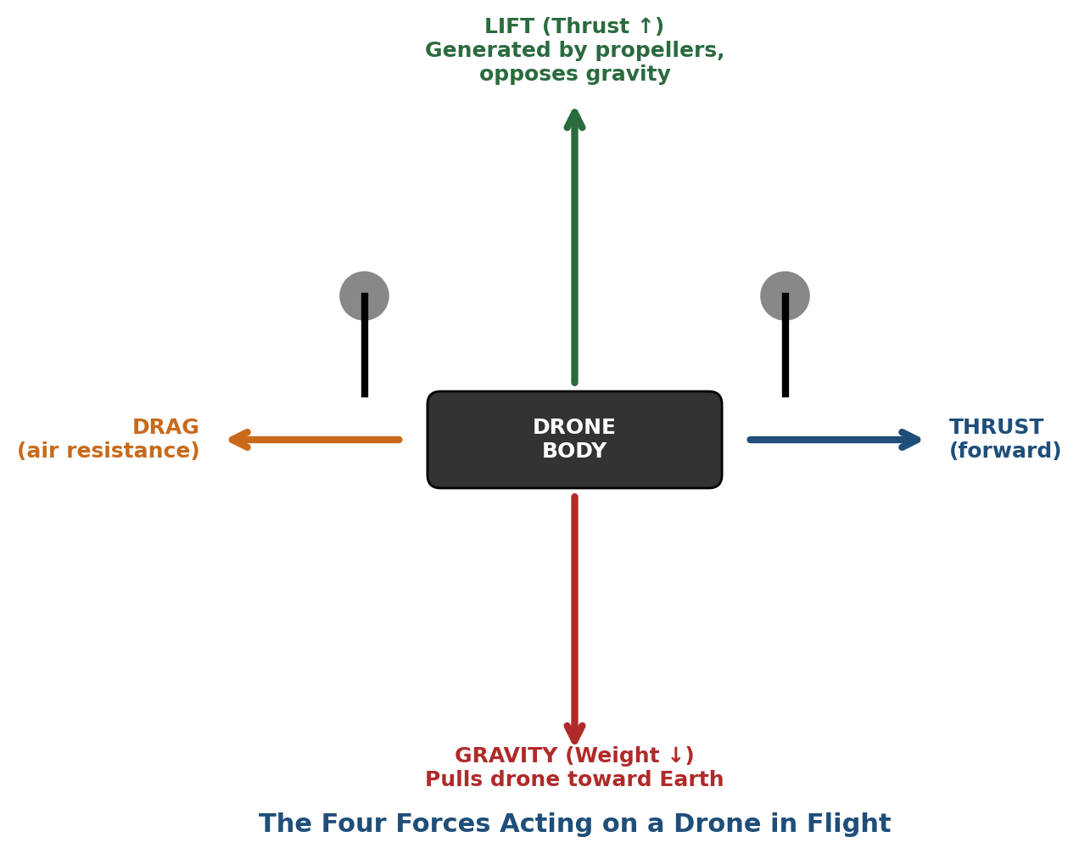
Figure 4.1 — The four forces acting on a drone in flight: lift, gravity, thrust and drag.

Propeller Rotation: Why CW and CCW Matter
Every spinning propeller creates a reactive torque on the drone body in the opposite direction to its spin, exactly the way a helicopter needs a tail rotor to stop the fuselage from spinning. A quadcopter solves this problem elegantly without needing a tail rotor at all: two of its four motors spin clockwise (CW) and the other two spin counter-clockwise (CCW), arranged diagonally opposite each other. Because the reactive torques from the CW pair and the CCW pair cancel out when all four motors run at equal speed, the drone body stays rotationally still even though every individual propeller is spinning fast.
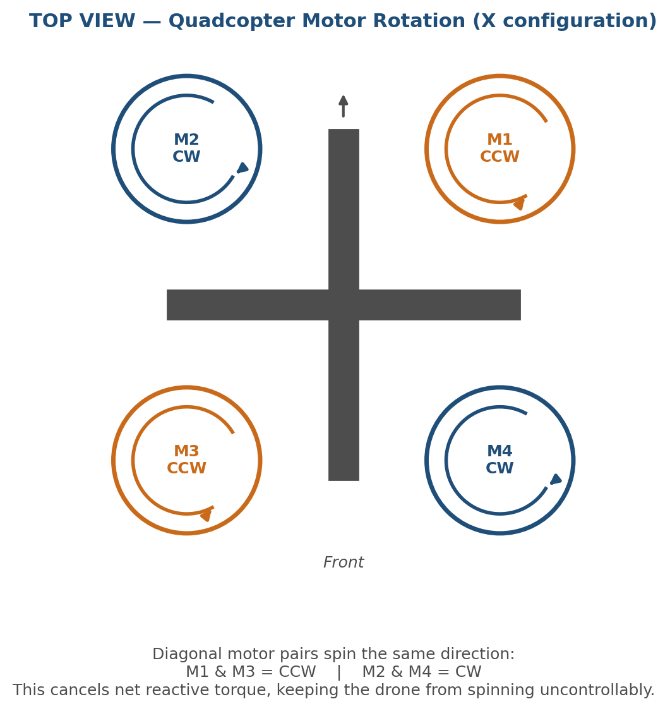
Figure 4.2 — Top view of a quadcopter showing diagonal CW/CCW motor pairing.
This single design detail is also what allows the drone to yaw (rotate about its vertical axis) on command — by deliberately speeding up the CW pair and slowing the CCW pair (or vice versa), the reactive torques no longer cancel, and the whole airframe rotates in the direction of the stronger torque. During the lab demonstration, spinning a hand-held propeller and feeling the reaction force in the wrist made this idea of 'reactive torque' click far more than reading about it ever did.

Q5. Explain how a drone performs take-off, landing, hovering, move forward, move backward, move left, move right, and rotate (yaw). Use suitable diagrams. [10 Marks]
A drone performs every manoeuvre by changing the relative RPM of its four (or more) motors. The flight controller translates a single stick movement from the pilot into four separate, precisely calculated motor commands, dozens of times per second. Each basic manoeuvre is explained below along with the underlying motor logic.
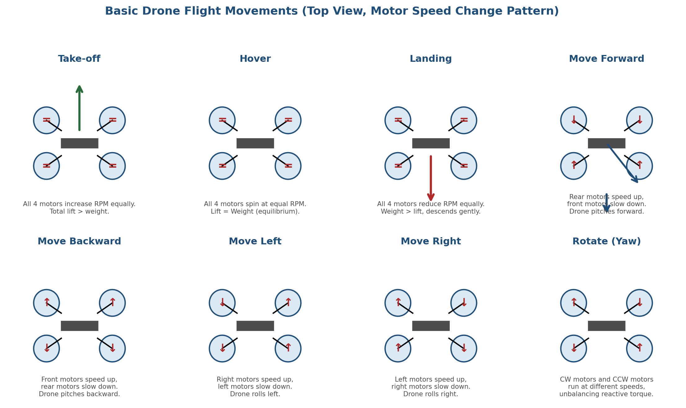
Figure 5.1 — Motor speed pattern for each basic drone manoeuvre (top view).
Manoeuvre | What Happens | Motor Logic
Take-off | Drone lifts off the ground vertically. | All four motors increase RPM equally until total lift exceeds weight.
Hover | Drone holds a fixed position and altitude. | All four motors spin at an equal, steady RPM so lift exactly balances weight.
Landing | Drone descends and touches down gently. | All four motors reduce RPM equally, so weight slightly exceeds lift for a slow, controlled descent.
Move Forward | Drone translates forward while staying level in yaw. | Rear motors speed up and front motors slow down, tilting (pitching) the nose down so a component of lift now points forward.
Move Backward | Drone translates backward. | Front motors speed up, rear motors slow down, pitching the tail down.
Move Left | Drone translates sideways to the left. | Right-side motors speed up, left-side motors slow down, rolling the drone left.
Move Right | Drone translates sideways to the right. | Left-side motors speed up, right-side motors slow down, rolling the drone right.
Rotate (Yaw) | Drone spins about its own vertical axis without translating. | CW motor pair and CCW motor pair are driven at different speeds, unbalancing reactive torque so the airframe rotates.
An important nuance covered during the flight-controller session is that a real drone rarely performs a 'pure' translation — pitching forward to move forward, for instance, also tends to reduce vertical lift slightly, so the flight controller compensates by raising the overall throttle of all four motors a little at the same time. This is one of the reasons PID tuning (covered in Q13) is not trivial: the controller has to solve several coupled corrections simultaneously, several hundred times a second.

Q6. Draw a labeled block diagram of a drone and explain the function of each component: flight controller, ESC, brushless motors, propellers, battery, power distribution board, GPS module, radio receiver, frame, telemetry module. [10 Marks]

The diagram below shows how the major hardware blocks of a quadcopter are wired together, followed by a short description of each block's function.
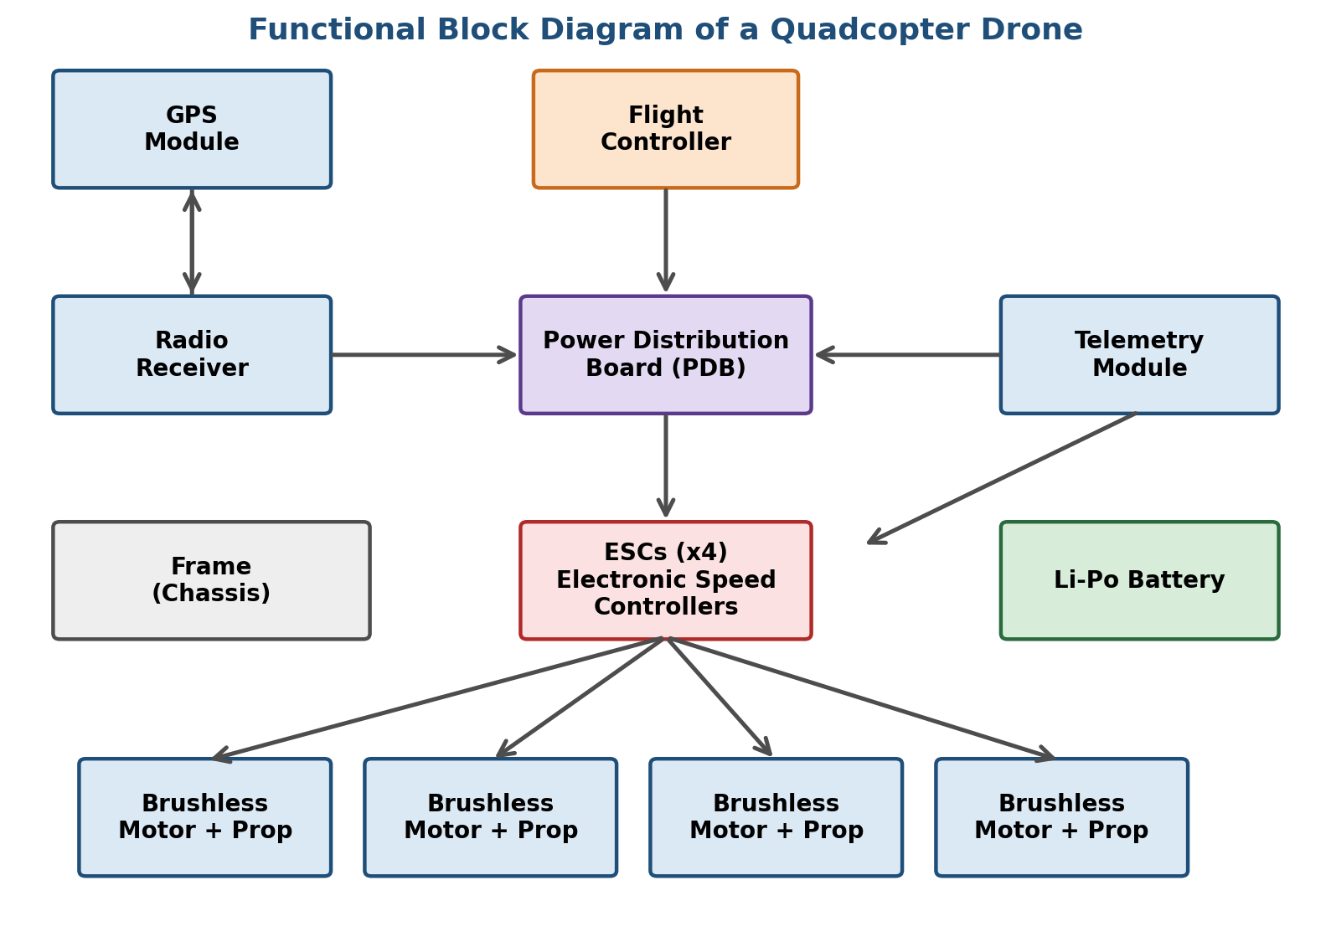
Figure 6.1 — Functional block diagram of a quadcopter drone.
Component | Function
Flight Controller | The 'brain' of the drone. Reads sensor data (IMU, GPS, barometer), runs the PID stabilisation loop, and sends corrected speed commands to each ESC many times per second.
ESC (Electronic Speed Controller) | Converts the flight controller's low-power digital signal into the high-current three-phase power needed to drive a brushless motor at a precise speed.
Brushless (BLDC) Motors | Spin the propellers. Chosen over brushed motors for higher efficiency, less heat, and much longer service life.
Propellers | Convert motor rotation into airflow, generating the lift and reactive torque discussed in Q4.
Battery (Li-Po) | Supplies electrical energy to the entire system; sized in mAh (capacity) and C-rating (max safe discharge current).
Power Distribution Board (PDB) | Distributes battery power from a single connector to all four ESCs and to the flight controller, often with built-in voltage regulation for low-power components.
GPS Module | Provides latitude, longitude, and (roughly) altitude, used for position hold, waypoint navigation, and Return-to-Home.
Radio Receiver | Receives the pilot's stick commands from the ground-based radio transmitter and passes them to the flight controller.
Frame (Chassis) | The structural skeleton holding all components in place; must be light yet rigid enough to resist vibration and flex.
Telemetry Module | A separate radio link (distinct from the RC control link) that sends live flight data — battery voltage, GPS position, altitude — back to the ground station.

Q7. Explain the role of the following components: flight controller, ESC, BLDC motor, propeller, Li-Po battery, GPS, radio transmitter, frame, battery eliminator circuit (BEC), telemetry module. [10 Marks]

This question overlaps with Q6 but asks for a more detailed, component-by-component explanation, including two components not covered above: the radio transmitter and the Battery Eliminator Circuit (BEC).

Flight Controller
A small circuit board built around a microcontroller (or a more powerful microprocessor on advanced systems) that fuses data from the onboard sensors and runs the stabilisation algorithm. It is the single most important part of the drone — everything else exists to either feed it information or execute its commands.

ESC (Electronic Speed Controller)
Sits between the battery/PDB and each motor. It takes a PWM (or digital protocol such as DShot) signal from the flight controller and switches battery current through the motor windings in the correct sequence and at the correct rate to achieve the requested RPM.

BLDC Motor
A brushless DC motor uses electromagnets on the stator and permanent magnets on the rotor; the ESC electronically commutates the current (switches which coil is energised) instead of using physical brushes. This removes the friction and sparking associated with brushed motors, giving higher efficiency and a much longer lifespan.

Propeller
A pair (or more) of angled blades that convert the motor's rotational energy into thrust. Propeller size and pitch are chosen to match the motor's power and the drone's weight — too large a propeller overloads the motor, too small under-utilises it.

Li-Po Battery
Lithium-Polymer batteries are used because of their high energy density and high discharge rate (C-rating), which lets them supply the large, sudden bursts of current a drone's motors demand during fast manoeuvres. This is discussed further in the Higher-Order Thinking Questions section.

GPS Module
Continuously triangulates the drone's position from satellite signals, enabling position-hold, autonomous waypoint missions, and the automatic Return-to-Home safety feature.

Radio Transmitter
The handheld unit the pilot uses; it converts stick and switch movements into a radio signal that is broadcast to the drone's receiver, typically on the 2.4 GHz band.

Frame
Provides the mechanical structure. Frame material (carbon fibre, aluminium, plastic) is chosen as a trade-off between weight, rigidity, and cost; a frame that flexes too much introduces vibration noise into the IMU readings.

Battery Eliminator Circuit (BEC)
A small voltage regulator, often built into the ESC or PDB, that steps the main battery voltage (often 3S–6S Li-Po, i.e. 11.1V–22.2V) down to the 5V (or lower) needed by the flight controller, receiver, camera, and other low-voltage electronics — 'eliminating' the need for a separate small battery for those components, hence the name.

Telemetry Module
A dedicated low-bandwidth radio link (commonly on 433 MHz or 915 MHz) that streams flight status data to the ground station software, separate from the main RC control channel, so the pilot always has visibility into battery level, GPS lock, and altitude even during autonomous missions.

Q8. Explain the working principle and application of IMU, accelerometer, gyroscope, magnetometer, barometer, GPS, optical flow sensor, ultrasonic sensor, LiDAR, and camera. For each sensor mention purpose, working principle, and application. [10 Marks]
A drone is only as stable as the sensors feeding its flight controller. During the sensor-fusion lab session we worked through each of these sensors individually before seeing how their outputs are blended together, and that order of learning is followed here as well.
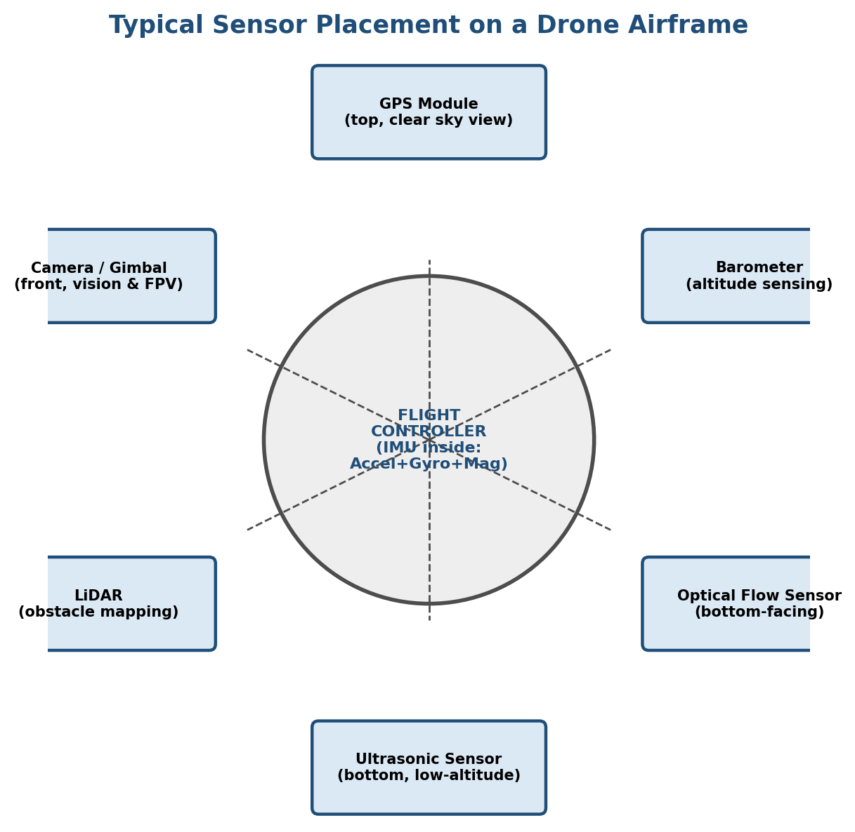
Figure 8.1 — Typical placement of sensors on a drone airframe.

IMU (Inertial Measurement Unit)
Purpose: The core stabilisation sensor package, usually combining an accelerometer and a gyroscope (and often a magnetometer) on a single chip.
Working principle: MEMS structures physically deflect under acceleration or rotation, and this tiny deflection changes a capacitance or piezoresistance that is converted into an electrical signal.
Application: Provides the raw orientation and motion data the flight controller needs to run its stabilisation loop, hundreds of times per second.

Accelerometer
Purpose: Measures linear acceleration along the X, Y and Z axes, including the constant 1g of gravity when stationary.
Working principle: A MEMS proof-mass suspended by tiny springs shifts position under acceleration, changing a measurable capacitance.
Application: Used to estimate tilt angle (roll/pitch) when combined with gravity as a reference, and to detect sudden movements or impacts.

Gyroscope
Purpose: Measures angular velocity (rate of rotation) about each axis.
Working principle: MEMS gyroscopes use the Coriolis effect — a vibrating mass, when rotated, experiences a secondary vibration proportional to the rotation rate, which is picked up electrically.
Application: Provides fast, short-term rotation data essential for real-time stability correction; it drifts slowly over time, which is why it is fused with the accelerometer and magnetometer.

Magnetometer
Purpose: Senses the Earth's magnetic field to determine heading (compass direction).
Working principle: Measures the strength and direction of the ambient magnetic field along three axes, typically using the Hall effect or magneto-resistive elements.
Application: Corrects the slow long-term yaw drift that a gyroscope alone would accumulate, and provides absolute heading for navigation.

Barometer
Purpose: Estimates altitude.
Working principle: Measures ambient air pressure, which decreases predictably with height, and converts the pressure reading into an altitude estimate using the barometric formula.
Application: Used for altitude-hold; because pressure sensors are sensitive to propeller-wash and wind gusts, their reading is usually smoothed and fused with GPS altitude and accelerometer data.

GPS (Global Positioning System)
Purpose: Provides absolute horizontal position (and rough altitude) anywhere with a clear sky view. Working principle: Calculates position by measuring the time delay of radio signals from multiple satellites (trilateration). Application: Position-hold, waypoint navigation, Return-to-Home, and geofencing.

Optical Flow Sensor
Purpose: Estimates horizontal velocity and helps hold position, especially indoors or at low altitude where GPS is unreliable.
Working principle: A small downward-facing camera captures successive frames of the ground and calculates how much the image has shifted between frames, similar to how an optical mouse tracks movement on a desk.
Application: Indoor and low-altitude position hold, often paired with an ultrasonic sensor for height reference.

Ultrasonic Sensor
Purpose: Measures short-range distance to the ground or an obstacle.
Working principle: Emits a high-frequency sound pulse and measures the time taken for the echo to return, then converts that time into distance using the known speed of sound.
Application: Precise low-altitude height-hold and basic obstacle detection, though it has a short effective range (a few metres).

LiDAR (Light Detection and Ranging)
Purpose: Builds a precise, high-resolution 3D map of the surrounding environment.
Working principle: Emits rapid laser pulses and measures the time-of-flight for each pulse's reflection, generating a dense point-cloud of distances.
Application: Obstacle avoidance, terrain-following surveys, and forestry/mining volumetric mapping, where centimetre-level accuracy matters.

Camera
Purpose: Captures visual imagery for photography, mapping, inspection, or computer-vision-based navigation.
Working principle: A CMOS or CCD image sensor converts incoming light into a digital image.
Application: Aerial photography and videography, orthomosaic mapping, and, increasingly, onboard object detection for autonomous obstacle avoidance and tracking.

Q9. Compare: (a) GPS vs Optical Flow, (b) LiDAR vs Ultrasonic, (c) Gyroscope vs Accelerometer. [5 Marks]

(a) GPS vs Optical Flow
Parameter | GPS | Optical Flow
Works indoors | No — needs clear sky view | Yes — works well indoors given adequate lighting
Reference frame | Absolute (latitude/longitude) | Relative (drift-corrected motion only)
Accuracy at low altitude | Poor (a few metres) | Very good (centimetres) close to the ground
Typical use | Outdoor waypoint missions, RTH | Indoor/close-proximity position hold

(b) LiDAR vs Ultrasonic
Parameter | LiDAR | Ultrasonic
Sensing medium | Laser (light) pulses | Sound pulses
Range | Long (tens to hundreds of metres) | Short (a few metres)
Resolution / detail | High — builds dense 3D point clouds | Low — single distance value
Cost & power | Expensive, higher power draw | Cheap, low power
Typical use | Detailed obstacle mapping, terrain survey | Simple low-altitude height-hold

(c) Gyroscope vs Accelerometer
Parameter | Gyroscope | Accelerometer
Measures | Angular velocity (rate of rotation) | Linear acceleration (including gravity)
Short-term accuracy | Excellent — very responsive | Good, but sensitive to vibration/noise
Long-term accuracy | Drifts over time | Stable reference via gravity, but noisy instantaneously
Primary role in fusion | Fast tilt-rate correction | Slow tilt-angle reference to correct gyro drift
A recurring theme across all three comparisons is that no single sensor is good enough on its own — every practical flight controller fuses at least two or three complementary sensors to cancel out each one's individual weakness, which is exactly the idea behind sensor fusion covered in the flight-controller architecture discussion (Q8, Q13).

Q10. Explain the concept of 6 Degrees of Freedom (6DOF). Include translation, rotation, X-axis, Y-axis, Z-axis. Draw suitable diagrams. [5 Marks]
Six Degrees of Freedom describes the six independent ways a rigid body can move in three-dimensional space: three translational movements (moving along an axis) and three rotational movements (rotating about an axis). A drone, being free to move through open air rather than constrained to a road or track, is a classic example of a 6-DOF system, and this is precisely why controlling it is much harder than controlling a car, which effectively has only 1-2 degrees of freedom.
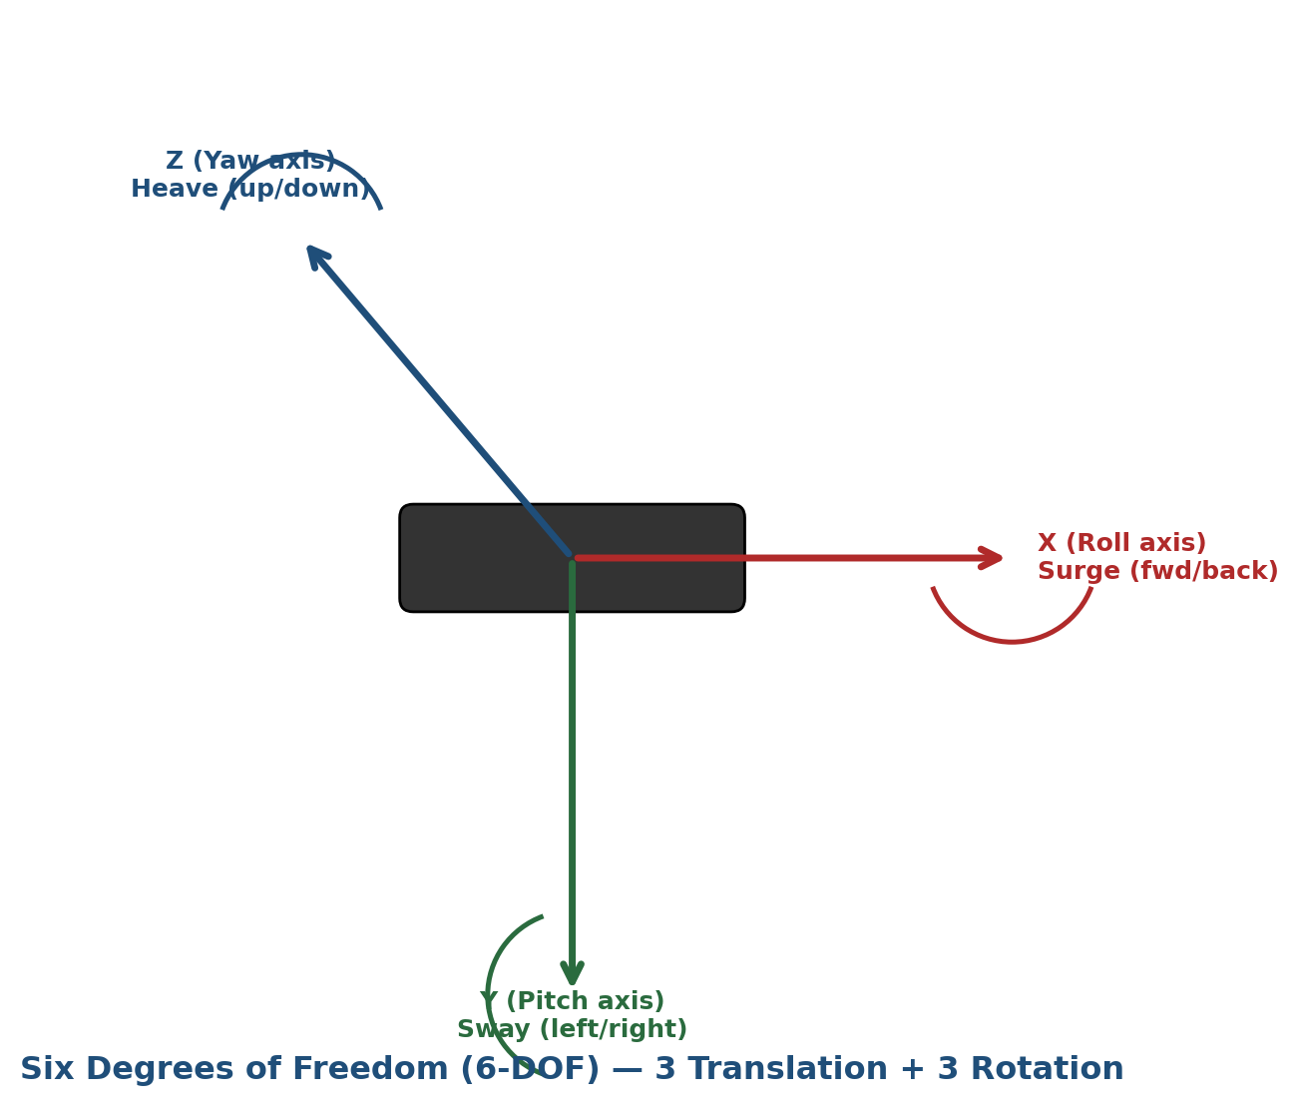
Figure 10.1 — The six degrees of freedom of a drone: three translations and three rotations.

Translation (Linear Movement)
- X-axis: Forward / backward movement (also called surge).
- Y-axis: Left / right movement (also called sway).
- Z-axis: Up / down movement (also called heave).

Rotation (Angular Movement)
- Rotation about X-axis: Roll — tilting one wing up and the other down.
- Rotation about Y-axis: Pitch — tilting the nose up or down.
- Rotation about Z-axis: Yaw — rotating left or right about the vertical axis while remaining level.
A flight controller must estimate and control all six of these simultaneously, in real time, using the fused sensor data described in Q8 — which is precisely why the PID control loop discussed in Q13 has to run so many times per second.

Q11. Explain roll, pitch, yaw, surge, sway, and heave with examples of each movement in a drone. [10 Marks]
These six terms are simply the named rotational and translational components of the 6-DOF motion introduced in Q10. Each is explained below with a concrete in-flight example.
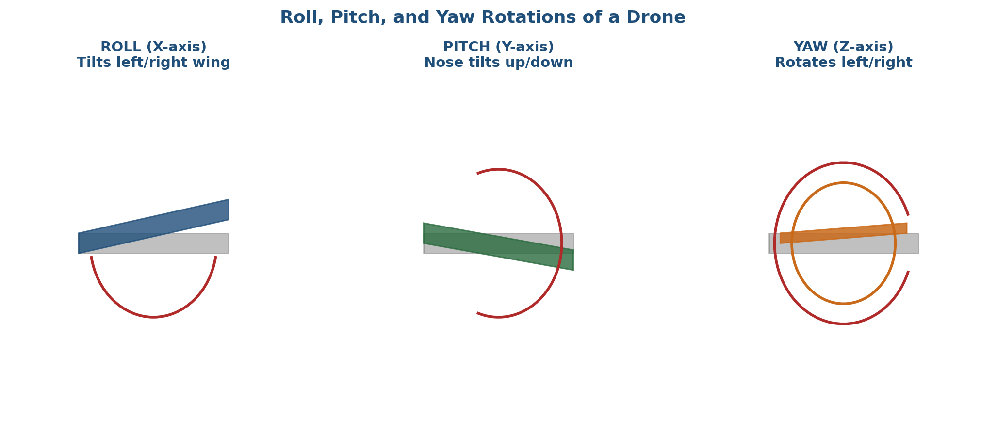
Figure 11.1 — Roll, pitch and yaw rotations shown from the top/front view.
Term | Type of Motion | In-Flight Example
Roll | Rotation about the X (front-to-back) axis | The drone tilts its left side down and right side up to move sideways to the left, as seen when strafing around an obstacle.
Pitch | Rotation about the Y (side-to-side) axis | The drone dips its nose down to accelerate forward, exactly like leaning forward on a bicycle to speed up.
Yaw | Rotation about the Z (vertical) axis | The drone rotates in place to point its front-facing camera at a different subject without changing its actual position.
Surge | Translation along the X-axis | The drone physically moves forward through the air, e.g. flying from one waypoint to the next.
Sway | Translation along the Y-axis | The drone drifts sideways, e.g. correcting its position after being pushed by a gust of crosswind.
Heave | Translation along the Z-axis | The drone climbs to gain altitude to clear a tree line, or descends to land.

During the practical simulator session, isolating each of these motions one at a time — for instance holding the drone in a pure yaw rotation without letting it drift sideways — turned out to be noticeably harder in manual mode than it sounds, precisely because a small stick input on one axis often bleeds slightly into another due to the coupled aerodynamics discussed in Q5.

Q12. Explain the complete signal flow in a drone: Pilot Input to Radio Transmitter to Receiver to Flight Controller to ESC to BLDC Motors to Propellers to Drone Movement. Illustrate with a block diagram. [5 Marks]
Every action a drone takes, from the moment a pilot nudges a stick to the moment the drone visibly moves, passes through a well-defined chain of hardware stages. This chain is shown below and then explained stage by stage.
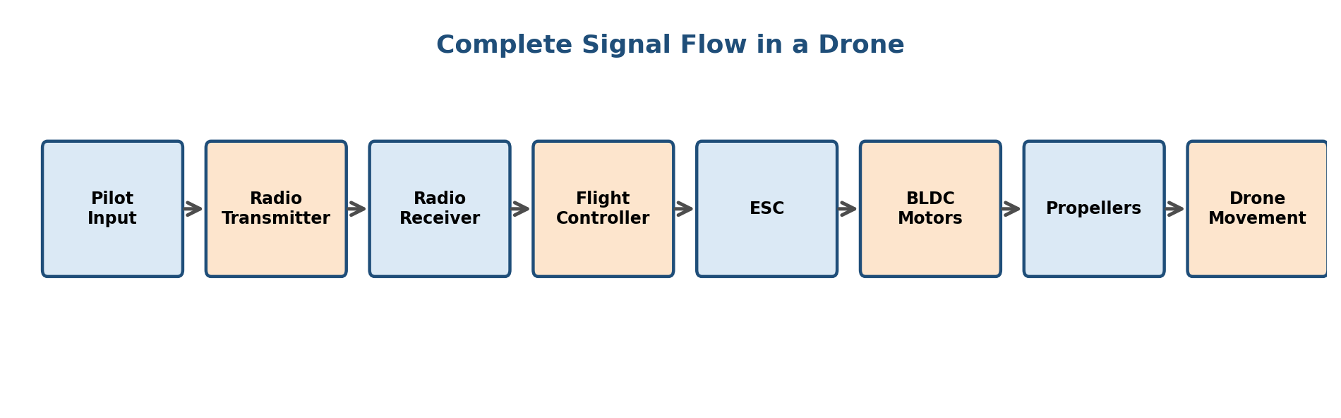
Figure 12.1 — Complete signal flow from pilot input to drone movement.
- Pilot Input: The pilot moves a stick or switch on the handheld controller (e.g., pushing the throttle stick up).
- Radio Transmitter: Converts this stick movement into a digital radio signal and broadcasts it, typically on 2.4 GHz.
- Radio Receiver: Mounted on the drone, it picks up the transmitted signal and decodes it back into channel values.
- Flight Controller: Reads the receiver's channel values as the pilot's intent, combines this with fused sensor data (Q8), runs the PID loop (Q13), and calculates the exact speed each motor needs to run at.
- ESC: Receives the flight controller's per-motor speed command and converts it into the correct high-current three-phase drive signal.
- BLDC Motors: Spin at the commanded RPM in response to the ESC's drive signal.
- Propellers: Convert the motor's rotation into airflow and hence lift/thrust.
- Drone Movement: The net force and torque from all four propellers produces the drone's actual physical motion — climbing, tilting, or rotating, as intended by the original stick input.
What is notable about this chain, as emphasised during the lab walkthrough, is how much happens between steps 4 and 7 — a single throttle nudge is silently translated into four independently-tuned motor commands, all within a few milliseconds, without the pilot ever being aware of the underlying computation.

Q13. Why is PID control important in drones? Explain the proportional, integral, and derivative terms. [5 Marks]

A drone is inherently unstable — left alone with all four motors at equal, fixed speed, tiny manufacturing imperfections, a gust of wind, or an uneven weight distribution will cause it to drift and eventually flip over. PID (Proportional-Integral-Derivative) control is the algorithm that continuously corrects for this instability, comparing the drone's actual orientation (from the IMU) against the desired orientation, and adjusting motor speeds to close that gap, hundreds of times per second.

The Three Terms
- Proportional (P): Produces a correction directly proportional to the current error — the bigger the tilt, the stronger the immediate correction. Too much P causes aggressive overshoot and oscillation; too little makes the drone sluggish to correct.
- Integral (I): Accumulates the error over time and corrects for small, persistent offsets that the P-term alone cannot fully eliminate — for example, a drone that is slightly nose-heavy will never quite reach a perfectly level pitch on P alone, and the I-term slowly nudges it the rest of the way.
- Derivative (D): Reacts to how fast the error is changing, acting as a 'brake' that dampens the correction as the drone approaches the target orientation, preventing overshoot and oscillation.
In practice, the three terms are combined as a weighted sum, and 'tuning' a drone means finding the right P, I and D gains for that specific airframe, weight, and propeller combination. During the lab session on flight-controller firmware (Betaflight/ArduPilot configuration), we observed how increasing the P-gain too far on a test bench rig caused visible, rapid oscillation in the motors — a very direct, physical demonstration of what 'an unstable PID loop' actually looks like, rather than just an abstract control-theory concept.

Q14. Bonus — Research Questions (Any Two) [10 Marks]

1. Compare DJI, ArduPilot, and PX4 Flight Controllers
DJI, ArduPilot, and PX4 represent three very different philosophies of flight-controller design, and comparing them was one of the more interesting parts of the research component of this assignment.
Parameter | DJI (proprietary) | ArduPilot (open-source) | PX4 (open-source)
Ecosystem type | Closed, tightly integrated hardware+software | Open-source, runs on many hardware boards | Open-source, runs on many hardware boards
Ease of use | Very easy — plug-and-fly consumer experience | Moderate — highly configurable, steeper learning curve | Moderate — modern GUI (QGroundControl) eases setup
Customisation | Limited — locked-down firmware | Extremely high — full source access, huge parameter set | High — modular architecture (uORB messaging)
Typical users | Consumers, commercial photographers | Hobbyists, researchers, agricultural/industrial builds | Academic and industrial R&D, companies needing certification-grade code
Vehicle types supported | DJI's own airframes only | Multirotors, planes, rovers, boats, submarines | Multirotors, planes, VTOL hybrids, rovers

In short, DJI trades flexibility for reliability and ease of use, while ArduPilot and PX4 trade a steeper learning curve for complete control over the flight stack — a distinction that matters a great deal to a researcher who needs to modify low-level control logic versus a photographer who just wants the drone to fly well out of the box.

2. Obstacle Avoidance in Drones
Obstacle avoidance is the capability that lets a drone detect a nearby object and automatically stop, slow down, or reroute around it rather than colliding with it. Modern systems generally combine several of the ranging sensors discussed in Q8: ultrasonic sensors for very short range, LiDAR for detailed medium-range mapping, and stereo or monocular cameras processed with computer-vision algorithms for richer semantic understanding (recognising that an object is, say, a tree branch versus open sky).
The general pipeline works in three stages. First, sensing: the drone continuously scans its surroundings using one or more of the sensors above. Second, mapping: the raw sensor readings are converted into a usable representation, commonly an occupancy grid or a 3D point cloud, that marks which regions of space are free versus blocked. Third, path planning: an algorithm (such as A* or a potential-field method) uses this occupancy map to compute a new, obstacle-free path or simply issues a stop/brake command if the obstacle appears suddenly. High-end consumer drones (DJI's APAS system, for instance) now perform this entire pipeline in real time using multiple stereo camera pairs pointed in different directions, giving near-360-degree awareness.

Q15. Identify and label every component of a real drone or a drone image.
For this practical activity, the option chosen was: identifying and labelling every visible component of a real quadcopter drone. The labelled illustration below is based on the physical drone frame examined during the hands-on lab session at the summer school, cross-checked against the block diagram covered in Q6.
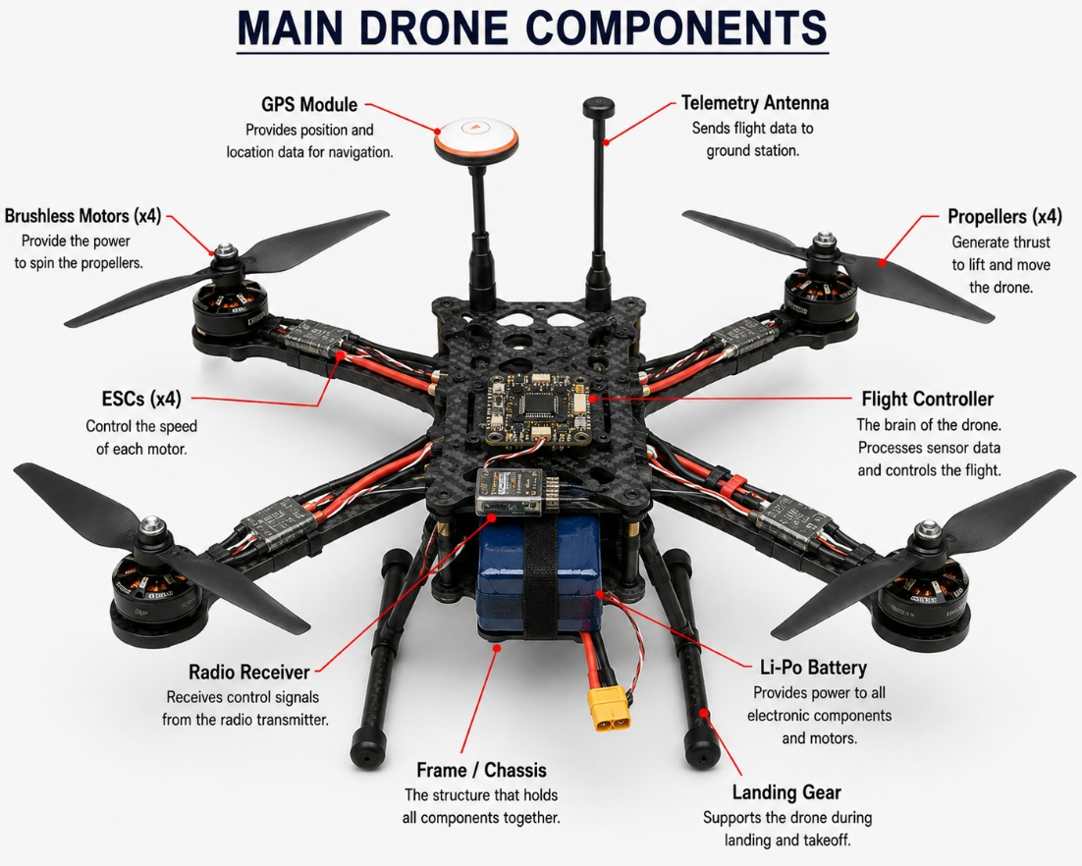
Figure 15.1 — Labelled component diagram of a quadcopter drone, prepared during the practical activity.

Component Descriptions
# | Component | Observed Location / Description
1 | Frame / Chassis | Central carbon-fibre plate holding all electronics; four arms extend diagonally to the motors.
2 | Brushless Motors (x4) | Mounted at the tip of each arm; two spin CW and two spin CCW as covered in Q4.
3 | Propellers (x4) | Snap-fit onto each motor shaft; paired CW/CCW propellers are marked differently to avoid incorrect fitting.
4 | ESCs (x4) | Small boards mounted just under each arm, close to the motor to minimise power-cable length.
5 | Flight Controller | Centre of the frame, mounted on soft rubber grommets to isolate it from frame vibration.
6 | GPS Module | Raised on a small mast above the frame to keep it clear of electromagnetic interference from the power wiring below.
7 | Li-Po Battery | Slung underneath the frame on a velcro strap, positioned close to the centre of gravity.
8 | Radio Receiver | Small unit near the rear of the frame with a short whip antenna.
9 | Telemetry Antenna | Mounted vertically for the best radio range back to the ground station.
10 | Landing Gear | Fixed legs beneath the rear arms, giving ground clearance for the battery and camera gimbal.

Observations
- The GPS module is deliberately placed as far away from the power distribution wiring as possible — during the session it was pointed out that placing it too close causes magnetic interference that shows up as erratic heading readings.
- The flight controller's rubber vibration mounts are not a cosmetic detail; touching the bare frame during motor spin-up made the difference between a rigid mount and a damped mount immediately obvious as a hand-felt vibration.
- The two propeller types (clockwise-rated and counter-clockwise-rated) are physically different in blade pitch direction, and fitting them on the wrong motor was shown to produce almost no lift at all when spun — a very quick, memorable way to understand why CW/CCW pairing (Q4) actually matters mechanically and not just electronically.

Conclusion of the Practical Activity
Physically tracing each wire from the battery to the PDB, from the PDB to each ESC, and from each ESC to its motor made the block diagram from Q6 far more concrete than it had been from the diagram alone. It also made clear just how much of a drone's reliability comes down to careful mechanical layout — vibration isolation, cable routing, and antenna placement — rather than firmware alone.

Higher-Order Thinking Questions

1. Why do quadcopters require four motors instead of one?

A quadcopter needs four motors because a single motor cannot keep the drone stable. If only one propeller was used, the body of the drone would start rotating in the opposite direction due to the reaction torque produced by the motor. By using four motors, the drone balances this torque, as two propellers rotate clockwise and the other two rotate counter-clockwise.

Having four motors also allows the flight controller to control roll, pitch, and yaw simply by changing the speed of individual motors. During the summer school, I understood how even a small change in the speed of one motor affects the balance of the entire drone. This showed me why four motors are the minimum requirement for a stable quadcopter.

2. What would happen if one motor stops working during flight?

If one motor suddenly stops during flight, the drone immediately loses its balance because both the lifting force and rotational balance are disturbed. As a result, the quadcopter starts spinning uncontrollably and usually crashes before the flight controller can recover it.

This is one reason why quadcopters are not fault tolerant. During the course, we also learned that drones like hexacopters and octocopters have additional motors, so they can sometimes continue flying even if one motor fails. This made me realize why larger professional drones are preferred for critical applications.

3. Why are brushless motors preferred over brushed motors?

Brushless motors are preferred because they are more efficient, produce less heat, and have a much longer life than brushed motors. Since there are no brushes rubbing against each other, there is very little friction and almost no wear and tear.

They can also rotate at very high speeds while providing better power for their weight, which is very important for drones. Although brushless motors require an Electronic Speed Controller (ESC), the improved performance and reliability make them the best choice. During the summer school, I learned that almost all modern drones use brushless motors because they provide smoother and more stable flight.

4. Can a drone fly indoors without GPS? Explain.

Yes, a drone can fly indoors even without GPS. GPS signals are usually weak or unavailable inside buildings, so drones use other sensors such as optical flow sensors, ultrasonic sensors, barometers, and the IMU to maintain stability and estimate their position.

If these sensors are not available, the drone can still fly in manual mode, but it becomes much more difficult because the pilot has to control the position continuously. During the summer school, I learned that modern drones rely on multiple sensors instead of GPS alone, which allows them to fly safely in indoor environments.

5. Why are Li-Po batteries used in drones instead of standard batteries?

Li-Po batteries are used because they can supply a large amount of power while remaining lightweight. Drone motors require high current during take-off, climbing, and quick movements, and Li-Po batteries are capable of providing this without a significant voltage drop.

Although Li-Po batteries require careful handling because they can be damaged by overcharging or physical impact, their high energy density and discharge capability make them the best option for drones. During the course, I also learned the importance of proper charging and safe handling of Li-Po batteries.

6. What factors reduce a drone's flight time?

Many factors can reduce a drone's flight time. Carrying heavier payloads such as cameras or additional sensors makes the motors work harder and consumes more battery power. Flying in strong winds, performing rapid manoeuvres, and maintaining a hover for long periods also increase energy consumption.

Weather conditions also play an important role. Cold temperatures reduce battery performance, while an ageing battery stores less energy than a new one. During the summer school, I understood that improving flight time is not only about using a bigger battery but also about reducing unnecessary weight and flying efficiently.

7. How can drone stability be improved during strong winds?

Drone stability can be improved by using proper PID tuning so that the flight controller reacts quickly to disturbances caused by wind. A strong frame, powerful motors, balanced propellers, and accurate sensor readings also help maintain stable flight.

Good sensor fusion between the IMU, GPS, and other sensors allows the drone to detect unwanted movement and correct it immediately. During the course, I learned that experienced drone operators also avoid flying when wind speed exceeds the recommended operating limits because software alone cannot overcome extreme weather conditions.

8. Why is sensor fusion important in drones?

No single sensor can provide completely accurate information under all conditions. For example, the gyroscope may drift over time, the accelerometer can be affected by vibrations, and GPS may become inaccurate or unavailable.

Sensor fusion combines data from multiple sensors so that the strengths of one sensor compensate for the weaknesses of another. This gives the flight controller a much more reliable understanding of the drone's position and orientation. During the summer school, I realized that stable flight depends on the combined performance of many sensors rather than relying on just one.

9. Explain how GPS and IMU work together for stable navigation.

The IMU measures acceleration and rotation very quickly, allowing the drone to respond instantly to changes in movement. However, if it is used alone, small measurement errors accumulate over time and reduce accuracy.

GPS provides accurate position information, although it updates more slowly than the IMU. By combining both sensors, the drone gets fast motion information from the IMU while GPS continuously corrects any accumulated errors. During the course, I understood that this combination helps drones navigate accurately over long distances while remaining stable during flight.

10. If you were designing a drone for mountain rescue operations, which sensors and components would you choose, and why?
If I were designing a drone for mountain rescue operations, I would choose a thermal camera to detect people even in darkness or through light vegetation. I would also include LiDAR for obstacle detection, GPS and IMU for navigation, a barometer for accurate altitude measurement, and high-resolution cameras for visual inspection.
For the drone itself, I would use a powerful brushless motor system, a high-capacity Li-Po battery, long-range telemetry, and a reliable flight controller with Return-to-Home capability. Since mountain areas often have difficult terrain and weak GPS signals, combining multiple sensors would make the drone more dependable. Based on what I learned during the IIT Jammu Summer School, I feel that integrating different sensors with a robust flight control system is essential for safe and effective rescue missions.

Conclusion
Working through this assignment made one thing clear that is easy to miss when just watching a drone hover smoothly overhead: nothing about stable flight is automatic or simple. Every calm hover is the visible result of dozens of sensors being read, fused, and corrected against a PID loop many times every second, while a chain of components — receiver, flight controller, ESC, motor, propeller — silently translates a pilot's intention into precise physical motion, as traced out in the signal-flow discussion in Q12.
The summer school's mix of theory sessions and hands-on lab time was what made these ideas stick. Reading about reactive torque is one thing; feeling it in a spinning propeller, or watching a mis-fitted CW propeller fail to generate lift, is what actually built the intuition behind the diagrams in this report. Similarly, the sensor comparisons in Q9 stopped being abstract trade-off tables once we saw, in the lab, how differently a GPS-only setup and an optical-flow-assisted setup behaved when flown indoors.
Looking ahead, the trends discussed briefly in the bonus section — richer obstacle avoidance, open flight-stack ecosystems like PX4 and ArduPilot, and increasingly autonomous mission planning — all point toward drones becoming even more capable of operating safely without constant manual piloting. For applications like mountain rescue, disaster response, and medical delivery, this shift toward reliable autonomy is arguably the single most important direction for the field to keep improving in. This assignment has been a useful checkpoint for consolidating that understanding before moving on to more advanced topics in the program.

References (IEEE Format)
[1] DJI, "DJI Flight Controller and Product Documentation," DJI Official Website. [Online]. Available: https://www.dji.com/support
[2] PX4 Development Team, "PX4 User Guide," PX4 Autopilot Documentation. [Online]. Available: https://docs.px4.io
[3] ArduPilot Dev Team, "ArduPilot Documentation," ArduPilot.org. [Online]. Available: https://ardupilot.org/ardupilot/
[4] National Aeronautics and Space Administration (NASA), "Unmanned Aerial Systems (UAS) Overview," NASA Armstrong Flight Research Center. [Online]. Available: https://www.nasa.gov/uas
[5] Federal Aviation Administration (FAA), "FAA Drone Pilot Ground School and Part 107 Guide," U.S. Department of Transportation. [Online]. Available: https://www.faa.gov/uas
[6] Indian Space Research Organisation (ISRO), "Remote Sensing and Geospatial Applications Publications," ISRO Official Website. [Online]. Available: https://www.isro.gov.in
[7] R. Austin, Unmanned Aircraft Systems: UAVS Design, Development and Deployment. Chichester, U.K.: John Wiley & Sons, 2010.
[8] K. Nonami, F. Kendoul, S. Suzuki, W. Wang, and D. Nakazawa, Autonomous Flying Robots: Unmanned Aerial Vehicles and Micro Aerial Vehicles. Tokyo, Japan: Springer, 2010.
[9] G. Cai, J. Chen, and T. H. Lee, Unmanned Rotorcraft Systems. London, U.K.: Springer-Verlag, 2011.
[10] Directorate General of Civil Aviation (DGCA), India, "Requirements for Operation of Civil Remotely Piloted Aircraft System (RPAS)," Government of India. [Online]. Available: https://www.dgca.gov.in
[11] IIT Jammu Summer School 2026, "IoT and Drones Program — Course Material and Laboratory Sessions," Indian Institute of Technology Jammu (internal program resource).

