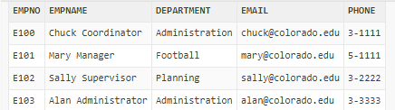

**CREATE TABLE** Employee

(

empno **VARCHAR2(8) PRIMARY KEY NOT NULL**,

empname **VARCHAR2(40) NOT NULL**,

department **VARCHAR2(30) NOT NULL**,

email **VARCHAR2(40) NOT NULL**,

phone **CHAR(6) NOT NULL**

);