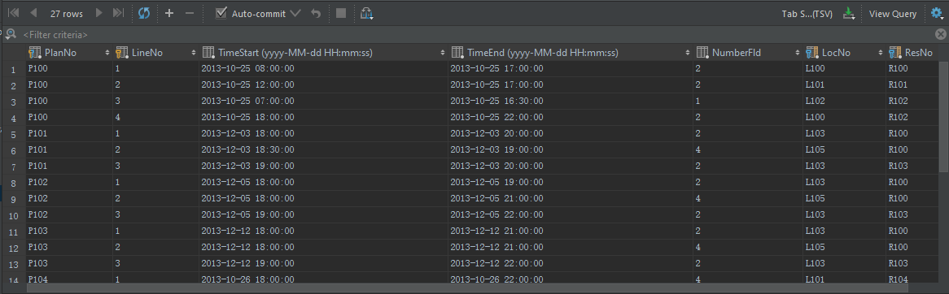

**CREATE TABLE** EventPlanLine  
(  
 PlanNo **CHAR**(8) **NOT NULL**,  
 LineNo **CHAR**(1) **NOT NULL**,  
 TimeStart **DATETIME NOT NULL**,  
 TimeEnd **DATETIME NOT NULL**,  
 NumberFld **INT NOT NULL**,  
 LocNo **CHAR**(8) **NOT NULL**,  
 ResNo **CHAR**(8) **NOT NULL**,  
 **CONSTRAINT** EventPlanLine_location_LocNo_fk **FOREIGN KEY** (LocNo) **REFERENCES** location (LocNo),  
 **CONSTRAINT** EventPlanLine_resourcetbl_ResNo_fk **FOREIGN KEY** (ResNo) **REFERENCES** resourcetbl (ResNo),  
 **CONSTRAINT** EventPlanLine_eventplan_PlanNo_fk **FOREIGN KEY** (PlanNo) **REFERENCES** eventplan (PlanNo),  
 **CONSTRAINT** EventPlanLine_PK **PRIMARY KEY** (PlanNo, LineNo),  
 **CONSTRAINT CHECK** (TimeEnd > TimeStart)  
)