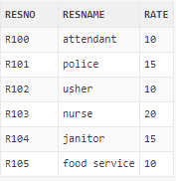

**CREATE TABLE** ResourceTbl

(

resno **VARCHAR2(8) PRIMARY KEY NOT NULL**,

resname **VARCHAR2(30) NOT NULL**,

rate **DECIMAL(8, 2) NOT NULL**,

**CONSTRAINT** check_Rate **CHECK (Rate > 0**)

);