Department of Computer Science and Engineering
Course: CSE447: Cryptography and Cryptanalysis
Semester: Spring 2026
Project Report
Sovereign Guard: Secure System for User Data and Social Posts using RSA/ECC
Submitted To: [Instructor Name]
Group No: [Update]
Section: [Update]
Submission Date: [DD Month YYYY]
Group Members
No. | Full Name | Student ID
1 | [Member 1 Full Name] | [Member 1 Student ID]
2 | [Member 2 Full Name] | [Member 2 Student ID]
3 | [Member 3 Full Name] | [Member 3 Student ID]

Table of Contents
1. Introduction and System Overview 3
2. Login and Registration Module 4
3. User Data Encryption and Decryption 5
4. Password Hashing and Salting 6
5. Two-Factor Authentication (2FA) 7
6. Key Management Module 8
7. Post and Profile Management 9
8. Data Storage Security 10
9. Message Authentication Code (MAC) 11
10. Role-Based Access Control (RBAC) 12
11. Secure Session Management 13
12. GitHub Repository and Project Structure 14
13. Conclusion 15

1. Introduction and System Overview
This report documents the design, implementation, and security analysis of Sovereign Guard, a secure browser-based web application for encrypted account management and encrypted social posts. The system implements multiple cryptographic operations from scratch and demonstrates how user data, profile records, posts, key metadata, and session tokens can be protected even if the application storage is inspected directly.
The application stores encrypted records in browser localStorage so the raw storage can be viewed as evidence. Plaintext user information and social post content are not stored directly. Records are encrypted before storage, verified with a Message Authentication Code before reading, and decrypted only inside the application after successful authorization.

1.1 Project Overview
Sovereign Guard allows users to register, log in with two-factor verification, manage profiles, and create or edit social posts. Administrators have additional authority to view the RBAC admin panel, inspect encrypted user summaries, rotate cryptographic keys, and manage sensitive operations.
- Prevent plaintext access to sensitive user and post data in storage.
- Use salted password hashes instead of storing plaintext passwords.
- Enforce two-step authentication before creating a session.
- Use at least two asymmetric algorithms: RSA for user/profile data and ECC for post data.
- Verify data integrity with HMAC before decryption and display.
- Restrict sensitive operations through role-based access control.
- Protect session tokens with signature, MAC, expiry time, and sessionStorage.

1.2 Technology Stack
Layer | Technology / Approach
Frontend | HTML5, CSS3, JavaScript
Storage | Browser localStorage for encrypted demo database
Session Store | Browser sessionStorage
RSA | From-scratch JavaScript BigInt implementation
ECC | From-scratch elliptic-curve point arithmetic and EC-ElGamal-style encryption
Hashing | SHA-256 implemented from scratch
MAC | HMAC-SHA256 implemented from scratch
External crypto libraries | None

1.3 System Architecture Diagram
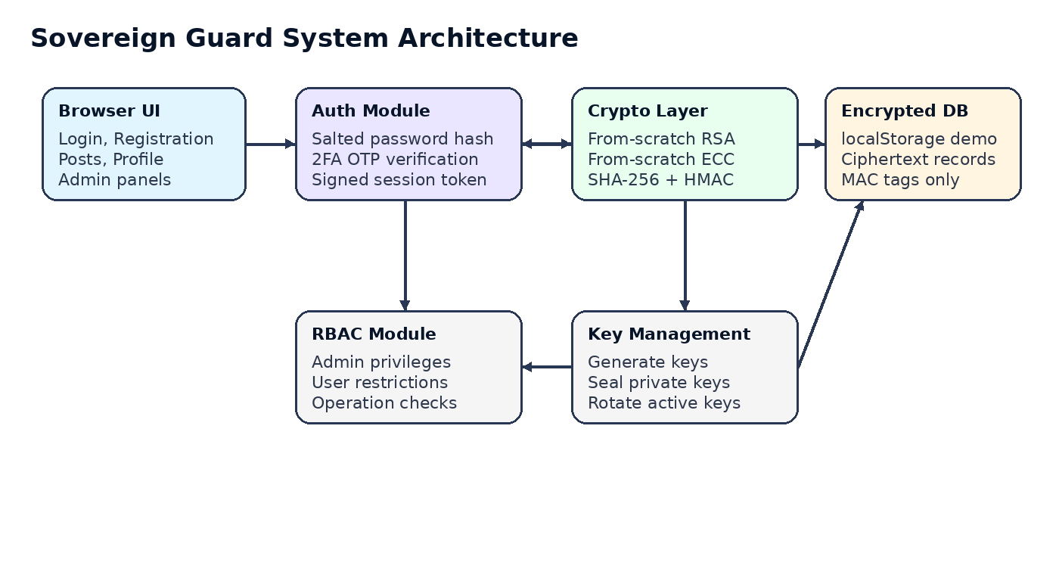
Figure 1: System architecture and data flow.

2. Login and Registration Module
The system provides secure registration and login flows. During registration, user profile fields are encrypted before storage. During login, stored encrypted user identifiers are decrypted only inside the application for credential matching. Passwords are never decrypted because they are not encrypted; they are salted and hashed.
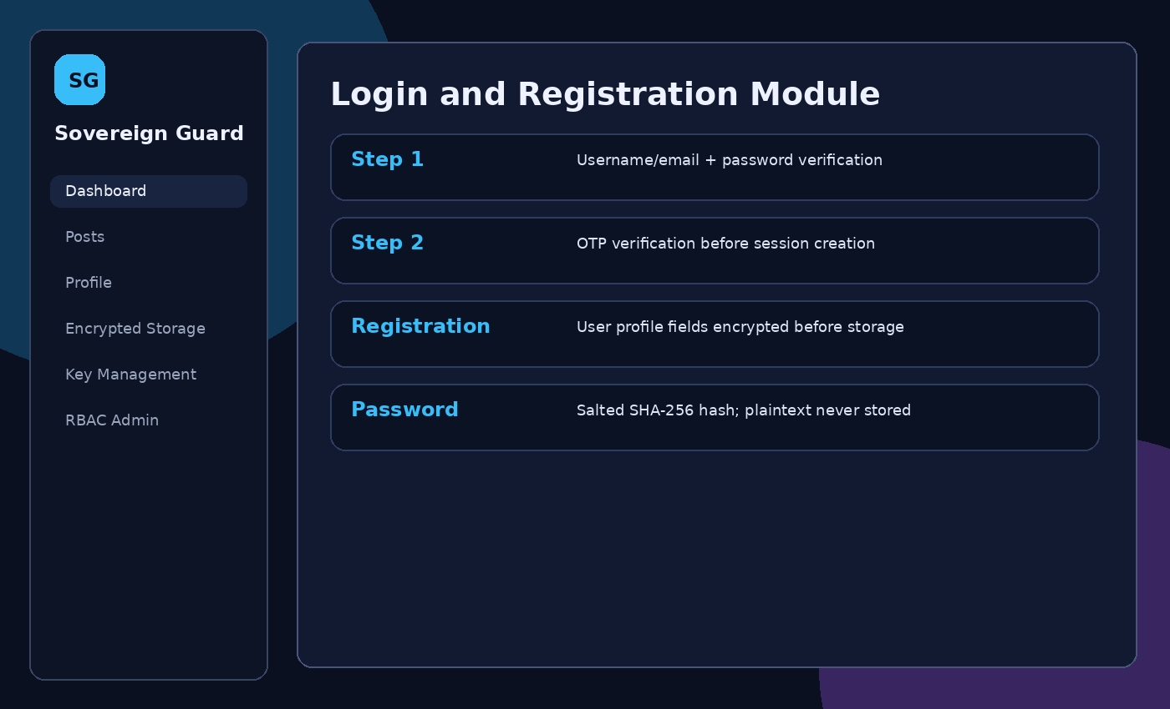
Figure 2: Login and registration screens.

2.1 Registration Flow
- The user enters full name, username, email, contact number, password, and role.
- If administrator is selected, the system requires the admin invite code.
- A unique random salt is generated for the password.
- The password hash is calculated as an iterative SHA-256 digest using the salt and password.
- A two-factor OTP secret is generated.
- User profile fields and the OTP secret are encrypted with the active RSA public key.
- A HMAC tag is calculated over the encrypted user record.
- The ciphertext record, salt, password hash, OTP ciphertext, role, key ID, and MAC are stored.

2.2 Login Flow
- The user enters username/email and password.
- The system scans encrypted user records, verifies HMAC, decrypts username/email, and finds the matching user.
- The stored salt is retrieved and the submitted password is re-hashed.
- The calculated hash is compared with the stored hash.
- If the password is correct, the system moves to OTP verification.
- If OTP is correct, a signed session token is issued.

2.3 Implementation Details
Requirement | Implementation Details
Login Module | Decrypts stored RSA-encrypted username/email for matching, verifies salted password hash, then requires OTP.
Registration Module | Collects name, username, email, phone, password, and role. Admin registration requires invite code SOVEREIGN-ADMIN.
Data Encrypted Before Storage | Name, username, email, phone, and OTP secret are encrypted with RSA.
Data Decrypted on Retrieval | User/profile fields are decrypted after HMAC verification using the sealed key registry.

3. User Data Encryption and Decryption
All sensitive user information is encrypted before storage using RSA. Post data uses ECC so the project uses two different asymmetric encryption approaches rather than one algorithm for all encryption.

3.1 Fields Encrypted
Data Type | Fields | Algorithm
User account | name, username, email, phone | RSA
OTP setup | OTP secret | RSA
Profile update | name, email, phone | RSA
Social post | title, tags, body | ECC / EC-ElGamal-style encryption
Key registry | private key records | RSA sealed key packets

3.2 Encryption Algorithm - RSA Implementation
The RSA module is implemented manually in JavaScript. It includes prime selection from a classroom prime pool, modulus calculation n = p * q, totient calculation, public exponent selection, private exponent calculation using the extended Euclidean algorithm, modular exponentiation using square-and-multiply, character-wise encryption/decryption, and RSA signing for session token integrity.
The implementation uses small educational parameters so it can run in a browser and be inspected by instructors. Production RSA would require large key sizes, secure random generation, OAEP/PSS padding, side-channel protection, and audited libraries.

3.3 Encryption Algorithm - ECC Implementation
The ECC module is implemented manually using a small educational curve over a finite prime field. It includes point addition, point doubling, scalar multiplication, byte-to-point mapping, EC-ElGamal-style encryption with ephemeral scalars, and decryption by removing the shared point generated from the private key and ciphertext point.

3.4 How Both Algorithms Are Used Differently
Area | Algorithm | Reason
Registration and profile fields | RSA | Straightforward public-key encryption of short user fields.
OTP secret storage | RSA | Keeps the second-factor seed encrypted in storage.
Post title, tags, body | ECC | Demonstrates a different asymmetric mechanism for social content.
Session token signing | RSA | Signs the session payload and verifies it on protected actions.
MAC | HMAC-SHA256 | Verifies record integrity; it is not used for encryption.

4. Password Hashing and Salting
Passwords are never stored in plaintext. During registration, the system generates a unique salt and combines it with the password before hashing. During login, the same salt is reused to verify the entered password.

4.1 Hashing Algorithm Used
The project uses a from-scratch SHA-256 implementation. The password hash is generated iteratively so a single password check requires repeated hashing.

4.2 Salt Generation
A random hexadecimal salt is generated per user account. The salt is stored beside the hash because it is not secret. Its purpose is to make identical passwords produce different hashes and reduce rainbow-table usefulness.

4.3 Verification Process
- Retrieve the stored salt and password hash.
- Combine the submitted password with the stored salt.
- Run the same iterative SHA-256 function.
- Compare the calculated hash to the stored hash.
- Continue to OTP verification only if the hashes match.

5. Two-Factor Authentication (2FA)
The application enforces two-step authentication. Passing the password check alone is not enough to enter the system. The user must also pass a second-factor OTP check.

5.1 2FA Method
The OTP is generated using a from-scratch HMAC-SHA256 function over a time window and the user encrypted OTP secret. During classroom testing, the OTP is displayed after password verification so the 2FA flow can be demonstrated without SMS or email services.

5.2 Code Snippet
const otp = (secret) =>
String(parseInt(hmac(secret, String(Math.floor(Date.now() / 30000))).slice(0, 8), 16) % 1000000)
.padStart(6, "0");

6. Key Management Module
The Key Management Module handles key generation, public-key distribution, sealed key storage, and key rotation. Administrators can rotate keys from the Key Management page.
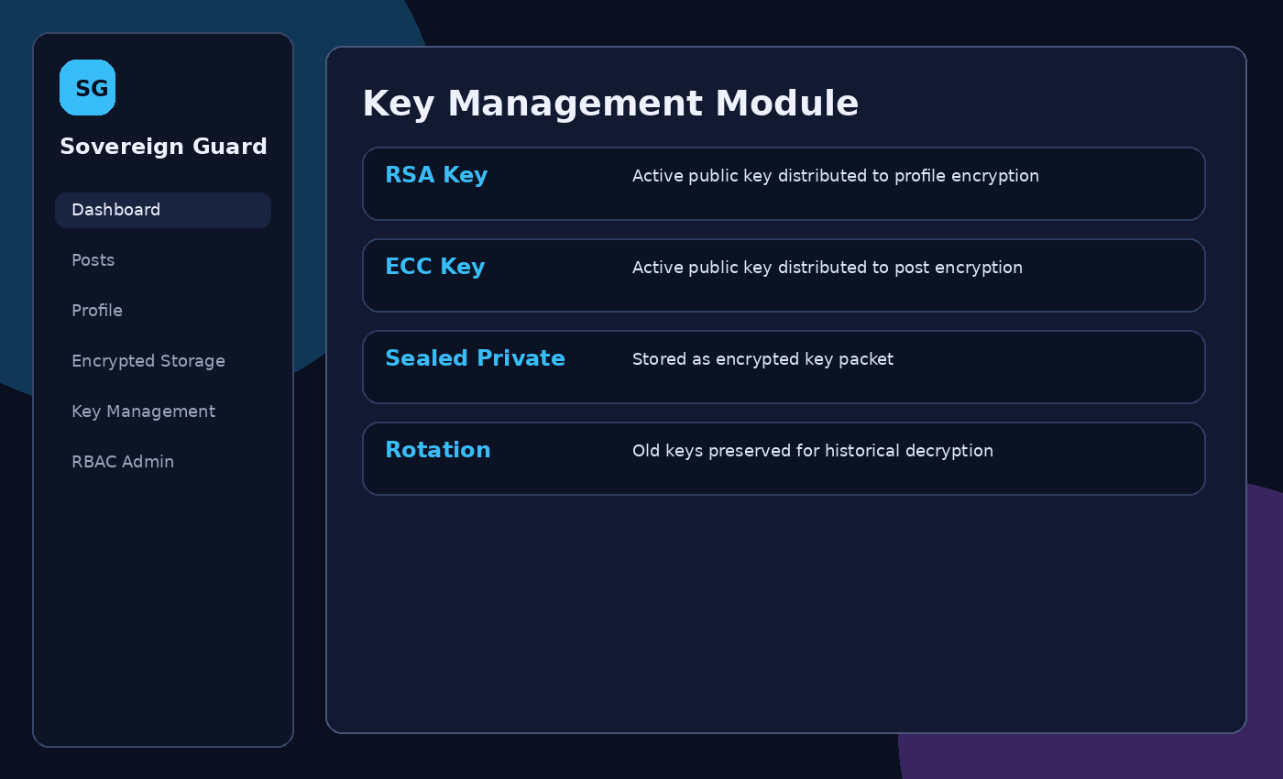
Figure 3: Key management module.

6.1 Key Storage Security
The key registry stores public keys and sealed private key packets. Private key objects are not written directly as plaintext in the demo database. The raw storage page therefore shows key ciphertext rather than direct private key values.

6.2 Key Rotation Policy
- Existing active RSA and ECC keys are marked old.
- New RSA and ECC key pairs are generated.
- New public keys become active for future encryption.
- Old sealed private keys are retained so old records remain readable.
- An audit log entry records the rotation event.

7. Post and Profile Management
Users can create, view, and edit posts and update their profiles. Every save operation encrypts data before storage. Every read operation verifies the MAC before decrypting and displaying data.
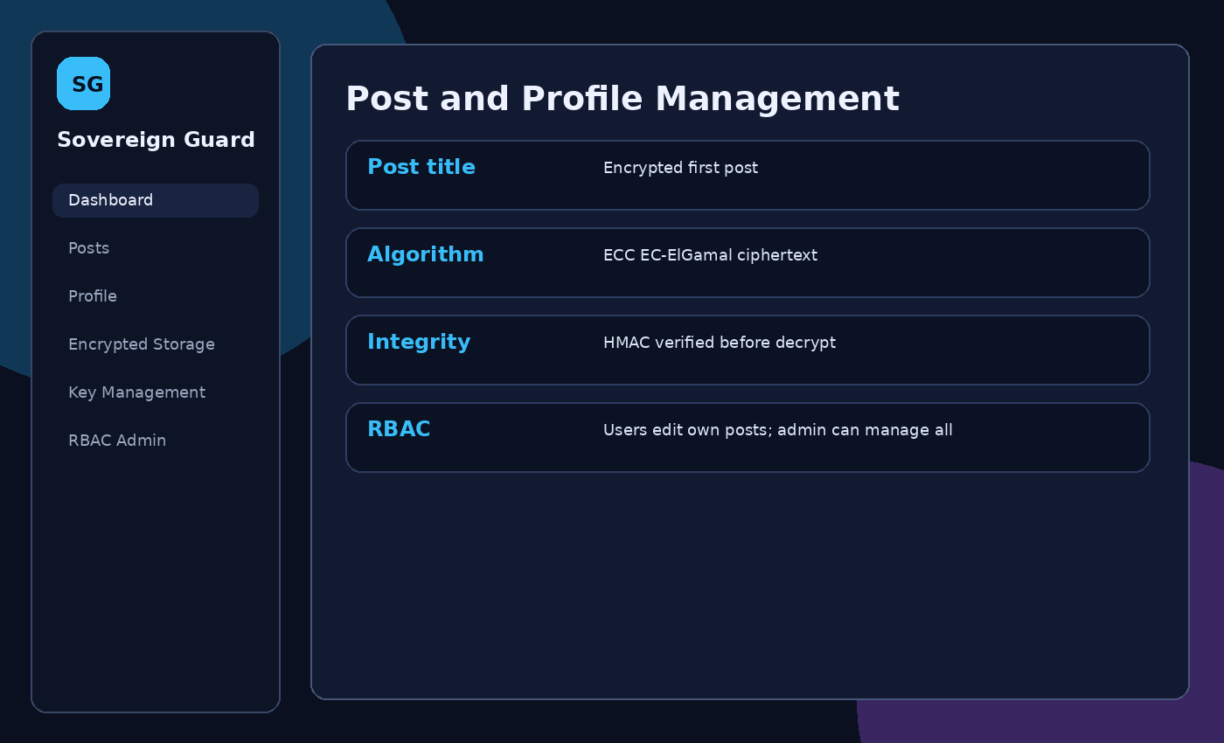
Figure 4: Post management module.

7.1 Post Module
Operation | Flow
Create post | Validate session, collect title/tags/body, encrypt each field with active ECC public key, attach HMAC, save record.
View post | Verify post HMAC, decrypt ECC ciphertext, display plaintext in UI.
Edit post | Check RBAC permission, decrypt existing post for editing, re-encrypt updated values, refresh HMAC.
Delete post | Regular users can delete own posts; admins can delete any post.

7.2 Profile Module
Profile view and update operations use RSA. The username remains stable for account identity; name, email, and contact can be updated. On update, profile fields are re-encrypted using the active RSA key and a new MAC is generated.

7.3 Screenshots
Screenshots included in this report demonstrate login and registration, dashboard, post management, raw encrypted database evidence, and key management.

8. Data Storage Security
All critical records are stored in encrypted form in the application database. The raw storage view intentionally displays the database object so the instructor can verify that profile fields and post fields are ciphertext.
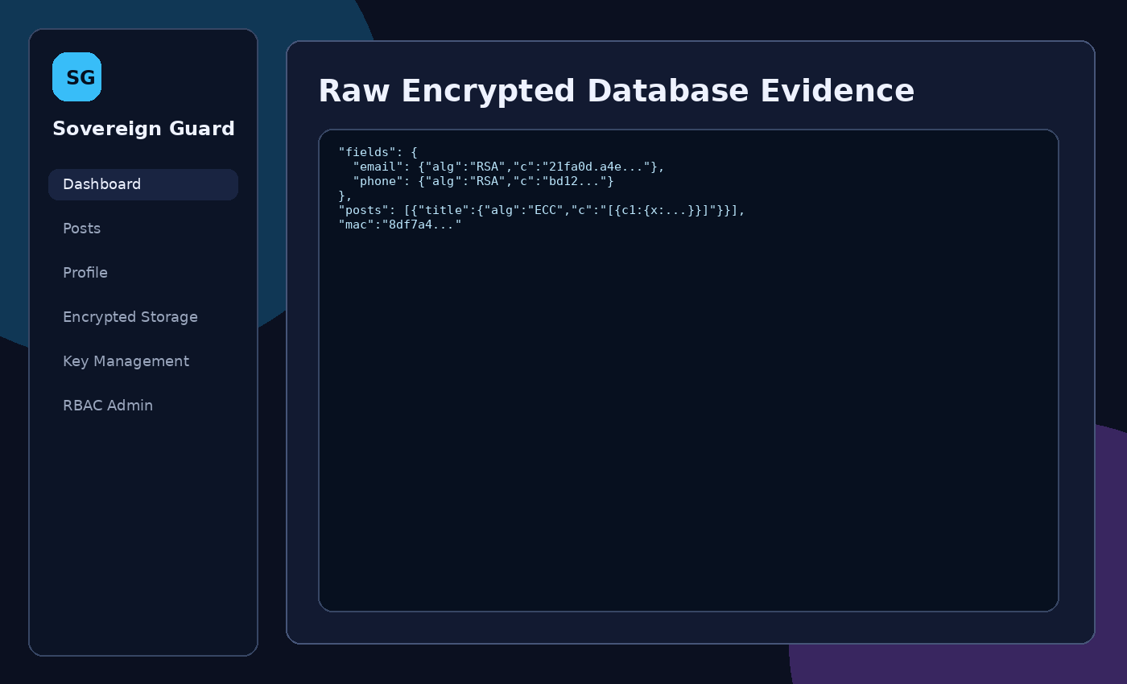
Figure 5: Raw encrypted database evidence.

8.1 Evidence of Encrypted Storage
"email": { "alg": "RSA", "keyId": "rsa_...", "c": "1af0.23bc..." }
"title": { "alg": "ECC", "keyId": "ecc_...", "c": "[{\"c1\":...,\"c2\":...}]" }
The plaintext name, email, contact number, and post body are not stored directly in the database.

9. Message Authentication Code (MAC)
Message Authentication Codes verify that encrypted records have not been modified without authorization. The system uses HMAC-SHA256 implemented from scratch.

9.1 MAC Algorithm Used
HMAC-SHA256 was chosen because it is widely used, simple to explain, and can be implemented using the project from-scratch SHA-256 function. The HMAC key is treated as a server-side application secret and is not stored inside the encrypted database.

9.2 Integrity Verification Flow
- Canonicalize encrypted fields and metadata before saving.
- Calculate HMAC-SHA256 over the canonical record.
- Store the MAC beside the encrypted record.
- Recalculate the MAC before displaying a record.
- Block decryption and show an integrity alert if the MAC fails.
- Use the tamper simulation button to demonstrate unauthorized modification detection.

10. Role-Based Access Control (RBAC)
RBAC separates administrator and regular user privileges. Admin-only screens are hidden from regular users and protected by runtime permission checks.

10.1 Roles Defined
Role | Responsibilities
Administrator | Manage keys, inspect user summaries, access RBAC panel, delete any post, and view extended audit events.
Regular User | Register, log in, update own profile, create posts, edit own posts, and view own records.

10.2 Permission Matrix
Operation / Resource | Admin | Regular User
View own profile | Yes | Yes
Edit own profile | Yes | Yes
Create / edit own posts | Yes | Yes
Delete any post | Yes | No
View all user accounts | Yes | No
Manage / rotate keys | Yes | No
Assign privileged role during registration | Invite code required | No
View audit logs | Full | Limited

11. Secure Session Management
Authentication tokens and session identifiers are protected to reduce risks from hijacking, fixation, and replay attacks in the demo environment.

11.1 Token Signing / Verification
After password and OTP verification, the application creates a session payload containing user ID, role, username, issue time, expiry time, and nonce. The payload is signed using RSA and protected with an HMAC tag. The token is stored in sessionStorage rather than persistent localStorage.
- HMAC correctness is checked.
- RSA signature correctness is checked.
- Expiration timestamp is checked.
- User role authorization is checked before sensitive operations.

12. GitHub Repository and Project Structure
Field | Details
GitHub Repository URL | [Add repository URL after uploading]

12.1 Repository Structure
sovereign_guard/
├── index.html
├── css/styles.css
├── js/crypto.js
├── js/app.js
├── screenshots/
├── docs/CSE447_Sovereign_Guard_Report.docx
└── README.md

12.2 README Overview
The README contains the project title, purpose, run instructions, demo credentials, implemented modules, and an academic-use security disclaimer. It explains that the app can be opened directly through index.html or served locally using a simple HTTP server.

13. Conclusion
Sovereign Guard demonstrates how cryptographic techniques can be integrated into a secure social web application. The project implements registration, login, 2FA, encrypted profile and post management, MAC-based integrity checking, key lifecycle management, RBAC, and session protection. The main challenge was implementing RSA, ECC, SHA-256, and HMAC from scratch while keeping the system understandable and runnable in a browser. The final result is a complete educational prototype that shows encrypted storage and controlled decryption flow across the application.
Security Disclaimer: This project uses small educational parameters and simplified browser storage for demonstration. It is suitable for CSE447 learning and presentation, but it should not be deployed as production security software.

