Pre-Lessons

Four Cowrie Shell

Lesson 3.0
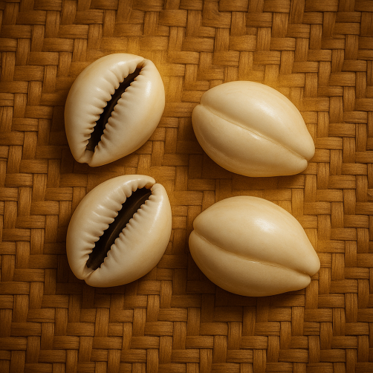

From 4 Cowrie
to
256 ODU
Table of contents
Motivation
Sample cowrie casting chart
Cowrie orientation
Cowrie direction
Major Odu opens
Minor Odu opens
Samples casting to Odu
Conclusion
Motivation

Why this course?
This is an offering for the enlightenment seekers. This is for those seekers who discover that blessings can appear as calamity, disaster, and delay. Having access to the uncompromising can reveal the sacredness of the seeker’s relationship to these three distractions. Transforming distraction into blessedness is breast milk for the seeker. Integrating tools, skills, art forms, or behaviors developed during this transformation period nourishes self-realization.

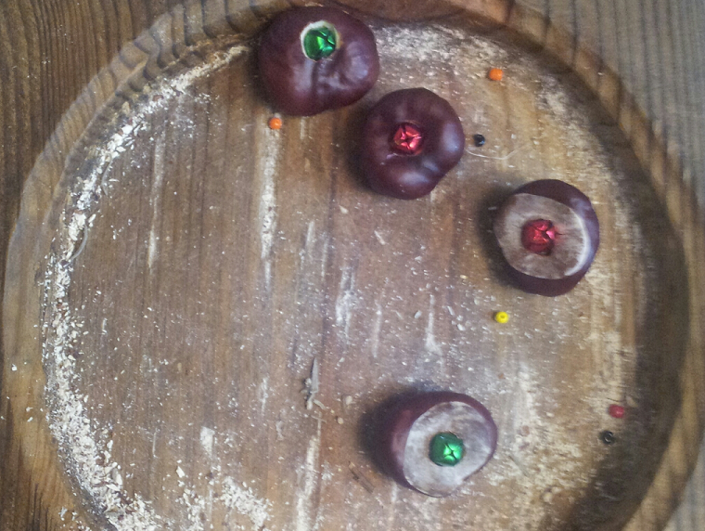
Enlightenment is not what it appears to be and is nevertheless beneficial. Self-realization is only temporal. This course may serve as a tool to pierce the veil of the One Truth. Hence this course is beneficial only to the enlightenment seekers.

This offering promotes conscious triangulation of inner knowing, Spirit, and the 3-D plane. The intersection of these three provide a portal. The other side of this portal MAY lead towards enlightenment. and it may not. Enlightenment is not a place of promises, guarantees, and simple difficulties. It is a journey, not a destination.

“Yes; Probably yes; Definitely; Probably no; Definitely no”, are the five (5) responses that are beneficial for transforming apparent difficulties into conscious intentional behaviors. These pentagonal responses have unique cultural expressions in the Yoruba language and are revealed later in this lesson. This pentagonal relationship is also found in other culturally based oracle systems. Obi Abata, Metu Neter, I Ching, and Tarot are some examples of such systems. Other oracle systems are discussed in later lessons designed for those bound to the path of enlightenment. Four Cowry Shell system provides a foundation for the casual and the more-than-curious seeker.

- This course offers supplemental and uncompromising support for the more-than-casual seeker of self-realization.
- This course stimulates deeper insights, broader perspectives with the opportunity to reassemble the fragmented self
- This course compels clarity of purpose and requires recommitment to that which is most important.
- This course provides a baseline for intuitive expression within an ancestral framework
- This course sifts those desiring spiritual adornments from those desiring spiritual alignment.
- This course is an incomplete offering for the authentic enlightenment seeker.
- This course precedes the beginning.

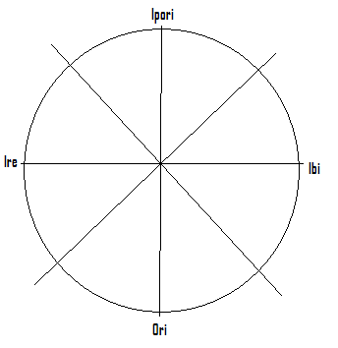

Shell | Ipori ↑ | Ipori/Ibi ↗ | Ibi → | Ibi/Ori → | Ori ↓ | Ori/Ire ↙ | Ire ← | Ire/Ipori ↖
Female  (Earth -) | 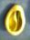  1 |   2 |   3 |   4 | 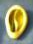5 |   6 |   7 |   8
Male  ( Sky +) | 9 |   10 | 11 |   12 | 13 |   14 | 15 |   16

Table 3.1

Arbitrary Cowrie Orientation
a) Earthward Cowrie
Earthward cowries can be considered positive when pointed TOWARD the observer or toward the left. See numbers 5, 6, 7, 8 in the table above. Otherwise earthward cowries can be arbitrarily considered negative.
b) Skyward facing Cowrie
Skyward facing cowries can be considered positive when pointed AWAY from the observer or toward the right. See numbers 9,10,11,12 above. Otherwise skyward facing cowries can be considered negative.
Each earthward facing cowrie shell is assigned two side by side parallel lines  . Each skyward facing cowrie is assigned one single vertical line. These form the first leg of an Odu pattern.











Figure 3.3
Figure 3.4
Figure 3.2
Figure 3.1

So the laying of the cowrie shells can be interpreted to form the first leg of an Odu pattern as shown in the figures above.

Arbitrary Cowrie Direction

Second leg of the ODU
Each earthward facing cowrie shell when directed inward towards the observer or to the left is positive and assigned a single vertical line. If the earthward cowrie is directed outward or facing the right, then a pair of parallel lines  are used to represent this direction.
Each skyward facing cowrie shell when directed outward from the observers or to the right is positive and assigned a single vertical line.
We will apply this concept to the first above column of cowrie shells and associated first leg.

Keys: Earthward cowrie are positive when facing left or inward
Skyward cowrie are positive when facing right or outward
Table 3.2

Skyward cowrie Facing inward and right
Earthward cowrie Facing outward
Skyward cowrie Facing left
Skyward cowrie Facing inward and right


The red in the diagram to the right shows the direction that each cowrie is pointing and the associated Odu markings based on these directions.
Table 3.3

