**SwamiG Institute**

***“Extending Royal Legacy”***

**HRM Nwa Chukwu Eri NashidKoleosoKarade**

**HRM Queen Mother OsunnikeIfeyinwaAnke Eri**

Anke-Karade Lineage Founders

|  |  |  |
| --- | --- | --- |
| AwiseWande Abimbola &Iya Besie Abimbola –  Nigeria West Africa | **1-Know Thyself( Heru) Ilekes**  **2-Cleanse and Purify (Herukhuti) Warriors**  **3- Living in Alignment With Absolute Truth( Ausar) Hand Of Ifa** | YaagbeOrisaKeyeAgbede – Nigeria West Africa |
| Iya Omoladun Anke – Nigeria West Africa | Chief Araba Malomo – Nigeria West Africa |
| Baba OgunyeyeAkangbe – Nigeria, West Africa | Baba Oloye Ifa Karade – US |
| *IyaOsunnike****Anke*** *– US* | *Baba Koleoso* ***Karade*** *– US* |
| **HRM Queen Mother Osunnike Ifeyinwa Anke Eri** | **H**RM**Nwa Chukwu Eri NashidKoleosoKarade** |

**PriestKing Nwachukwu EriNashidKoleosoKarade**

Extending Royal Legacy

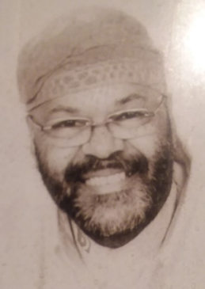

*AwoFasuuruateAnke-Karade- US*

*“SwamiG”*

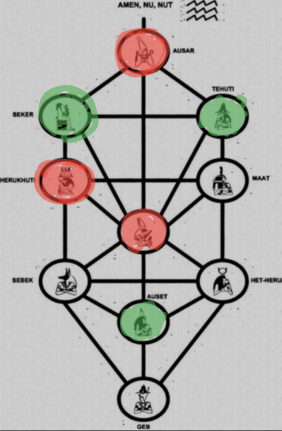

[SwamiG Institute](http://swamiginstitute.com) and its three(3) pillars: wisdom, words and devotion,

2

1. Infinite **Wisdom(Tehuti) Ilekes**
2. Speaking **words** of power **(Sekert) Warriors**
3. Transformational ***Devotion*(Auset) Hand of Ifa**

**“…Extending Royal Legacy…”**

**“…on the shoulders of enlightened ancestors…”**