12

设计和放映幻灯片
对设计的强调转到Impress来，这是LibreOffice的幻灯片应用。就像在Writer里一样，模板依然很重要，但样式变得相对次要。相反，对问题的关注从格式化转为结构化内容——通常，再到为避免设计一个全是总结的幻灯片，导致你不断地把头从观众转开去直接阅读幻灯片，的挑战。

为什么幻灯片无聊？
用得好的话，Impress可以助力演讲成功。问题是，正如很多人从来没学会怎样正确地用一个字处理工具一样，很多人没明白幻灯片的用处和不足。
信息设计师Edward Tufte指出，演示是为讲座格式设计的。事实上，在滑稽的夸张之下，他把它们比作一个五一集会。除非安排得当，一个幻灯片展示会阻止观众的问题，以及观众之间的交谈。
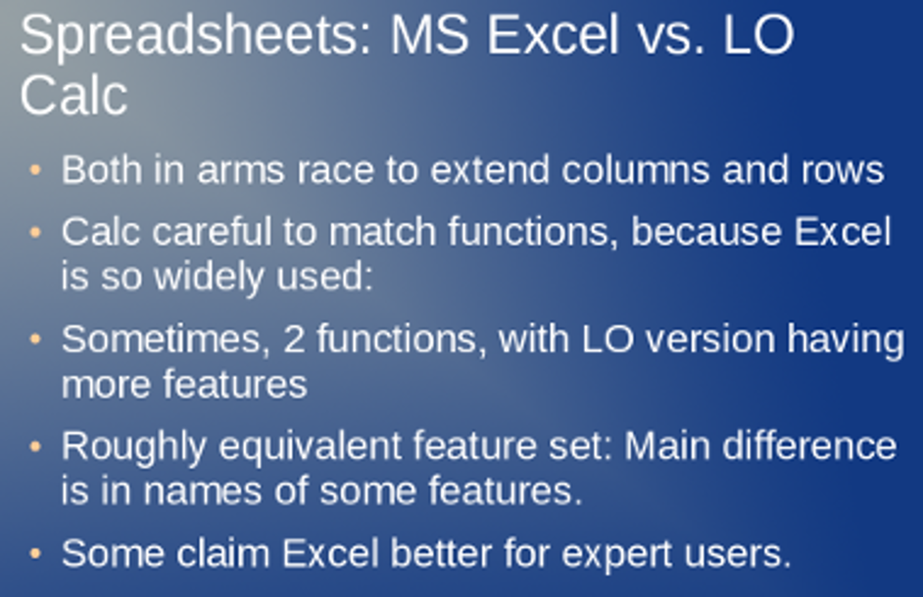
来自一个总结性演示的一张幻灯片。只有在一个演示无人监督的时候，这样的幻灯片才是有效的。
这种单向流动的信息让很多演讲者相信一个演示应当是他们想法的一个完全总结。他们的讲话用最无想象力的方式讲遍每个细节。在很多情形下，演讲者可以把他们的幻灯片发出去，然后呆在家里，来要求所有他们物理出场的增加。
有时，一个总结性的幻灯片演示是合理的——例如，如果演示是用来以不断循环的形式无人监督地放映在一个贸易展览上。但很多信息的交换，就像一个计划会议或一种语言的学习这样的，就不适合一个讲座格式。
更为重要的是，很多——可能大多数——的想法在不冒过度精简的风险的情形下，不适合放在一种分离的要点和幻灯片的结构中。
这些问题解释了为什么宣布你不会在演讲中用幻灯片，是赢得观众掌声的一种几乎有保障的方式。
因为这些问题，一些评论家完全地放弃了演示文稿的想法。例如亚马逊已经在它的业务中禁止了演示文稿。
但这样的反应过于严厉了。在事先警告了这些问题之后，你还是可以让你的幻灯片成为一个增强你的演讲的手段，而不是压制了你演讲的替代品。

决定用幻灯片的时机
幻灯片是一种有严重不足的媒体。在每屏不超过75词的情况下，一张幻灯片本身不能简单地交流复杂的信息。更严重的是，幻灯片会阻碍任何演讲者和观众之间的思想交流。
通过一些工作，你可以减少这些倾向，虽然你会总是竭力抵抗它们。然而，在你选择使用幻灯片之前（假设你有一种选择），你应该问自己是不是需要幻灯片。
使用幻灯片，如果： | 不用幻灯片，如果：
- 你的目的是不受打扰地，和/或在无演讲者时，传递信息。 | - 你的一个目标是观众的参与。
- 观众的参与有限。 | - 观众中的成员需要个人注意力，或者讨论很重要。
- 你的主题简单或者很好地统一。 | - 你的主题很复杂或者抽象，并且思想间的联系对理解整体很重要。
- 你的主题是技术性的。 | - 你的主题涉及了语言的理解或欣赏。
- 你的讲话包括图表或说明。 | - 你的观众不需要图表或说明，或者你正在以讲义或其他某种方式展示它们。
- 你的讲话有一系列问题和答案，就像在词汇训练中一样。 | - 你的讲话是关于高级，抽象的概念的。
- 这个演示是循环运行并且无人监督的。 | - 你在现场发表这个讲话。
- 你要强调关键词并展示它们是怎样拼写的。
这些指导方针限制了幻灯片到难以用任何其他方式演示的信息，事实上是用演讲者曾经配合幻灯片使用投影仪一样的方法用演示文稿。如果跟随这些指导方法，它们可以通过鼓励你，只当在它帮助观众明白的时候，添加一张幻灯片，让你从不断做总结的困扰中解放出来。

Designing a presentation
In early releases, OpenOffice.org used to start Impress with a wizard that made clear the design is both format and structure. Recent releases of LibreOffice no longer follow that practice, but you might still consider starting your building of a presentation by running File > Wizards > Presentation. You can make Impress default to using the wizard by clicking Tools > Options > General, New Document > Start with wizard check box.
Regardless of whether you use the wizard, remember that designing an effective slide show consists of six steps:
- Plan the presentation structure.
- Use the Master view to set up features such as backgrounds, footers, Presentation styles, and transitions.
- Set the slide design as needed for individual slides.
- Use the Draw-like features in Impress to create any charts and diagrams or tables. Alternatively, you may want to insert charts and diagrams made in another program and imported in a standard graphics format.
- Add any notes for your talk.
- Choose slide show settings from Slide Show > Slide Show Settings.
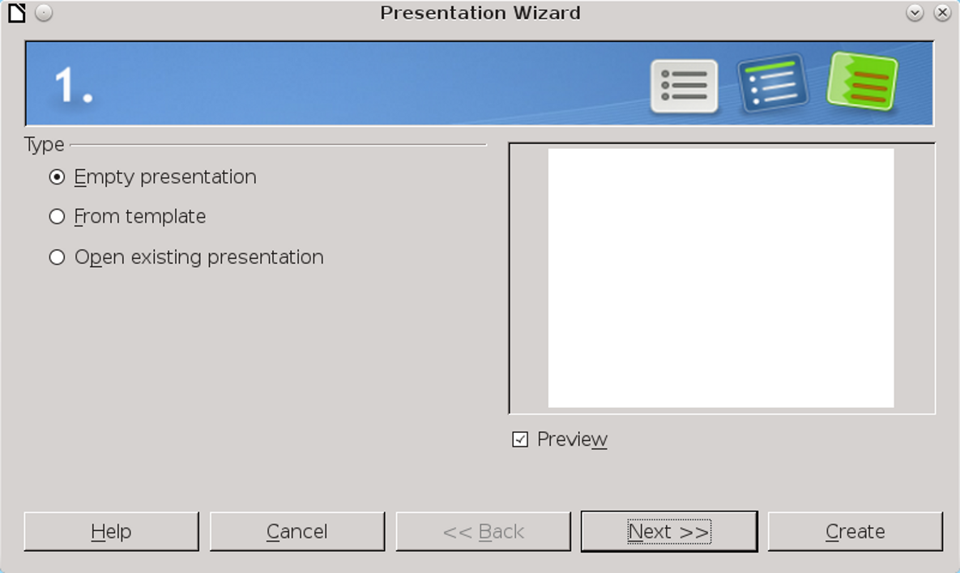
Impress’ Presentation Wizard helps you to structure your presentation.
In all these stages, keep everything simple and make design choices to enhance legibility. Just as the average text-based document rarely needs more than two fonts (plus, of course, their font styles or weights), so a slide show rarely needs more than one type of slide transition, or more than a few slide designs.
Each slide show is, in fact, an exercise in design under restricted conditions. Compared to the possibilities of a Writer document, a presentation is extremely simple, with limited choices to make.
For instance, instead of setting up a complex format feature by feature, you are more likely to choose a slide design. In effect, you are designing a series of posters that are readable at a distance.
To an extent, you can add some flexibility by adding graphic text, which is treated as an object instead of as regular text. However, as you design, take constant reality checks. If you start feeling that you are struggling against the structure of Impress – for instance, by trying to wrap text around a graphic, or to set up text to flow from frame to frame – you should probably give up and accept the limitations of a slide show.
- Tip
If you really want a complex format, design slides as Writer pages, and then export them to PDF. You will need to be careful that you don't use font sizes that are too small, but many alternative presentation apps use PDF slides, and the audience probably never notices.

Outlining slide shows
People plan in different ways. A tree of main points, mind mapping, scribbling main points – all can be effective ways for different types of people to plan. Too many, though, plunge into developing a slide show with only a limited idea of the structure.
This approach is inefficient, because it means that you are trying to get ideas down at the same time that you are structuring, giving only half your mind to each of two tasks, each of which deserves your full attention. Instead of thinking and
structuring well, you most likely end up doing both poorly.
Even worse, this practice encourages slide shows that are complete summaries of your talk.
The best place to begin a presentation in Impress is in the Outline view. Each top outline heading is a new slide, the others a bullet point on the slide. You can descend a level in the outline by pressing Tab, and ascend a level by pressing Shift+Tab.
- Tip
The Outline view is simple yet powerful enough that you might consider using it for all your outlining, even for text documents.
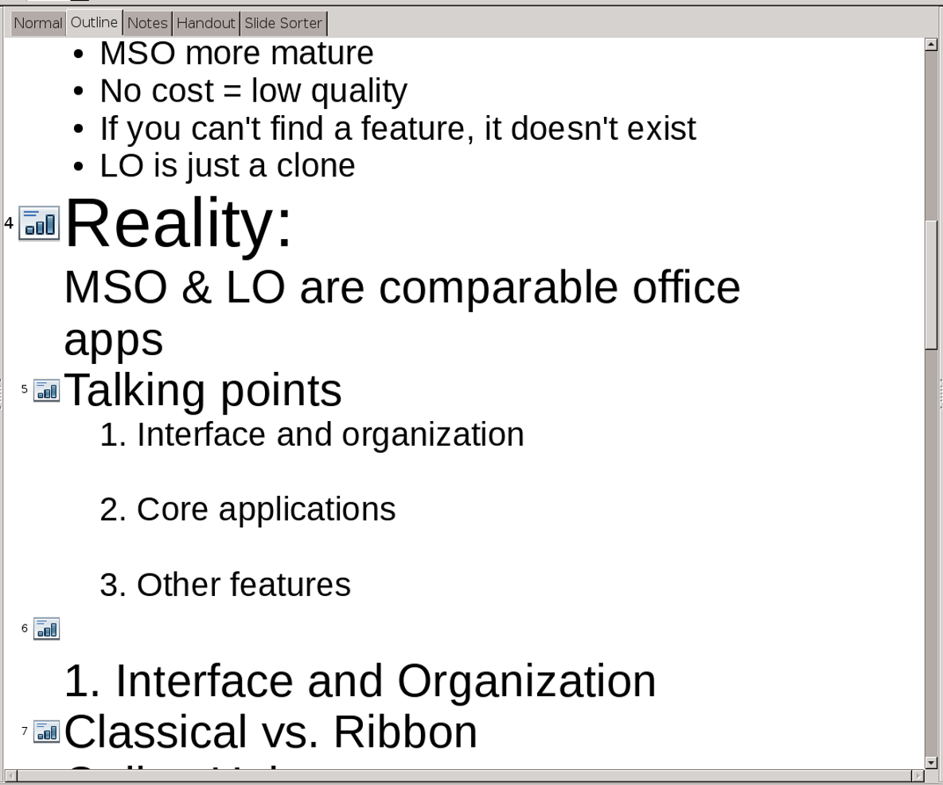
Use Impress’ Outline tab as the starting point for a slide show.
Alternatively, outline in Writer, then transfer the outline to Impress by selecting File > Send > Outline to Presentation.
However, whichever way you work, do not stop with the outline. When you have the complete outline, go back and mark the items that should be enhanced by illustrations or emphasized by giving them a slide. Aside from structural slides such as the title page, only these points will have a slide.
No firm rule exists, but if more than about one-third of your points are listed as having a slide, you are probably still too close to a summary
presentation. Rework the outline until points marked to become slides are as few as possible.
You should now have an outline consisting consists of only useful slides, and that you cannot simply read when presenting.

Making a structural template
If you find yourself continually doing similar types of presentations, you can save structural templates. At the very least, you might want to save a structural template with the first few slides. These include:
- The title page: Use the Title Slide layout, with the presentation’s title at the top and your name below it. In a long slide show, you might want title pages for each section.
- Biography: Placed near the start, this slide is not a general life history, but proof that you are an expert on your subject, and that your ideas are worth listening to. If you have a reputation among audience members for your expertise, you might omit the biography.
- Talk outline: A summary of the major sections of your talk after the title page and biography. You can make it more informal by wording the sections as questions. Listeners can follow your presentation better if they have a sense of the structure of your talk.
- A sub-title page: Sub-title pages can be shown briefly to let listeners know what stage your talk is
- at. Usually, if you use sub-titles, you should also use a talk outline.
- Conclusion: A summary, a call to action, or an example that emphasizes your main point. Whatever tactic you choose, the conclusion is your last chance to leave an impression with listeners.
- Bibliography: In a formal or academic presentation, you may want to show your sources and comment on them briefly. In other circumstances, you might omit the bibliography, but, if you do, be ready to provide your sources for those who ask for them.
- Question: The last slide in the presentation, the Question slide indicates that you are opening the topic to general discussion. Generally, you want to time your presentation so that the audience has at least fifteen minutes to discuss it.
- Tip
Adding tables can be laborious in Impress, so add a slide with a table in the colors you want.
Add content as necessary between these slides. Use the template as the source for other, more specialized templates.

Designing with master slides
Master slides are Impress’ equivalent of Writer’s page styles. They set the look of your slides in one place rather than for each slide. However, unlike page styles, each master slide also has its own set of styles for text.
Most presentations need only a single master slide. However, you may want design elements such as reversing the background and foreground colors on title and biography pages to emphasize their differences from the body of the presentation.
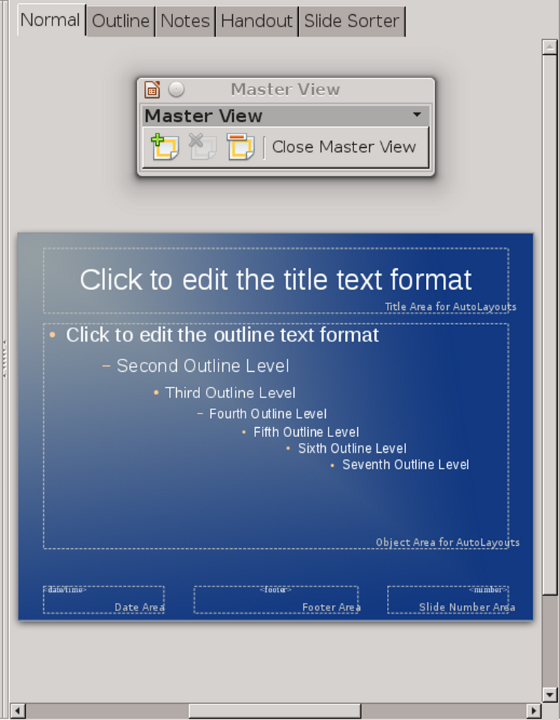
Edit master slides from View > Master > Slide Master.

Creating master slides
To create each master slide:
- Find a background template. You might find one in the Presentations Backgrounds folder of the Template Manager, or else create one using Draw or a third-party application like GIMP.
- Select a presentation structure from File > New > Templates. LibreOffice has a separate folder in the Template Manager for structures, marked simply Presentations.
- Select View > Master > Slide Master. The Slide Master view opens.
- Optionally, click the Rename Master icon in the floating window in the top middle of the editing window.
- Right-click anywhere on the master slide and select Page Setup to set the slide dimensions.
- Right-click anywhere on the master slide and select Set Background Image for Slide or the Available for Use pane in the sidebar. Use the file manager to select the file for the background.
- Optionally, enter information in the footer.
- Adjust the presentation styles as needed.
- If you want to create another master slide, click the New Master icon in the floating window. When
- finished, click Close Master View in the floating window.

Choosing slide backgrounds
When you select backgrounds, you face the usual design challenges of any background (see “Error: Reference source not found,” page Error: Reference source not found).
On the one hand, a single-color background risks looking amateurish. On the other hand, a background full of gradients or different colors risks leaving large portions of the screen with too little or too much contrast for adding text. The ideal background is somewhere between these extremes, with the more complicated parts of the design either extremely simple, or else confined to the corners or the top and bottom of the slide, leaving the center free for displaying text.
Test possible backgrounds against a variety of different colored texts. Setting the background to be partly transparent can often make a major difference. Just make sure that the two contrast, so that the text is as readable as possible.
If you plan to distribute your slides in grayscale, also check how your slides look in black and white.
Just as importantly, you might want a background that uses personal or corporate colors.

Finding backgrounds
LibreOffice comes with a selection of backgrounds, in the Presentation Backgrounds
folder of the Template Manager. You can also find many more choices with a quick web search, although the quality of the selections varies. Just because a background is available online does not mean that it is suitable for use.
The most common problem with downloaded backgrounds is that they are too busy for text to be readable against them.
- Tip
Remember that you can also use PowerPoint backgrounds. You should have no trouble importing most PowerPoint backgrounds – although when you save you are asked if you want to convert to Open Document Format.

Designing backgrounds
If you are unable to find a suitable background, you can design your own, or modify an existing one in a graphics editor. Impress rescales slides as needed, but rescaling distorts not only screenshots, but also text on logos. For this reason, do not rely on rescaling without thoroughly checking the results.
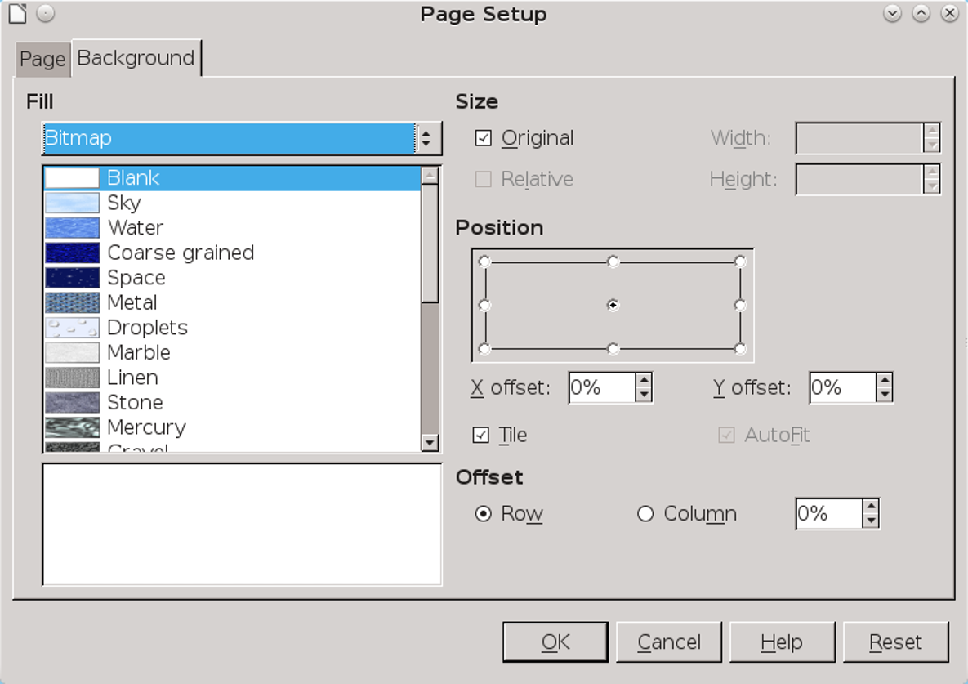
Use Format > Page > Background to design and choose a patterned background.
- Tip
If you need to add a logo to the slide background, consider placing it where the footer would otherwise go.
Writer does its best to adjust images, but to guarantee avoiding distortion, use one of the standard monitor ratios: 16:9 for wide screens, or 4:3 for older screens.
You can also use the tools on the Background tab to reduce an image’s size, position it, or offset it.
To design your own patterned backgrounds, go to View > Master > Slide Master, and from the menu select Format > Page > Background to choose a color, gradient, cross-hatching, or bitmap tile for the
background for all slides with the same master slide. Click the Gallery button on the sidebar for more patterns and images. If other options fail, create a patterned background.
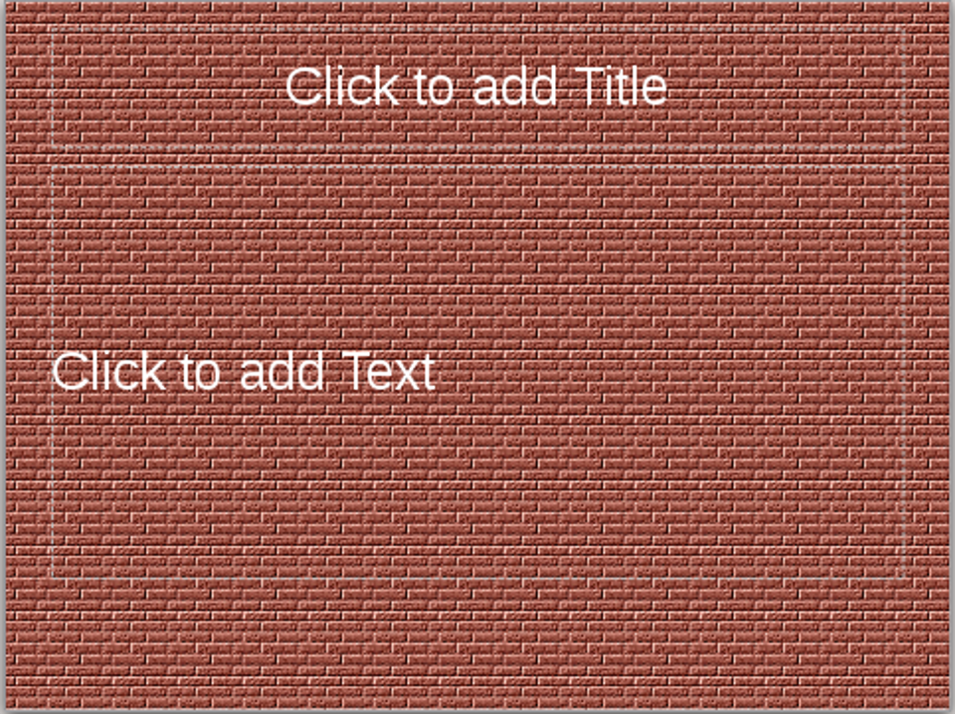
A tiled background using a brick pattern. The design is intricate, but small enough that foreground text is readable.

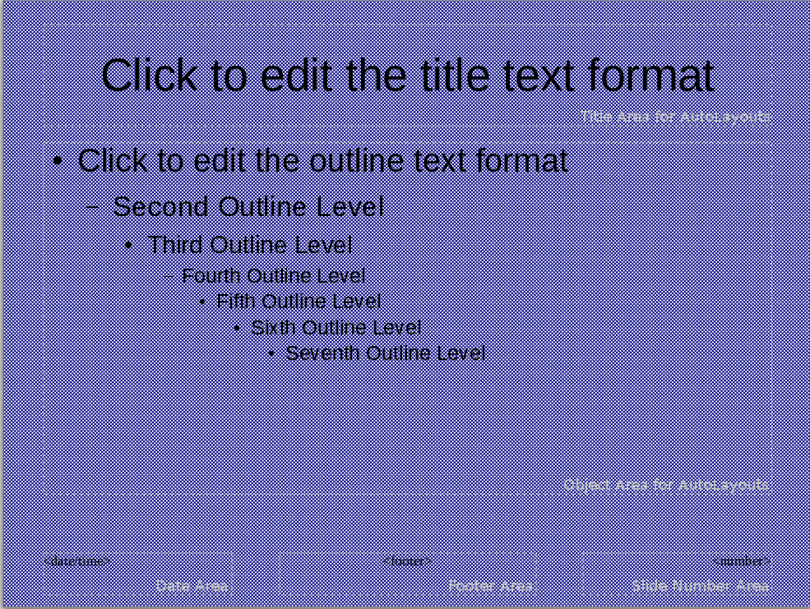
A hatched background. Be careful that a hatched background has enough contrast with the foreground text and is readable. Take particular care when printing in black and white.
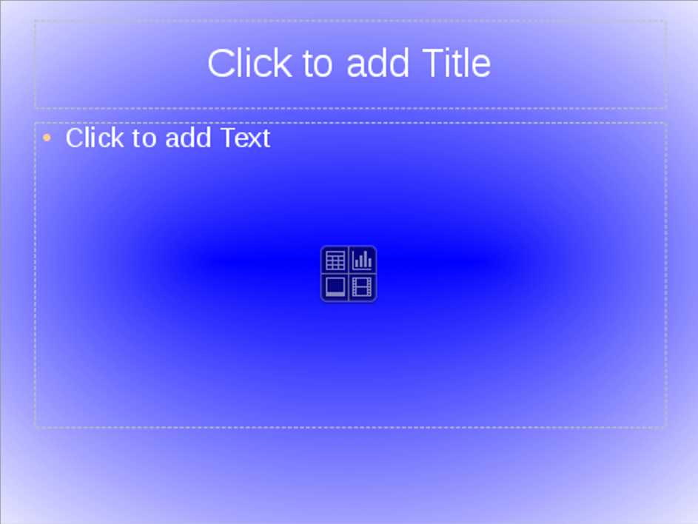
A gradient background. This gradient leaves most of the slide’s center with a strong contrast, leaving the lesser contrast to the sides where there is less text.

When you are finished designing, save the result by selecting File > Templates > Save As Template > Presentation Backgrounds. The background is then available for use in other presentations.

Adding footer information
All slides include three frames for footers: from left to right, date and time, optional fields, and slide number.
In practice, only the slide number is used regularly these days, and, sometimes, not even it. Instead, the footer area often holds a company logo and ignores the frame altogether.
The footer section of Impress’ Master View provides a simple arrangement for basic information.

Setting Presentation styles
Impress has two types of styles for fonts. Drawing Object styles (called Graphics styles in OpenOffice and earlier versions of LibreOffice) treat text as one feature of objects, and are covered in Chapter 13 when Draw is discussed.
The more common font styles are Presentation styles – the styles for each level of bullet point on the slides. Most options for Presentation styles are explained in Chapters 5 and 6 in the discussion of paragraph styles.
Most people change little except Fonts and Font Effects. Unlike styles elsewhere in LibreOffice, you cannot create new Presentation styles. However, each master slide can format its Presentation styles differently. If you want a design that Presentation styles cannot handle, use a Drawing Object style.
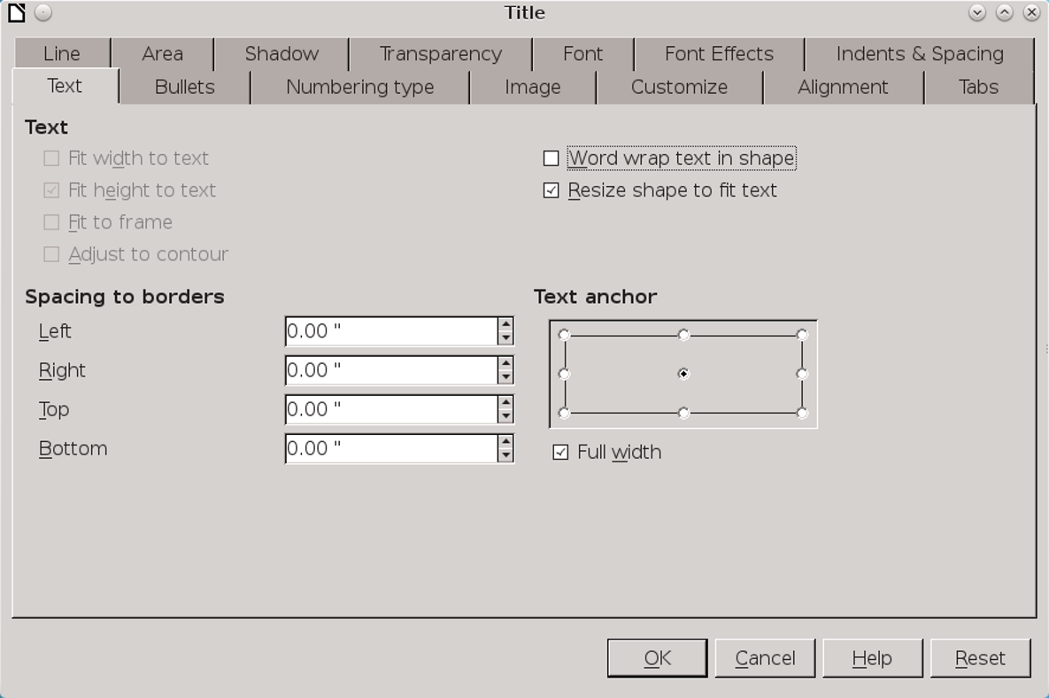
The Presentation Styles dialog window formats the bullets in a slide show.

Selecting fonts for slides
Since slides are presented at a low resolution, sans serif or slab serif fonts are generally preferable to serif ones for content. Titles and sub-titles are generally large enough that they can use any fonts.
Because backgrounds vary more in slide shows than in text documents, experiment with the colors on the Font Effects tab to get the one that stands out most from the background.
The default font sizes for slides are 44 points for a title and 18 points for an Outline 1 style. If you can possibly make the Outline 1 style larger, do so.
By contrast, the temptation to make a font size smaller than the defaults is a sure sign that you are cramming too many details on the slide and need to rethink.

Adjusting lists
The Outline styles in Impress default to bullet lists. You can customize them using the Bullets, Numbering Type, Image, and Customize tabs, but, as with list styles in Writer, avoid the retro-styled Image tab. The Customize tab allows adjustment of spacing or the selection of custom bullets and numbers or larger-sized ones for special circumstances.
However, in many cases, the default spacing is adequate. That means that you may be mostly using the Bullets and Numbering Type tabs to set up lists.
- Tip
If you do not want lists, set the Number field on the Customize tab to None. This one customization alone adds greatly to the flexibility of your design.
- Tip
As with headings in text documents, restrict your Outline styles to 3 or 4 levels. You can use some of the rest to create numbered lists or lines with neither bullets or numbers.
An especially useful style to create is an Impress equivalent of the paragraph style Text Indent – that is, one with no bullets or numbers, indented to start where the text in the list starts.
You will not be able to rename the styles, but their limited number should make them easy to find.

Setting alignment
Presentation styles include an Alignment tab, so those who want justified text in slides can have them. However, at the large font sizes that slides use, justified lines frequently have too many hyphens and irregular spacing between words.
Instead of giving yourself one more worry, accept the default Left alignment for content. Your audience will never notice.
- Tip
Titles are centered on slide designs that include both titles and contents. However, giving them a left alignment simplifies the design while emphasizing that they belong to the content that follows.

Setting indents and spacing
Line spacing, indentations, and spacing above and below lines are all set on the Indents & Spacing tab.
These settings are useful for large font sizes, but needing them in other circumstances is often a sign that you are adding too many words per slide and risking readability. Nothing requires that the words fill the entire slide.

Setting wrap
The Text tab for Presentation styles sets how content fits into Impress’ pre-existing frames. Most users are likely to be content with the defaults – especially since many of these settings can have unexpected results when you change slide designs.

Deciding on tabs or tables
Mostly, you can let slide designs determine how content is arranged on slides. If you find the default slide designs too limiting, you are likely trying to make slides do something that they were never intended to.
However, if you decide that you do have a reason for more complex layouts, you can use the Tabs tab for a Presentation style, or else a table.
Of the two choices, a table positions information more securely. You can add a table by positioning the cursor and selecting Insert > Table.
- Tip
After you have added a table, a table design pane opens in the sidebar.
When you add a table, the Properties pane adds a Table Design tab. Many of the check boxes under Table Design can be useful for formatting, but, unfortunately, the default colors are unlikely to match your slide show. In particular, the default black text will probably need to be changed.
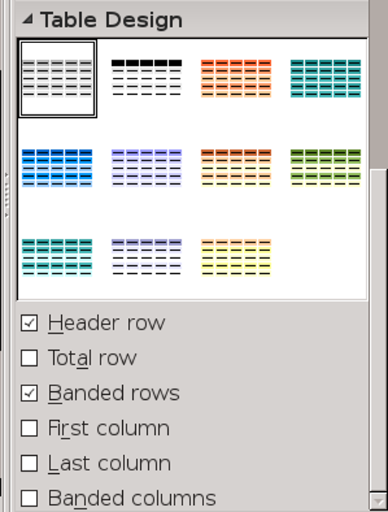
When using Impress’ Table Design tab, a plain gray table is the least garish choice.

Selecting a slide transition
LibreOffice offers nearly sixty different transitions available from Slide Show > Slide Transition or the Slide Transition tab in the sidebar. You can set the speed of each transition, and a sound to accompany it, and apply it to the entire presentation, or just to the movement between two particular slides.
This variety has a certain fascination, and every now and then you might find a match between your topic and an available transition.
For example, Checkerboard Down might be suitable for a slide show that discusses chess or uses a chess
metaphor. Or a small sound clip might emphasize the start of a major topic.
However, obsessing over slide transitions is not the best use of your time. Few ever notice the visual slide transitions – the audience will judge your talk on its content and its delivery. Whenever possible, choose a transition and click the Apply to All Slides button, and move on as quickly as possible.
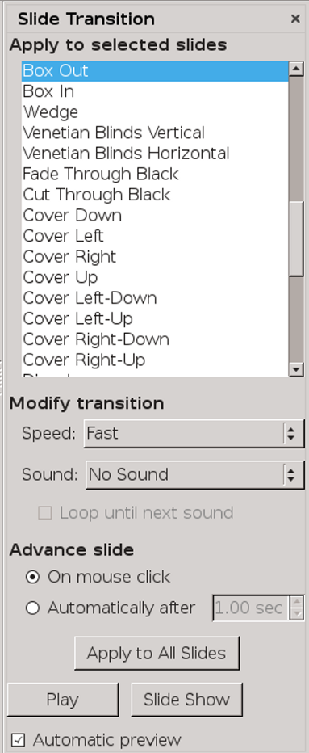
Elaborate transitions are rarely worth the effort to pick them.

Setting slide layouts
Slide layouts are applied to individual slides. On the sidebar, you can select from twelve different layouts, each with frames for different combinations of text and objects.
The layouts allow you to place text and objects with a degree of symmetry without requiring much time. In practice, however, the last six have far too many frames to be useful except for handouts. At best, they make your slides hard to read.
- Tip
The frames on slide layouts can be adjusted by dragging on their edges with the mouse. You can also delete (but not add) frames.
You can use Drawing Object styles to add your own unique designs, but selecting from the pre-defined layouts is almost always a better use of your time.
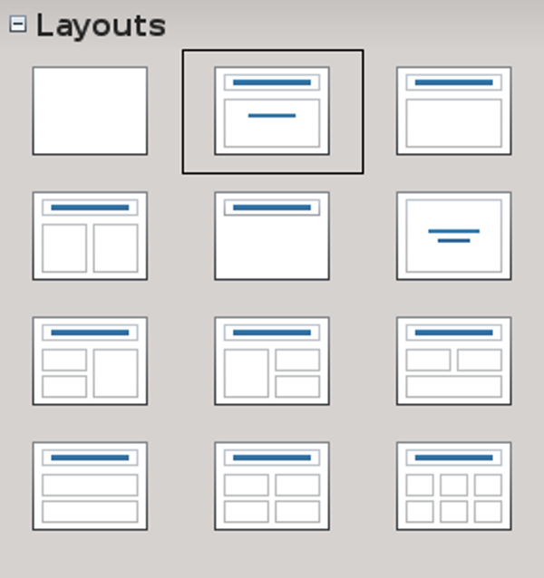
While you can design your own slide layouts, there are few reasons not to stay with the default ones..

Adding other elements
Impress slide shows are primarily words and images. However, you can also add:
- Additional images (Insert > Image).
- Objects (Insert > Object): A separate LibreOffice file that can be updated as needed.
- Animated GIFs (Insert > Animated Image): Animations can be constructed using Slide Show > Custom Animation, setting up the separate images one at a time. They are especially useful for before and after pictures when giving instructions.
- Movies and sound (Insert > Media > Audio or Video): Both are set to play only on a certain slide. That means that, if you want a continuous narration, you must break it down slide by slide, and set each slide to change only after the narration is complete. Do this by right-clicking on the slide and filling in the field Slide Transition > Advance Slide > Automatically After. In this circumstance, each slide needs its own transition setting.
- Tip
Use Slide Show > Rehearse Timings to help sync movies and sounds with your narration.
If adding these elements sounds too complex, don’t worry – few presentations use them, and you can deliver an effective slide show without them.
- Example: Displaying one line at a time
Many animations are not worth the time they take to develop, although sometimes they can take the place of before and after pictures.
I remember, for example, an animation that showed how the links in chain mail slide into place so that each ring is connected to six other rings.
These uses aside, one of the most common animations is displaying bullet points or lines one at a time. This animation helps the audience to focus on the current point being discussed, instead of encouraging their thoughts to drift to the other points.
Showing bullet points one at a time is especially handy for oral quizzes or in-class vocabulary reviews, or any sort of question/answer structure.
You could get a similar effect with two slides, but putting the question and answer on the same slide helps to keep the answer in context. Just as importantly, having only two items on one slide lets you use a larger font size.
To advance the slide show one line at a time:
- Enter the question or vocabulary item on the first line. Since only two items are on the slide, you can make the font size much larger than usual.
- Select Custom Animation from the Slide Show menu or sidebar. The Custom Animation pane opens.
- Place the cursor at the start of the first line. In the Custom Animation pane, click the Plus button and select Entrance > Appear from the dialog box.
- Check that Effect Appear > Start on the Custom Animation pane is set to On Click.
- Tip
You can adjust animations from the Direction and Speed fields, but in this case you probably don’t need to.
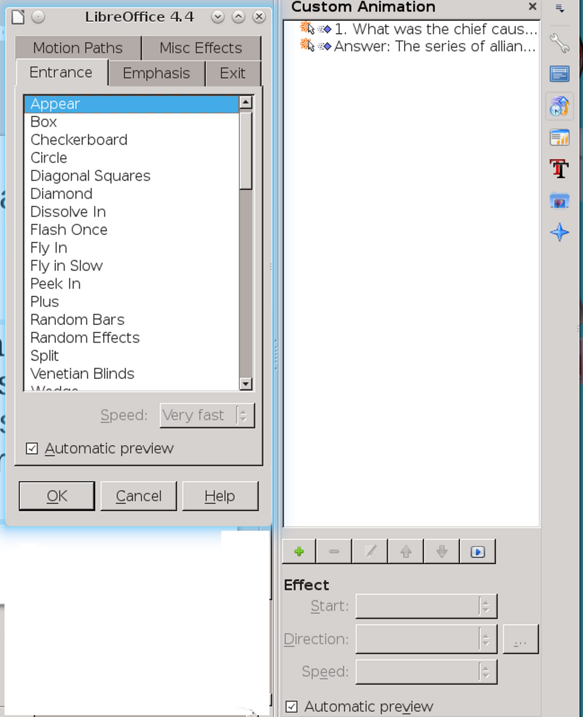
The Custom Animation pane and its dialog window. Make sure that any animations you add are not just bells and whistles, but illustrate something that cannot be easily shown any other way. Usually, animations are particularly useful when you need to show motion.
- Repeat steps 1–4 for the paragraph for the answer.
When you present, move the mouse cursor to the start of a line and click the mouse once to reveal the line.
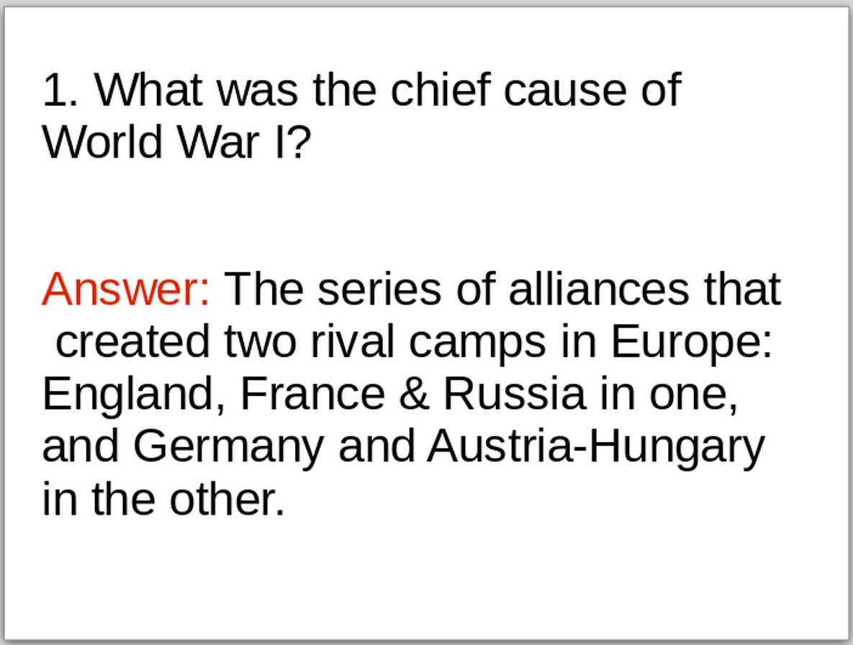
A slide that uses animation to reveal a question in one line, then the answer in the second line. During the presentation, each line will be hidden until you click on it.

Preparing notes and handouts
Many versions of LibreOffice have a console built in that let you read the Notes tab as the slide show runs. If yours does not, consider installing the Presenter Console extension.
Handouts are generally copies of the slide show printed out to give to the audience. Once part of any well-organized slide presentation, they have been largely replaced in recent years by putting the entire
presentation online. In theory, presenters can prepare any sort of handout, but, typically, unless you do a detailed summary presentation, handouts usually give only the vaguest sense of your talk and are only minimally useful.
- Tip
If you do decide to use handouts and cannot print them in color, check their appearance in black and white for contrast.
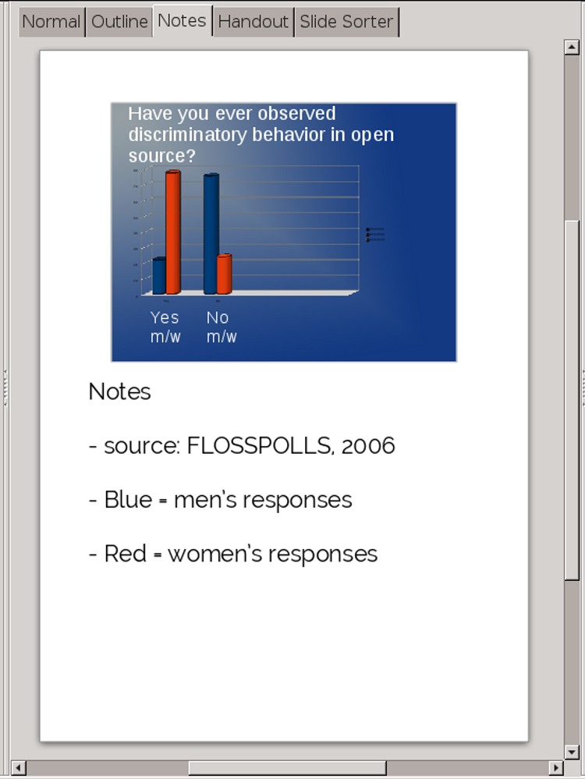
Impress’ Notes tab is for information you want to remember while presenting. Put the information in bullet or number lists to keep yourself from reading the notes.
Unless you are an accomplished speaker, you will sound much worse reading your notes word for word.

Setting presentation options
Most of the options in the Slide Show dialog window are obvious from their description. However, the implications of some are not always clear:
- Like the Hide Font effect, the Range pane is useful for single-sourcing similar presentations in the same file. Within the same presentation, you can store
- several different shows, each for a different audience or circumstance.
- Create custom slides shows from Slide Show > Custom Slide Show.
- Caution
Until you create a custom slide show, the Use Custom Slide Show option is not active.
- Type > Auto sets the time between repetitions of the presentation when it runs unattended.
- The Navigator visible check box gives you another way to move back and forth between slides. However, other formats for switching slides make it unnecessary.
- Presentation always on top floats Impress above any other open windows, preventing you from fumbling in front of your audience. This option can keep you from fumbling in the middle of a presentation when a mouse slips.
- Multiple Displays sets the display on which the presentation runs. Usually, you will need to adjust this option so that the presentation runs on the projector.
Other options are a matter of taste or necessity.
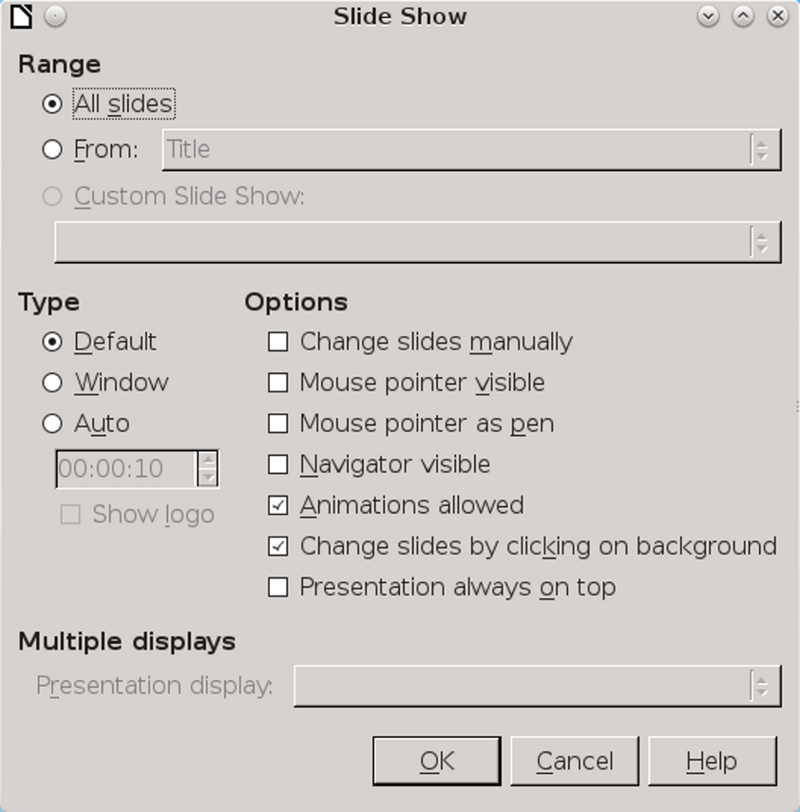
Slide Show > Slide Show options provide the finishing touches to a presentation.

Saving templates
Designing a slide show is not as complicated as designing a document that may be printed. The distance at which slides are seen is very forgiving and obscures details.
All the same, nobody wants to do the same job twice unless they have to. Save your background and structural templates and copies of complete presentations using File > Templates > Save As Template. Even if your next presentation is on an entirely different subject, you can probably cannibalize large pieces of your previous presentations and save yourself time.

Delivering a slide show
Slide design can only do so much to make your presentation effective. Practicing your talk – even how you will move on stage to keep listeners’ attention – is equally important. Having designed an effective slide show, you must also design an effective means of delivery. After having made the effort to create a genuinely useful slide show, you should make sure that your delivery does not ruin your previous work.
In particular, you want to discourage yourself from reading from the screen, and your audience from reading the screen instead of paying attention to you.
If you create your slide show as suggested in this chapter, such problems should be minimized. However, you can reduce potential problems even further if you:
- Always carry a backup of your presentation.
- Create at least a rough outline of how you will deliver your presentation if a slide projector is unavailable.
- Reduce your nervousness by arriving and setting up before the talk starts. The less nervous you are, the less likely you are to let the limits of the medium control the presentation.
- Know your material well enough that you only occasionally need to refer to your notes or slides.
- Continually position yourself (from the audience’s perspective) to the left of the screen you are using for the slide show. If you are speaking in a language that reads left to right, listeners’ eyes are more likely to move toward you.
If you are using a lectern, position it to the left of the screen, if possible. You do not need to stay in that position, but when you start to refer to a slide, move to that position, and keep coming back to it as you continue to discuss the slide. With any luck, you will draw at least some listeners’ attention toward you and what you are saying, and away from the slide.
- Move around as you deliver your presentation in order to distract the audience from looking at the screen. In fact, you can signal changes of topic by changing your position.
- Get somebody else to change slides, or be well-enough rehearsed that you can set the slide show to advance automatically. The less you interact with the slide show, the less likely you are to start reading slides.
With these hints, you should be able to control your slide shows, rather than being controlled by them.

Understanding design constraints
Slide shows are a design challenge with well-defined conditions. Structurally, the conditions
mean that building a presentation is a contest in which either you succumb to the internal logic of the form, or learn how to make the conditions serve your own purposes. Aesthetically, the conditions mean that the choices are heavily constrained, which can help you learn more about design.

