2

Going in style
You have two ways to design a document in LibreOffice: by manual formatting and by applying styles. Or, as I like to joke: the wrong way and the right way.
Manual formatting (also called direct formatting) is how most people design a document. When you format manually, whenever you want to change the default formatting, you select part of the document – for example, a paragraph or a page – and then apply the formatting using the tool bars or one of the menus.
Then you do the same thing all over again in the next place that you want the same formatting. And the next, and the next.
If you decide to change the formatting, you have to go through the entire document, changing the design one place at a time.
Manual formatting is popular because it requires little knowledge of the software. In effect, you are using the office application as though it were a typewriter.
But although this approach gets the job done, it’s slow. Not only that, but many features are awkward to use when you format manually – assuming you can use them at all.
By contrast, a style is a set of formats. For example, a character style might put characters into italics if they form the title of the book. A page style might list everything about how a page is designed, from the width of its margins to its orientation and the background color.
The advantage of styles is that you design everything once. Instead of adding all the characteristics every place where you format, you apply the style.
If you decide you want a different format, you edit the style once, and within seconds, every place where you applied the style has the new format as well.
You don’t have to remember the details of the formatting, either – just the name of the style.
- Example: Formatting with styles
To fully appreciate the difference between formatting manually and formatting with styles, imagine that you are preparing a twenty page essay for a university class. You have decided to use the DejaVu Serif typeface with a size of 10 points. Twenty
minutes before you leave for class, you re-read the professor's instructions and realize that she only accepts essays in 12 point Times New Roman.
If you have manually formatted, you will be lucky to finish editing before you leave. But if you have used styles, you can change the font and its size in less than a minute, and print out a new copy of the essay with time to spare.
Then you can save the document as a template. The next essay you write for that professor, you can concentrate on content and not have to worry about formatting.
Other advantages of styles? You can mostly eliminate the need for tabs, especially at the start of a new paragraph, because you can create a style that automatically indents for you.
Similarly, instead of creating a separate frame for a section formatted differently from the rest of the document, you can include the different format in a set of styles and keep typing.
Another major advantage is that if you use heading styles, you can use them as bookmarks in Navigator to help you move around in a document. But unlike normal bookmarks, you don’t have to define them in a separate task. Instead, headings are available for use the moment that you set the styles.
In the same way, headings let you generate a table of contents with a minimum of settings. Separate headers and footers for different pages are easier to maintain. You can give a uniform look to the frames around photos you add, set up a drop
capital to mark the start of a new chapter, and automatically change page layouts, freeing yourself to focus on content.
However, the real saving comes when you save your design as a template. Once you have created your basic templates, the next time you start a document, you won’t have to think about formatting at all – instead, you can open the template and start writing. Usually, the more you use styles, the more time you save.
Amazingly, some users view styles as an intrusion on their rights to work as they please. Of course they can do as they like, but not using styles means they work harder than necessary.

Debunking myths about styles
People who have never used styles often have bizarre ideas about them. Sometimes, these ideas may be excuses to rationalize not using styles, but often they are misunderstandings.
Here are some of the most common myths about styles that are repeated whenever the subject of manual formatting vs. styles is discussed:
Myth about styles | Reality
- Styles impose on users’ right to work the way they choose. | - You can work without styles. But why demand the right to inconvenience yourself?
- Styles are hard to learn. | - Styles represent a different way of thinking than manual formatting. However, you can learn their basic concepts in ten minutes.
- Styles are for programmers, not ordinary users. | - Styles are for anybody who wants to work efficiently. Actually, just as many programmers format manually as anyone else.
- Styles require you to memorize their names. | - You don’t need to memorize anything. You just need to read from the lists of styles in LibreOffice.
- What you set in styles applies to all the document, so styles more limited than manual formatting. | - A style affects only the parts of a document to which you apply it.
- Styles are too complicated. | - You don’t need to understand every feature of every style. Often, you can just accept the defaults.
- Styles are limiting. You can’t change what’s built into them. | - Most aspects of styles can be fine-tuned, toggled on or off, or ignored until you need them. You can’t do anything manually that you can’t do with styles much more easily.
- Styles can conflict with each other. | - Only one style of a particular type can apply to a selection. You can have a character and a paragraph style applying to the same selection, but not two different character styles or two different paragraph styles.
- Manual formatting is preferable because you can make changes on the fly. | - You can change styles on the fly, too. In fact, changing styles is quicker; you only have to make a change once to apply it through the entire document.
- Example: Styles save time
Just how much time do you save by using styles? Let's imagine that you have a heading paragraph that you want to format extensively.
Specifically, you want to set the font, font size, font weight, font color, and the space above the paragraph. In addition, you want to edit the heading so that it starts with a number.
The shortest way to make these changes manually is:
Steps | Action
1 | Highlight the text of the header.
2–4 | Open the font list in the tool bar, scroll, and select the font.
5–-6 | Open the font size in the tool bar, scroll, and select the font size.
7 | Select font weight from the tool bar icon.
8–9 | Open Font Color in the tool bar and select the color.
10–14 | Select from the menu Format > Paragraph > Indents & Spacing, edit the Space Above field, and click OK.
15 | Add a numbered list from the tool bar.
If you are lucky, you might save a few actions if you don’t have to scroll for a setting, but this series of steps is a good average. You would have to repeat these steps, of course, for every header in the document.
By contrast, setting up a style would take 21 steps. Once the style is ready, here's how you would make the same changes using styles:
Steps | Action
1 | Place the cursor anywhere in the header paragraph.
2 | Press F11 to open the Styles and Formatting floating window.
3 | Change the display in Styles and Formatting to All Styles (or another view that shows the style you want).
4 | Scroll to the paragraph style you want.
5 | Select the paragraph style.
This example is extremely conservative. If you are using styles, then probably the Styles and Formatting window is already open. Often, too, you may not need to change the view.
However, even being conservative, applying the style requires one-third the number of actions than making the changes manually. When you change one paragraph’s style, you also change every other use of the style in the same document. That means that if the document has more than two instances of the heading, using styles saves you effort.

When should you use styles?
The short answer is, “Whenever it saves time.” Still, in practice, even experts sometimes use manual formatting in certain circumstances.
Format manually if: | Use styles if:
- The document is short (1-2 pages), and you have no templates that you can use. | - The document is long (over 3 pages).
- The document will be used once and never reused. | - The document is going to be used over and over.
- The document will only be edited by a single person. | - The document will be edited by more than one person.
- Any editing will only take place within a few days of finishing the document. | - The document will be edited weeks, months, or even years after the first version.
- Some people who will edit the document have no idea how to use styles, and refuse to learn. | - The document belongs to a standard class of documents, such as a letter, a fax, or memo.
- A consistent format doesn’t matter for some other reason. For example, the document is informal, and won’t affect your company's branding. | - The document design must match that of other documents from you or your company or organization.
- You are experimenting with styles while building a template. Until you finalize the styles, you will make so many changes that creating styles is mostly wasted effort. | - You want to use the document in a number of different ways, each of which requires some minor changes: for example, printing it on both a white and a red background.
- The document’s formatting is extremely simple and regular, like an essay. | - The document is highly formatted, like a brochure.
The more circumstances that apply, the clearer your decision.
However, even if all indications are to use manual formatting, check the templates you have saved. You may find one close enough to your needs to re-use.

The types of styles
Most office suites confine themselves to paragraph and character styles in their word processors. However, LibreOffice adds three more styles in Writer (plus a pseudo-style for tables), and other styles for spreadsheets, presentations, and diagrams.
These additional styles greatly extend what LibreOffice can do. They make Writer less a word processor than an intermediate desktop publishing tool. Writer may not have all the precision of a tool like InDesign, but it compares favorably with a tool like FrameMaker for text-heavy documents. In fact, I know of several publishers who use Writer for designing their books.
Admittedly, styles are less useful in other applications. The layout in their files tends to be less uniform than in Writer. However, in other applications, styles do help to centralize frequently used settings, which is a benefit by itself.
The styles available are:
Style | Comment
Writer
Paragraph | Paragraph styles are the most commonly used style. A paragraph begins and ends when you press the Enter key. Common paragraph styles include those for body text and headings. Equivalent to manual formatting with Format > Paragraph, plus some extras.
Character | Character styles modify selected letters in a paragraph style. Common character styles are bold lettering for emphasis, italics for a book title, and underlining and a different color for a web link. An exact equivalent to manual formatting with Format > Character.
Frame | All objects inserted to a Writer document are contained by a frame. By customizing Frame styles, you can automatically adjust elements such as the border around objects and how text flows around them. Right-click on a selected frame for the manual equivalent.
Page | Page styles are the most reliable way to format pages differently, including headers and footers and footnotes. The main drawback is that you cannot easily set an object to reoccur on every page that uses the same page style. Exact equivalent to manual formatting with Format > Page.
List | Styles for configuring bullet lists and numbered lists. List styles can be applied directly to a list, or, more elegantly, associated with one or more paragraph styles. Equivalent to manually formatting with Format > Bullets and Numbering.
(Tables) | Technically, Writer has no table styles. However, you can save and apply table designs in a style-like way by selecting Table > AutoFormat > Add.
Calc
Cell | Cell styles set both the appearance of cells and the types of content in them, such as percentages or currency. They also can automatically set the number of decimal places used by the cell, and automatically wrap and hyphenate the contents of a style.
Page | Page styles set how to arrange selected sheets or cells to print to paper.
Draw & Impress
Graphic | Styles for drawing objects, including graphic text.
Presentation | Styles for the contents of slides (Impress only).

Working with styles
To open the Styles and Formatting window, do one of the following:
- Select Format > Styles and Formatting from the menu bar.
- Press the F11 key.
- Click the More... link at the bottom of the style list in the Formatting tool bar.
- Select the Styles and Formatting button on the sidebar.
- Tip
You can also highlight an entry in the tool bar’s style list and select Edit to open the style’s dialog window.
In LibreOffice releases before 4.4 and in Apache OpenOffice, you can click the first icon on the left on the Formatting tool bar (the bottom default tool bar).
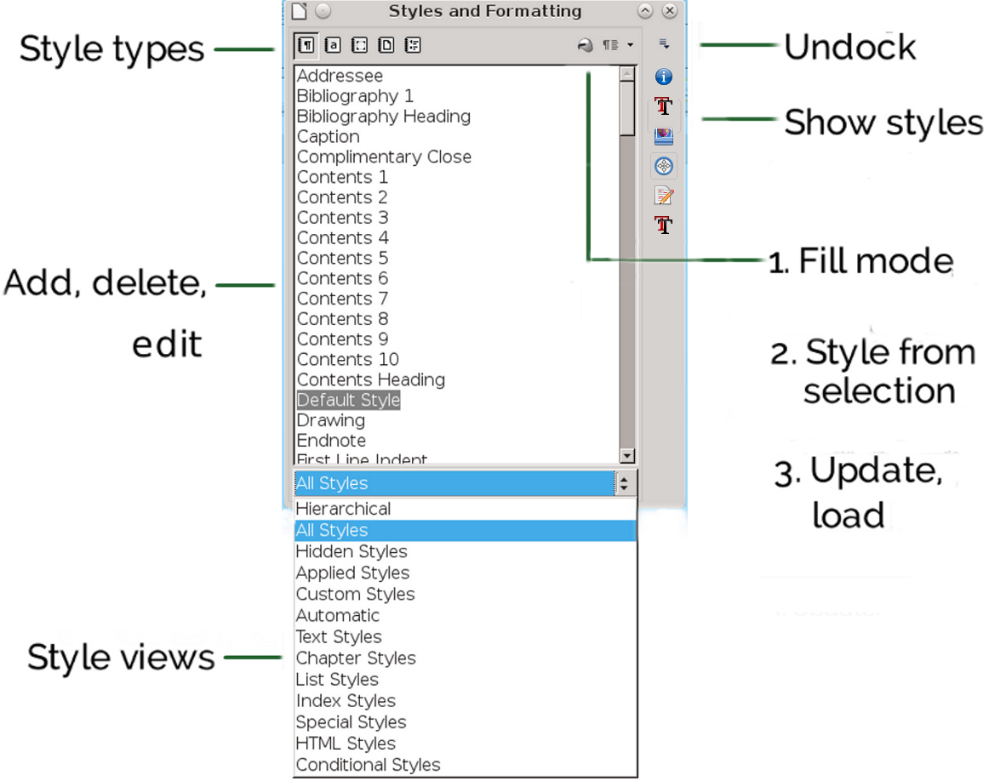
Writer’s version of the Styles and Formatting window.

Undocking the Styles and Formatting window
Until LibreOffice version 4.4, the Styles and Formatting window opened as a floating window. The floating window could be placed anywhere on the screen, or dragged to be docked on either side of the editing window. However, starting in version 4.4, it opens in the sidebar.
To undock the window (or any other display in the sidebar), click the drop-down list of commands on the top right of the tool bar and select Undock. When the window is undocked, select Dock from the drop-down list to redock it. LibreOffice remembers
whether the window is docked or undocked when you restart it.
- Tip
The sidebar remains undocked, even after you exit and restart LibreOffice.
In OpenOffice and many earlier LibreOffice versions, drag the floating window by its title bar to the left or right edge of the editing window. When a frame appears, release the floating window, and it is docked. Dragging on the title bar of the docked window should undock it, although the reliability of the feature varies with the release.

Changing the style type
On the top left of the window are icons for each type of style. If you hover the mouse over them, you will see what type of style each icon represents. Click an icon to display the styles for its particular type.
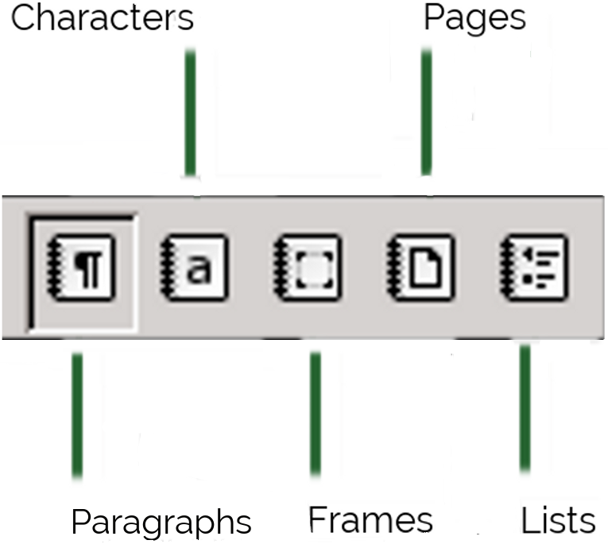
The types of styles in Writer. Paragraph styles are currently selected.

Viewing styles
Because the list of styles is long, the drop-down list at the bottom of the window has filtered views that need less scrolling.
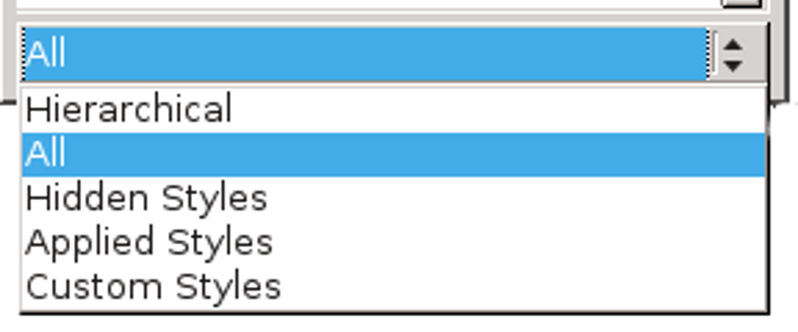
Style views filter the styles that display.
The best view depends on what you are doing. For example, when you are designing, the Hierarchical view helps you work with related styles. By contrast,
after you have written a few pages, the Applied Styles view minimizes the styles displayed.
The basic views vary with the application. The most common ones are:
- Hierarchical: Shows how styles are related to each other (See “The hierarchy of styles,” page 16). Helps you decide where to make changes in multiple styles by editing just one of them.
- Applied Styles: The styles used in the current document. This view is useless with a new document, but as you continue to work, it reduces the number of styles displayed.
- Custom Styles: The styles you have created, as opposed to the pre-defined ones.
- Automatic: A minimalist list of pre-defined styles. Automatic is the default view when you open a new document.
- All Styles: Especially when you are viewing paragraph styles, the All Styles view can give you so many names to scan that using it is counter-productive. Use All Styles only when you are completely unable to find the style you want.
- Hidden Styles: Styles you have removed from the other views to reduce the clutter.
Paragraph styles have a number of additional views. Most are self-explanatory divisions of the uses for styles, such as HTML Styles and Index Styles.
Styles that don’t fit into any other category, such as Caption, Footer Left, or Table Contents are listed as Special Styles.
- Tip
The HTML view shows the paragraph styles that LibreOffice has mapped directly to specific HTML tags.

Finding current styles
The Styles and Formatting window always opens with the style for the current cursor position highlighted. If you change the type of style displayed in the Styles and Formatting window, then the highlighted style also changes, if possible.
For example, if you are using the Text Body paragraph style and switch the display to character styles, ordinarily the Default Style will be highlighted. However, if you switch to the list styles, nothing will be highlighted unless the cursor is at a position where a list style is being used.
In Writer, you can identify current styles in other places in the editing window. When closed, the list of paragraph styles on the Formatting tool bar always displays the current style.
Similarly, the current page style is shown, third from the left, in the indicators at the bottom of the editing window. As you scroll through a document, it is updated automatically.
In addition, you can select Edit > Find & Replace > Other Options > Search for Paragraph styles to locate where a style is used in a document. Finding character styles is not directly possibly, but Find & Replace’s Other Options do include search by settings of character styles using Attributes and Format.
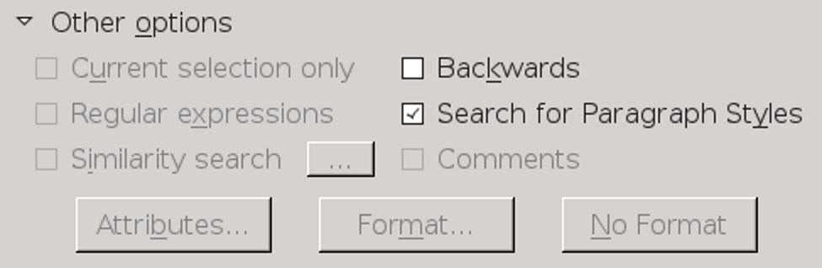
Search for Paragraph Styles is an essential option for editing format and structure.

The nature of styles
LibreOffice has pre-defined styles that you can modify but not delete. In each style type, especially paragraph and character styles, the pre-defined styles are well thought out, and might be all that you need. In fact, one school of thought holds that you have less trouble if you use only pre-defined styles, even though that may limit your designs. Whether that is true is uncertain, but the pre-defined styles are useful references for what you can do with styles.
In addition, you can create custom styles that are based on pre-defined ones, or entirely new ones by clicking on any pre-defined style. Custom styles provide the specialized needs that the pre-defined styles do not.
Both custom and pre-defined styles behave similarly. Understanding their behaviors is essential for working with all styles.

The hierarchy of styles
Many styles in LibreOffice are hierarchical (although for some reason a few, such as List styles, are not). In other words, they are ordered in a tree, with each style taking its characteristics from the one at the top and modifying some of them.
A style that is one level above another is called the parent of the style directly below it. Similarly, styles that are one level below another one are called its children. Changing a parent style also changes its children.
This relationship can be confusing, especially the first time a style apparently changes its characteristics spontaneously. However, by making changes to the parent, you save the time you would spend changing its children one at a time.

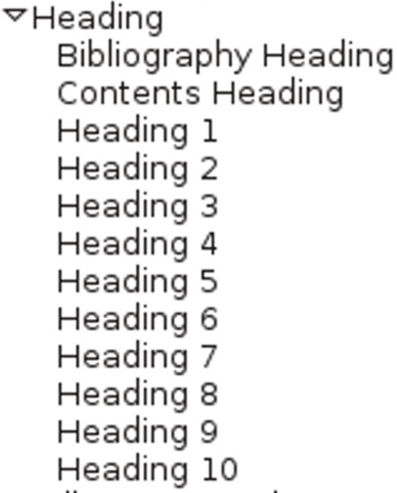
A style hierarchy for paragraph styles in Writer. Changes to the Heading style will change all the styles below it.

Changing the style hierarchy
You can manipulate the style hierarchy using the Inherit from field on the Organizer tab. The style inherited from is the current style’s parent – the style from which the current style inherits characteristics.
- Tip
In Apache OpenOffice and earlier LIbreOffice releases, the Inherit from field is called Linked with.
Sometimes, you may want to use the field to set an arbitrary parent. For example, if you created two paragraph styles for bullets, differing only in the list style each used, you could save time by setting one of the styles as the parent of another. Either one would do – the point is to make changes only once, not twice.

The Default styles
The only styles that do not have a hierarchical parent are those at the top of the entire tree. In paragraph and character styles, this style is called Default. All other styles of the same type are based upon the Default style.
You can choose to edit the Default style so that it includes the basic formatting you have chosen for the document. Alternatively, you can leave the Default style unchanged, so that you can exchange documents easily with people on other machines.
This second choice is not always possible because different versions of LibreOfice may set different Default styles, but is worth trying. In effect, this approach uses another style such as Text Body as an unofficial default, leaving the Default style to function like Format > Clear Direct Formatting.
Either way, the Default styles are useful when pasting formatted text from inside or outside the current document creates formatting problems.
The easiest way to solve these problems is to strip out most of the formatting by applying the Default character and/or paragraph style, then to apply the formatting you want.
- Tip
Lists sometimes leave bullets or numbers behind after you apply the default paragraph style to them. When that happens, press the Backspace key until the bullet or number disappears.

The Organizer tab
The window for each style throughout LibreOffice is divided into tabs. Many tabs, such as the Border and the Area tabs, display identical features throughout LibreOffice; so, in later chapters, the book gives cross-references to prevent repetition.
Of all the tabs, the Organizer tab is most important. It summarizes the style and its relation to other styles.
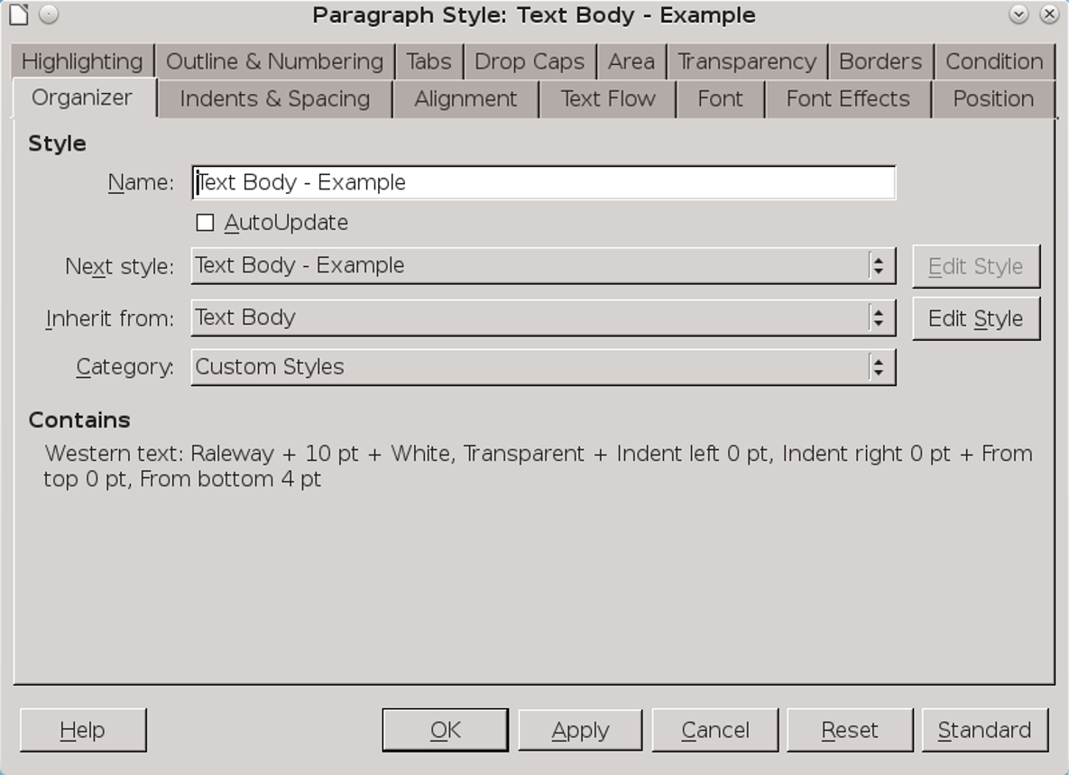
To change a style’s parent, change the Inherit from field on the Organizer tab (may be called Linked with).
The Organizer tab can include four fields:
- Name: The entry that appears in the Style and Formatting window. It should be descriptive or suggest the style’s function.
- Next Style: The style that is automatically used next when you press the Enter key. For instance, Heading 1 is often followed by Text Body. Since a heading is almost never followed immediately by another heading, this is a reasonable choice. By contrast, Text Body’s Next Style is usually Text Body, because several paragraphs in a row are likely to be text.
- Inherit from (Linked With): The parent style in the hierarchy. Changes to the parent style will change the current style, so you don’t have to make changes to every related style.
- Category: The view in which the style is listed. By default, styles you create are displayed in Custom Styles, but you can choose any other view instead.
- Tip
You can sometimes make a view more effective by changing which category each of your custom styles displays in.
In addition, the Organizer tab shows a summary of all the formatting options selected for the style, similar to the one that WordPerfect gives.
The fields in the Organizer tab are grayed-out in types of styles where they would make no sense. For example, two frames seldom occur one after the other, so a Frame style window omits the Next Style
category. Similarly, the Category field is grayed out, because only one view is necessary for frames.

Applying styles
To apply a style, you must select part of the document. A paragraph or page is selected when the mouse cursor is anywhere in or on them, but frames or drawing objects must be selected by clicking in them so the frame and its eight handles displays. You can also drag the mouse to select multiple paragraphs or spreadsheet cells.
You have several options for applying a style: the Styles and Formatting window, the Formatting tool bar, Fill Format mode, pasting from your system’s clipboard, and applying keyboard shortcuts.

Using the Styles and Formatting window
With the Styles and Formatting window open, you can apply a style with a single mouse-click – or maybe two as you select another style category to list.
For many users, the Styles and Formatting window is the most efficient way to apply styles. Some users keep it docked in the sidebar, which can mean that a maximized window is necessary, depending on the size of your monitor.
If you prefer not to work in maximized windows, undock the window and place it where it is close enough to the editing window to minimize mouse
motions, but far enough away that it doesn’t block what you are doing.
Starting with version 5.0, the Styles and Formatting window shows a preview of the current font formatting. This preview is useful when dealing with character styles, but omits most of the information in a paragraph or a list style. With frame and page styles, it is mostly a distraction.

Using the Formatting tool bar
In Writer, you can apply paragraph styles to a selection by opening the drop-down list of styles that is on the left on the Formatting tool bar (the default bottom tool bar).
- Tip
When applying a style, always click on the left of a list item. Otherwise, you risk being entangled in the menu.
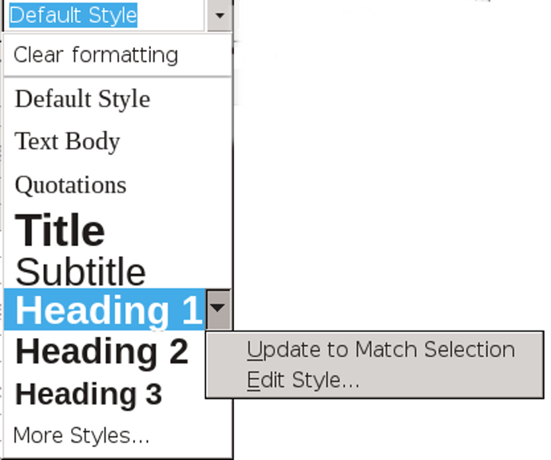
The styles list in the Formatting toolbar.

When you first open a document, the list includes only a half dozen commonly used styles. Gradually, though, other paragraph styles are listed as they are used in the document. Clicking the More Styles... link at the bottom of the list opens the Styles and Formatting window, while selecting Edit Style from a style’s drop-down menu opens the dialog window for the style.
Similarly, Update to Match Selection edits the style based on the formatting of the text you select before opening the drop-down list.
The list has the advantage of offering a preview of each paragraph style. Unfortunately, that preview is only the name of the style, which means that many formatting elements are not shown in the preview.
Consequently, the list is a limited tool at best. At most it serves as a reminder of what the style looks like.

Using Fill Format Mode
With the Styles and Formatting window, you also have the option with some style categories of reversing the basic application technique, choosing the style first, and where to apply it second. When applying character styles, it is almost like painting with the cursor, as its icon in the Styles and Formatting window suggests.
To use Fill Format:
- Select a style.
- Click the Fill Format Mode button (the second from the right at the top of the Styles and Formatting window).
When Fill Format is available, the cursor changes to a paint bucket.
If the button is grayed out, you cannot use Fill Format with the style category selected.
- Drag the cursor over the part of the document you wish to format. You need to drag the cursor for only a few characters to apply the style to a paragraph or a page. However, to apply a character style, you need to drag the cursor across all the characters you plan to format.
- Click the Fill Format Mode button a second time to turn the mode off.
- Caution
Right-clicking anywhere in a document when Fill Format Mode is turned on stops it from being applied.

Pasting styles
The rules for copying and pasting styles are simple regardless of whether you use Paste or Paste Special, or are copying from one document to another:
- When source material formatted in a style with the same name as a style in the target is copied into a paragraph, then the target’s style is used.
- When source material formatted in a style not in the target is copied into a new paragraph, then the formatting is kept and the style name is added to the target document.
- Any formatting done manually or with a character style in the source is copied wherever it is pasted.
These rules hold true for all types of styles.
They also hold true for any Open Document Format file, including those created in Apache OpenOffice or Calligra Suite, the free office program designed for the KDE desktop.
You can remove most of this formatting by selecting Clear formatting from the top of the drop-down list of paragraph styles on the Formatting tool bar.
Unfortunately, some of the original formatting, including the text color and any underlining, sometimes remains when available system memory is low. When it does, applying the Default character style may remove it. If some formatting still persists, retype the material.
- Tip
When you paste material, click the arrow beside the Paste icon in the top toolbar and select Unformatted text. The extra step may prevent formatting difficulties.

Applying styles using keyboard shortcuts
Pressing Ctrl+1 ... Ctrl+10 applies the Heading 1-10 styles. These shortcuts can be useful in documents such as an outline, in which you are using only Heading paragraph styles. You can set keyboard shortcuts for other styles from Tools > Customize > Functions > Styles.
Keyboard shortcuts can save stress on your wrists and hands when you are typing for long periods, so you may want to record additional macros and assign them to keyboard shortcuts. The Default Style and Text Body paragraph styles are likely candidates for macros, and so are the Emphasis and Strong Emphasis character styles.
- Caution
To record macros in LibreOffice, you first need to select Tools > Options > LibreOffice > Advanced > Enable Macro Recording (Limited). The menu item Record Macro is then listed under Tools > Macros without any need to re-start LibreOffice.

Creating and modifying styles
LibreOffice has styles for most ordinary purposes, so one way to save time is to use only pre-defined styles, changing no more attributes than necessary. On the whole, the styles have intelligent defaults, and you usually only have to make a few changes while designing.
However, if you decide to edit styles, you have several options in Writer:
- Right-click on a style in the Styles and Formatting window and select New to create a style that clones the selected style (in other words, one that is a child of the selected style in the hierarchy). Be sure to rename it immediately. If you forget to rename, you can find the new style at the bottom of the list of styles, named something like Untitled1.
- Right-click on a style in the Styles and Formatting window and select Modify to edit the selected style.
- Manually format and select part of the document. Open the drop-down list on the top right of the Styles and Formatting window and select New Style from Selection. This option is handy for creating styles on-the-fly or if you have a hard time visualizing settings while you are planning a design.
- Select a passage and drag it to the Styles and Formatting window when it displays paragraph or character styles. A dialog window opens so that you can give the new style a title.
- Select the AutoUpdate check box on the Organizer tab of a style. When this box is selected, any manual formatting you do automatically updates the style.
- Edit styles from the tool bar. In LibreOffice 4.4 and later, you can update styles by highlighting part of the document, then selecting a style in the tool bar’s drop-down list and clicking Update to Match Selection.
- Caution
Only select AutoUpdate if everyone editing the document uses styles. Otherwise, the result could be stylistic chaos. In fact, when using styles, discourage any editors from doing any manual formatting.
You also have the option of copying styles from a template into the current document. See “Error: Reference source not found,” page Error: Reference source not found.
- Tip
LibreOffice usually updates its styles in a matter of seconds. However, if you make enough changes quickly enough, it may fail to keep up, especially on machines with minimal memory.
If problems continue, try selecting Update Style from the drop-down list on the right of the Styles and Formatting window after working on each style. If you continue to have problems, closing and reopening the document should solve it.

Hiding and deleting styles
Hiding styles reduces the clutter in the Styles and Formatting window. To hide a style, select Hide from the right-click menu, one style at a time. If you need to use the style again, you can restore it from the Hidden Styles view.
A custom style that is no longer needed can be deleted using the right-click menu. You cannot delete a pre-defined style. Styles installed from an extension can only be deleted by removing the extension in Tools > Extension Manager.
- Caution
LibreOffice warns that a style is in use, but does not stop you deleting it. The default style replaces a deleted one.

Naming styles
Especially in Writer, styles are named for their functions, followed by their position in the file hierarchy. For instance, User Index1 is the paragraph style for the first level of text in an index. Similarly, character styles include Emphasis and Internet Link.
Other names for pre-defined styles are descriptive, such as Object without fill in Draw.
- Tip
Since you will probably be using at least some pre-defined styles, you may decide to use the same conventions for custom styles.
However, to save yourself scrolling endlessly through the Styles and Formatting window, consider prefacing any custom styles with “C-” or some other unique preface. That way, you can easily find and apply custom styles without having to change the view.
In Writer, you sometimes find that you use different categories of styles in the same design. For example, a list style can have a character style associated with it so that you can have colored bullets or numbers. In addition, the same list style can be assigned to a paragraph style so that it is used whenever you choose the paragraph style. To help you find each of these styles later, give them the same name. Since each is in a different category, neither you nor LibreOffice should confuse them.

Automating style application
In most documents, some styles follow one another in a set pattern. A Title paragraph style is usually followed by a Subtitle, and a Text Body paragraph style by another Text Body. A First Page style is usually followed by a Left Page, which is followed by a Right Page.
You can take advantage of such patterns by filling in the Next Style field on the Organizer tab. With
some types of styles, such as lists, having a Next Style makes no sense, and the field is grayed out. But with the Next Style field filled in, just starting a new paragraph or page will automatically apply the next style without your hands leaving the keyboard.

Another way of writing
Don’t be surprised if you need time to get used to the idea of styles. Using styles involves more planning beforehand than manual formatting. Yet the basic concepts are straightforward, and already you might be starting to see how styles can automate formatting.
In the next chapter, you’ll see how templates can help you recycle document designs to save you even more time.

