Battery Upgrade Process
1.Connect the battery to the computer by an (RS485 to USB cable)
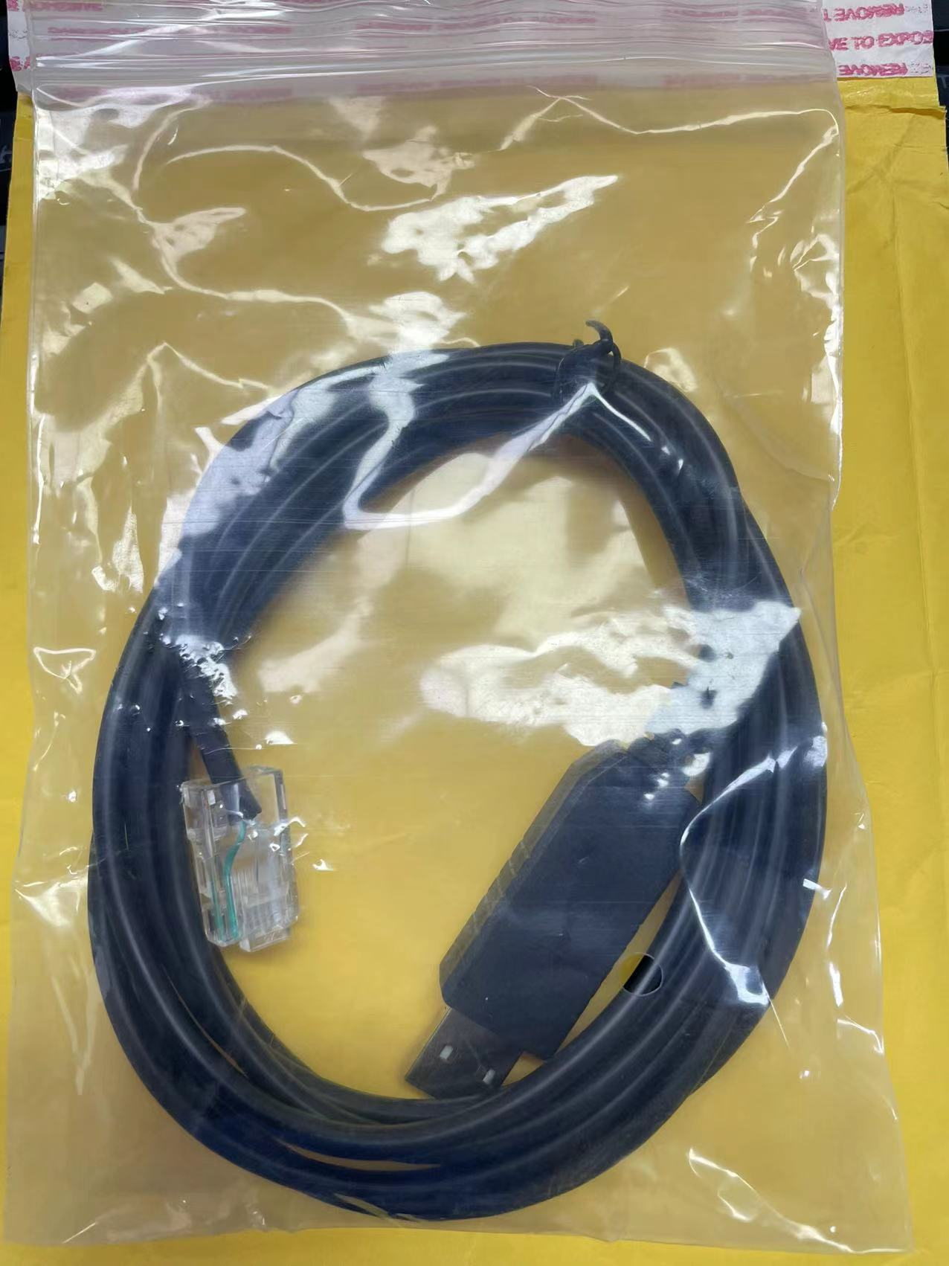
2.Open file 1 and install the upgrade software
3.Turn on the battery DIP switch 1
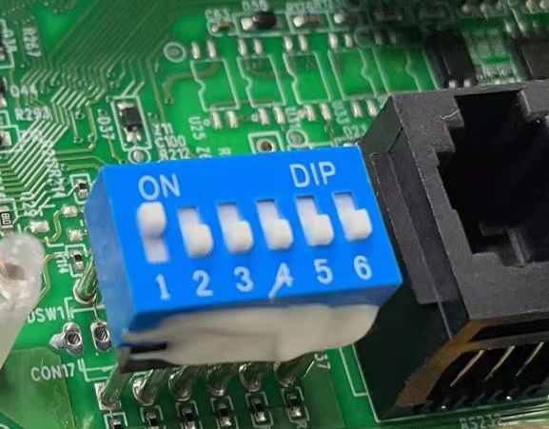
4.Open Video 2 to check the operation process. The software in the video is Chinese version,
but the operation can be completed according to software 1 of the video process. It is very easy.
5.During operation, upload code 3, which is the battery upgrade code
6.After the upgrade is complete, connect the battery to the inverter, battery dip 5 and 6 for SMA
Turn on the 5 and 6.
