PocketPrune
Edge LLM Compression & Deployment Toolkit
Software Requirement Specifications
Bachelor of Science in Computer Science (BSCS)
By

 | Name | Registration # | Mobile # | E-Mail
1 | Sibghatullah | Fa-23/BSCS/352 | 0319-1939658 | fa23-bscs-352@lgu.edu.pk
2 | Huzaifah Saleem | Fa-23/BSCS/361 | 0349-1173759 | fa23-bscs-361@lgu.edu.pk

Supervised by Co-Supervised by

______________________ ______________________
Ms. Hafsa Tahir Ms. Unaisa Batool



Department of Computer Science
Lahore Garrison University
Lahore
Table of Contents
1. Introduction 4
1.1 Purpose 4
1.2 Document Conventions 4
1.3 Intended Audience and Reading Suggestions 4
1.4 Product Scope 4
2. Overall Description 5
2.1 Product Perspective 5
2.2 Product Functions 5
2.3 User Classes and Characteristics 5
2.4 Operating Environment 6
2.5 Design and Implementation Constraints 6
2.6 User Documentation 6
2.7 Assumptions and Dependencies 7
3. External Interface Requirements 7
3.1 User Interfaces 7
3.2 Hardware Interfaces 7
3.3 Software Interfaces 8
3.4 Communications Interfaces 8
4. System Features 8
4.1 Model Catalog and Device Profiles 8
4.1.1 Description and Priority 8
4.1.2 Stimulus/Response Sequences 8
4.1.3 Functional Requirements 9
4.2 Job Setup and Preflight Checks 9
4.2.1 Description and Priority 9
4.2.2 Stimulus/Response Sequences 9
4.2.3 Functional Requirements 9
4.3 Conversion, Quantization and Validation Pipeline 10
4.3.1 Description and Priority 10
4.3.2 Stimulus/Response Sequences 10
4.3.3 Functional Requirements 10
4.4 Benchmarking and Perplexity Evaluation 10
4.4.1 Description and Priority 10
4.4.2 Stimulus/Response Sequences 11
4.4.3 Functional Requirements 11
4.5 Rule-Based Recommendation 11
4.5.1 Description and Priority 11
4.5.2 Stimulus/Response Sequences 11
4.5.3 Functional Requirements 11
4.6 Progress, Results, History and Downloads 12
4.6.1 Description and Priority 12
4.6.2 Stimulus/Response Sequences 12
4.6.3 Functional Requirements 12
4.7 User Access and Mobile Companion App 12
4.7.1 Description and Priority 12
4.7.2 Stimulus/Response Sequences 13
4.7.3 Functional Requirements 13
5. Other Nonfunctional Requirements 13
5.1 Performance Requirements 13
5.2 Safety Requirements 13
5.3 Security Requirements 13
5.4 Software Quality Attributes 14
5.5 Business Rules 14
5.6 Detailed Subsystem Design 14
References 19

1. Introduction

1.1 Purpose
This document specifies the software requirements of PocketPrune – Edge LLM Compression & Deployment Toolkit, Release 1.0, the Final Year Project of the BSCS programme, Department of Computer Science, Lahore Garrison University. It covers the complete system: the React web dashboard, the companion mobile app, the Node.js/Express back end with MongoDB, the background job queue and worker, the evaluation engine and the rule-based recommender. It also fixes the items the approved proposal deferred to the SRS: the reference hardware and size limit, the tested model catalog, the quantization levels, the job queue, the database and the mobile framework.

1.2 Document Conventions
The document follows the departmental SRS template (based on IEEE Std 830-1998 [15]). Body text is Times New Roman 12 pt; commands, file names and endpoints are written in monospace. Each functional requirement has a unique tag REQ-n and its own priority (High, Medium or Low); priorities are not inherited from the feature. "Shall" marks a mandatory requirement and "should" a desirable one. Quantization levels use llama.cpp names: F16 (unquantized baseline), Q5_K_M (5-bit) and Q4_K_M (4-bit).

1.3 Intended Audience and Reading Suggestions
The SRS is intended for the supervisor and co-supervisor and the FYP evaluation committee (scope and feasibility: Sections 1, 2 and 4), the two developers (all sections, especially 3–5), testers and peer users (the REQ statements in Section 4 and the measurable requirements in Section 5) and end users (Sections 1.4, 2.2 and 2.3). Section 2 gives the overall description, Section 3 the external interfaces, Section 4 the system features and functional requirements, and Section 5 the non-functional requirements and detailed design diagrams. Readers new to the project should read Sections 1 and 2 first.

1.4 Product Scope
Even "small" open language models have billions of parameters and need several gigabytes of memory [1]. Quantization can shrink them substantially [2], [3], and llama.cpp [4] with the GGUF format [5] makes this possible on an ordinary CPU, but the workflow is manual: find a compatible model, convert it, choose a level, check that it loads and measure the result. PocketPrune turns this into one guided web and mobile application. It does not create new models or a new compression algorithm; it automates a tested route, detects problems before they happen and reports measured trade-offs so users can choose the right model for their device.
Objectives: (1) a catalog of tested small models convertible to GGUF and quantizable to 4-bit and 5-bit levels; (2) automated download, conversion, quantization and smoke testing; (3) measurement of file size, speed, memory and perplexity shown side by side; (4) a rule-based recommendation for the user's device, evaluated against simple baselines; (5) evaluation of the toolkit's reliability and usability. Out of scope: arbitrary model uploads, GPTQ [8], AWQ [9], pruning [10], multi-cloud GPU support and model training. PocketPrune is a learning and research prototype, not a production service.

2. Overall Description

2.1 Product Perspective
PocketPrune is a new, self-contained product that acts as an orchestration and decision-support layer on top of llama.cpp. It has three layers (Figure 3): a presentation layer (web dashboard and mobile app) that talks only to the back end through a REST API; an application layer with the Express API service, a MongoDB-backed job queue and an independent Node.js pipeline worker; and a data and tool layer with the MongoDB database, the model files on disk, a pinned llama.cpp build and a fixed copy of the WikiText-2 test split [13]. The only external system is the Hugging Face Hub, from which catalog models are downloaded.

2.2 Product Functions
- Browse a curated catalog of tested models and describe the target device in a device profile.
- Configure a job and run preflight checks (catalog, disk, RAM, licence, tool version) before any download.
- Download, convert to F16 GGUF, quantize to Q5_K_M/Q4_K_M and smoke-test every file in the background.
- Measure file size, speed (tok/s), peak memory and perplexity, and recommend the best variant for the device.
- Follow live progress, cancel or retry jobs, compare results, export reports, view history and download files.
- Access catalog, jobs, progress and results from the companion mobile app.

2.3 User Classes and Characteristics
Students and developers (primary): basic ML knowledge, mid-range laptops, unfamiliar with llama.cpp commands; use catalog, jobs, results and the mobile app. Researchers and lab instructors (primary): need repeatable comparisons and exported data. Small companies and startups (secondary): want lower hosting cost; mainly use recommendations and downloads. Administrator (essential): a team member or lab staff with high technical skill who maintains the catalog, storage and deployment. Supervisors and evaluators read results through a normal user account.

2.4 Operating Environment
The server runs on one machine: an x86-64 CPU with AVX2 (4 cores or more), 16 GB RAM and an SSD with at least 80 GB free, using Windows 11 (64-bit), Node.js 20, MongoDB 7 and a pinned llama.cpp build (Python 3.11 is used only to run its conversion script and the Hugging Face download tool). The web client runs on the latest Chrome, Edge or Firefox; the mobile app runs on Android 10+ (and iOS 15+ where an Expo build is available). Clients reach the server over the LAN by default; for the final showcase the system may optionally be deployed on free hosting tiers. The server needs outbound HTTPS to huggingface.co. This hardware sets the catalog limit to 4 billion parameters (F16 file ≤ 8 GB). A GPU, if present, is not used for reported measurements.

2.5 Design and Implementation Constraints
- Conversion, quantization and evaluation shall use llama.cpp and GGUF only; one llama.cpp release is pinned at the end of Phase 1 and recorded in every report.
- Supported levels are F16 (baseline), Q5_K_M and Q4_K_M; Q8_0 is optional. Only catalog models in safetensors format are accepted.
- Technology stack (MERN): MongoDB with Mongoose (data and job queue), Express on Node.js 20 (API and worker), React 18 + Vite with a shared theme file (web) and React Native with Expo (mobile). All code is plain JavaScript (JS/JSX) to keep it easy to read and explain.
- Development uses GitHub: one feature branch and pull request per work package, review by the other team member, merge commits into main, and a tagged release at each milestone.
- Heavy jobs run one at a time so measurements do not interfere; all measurements are tied to the machine that produced them.
- Two developers, 24 weeks in five phases; the SRS must be prepared in LaTeX on Overleaf using the department template.

2.6 User Documentation
An in-app Help page (levels, metrics, recommendation rules and error codes), a User Guide (PDF with screenshots for web and mobile), an Installation and Administration Guide (README.md), API documentation (docs/API.md with example requests and responses), project status and development log files (docs/PROJECT_STATUS.md, docs/DEV_LOG.md), and the final FYP report with a demonstration video.

2.7 Assumptions and Dependencies
- The Hugging Face Hub stays reachable and catalog models stay available at their pinned revisions; gated models (e.g. Llama 3.2) need an access token.
- The pinned llama.cpp release converts every catalog architecture; models that fail in Phase 1 are removed from the catalog.
- The reference machine is available for all 24 weeks; WikiText-2 is stored locally once and reused.
- The project depends on open-source components (llama.cpp, Node.js, Express, MongoDB, Mongoose, Hugging Face Hub client, React, Expo) and on the 24-week schedule: catalog and pipeline first (Phases 1–2, about 40 % of the work, demonstrated at the mid-term on 7 December 2026), then evaluation and recommender, the complete web and mobile application, and finally testing and delivery.

3. External Interface Requirements

3.1 User Interfaces
The web dashboard has a top navigation bar with the pages Catalog (model cards with size, licence and supported levels), Job Setup (model, levels, device profile and a preflight checklist), Live Progress (stage stepper, percentage, log panel and Cancel), Results (recommendation card, comparison table, charts and CSV/JSON export), History, Downloads and Help. The mobile app offers Catalog, New Job, Progress, Results and History through a bottom tab bar; model files are downloaded only on the web. Status badges use fixed colours (grey queued, blue running, green completed, red failed), every value shows its unit, and every error message states what failed, why and how to fix it, with an error code explained on the Help page.

3.2 Hardware Interfaces
There is no dedicated hardware. The system reads CPU features, RAM and free disk space through the operating system (Node os, fs.statfs, pidusage, /proc/cpuinfo), runs llama.cpp on the CPU with a fixed thread count, samples peak process memory every 100 ms, and writes model files to its own data directories. Client devices are ordinary PCs and smartphones connected by Wi-Fi or Ethernet.

3.3 Software Interfaces
Table 1: Software interfaces
Component | Purpose and data exchanged
llama.cpp (pinned) | convert_hf_to_gguf.py, llama-quantize, llama-cli (smoke test), llama-bench (tok/s) and llama-perplexity, run as subprocesses through one adapter module.
Hugging Face Hub | The hf download command (huggingface_hub) downloads safetensors weights, tokenizer and config at a fixed revision.
MongoDB + Mongoose | Stores users, catalog, profiles and jobs (with embedded variants, metrics and recommendation) and job events.
MongoDB-backed job queue | The worker claims the oldest queued job atomically; one heavy job at a time; heartbeat and cancellation flag.
Node.js 20 + Express | REST API with input validation, JWT authentication (bcryptjs, jsonwebtoken) and documented endpoints; the worker is a separate Node process.
React 18, Vite, axios, Recharts | Web dashboard, API calls and charts; colours and spacing come from one theme file that the mobile app reuses.
React Native (Expo) | Mobile app (built after the website) using the same REST API as the dashboard.

3.4 Communications Interfaces
Clients and server communicate through HTTP REST with UTF-8 JSON under /api/v1, authenticated with a JWT bearer token. Clients poll job status every 2 seconds while a job is active. Model files are streamed with resumable HTTP range requests and shown with a SHA-256 checksum. HTTPS through a reverse proxy is required whenever the server is reachable from other machines; outbound HTTPS is used for Hugging Face downloads. No e-mail or push notifications are required.

4. System Features

4.1 Model Catalog and Device Profiles

4.1.1 Description and Priority
A curated list of models tested end to end on the reference machine, and device profiles that describe the user's target device. Initial catalog (confirmed in Phase 1): a demo tier of SmolLM2-135M-Instruct, SmolLM2-360M-Instruct and Qwen2.5-0.5B-Instruct, whose full jobs finish in about 2–3 minutes for live demonstration, and TinyLlama-1.1B-Chat, Llama-3.2-1B-Instruct, Qwen2.5-1.5B-Instruct, SmolLM2-1.7B-Instruct and Phi-3.5-mini-instruct (3.8B, stretch). Priority: High.

4.1.2 Stimulus/Response Sequences
- User opens Catalog → system lists active models with size, licence and supported levels.
- User creates a device profile (RAM, free disk, CPU threads, preference) → system saves it for later jobs.

4.1.3 Functional Requirements
REQ-1: The system shall display each catalog model with name, repository ID, parameter count, F16 size, licence and supported levels. (High)
REQ-2: The system shall store a fixed Hugging Face revision for every catalog model. (High)
REQ-3: The system shall reject models larger than the configured limit of 4 B parameters. (High)
REQ-4: The system shall let users create, edit and delete device profiles with RAM, free disk, threads and preference (quality, speed, smallest or balanced). (High)
REQ-5: The system shall allow only administrators to add, edit or deactivate catalog models. (Medium)

4.2 Job Setup and Preflight Checks

4.2.1 Description and Priority
The user chooses a model, levels and a device profile; before anything is downloaded the system checks that the job can succeed, so problems are detected before they waste time. Priority: High.

4.2.2 Stimulus/Response Sequences
- User selects model, levels and profile and clicks Run preflight → system shows pass/fail for each check with reasons.
- All checks pass and the user submits → system creates the job, queues it and opens Live Progress.
- A check fails → submission is blocked and the message explains how to fix it.

4.2.3 Functional Requirements
REQ-6: The system shall accept only an active catalog model, one or more levels from {Q5_K_M, Q4_K_M} and one profile; F16 is always produced as the baseline. (High)
REQ-7: The system shall check that free disk space is at least 3 × F16 size + quantized sizes + 2 GB. (High)
REQ-8: The system shall check that available RAM is at least 1.2 × F16 size. (High)
REQ-9: The system shall check that the model licence has been accepted and that the pinned llama.cpp binaries are present. (High)
REQ-10: The system shall return HTTP 202 with a job ID within 1 s and limit each user to 2 active jobs. (Medium)

4.3 Conversion, Quantization and Validation Pipeline

4.3.1 Description and Priority
The background worker downloads the model, converts it to F16 GGUF, quantizes it to each selected level and smoke-tests every produced file. Priority: High.

4.3.2 Stimulus/Response Sequences
- Worker takes a queued job → status moves through DOWNLOADING, CONVERTING, QUANTIZING and VALIDATING.
- A file loads and generates text → it is marked valid; otherwise it is marked invalid with the reason logged.
- A stage fails or times out → the job becomes FAILED, partial files are deleted and the last log lines are shown.

4.3.3 Functional Requirements
REQ-11: The system shall download only safetensors weights, tokenizer and configuration at the catalog revision, with resume support. (High)
REQ-12: The system shall convert models to F16 GGUF with the pinned convert_hf_to_gguf.py and quantize them with llama-quantize. (High)
REQ-13: The system shall smoke-test each file with a fixed prompt, seed and 32 new tokens, and mark it valid only if it finishes within 120 s with non-empty output. (High)
REQ-14: The system shall record size, SHA-256, command and duration of every file and write all tool output to the job log. (High)
REQ-15: The system shall apply time limits to every stage, delete partial files on failure, remove intermediate downloads after conversion and delete the F16 file once evaluation is complete. Model files are kept on disk, never in the database, which stores only their path, size and checksum. (High)
REQ-16: The pipeline shall also be runnable from the command line for testing without the user interface. (High)

4.4 Benchmarking and Perplexity Evaluation

4.4.1 Description and Priority
Every valid variant and the F16 baseline are measured on the same machine with the same settings, and all settings are recorded so results can be reproduced. Priority: High.

4.4.2 Stimulus/Response Sequences
- Validation completes → status becomes BENCHMARKING; each variant is benchmarked three times.
- Benchmarks complete → status becomes EVALUATING; perplexity is computed for each variant and for F16.

4.4.3 Functional Requirements
REQ-17: The system shall measure file size, prompt speed (pp512) and generation speed (tg128) in tok/s, and peak RAM for each valid variant and F16. (High)
REQ-18: The system shall compute perplexity on the fixed WikiText-2 test split with context 512 and the first 100 chunks. (High)
REQ-19: The system shall repeat speed and memory measurements 3 times and store mean and standard deviation. (High)
REQ-20: The system shall compute absolute and relative change of each metric versus F16. (High)
REQ-21: The system shall record thread count, llama.cpp version, dataset checksum, machine name and demo-mode flag with every result; demo mode uses 10 perplexity chunks and shorter benchmarks. (High)

4.5 Rule-Based Recommendation

4.5.1 Description and Priority
Using the measurements and the device profile, transparent rules choose the most suitable variant and explain the choice; the result is compared with simple baselines. Priority: High.

4.5.2 Stimulus/Response Sequences
- Evaluation completes → the recommender selects a variant and shows the rule used and a plain-language explanation.
- No variant fits → the system says so and states the RAM or disk that would be needed.
- User changes profile or preference → the recommendation is recomputed from stored metrics.

4.5.3 Functional Requirements
REQ-22: The system shall exclude variants whose peak RAM exceeds 75 % of profile RAM or whose size exceeds free disk minus 2 GB. (High)
REQ-23: The system shall flag variants whose perplexity is more than 10 % above F16 and avoid them when another variant fits. (High)
REQ-24: The system shall rank remaining variants by the profile preference and break ties in favour of the smaller file. (High)
REQ-25: The system shall show the recommendation against baseline B1 (smallest variant that fits) and B2 (largest variant that fits). (High)

4.6 Progress, Results, History and Downloads

4.6.1 Description and Priority
Heavy work runs in the background so the website never freezes; users follow jobs live, compare results, revisit past jobs and download verified files. Priority: High.

4.6.2 Stimulus/Response Sequences
- User opens Live Progress → system shows stage, percentage and recent log lines, refreshed every 2 s.
- User cancels a job → the running process stops, partial files are deleted and the job is CANCELLED.
- Job completes → user opens Results, exports CSV/JSON, or downloads a GGUF file.

4.6.3 Functional Requirements
REQ-26: The system shall show job status, current stage, percentage, queue position and the latest 200 log lines. (High)
REQ-27: The system shall allow the owner to cancel a queued or running job and to retry a failed job. (Medium)
REQ-28: The system shall show a comparison table with size, speed, peak RAM and perplexity, plus bar charts for size, speed and memory. (High)
REQ-29: The system shall export results with all settings as CSV and JSON. (Medium)
REQ-30: The system shall list past jobs and let users download valid files with their SHA-256 checksum; files are deleted after 7 days unless pinned, identical requests reuse an existing file, and each user has a storage limit (default 3 GB). (Medium)

4.7 User Access and Mobile Companion App

4.7.1 Description and Priority
Accounts keep each user's work separate; the mobile app gives access to the main functions from a phone. Priority: Medium.

4.7.2 Stimulus/Response Sequences
- User logs in on web or phone → system opens the Catalog.
- User starts a job on the phone → the app sends the same API request as the dashboard and shows progress.

4.7.3 Functional Requirements
REQ-31: The system shall support registration and login with JWT tokens and two roles: User and Administrator. (Medium)
REQ-32: The system shall show users only their own jobs, profiles and files. (Medium)
REQ-33: The mobile app shall provide Catalog, New Job, Progress, Results and History using the same REST API as the dashboard. (Medium)

5. Other Nonfunctional Requirements

5.1 Performance Requirements
- Non-job API requests shall respond within 500 ms for 95 % of requests with up to 5 concurrent users.
- The dashboard shall be interactive within 3 s on the LAN, and displayed progress shall lag the worker by at most 3 s.
- A complete job for a model up to 1.5 B parameters with two levels shall finish within 60 minutes on the reference machine, excluding download time.

5.2 Safety Requirements
- The system shall write only inside its data directories and stop work when free disk space falls below a 2 GB reserve.
- Jobs that would exceed available RAM shall be refused, and every external process shall have a time limit.
- Each model's licence shall be shown and accepted before download, and results shall be labelled as measurements on a specific machine, not guarantees.

5.3 Security Requirements
- Passwords shall be stored as bcrypt hashes; secrets and the Hugging Face token shall be read from environment variables and never sent to clients.
- All input shall be validated; models and levels shall come only from allow-lists; files shall be served by ID only (no user-supplied paths).
- Only safetensors weights shall be downloaded, and subprocesses shall be started with argument lists to prevent command injection.

5.4 Software Quality Attributes
- Reliability: at least 95 % of automated runs over all catalog models and levels shall succeed.
- Reproducibility: repeating a job with identical inputs shall give identical file checksums and perplexity, and speed within ±10 %.
- Usability: a first job can be started in at most 5 clicks; peer testing with at least 5 students shall reach an SUS score of 68 or higher.
- Maintainability and testability: all llama.cpp calls go through one adapter module; back-end tests cover at least 60 % of lines, including failure cases.

5.5 Business Rules
- Only active catalog models can be processed; only administrators can change the catalog, retention settings or view all users' jobs.
- Users can view, cancel, retry and download only their own jobs; each user may have at most 2 active jobs.
- The worker runs one heavy job at a time; results are comparable only when machine, tool version, dataset and settings match.
- Changing the pinned llama.cpp version requires re-validating every catalog model.

5.6 Detailed Subsystem Design
The system consists of the Web Dashboard and Mobile App (presentation), the API Service (Express: authentication, validation, preflight, results and file streaming; no heavy work), the Job Queue (a MongoDB collection claimed atomically by the worker), the Pipeline Worker (a Node.js process for stage execution, progress, time limits and clean-up), the LlamaCppAdapter (the only module that runs llama.cpp), the Evaluation Engine (smoke test, benchmarks, perplexity), the Recommender and the Storage Manager (disk checks, caching and retention). The recommender keeps variants that fit (RAM ≤ 75 % of profile RAM, size ≤ free disk − 2 GB), removes those more than 10 % worse than F16 in perplexity when possible, then ranks by preference: quality (lowest perplexity), speed (highest tok/s), smallest (smallest file) or balanced (0.4 × speed + 0.4 × quality + 0.2 × size, each normalised). The required diagrams follow.
1. Use Case Diagram
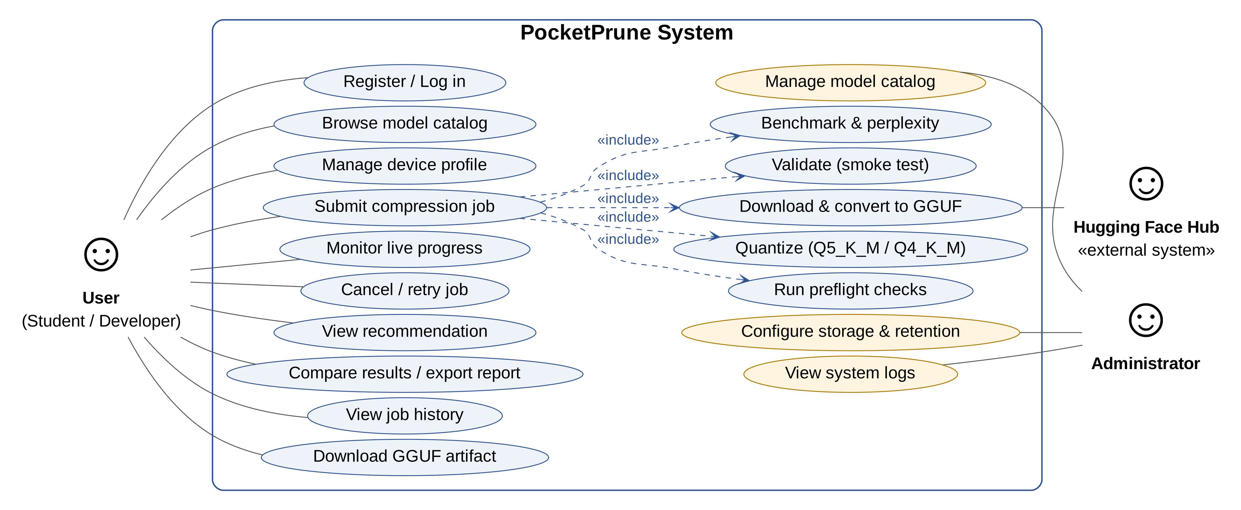
Figure 1: Use case diagram
2. ER Diagram
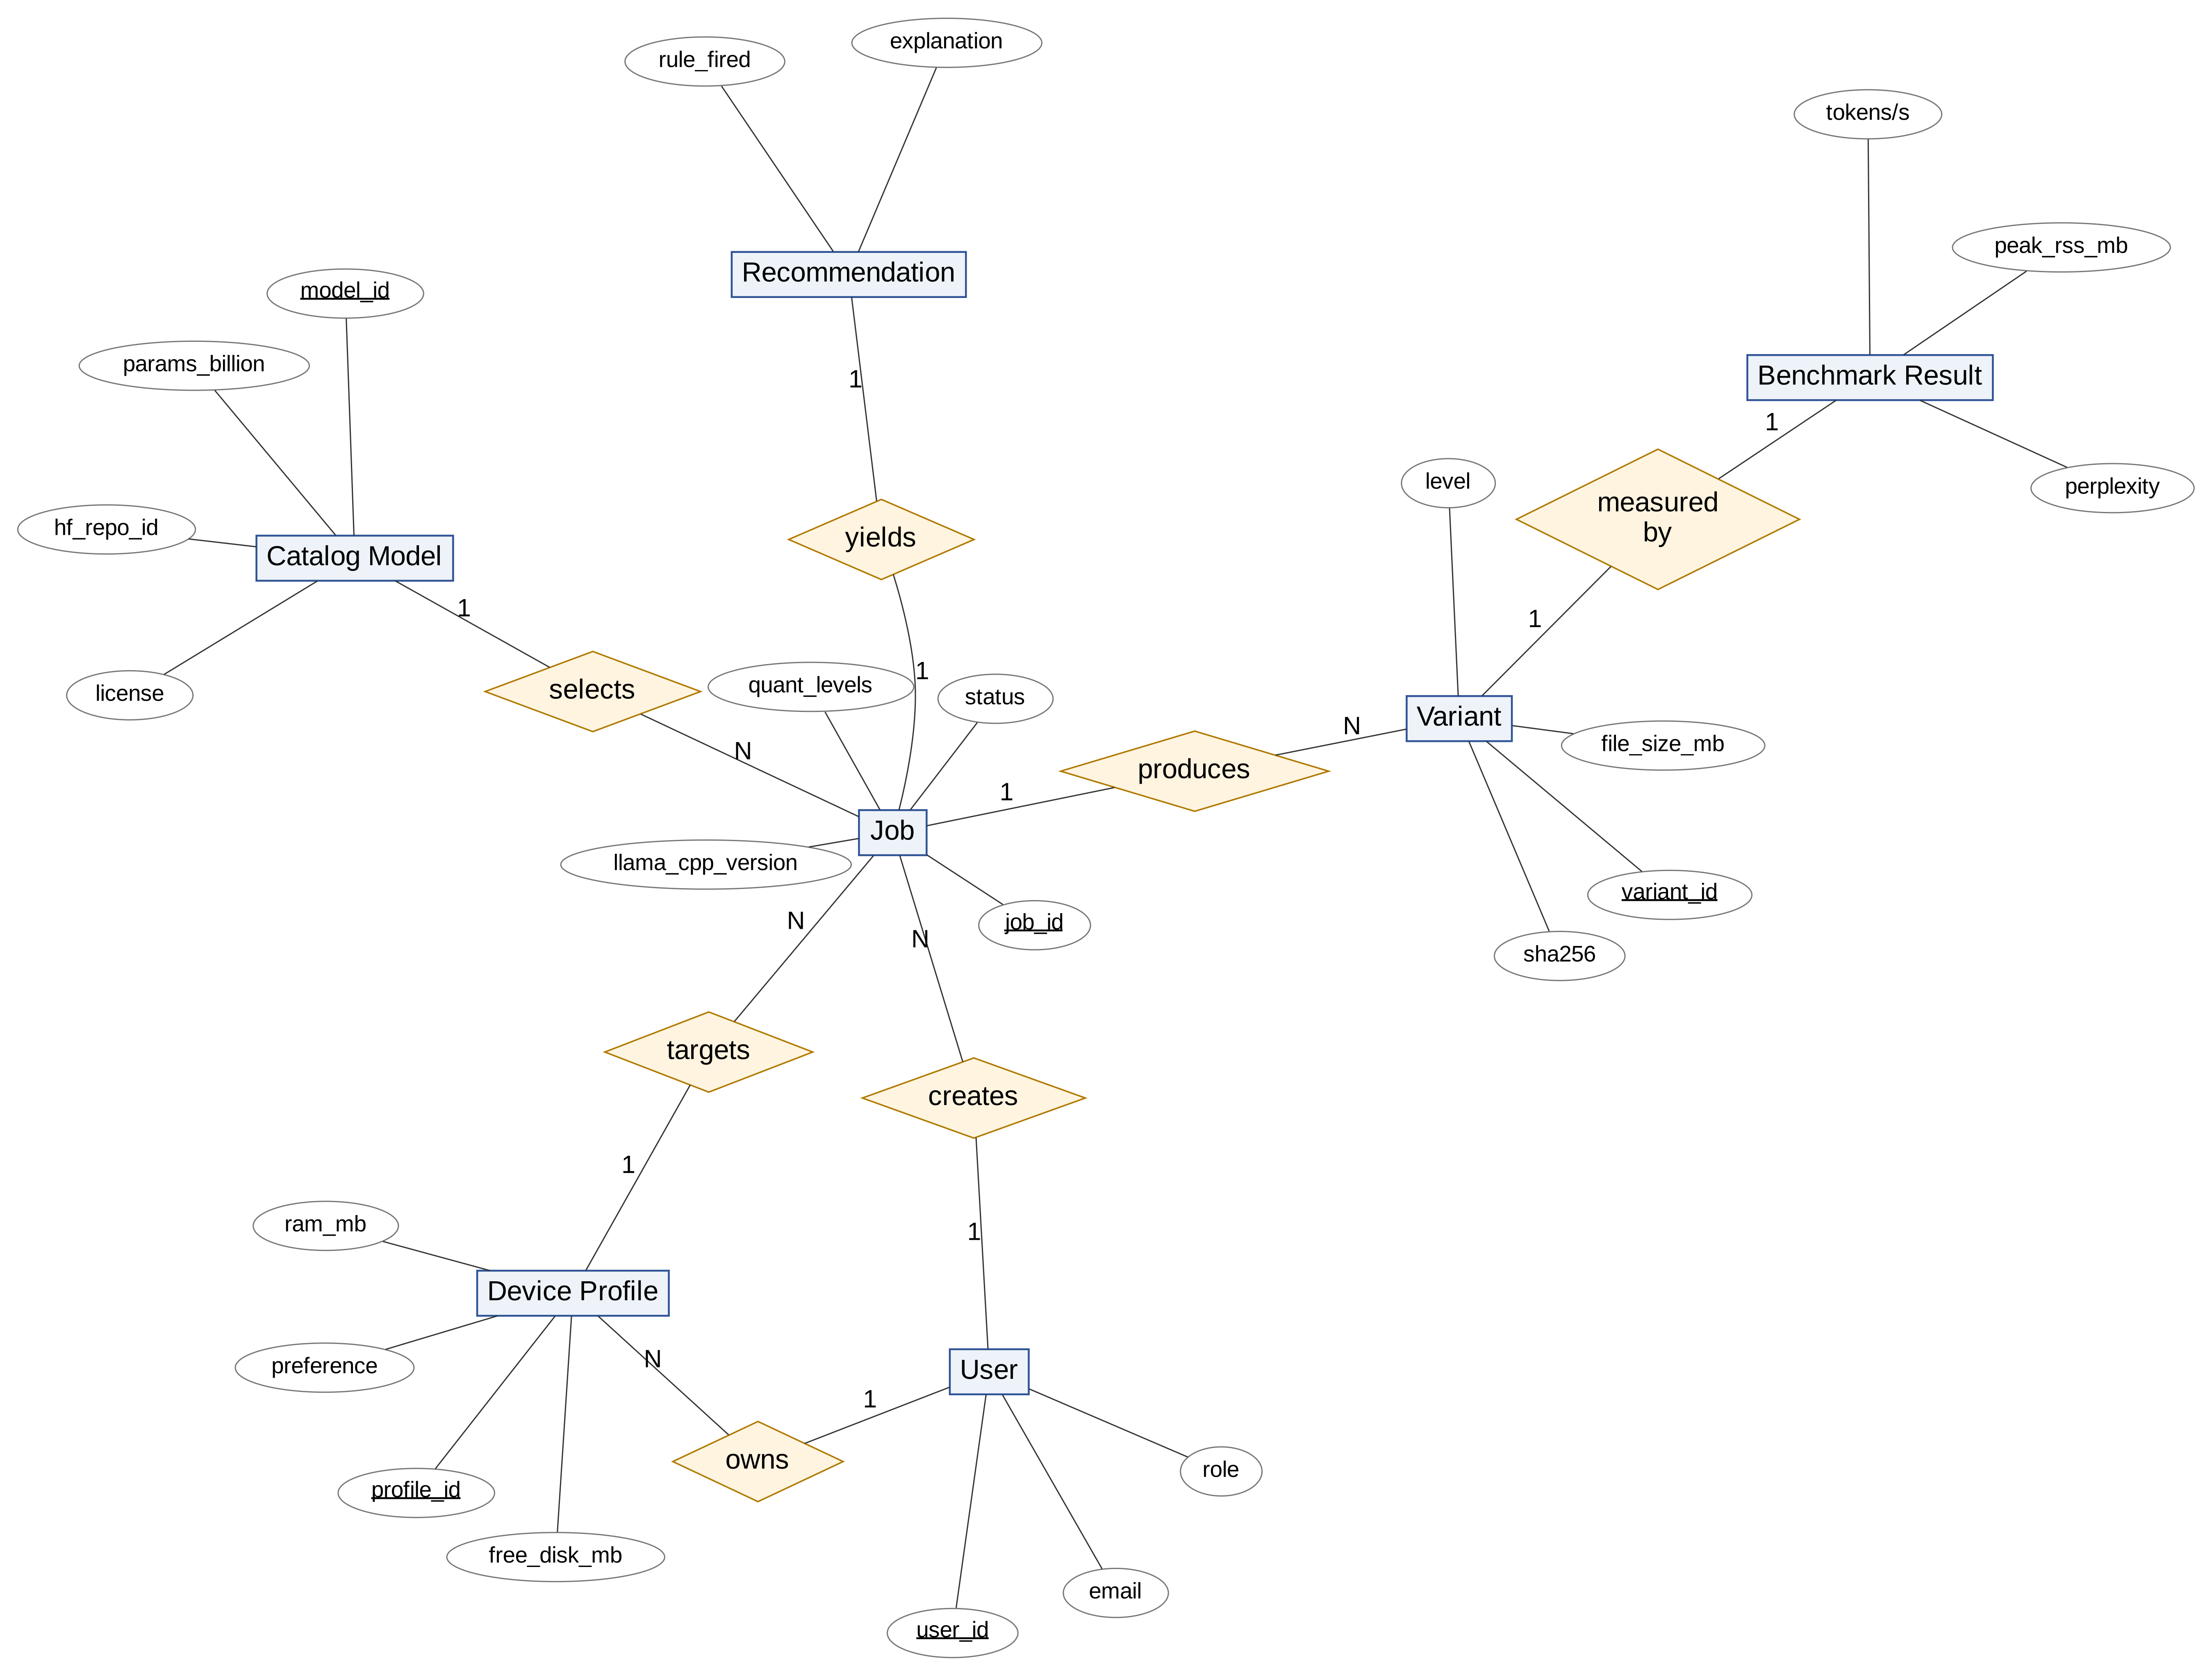
Figure 2: Entity–relationship diagram
3. Architectural Diagram
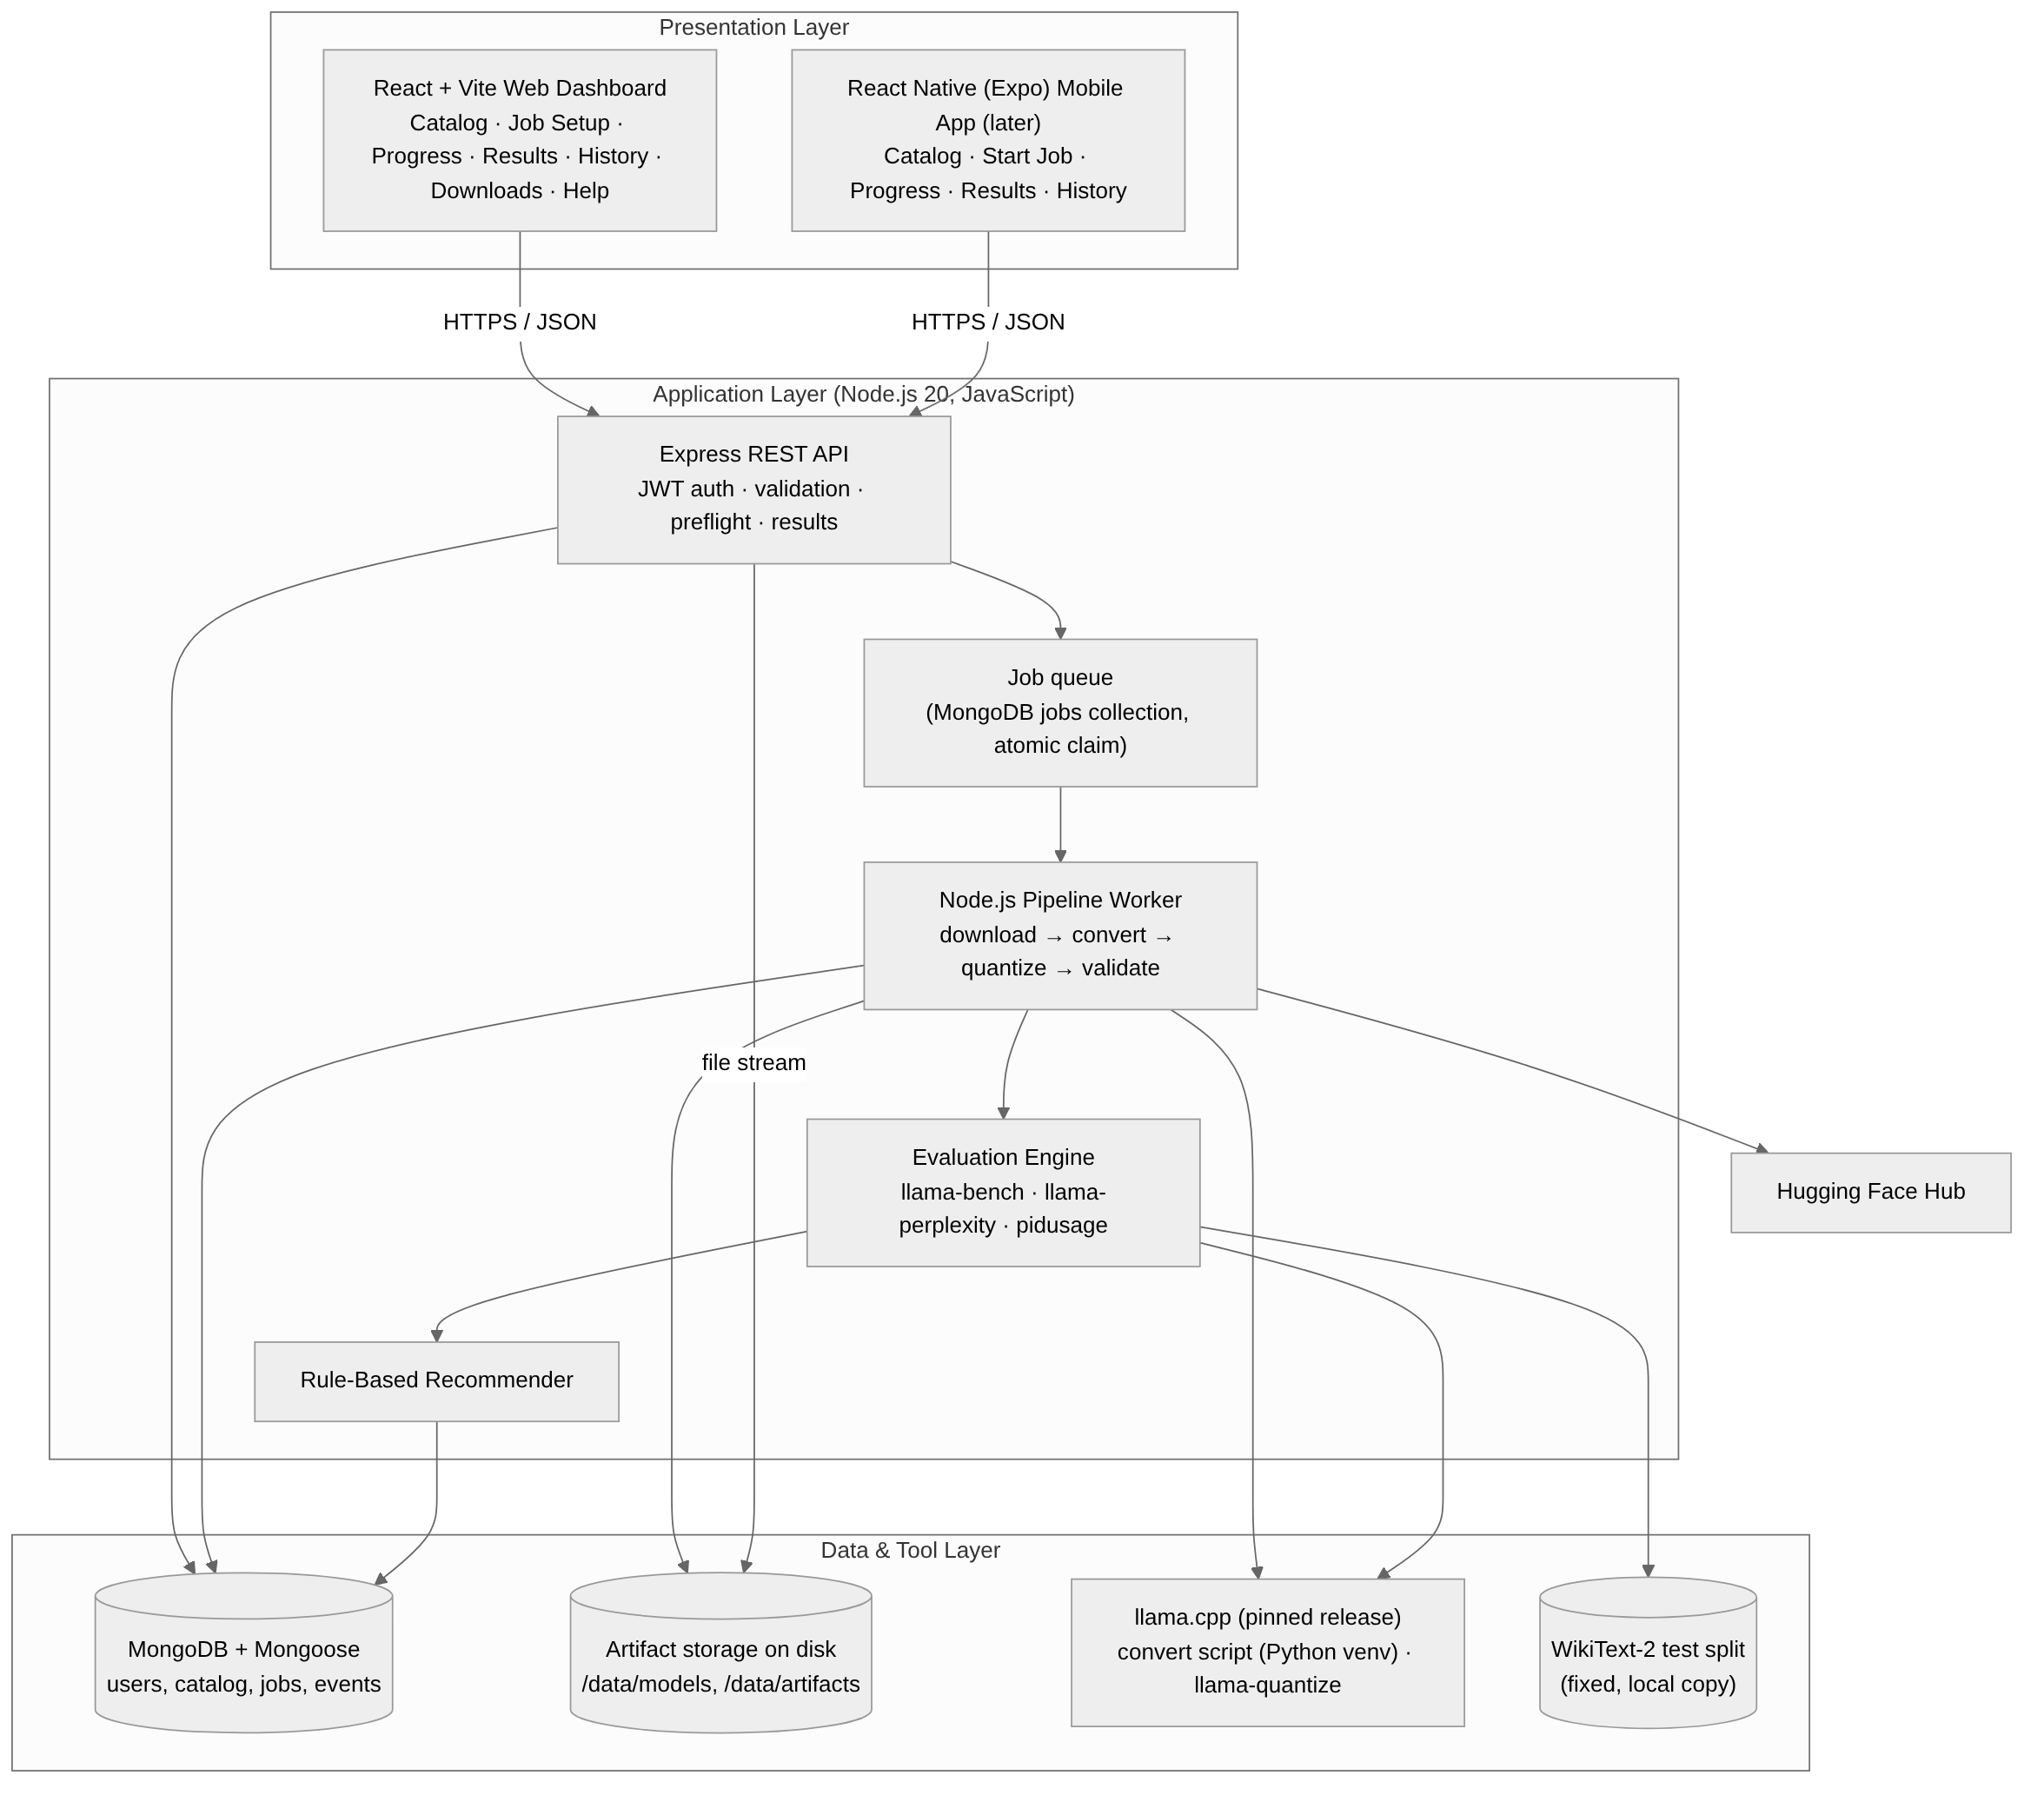
Figure 3: System architecture
4. Activity Diagram
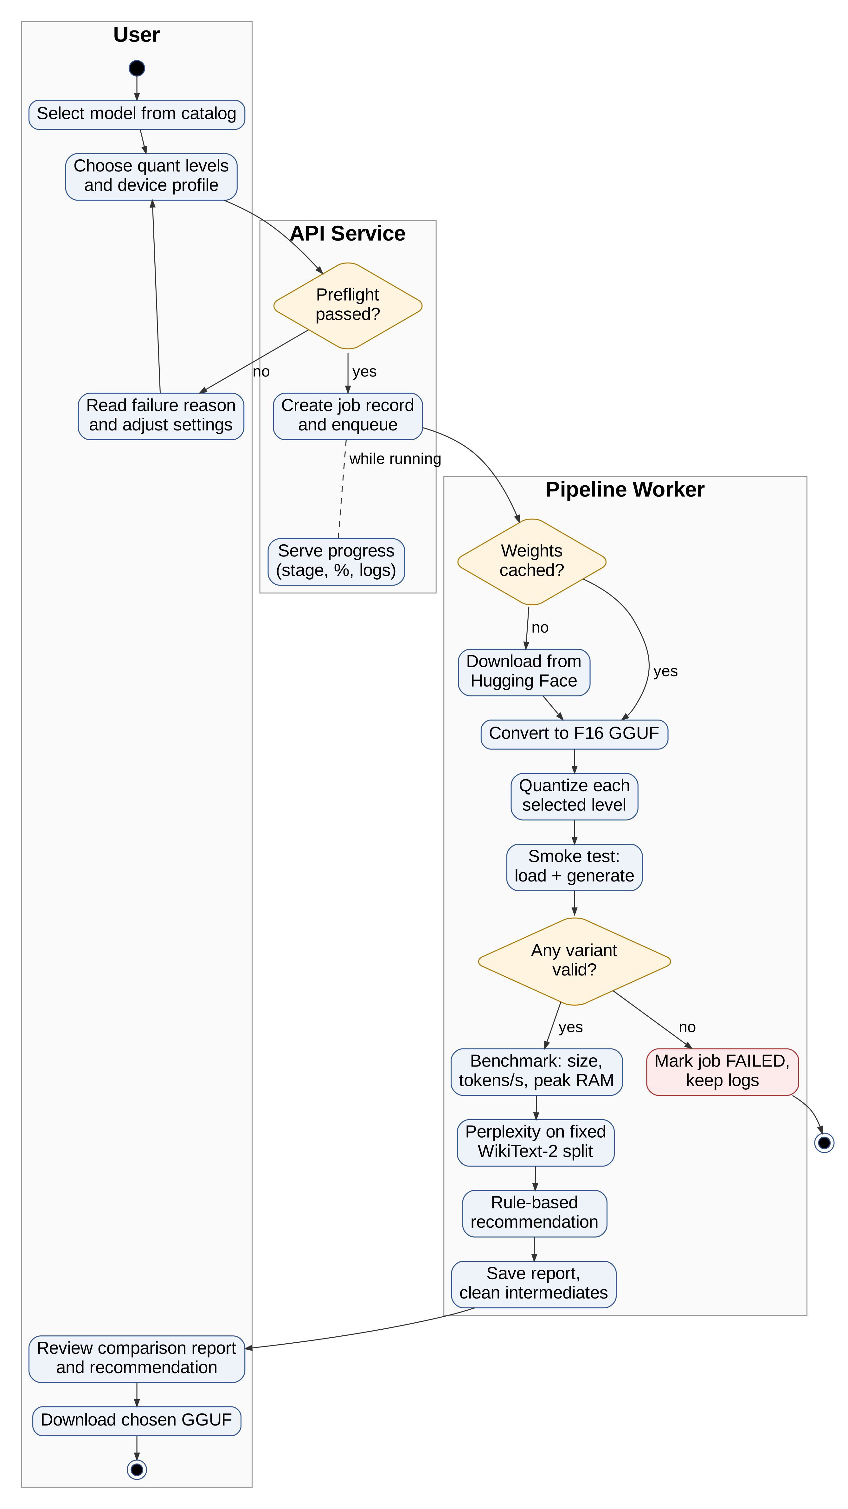
Figure 4: Activity diagram of a compression job
5. Sequence Diagram
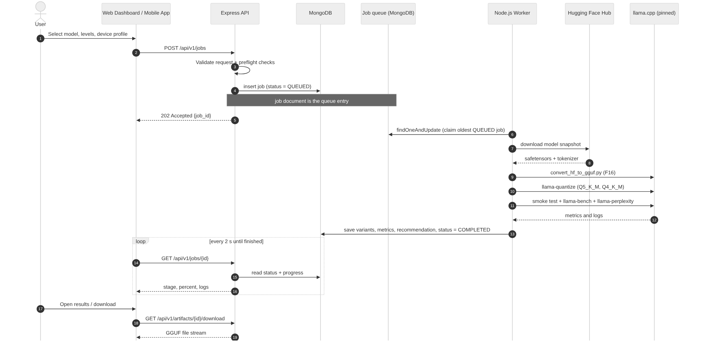
Figure 5: Sequence diagram: create, process, poll and download
6. Component Diagram
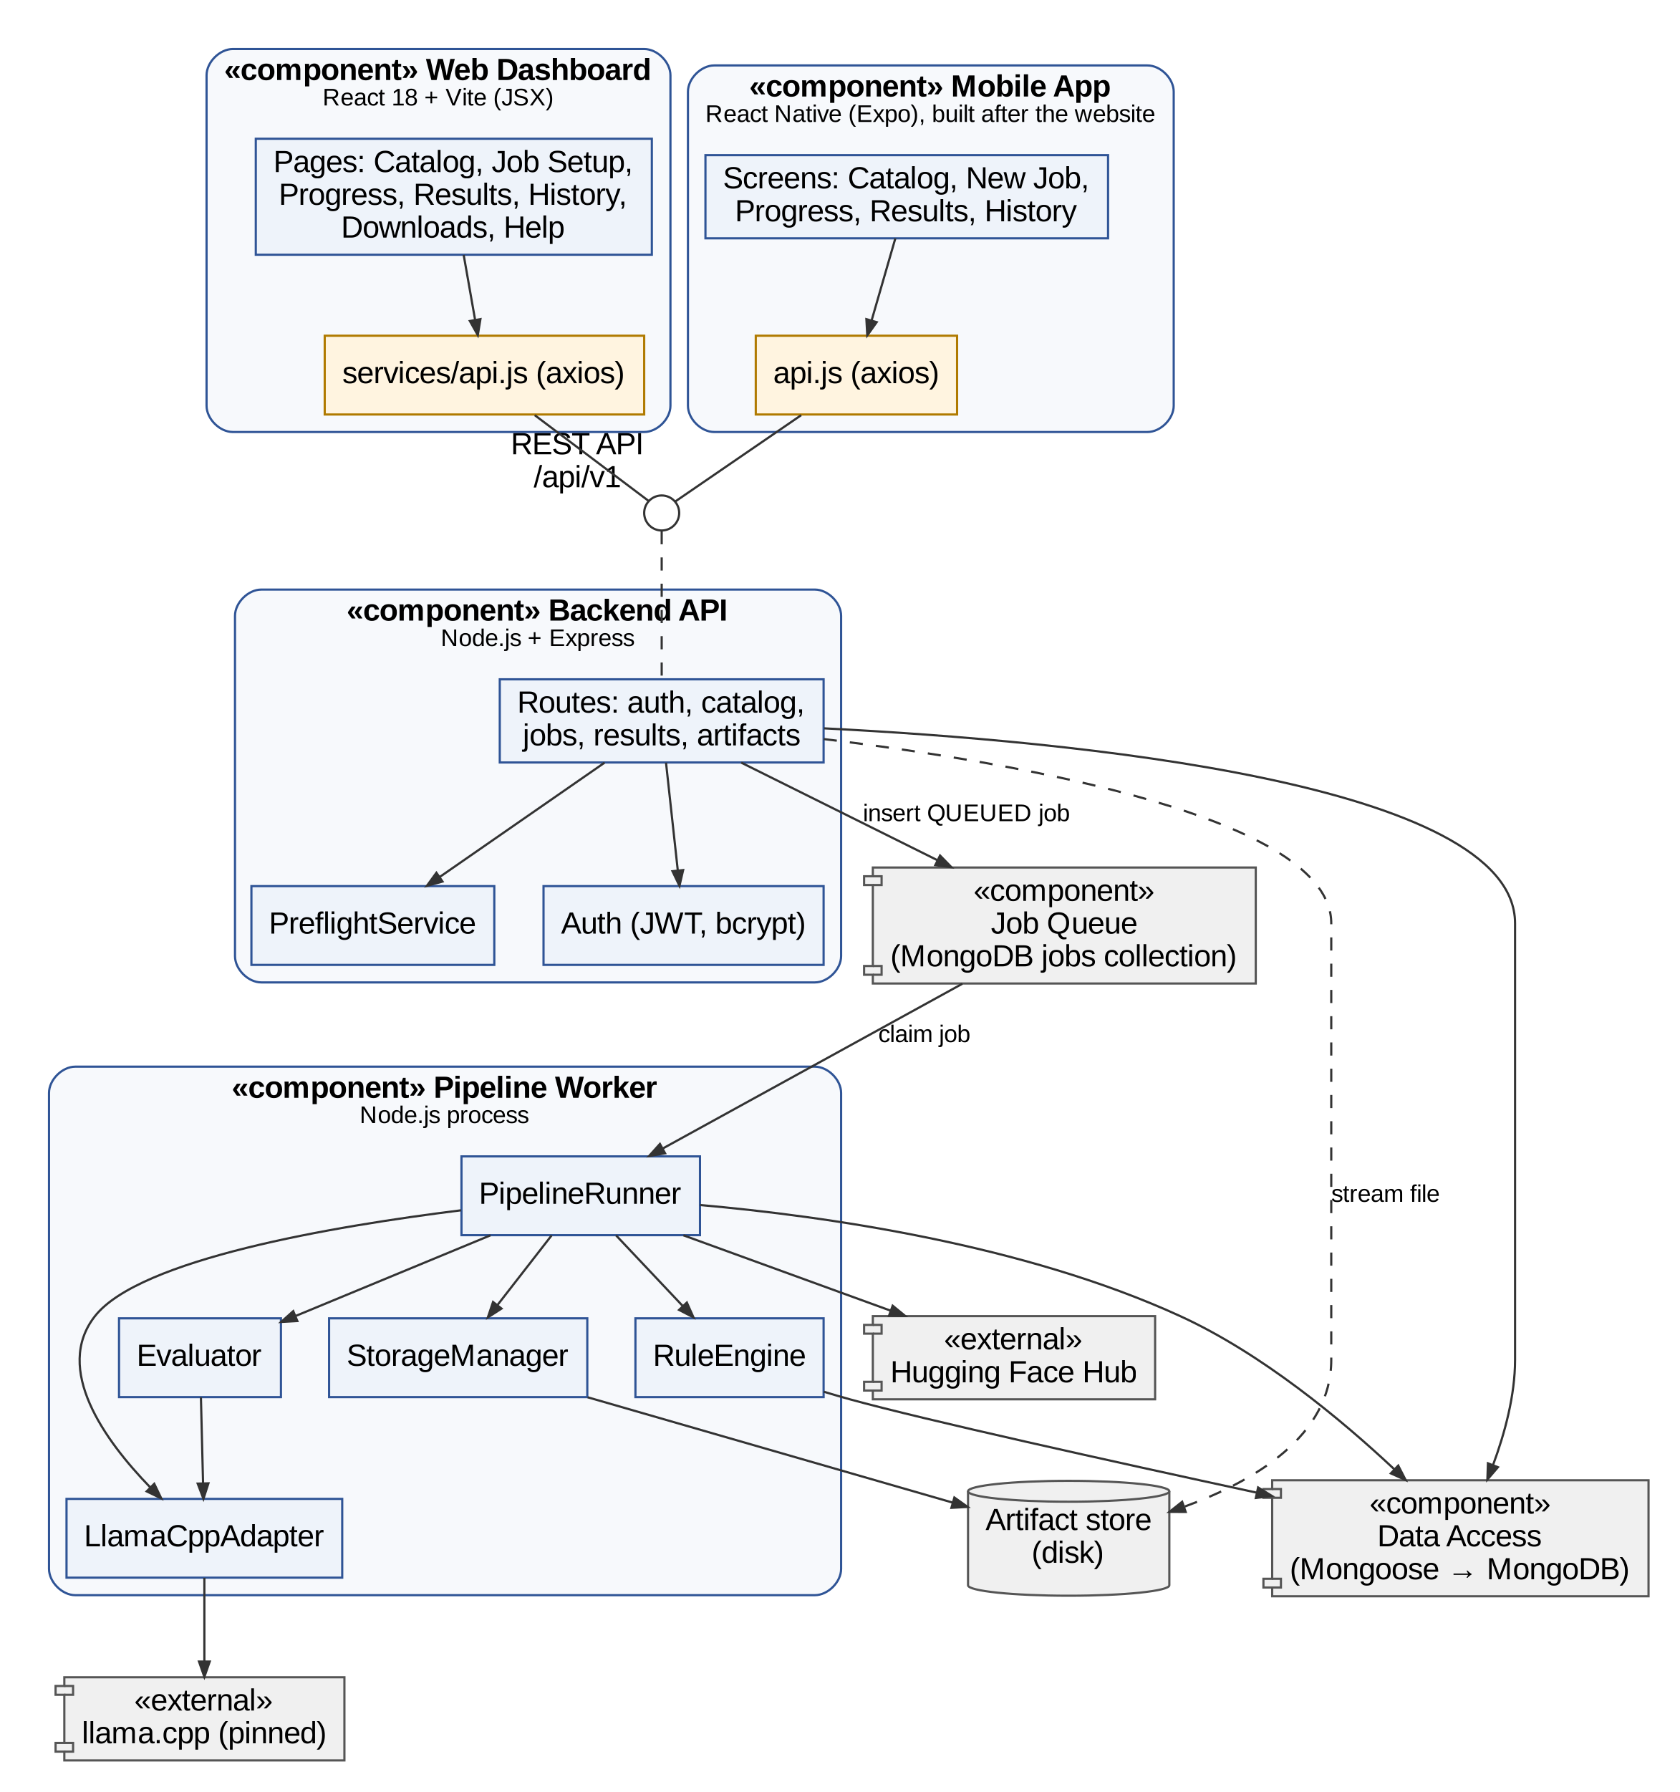
Figure 6: Component diagram
7. State Machine Diagram
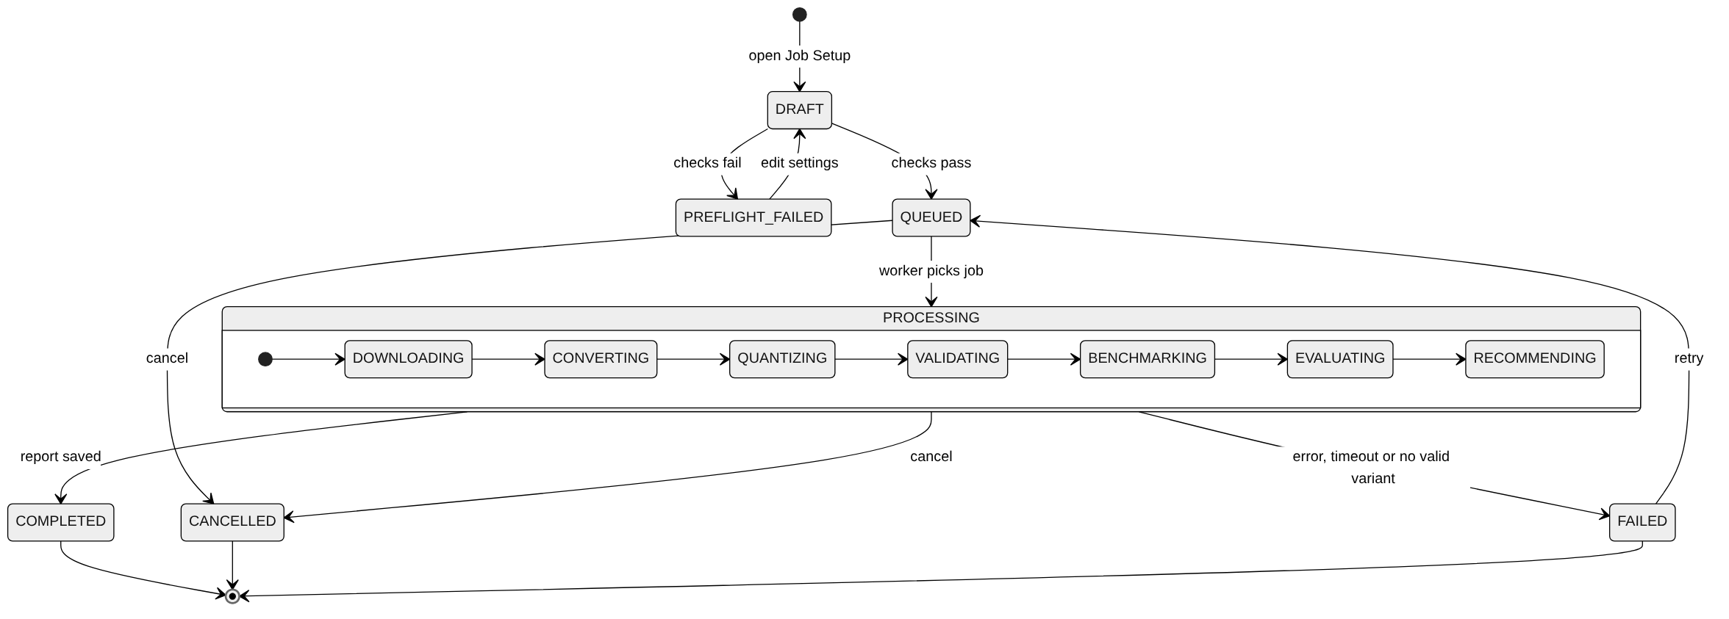
Figure 7: State machine diagram of a job
8. Class Diagram
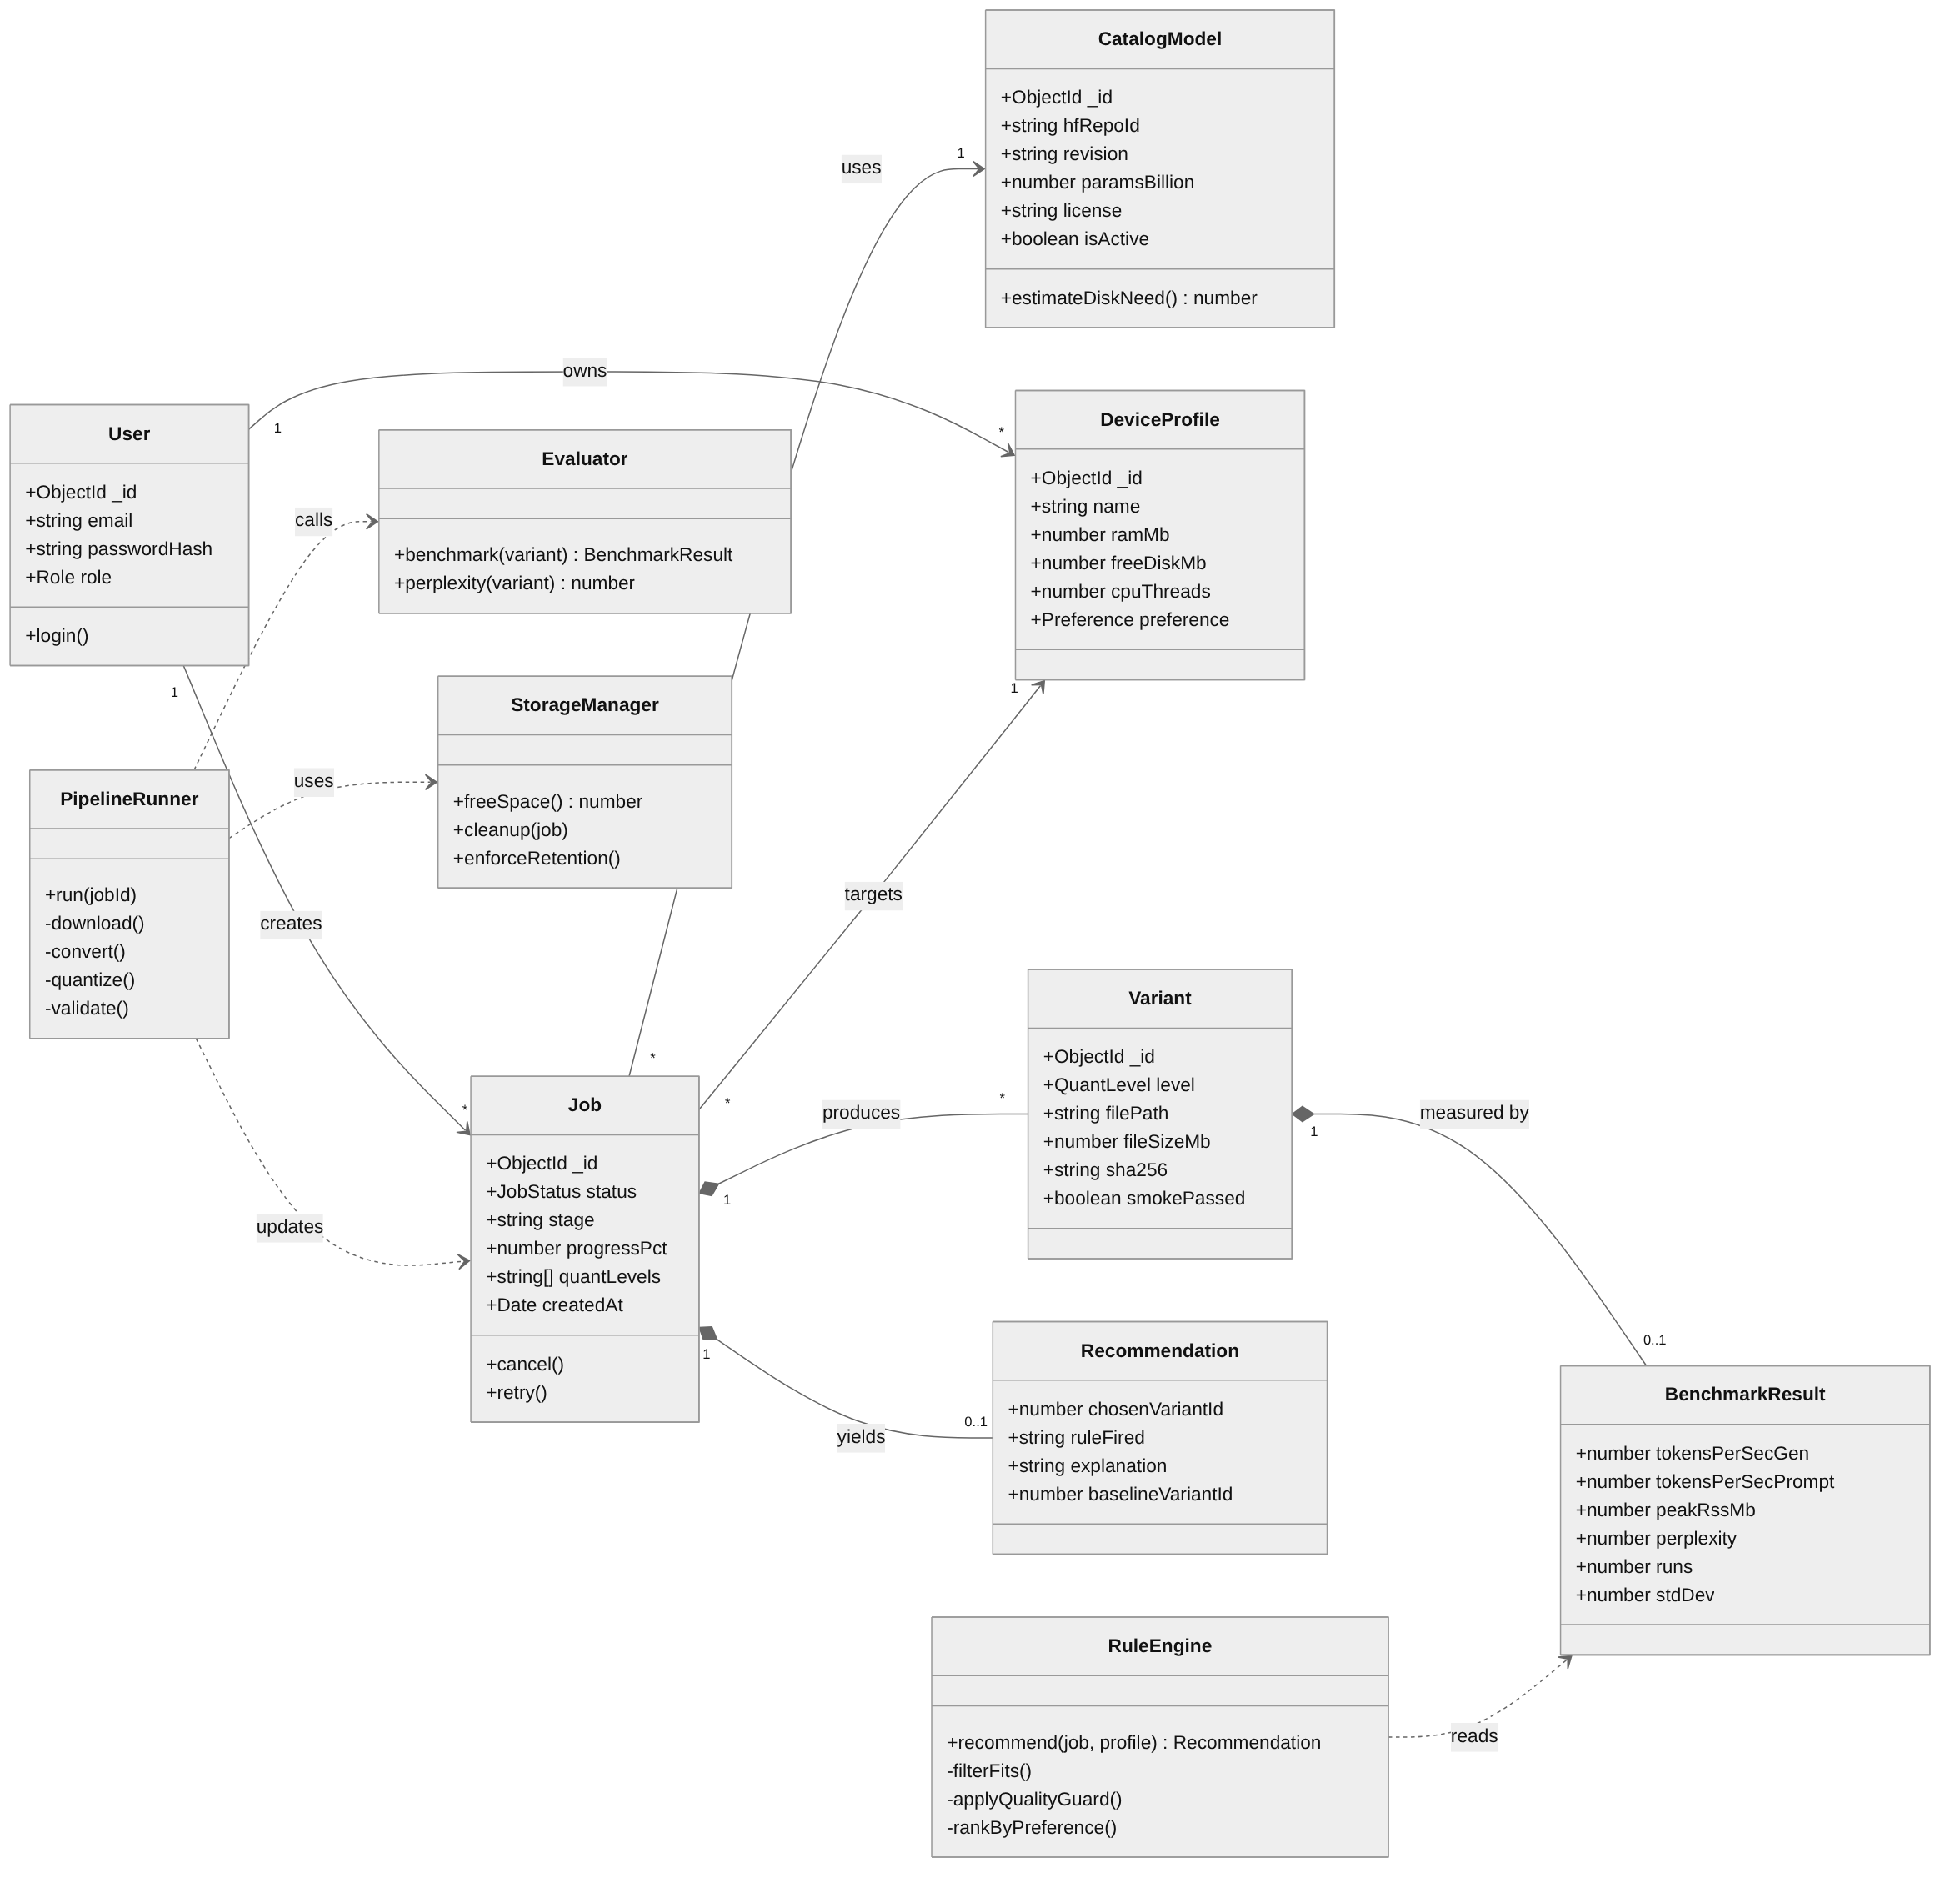
Figure 8: Class diagram
9. Data Flow Diagram
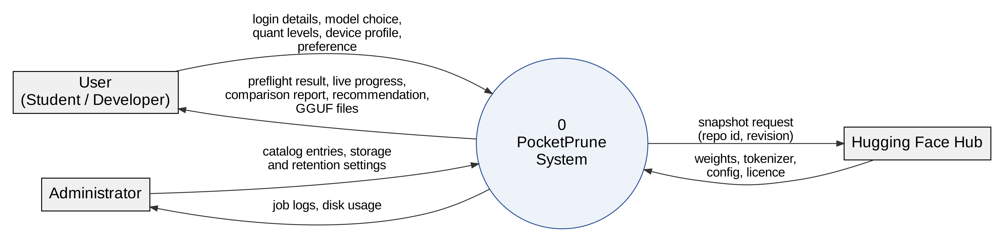
Figure 9: Data flow diagram – Level 0 (context)
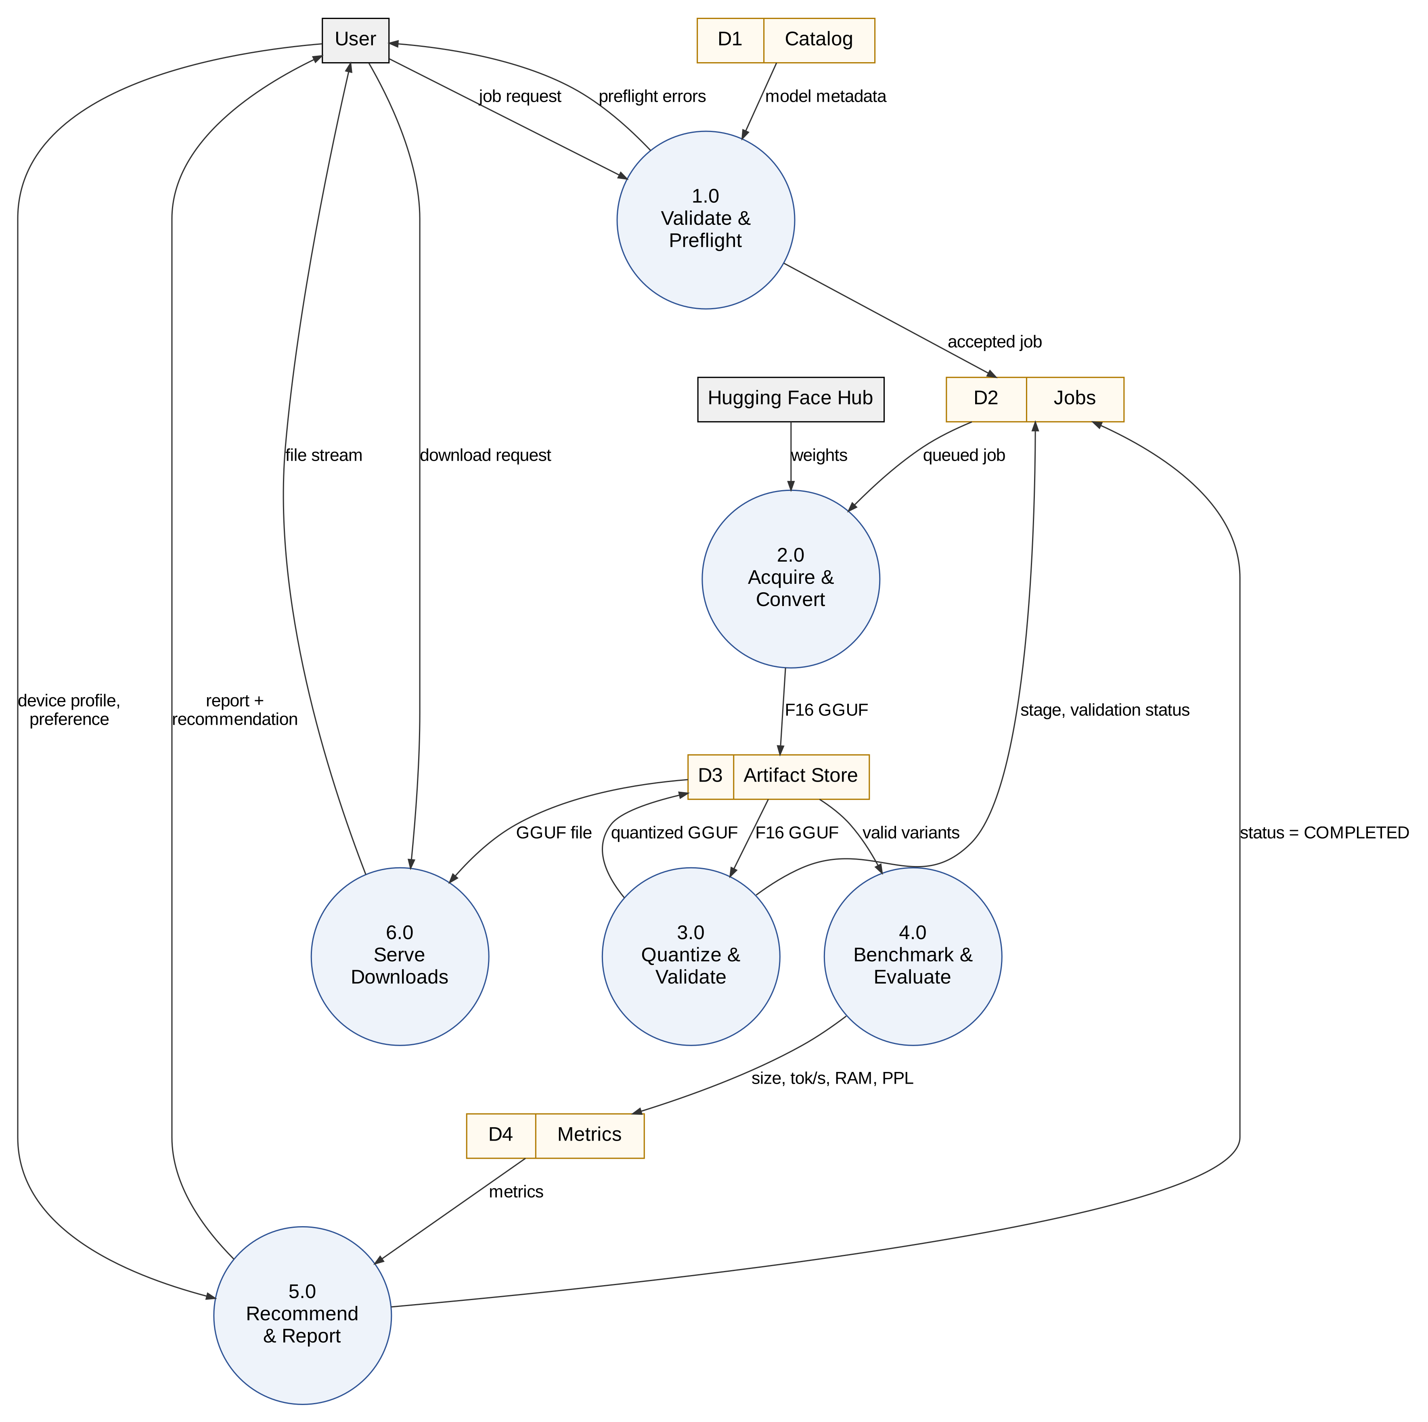
Figure 10: Data flow diagram – Level 1
10. Database Diagram
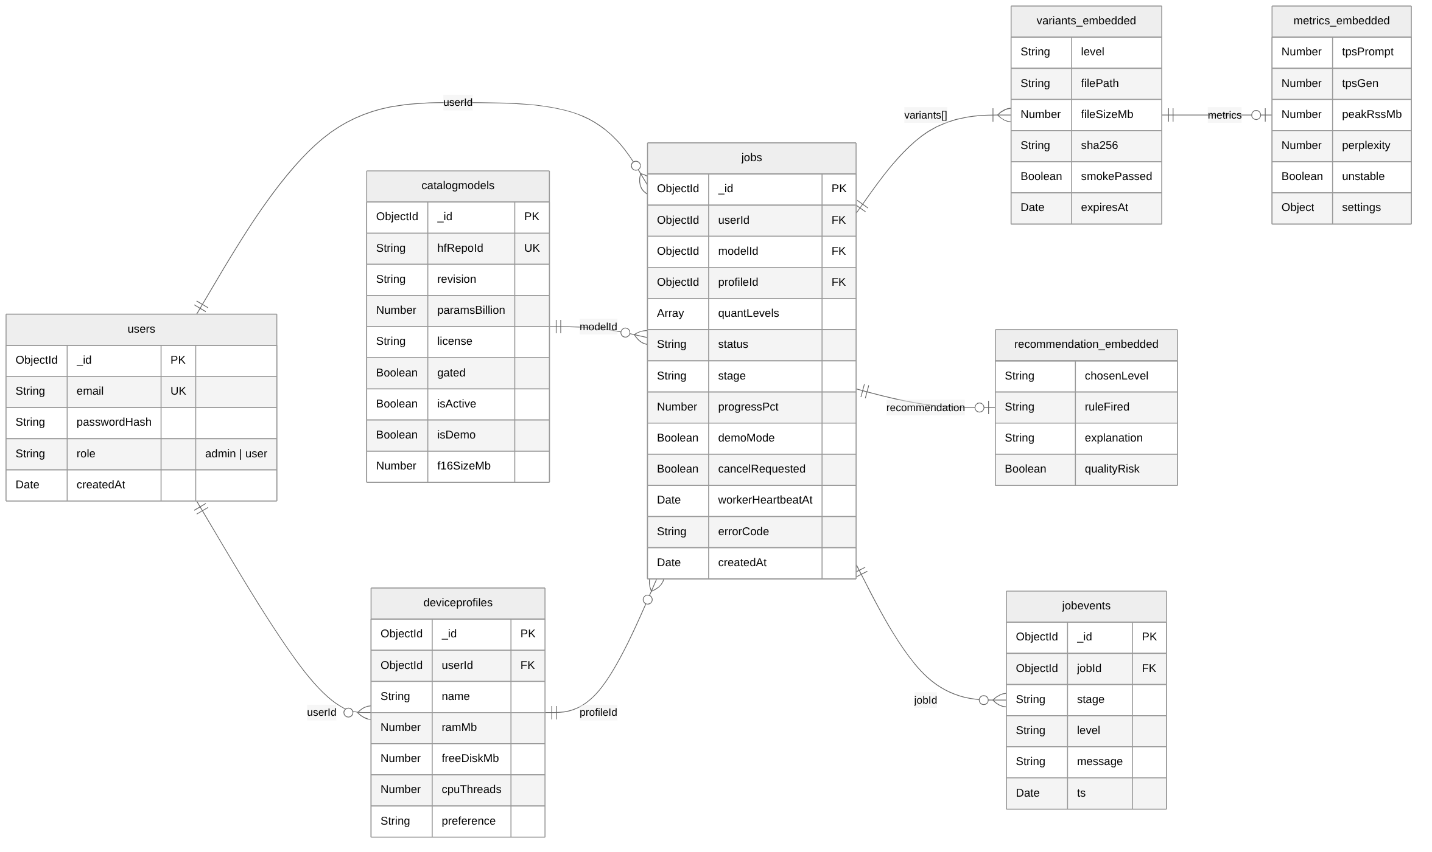
Figure 11: Database diagram (MongoDB collections)

References
[1] H. Touvron et al., "LLaMA: Open and efficient foundation language models," arXiv:2302.13971, 2023.
[2] S. Han, H. Mao, and W. J. Dally, "Deep compression: Compressing deep neural networks with pruning, trained quantization and Huffman coding," in Proc. ICLR, 2016.
[3] A. Gholami, S. Kim, Z. Dong, Z. Yao, M. W. Mahoney, and K. Keutzer, "A survey of quantization methods for efficient neural network inference," arXiv:2103.13630, 2021.
[4] G. Gerganov et al., "llama.cpp: LLM inference in C/C++," GitHub repository. [Online]. Available: https://github.com/ggml-org/llama.cpp [Accessed: Nov. 2026].
[5] ggml-org, "Quantize: llama.cpp model quantization tool." [Online]. Available: https://github.com/ggml-org/llama.cpp/tree/master/tools/quantize [Accessed: Nov. 2026].
[6] B. Jacob et al., "Quantization and training of neural networks for efficient integer-arithmetic-only inference," in Proc. IEEE/CVF CVPR, 2018, pp. 2704–2713.
[7] T. Dettmers, M. Lewis, Y. Belkada, and L. Zettlemoyer, "LLM.int8(): 8-bit matrix multiplication for transformers at scale," in Proc. NeurIPS, vol. 35, 2022.
[8] E. Frantar, S. Ashkboos, T. Hoefler, and D. Alistarh, "GPTQ: Accurate post-training quantization for generative pre-trained transformers," in Proc. ICLR, 2023.
[9] J. Lin et al., "AWQ: Activation-aware weight quantization for on-device LLM compression and acceleration," in Proc. MLSys, vol. 6, 2024.
[10] M. Sun, Z. Liu, A. Bair, and J. Z. Kolter, "A simple and effective pruning approach for large language models," in Proc. ICLR, 2024.
[11] T. Wolf et al., "Transformers: State-of-the-art natural language processing," in Proc. EMNLP: System Demonstrations, 2020, pp. 38–45.
[12] Hugging Face, "Quantization," Transformers Documentation. [Online]. Available: https://huggingface.co/docs/transformers/main/quantization/overview [Accessed: Nov. 2026].
[13] S. Merity, C. Xiong, J. Bradbury, and R. Socher, "Pointer sentinel mixture models," in Proc. ICLR, 2017.
[14] OpenJS Foundation, "Express documentation." [Online]. Available: https://expressjs.com/ [Accessed: Nov. 2026].
[15] IEEE Recommended Practice for Software Requirements Specifications, IEEE Std 830-1998, 1998.
[16] Expo, "Expo documentation." [Online]. Available: https://docs.expo.dev/ [Accessed: Nov. 2026].
[17] MongoDB, Inc., "MongoDB documentation" and "Mongoose documentation." [Online]. Available: https://www.mongodb.com/docs/ and https://mongoosejs.com/docs/ [Accessed: Nov. 2026].

