CS 100: Software Construction
Assignment 1
Peter H. Fröhlich (Amended by Jill Brady)

You must put your name, student ID, and login into every file you turn in. All code you turn in will be graded on functionality (80%), design (10%), and documentation (again 10%). Zip all the files together for turn-in, and name them: FirstName_LastName_Assignment1.zip. Submit this file to Moodle by the assignment deadline given in Moodle.
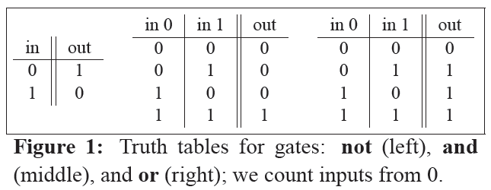
Combinatorial Circuits
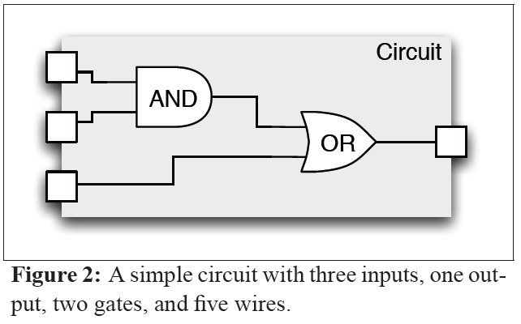
The project for CS 100: Software Construction is building a basic simulator for combinatorial circuits. We abstract from some of the physical details of these circuits and end up with a view that involves inputs, outputs, gates, and wires. Every input, output, or wire can be in two “electric” states: 0 means that no “current” is flowing, 1 means that “current’ is flowing.
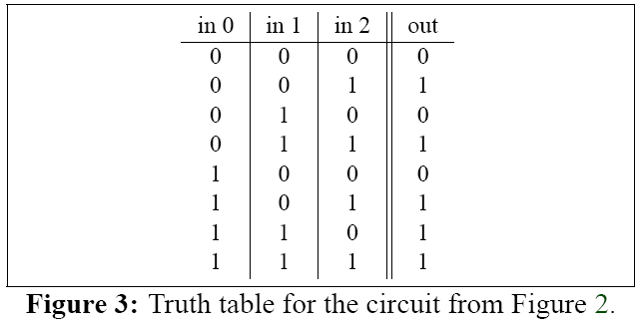
For now we assume only three possible gates: and, or, and not. Like circuits as a whole, gates also have inputs and outputs; for now we assume that and-gates and or-gates have two inputs while not gates have one input; all gates have one output.
The not-gate “negates” its input: its output is 0 if its input is 1, and its output is 1 if its input is 0. The and-gate performs a logical “and” between its inputs; its output is 1 if both of its inputs are 1, otherwise its output is 0. The or-gate performs a logical “or” between its inputs; its output is 0 if both of its inputs are 0, otherwise its output is 1. We can also describe these gates by their truth tables as shown in Figure 1.
Building a circuit requires deciding on a number of inputs and outputs; a number of gates of certain types; and a bunch of wires to connect everything. Figure 2 shows a simple circuit built up from two gates. Setting the inputs to 1, 0, 1 (from top to bottom) will result in an output of 1; setting them to 0, 1, 0 will result in an output of 0. As shown in Figure 3, we can again use a truth table to describe the circuit.

1 Simulator (40 points)
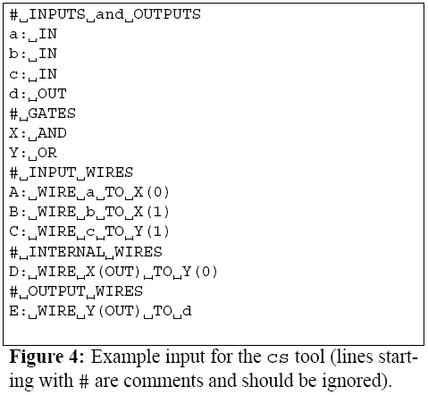
This is an individual assignment. Your task for this assignment is to implement a first version of the cs (“circuit simulator”) tool. Your executable should be called cs and your Makefile should produce that executable in the current directory. You must use C++ for this assignment, and you are free to use the standard template library (STL) as well. Please do not just hack in the C subset! Try to use C++ features like namespaces, classes, templates, exceptions, etc. if they seem useful. Also, stay away from C-style string handling (use std::string instead of char* please) and C-style I/O (use std::istream and
std::ostream instead of scanf and printf please). You may not use additional libraries, languages, or tools.
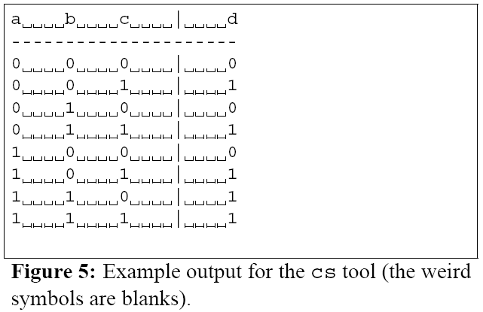
The cs tool accepts a description of a circuit on the standard input; the circuit “ends” either with an empty line or end-of-file. The cs tool produces the truth table of the given circuit on the standard output. Figure 4 shows the format of the input (corresponding to Figure 2) while Figure 5 shows the format of the output. It is important that your output matches this format as closely as possible; otherwise our automated grading system might take away points even if the content of your table is basically correct!
For this first version of cs you can make a number of simplifying assumptions. Efficiency in terms of time or space is not an issue as long as we can actually test your code; it’s fine if it takes 30 seconds to analyze the example circuit, but if it takes 10 minutes to do the same, you won’t get a very good score. Also, you don’t have to worry about detailed resource management or error handling; you can assume that memory is basically infinite, that all wires are connected correctly (e.g. you don’t have to check for circular connections), etc.
Feel free to post messages to the course Questions and Discussion Forum if you need to clarify a requirement or if you have trouble with basic input and output. Also, you are free to exchange test cases (but not code of course) on this forum.

