AQ7.3: Activity Question 6 - Not Graded

**This assignment will not be graded and is only for practice.**

**Note : This activity is for your practice purpose only. Your score in this will not count towards the Final score.**

***1 point***

Consider the dictionary chemMarks**chemMarks** discussed in the lecture. What does keys(chemMarks)**keys**(**chemMarks**) represents?

List of keys of the dictionary chemMarks**chemMarks**

List of keys of the dictionary chemMarks**chemMarks** in order at which the key is stored.

List of values of the dictionary chemMarks**chemMarks** in order at which the key is stored.

List of both keys and values of the dictionary chemMarks**chemMarks** in order at which the key is stored.

***1 point***

Consider the dictionary chemMarks**chemMarks** discussed in the lecture. What will be the output of the procedure isKey(chemMarks,48)**isKey**(**chemMarks**,**48**)?

Found

True

False

Undefined

***1 point***

Consider the dictionary chemMarks**chemMarks** discussed in the lecture. Find the correct pseudocode block(s) which stores the number of students with marks greater than 50 in variable N**N**?

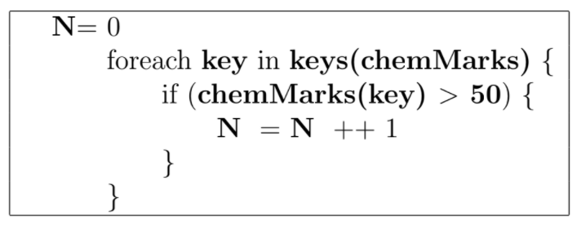

***1 point***

A Dictionary is used to store the total sum of mathematics marks of students from each city. Identify the mistake(s) in the pseudocode.  
  
Error in line 1

Error in line 5

Error in line 6

Error in line 9

No error in the pseudocode