COMMANDS

Date: to display date and time
Syntax: $date
Date displays 6 fields of output:
1. Day 2. Month name 3. Date 4. time 5. time zone 6. year Options with date:
+%a – day
+%h – Month name
+%d – date
+%T –time
+%Z- Time Zone
+%Y-year
+%H-Hour
+%M- Minute
+%S – Second
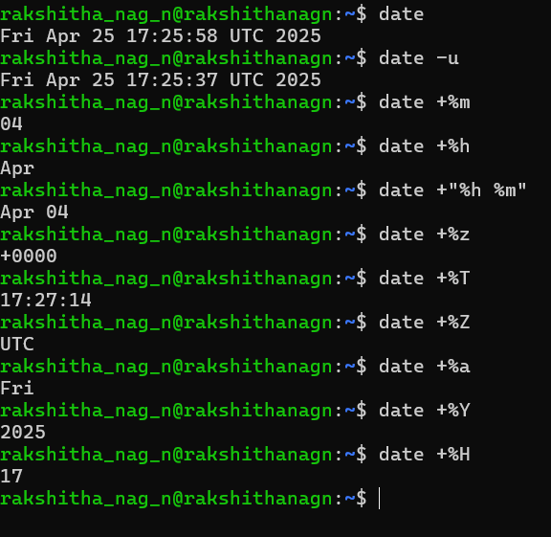

who: The who command prints information about all users who are currently logged in.
Syntax: who [ OPTION ]... [ FILE ] [ am i ]
$who –u
Indicates how long it has been since there was any activity on the line. This is known as Idle time. It also returns the process id for the user.
-H – HEADING : Print a line of column headings
$who -uH
Displays "all" information, and headers above each column of data.
$whoami
Displays the same information, but only for the terminal session where the command was issued.
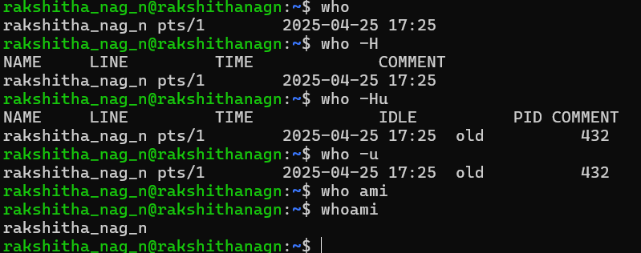

passwd:
The passwd command is used to change the password of a user account.
Syntax: passwd [OPTION] [USER] Password framing rules:
 Some of the rules which should be followed while framing password  Don’t choose a password similar to old one.
 Don’t use commonly used names like names of friends, relatives, pets,etc  Use mix of alphabetic or numeric characters.
 Don’t write password in a easily accessible document.

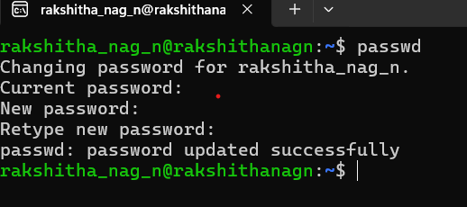

echo: The echo command used to display a message.
To display the diagnostic messages on the terminal or to issue prompts for taking user input. Syntax: $ echo [SHORT-OPTION]... [STRING]...
Options:
 -e : Enable interpretation of backslash escape sequences  \b : Backspace
 \c : No newline  \t : Tab
 \n : New line

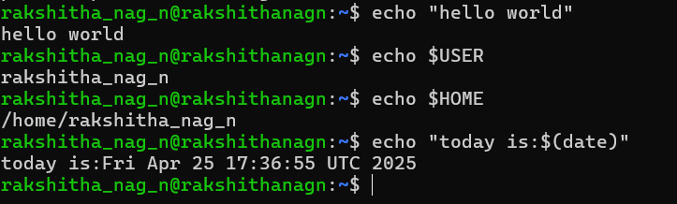

printf : printf can be used as alternative command to echo.
The difference is echo command by default inserts ‘\n’ character at the end, but printf does not insert newline at the end.
Eg: $printf cseise
Output: cseise $ //prompt will be in the same line.

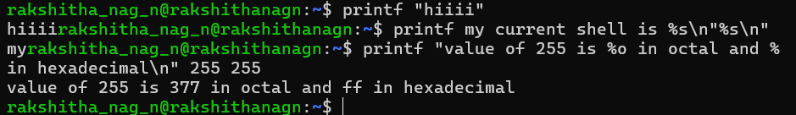

wc: Counting Lines, words, and Characters:
we can use ‘wc’ command to count number of lines, words and characters in a file. Eg: $wc list.txt
6 6 42 list.txt
Output shows that the file ‘list’ contains 6lines, 6words and 42 characters.

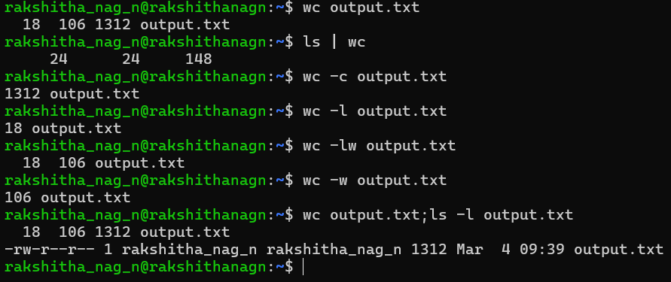

bc: calculator that supports arbitrary precision arithmetic
Simply type bc in the terminal and start entering expressions: Syntax : $ bc
5 + 3
8
Exit with Ctrl+D or type quit.

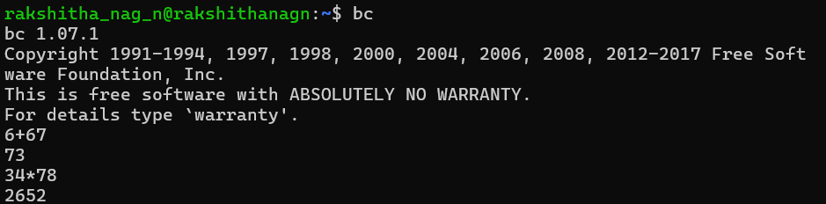

Script Command : Used to record a terminal session.
It captures everything displayed on the terminal and saves it to a file, which can be useful for logging, debugging, or documentation purposes.
To start recording a session:
Syntax: $ script
  - This starts recording everything you type and see on the terminal.
  - To stop recording, type exit or press Ctrl+D.
The output is saved in a file named typescript (default). Save Output to a Specific File
$ script my_session.log
This records the terminal session into my_session.log.
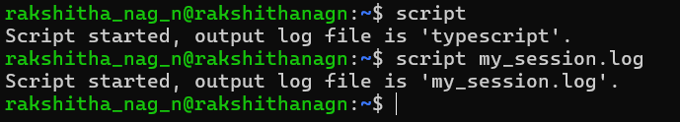

uname : Used to display system information such as the operating system, kernel version, and system architecture.
Syntax: $ uname
Default behavior, shows only the operating system name I e Linux Display All System Information
$ uname -a This provides:
- Kernel name (Linux)

- Hostname (myhostname)
- Kernel version (5.15.0-91-generic)
- Build info (#101-Ubuntu SMP)
- Machine hardware name (x86_64)
- OS type (GNU/Linux)

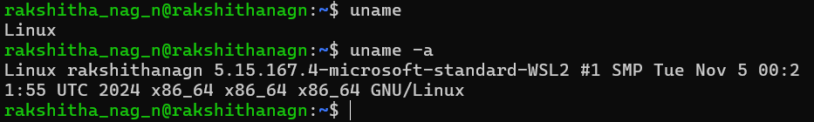

tty command: Used to display the file name of the terminal connected to the standard input.
Syntax : tty [options]

Check if the input is a terminal
$tty –s
This returns:
Exit code 0 (success) if the standard input is from a terminal.
Exit code 1 if the input is from a pipe or file.

stty:
The stty (set terminal type) command in Ubuntu is used to change and print terminal line settings. It allows users to configure input and output settings of the terminal, such as baud rate, character size, control characters, and various other terminal behavior settings
Display current terminal settings
Ex: $stty -a
This lists all terminal settings.

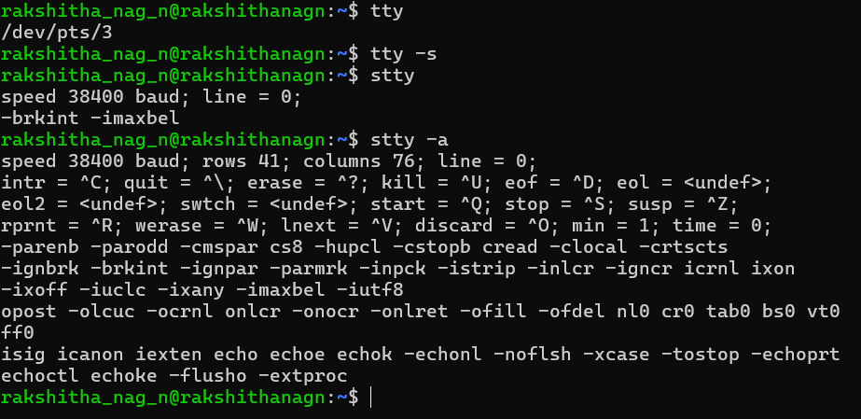

pwd: Checking your current directory
User can move around from one directory to another, but at any point of time, if user wants to find out in which directory he is present then user can use Print Working Directory(pwd) command.
Sytnax: pwd
/home/kumar/SantoshReddyP
pwd also displays the absolute pathname.

cd: Changing the current directory

User can move around the UNIX file system using cd (change directory) command.

When used with the argument, it changes the current directory to the directory specified as argument, progs:
Syntax: $ pwd
/home/kumar
$cd progs
$ pwd
/home/kumar/progs

Here we are using the relative pathname of progs directory. The same can be done with the absolute pathname also.
$cd /home/kumar/progs
$ pwd
/home/kumar/progs

$cd /bin
$ pwd
/bin
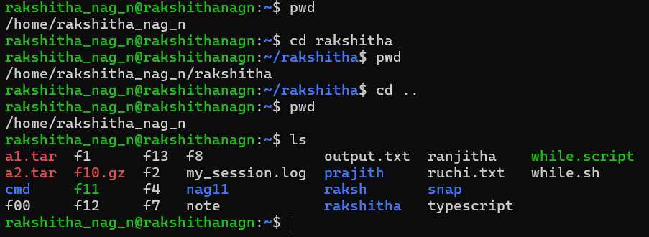

mkdir : Making Directory
Directories are created with mkdir (make directory) command. The command is followed by names of the directories to be created.
Synatx: $mkdir patch
You can create a number of subdirectories with one mkdir command:
$mkdir patch dba doc
System refuses to create a directory due to fallowing reasons:
- The directory is already exists.
- There may be ordinary file by that name in the current directory.
- User doesn‘t have permission to create directory.

rmdir: Removing a Directory

rmdir command removes the directory.

The directory must be empty before using rmdir with the directory name.
- Ex: rmdir pis

Multiple directories can be removed.
- Ex: $rmdir pis/data pis/progs pis

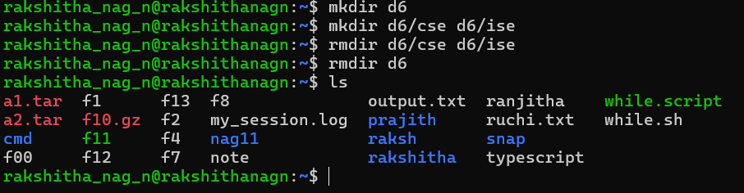

cat: Displaying and creating files
cat is also useful for creating a file. Enter the command cat, followed by > character and the filename.
Sytnax: $ cat > new cat options:
- Displaying Nonprinting Characters (-v): cat without any option it will display text files. Nonprinting ASCII characters can be displayed with –v option.
- Numbering Lines (-n): -n option numbers lines. This numbering option helps programmer in debugging programs.

mv: Renaming the files:
The mv command renames (moves) files. Syntax: $ mv csb csa
A group of files can be moved to a directory.
Ex: Moves three files ch1,ch2,ch3 to the directory module
$ mv ch1 ch2 ch3 module

Can also used to rename directory
$ mv rename newname

mv replaces the filename in the existing directory entry with the new name.

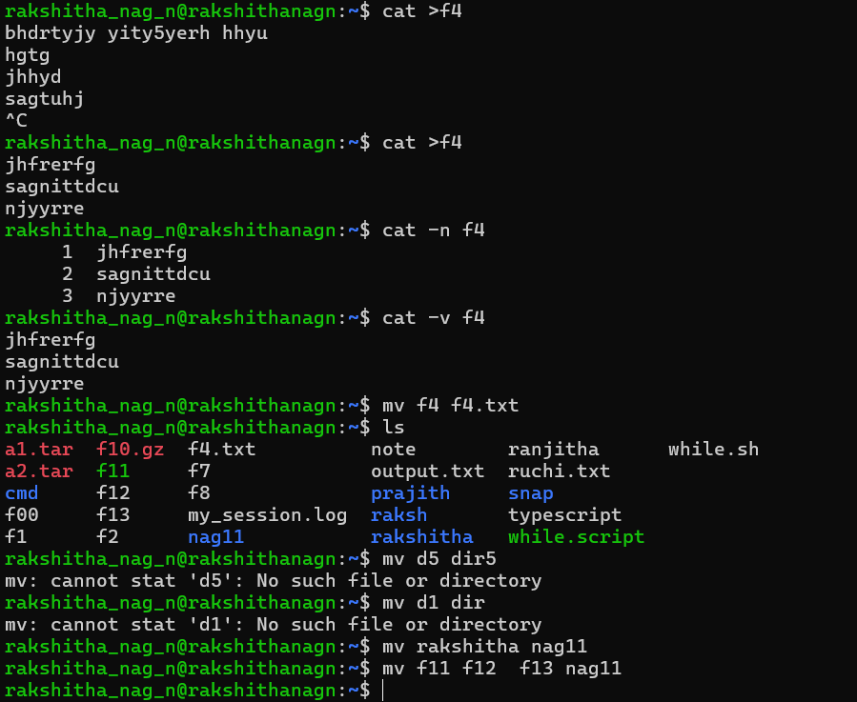

rm: Deleting Files
The rm command deletes one or more files. Ex: Following command deletes three files:
Syntax: $ rm mod1 mod2 mod3 rm options
- Interactive Deletion (-i) : Ask the user confirmation before removing each file:
$ rm -i ch1 ch2 rm: remove ch1 (yes/no)? ? y rm: remove ch1 (yes/no)? ? n
- A y̳‘ removes the file (ch1) any other response like n or any other key leave the file undeleted.
- Recursive deletion (-r or -R): It performs a recursive search for all directories and files within these subdirectories. At each stage it deletes everything it finds.
$ rm -r * #Works as rmdir
- It deletes all files in the current directory and all its subdirectories.

- Forcing Removal (-f): rm prompts for removal if a file is write-protected. The -f option overrides this minor protection and forces removal.
rm -rf* #Deletes everything in the current directory and below

cp: Copying a file
The cp command copies a file or a group of files. It creates an exact image of the file on the disk with a different name.
Syntax: $ cp csa csb cp options
- Interactive Copying(-i) : The –i option warns the user before overwriting the destination file, If unit 1 exists, cp prompts for response
$ cp -i ch1 unit1
$ cp: overwrite unit1 (yes/no)? Y
- A y at this prompt overwrites the file, any other response leaves it uncopied. Copying directory structure (-R) :
- It performs recursive behavior command can descend a directory and examine all files in its subdirectories.
- -R : behaves recursively to copy an entire directory structure
$ cp -R usp newusp
$ cp -R class newclass
- If the newclass/newusp doesn‘t exist, cp creates it along with the associated subdirectories.
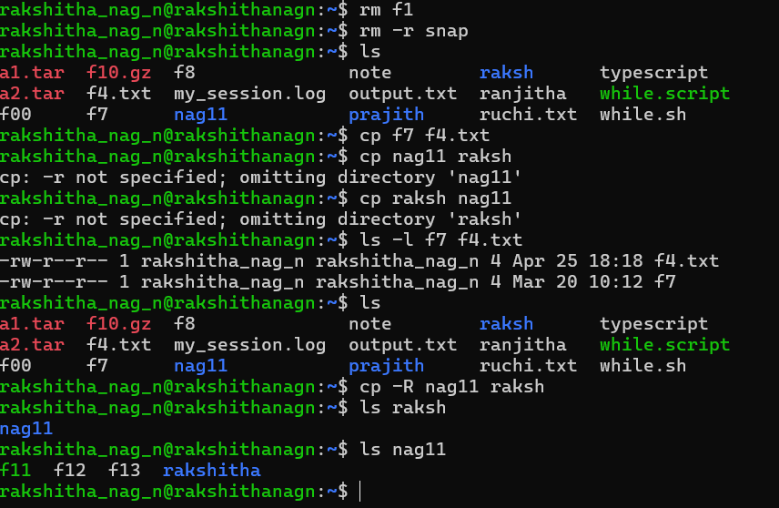

file command: The file command in Ubuntu is used to determine the type of a file.
Syntax: file [options] filename
Check multiple files: $ file file1.txt file2.jpg file3.bin Example output:
file1.txt: ASCII text
file2.jpg: JPEG image data file3.bin: data
Check all files in a directory: $file *
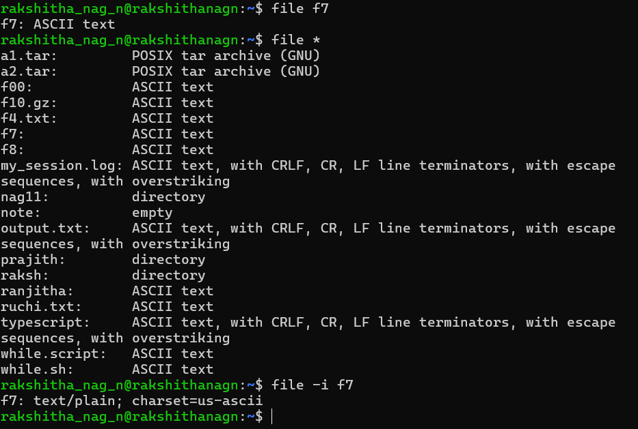

Cmp Command : The cmp (compare) command in Ubuntu is used to compare two files byte by byte.
It is mainly used to check if two files are identical or different. Syntax : cmp [options] file1 file2

Check if two files are identical
$ cmp file1.txt file2.txt

If files are identical, there is no output. If different, it shows the first differing byte and location.

Show all differences
$cmp -l file1.txt file2.txt
This displays differing byte positions and values.

Compare and stop after the first difference
$cmp -s file1.txt file2.txt
No output means the files are the same.
A different exit status (1) indicates a difference.

Compare only a specific number of bytes
$cmp -n 100 file1.txt file2.txt
This compares only the first 100 bytes. Skip initial bytes in comparison
$cmp -i 10 file1.txt file2.txt
This skips the first 10 bytes before comparing.

comm Command : Used to compare two sorted files line by line
display the differences and similarities. It outputs three columns:
  - Lines unique to the first file
  - Lines unique to the second file
  - Lines common to both files Syntax: comm [options] file1 file2 Show Only Common Lines
comm -12 file1.txt file2.txt
(Suppresses columns 1 and 2, showing only common lines.)

Show Only Differences
comm -3 file1.txt file2.txt
(Suppresses the common column, showing only unique lines.)

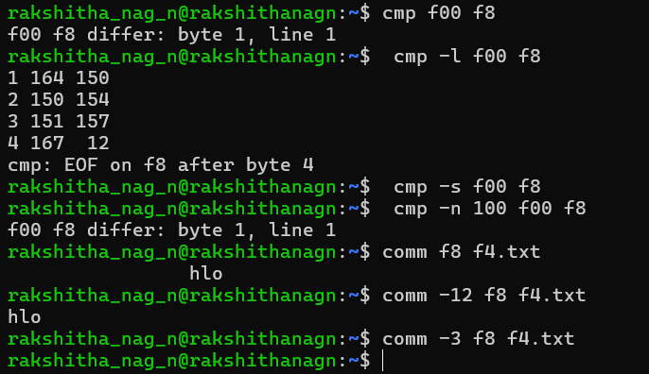

diff Command : Used to compare two files line by line
Highlight the differences. It is mainly used for text files but can also be used for directories.
Syntax : diff [options] file1 file2
Basic File Comparison: diff file1.txt file2.txt
- Show Differences Side by Side: diff -y file1.txt file2.txt
- Ignore Case Differences: diff -i file1.txt file2.txt
- Ignore White Spaces: diff -w file1.txt file2.txt
- Show Only Different Lines: diff --brief file1.txt file2.txt

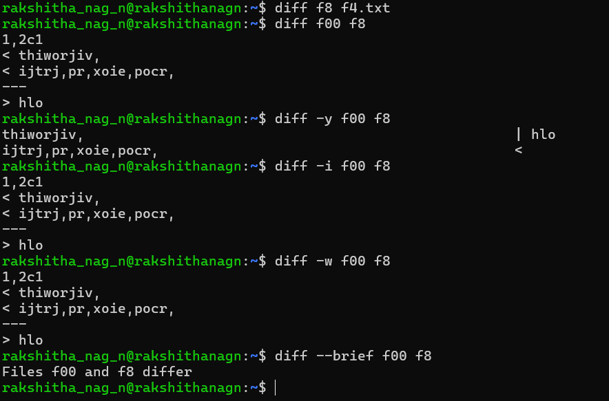

od: od command displays the contents of executable files in a ASCII octal value.
- -b:option displays this value for each character separately.
$ od –b file
- -c: it shows the printable characters and its corresponding ASCII octal representation
$ od –bc file

more: Used to view the contents of a file one page at a time in the terminal.
It is useful for reading long text files without opening an editor.
Syntax: $ more [options] filename View a file page by page
$more filename.txt
View long command output
$ ls -l | more

Display file with line numbers

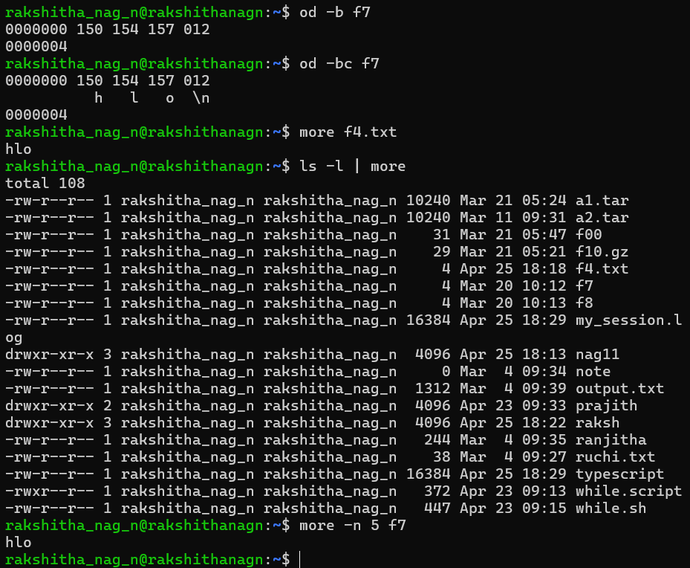

Converting Windows to Unix (dos2unix):
Syntax: dos2unix filename.txt
To overwrite the file: dos2unix -o filename.txt
Convert multiple files: dos2unix file1.txt file2.txt file3.txt

Converting Unix to Windows (unix2dos):
Syntax: unix2dos filename.txt
To overwrite the file: unix2dos -o filename.txt
Convert multiple files: unix2dos file1.txt file2.txt file3.txt

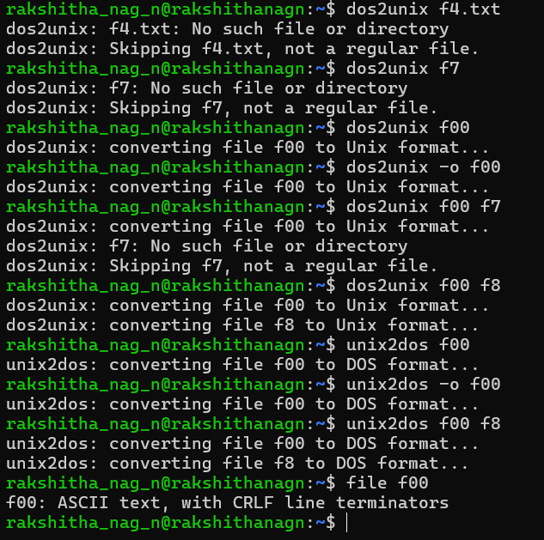

Compressing and archiving files:
- Compress a file using gzip: $ gzip filename
- Check compression details: $ gzip -l filename.gz
- Decompress a compressed file (.gz file) using gzip -d: $ gzip -d filename.gz
- Decompress using gunzip: $ gunzip filename.gz
- Compress all files in a directory recursively: $ gzip -r dirname

zip and unzip Commands:
Creating a Zip Archive:

Syntax: zip archive_name.zip file1 file2 directory Extracting a Zip Archive (unzip Command):
Syntax: unzip archive_name.zip
Viewing the Contents of a Zip Archive (unzip -v Command):
Syntax: unzip -v archive_name.zip
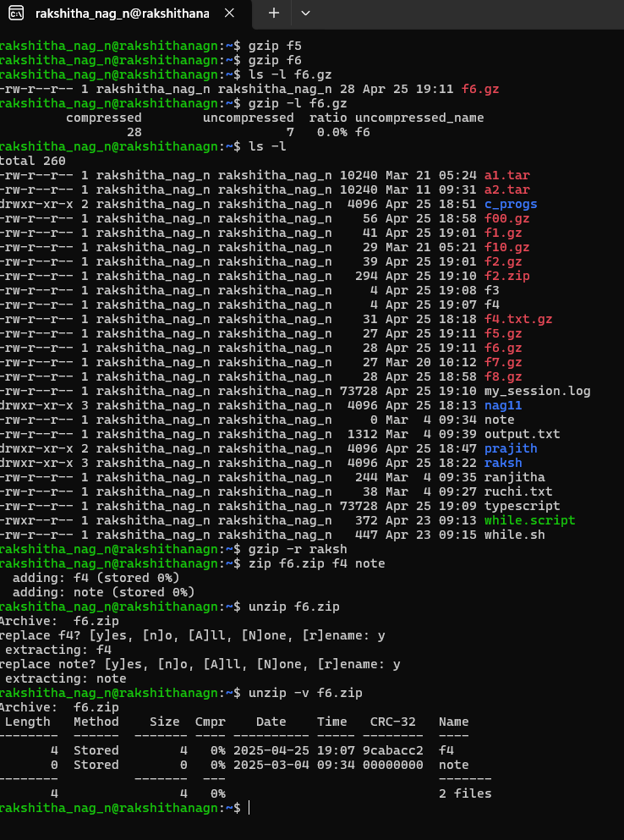

chmod: A file or a directory is created with a default set of permissions, which can be determined by umask.
  - RELATIVE PERMISSIONS:
chmod only changes the permissions specified in the command line and leaves the other permissions unchanged.
Syntax: chmod category operation permission filename(s) Ex:$chmod u+x xstart
$ ls –l xstart
Output:-rwxr--r-- 1 kumar metal 1906 sep 23:38 xstart

  - ABSOLUTE PERMISSIONS:
A string of three octal digits is used as an expression. The permission can be
represented by one octal digit for each category. For each category, we add octal digits.
- Read permission – 4 (octal 100)
- Write permission – 2 (octal 010)
- Execute permission – 1 (octal 001
- Ex:$chmod 666 xstart

