What is GitHub:

GitHub is an online software development platform. It's used for storing, tracking changes and collaborating on software projects.  It makes it easy for developers to share code files and collaborate with multiple developers on open-source projects.

Why we use GitHub:

GitHub is used to tracking changes in the source code, enabling multiple developers to work together on non-linear development.

Repository:

A repository is a storage space where your project lives. It can be local to a folder on your computer, or it can be a storage space on GitHub or another online host. You can keep code files, text files or any kind of a file in a repository.

How to Push a file to GitHub repository:

Steps:

1.Create a new Repository in GitHub.

How to create a new repository in GitHub.

1.Open the browser and then type github.com

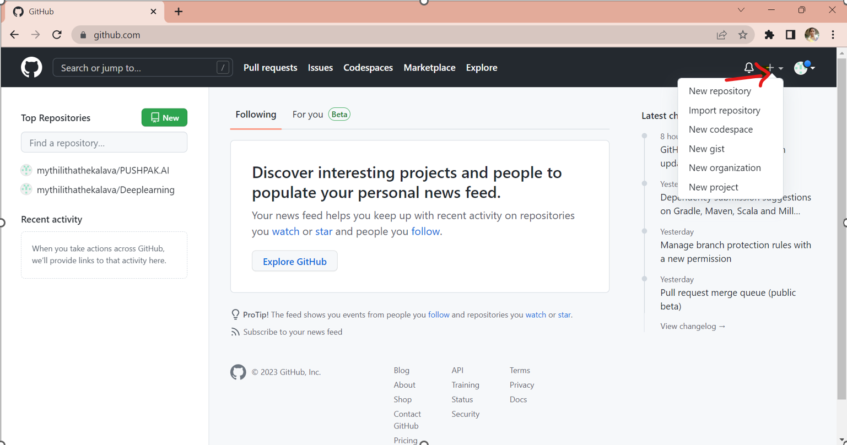­­­­­

2.In the right top corner of the image + sign is there if you click on that it will show pop over after you click on New Repository.

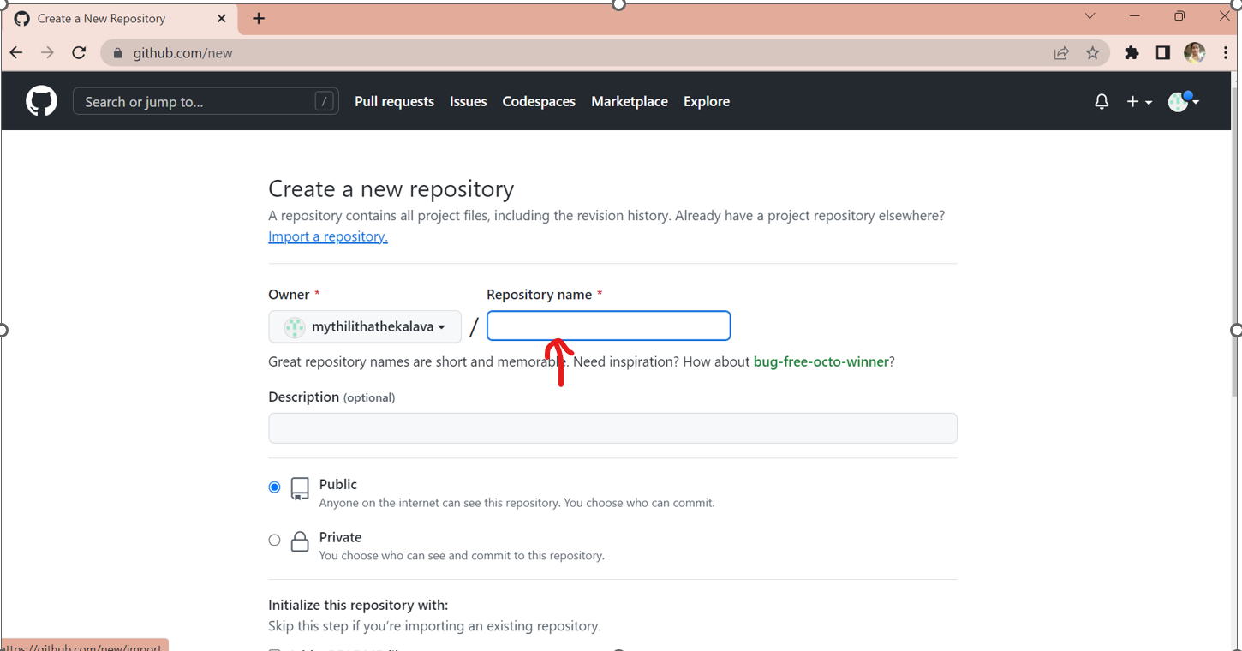

3.In the above image repository name is there in that you have to give your new repository name.

4.If you scroll up the screen it shows like this. I am attaching the image given below.

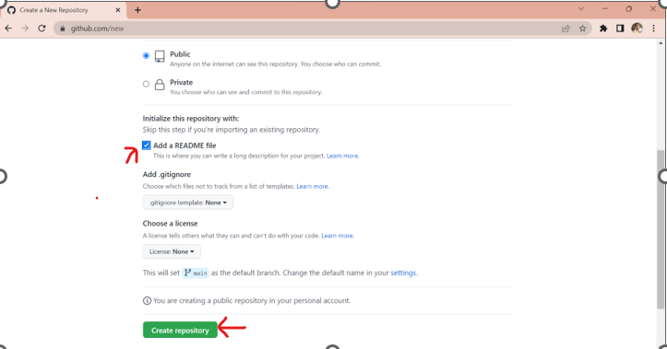

5.In above image you click on Add a README file after you click on create repository. then it will create new repository.

2.Open the GitBash Terminal.

How to download git:

1.Open the browser type git download

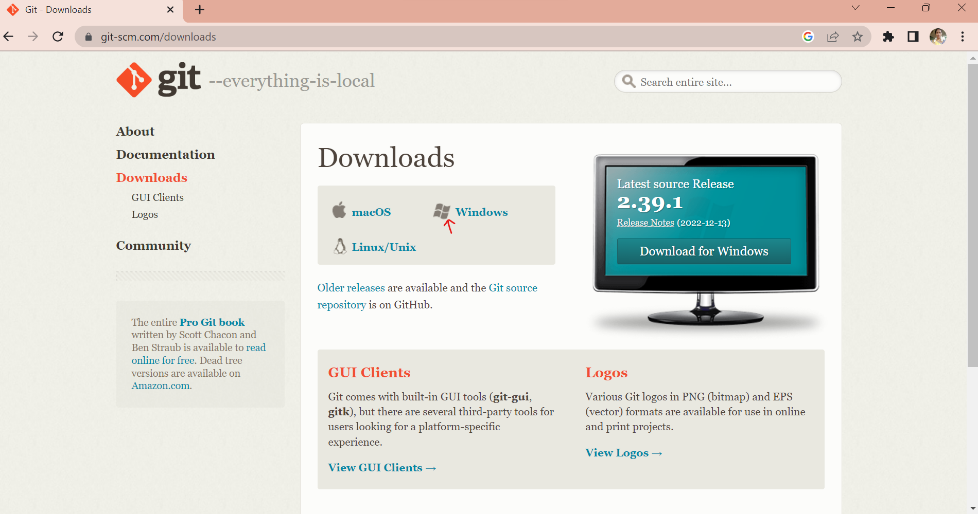

2.If you click on windows symbol then it will show another image.

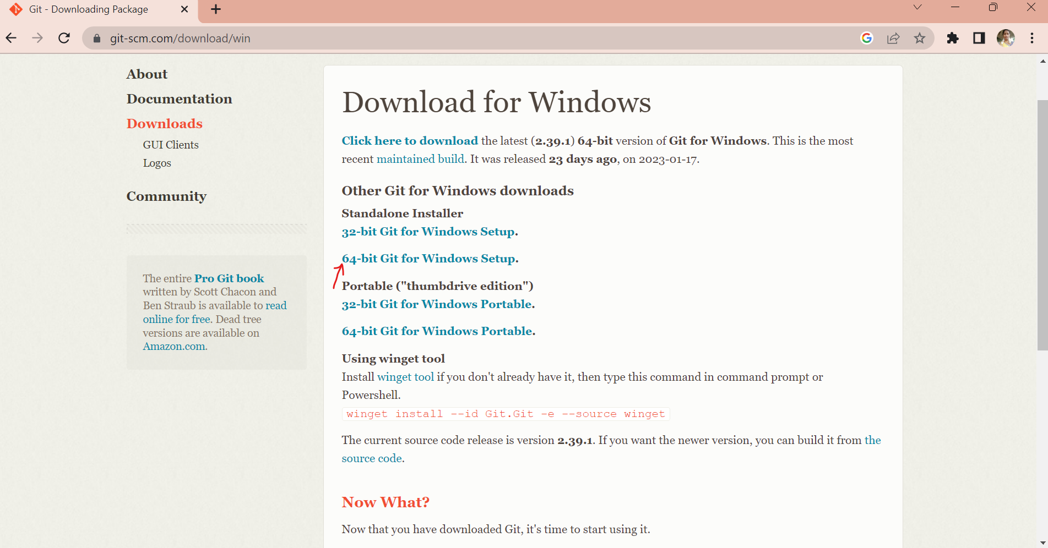

3.if you click on 64-bit Git for Windows Setup then it will starts downloading.

4.Open the GitBash terminal

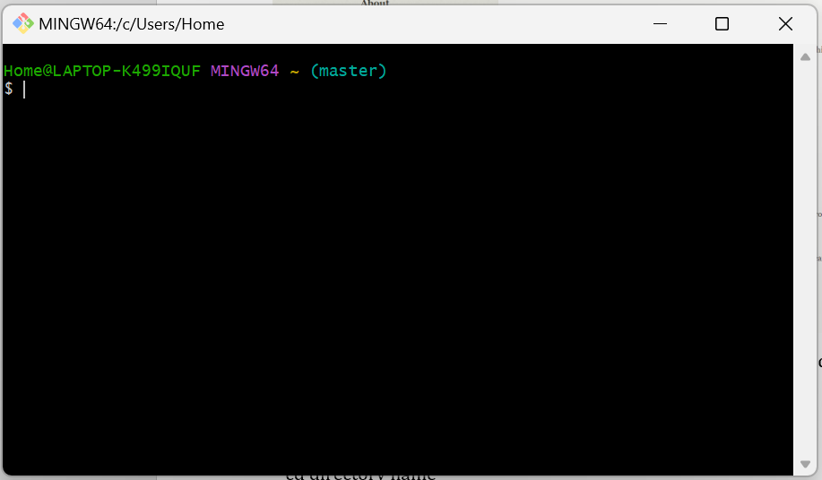

3.Change the current working directory as our local project.

cd <directory name>

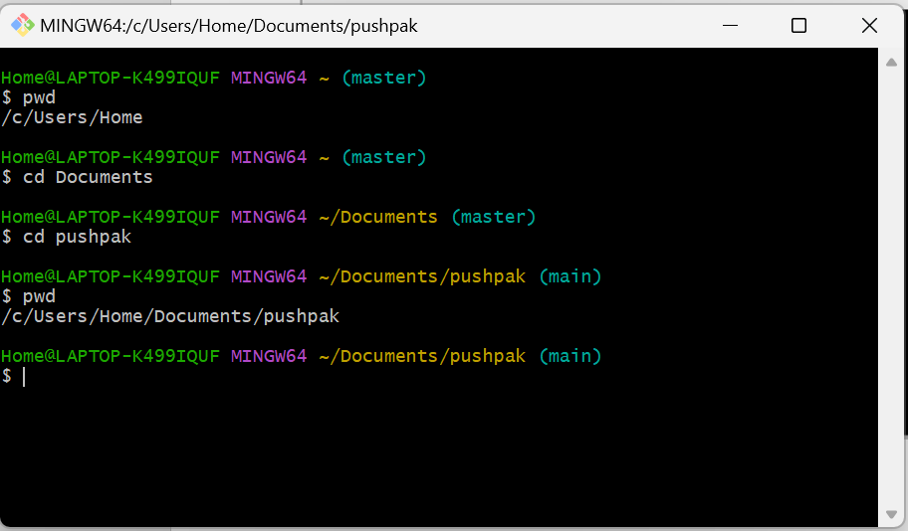

4.Use the git init command to initialize the local directory as a git repository.

git init

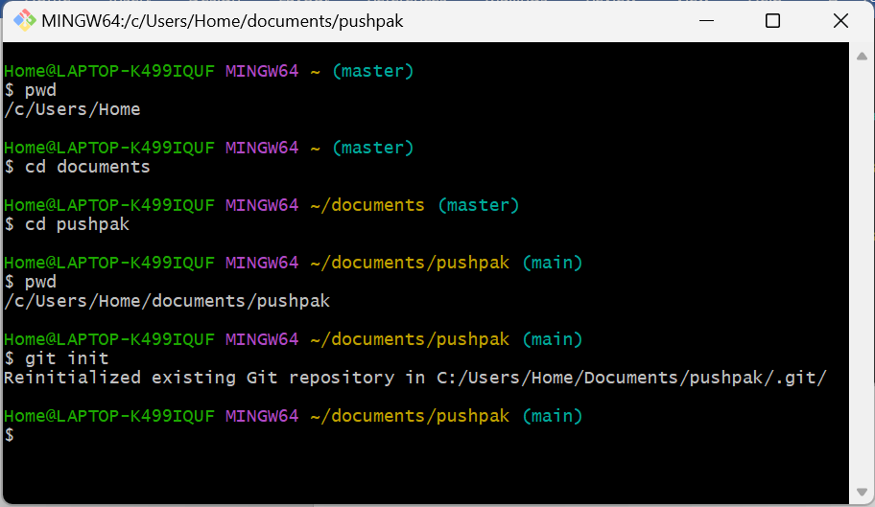

5. Copy the repository URL

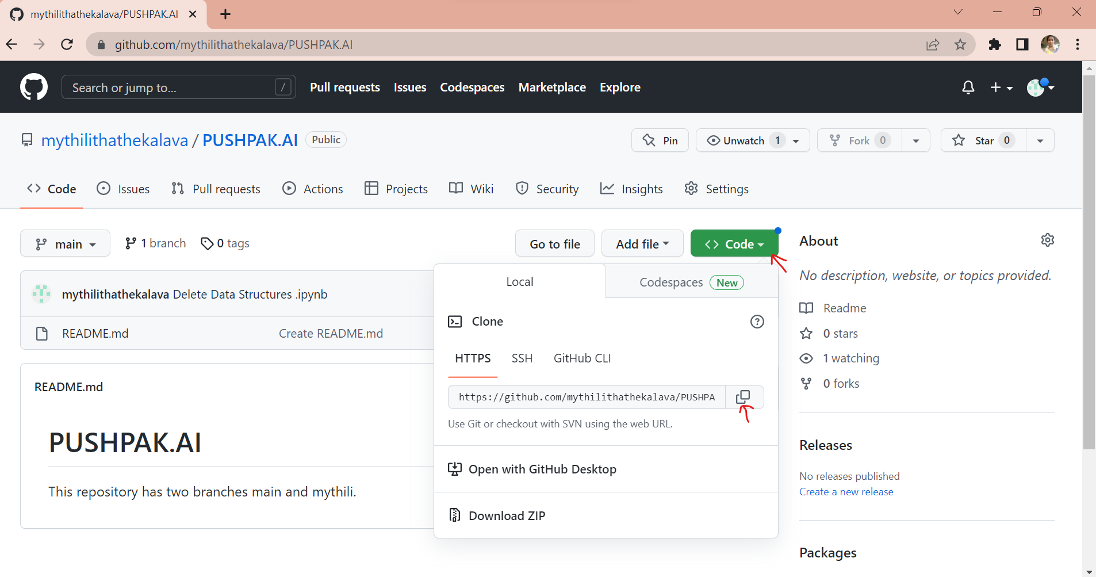

6. Add the URL to remote repository where your local repository will be pushed.

git remote add origin <URL link>

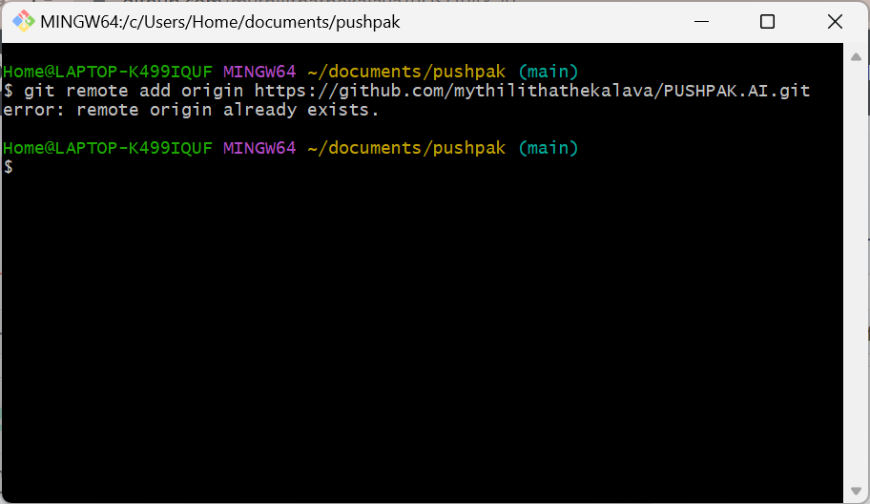

7.Add the files in your new local repository.

git add .

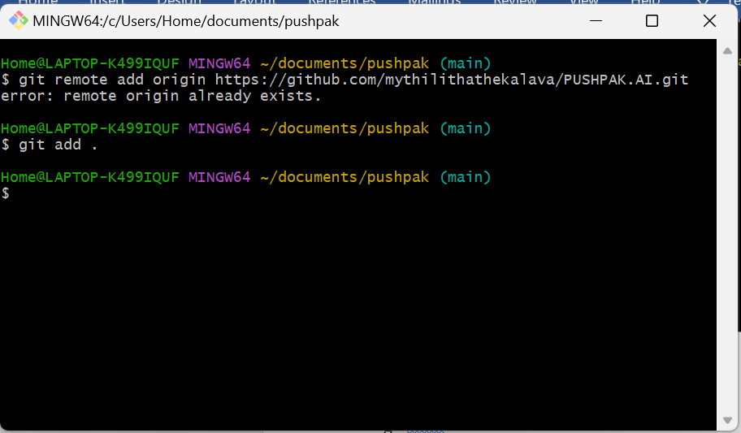

8.Commit the files that you’ve staged in your local repository.

git commit -m “first commit”

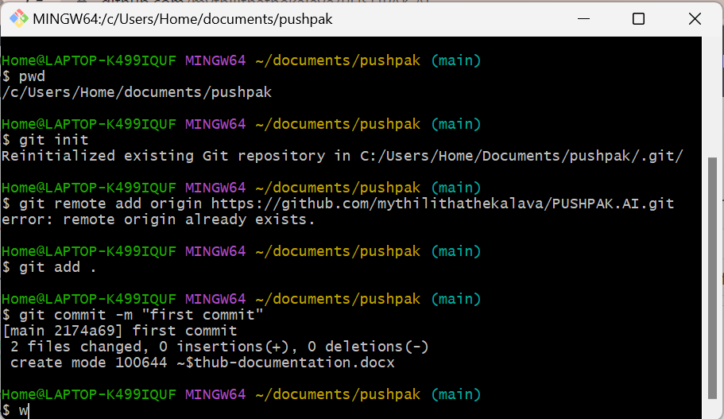

9.Push the Added files to GitHub repository.

git push -u origin main

main is the branch name

What is init:

git init is one way to start a new project with Git. To initialize a repository, Git creates a hidden directory called. git.

**Why we need init:**

To communicate from local to remote we need initialize our local directory. As you run git init command it will create a git subdirectory where your current folder or project will be assigned in that directory, it will then able to recognize your current directory. If git initialize then you will be able to run other git commands. This is very first command you need to communicate with git local to remote. In very short and simple understanding git init command is mediator between local and remote which is responsible to know you that this current directory is now already under git. Git init is only need when you want to start very first project upload on git.

What is Commit:

In version control systems, a commit is an operation which sends the latest changes of the source code to the repository, making these changes part of the head revision of the repository.

Why Commit is necessary:

Git commit messages are necessary to look back and see the changes made during a particular commit. If everyone will just commit without any message, no one would ever know that changes a developer has done. Moreover, you won’t be able to track down these changes once you see the history.

What is Version Control System:

Version Control System is a process to store all members changes in centralized location and keep track all changes being done in the VCS by whom, when and why. VCS — version control systems — are software tools designed to help teams work in parallel.

What is status:

The git status command displays the state of the working directory and the staging area. It lets you see which changes have been staged, which haven't, and which files aren't being tracked by Git. Status output does not show you any information regarding the committed project history.

What is Branch:

In git, a branch is a new\separate version of main branch, A repository can contain multiple branches, which means there are multiple versions of the repository.

How to create new branch:

git branch -M <new branch name>

How to see all branches in our repository:

Git branch -a

How to change one branch to another branch:

git checkout -b main

What is Push:

git push updates the remote branch with local commits.