Integrating Yolov5 with SORT Tracking Algorithm process steps:

Step1: searching in google yolov5 with sort GitHub.

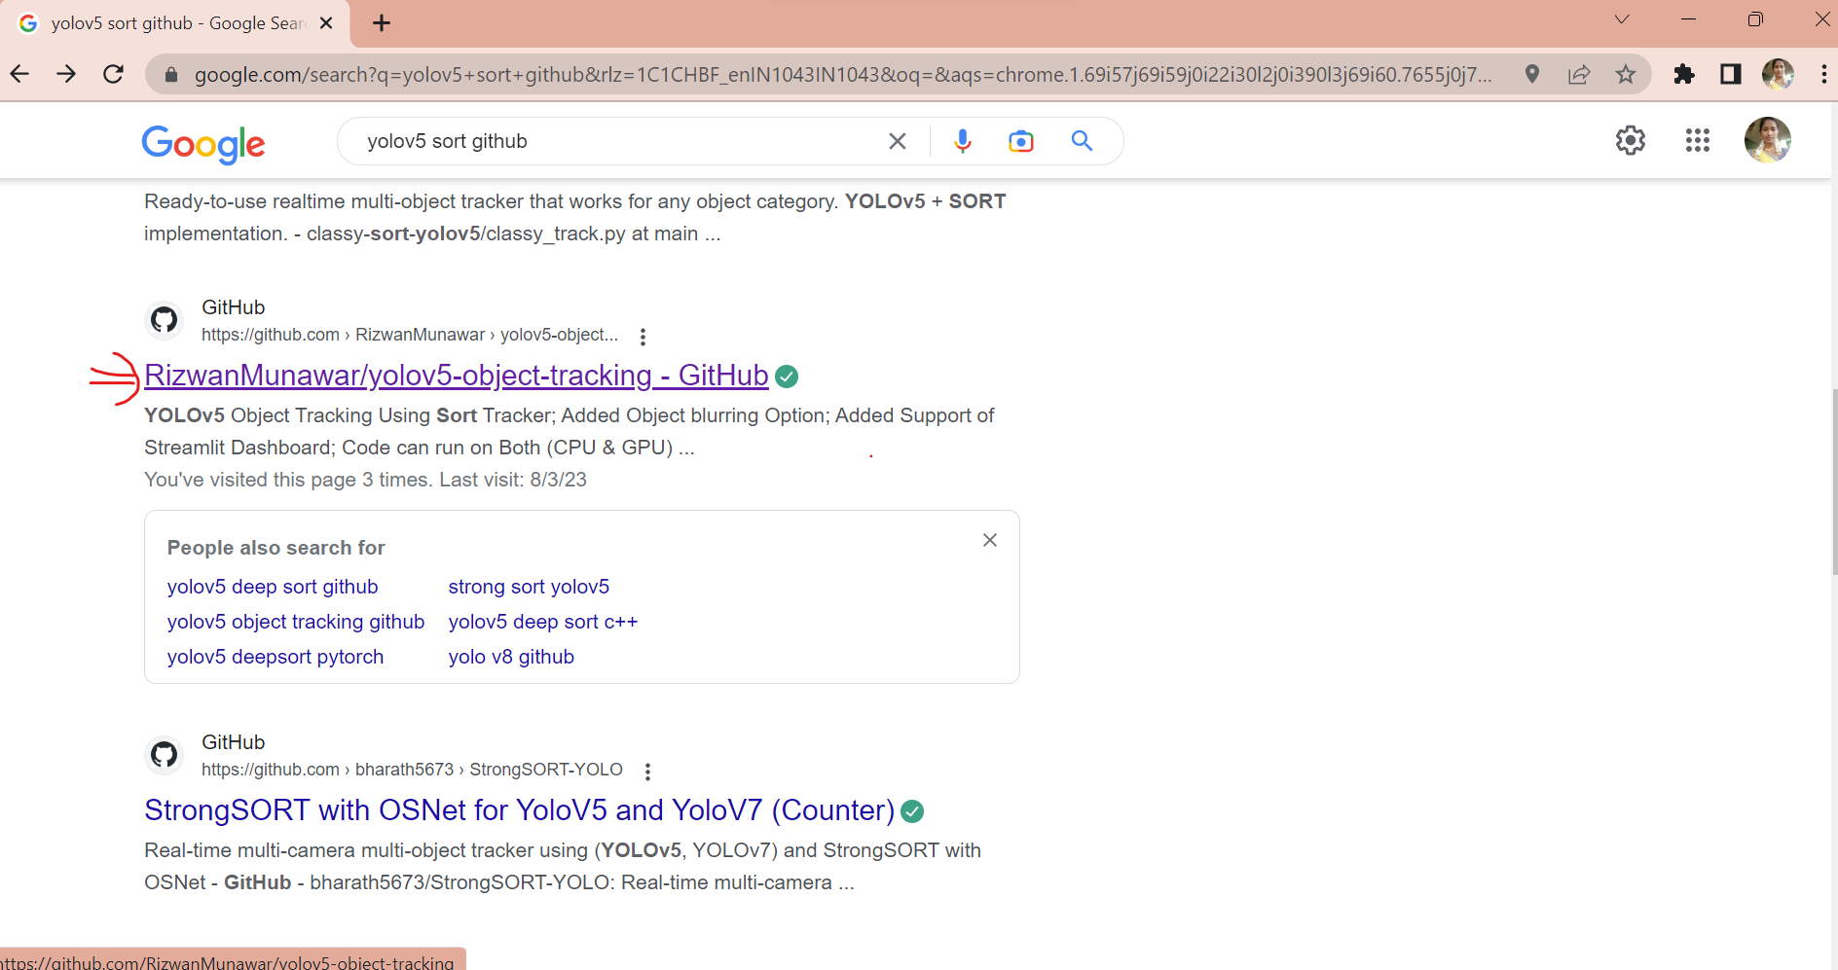

Step2: Go with Rizwan Munawar/yolov5-object-tracking – GitHub. Click on Code and copy the repository link.

Repository link: https://github.com/RizwanMunawar/yolov5-object-tracking

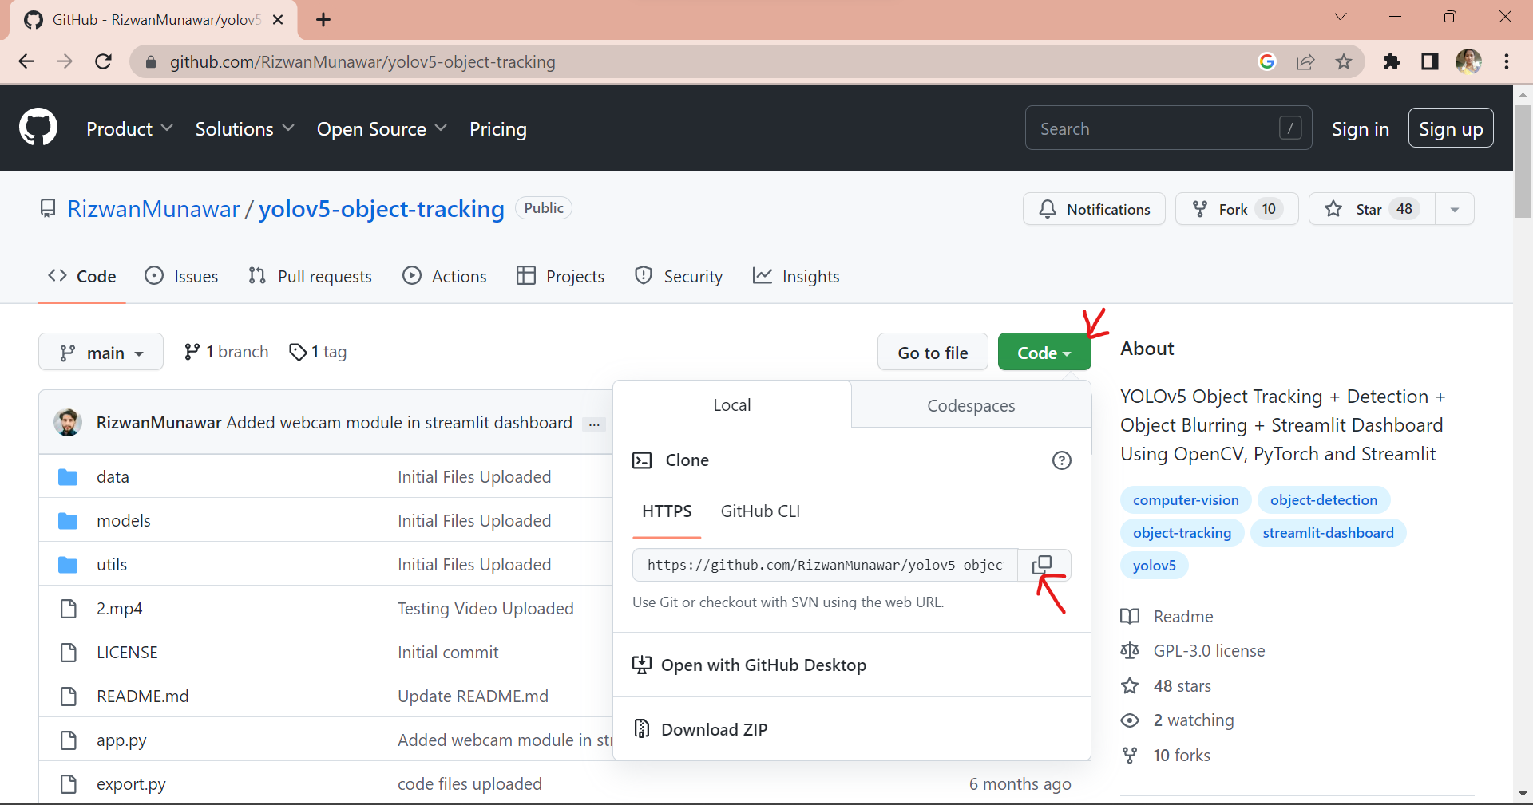

Step3: Open the anaconda terminal go to the whichever directory you want and clone this repository link.

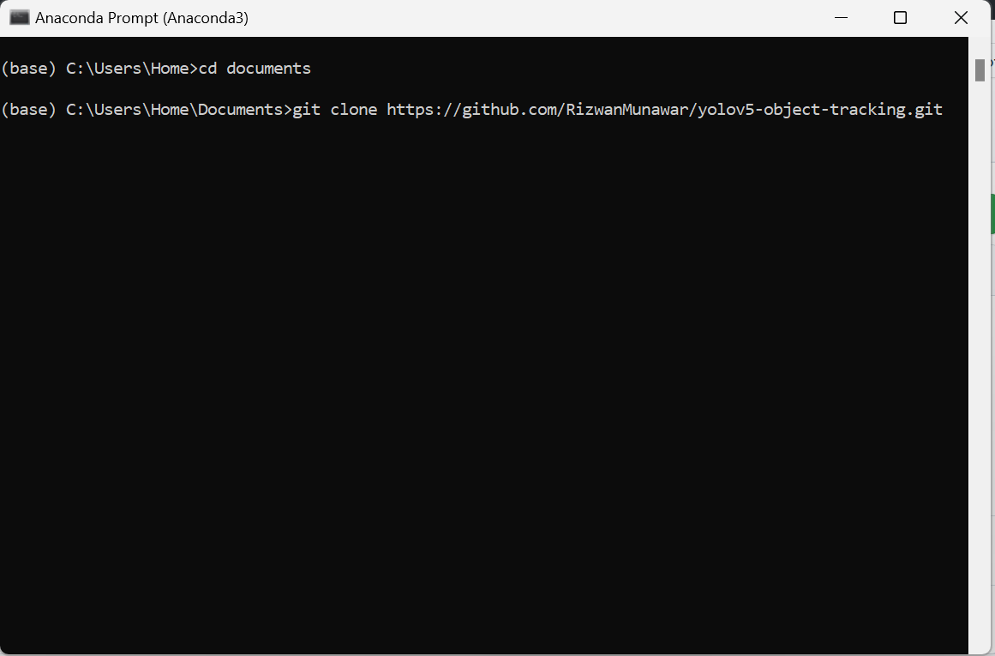

After giving the above command automatically it will download the GitHub repository in your directory.

Step4: In which directory you clone that repository go to that directory in that directory it will show the cloned repository. Open the yolov5-object-tracking.

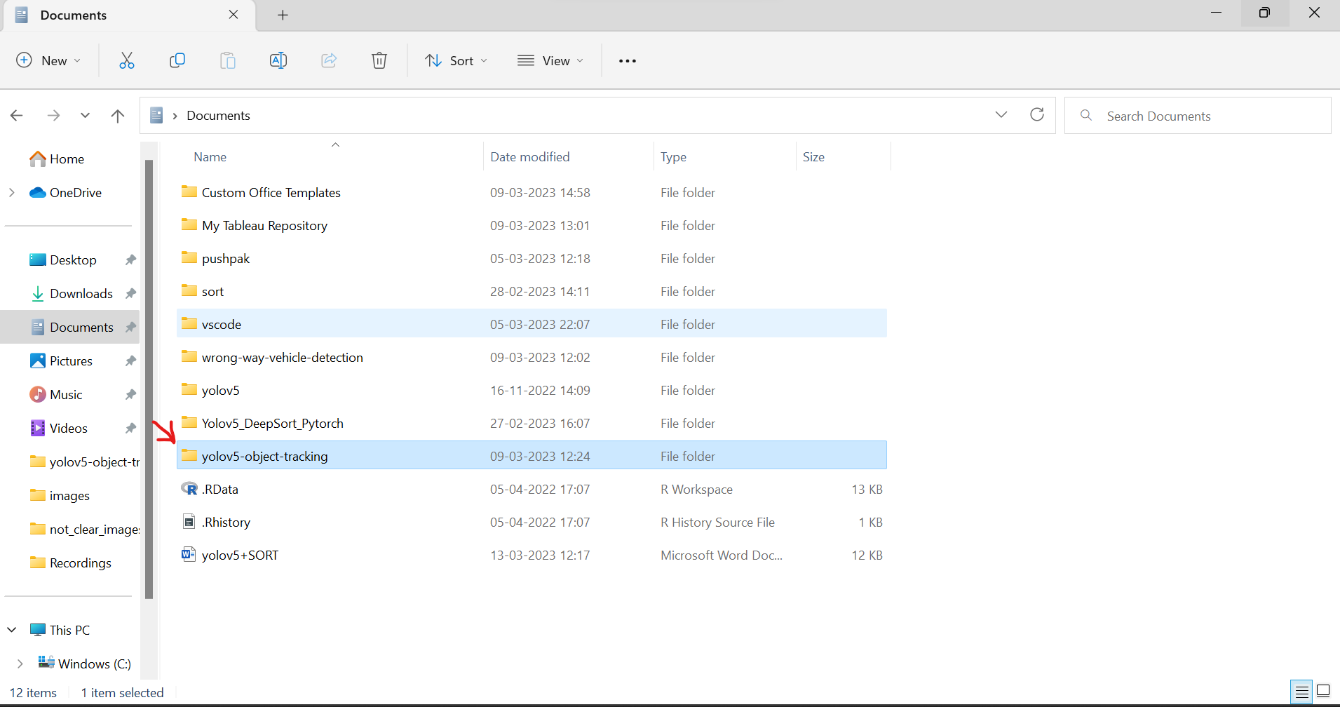

Step5: This repository is already integrated yolov5 with SORT.

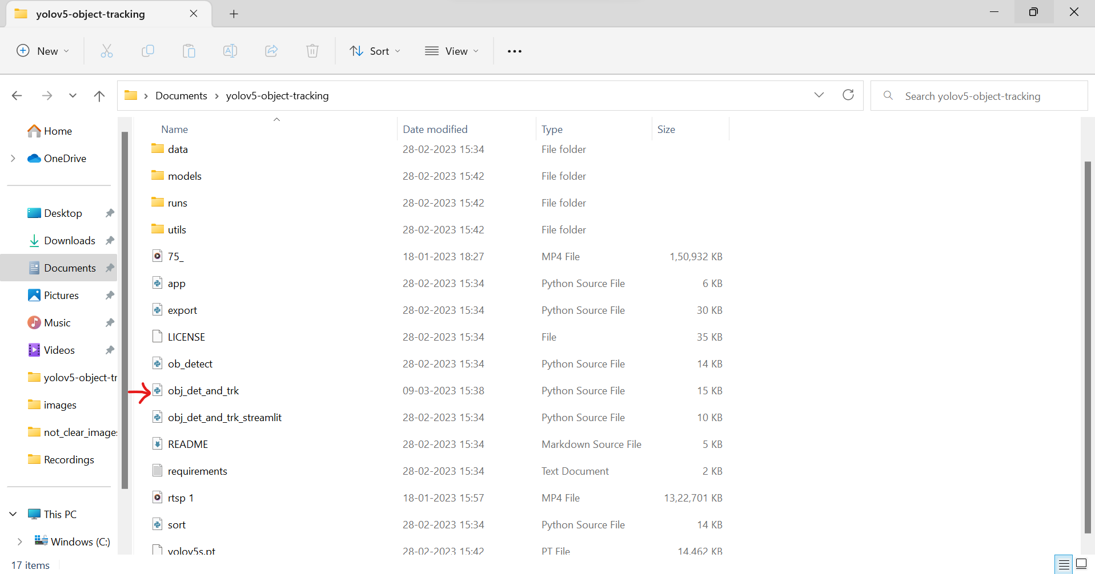

Step6: Open the anaconda terminal. Go to the directory wherever your GitHub repository in your computer and then activate your Environment.

# Changing Directory

Changing directory command: cd <directory name>

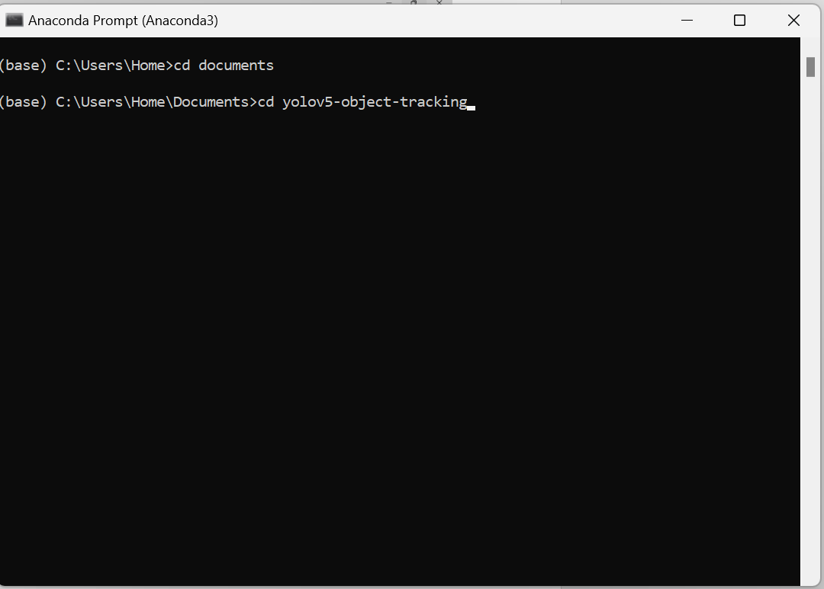

# Activating new Environment.

Activating Environment command: conda activate <environment name>

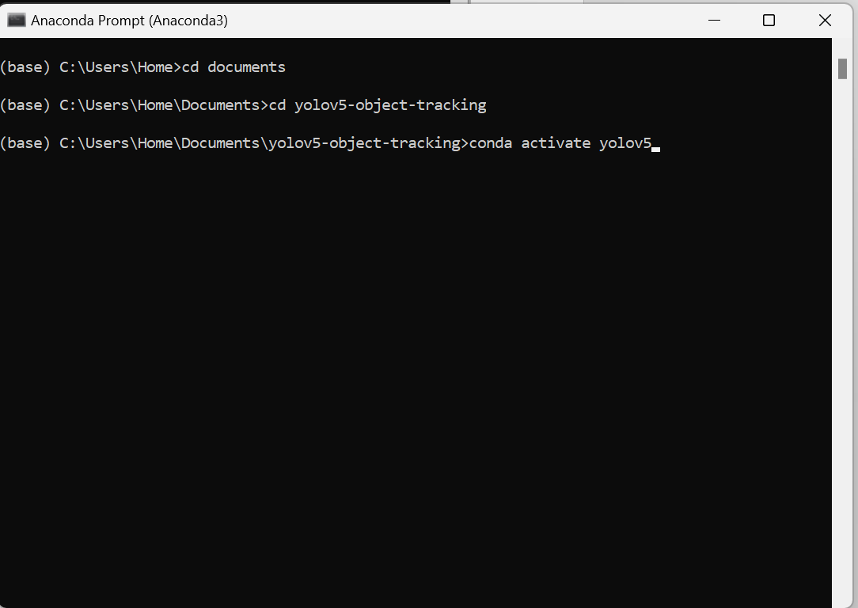

Step7: Give the actual repository commands in anaconda prompt.

python obj_det_and_trk.py --source <video path> --weights yolov5s.pt --view-img --classes 2 3 5 7

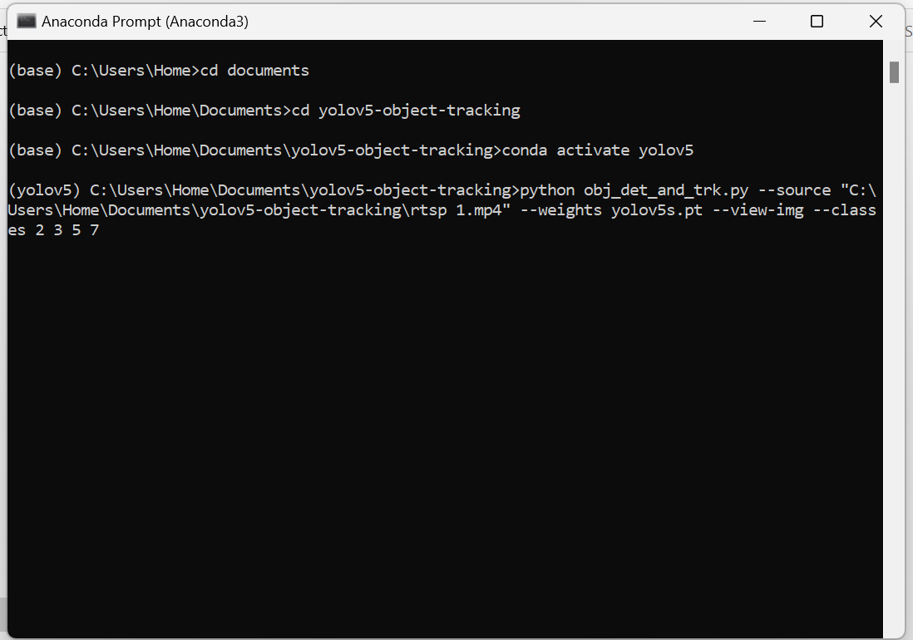

After this it will run and show the video and it save the results in run\detect\exp. If you have any doubts about this repository read the README file in repository.

