“Design and Development of CareSync: An Integrated Hospital Management System”
A Project Report Submitted in the partial fulfillment of the requirements for the award of the degree of
BACHELOR OF TECHNOLOGY
In
DEPARTMENT OF COMPUTER SCIENCE AND ENGINEERING
By
AAKASH DADHIRAO | : | 2520030337
SOURADEEPTA DAS | : | 2520030347
MYTHRI | : | 2520030296

Under the Esteemed Guidance of
Dr. S. Spandana
Department of Computer Science and Engineering



K L (Deemed to be) University
DEPARTMENT OF COMPUTER SCIENCE AND ENGINEERING

Declaration
The Project Report entitled “Design and Development of CareSync: An Integrated Hospital Management System” is a record of Bonafide work of AAKASH DADHIRAO - 2520030337, SOURADEEPTA DAS - 2520030347, MYTHRI - 2520030296 submitted in partial fulfillment for the award of B. Tech in Computer Science and Engineering to the K L University. The results embodied in this report have not been copied from any other departments/University/Institute.

AAKASH DADHIRAO – 2520030337
SOURADEEPTA DAS – 2520030347
MYTHRI – 2520030296

K L (Deemed to be) University
DEPARTMENT OF COMPUTER SCIENCE AND ENGINEERING

CERTIFICATE
This is to certify that the mini project based report entitled “Design and Development of CareSync: An Integrated Hospital Management System” is a bonafide work done and submitted by AAKASH DADHIRAO - 2520030337, SOURADEEPTA DAS - 2520030347, MYTHRI - 2520030296 in partial fulfillment of the requirements for the award of the degree of BACHELOR OF TECHNOLOGY in Department of Computer Science and Engineering, K L (Deemed to be University), during the academic year 2026-2027.

Signature of the Guide
Signature of the Course Coordinator | Signature of the HOD
ACKNOWLEDGEMENT
The success of this project would not have been possible without the timely help and guidance rendered by many people. We wish to express our sincere thanks to all those who have assisted us in one way or the other in the completion of our project.
Our greatest appreciation goes to our project guide, Dr. S. Spandana, Department of Computer Science and Engineering, whose tremendous support, encouragement and guidance throughout this project cannot be expressed in words.
We express our gratitude to the Head of the Department of Computer Science and Engineering for providing us with adequate facilities, ways and means by which we were able to complete this project-based lab.
We thank K L (Deemed to be) University and all the members of the teaching and non-teaching staff, as well as our peers who gave us valuable feedback and assisted us directly or indirectly in the successful completion of this project.
We also acknowledge the open-source communities behind React, FastAPI, Python, SQLAlchemy and the many supporting libraries, whose freely available technologies formed the foundation on which the CareSync platform was developed.
Finally, we sincerely thank our parents, friends and classmates for their kind help and cooperation during our work.

AAKASH DADHIRAO – 2520030337
SOURADEEPTA DAS – 2520030347
MYTHRI – 2520030296
Abstract
CareSync is a comprehensive, full-stack Hospital Management System designed to unify healthcare administration, clinical tracking, and patient data into a single, cohesive platform. Healthcare facilities commonly depend on disconnected tools for billing, scheduling and vital-sign charts, which creates data silos and administrative bottlenecks. CareSync addresses this fragmentation by bringing every stage of a patient’s journey into one system.
The platform is built using a modern React frontend and a robust Python FastAPI / MySQL backend. It implements Role-Based Access Control (RBAC) to provide specialized interfaces for Doctors, Patients, Admins, Pharmacists, and Receptionists. Key capabilities include real-time telemetry charting of patient vitals, integrated pharmacy billing with a database-driven medicine inventory, seamless patient transfers between doctors, a discharge consent flow, and live executive analytics for administrators.
By solving the problem of fragmented medical records and manual, disconnected workflows, CareSync improves operational efficiency and the overall quality of patient care. In summary, the project delivers a functional, synchronized and demo-ready hospital administration platform that bridges the gap between medical care, pharmacy logistics, and administrative oversight.
Index
S. No | Chapters | Topics | Page.no
Acknowledgement
Abstract
1 | Introduction | 1.1 Background of the project  1.2 Problem statement  1.3 Scope of the project  1.4 Objective(s)  1.5 Importance of the application  1.6 Target users/audience | 1-3
2 | System Requirements | 2.1 Hardware requirements  2.2 Software requirements  2.3 Development tools and frameworks | 4
3 | Technology Stack | 3.1 Front-end  3.2 Back-end  3.3 Database  3.4 Version Control  3.5 APIs or External services | 5
4 | System Architecture | 4.1 High-level architecture diagram  4.2 Description of each layer (frontend, backend, database)  4.3 Deployment architecture | 6-7
5 | Design | 5.2 ER Diagram / Database schema | 8-9
6 | Implementation | 6.1 Module-wise implementation  6.2 Front-end logic (UI rendering, state management)  6.3 API integration  6.4 Authentication & Authorization | 10
7 | Features | 7.1 List of main features  7.2 How each feature works (user perspective + technical description) | 11
8 | Testing | 8.1 Postman testing  8.2 Integration testing  8.3 Tools used for testing  8.4 Test cases and results | 12
9 | Deployment | 9.1 Steps to deploy  9.2 Environment configuration  9.3 Hosting of frontend and backend | 13
10 | Challenges & Limitations | 10.1 Issues faced during development  10.2 Solutions applied  10.3 Current limitations or known bugs | 14
11 | Future Enhancements | 11.1 Planned features  11.2 Possible integrations or optimizations | 15
12 | Conclusion | 12.1 Summary of the project  12.2 What was achieved  12.3 Skills learned during development | 16
13 | References | Books, tutorials, APIs, documentation sites used | 17
14 | Appendices | Screenshots of the app  Sample code snippets  Installation/setup instructions  User manual or guide  Geo Tag photos with guide  Review forms with guide signatures | 18-20

CHAPTER -1 INTRODUCTION

1.1 Background of the Project
Healthcare is one of the most information-intensive sectors in the world. Every patient visit produces a stream of data: registration details, assigned physicians, vital signs, prescriptions, medicine dispensing records, invoices, and discharge decisions. Managing this data accurately and in a timely manner is central to both the quality of care and the financial health of a hospital.
Despite this, modern healthcare facilities often rely on fragmented software – one system for billing, another for scheduling, and physical charts for vitals. These tools rarely communicate with one another, so the same patient information has to be re-entered in several places, and each department works with its own partial view of the patient. This fragmentation leads to data silos and administrative bottlenecks.
CareSync was conceived to remove these barriers. It is a full-stack Hospital Management System that brings reception, clinical care, pharmacy, patient services and executive administration onto one shared platform. The frontend is built with React, the backend with FastAPI (Python), and all information is stored in a MySQL relational database, so every user role works from the same, always up-to-date source of truth.

1.2 Problem Statement
Hospitals struggle with disjointed patient handoffs, delayed discharge processes, manual inventory tracking in pharmacies, and a lack of real-time administrative oversight, leading to inefficiencies and potential medical errors. The main problems that CareSync sets out to solve are:
- Disjointed patient handoffs – when a patient moves between departments or physicians, information is passed on manually and can be delayed or lost.
- Delayed discharge processes – the clinical decision to discharge, the pharmacy bill and the patient’s consent are handled separately, which slows the process down.
- Manual pharmacy inventory tracking – stock levels are checked by hand, so shortages are noticed late and billing errors are likely.
- No real-time administrative oversight – administrators cannot see revenue, stock levels or staffing at a glance.
- Fragmented medical records – vitals, prescriptions and bills live in different systems or on paper, increasing the potential for medical errors.

1.3 Scope of the Project
The project encompasses a complete lifecycle application. It covers the full path a patient takes through the hospital and the work of every department involved along the way:
- Patient intake at reception, including walk-in queue management and conversion of a walk-in guest into a registered patient.
- Clinical diagnostics and telemetry tracking by physicians, including recording vital signs, viewing them as live charts, and prescribing medicines.
- Prescription and invoice generation by the pharmacy using a database-driven medicine inventory.
- Patient consent signing as part of the discharge flow.
- Executive oversight by administrators through a live analytics dashboard and staff onboarding.

The system is delivered as a web application and is deployed locally for demonstration, with an architecture that can later be moved to the cloud. Features such as encrypted individual user sessions, automated e-mail/SMS notifications and online payments are outside the scope of the current version and are listed under Future Enhancements (Chapter 11).

1.4 Objectives of the Project
The overall objective of CareSync is to centralize medical data, automate inter-departmental communication, secure patient records via strict role-based access, and provide interactive data visualization for clinical decision-making. The specific objectives are:
- To centralize patient, clinical, pharmacy and billing data in a single relational database.
- To automate communication between departments (reception, doctors, pharmacy and administration) so that handoffs are instant and traceable.
- To secure patient records through strict Role-Based Access Control (RBAC), so each role sees only the views and actions it needs.
- To provide interactive data visualization – such as real-time telemetry charts of vital signs – that supports clinical decision-making.
- To generate accurate, instant pharmacy invoices and flag low-stock medicines before stockouts occur.
- To give administrators live financial and operational analytics.

1.5 Importance of the Application
CareSync drastically reduces administrative overhead by replacing paper charts and disconnected tools with one integrated workflow. Billing is accurate and instant because invoice totals are calculated automatically from the medicines selected, and permanent invoices are saved to the database.
The application also helps prevent medicine stockouts. Low-stock items are flagged on the administrator’s dashboard, allowing the pharmacy to reorder in time. Clinically, doctors can see a patient’s vital-sign history as a chart instead of a table of numbers, which makes trends easier to spot.
Finally, CareSync empowers patients by giving them transparent access to their active medical profile and to the discharge procedure. Patients can follow where they stand in the discharge process instead of waiting without information.

1.6 Target Users / Audience
CareSync is designed for five groups of users, each with a dedicated workspace:
User | How they use CareSync
Physicians | View only their assigned patients, record vital signs, prescribe medicines and mark patients ready for discharge.
Hospital Administrators | Monitor live revenue and low-stock inventory, and onboard new medical staff.
Pharmacy Technicians | Build patient invoices from the medicine inventory and maintain the pharmacy ledger.
Front-Desk Receptionists | Manage the walk-in queue and register guests as patients.
Admitted Patients | View their active medical profile and follow the discharge procedure, including consent signing.

CHAPTER -2 SYSTEM REQUIREMENTS

2.1 Hardware Requirements
The following minimum hardware is required to run CareSync (frontend, backend and database) in a local environment:
Component | Minimum requirement
Processor | Intel i3 / AMD Ryzen 3 or higher
Memory (RAM) | 8 GB
Storage | 10 GB of available disk space
Network | Standard network interface card for client–server communication

2.2 Software Requirements
Software | Requirement
Operating system | Windows 10/11, macOS, or Linux
Node.js | Version 18 or higher (for the React / Vite frontend)
Python | Version 3.8 or higher (for the FastAPI backend)
Database server | MySQL Server 8.0 or higher
Web browser | A modern browser – Google Chrome, Microsoft Edge or Safari

2.3 Development Tools and Frameworks
- Visual Studio Code – the IDE used for writing the frontend and backend code.
- MySQL Workbench – the database GUI used to design, inspect and verify the data.
- Vite – the frontend build tool and development server.
- Postman – used to test the REST API endpoints.

CHAPTER -3 TECHNOLOGY STACK
CareSync follows a modern three-tier web stack: a React single-page application on the client, a FastAPI service for the business logic, and a MySQL relational database for persistence.
Layer | Technologies
Front-end | React.js, HTML5, CSS3, Vite, Lucide React, Recharts
Back-end | FastAPI, Uvicorn, Python 3
Database | MySQL, SQLAlchemy ORM
Version control | Git and GitHub
API communication | Axios (HTTP REST requests)

3.1 Front-end
The user interface is built with React.js, a JavaScript library for component-based UIs, together with HTML5 and CSS3 for structure and styling. Vite is used as the frontend tooling, giving fast start-up and hot reloading during development. Lucide React provides the icon set used throughout the dashboards, and Recharts is used to draw the real-time telemetry (vital-sign) line charts in the Doctor Console.

3.2 Back-end
The backend is written in Python 3 using FastAPI, a high-performance web framework that provides automatic request validation and clear API routing. FastAPI is served by Uvicorn, an ASGI web server. Together they expose the REST endpoints that the React frontend calls.

3.3 Database
Persistent data is stored in MySQL, a relational database. The backend accesses it through SQLAlchemy, an Object-Relational Mapper (ORM) that maps Python classes to database tables. Using an ORM keeps the code readable and reduces the risk of hand-written query errors.

3.4 Version Control
Git and GitHub are used for source code management, allowing the team to work on the project in parallel, track changes and keep a history of the code.

3.5 APIs or External Services
Axios is used to execute HTTP REST API requests from the frontend to the backend. CareSync does not currently depend on any third-party external services; integrations such as Stripe and Twilio are planned for the future (Chapter 11).

CHAPTER -4 SYSTEM ARCHITECTURE

4.1 High-level Architecture Diagram
CareSync uses a client–server architecture. The frontend (a React single-page application) communicates asynchronously via RESTful HTTP requests with the backend (FastAPI), which queries the database (MySQL) through an ORM layer and returns JSON payloads.
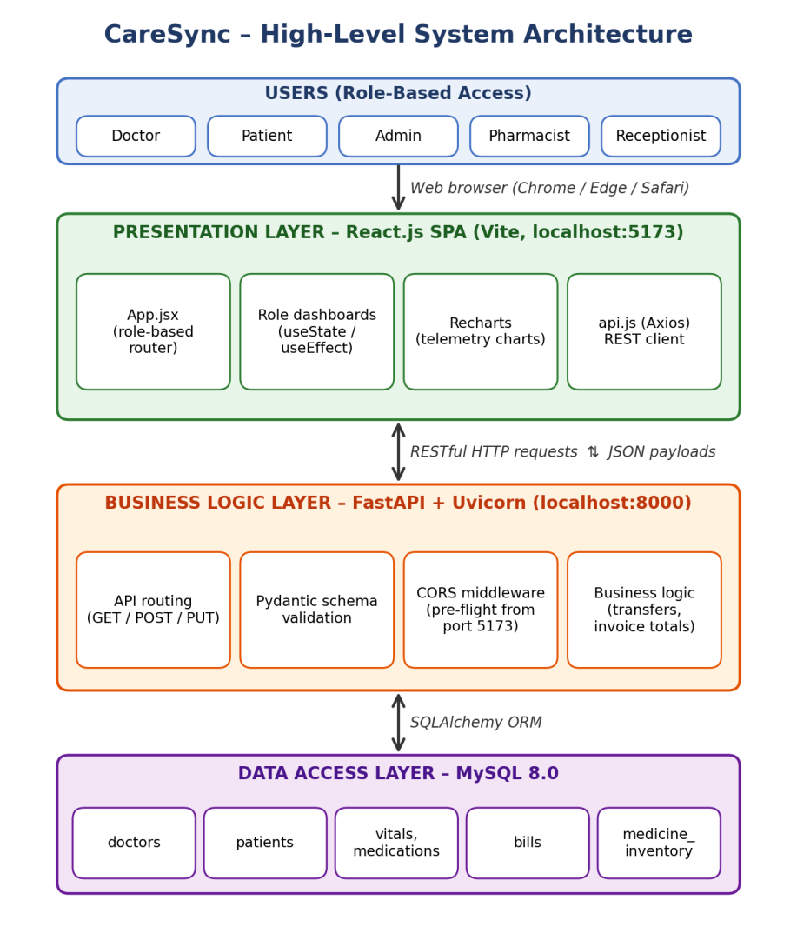
Figure 4.1: High-level architecture of CareSync

4.2 Description of Each Layer (Frontend, Backend, Database)

Frontend (Presentation Layer)
The frontend manages UI state, renders dynamic dashboards based on the user’s role, and visualizes data using Recharts. It never talks to the database directly; every read or write goes through the backend API.

Backend (Business Logic Layer)
The backend handles API routing, data validation via Pydantic schemas, and complex operations such as patient transferring and total invoice calculations. Keeping this logic on the server ensures that the rules are applied consistently regardless of which screen triggers them.

Database (Data Access Layer)
The database provides persistent storage with strict relational constraints and cascading deletions to maintain data integrity. Foreign keys tie vitals, medications and bills to the correct patient, and patients to their doctor.

4.3 Deployment Architecture
The system is configured for local environment deployment, with the frontend served at localhost:5173 and the backend at localhost:8000. The architecture is designed to be scalable to cloud providers such as AWS or Render using Docker containers and CI/CD pipelines.

CHAPTER -5 DESIGN

5.2 ER Diagram / Database Schema
The CareSync database is organised around the patients table, which is the central node of the schema. The tables and their relationships are described below.
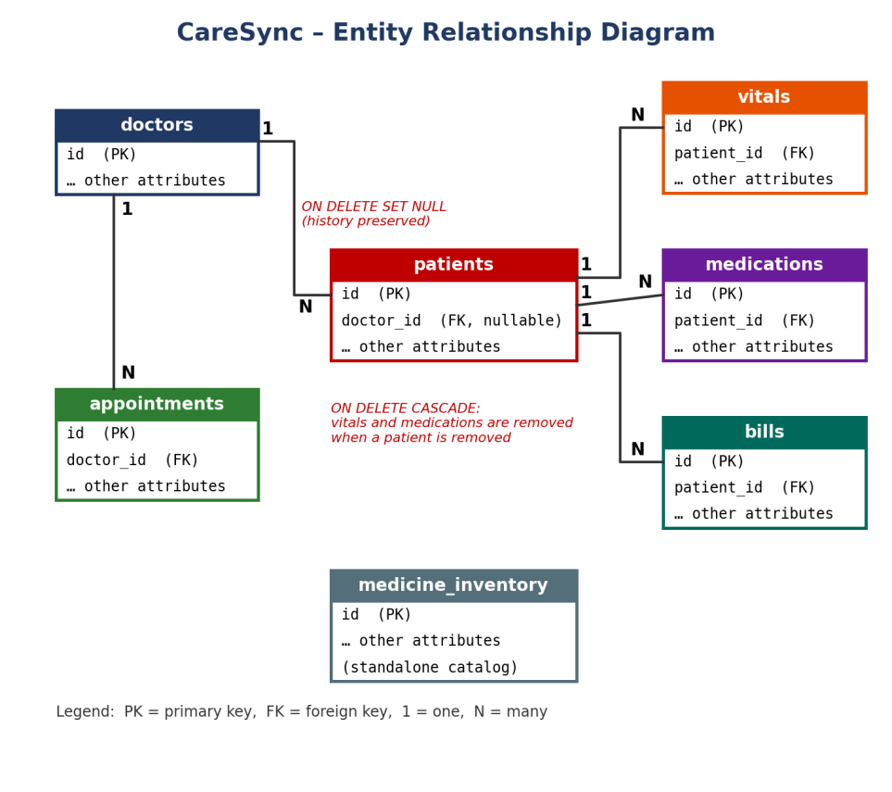
Figure 5.1: Entity Relationship (ER) diagram of CareSync
Table | Purpose and relationships
doctors | Stores medical staff. Has a one-to-many relationship with patients and with appointments.
patients | The central table. Has one-to-many relationships with vitals, medications and bills.
vitals | Time-stamped vital-sign readings for a patient, used for telemetry charting.
medications | Medicines prescribed to a patient.
bills | Permanent pharmacy invoices generated for a patient.
appointments | Appointments linked to a doctor.
medicine_inventory | A standalone catalog of medicines used for pharmacy lookups and stock tracking.

Referential integrity rules
- ON DELETE CASCADE is applied to vitals and medications, so when a patient is removed their dependent records are removed with them and no orphan rows remain.
- ON DELETE SET NULL is applied to the doctor reference on patients, so if a doctor is removed the patient history is preserved and the patient simply becomes unassigned.

CHAPTER -6 IMPLEMENTATION

6.1 Module-wise Implementation
The application is divided into six modules:
Module | Description
Authentication | Role selection and passcode entry that decide which workspace is shown.
Reception Queue | Walk-in queue management and conversion of guests into registered patients.
Doctor Console | Assigned-patient list, vitals entry with live charts, prescriptions and the discharge-ready flag.
Patient Portal | Patient’s active medical profile, discharge tracker and consent flow.
Pharmacy Ledger | Invoice builder driven by the medicine inventory, and permanent invoice records.
Admin Dashboard | Live revenue, low-stock alerts and onboarding of new doctors.

6.2 Front-end Logic (UI Rendering, State Management)
State is managed with React Hooks – useState for local component state and useEffect for loading data when a component appears or when its inputs change. The App.jsx file acts as the central router: it holds the userRole state and conditionally renders the complex component tree that belongs to that role.

6.3 API Integration
A centralized api.js file uses Axios to create reusable async functions such as getPatients and createBill. Each function maps directly to a Python FastAPI endpoint.

6.4 Authentication & Authorization
CareSync implements Role-Based Access Control (RBAC). The UI restricts the views and capabilities available to a user based on the role they select and a role passcode. For demo readiness the passcodes are mocked; replacing them with individual, encrypted user sessions (JWT) is listed as a planned enhancement.
Role | Access
Doctor | Own assigned patients only; vitals, prescriptions, discharge flag.
Patient | Own active medical profile and discharge procedure.
Admin | Executive overview, revenue, low-stock alerts, staff onboarding.
Pharmacist | Pharmacy invoice builder and ledger.
Receptionist | Walk-in queue and patient registration.

CHAPTER -7 FEATURES

7.1 List of Main Features
- Multi-role workspaces
- Live telemetry charting
- Patient transfer system
- Discharge consent flow
- Pharmacy invoice builder
- HR doctor onboarding
- Walk-in queue management

7.2 How Each Feature Works

Doctor Console
Doctors view only their assigned patients. They can append vital signs, which instantly plot on line charts (live telemetry charting), prescribe medicines, and toggle a strict “Ready for Discharge” flag that starts the discharge process.

Pharmacy Invoice Builder
Pharmacy technicians select medicines from a database-driven inventory dropdown to populate a patient’s cart. The system calculates precise totals and pushes a permanent invoice to the SQL database.

Admin Dashboard
The dashboard calculates live financial revenue by reducing over the array of bills, flags low-stock inventory items, and allows administrative onboarding of new medical staff (HR doctor onboarding).

Reception and Walk-in Queue
Receptionists manage the walk-in queue. Converting a guest into a patient creates a new record in the MySQL patients table, which assigns the primary key.

Patient Transfer System
When a patient needs to move to another doctor, the backend performs the transfer as a single operation so that the handoff is immediate and the patient’s history stays intact.

Discharge Consent Flow
Once the doctor marks a patient as ready for discharge, the patient can follow the discharge procedure in the Patient Portal and sign the required consent.

CHAPTER -8 TESTING

8.1 Postman Testing
The REST endpoints (GET, POST and PUT) were individually tested with Postman to ensure valid JSON serialization and correct HTTP status codes, such as 200 OK for successful requests and 404 Not Found for missing resources.

8.2 Integration Testing
Integration testing verified that frontend state successfully triggers database mutations. For example, we checked that converting a guest in Reception successfully assigns a primary key in the MySQL patients table.

8.3 Tools Used for Testing
- Chrome Developer Tools (Network tab) – to inspect requests and responses.
- MySQL Workbench – for raw data verification in the database.
- Python Uvicorn terminal logs – to confirm which requests reached the backend and how they were handled.

8.4 Test Cases and Results
No. | Test case | Result | Status
1 | Save patient manifest without 100% macro diet distribution. | Save button remains disabled (frontend validation). | Pass
2 | Render charts for a patient with no vitals. | Previously caused a fatal crash; resolved with default array fallbacks and backend data seeding. | Fixed / Pass

CHAPTER -9 DEPLOYMENT

9.1 Steps to Deploy
- Initialize the MySQL database by running the seeder script: python seed.py.
- Install the Python requirements: pip install -r requirements.txt.
- Start the backend: uvicorn main:app (add --reload during development).
- Install the Node modules for the frontend: npm install.
- Start the frontend: npm run dev. The application opens at localhost:5173.

9.2 Environment Configuration
The backend requires CORS middleware configuration so that it accepts pre-flight requests from the Vite local development port (5173). Without it, the browser blocks the frontend’s calls to the API at localhost:8000.

9.3 Hosting of Frontend and Backend
CareSync is designed to be split-hosted: the frontend on a static host such as Vercel or Netlify, and the backend on a server instance such as Render, Heroku or AWS EC2, connected to a managed MySQL cloud database.

CHAPTER -10 CHALLENGES & LIMITATIONS

10.1 Issues Faced During Development
- “White Screen of Death” crashes in React – the charting library attempted to render undefined arrays when a patient had no vitals, which crashed the whole screen.
- Timezone shifting – JavaScript altered the Python-generated UTC timestamps, so appointment dates appeared on the wrong day or time.

10.2 Solutions Applied
- Built a robust Python database seeder (seed.py) to guarantee baseline data (vitals) for all components, and added default array fallbacks in the frontend.
- Bypassed JavaScript timestamp mutations by passing appointment dates directly as strings.

10.3 Current Limitations or Known Bugs
- Authentication relies on generic role-based passcodes rather than encrypted individual user sessions.
- The system lacks automated e-mail/SMS notifications for booked appointments.

CHAPTER -11 FUTURE ENHANCEMENTS

11.1 Planned Features
- Secure JWT (JSON Web Token) authentication with individual user accounts.
- PDF generation for Patient Discharge Summaries and Pharmacy Invoices.
- A staff shift-scheduling module.

11.2 Possible Integrations or Optimizations
- Integration with the Stripe API for processing actual hospital bill payments online.
- Integration with the Twilio API to send automated SMS appointment reminders to guests.

CHAPTER -12 CONCLUSION

12.1 Summary of the Project
CareSync successfully demonstrates a highly functional, synchronized hospital administration platform that bridges the gap between medical care, pharmacy logistics, and administrative oversight. It combines a role-aware React interface with a FastAPI backend and a MySQL database to support the whole patient journey, from reception to discharge.

12.2 What Was Achieved
We created a 100% demo-ready, responsive React UI tightly coupled with a persistent MySQL relational database, eliminating data silos and enabling real-time clinical workflows. Doctors, patients, pharmacists, receptionists and administrators each have a workspace that shows only what they need, while sharing one consistent data source.

12.3 Skills Learned During Development
- Advanced React state management
- REST API design with FastAPI
- Python ORM integration (SQLAlchemy)
- UI/UX design principles
- Complex relational database architecture

CHAPTER -13 REFERENCES
- React Documentation – react.dev
- FastAPI Documentation – fastapi.tiangolo.com
- SQLAlchemy Documentation – sqlalchemy.org
- Lucide Icons Directory – lucide.dev
- Recharts API Documentation – recharts.org

CHAPTER -14 APPENDICES

Screenshots of the App
Insert the screenshots below in the places marked.
Admin Executive Overview
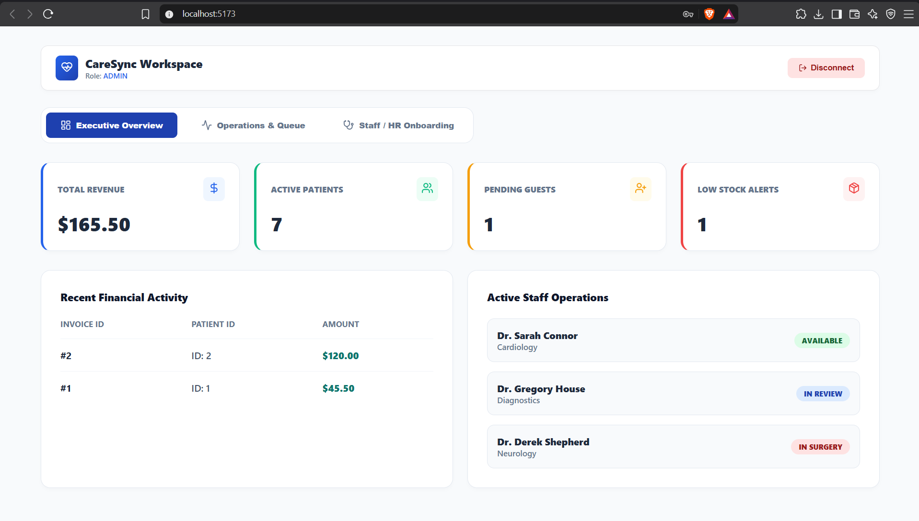

Doctor Console (showing the telemetry charts)
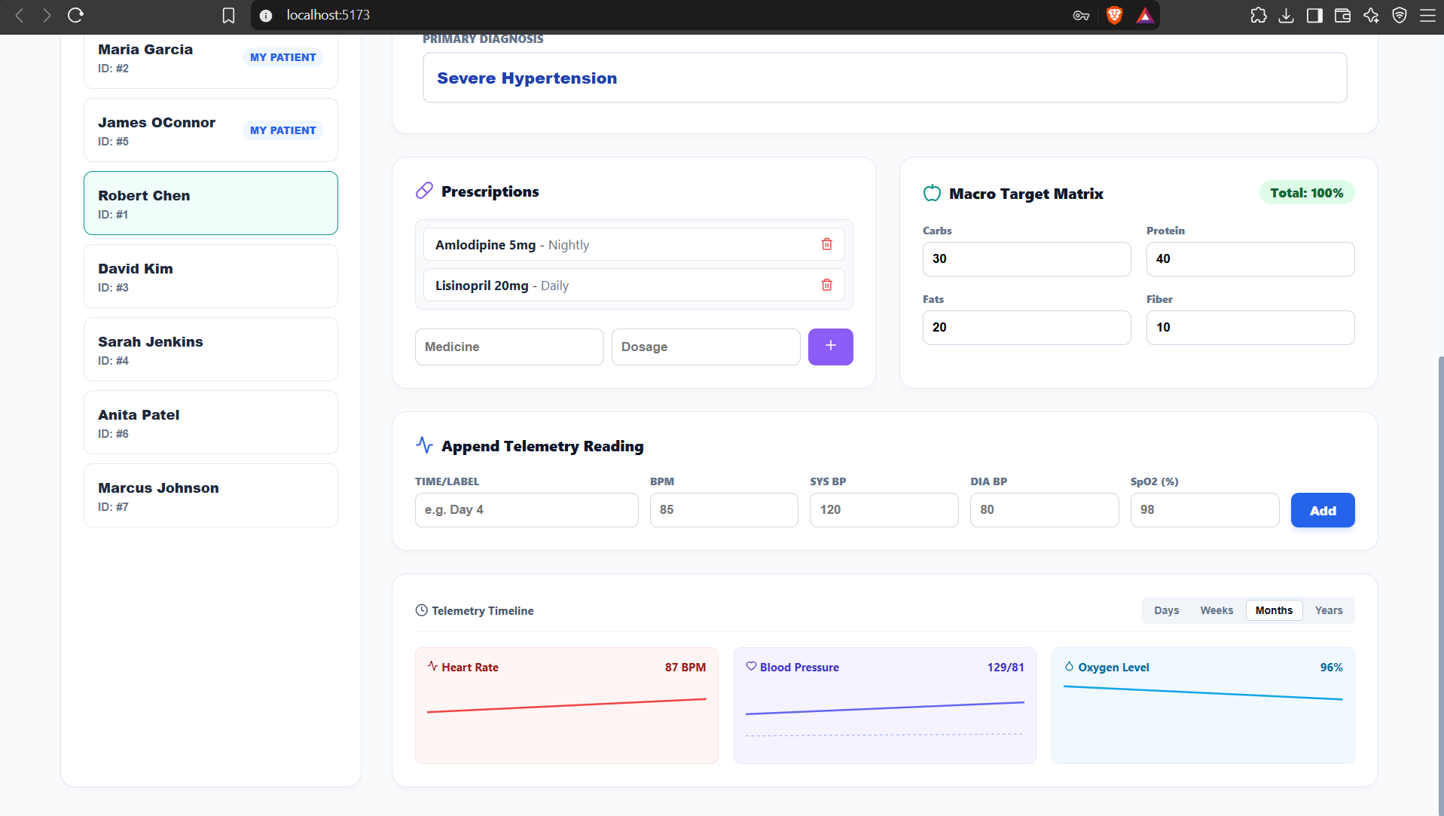

Pharmacy Invoice Builder
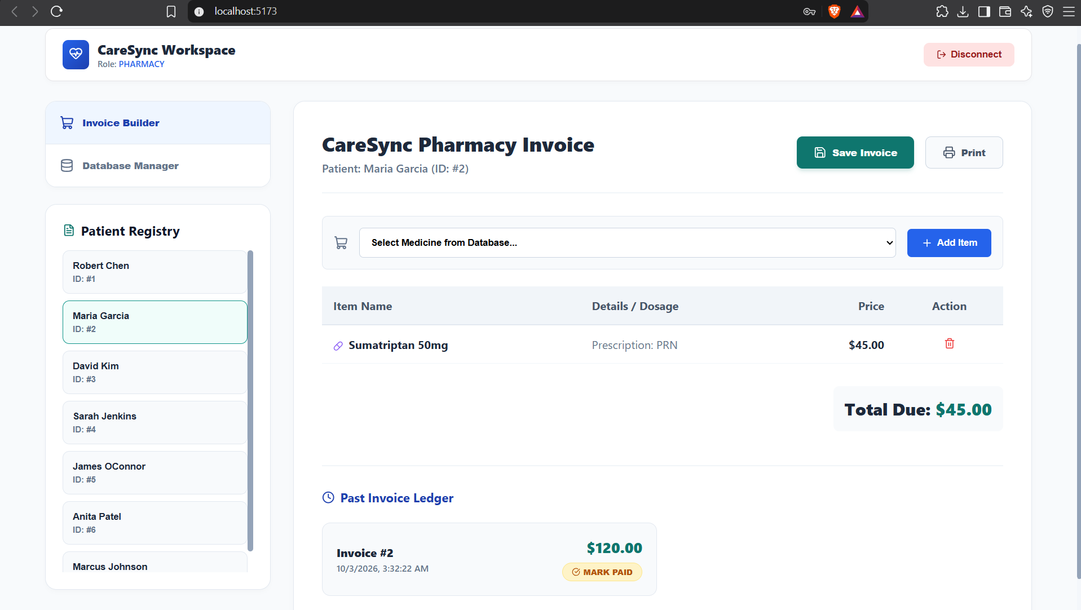

Patient Discharge Tracker
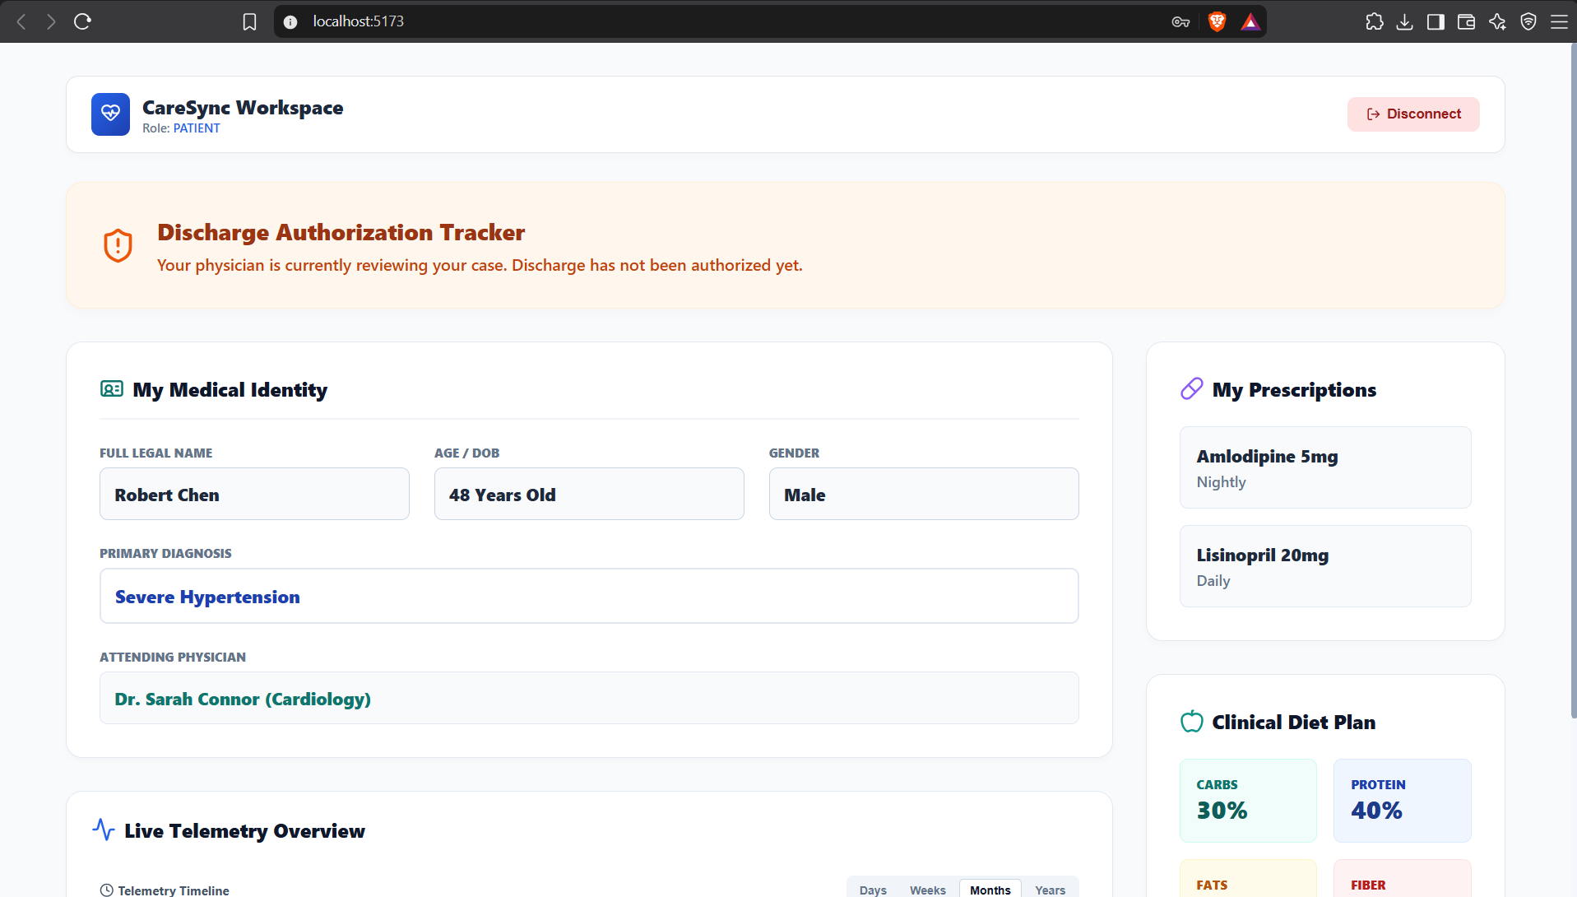

Sample Code Snippets
Paste the following from the project source code:
- The seed.py database generation script.
- The app.get("/patients") backend route.

seed.py
from database import SessionLocal, engine
import models
from datetime import date, datetime, timedelta
import random

print("Rebuilding CareSync database schema...")
models.Base.metadata.drop_all(bind=engine)
models.Base.metadata.create_all(bind=engine)

db = SessionLocal()

try:
docs = [
models.Doctor(email="dr.connor@caresync.com", password_hash="1234", first_name="Sarah", last_name="Connor", specialty="Cardiology", status="Available"),
models.Doctor(email="dr.house@caresync.com", password_hash="1234", first_name="Gregory", last_name="House", specialty="Diagnostics", status="In Review"),
models.Doctor(email="dr.shepherd@caresync.com", password_hash="1234", first_name="Derek", last_name="Shepherd", specialty="Neurology", status="In Surgery")
]
db.add_all(docs)
db.commit()

patients_data = [
{"fn": "Robert", "ln": "Chen", "dob": date(1978, 11, 4), "gender": "Male", "status": "Critical Monitoring", "diag": "Severe Hypertension", "carbs": 30, "prot": 40, "fat": 20, "fib": 10},
{"fn": "Maria", "ln": "Garcia", "dob": date(1992, 3, 15), "gender": "Female", "status": "Evaluating", "diag": "Chronic Migraine", "carbs": 40, "prot": 30, "fat": 20, "fib": 10},
{"fn": "David", "ln": "Kim", "dob": date(1985, 7, 22), "gender": "Male", "status": "Fully Discharged", "diag": "Post-Op Recovery", "carbs": 50, "prot": 20, "fat": 15, "fib": 15},
{"fn": "Sarah", "ln": "Jenkins", "dob": date(1965, 9, 10), "gender": "Female", "status": "Admitted", "diag": "Heart Failure", "carbs": 20, "prot": 50, "fat": 20, "fib": 10},
{"fn": "James", "ln": "OConnor", "dob": date(1955, 12, 5), "gender": "Male", "status": "Admitted", "diag": "Pneumonia", "carbs": 40, "prot": 30, "fat": 20, "fib": 10},
{"fn": "Anita", "ln": "Patel", "dob": date(1998, 1, 18), "gender": "Female", "status": "Evaluating", "diag": "Suspected Seizure", "carbs": 40, "prot": 30, "fat": 20, "fib": 10},
{"fn": "Marcus", "ln": "Johnson", "dob": date(2005, 6, 30), "gender": "Male", "status": "Admitted", "diag": "Myocarditis", "carbs": 35, "prot": 35, "fat": 20, "fib": 10}
]

for i, p in enumerate(patients_data):
pat = models.Patient(
doctor_id=(i % 3) + 1, first_name=p["fn"], last_name=p["ln"], date_of_birth=p["dob"], gender=p["gender"],
status=p["status"], diagnosis=p["diag"], contact_number="555-010" + str(i),
diet_carbs=p["carbs"], diet_protein=p["prot"], diet_fats=p["fat"], diet_fiber=p["fib"]
)
db.add(pat)
db.commit()

today = datetime.now()
for i in range(1, len(patients_data) + 1):
db.add(models.Vital(patient_id=i, recorded_at=today-timedelta(days=1), heart_rate=random.randint(70,90), blood_pressure_systolic=random.randint(110,130), blood_pressure_diastolic=random.randint(70,85), oxygen_saturation=random.randint(95,99), notes="Admission Baseline"))
db.add(models.Vital(patient_id=i, recorded_at=today, heart_rate=random.randint(70,90), blood_pressure_systolic=random.randint(110,130), blood_pressure_diastolic=random.randint(70,85), oxygen_saturation=random.randint(95,99), notes="Current Reading"))
db.commit()

db.add_all([
models.Medication(patient_id=1, name="Lisinopril 20mg", dosage="Daily"),
models.Medication(patient_id=1, name="Amlodipine 5mg", dosage="Nightly"),
models.Medication(patient_id=2, name="Sumatriptan 50mg", dosage="PRN")
])

inventory = [
models.MedicineInventory(name="Amoxicillin 500mg", price=15.99, stock=500),
models.MedicineInventory(name="Lisinopril 20mg", price=12.50, stock=300),
models.MedicineInventory(name="Atorvastatin 40mg", price=22.00, stock=45),
models.MedicineInventory(name="Ibuprofen 800mg", price=5.50, stock=1000),
models.MedicineInventory(name="Sumatriptan 50mg", price=45.00, stock=120),
models.MedicineInventory(name="Amlodipine 5mg", price=9.99, stock=400)
]
db.add_all(inventory)
db.commit()

db.add_all([
models.Bill(patient_id=1, total_amount=45.50, status="Paid", issued_at=today-timedelta(days=2)),
models.Bill(patient_id=2, total_amount=120.00, status="Unpaid", issued_at=today-timedelta(hours=5)),
models.Appointment(doctor_id=1, patient_id=1, appointment_date=today + timedelta(hours=2), reason="Follow-up BP Check"),
models.Appointment(doctor_id=2, guest_name="Marcus Vance", guest_contact="marcus@email.com", appointment_date=today + timedelta(days=1), reason="Severe joint pain consult")
])
db.commit()

print("CareSync EXTREME Database successfully seeded! Start Uvicorn.")

except Exception as e:
db.rollback()
print(f"Error seeding database: {e}")
finally:
db.close()

Installation / Setup Instructions
Run the following commands from the project folders:
# 1. Backend (from the backend folder)
pip install -r requirements.txt
python seed.py # create and seed the MySQL database
uvicorn main:app --reload # start API at localhost:8000

# 2. Frontend (from the frontend folder)
npm install
npm run dev # start UI at localhost:5173

User Manual or Guide
- Open localhost:5173 in a web browser and choose your role on the login screen.
- Receptionist: add walk-in guests to the queue and convert a guest into a registered patient.
- Doctor: open an assigned patient, add vital signs to see the charts update, prescribe medicines, and toggle “Ready for Discharge” when appropriate.
- Pharmacist: choose the patient, add medicines from the inventory dropdown to the cart, and save the invoice.
- Patient: view your active medical profile and follow the discharge tracker, signing consent when prompted.
- Admin: review revenue and low-stock alerts on the dashboard, and onboard new doctors.

Geo Tag Photos with Guide
Insert geo-tagged photo(s) with guide here

Review Forms with Guide Signatures
Insert scanned review forms with guide signatures here

